# Supporting strategies – worked examples (Your turn)

Research has shown that learning from worked examples is often very effective and so is an important source of learning. To successfully learn from these types of examples, the learner must actively explain the solution steps to themselves or a partner.

This explicit teaching technique used in the Mathematics Curriculum team’s resources is an adaptation of the process made popular by Michael Pershan (2021), Craig Barton (2020), and John Hollingsworth and Silvia Ybarra (2017).

## Process

1. Reveal the worked example to students.
2. Students read in silence.
3. Students individually think and explain to themselves what is happening in each step.
4. Students give a thumbs up to the teacher when they have finished reading and have some level of understanding.
5. Students join with a partner and take turns explaining what is happening in the worked example.
6. The teacher then reveals the self-explanation prompts and pairs discuss the answers.
7. The teacher randomly selects students to share their answers to the self-explanation prompts with the whole class.
8. Finally, the teacher reveals a ‘Your turn’ question for students to complete individually, before then displaying the solution.

This process is then repeated, if necessary, for additional worked examples.

## Sample process

Figure 1 – example ‘Your turn’

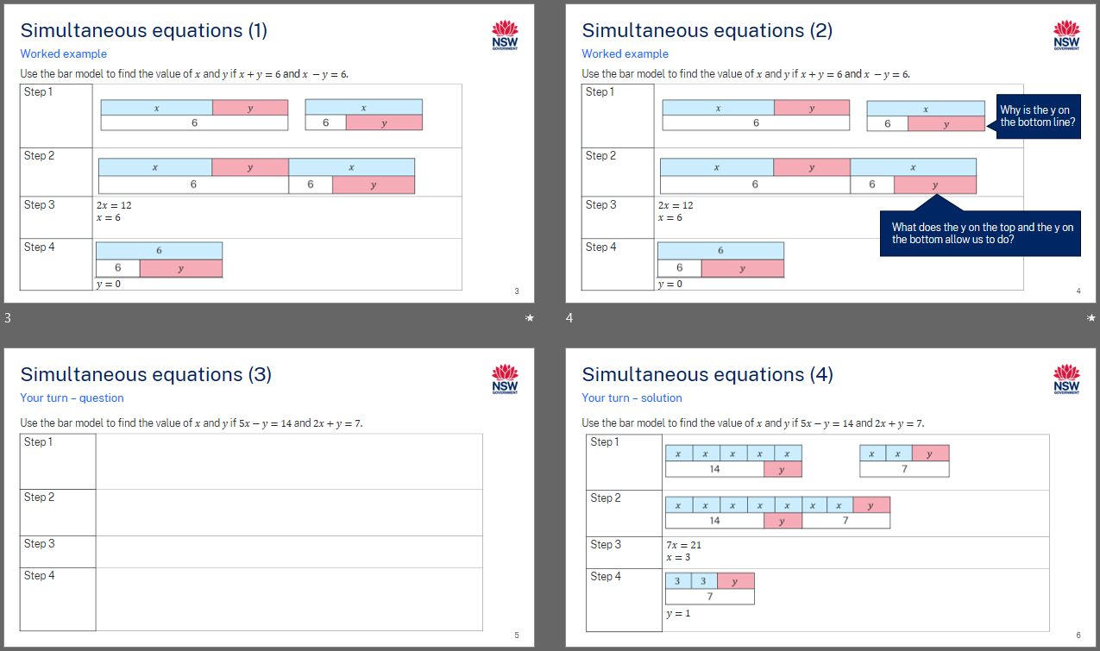

## References

**Barton C (2020) *Reflect, Expect, Check, Explain*, John Catt Educational, GB.**

**Hollingsworth JR and Ybarra SE (2017) *Explicit Direct Instruction (EDI)*, SAGE Publications Inc, US.**

**Pershan M (2021) Teaching Math With Examples, John Catt Educational, GB.**

**© State of New South Wales (Department of Education), 2024**

The copyright material published in this resource is subject to the Copyright Act 1968 (Cth) and is owned by the NSW Department of Education or, where indicated, by a party other than the NSW Department of Education (third-party material).

Copyright material available in this resource and owned by the NSW Department of Education is licensed under a [Creative Commons Attribution 4.0 International (CC BY 4.0) license](https://creativecommons.org/licenses/by/4.0/).

[](https://creativecommons.org/licenses/by/4.0/)

This license allows you to share and adapt the material for any purpose, even commercially.

Attribution should be given to © State of New South Wales (Department of Education), 2024.

Material in this resource not available under a Creative Commons license:

* the NSW Department of Education logo, other logos and trademark-protected material
* material owned by a third party that has been reproduced with permission. You will need to obtain permission from the third party to reuse its material.

**Links to third-party material and websites**

Please note that the provided (reading/viewing material/list/links/texts) are a suggestion only and implies no endorsement, by the New South Wales Department of Education, of any author, publisher, or book title. School principals and teachers are best placed to assess the suitability of resources that would complement the curriculum and reflect the needs and interests of their students.

If you use the links provided in this document to access a third-party's website, you acknowledge that the terms of use, including licence terms set out on the third-party's website apply to the use which may be made of the materials on that third-party website or where permitted by the Copyright Act 1968 (Cth). The department accepts no responsibility for content on third-party websites.