# Cross-sections

Students explore the cross-sections of solids to define prisms and discuss how we find uniform cross-sections and why they are useful.

Students will need at least one digital device per group of 3 to interact with GeoGebra during this lesson.

## Visible learning

### Learning intention

* To be able to determine if a solid is a prism.

### Success criteria

* I can identify the cross-sections of a solid.
* I can determine if a solid has a uniform cross-section.

### Syllabus outcomes

A student:

* develops understanding and fluency in mathematics through exploring and connecting mathematical concepts, choosing and applying mathematical techniques to solve problems, and communicating their thinking and reasoning coherently and clearly **MAO-WM-01**
* applies knowledge of volume and capacity to solve problems involving right prisms and cylinders **MA4-VOL-C-01**

[Mathematics K–10 Syllabus](https://curriculum.nsw.edu.au/learning-areas/mathematics/mathematics-k-10-2022/overview) © NSW Education Standards Authority (NESA) for and on behalf of the Crown in right of the State of New South Wales, 2022.

## Activity structure

### Warm up

1. Distribute mini whiteboards ([bit.ly/miniwhiteboards](https://bit.ly/miniwhiteboards)) and whiteboard markers to pairs of students.
2. Display the *Rounding Bean Bags* PowerPoint (PPT 4997 KB) ([bit.ly/beanbagguess](https://bit.ly/beanbagguess)) on the board.
3. Pause on slide 4 for each pair of students to guess the number of bean bags in the vase.
4. Each pair of students is to agree on an answer and to write their answer on their mini whiteboard. Students can modify their answer each time a clue is displayed, if they wish.

This activity could turn into a class competition where pairs decide to bank their answer early if they are confident. Teachers could create a scoring method to determine the winner, such as how far away from the answer they were, minus the number of clues they did not use.

1. Use a questioning strategy such as Pose-Pause-Pounce-Bounce question strategy (PDF 557KB) ([bit.ly/posepausepouncebounce](https://aus01.safelinks.protection.outlook.com/?url=https%3A%2F%2Fbit.ly%2Fposepausepouncebounce&data=05%7C02%7CNadine.Cannings%40det.nsw.edu.au%7C1f1fc552ae2c4b71f90d08dc5f323815%7C05a0e69a418a47c19c259387261bf991%7C0%7C0%7C638489916508485711%7CUnknown%7CTWFpbGZsb3d8eyJWIjoiMC4wLjAwMDAiLCJQIjoiV2luMzIiLCJBTiI6Ik1haWwiLCJXVCI6Mn0%3D%7C0%7C%7C%7C&sdata=eFr%2BY9nP5mcLUbuiw2cZ3Ag3EeTDq6Ksb5Q4wr8%2F2ZY%3D&reserved=0)) to hear students’ reasoning and bounce to other students to see if they agree.

This is a good opportunity to check students’ understanding of volume. You can use prompts such as:

* Is there the same number of bean bags on the bottom layer as the top layer?
* Is the vase a prism?

### Launch

This activity is based on nrich’s ‘Tic Tac Toe’ ([nrich.maths.org/538](https://nrich.maths.org/538)) activity.

1. Play a game of Tic Tac Toe (also known as noughts and crosses) with a student, on the board.
2. In a Think-Pair-Share ([bit.ly/thinkpairsharestrategy](https://bit.ly/thinkpairsharestrategy)) ask students to consider how many ways someone could win a game.
3. Have a student come to the board and model the different ways to confirm that the answer is 8.
4. Ask the students if they have ever played 3D Tic Tac Toe.
5. Explain that 3D Tic Tac Toe is a 3 by 3 by 3 grid giving 27 potential places to move. The rules are the same and the winner still has to connect 3 cells in a row.
6. Assign visibly random groups of 3 ([bit.ly/visiblegroups](https://bit.ly/visiblegroups)) and position groups at vertical non-permanent surfaces (VNPS) ([bit.ly/VNPSstrategy](https://bit.ly/VNPSstrategy)). Have students determine how many ways there are of winning 3D Tic Tac Toe.
7. Students complete a gallery walk ([bit.ly/DLSgallerywalk](https://bit.ly/DLSgallerywalk)) to observe the different methods used by other groups.

### Explore

1. Define a prism for students using the definition below:

A prism is a solid shape with a uniform cross-section and flat sides.

1. Students discuss in a Think-Pair-Share:

* Using your Tic Tac Toe gamepad as a reference, how would you cut a cube to have a uniform cross-section?
* Is the cross-section equal to the base area?
* Is a cube a prism?
* How could you dissect a rectangular prism to create a uniform cross-section?

1. Display the GeoGebra app ‘Sections of Rectangular Prisms (Cuboids)’ ([bit.ly/geogebrarectangular](https://bit.ly/geogebrarectangular)).
2. Select and drag the **Height** slider to show that the cross-section of the rectangular prism is uniform and equal to the area of the base.
3. Select the **refresh** icon in the top right corner.
4. Select and drag the **Rotate 1** slider from **Horizontal** to **Vertical** to show a different way that a uniform cross-section can be cut.
5. Select and drag the **Rotate 2** slider fully to show another way that a uniform cross-section can be cut.

### Summarise

1. Continuing at vertical non-permanent surfaces, ask groups to discuss what characteristics they can identify to determine if a solid is a prism.

A sentence starter such as ‘I can recognise a prism because …’ could be used.

1. Ask groups to write an explanation of the most effective way to determine if a solid is a prism.
2. Ask groups to do a gallery walk to allow students to observe the methods of other groups.
3. Groups return to their VNPS and if necessary, refine their method of determining if a solid is a prism.
4. Establish new visibly random groups of 3 and get groups to work at their VNPS using Appendix A ‘3D solids’. Students are to decide if each shape is a prism.

It would be ideal if Appendix A was cut into cards and students could stick the shapes under 2 headings, prisms and not prisms.

1. Allow students time to do a gallery walk to observe other group’s selections.
2. Students are to complete Appendix B ‘Frayer diagram’ ([bit.ly/frayerdiagram](http://bit.ly/frayerdiagram)) by filling in examples and non-examples from Appendix A, and the facts or characteristics of a prism, referring to their method for the most effective way to determine if a solid is a prism.

### Apply

1. Using one device per pair, ask students to open the ‘Map of the Las Vegas Strip’ ([bit.ly/vegasmap3d](https://bit.ly/vegasmap3d)). This is a 3D model of Las Vegas, USA.
2. Ask students to use their definitions of prisms to identify buildings that are prisms.

## Assessment and differentiation

### Suggested opportunities for differentiation

**Warm up**

* Students could write another clue or alter an existing clue to reduce the puzzle to only one answer.

**Explore**

* Students could be presented with alternate definitions for a prism, to that of the syllabus definition, such as ‘a solid geometric figure whose 2 ends are the same size, shape and parallel’.
* **Students could be encouraged to shade the cross-section of the shapes in Appendix A to clarify their understanding.**
* **Students could be encouraged to build their own prisms from centicubes.**

**Summarise**

* Students could consider a third category to define shapes such as pyramids.

**Apply**

* Students could suggest why more buildings are prisms rather than pyramids.
* Students could use their own knowledge or research to identify other famous buildings that are prisms.
* Students could design their own buildings that are prisms, pyramids or neither.

### Suggested opportunities for assessment

**Launch**

* Students will demonstrate their Working mathematically skills when discussing and justifying the shape of the Tic Tac Toe game.

**Explore**

* When placed in groups of 3, students provide and receive peer feedback on their understanding**.**
* Monitor students’ responses when groups are forming definitions to check understanding of the definition of a prism.

**Summarise**

* Student’s **Frayer diagrams could be collected as formative assessment for this unit.**

**Apply**

* Teachers could create an exit ticket asking students to sketch an example and a non-example of a prism. A competition could be created to reward the most creative correct answers.

## Appendix A

### 3D solids

|  |  |
| --- | --- |
| A  Cone. | B |
| C  **Triangular isosceles prism.** | D  An L shaped prism. |
| E  A right angled triangular prism. | F  Rectangular prism. |
| G  A hemi-sphere. | H  Trapezoidal prism. |
| I  A rectangular prism that has a half-cylinder removed from the top. | J  Hexagonal prism. |
| K  Pyramid shape outline. | L  Rectangular prism. |
| M  Trapezoidal prism. | N  Cylinder outline. |
| O  Sphere outline. | P |

## Appendix B

### Frayer diagram

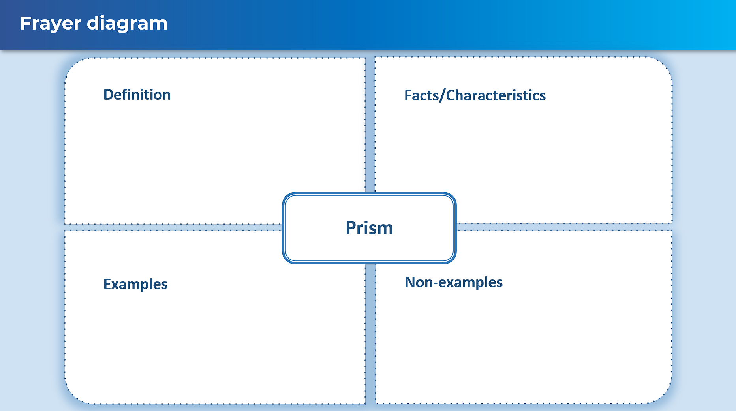

## Sample solutions

### Appendix A – 3D solids

Prisms: B, C, D, E, F, H, I, J, L, M

Not prisms: A, G, K, N, O, P

## References

This resource contains NSW Curriculum and syllabus content. The NSW Curriculum is developed by the NSW Education Standards Authority. This content is prepared by NESA for and on behalf of the Crown in right of the State of New South Wales. The material is protected by Crown copyright.

Please refer to the NESA Copyright Disclaimer for more information <https://educationstandards.nsw.edu.au/wps/portal/nesa/mini-footer/copyright>.

NESA holds the only official and up-to-date versions of the NSW Curriculum and syllabus documents. Please visit the NSW Education Standards Authority (NESA) website <https://educationstandards.nsw.edu.au/> and the NSW Curriculum website <https://curriculum.nsw.edu.au/>.

[Mathematics K–10 Syllabus](https://curriculum.nsw.edu.au/learning-areas/mathematics/mathematics-k-10-2022/overview) © NSW Education Standards Authority (NESA) for and on behalf of the Crown in right of the State of New South Wales, 2022.

**© State of New South Wales (Department of Education), 2024**

The copyright material published in this resource is subject to the *Copyright Act 1968* (Cth) and is owned by the NSW Department of Education or, where indicated, by a party other than the NSW Department of Education (third-party material).

Copyright material available in this resource and owned by the NSW Department of Education is licensed under a [Creative Commons Attribution 4.0 International (CC BY 4.0) license](https://creativecommons.org/licenses/by/4.0/).

[](https://creativecommons.org/licenses/by/4.0/)

This license allows you to share and adapt the material for any purpose, even commercially.

Attribution should be given to © State of New South Wales (Department of Education), 2024.

Material in this resource not available under a Creative Commons license:

* the NSW Department of Education logo, other logos and trademark-protected material
* material owned by a third party that has been reproduced with permission. You will need to obtain permission from the third party to reuse its material.

**Links to third-party material and websites**

Please note that the provided (reading/viewing material/list/links/texts) are a suggestion only and implies no endorsement, by the New South Wales Department of Education, of any author, publisher, or book title. School principals and teachers are best placed to assess the suitability of resources that would complement the curriculum and reflect the needs and interests of their students.

If you use the links provided in this document to access a third-party's website, you acknowledge that the terms of use, including licence terms set out on the third-party's website apply to the use which may be made of the materials on that third-party website or where permitted by the *Copyright Act 1968* (Cth). The department accepts no responsibility for content on third-party websites.