Multiple cubes
Students will develop the formulas for finding the volume of a rectangular prism ($V=lbh \text{and }V=Ah$). They will then use the formula to solve problems.

Visible learning

Learning intention
- To develop the formula for calculating the volume of a rectangular prism.

Success criteria
- I can calculate the base area (cross-section) of a rectangular prism.
- I can calculate the volume of a rectangular prism.
- I can explain how the formula for the volume of a rectangular prism was developed.
- I can substitute values into the formula for the volume of a rectangular prism.

Syllabus outcomes
A student:
- develops understanding and fluency in mathematics through exploring and connecting mathematical concepts, choosing and applying mathematical techniques to solve problems, and communicating their thinking and reasoning coherently and clearly MAO-WM-01
- applies knowledge of volume and capacity to solve problems involving right prisms and cylinders MA4-VOL-C-01
Mathematics K–10 Syllabus © NSW Education Standards Authority (NESA) for and on behalf of the Crown in right of the State of New South Wales, 2022.

Activity structure
Please use the associated PowerPoint Multiple cubes to display images in this lesson.

Launch
- Display slides 3–5 of the PowerPoint Multiple cubes, pausing after each slide for students to do a Think-Pair-Share (bit.ly/thinkpairsharestrategy). Students should consider what they notice and wonder ((bit.ly/noticewonderstrategy) and whether these observations change when more information is given.
Figure 1: colourful blocks and a box
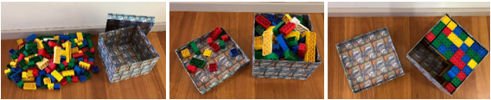
- After displaying slide 5 and giving pairs time to discuss, use the Pose-Pause-Pounce-Bounce questioning strategy (PDF 557KB) (bit.ly/posepausepouncebounce) to facilitate sharing of each pair’s thoughts. Useful question prompts may include:
- Why might it be easy to believe in the beginning that the blocks were not going to fit?
- Why do the blocks fit easily at the end?
- How might it have been possible to determine that the blocks could fit?
- How might it be possible to determine the total number of blocks that would fit in the box?

Explore
An optional activity to make a box from paper and fill it with centicubes is included in Appendix A ‘Make a box’.
This optional activity could be useful to support students to see the multiplicative relationship between the area of the base, the height and the volume of the prism by creating boxes with the same rectangular bases, but with varying heights.
- Divide students into pairs and distribute approximately 150 centicubes to each pair.
- Ask the students to make a rectangular prism, one layer high. Pairs should decide together what dimensions to make the prism.
- Use the Pose-Pause-Pounce-Bounce questioning strategy to discuss the prisms students have created and the centicubes. Useful questions may include:
- Why are the cubes named ‘centicube’?
- What are the dimensions of a centicube?
- What is the volume of each centicube?
- What do you know about the rectangular prism you have created?
- Distribute a copy of Appendix B ‘Multiple cubes’ and ask students to fill in the first row of the table, based on the dimensions of their rectangular prism.
- Ask students to add more layers to their rectangular prism to increase the height. Students should continue to fill in the table from Appendix B as they add additional layers.
The aim is for all students to recognise the pattern in the table and to recognise that they do not need to physically create a rectangular prism to complete the table. Some students may need more time with the centicubes before they can recognise the pattern.
- Use the Pose-Pause-Pounce-Bounce questioning strategy to discuss the strategies used to complete the table.
- What does the ‘number of cubes’ column represent?
- How is the number of cubes you’ve used linked to the number of cubes in the original rectangular prism (with only one layer)?
- Can you explain to someone how to find the total number of cubes, without having to build the prism?
- Distribute Appendix C ‘Number of cubes’ to pairs of students and ask them to complete the table.
- Ask students assessing and advancing questions (DOCX 327 KB) to further student thinking.
Table 1: assessing and advancing questions
Assessing questions | Advancing questions
Which cells in the table have you been able to calculate so far? | What could the dimensions of the base have been to make an area of $20 {cm}^{2}$?
What shape is the base of the prism? | How many other ways could you make a volume of 40 ${cm}^{3}$?
How do we calculate the area of a rectangle? | When the dimensions are doubled, what happens to the area of the base?
Can you use the centicubes to show what you know about the prism so far? | When the dimensions are doubled, what happens to the volume?
 | How might you calculate the volume of a triangular prism with the same dimensions as a rectangular prism?

Summarise
- Assign students to visibly random groups of 3 (bit.ly/visiblegroups) at vertical non-permanent surfaces (bit.ly/VNPSstrategy). Ask students to find 2 different ways they can calculate the volume of a rectangular prism. They are to record their 2 different rules on their vertical surfaces.
- Students are to conduct a gallery walk (bit.ly/DLSgallerywalk) to look at the rules that other groups have created, and how they have expressed them.
It is expected that students will come up with rules similar to Volume = length × breadth × height and Volume = area of base × height.
- Draw student’s attention to the different rules that have been used and the different notation that has been used to write rules in ‘shorthand’.
- Use the Pose-Pause-Pounce-Bounce questioning strategy to facilitate a class discussion about the different rules. Useful question prompts may include:
- When finding the volume of a rectangular prism, why can we either multiply the length, breadth and height of the prism or multiply the area of the base by the height?
- How would the volume change if the box was turned on its side?
The class should come to a consensus that we can use 2 different rules for finding the volume of a rectangular prism and that they can be written as $V=lbh$ and $V=Ah$.
Teachers should remind students that there is a multiplication sign between each variable in the rules.
- Use slides 7–18 from the PowerPoint Multiple cubes for explicit teaching of the formula for the volume of a rectangular prism using the Worked examples (Your turn) method (DOCX 420 KB).
- Distribute Appendix D ‘What is different?’ to students and ask them to work in pairs to complete the questions.
- On completion, use a Pose-Pause-Pounce-Bounce to consider how changing the dimensions of a rectangular prism impacts the volume. Useful questions for the class discussion may include:
- How was the volume affected when changes were made to the dimensions of the prisms?
- How could you use what you knew about the volume of one prism, to calculate the volume of other prisms?
- How could you use what you knew about the volume of the rectangular prism to determine the volume of the triangular prism?

Apply
- In their previous groups of 3 at vertical non-permanent surfaces, distribute Appendix E ‘Volume problems’ and ask students to solve the problems.
- Use a gallery walk for students to view the solutions of other groups.
- Use a Pose-Pause-Pounce-Bounce questioning strategy to discuss the solutions. Useful question prompts may include:
- How did you know which rectangular prism had the greatest height?
- Which of the formulas, $V=Ah$ or $V=lbh$ did you use to solve the problems?
- What did you notice when comparing your own solution to the solutions of others?
- What technique did you use to find a solution?
- What technique could you use to find multiple solutions?

Assessment and differentiation

Suggested opportunities for differentiation
Launch
- All students can participate as there are no right answers and everyone can notice and wonder.
Explore
- If teachers have chosen to use the optional activity from Appendix A, teachers could have some preconstructed boxes available to support students, allowing them to focus on filling the box with centicubes.
- Ensure the centicubes are still available for students when completing Appendix C.
Summarise
- Teachers may choose to omit Example 3 from the PowerPoint if their students are not yet ready to solve problems to find an unknown side.
Apply
- Have centicubes available to provide a physical representation of the problems.
- Students requiring support could be directed to the ‘Transum Volume’ webpage (bit.ly/volumetransum). Level 1 reinforces the concept of volume of a rectangular prism through counting cubes. Level 2 provides more practise using the formula to calculate the volume of a rectangular prism. (Note that the site uses the term ‘cuboid’ rather than rectangular prism.)

Suggested opportunities for assessment
Launch
- Monitor student discussion noticing the use of terms associated with measurement and volume.
Explore
- Students will be completing the table in Appendix A based on the dimensions of the prism they created, which will be different to other groups. Monitor how quickly students transition from using the centicubes to identifying the patterns and completing the table without the concrete materials.
Summarise
- Teachers can collect students’ answers to Appendix D ‘What is different?’ to check for understanding.
Apply
- Encourage students to justify their conclusions, formatively assessing their reasoning for their thinking.

Appendix A

Make a box

Equipment
- Scissors, one per student
- Sticky tape, one per group
- Centicubes, 100 to 200 available
- 16 cm by 20 cm grid, one per student

Method
- Assign students to visibly random groups of 3.
- Tell students to draw a rectangle on the grid. Important points to emphasise include:
- all members of the group should draw the same size rectangle
- the rectangle should have side lengths with values from 4 cm to 10 cm
- the rectangle should be drawn towards the centre of the grid, not on the edge
- the lengths need to be integer values.
- Explain that the rectangle they have drawn will be the base of their box.
- Ask students to draw either a 1 cm border, a 2 cm border or a 3 cm border around their rectangle, with a member of each group choosing a different one.
- Ask students to mark out a square in the border at each corner of their rectangle and instruct them to cut the square out. Encourage students to place a cross in each square before they cut the square out, to avoid cutting the wrong part.
- Ask students to fold the edges up to form a box. Students may use sticky tape to hold the sides of the box in place.
- Ask students to fill their box with centicubes and to count the number of centicubes used.
Figure 2: photos showing the box with a height of 2 cm and cubes
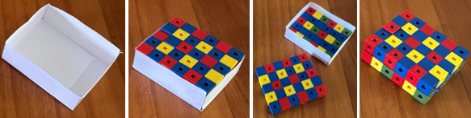

Appendix B

Multiple cubes
Complete the table below.
Length of base  $$(l)$$ | Breadth of base  $$(b)$$ | Area of base  $$(A)$$ | Height of prism  $$(h)$$ | Number of cubes  $$(V)$$
 |  |  | 1
 |  |  | 2
 |  |  | 3
 |  |  | 5
 |  |  | 8
 |  |  | 10
 |  |  | 20
 |  |  | 100

Appendix C

Number of cubes
Complete the table by filling in the blank spaces.
Length of base  $$(l)$$ | Breadth of base  $$(b)$$ | Area of base  $$(A)$$ | Height of box  $$(h)$$ | Number of cubes  $$(V)$$
4 $cm$ | 5 $cm$ |  | 2 $cm$
4 $cm$ | 5 $cm$ |  | 3 $cm$
 | 2 $cm$ | 20 ${cm}^{2}$ | 4 $cm$
 |  | 20 ${cm}^{2}$ | 5 $cm$
2 $cm$ | 3 $cm$ |  |  | 30 ${cm}^{3}$
2 $cm$ | 4 $cm$ |  |  | 40 ${cm}^{3}$
3 $cm$ |  | 12 ${cm}^{2}$ | 3 $cm$
 |  | 7 ${cm}^{2}$ | 5 $cm$
5 $cm$ | 6 $cm$ |  | 10 $cm$
8 $cm$ | 10 $cm$ |  | 6 $cm$

Appendix D

What is different?
Question number | Diagram | What has changed from the previous question?  How will the volume change? | Calculate the volume
 | 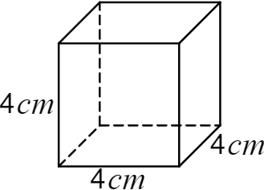
 | 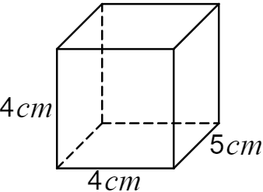
 | 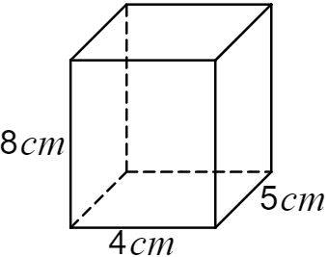
 | 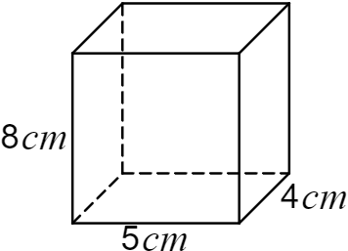
 | 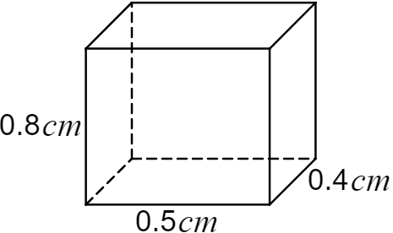
 | 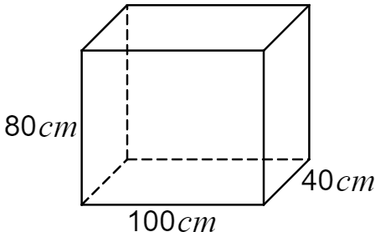
 | 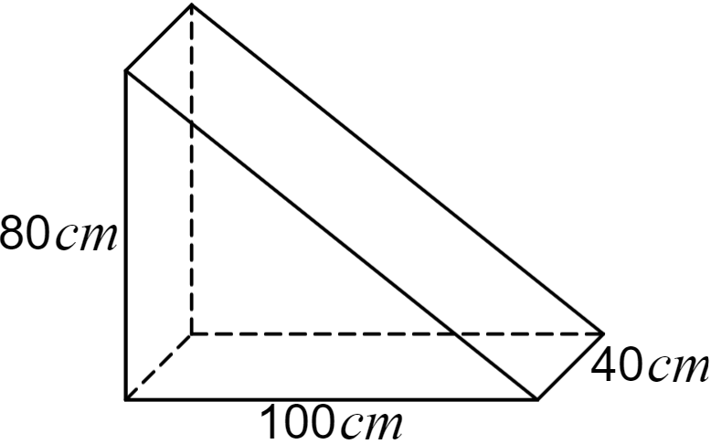

Appendix E

Volume problems
- Here are the bases of rectangular prisms A, B and C.
Each rectangular prism has the same volume.
Which prism has the greatest height?
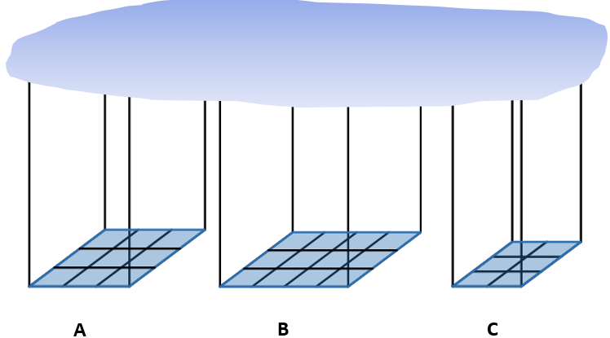
- Jo found he could cover the base of his box with blocks, as the picture shows, and he could stack the blocks 5 high to fill the box.
- How many blocks could he fit in the box?
- How many different bases could Jo use for a rectangular prism if he had 180 blocks to build the prism?

Sample solutions

Appendix C – number of cubes
Length of base  $$(l)$$ | Breadth of base  $$(b)$$ | Area of base  $$(A)$$ | Height of box  $$(h)$$ | Number of cubes  $$(V)$$
4 cm | 5 cm | 20 ${cm}^{2}$ | 2 cm | 40 ${cm}^{3}$
4 cm | 5 cm | 20${ cm}^{2}$ | 3 cm | 60 ${cm}^{3}$
10 cm | 2 cm | 20 ${cm}^{2}$ | 4 cm | 80 ${cm}^{3}$
Factor of 20  1, 2, 4, 5, 10 | Factor of 20 | 20 ${cm}^{2}$ | 5 cm | 100 ${cm}^{3}$
2 cm | 3 cm | 6 ${cm}^{2}$ | 5 cm | 30 ${cm}^{3}$
2 cm | 4 cm | 8 ${cm}^{2}$ | 5 cm | 40 ${cm}^{3}$
3 cm | 4 cm | 12 ${cm}^{2}$ | 3 cm | 36 ${cm}^{3}$
1 cm or 7 cm | 1 cm or 7 cm | 7 ${cm}^{2}$ | 5 cm | 35 ${cm}^{3}$
5 cm | 6 cm | 30 ${cm}^{2}$ | 10 cm | 300 ${cm}^{3}$
8 cm | 10 cm | 80 ${cm}^{2}$ | 6 cm | 480 ${cm}^{3}$

Appendix D – What is different?
$$V=4×4×4$$
$$=64 {cm}^{3}$$
$$V=4×4×5$$
$$=80 {cm}^{3}$$
$$V=8×4×5$$
$$=160 {cm}^{3}$$
$$V=8×5×4$$
$$=160 {cm}^{3}$$
$$V=0.8×0.5×0.4$$
$$=0.16 {cm}^{3}$$
$$V=80×100×40$$
$$=320 000 {cm}^{3}$$
$$V=\frac{1}{2}×(4×50×20)$$
$$=2000 {cm}^{3}$$

Appendix E – volume problems
- C has the greatest height.
- Box of blocks
- 48 x 5 = 240 blocks
- Possible dimensions include: $3×6×10=180, 4×5×9=180, 3×5×12=180$

References
This resource contains NSW Curriculum and syllabus content. The NSW Curriculum is developed by the NSW Education Standards Authority. This content is prepared by NESA for and on behalf of the Crown in right of the State of New South Wales. The material is protected by Crown copyright.
Please refer to the NESA Copyright Disclaimer for more information https://educationstandards.nsw.edu.au/wps/portal/nesa/mini-footer/copyright.
NESA holds the only official and up-to-date versions of the NSW Curriculum and syllabus documents. Please visit the NSW Education Standards Authority (NESA) website https://educationstandards.nsw.edu.au/ and the NSW Curriculum website https://curriculum.nsw.edu.au/.
Mathematics K–10 Syllabus © NSW Education Standards Authority (NESA) for and on behalf of the Crown in right of the State of New South Wales, 2022.

© State of New South Wales (Department of Education), 2024
The copyright material published in this resource is subject to the Copyright Act 1968 (Cth) and is owned by the NSW Department of Education or, where indicated, by a party other than the NSW Department of Education (third-party material).
Copyright material available in this resource and owned by the NSW Department of Education is licensed under a Creative Commons Attribution 4.0 International (CC BY 4.0) license.
This license allows you to share and adapt the material for any purpose, even commercially.
Attribution should be given to © State of New South Wales (Department of Education), 2024.
Material in this resource not available under a Creative Commons license:
- the NSW Department of Education logo, other logos and trademark-protected material
- material owned by a third party that has been reproduced with permission. You will need to obtain permission from the third party to reuse its material.
Links to third-party material and websites
Please note that the provided (reading/viewing material/list/links/texts) are a suggestion only and implies no endorsement, by the New South Wales Department of Education, of any author, publisher, or book title. School principals and teachers are best placed to assess the suitability of resources that would complement the curriculum and reflect the needs and interests of their students.
If you use the links provided in this document to access a third-party's website, you acknowledge that the terms of use, including licence terms set out on the third-party's website apply to the use which may be made of the materials on that third-party website or where permitted by the Copyright Act 1968 (Cth). The department accepts no responsibility for content on third-party websites.

