# A loaf of bread

Students will investigate how a loaf of bread can be used to explore uniform cross-sections. They will then use the formula for the volume of a prism to solve problems.

## Visible learning

### Learning intention

* To be able to solve problems involving the volume of a prism.

### Success criteria

* I can identify the cross-section of a prism.
* I can explain why the height of a prism is the length between the parallel faces.
* I can explain why you can multiply the area of the cross-section by the height to find the volume of a prism.

### Syllabus outcomes

A student:

* develops understanding and fluency in mathematics through exploring and connecting mathematical concepts, choosing and applying mathematical techniques to solve problems, and communicating their thinking and reasoning coherently and clearly **MAO-WM-01**
* applies knowledge of volume and capacity to solve problems involving right prisms and cylinders **MA4-VOL-C-01**

[Mathematics K–10 Syllabus](https://curriculum.nsw.edu.au/learning-areas/mathematics/mathematics-k-10-2022/overview) © NSW Education Standards Authority (NESA) for and on behalf of the Crown in right of the State of New South Wales, 2022.

## Activity structure

Please use the associated PowerPoint *A loaf of bread* to display images in this lesson.

### Warm up

#### Equipment

* Adhesive putty
* Appendix A ‘Always, sometimes, never’, cut into cards and mixed up

#### Method

1. Assign students to visibly random groups of 3 ([bit.ly/visiblegroups](https://bit.ly/visiblegroups)) on vertical non-permanent surfaces (VNPS) ([bit.ly/VNPSstrategy](https://bit.ly/VNPSstrategy)).
2. Distribute a set of cards from Appendix A ‘Always, sometimes, never’ and some adhesive putty to each group.
3. Students are to decide whether each statement is always true, sometimes true or never true and arrange the cards on their VNPS to reflect their decision.
4. After approximately 15 minutes, use a gallery walk ([bit.ly/DLSgallerywalk](https://bit.ly/DLSgallerywalk)) for students to compare their decisions with others.
5. Once students have completed a gallery walk, ask them to return to their board and consider if they should change any of their decisions.
6. Initiate a sharing of ideas and reasoning using the Pose-Pause-Pounce-Bounce question strategy (PDF 557KB) ([bit.ly/posepausepouncebounce](https://aus01.safelinks.protection.outlook.com/?url=https%3A%2F%2Fbit.ly%2Fposepausepouncebounce&data=05%7C02%7CNadine.Cannings%40det.nsw.edu.au%7C1f1fc552ae2c4b71f90d08dc5f323815%7C05a0e69a418a47c19c259387261bf991%7C0%7C0%7C638489916508485711%7CUnknown%7CTWFpbGZsb3d8eyJWIjoiMC4wLjAwMDAiLCJQIjoiV2luMzIiLCJBTiI6Ik1haWwiLCJXVCI6Mn0%3D%7C0%7C%7C%7C&sdata=eFr%2BY9nP5mcLUbuiw2cZ3Ag3EeTDq6Ksb5Q4wr8%2F2ZY%3D&reserved=0)). The following question prompts may be useful:

* How do you know a statement is always true?
* Can you select a statement and explain why you think it is sometimes true?
* Is a pyramid ever a prism?
* When is the statement ‘The cross-section of a triangular prism is an equilateral triangle’ true?
* Why isn’t a cylinder classified as a prism?
* Why can the height sometimes be horizontal?

### Launch

1. Display slide 3 from the *A loaf of bread* PowerPoint.

Figure 1: slide 3 showing a rectangular loaf of bread

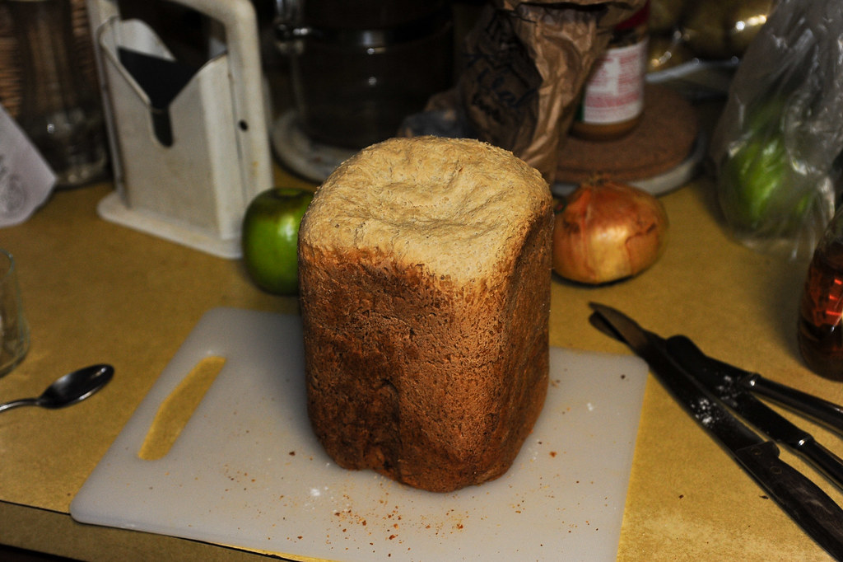

‘[Oatmeal bread](https://www.flickr.com/photos/72923429@N00/4043831966)’ by [eddie welker](https://www.flickr.com/photos/72923429@N00) is licensed under [CC BY 2.0](https://creativecommons.org/licenses/by/2.0/?ref=openverse).

1. In a Think-Pair-Share ([bit.ly/thinkpairsharestrategy](https://bit.ly/thinkpairsharestrategy)), students are to discuss the different ways the loaf of bread could be sliced.
2. Use the Pose-Pause-Pounce-Bounce question strategy to share ideas about how the bread could be sliced. Useful question prompts may include:

* What shape is the loaf of bread?
* How could we describe the shape of the slices if we repeatedly sliced the bread vertically?
* How could we describe the shape of the slices if we repeatedly sliced the bread horizontally?
* How could we describe the shape of the slices if we repeatedly sliced the bread at a   
  45-degree angle or diagonally?

Teachers could consider bringing in loaves of bread to cut in front of students.

1. Remind students of the definition of a prism.

A prism is a solid shape with a uniform cross-section and flat sides. Students learned the definition of a prism in Lesson 02 – cross sections.

1. Use the Pose-Pause-Pounce-Bounce question strategy to revise how to find the volume of a loaf of bread. Questions to encourage student reasoning may include:

* What part of the loaf of bread would represent the area of the cross-section?
* What part of the bread would represent the height?
* If we knew the area of one slice of bread was $120 {cm}^{2}$ and the length of the loaf was $30 cm$, how could we calculate the volume of the loaf?

1. Remind students that the formula for the volume of a rectangular prism is $V=lbh \text{ or }V=Ah$. That is, the volume equals the area of the cross-section times the height of the prism.

### Explore

1. Display slide 4 of the *A loaf of bread* PowerPoint.

Figure 2: triangular loaf of bread

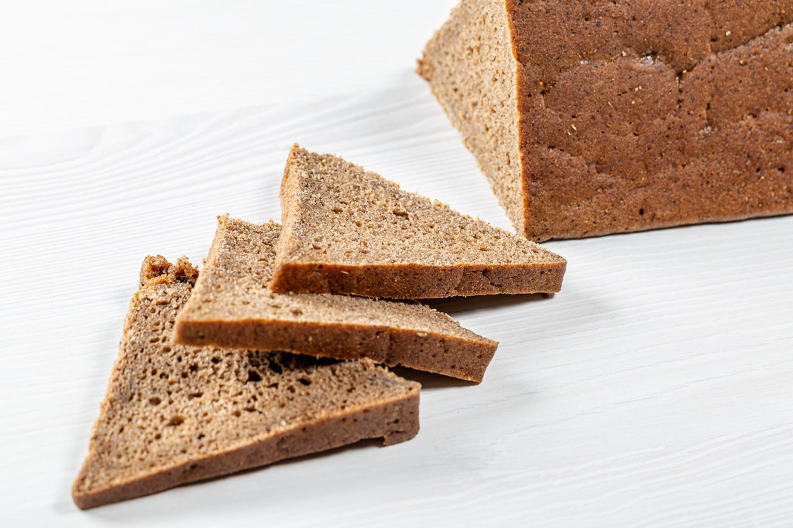

‘[Sliced triangular](https://www.flickr.com/photos/30478819@N08/48312995557) [pieces of black bread on a white table](https://foto.wuestenigel.com/sliced-triangular-pieces-of-black-bread-on-a-white-table/)’ by [Marco Verch](https://linktr.ee/wuestenigel) is licensed under [CC BY 2.0](https://creativecommons.org/licenses/by/2.0/?ref=openverse).

1. In a Think-Pair-Share, students are to discuss how they would find the volume of this loaf of bread.
2. Use the Pose-Pause-Pounce-Bounce questioning technique for students to share their strategies. Questions to encourage student reasoning may include:

* What shape is the loaf of bread?
* What shape is each slice of bread?
* Does changing the thickness of the slice change the volume of the loaf of bread?
* Can we still use the formulas $V=lbh \text{ or }V=Ah$?

Students should conclude that the $V=lbh$ formula no longer works (or needs to be adjusted). They should realise that the formula $V=Ah$ will work because it doesn’t rely on each slice being a particular shape.

1. Display slide 5 of the *A loaf of bread* PowerPoint.

Figure 3: hexagonal prism

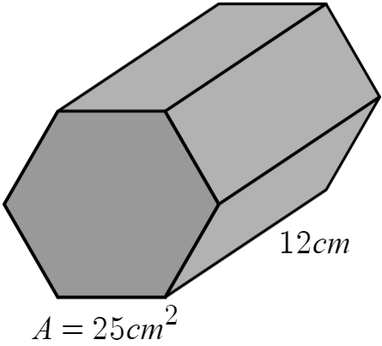

1. In a Think-Pair-Share, students are to discuss how they would find the volume of the hexagonal prism, if it were a loaf of bread.
2. Use the Pose-Pause-Pounce-Bounce questioning technique for students to share their strategies. Question prompts may include:

* What shape would each slice of bread be?
* What is the height of the loaf of bread?
* How many slices of bread would there be?

1. Students are to draw as many different shaped ‘loaves of bread’ as they can, marking in the area of each slice and the length. Students are then to swap with another student to find the volume.

### Summarise

1. Use slides 7–14 from the *A loaf of bread* PowerPoint for explicit teaching of the formula $V=Ah$ for calculating the volume of a prism using the [Worked examples (Your turn) method (DOCX 420 KB)](https://education.nsw.gov.au/content/dam/main-education/documents/teaching-and-learning/curriculum/mathematics/mathematics-s4-supporting-strategies-worked-examples-your-turn.docx).
2. Return students to their groups of 3, working on vertical non-permanent surfaces.
3. Distribute Appendix B ‘Which one doesn’t belong?’ to each group.
4. Ask students to find a reason why each of the volume problems doesn’t belong.

Students should be encouraged to perform calculations and not just base their decisions on what they observe visually.

1. Use a Pose-Pause-Pounce-Bounce questioning strategy for students to share reasons why each shape doesn’t belong.

### Apply

#### Investigating more loaves

1. Distribute Appendix C ‘Loaves of bread’ to each group of 3.
2. Students are to continue to work in their groups of 3 to solve the problems in the Appendix.
3. Select a non-volunteer student to present their group’s strategy and solution to the class.
4. Use a Pose-Pause-Pounce-Bounce questioning strategy to discuss why the formula for the volume of a prism can be used, when the loaves of bread aren’t prisms. Useful question prompts include:

* How is a loaf of bread like a prism?
* What does the term ‘uniform cross-section’ mean?
* Where might you see shapes that have a uniform cross-section?
* When can the formula $V=Ah$ be used?

#### Volume of a pool

1. With students still in their groups of 3, distribute a copy of Appendix D ‘Swimming pool’.
2. Ask students to work together to calculate the volume of the swimming pool in as many different ways as possible.
3. Use a Pose-Pause-Pounce-Bounce questioning strategy for students to explain the different ways they calculated the volume of the swimming pool. Useful questions may include:

* What shape is the pool?
* What shape is the cross-section?
* Which measurement represents the cross-section?
* Which measurements could be used to calculate the volume of the swimming pool?

## Assessment and differentiation

### Suggested opportunities for differentiation

**Warm up**

* Students requiring support could be given a reduced sub-set of the cards to consider.
* A set of 3-dimensional solids may be useful for students to visually consider the statements.

**Launch**

* A physical rectangular prism or loaf of bread may assist students in considering the different ways that the loaf could be cut.
* Students could use centicubes to assist them in revising the formula for the volume of a rectangular prism.

**Explore**

* Students could be given access to loaves of bread or slices of bread to measure and calculate the volume.
* Encourage students to be creative when drawing their own loaves of bread.

**Summarise**

* Discussion of different multiplicative strategies can encourage students to calculate the volume without using a calculator.
* Students could be challenged to make their own set of ‘Which one doesn’t belong?’ questions.

**Apply**

* Students could be given prisms which include measurements to one decimal place.
* A simplified diagram of a trapezoidal prism, without measurements, could be used to ask students to shade the cross-section.

### Suggested opportunities for assessment

**Warm up**

* Monitor student discussion to check for understanding and any misconceptions relating to prisms.

**Launch**

* Monitor student responses to question prompts to determine if students can identify that rectangular prisms can have multiple uniform cross-sections.

**Explore**

* Check student understanding of the cross-section of a prism when students are presenting their strategies to calculate the volume of the bread.
* Check student understanding that the thickness of a slice of bread does not affect the volume of the loaf of bread by monitoring the discussion during the Pose-Pause-Pounce-Bounce.

**Summarise**

* Monitor student working and use of reasoning to justify why each shape doesn’t belong to indicate that students can calculate the volume of a variety of prisms.

**Apply**

* Monitor responses to the questions, checking that students are applying the formula for the volume of a prism correctly.
* Check that students were correctly able to identify the cross-section of the pool.
* Monitor student responses to the swimming pool problem, noticing if students used the area of the cross-section, as included in the question, or calculated the area using the dimensions.

## Appendix A

### Always, sometimes, never

|  |
| --- |
| The front and back faces of a prism are joined by squares. |
| The cross-section of a triangular prism is an equilateral triangle. |
| A pyramid is a type of prism. |
| The sides joining the front and back faces of a prism are perpendicular to the faces. |
| A cylinder is a prism. |
| The height of a prism is the vertical length. |
| A prism is named after its cross-section. |
| A prism can have curved edges. |
| The cross-section of a prism is the same shape but can be different sizes. |
| A prism has a uniform cross-section that is equal to the base area. |
| The front and back faces of a prism are joined by rectangles. |

## Appendix B

### Which one doesn’t belong?

Find a reason to explain why each one of the following volume problems doesn’t belong.

|  |  |
| --- | --- |
| Calculate the volume.  A green and blue triangular prism. The blue triangular face is 8 centimetres wide and 6 centimetres high. The green body of the prism is 5 centimetres deep. | Calculate the volume.  A blue and white hexagon prism. The blue face has an area of 30 square metres and the prism body has a depth of 4 metres. |
| Calculate the volume.  A blue and white wavy object, similar to a prism, with black text. The blue face of the shape has an area of 12 square centimetres and a height of 10 centimetres. | Calculate the volume.  A black and white drawing of a triangular prism. The base triangle shape has an area of 30 square centimetres and the height of the prism is 6 centimetres. |

## Appendix C

### Loaves of bread

|  |  |  |
| --- | --- | --- |
|  | Turkish bread garlic loaf.  ‘[[food] Turkish bread garlic loaf from Woolworths](https://www.flickr.com/photos/58301516@N00/49466896133)’ by [David Jackmanson](https://www.flickr.com/photos/58301516@N00) is licensed under [CC BY 2.0](https://creativecommons.org/licenses/by/2.0/?ref=openverse). | Calculate the volume of the loaf of bread if the area of its cross-section is $20 {cm}^{2}$ and the length of the loaf is . |
|  | Sliced Bread with a white trapezium placed over the cross-section of the loaf. The trapezium has parallel side lengths of 8 centimetres and 12 centimetres and a height of 10 centimetres.  ’[Sliced Bread](https://www.flickr.com/photos/11018968@N00/8311347461)’ by [Bart Everson](https://www.flickr.com/photos/editor/) is licensed under [CC BY 2.0](https://creativecommons.org/licenses/by/2.0/?ref=openverse). | The loaf of bread is approximately in the shape of a trapezoidal prism. There were 15 slices, $1 cm$ thick cut from the loaf. What was the volume of the loaf of bread? |
|  | Sliced bread, butter, black and red caviar on the table.  ‘[Sliced bread, butter, black and red caviar on the table](https://foto.wuestenigel.com/sliced-bread-butter-black-and-red-caviar-on-the-table/)’ by [Marco Verch](https://linktr.ee/wuestenigel) is licensed under [CC BY 2.0](https://creativecommons.org/licenses/by/2.0/?ref=openverse). | Each slice of the baguette has an area of $30 {cm}^{2}$. What was the volume of the baguette if its length was ? |
|  | A slice of a L’oven Fresh Honey Wheat Bread loaf.  ‘[2021-12-01 01 56 15 A slice of a L’oven Fresh Honey Wheat Bread loaf in the Dulles section of Sterling, Loudoun County, Virginia](https://commons.wikimedia.org/w/index.php?curid=112984408)’ by [Famartin](https://commons.wikimedia.org/wiki/User:Famartin) is licensed under [CC BY-SA 4.0](https://creativecommons.org/licenses/by-sa/4.0/?ref=openverse). | The area of the slice of bread is approximately $120 {cm}^{2}$ and the loaf produced 25 slices of bread that were 1 $cm$  thick.  What was the volume of the loaf of bread? |

## Appendix D

### Swimming pool

How many ways can you calculate the volume of the swimming pool?

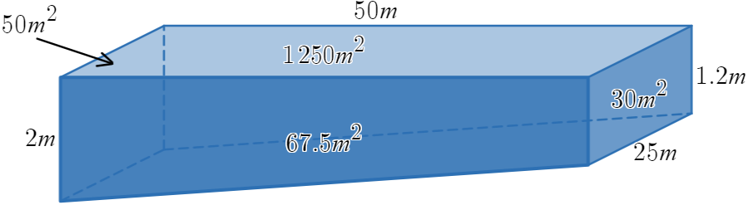

## Sample solutions

### Appendix A – always, sometimes, never

|  |  |
| --- | --- |
| **Always** | The front and back faces of a prism are joined by rectangles. |
| **Always** | A prism has a uniform cross-section that is equal to the base area. |
| **Always** | The sides joining the front and back faces of a prism are perpendicular to the faces. |
| **Always** | A prism is named after its cross-section. |
| **Sometimes** | The front and back faces of a prism are joined by squares. |
| **Sometimes** | The height of a prism is the vertical length. |
| **Sometimes** | The cross-section of a triangular prism is an equilateral triangle. |
| **Never** | The cross-section of a prism is the same shape but can be different sizes. |
| **Never** | A prism can have curved edges. |
| **Never** | A cylinder is a prism. |
| **Never** | A pyramid is a type of prism. |

### Appendix B – Which one doesn’t belong?

|  |  |
| --- | --- |
| Calculate the volume.  A green and blue triangular prism. The blue triangular face is 8 centimetres wide and 6 centimetres high. The green body of the prism is 5 centimetres deep.   * Need to calculate area of cross section first * Blue and green | Calculate the volume.  A blue and white hexagon prism. The blue face has an area of 30 square metres and the prism body has a depth of 4 metres.   * Unit of measurement is metres |
| Calculate the volume.  A blue and white wavy object, similar to a prism, with black text. The blue face of the shape has an area of 12 square centimetres and a height of 10 centimetres.   * Not a prism | Calculate the volume.  A black and white drawing of a triangular prism. The base triangle shape has an area of 30 square centimetres and the height of the prism is 6 centimetres.   * Volume is different to the other diagrams |

### Appendix C – loaves of bread

1. Calculate the volume of the loaf of bread if the area of its face is $20 {cm}^{2}$ and the length of the loaf is $40 cm$.
$$V=20×40 \\ =800 {cm}^{3}$$

2. The loaf of bread is in the shape of a trapezoidal prism. There were 15 slices, $1 cm$ thick, cut from the loaf. What was the volume of the loaf of bread?
$$V=\frac{10}{2}\left(8+12\right)×15 \\ =1500 {cm}^{3}$$

3. Each slice of the baguette has an area of $30 {cm}^{2}$. What was the volume of the baguette if the length of the roll was $30 cm$?
$$V=30×30 \\ =900 {cm}^{3}$$

4. The area of the slice of bread is approximately $120 {cm}^{2}$ and the loaf produced 25 slices of bread that were 1 $cm$  thick.

What was the volume of the loaf of bread?

$$V=120×25 \\ =3000 {cm}^{3}$$

### Appendix D – swimming pool

Here are 2 possible methods.

|  |  |
| --- | --- |
| Method 1: $$A=\frac{50}{2}\left(2+1.2\right) \\ =80 \\ V=Ah \\ =80×25 \\ =2000 m^{3}$$ | Method 2:  Rectangular prism $$V=50×25×1.2 \\ =1500$$ Triangular prism $$V=\frac{1}{2}×50×0.8×25 \\ =500$$ Total volume $$=1500+500 \\ =2000 m^{3}$$ |

## References

This resource contains NSW Curriculum and syllabus content. The NSW Curriculum is developed by the NSW Education Standards Authority. This content is prepared by NESA for and on behalf of the Crown in right of the State of New South Wales. The material is protected by Crown copyright.

Please refer to the NESA Copyright Disclaimer for more information <https://educationstandards.nsw.edu.au/wps/portal/nesa/mini-footer/copyright>.

NESA holds the only official and up-to-date versions of the NSW Curriculum and syllabus documents. Please visit the NSW Education Standards Authority (NESA) website <https://educationstandards.nsw.edu.au/> and the NSW Curriculum website <https://curriculum.nsw.edu.au/>.

[Mathematics K–10 Syllabus](https://curriculum.nsw.edu.au/learning-areas/mathematics/mathematics-k-10-2022/overview) © NSW Education Standards Authority (NESA) for and on behalf of the Crown in right of the State of New South Wales, 2022.

**© State of New South Wales (Department of Education), 2024**

The copyright material published in this resource is subject to the *Copyright Act 1968* (Cth) and is owned by the NSW Department of Education or, where indicated, by a party other than the NSW Department of Education (third-party material).

Copyright material available in this resource and owned by the NSW Department of Education is licensed under a [Creative Commons Attribution 4.0 International (CC BY 4.0) license](https://creativecommons.org/licenses/by/4.0/).

[](https://creativecommons.org/licenses/by/4.0/)

This license allows you to share and adapt the material for any purpose, even commercially.

Attribution should be given to © State of New South Wales (Department of Education), 2024.

Material in this resource not available under a Creative Commons license:

* the NSW Department of Education logo, other logos and trademark-protected material
* material owned by a third party that has been reproduced with permission. You will need to obtain permission from the third party to reuse its material.

**Links to third-party material and websites**

Please note that the provided (reading/viewing material/list/links/texts) are a suggestion only and implies no endorsement, by the New South Wales Department of Education, of any author, publisher, or book title. School principals and teachers are best placed to assess the suitability of resources that would complement the curriculum and reflect the needs and interests of their students.

If you use the links provided in this document to access a third-party's website, you acknowledge that the terms of use, including licence terms set out on the third-party's website apply to the use which may be made of the materials on that third-party website or where permitted by the *Copyright Act 1968* (Cth). The department accepts no responsibility for content on third-party websites.