# Finding volumes

Students apply the formula for the volume of a prism to solve problems, including solving equations to find missing lengths.

## Visible learning

### Learning intention

* To solve problems involving the volume of a prism.

### Success criteria

* I can identify a prism.
* I can identify the cross section of a prism.
* I can use a formula to find the volume of a prism.
* I can calculate an unknown side length of a prism, given the volume.

### Syllabus outcomes

A student:

* develops understanding and fluency in mathematics through exploring and connecting mathematical concepts, choosing and applying mathematical techniques to solve problems, and communicating their thinking and reasoning coherently and clearly **MAO-WM-01**
* applies knowledge of volume and capacity to solve problems involving right prisms and cylinders **MA4-VOL-C-01**

[Mathematics K–10 Syllabus](https://curriculum.nsw.edu.au/learning-areas/mathematics/mathematics-k-10-2022/overview) © NSW Education Standards Authority (NESA) for and on behalf of the Crown in right of the State of New South Wales, 2022.

## Activity structure

Please use the associated PowerPoint *Finding volumes* to display images in this lesson.

### Warm up

1. Remind students that in the previous lesson, they developed the formula for the volume of a prism $V=Ah$. In this lesson, students will apply the formula to solve a variety of problems.
2. Display Figure 1: square and triangle, which is on slide 3 of the *Finding volumes* PowerPoint.

Figure 1: square and triangle

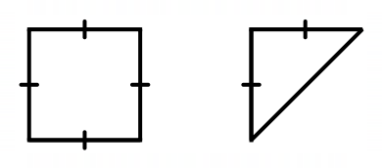

1. Students discuss in a Think-Pair-Share ([bit.ly/thinkpairsharestrategy](https://bit.ly/thinkpairsharestrategy)), the following question:

Two prisms, with these bases, are made to have the same volume. Which would be taller?

1. Use a questioning strategy such as Pose-Pause-Pounce-Bounce question strategy (PDF 557KB) ([bit.ly/posepausepouncebounce](https://aus01.safelinks.protection.outlook.com/?url=https%3A%2F%2Fbit.ly%2Fposepausepouncebounce&data=05%7C02%7CNadine.Cannings%40det.nsw.edu.au%7C1f1fc552ae2c4b71f90d08dc5f323815%7C05a0e69a418a47c19c259387261bf991%7C0%7C0%7C638489916508485711%7CUnknown%7CTWFpbGZsb3d8eyJWIjoiMC4wLjAwMDAiLCJQIjoiV2luMzIiLCJBTiI6Ik1haWwiLCJXVCI6Mn0%3D%7C0%7C%7C%7C&sdata=eFr%2BY9nP5mcLUbuiw2cZ3Ag3EeTDq6Ksb5Q4wr8%2F2ZY%3D&reserved=0))to facilitate a class discussion, asking ‘How much taller would the triangular prism be?’.

Students should identify that the triangular prism would be twice as tall as the rectangular prism, as the triangle base has half the area of the square. The purpose of this problem is for students to recognise that $V=Ah$ is equivalent to $V=(\frac{1}{2}A)×(2h)$.

### Launch

1. Assign visibly random groups of 3 ([bit.ly/visiblegroups](https://bit.ly/visiblegroups)) and position groups at vertical non-permanent surfaces ([bit.ly/VNPSstrategy](https://bit.ly/VNPSstrategy)) around the classroom.
2. Display Figure 2: three rectangular prisms, which is on slide 4 of the *Finding volumes* PowerPoint.

Figure 2: three rectangular prisms

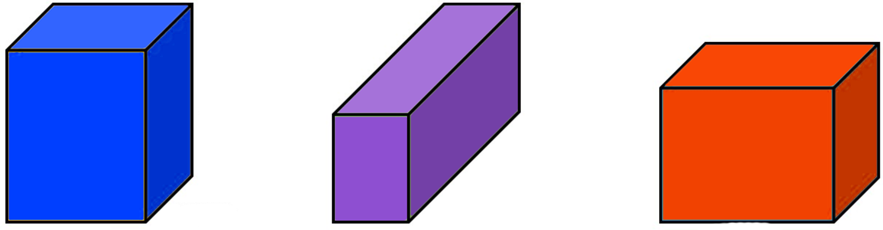

1. Pose the following problem to students:

Using the numbers 1–9 at most one time each, find the dimensions of the 3 rectangular prisms so that their volumes are as close as possible.

The problem ‘Three rectangular prisms’ can be found on the ‘Open Middle’ website ([bit.ly/openmiddlerectangles](https://bit.ly/openmiddlerectangles)). The following hints can be provided:

* All the volumes are under 100 cubic units.
* Can you find 3 volumes that are within the range of 50 and 90?
* Can you find 3 volumes that are within the range of 60 and 80?
* The difference between all 3 volumes is less than 10.

1. Students complete a gallery walk ([bit.ly/DLSgallerywalk](https://bit.ly/DLSgallerywalk)) to view their peers’ working and solutions.

### Explore

1. Distribute Appendix A ‘Volume formula’ to each student.
2. Students complete at least 3 questions from each section: mild, medium, spicy. Following each set of questions in the appendix is a space for students to write a 1–2 sentence note to their future forgetful self ([bit.ly/notesstrategy](https://bit.ly/notesstrategy)) on how they completed these questions.

Students should complete at least one question from each level of mild, medium and spicy. They should be able to choose how many to complete and which questions they complete.

As the questions increase in difficulty from mild to spicy, students are required to use the formula for the volume of a prism to find unknown lengths. These questions deliberately look the same as previous questions, allowing students to develop their problem-solving strategies.

The volume is provided at the bottom of each question so that in some cases students can check their answers are correct and the emphasis is instead on students showing their working.

1. After students have completed all questions, have them share their notes to their future forgetful selves with a partner.
2. Randomly select students to share their favourite note to their future forgetful self that their partner shared.

### Summarise

1. In students’ workbooks, they compile their notes to their future forgetful selves from Appendix A ‘Volume formula’.

Students should be encouraged to create worked examples to show the types of problems they can solve using the formula for the volume of a prism.

1. Use slides 6–13 from the *Finding volumes* PowerPoint for explicit teaching of finding unknown lengths using the formula for the volume of a prism. The PowerPoint uses the [Worked examples (Your turn) method (DOCX 420 KB)](https://education.nsw.gov.au/content/dam/main-education/documents/teaching-and-learning/curriculum/mathematics/mathematics-s4-supporting-strategies-worked-examples-your-turn.docx).

### Apply

1. Print Appendix B ‘Prism Venn’ on A3 paper and place in plastic pockets. Use adhesive putty to stick the plastic pockets on walls around the classroom.
2. Assign new visibly random groups of 3 and position groups at plastic pockets.
3. Explain the problem to students:

Your challenge is to draw a rectangular prism in each region of the Venn diagram. If you think a region is impossible to fill you must be able to justify why.

1. Students should be encouraged to observe other groups’ answers and collaborate with neighbouring groups.
2. Once all groups have had time to attempt the task, students complete a gallery walk to observe their peers’ answers.
3. Facilitate a class discussion using the Pose-Pause-Pounce-Bounce questioning strategy, to ask:

* Which region was easiest to fill?
* Which region was hardest to fill?
* What strategy did you use to fill region C?

## Assessment and differentiation

### Suggested opportunities for differentiation

**Warm up**

* To help students visualise cutting a prism in half to create a triangular prism, students could be provided with centicubes.

**Launch**

* Students may benefit from recall questions to practise applying the volume of a prism formula at the start of the lesson.
* Challenge students to consider how many different prisms they can create with a volume of 24 cubic centimetres.

**Explore**

* Appendix A contains problems that are graded by difficulty. Students should start and finish at a level that matches their readiness.
* Challenge students to create 3 prisms where one side is an unknown pronumeral and the volume is provided. Students can then swap with a partner, to complete each other’s problem.

**Summarise**

* Students could create worked examples for a variety of prisms or if more appropriate, their examples could be rectangular prisms only.
* Model and encourage students to draw bar models to aid them in solving equations.

**Apply**

* Challenge students to complete Appendix B ‘Prism Venn’ by using prisms other than rectangular prisms. Students would need to change the red category to be 3 dimensions less than 4.
* If a student is struggling to contribute to the task, encourage them to move around the room and find an answer from another group. They should ask that group how they know that prism is correct before reporting back to their own group.
* If students are not ready to compare the 3 circles in the Venn diagram, they could ignore the blue circle and focus on the other 2.

### Suggested opportunities for assessment

**Warm up**

* Students’ reasoning may reveal misconceptions about area and cross sections which should be addressed prior to continuing with the lesson.

**Launch**

* Listen for misconceptions in students’ reasoning as they complete the task.

**Explore**

* Appendix A ‘Volume formula’ could be collected and analysed as evidence of student learning.
* Take note of students’ notes to future forgetful selves after each set of questions.
* Take note of how students show their working for each problem. The volume is provided so that the emphasis is on students’ demonstrating their understanding through their working.

**Summarise**

* Students’ worked examples and notes to future forgetful selves could be collected and analysed to assess understanding.
* Students’ worked examples and notes to future forgetful selves could be shared in an online classroom for students to access and peer review.

**Apply**

* Students working at vertical non-permanent surfaces, means that they can self-assess by comparing their answers to their peers’.
* Ask students to justify their answers as you move around the room.

## Appendix A

### Volume formula

**Mild –** show how to find the volume of each prism.

|  |  |  |
| --- | --- | --- |
| a | b | c |
| Rectangular prism with area 10 cm^2 and height 2 cm. | Rectangular prism with area 20 cm^2 and height 2 cm. | Rectangular prism with area 30 cm^2 and height 2 cm. |
|  |  |  |

|  |  |  |
| --- | --- | --- |
| ****d**** | ****e**** | ****f**** |
| Rectangular prism with area 15 cm^2 and height 6 cm. | Rectangular prism with area 15  cm^2 and height 10 cm. | Rectangular prism with area 15  cm^2 and height 20.25 cm. |
|  |  |  |

**Note to future forgetful self:**

**Medium –** show how to find the volume of each prism.

|  |  |  |
| --- | --- | --- |
| g | h | i |
| Triangular prism with area 15 cm^2 and height 3 cm. | Pentagonal prism with area 27 cm^2 and height 1.8 cm. | Octagonal prism with area 56 mm^2 and height 7mm and side length 3.41 mm. |
|  |  |  |

|  |  |  |
| --- | --- | --- |
| j | k | l |
| Rectangular prism with side lengths 2cm, 7cm and 5cm. | Triangular prism with side lengths 3cm, 7cm, and 12cm. | Parallelogram prism with face height 9 cm, face width 4 cm and prism height 1.5 cm. |
|  |  |  |

**Note to future forgetful self:**

**Spicy –** show how to find the value of the pronumeral of each prism.

|  |  |  |
| --- | --- | --- |
| m | n | o |
| Rectangular prism with area 24  cm^2 and height x cm. | Triangular prism with area 25  cm^2 and height y cm. | Cube with side lengths a cm. |
|  |  |  |

**Note to future forgetful self:**

## Appendix B

### Prism Venn

Your challenge is to draw a rectangular prism in each region of the Venn diagram. If you think a region is impossible to fill you must be able to justify why.

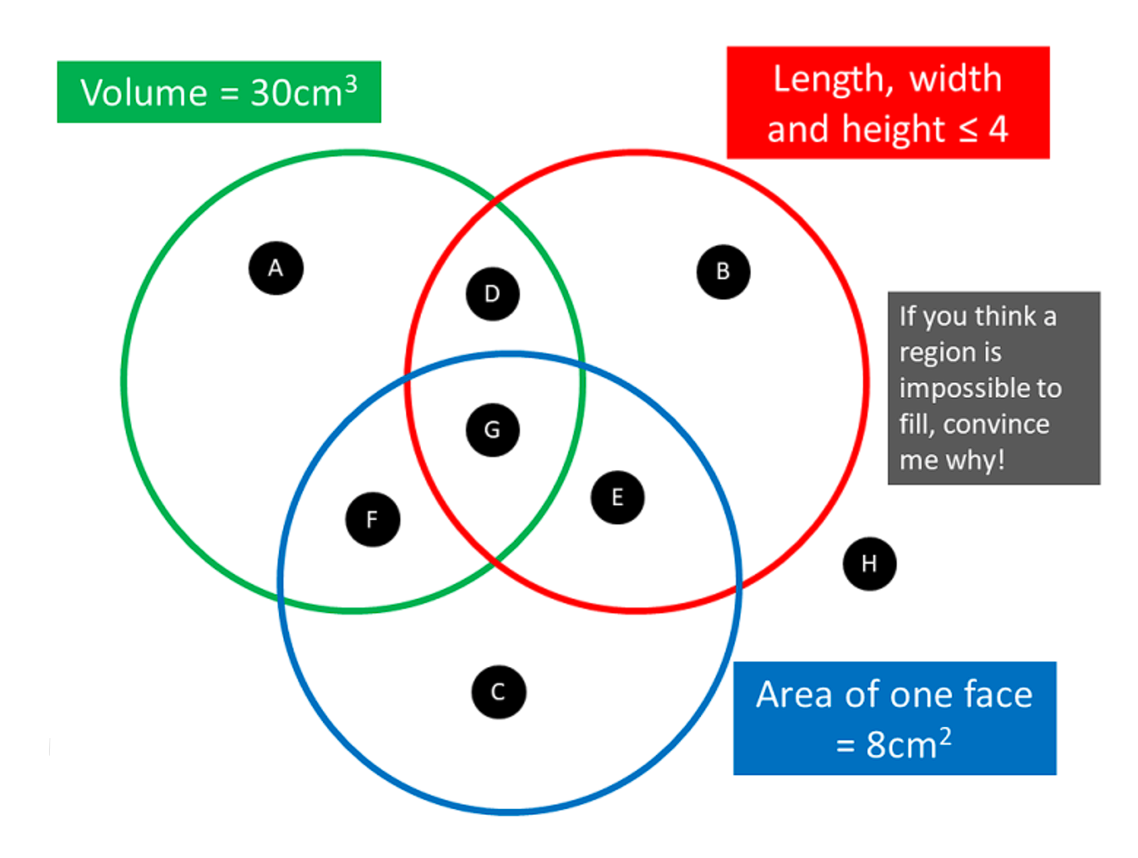

## Sample solutions

### **Launch**

You can’t get a perfect match, but you can get close, with dimensions of (1, 8, 9), (2, 5, 7) and (3, 4, 6).

### Appendix A – volume formula

**Mild –** show how to find the volume of each prism.

|  |  |  |
| --- | --- | --- |
| a | b | c |
| Rectangular prism with area 10 cm^2 and height 2 cm. | Rectangular prism with area 20 cm^2 and height 2 cm. | Rectangular prism with area 30 cm^2 and height 2 cm. |
|  |  |  |

|  |  |  |
| --- | --- | --- |
| ****d**** | ****e**** | ****f**** |
| Rectangular prism with area 15 cm^2 and height 6 cm. | Rectangular prism with area 15  cm^2 and height 10 cm. | Rectangular prism with area 15  cm^2 and height 20.25 cm. |
|  |  |  |

**Note to future forgetful self: when the area of the base of a prism is provided, the volume is that area multiplied by the height of the prism.**

**Medium –** show how to find the volume of each prism.

|  |  |  |
| --- | --- | --- |
| g | h | i |
| Triangular prism with area 15 cm^2 and height 3 cm. | Pentagonal prism with area 27 cm^2 and height 1.8 cm. | Octagonal prism with area 56 mm^2 and height 7mm and side length 3.41 mm. |
|  |  |  |

|  |  |  |
| --- | --- | --- |
| j | k | l |
| Rectangular prism with side lengths 2cm, 7cm and 5cm. | Triangular prism with side lengths 3cm, 7cm, and 12cm. | Parallelogram prism with face height 9 cm, face width 4 cm and prism height 1.5 cm. |
|  |  |  |

**Note to future forgetful self: multiplying a provided area by the height works for any prism. Sometimes you’ll need to find the area of the base yourself. For rectangular prisms, any face can be the base but for other prisms you need to choose the face with a uniform cross section.**

**Spicy –** show how to find the value of the pronumeral of each prism.

|  |  |  |
| --- | --- | --- |
| m | n | o |
| Rectangular prism with area 24  cm^2 and height x cm. | Triangular prism with area 25  cm^2 and height y cm. | Parallelogram prism with face height 9 cm, face width 4 cm and prism height 1.5 cm. |
|  |  |  |

**Note to future forgetful self: if using the volume to find an unknown side, it helps to set up and solve an equation.**

### Appendix B – prism Venn

* A = 5, 6, 1
* B = 1, 1, 1
* C = 9, 2, 4
* D = 3, 3, 3.33
* E = 2, 4, 2
* F = 3.75, 1, 8
* G = 3.75, 2, 4
* H = 9, 4, 5

## References

This resource contains NSW Curriculum and syllabus content. The NSW Curriculum is developed by the NSW Education Standards Authority. This content is prepared by NESA for and on behalf of the Crown in right of the State of New South Wales. The material is protected by Crown copyright.

Please refer to the NESA Copyright Disclaimer for more information <https://educationstandards.nsw.edu.au/wps/portal/nesa/mini-footer/copyright>.

NESA holds the only official and up-to-date versions of the NSW Curriculum and syllabus documents. Please visit the NSW Education Standards Authority (NESA) website <https://educationstandards.nsw.edu.au/> and the NSW Curriculum website <https://curriculum.nsw.edu.au/>.

[Mathematics K–10 Syllabus](https://curriculum.nsw.edu.au/learning-areas/mathematics/mathematics-k-10-2022/overview) © NSW Education Standards Authority (NESA) for and on behalf of the Crown in right of the State of New South Wales, 2022.

**© State of New South Wales (Department of Education), 2024**

The copyright material published in this resource is subject to the *Copyright Act 1968* (Cth) and is owned by the NSW Department of Education or, where indicated, by a party other than the NSW Department of Education (third-party material).

Copyright material available in this resource and owned by the NSW Department of Education is licensed under a [Creative Commons Attribution 4.0 International (CC BY 4.0) license](https://creativecommons.org/licenses/by/4.0/).

[](https://creativecommons.org/licenses/by/4.0/)

This license allows you to share and adapt the material for any purpose, even commercially.

Attribution should be given to © State of New South Wales (Department of Education), 2024.

Material in this resource not available under a Creative Commons license:

* the NSW Department of Education logo, other logos and trademark-protected material
* material owned by a third party that has been reproduced with permission. You will need to obtain permission from the third party to reuse its material.

**Links to third-party material and websites**

Please note that the provided (reading/viewing material/list/links/texts) are a suggestion only and implies no endorsement, by the New South Wales Department of Education, of any author, publisher, or book title. School principals and teachers are best placed to assess the suitability of resources that would complement the curriculum and reflect the needs and interests of their students.

If you use the links provided in this document to access a third-party's website, you acknowledge that the terms of use, including licence terms set out on the third-party's website apply to the use which may be made of the materials on that third-party website or where permitted by the *Copyright Act 1968* (Cth). The department accepts no responsibility for content on third-party websites.