Volume and capacity
Students explore conversions between metric units of volume and capacity.

Visible learning

Learning intention
- To be able to convert between units of volume and capacity.

Success criteria
- I can accurately estimate the capacity of containers.
- I can calculate the capacity from a volume measured in cubic centimetres.
- I can calculate the capacity from a volume measured in cubic millimetres or metres.

Syllabus outcomes
A student:
- develops understanding and fluency in mathematics through exploring and connecting mathematical concepts, choosing and applying mathematical techniques to solve problems, and communicating their thinking and reasoning coherently and clearly MAO-WM-01
- applies knowledge of volume and capacity to solve problems involving right prisms and cylinders MA4-VOL-C-01
Mathematics K–10 Syllabus © NSW Education Standards Authority (NESA) for and on behalf of the Crown in right of the State of New South Wales, 2022.

Activity structure
Please use the associated PowerPoint Volume and capacity to display images in this lesson.

Warm up
- Students estimate, in a Think-Pair-Share (bit.ly/thinkpairsharestrategy) the litres of water for each context below, writing their estimate on mini whiteboards. Answers are provided in brackets.
- How many litres of water should a teenager drink per day? (1.6–1.9 litres)
- How many litres of water is in the average human body? (42 litres)
- How many litres does the average person urinate in a year? (550 litres)
- How many litres of water is on Earth? (3.785 trillion litres)

Launch
Students should be familiar with the definitions of capacity and volume from Stage 3. If students do not have a strong understanding of the difference between capacity and volume, this should be defined before continuing with the lesson.
- Navigate to the website ‘Tap into teen mind’s – 3 Act Math: Soup du jour’ (bit.ly/3actsoup).
- Ask students to create a t-chart (bit.ly/tchartstrategy) with headings ‘notice’ and ‘wonder’.
- Play the video under the heading Act 1: Sparking Curiosity and ask students to record at least one thing that they notice and one thing they wonder (bit.ly/noticewonderstrategy).
Bringing in a box of soup (or any liquid) and a rectangular container would be more effective than showing the videos.
- Ask students ‘Will the soup fit in the container’? Conduct a vote, with a tally recorded on the board. Ask randomly selected students to explain their vote.
- Display the image under the heading Act 2: Reveal Information to Fuel Sense Making, which shows the dimensions of the soup carton and plastic container.
- Give students time to analyse the information given and discuss with a partner if the soup will fit in the container.
- Randomly select students to share what they discussed.
- Play the video under the heading Act 3: Reveal the answer.
- Return to the video under the heading Act 1: Sparking Curiosity and pause at 0:04. Ask students if they notice anything else about the packaging of the soup that could have helped them to decide if the soup would fit in the container.
- Draw students’ attention to the 500 mL on the label. Ask students to estimate how many millilitres would fit in the container. Have students recall and compare containers that they often see measured in millilitres, such as soft drink cans and bottles.
The dimensions provided in the picture in Act 2 equate to a volume of $472.5 cm^{3}$ not $500 cm^{3}$ as the $500 mL$ label would suggest. This is due to rounding and could be an interesting discussion to have with students if they notice this.

Explore
- Show students the video ‘$1mL=1cm^{3}$ (1:48)’ (bit.ly/1ml1cm3). Asking them to again record what they notice and what they wonder.
- Use a questioning strategy such as Pose-Pause-Pounce-Bounce (PDF 557KB) (bit.ly/posepausepouncebounce) to hear what students noticed and wondered, writing a list of class responses on the board.
The video shows a 10-centimetre cube filled with 1000 millilitres of water. If students don’t notice that the volume of a 10-centimetre cube is 1000 cubic centimetres, then explicitly make this clear.
- Display Table 1: volume to capacity, which is also available on slide 3 of the PowerPoint Volume and capacity.
Table 1: volume to capacity
Volume | Visual representation | Capacity
$$1 cm^{3}$$
$$100 cm^{3}$$
$$1000 cm^{3}$$ | 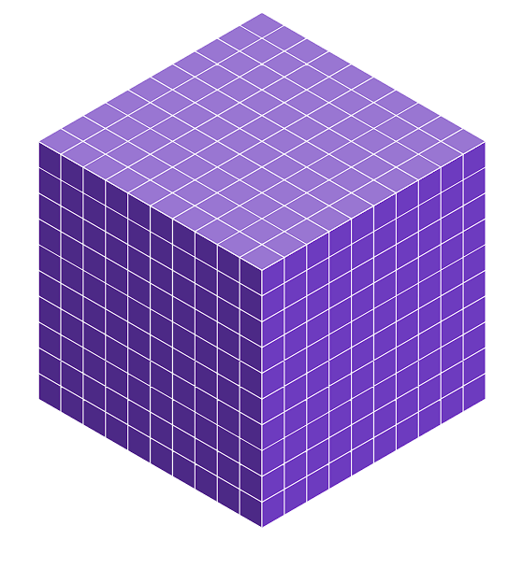 | $$1000 mL$$
- Explain to students that the $1000 cm^{3}$ row is already completed because $1000 cm^{3}$ is the volume they saw being filled in the video.
- Challenge students to copy the table into their workbooks and fill in the empty cells of the table, including drawing a visual representation of each volume.
- Use a questioning strategy such as Pose-Pause-Pounce-Bounce to discuss how students filled in the table. Some prompting questions are provided below:
- Why do we need to be able to convert between volume and capacity?
- When would you choose to measure an object’s volume as opposed to its capacity?
- If you wanted to know whether 500 mL of soup would fit in a container, would you measure and calculate the volume or would you pour in water from a jug to determine the capacity?
- How many millilitres are in one litre? What is the equivalent volume of one litre?
- Assign pairs and provide each pair with a mini whiteboard. Challenge pairs to calculate the capacity of 1 cubic metre.
Students are likely to convert to centimetres first and then convert to millilitres as shown below.
$$1 m ×1 m×1 m \\ =100 cm×100 cm×100 cm \\ =1 000 000 cm^{3} \\ =1 000 000 mL$$
- Facilitate a class discussion, asking students to discuss their results. Did they expect $1 m^{3}$ to have a capacity of $1000 L$?

Summarise
- Use slides 5–12 from the PowerPoint Volume and capacity for explicit teaching of converting metric units of volume to capacity using the Worked examples (Your turn) method (DOCX 420 KB).
The explicit teaching technique used in the PowerPoint is ‘Your turn’. The first slide is a worked example which should be displayed for the students before using the following steps.
- Reveal the question to students and its solution.
- Students read in silence.
- Students individually explain to themselves what is happening in each step.
- Students hold a thumbs up to the teacher when they have finished reading and have some sort of understanding.
- Think-Pair-Share. Students explain the solution to their partner.
- In pairs, students then answer the self-explanation questions.
- Finally, randomly select students to share their answers with the whole class.
- Print and distribute one copy of Appendix A ‘Converting units of volume and capacity’ between pairs of students.
- Pairs work together to fill in the missing volumes and capacities, choosing appropriate units for each answer.
- Students write notes to their future forgetful selves (bit.ly/notesstrategy) on converting units of volume and capacity.

Apply
- Assign visibly random groups of 3 (bit.ly/visiblegroups) and position groups at vertical non-permanent surfaces (bit.ly/VNPSstrategy) around the room.
- Display Figure 1: Meal prep, which is also on slide 14 of the PowerPoint Volume and capacity.
Figure 1: meal prep
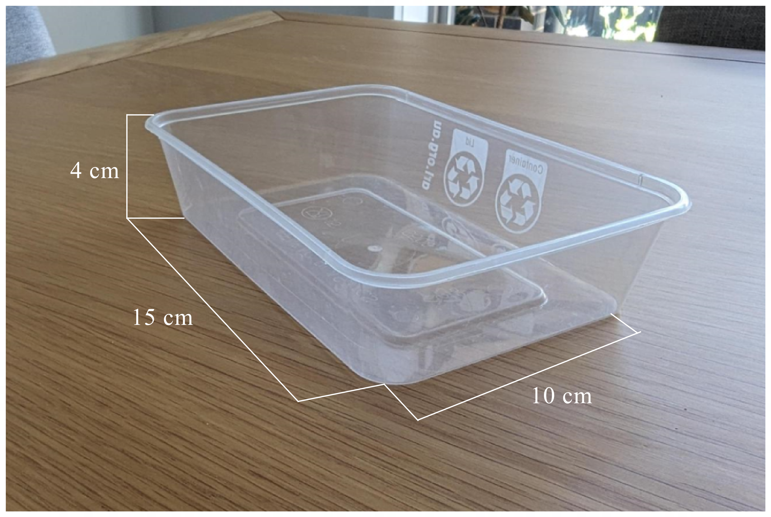
- Read the following context to students:
I found a recipe that makes 2.5 litres of pumpkin soup.
I want to have a container of soup for 5 days of school.
These are the only containers I have (Referring to the container in Figure 1).
- Challenge groups to determine if 2.5 litres of soup will fit in 5 of the containers shown.
- As groups reach a conclusion, offer one or all the below extensions:
- If you shared 2.5 litres of soup between 5 containers, what percentage of the containers would be empty?
- Can you design a container that would fit exactly 2.5 litres of soup shared between 5 containers?
- Could you scale up the recipe to make enough soup for exactly 7 containers? By what scale factor?
By providing unique extensions to different groups, when other groups are finished you can direct them to ‘steal’ an extension from a group working on one already. Saving time for the teacher to assess students’ understanding and assist those who need support.

Assessment and differentiation

Suggested opportunities for differentiation
Launch
- By bringing in a container and a jug of water (alternatively beads or kinetic sand could be used) as opposed to showing the video, students will be more engaged. Additionally, students may benefit from pouring the water themselves, being taught through a tactile experience.
Explore
- Base-10 blocks could be provided for students to see and hold the representation of each volume, helping to consolidate what one cubic centimetre represents.
- Challenge students who have completed the table of conversions to consider how many millilitres would be in 1 cubic metre of volume.
- Challenge students to express the capacity of 1 cubic metre in litres or kilolitres.
Summarise
- To enable low-readiness students, provide them with a device and Google search ‘convert cubic centimetres to millilitres’. Allow them to use Google’s conversion tool to perform the conversions. Students could then create 5 conversions of their own for a partner to calculate.
- Challenge students to justify their choice of units when completing Appendix A.
- Challenge students to calculate the volume conversion for 1 kilolitre (kL).
Apply
- Challenge students to find the volume of the container more precisely by considering how the container is wider at the top than the bottom. The 15 cm measurement is for the bottom length, the top length is 16.5 cm. The 10 cm measurement is for the bottom width, the top width is 11.5 cm.
- If a student is not confident engaging in the task, prompt them to walk around the room taking note of how other groups have approached the task. They should then report back to their group with a suggestion on how to move forward or set out their work.
- Students could be challenged to find the capacity of an Olympic-sized swimming pool.

Suggested opportunities for assessment
Warm up
- Use the warmup activity as an opportunity to assess students’ prior understanding of capacity. Students may require additional instruction before continuing with the lesson.
Launch
- Students have opportunities to contribute to and hear from pair and class discussions, these act as opportunities for self and peer reflection.
- Listen for student reasoning to assess their understanding of volume and capacity.
Explore
- Ensure students can successfully complete Table 1 before continuing with the lesson. If select students are struggling, ensure they are provided additional support before completing the summarise activity Appendix A.
Summarise
- Appendix A could be collected as evidence of student learning.
- Observe students’ notes to future selves to assess students’ understanding from the lesson.
Apply
- Students working at vertical non-permanent surfaces means the teacher can assess student progress and provide support where appropriate.
- Assess how students set out their working. Students may start to recognise simplifications that can be made when they have a better understanding of the conversions between volume and capacity.

Appendix A

Converting units of volume and capacity
Fill in the missing volumes and capacities in the table.
Choose appropriate units of volume and capacity.
Volume | Capacity
$$1 cm^{3}$$
$$100 cm^{3}$$
$$1 000 cm^{3}$$
$$10 000 cm^{3}$$
$$100 000 cm^{3}$$
 | 1000 L
 | 3 L
 | 1.2 L
 | 600 mL
$$100 mm^{3}$$
$$10 mm^{3}$$
$$1 mm^{3}$$

Sample solutions

Appendix A – converting units of volume and capacity
Volume | Capacity
$$1 cm^{3}$$ | 1 mL
$$100 cm^{3}$$ | 100 mL or $0.1 L$
$$1 000 cm^{3}$$ | 1 000 mL or 1 L
$$10 000 cm^{3}$$ | 10 000 mL or 10 L
$$100 000 cm^{3}$$ | 100 000 mL or 100 L
$1 m^{3}$ or $1 000 000 cm^{3}$ | 1000 L
$3000 cm^{3}$ or $0.003 m^{3}$ | 3 L
$1200 cm^{3}$ or $0.0012 m^{3}$ | 1.2 L
$600 cm^{3}$ or $0.0006 m^{3}$ | 600 mL
$$100 mm^{3}$$ | 0.1 mL
$$10 mm^{3}$$ | 0.01 mL
$$1 mm^{3}$$ | 0.001 mL

References
This resource contains NSW Curriculum and syllabus content. The NSW Curriculum is developed by the NSW Education Standards Authority. This content is prepared by NESA for and on behalf of the Crown in right of the State of New South Wales. The material is protected by Crown copyright.
Please refer to the NESA Copyright Disclaimer for more information https://educationstandards.nsw.edu.au/wps/portal/nesa/mini-footer/copyright.
NESA holds the only official and up-to-date versions of the NSW Curriculum and syllabus documents. Please visit the NSW Education Standards Authority (NESA) website https://educationstandards.nsw.edu.au/ and the NSW Curriculum website https://curriculum.nsw.edu.au/.
Mathematics K–10 Syllabus © NSW Education Standards Authority (NESA) for and on behalf of the Crown in right of the State of New South Wales, 2022.

© State of New South Wales (Department of Education), 2024
The copyright material published in this resource is subject to the Copyright Act 1968 (Cth) and is owned by the NSW Department of Education or, where indicated, by a party other than the NSW Department of Education (third-party material).
Copyright material available in this resource and owned by the NSW Department of Education is licensed under a Creative Commons Attribution 4.0 International (CC BY 4.0) license.
This license allows you to share and adapt the material for any purpose, even commercially.
Attribution should be given to © State of New South Wales (Department of Education), 2024.
Material in this resource not available under a Creative Commons license:
- the NSW Department of Education logo, other logos and trademark-protected material
- material owned by a third party that has been reproduced with permission. You will need to obtain permission from the third party to reuse its material.
Links to third-party material and websites
Please note that the provided (reading/viewing material/list/links/texts) are a suggestion only and implies no endorsement, by the New South Wales Department of Education, of any author, publisher, or book title. School principals and teachers are best placed to assess the suitability of resources that would complement the curriculum and reflect the needs and interests of their students.
If you use the links provided in this document to access a third-party's website, you acknowledge that the terms of use, including licence terms set out on the third-party's website apply to the use which may be made of the materials on that third-party website or where permitted by the Copyright Act 1968 (Cth). The department accepts no responsibility for content on third-party websites.

