Fuel
Students will investigate the fuel-carrying capacity of aircraft and tanker trucks as they convert between litres, kilolitres and megalitres.

Visible learning

Learning intentions
- To understand the relationship between litres, kilolitres and megalitres.
- To be able to choose the correct unit of capacity for different objects.

Success criteria
- I can describe how much space a kilolitre and megalitre takes up.
- I can convert between kilolitres and litres.
- I can convert between megalitres and kilolitres.

Syllabus outcomes
A student:
- develops understanding and fluency in mathematics through exploring and connecting mathematical concepts, choosing and applying mathematical techniques to solve problems, and communicating their thinking and reasoning coherently and clearly MAO-WM-01
- applies knowledge of volume and capacity to solve problems involving right prisms and cylinders MA4-VOL-C-01
Mathematics K–10 Syllabus © NSW Education Standards Authority (NESA) for and on behalf of the Crown in right of the State of New South Wales, 2022.

Activity structure
Please use the associated PowerPoint Fuel to display images in this lesson.

Launch
- Show students the video ‘Aviation’s country-sized carbon footprint (1:37)’ (bit.ly/aviationcarbon).
- Inform students that in this lesson we are going to investigate how much fuel different aircraft can carry to answer the driving question ‘Is it better on the environment to fly or drive?’.

Explore
- Ask students to discuss in a Think-Pair-Share (bit.ly/thinkpairsharestrategy), what factors could determine how much fuel a plane may need to carry.
Ideas could include plane weight, distance travelled, engine size, number of engines, passenger numbers and payload (amount of cargo).
- Display slide 3 of the PowerPoint Fuel which contains the conversions moving from millilitres into litres and kilolitres then introducing megalitres.
- Ask students if they can visualise a megalitre.
Two different visualisations that might help students are:
- 1 ML will fit in a 10 m $×$ 10 m $×$ 10 m cube (this is often 4 classrooms on top of each other).
- a 50 m swimming pool holds approximately 2 ML of water.
- Display slide 4 of the PowerPoint Fuel and ask students to discuss in a Think-Pair-Share the answer to the prompting questions.
- Using the Pose-Pause-Pounce-Bounce question strategy (PDF 557 KB) (bit.ly/posepausepouncebounce) have students share their responses.
This discussion aims to allow students to verbalise how they know that the converted answer is going to be a larger or smaller number than the original.
- Issue students with mini whiteboards (bit.ly/miniwhiteboards) and a whiteboard marker. Alternatively, students can use their book to write their estimates.
- Use slides 5–14 of the PowerPoint Fuel to display 5 different images of fuel-carrying vessels. Pause at each image and ask students to write an estimate of the fuel-carrying capacity on their whiteboards.
- Have students display their estimates and move to the next slide which displays the carrying capacity of the vessel.
- Using the Pose-Pause-Pounce-Bounce question strategy (PDF 557 KB) (bit.ly/posepausepouncebounce), ask students if their estimates became more accurate over time and if so, why they think that is.
- Distribute Appendix A ‘Planes’ to students and allow them time to look at the different plane types, fuel capacities, range and passenger capacity. Ask students which planes would carry more than a megalitre of fuel.

Summarise
- Use slides 16–23 of the PowerPoint Fuel for explicit teaching of the skills required to convert capacities between litres, kilolitres and megalitres using the Worked examples (Your turn) method (DOCX 420 KB).
- Distribute Appendix B ‘Converting’ to each student. Students are to convert each measurement to litres, kilolitres or megalitres, depending on which unit they think would make the most sense.
Students should aim to simplify each measurement to ease comprehension. For example, 0.34 kL converted to 340 L.
- Students discuss with a partner, which units they chose to convert to and why.

Apply
- Present the following scenario:
Mr and Mrs Nguyen wish to get from Sydney to Perth. The distance between them is 3963 km. They can drive their car which averages 1 L fuel per 10 km or they can fly on the Boeing 737. The aircraft averages 1 L fuel per 200 m or 5 L per km. The aircraft carries 190 passengers.
- In a Think-Pair-Share have students discuss if it is better for the environment for the Nguyens to drive or fly.
- Students work in pairs to provide mathematical calculations to support their conclusion.
The scenario along with a suggested solution can be found on slides 25 and 26 of the PowerPoint Fuel.

Assessment and differentiation

Suggested opportunities for differentiation
Explore
- Students may benefit from being reminded of how to divide by 1000 without a calculator.
- Students may benefit from teachers linking the conversion between litres, kilolitres and megalitres using arrows.
Summarise
- The explicit teaching contains 2 steps. Students may need these separated into different examples.
- Two questions in Appendix B ‘Converting’ move between L and ML. Additional practice may be required.
- Students could suggest rectangular prism dimensions for each capacity provided in Appendix B.
Apply
- The scenario could be simplified by using 4000 km or 200 passengers.

Suggested opportunities for assessment
Explore
- Multiple choice questions could be used to check student's understanding of multiplying and dividing by 1000 before commencing with the activity.
Summarise
- Students’ responses during the worked examples could be monitored for understanding.
- Appendix B could be collected and used as summative assessment for this unit of learning.

Appendix A

Planes
Planes | Details
Small plane  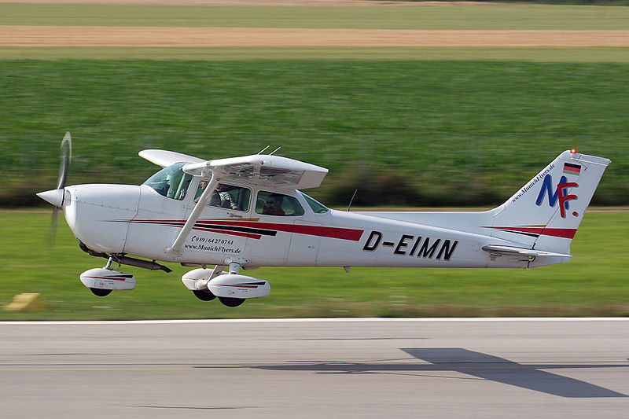  ‘Cessna - 172 Skyhawk D-EIMN’ by unknown is licensed under CC BY 2.0. | Cessna  Fuel capacity: 300 L  Passenger number: 19  Flying range: 1185 km
Regional jet  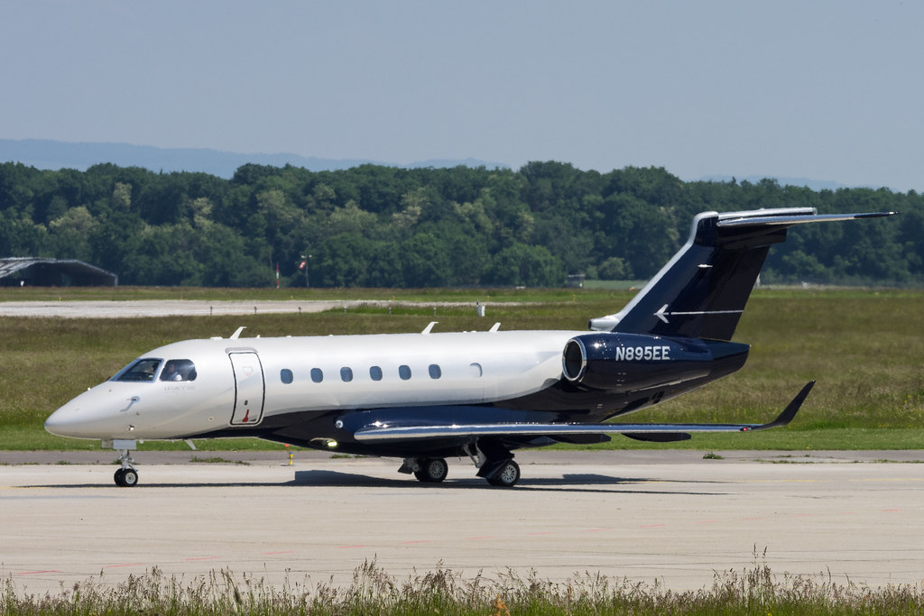  ‘N895EE EMBRAER LEGACY 500 E550 c/n 550000014’ by Markus Eigenheer is licensed under CC BY-SA 2.0. | Embraer E190-100  Fuel capacity: 28 600 L  Passenger number: 94  Flying range: 4500 km
Narrow body airline  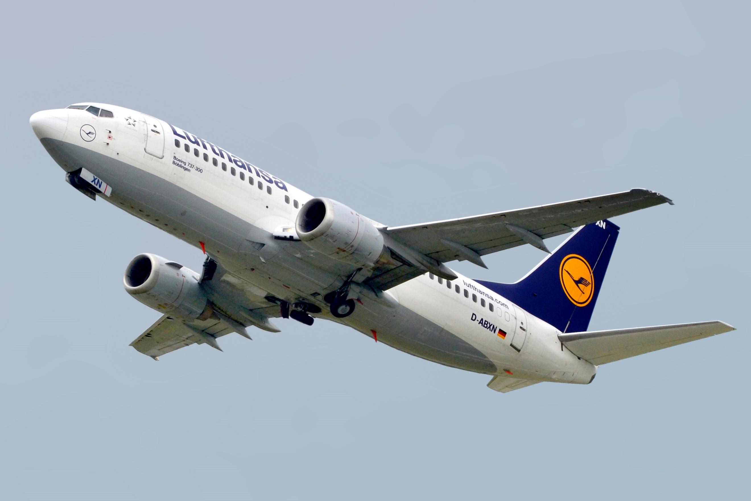  ‘Lufthansa Boeing 737-300’ by Boeing 737-300 (D-ABXN) 01.jpg is licensed under CC-BY-3.0. | Boeing 737  Fuel capacity: 26 000 L  Passenger number: 174  Flying range: 5200 km
Wide body planes  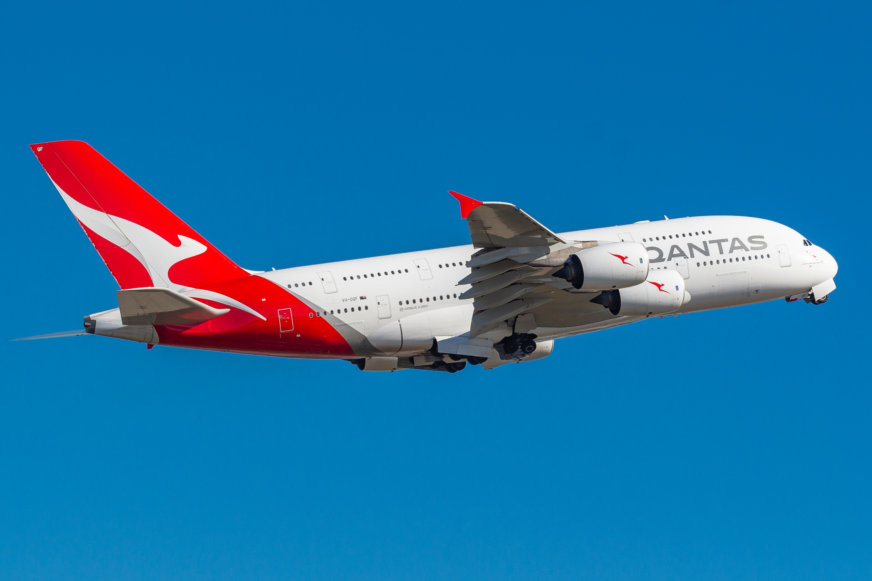  ‘Qantas A380 VH-OQF 4974.jpg’ by Vismay Bhadra is licensed under CC-BY-SA-4.0. | Airbus A380  Fuel capacity: 320 000 L  Passenger number: 525  Flying range: 12800 km
Cargo aircraft  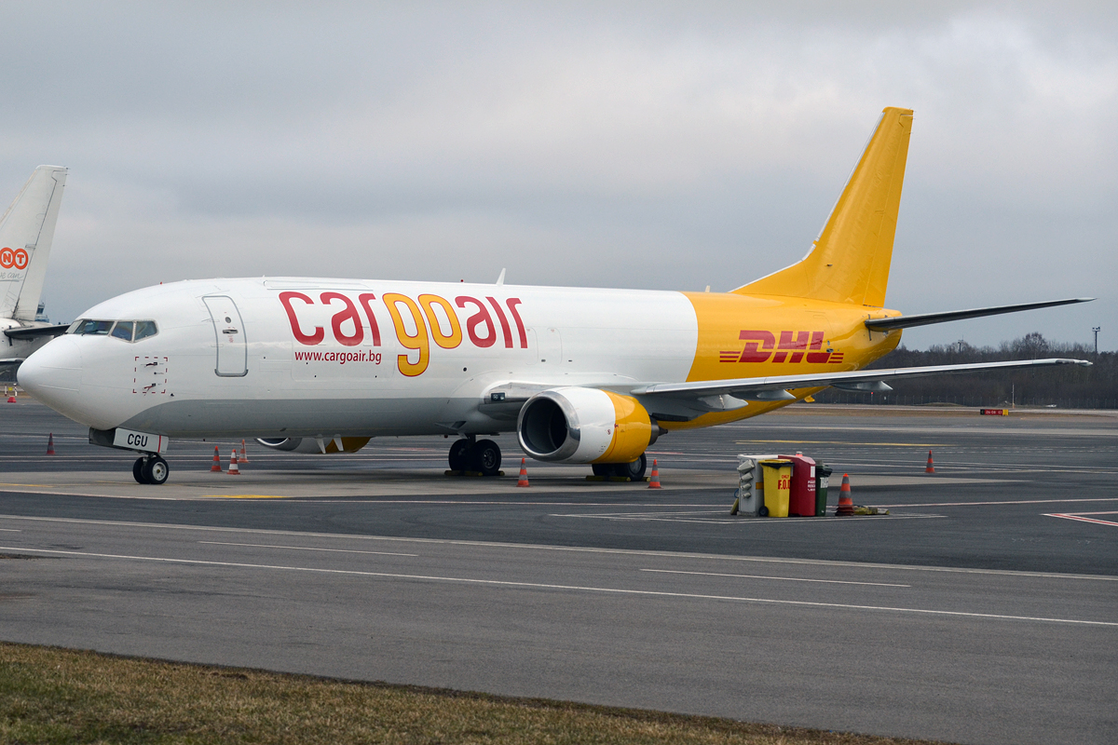  ‘Cargo Air, LZ-CGU, Boeing 737-448 SF’ by Anna Zvereva, is licensed under CC BY-SA 2.0. | Boeing 7470400F  Fuel capacity: 1 500 000 L
Fighter jets  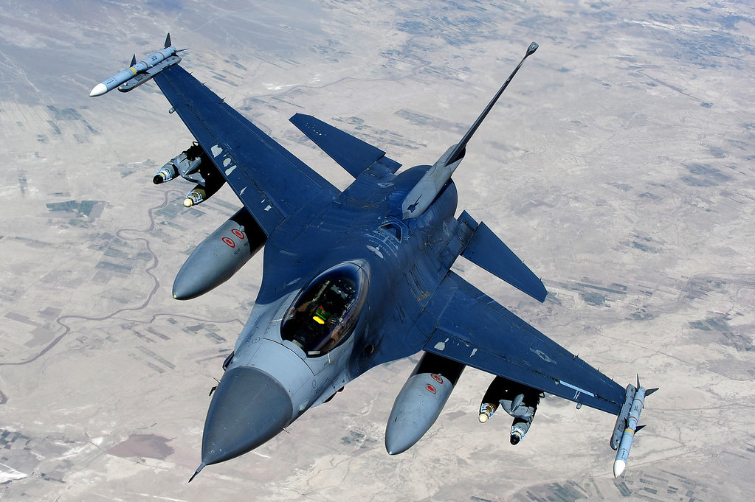  ‘F-16 Fighting Falcon 002’ by Master Sgt. William Greer, is licensed under CC BY-NC 2.0. | F-16 Fighting Falcon  Fuel capacity: 9000 L
Military aircraft  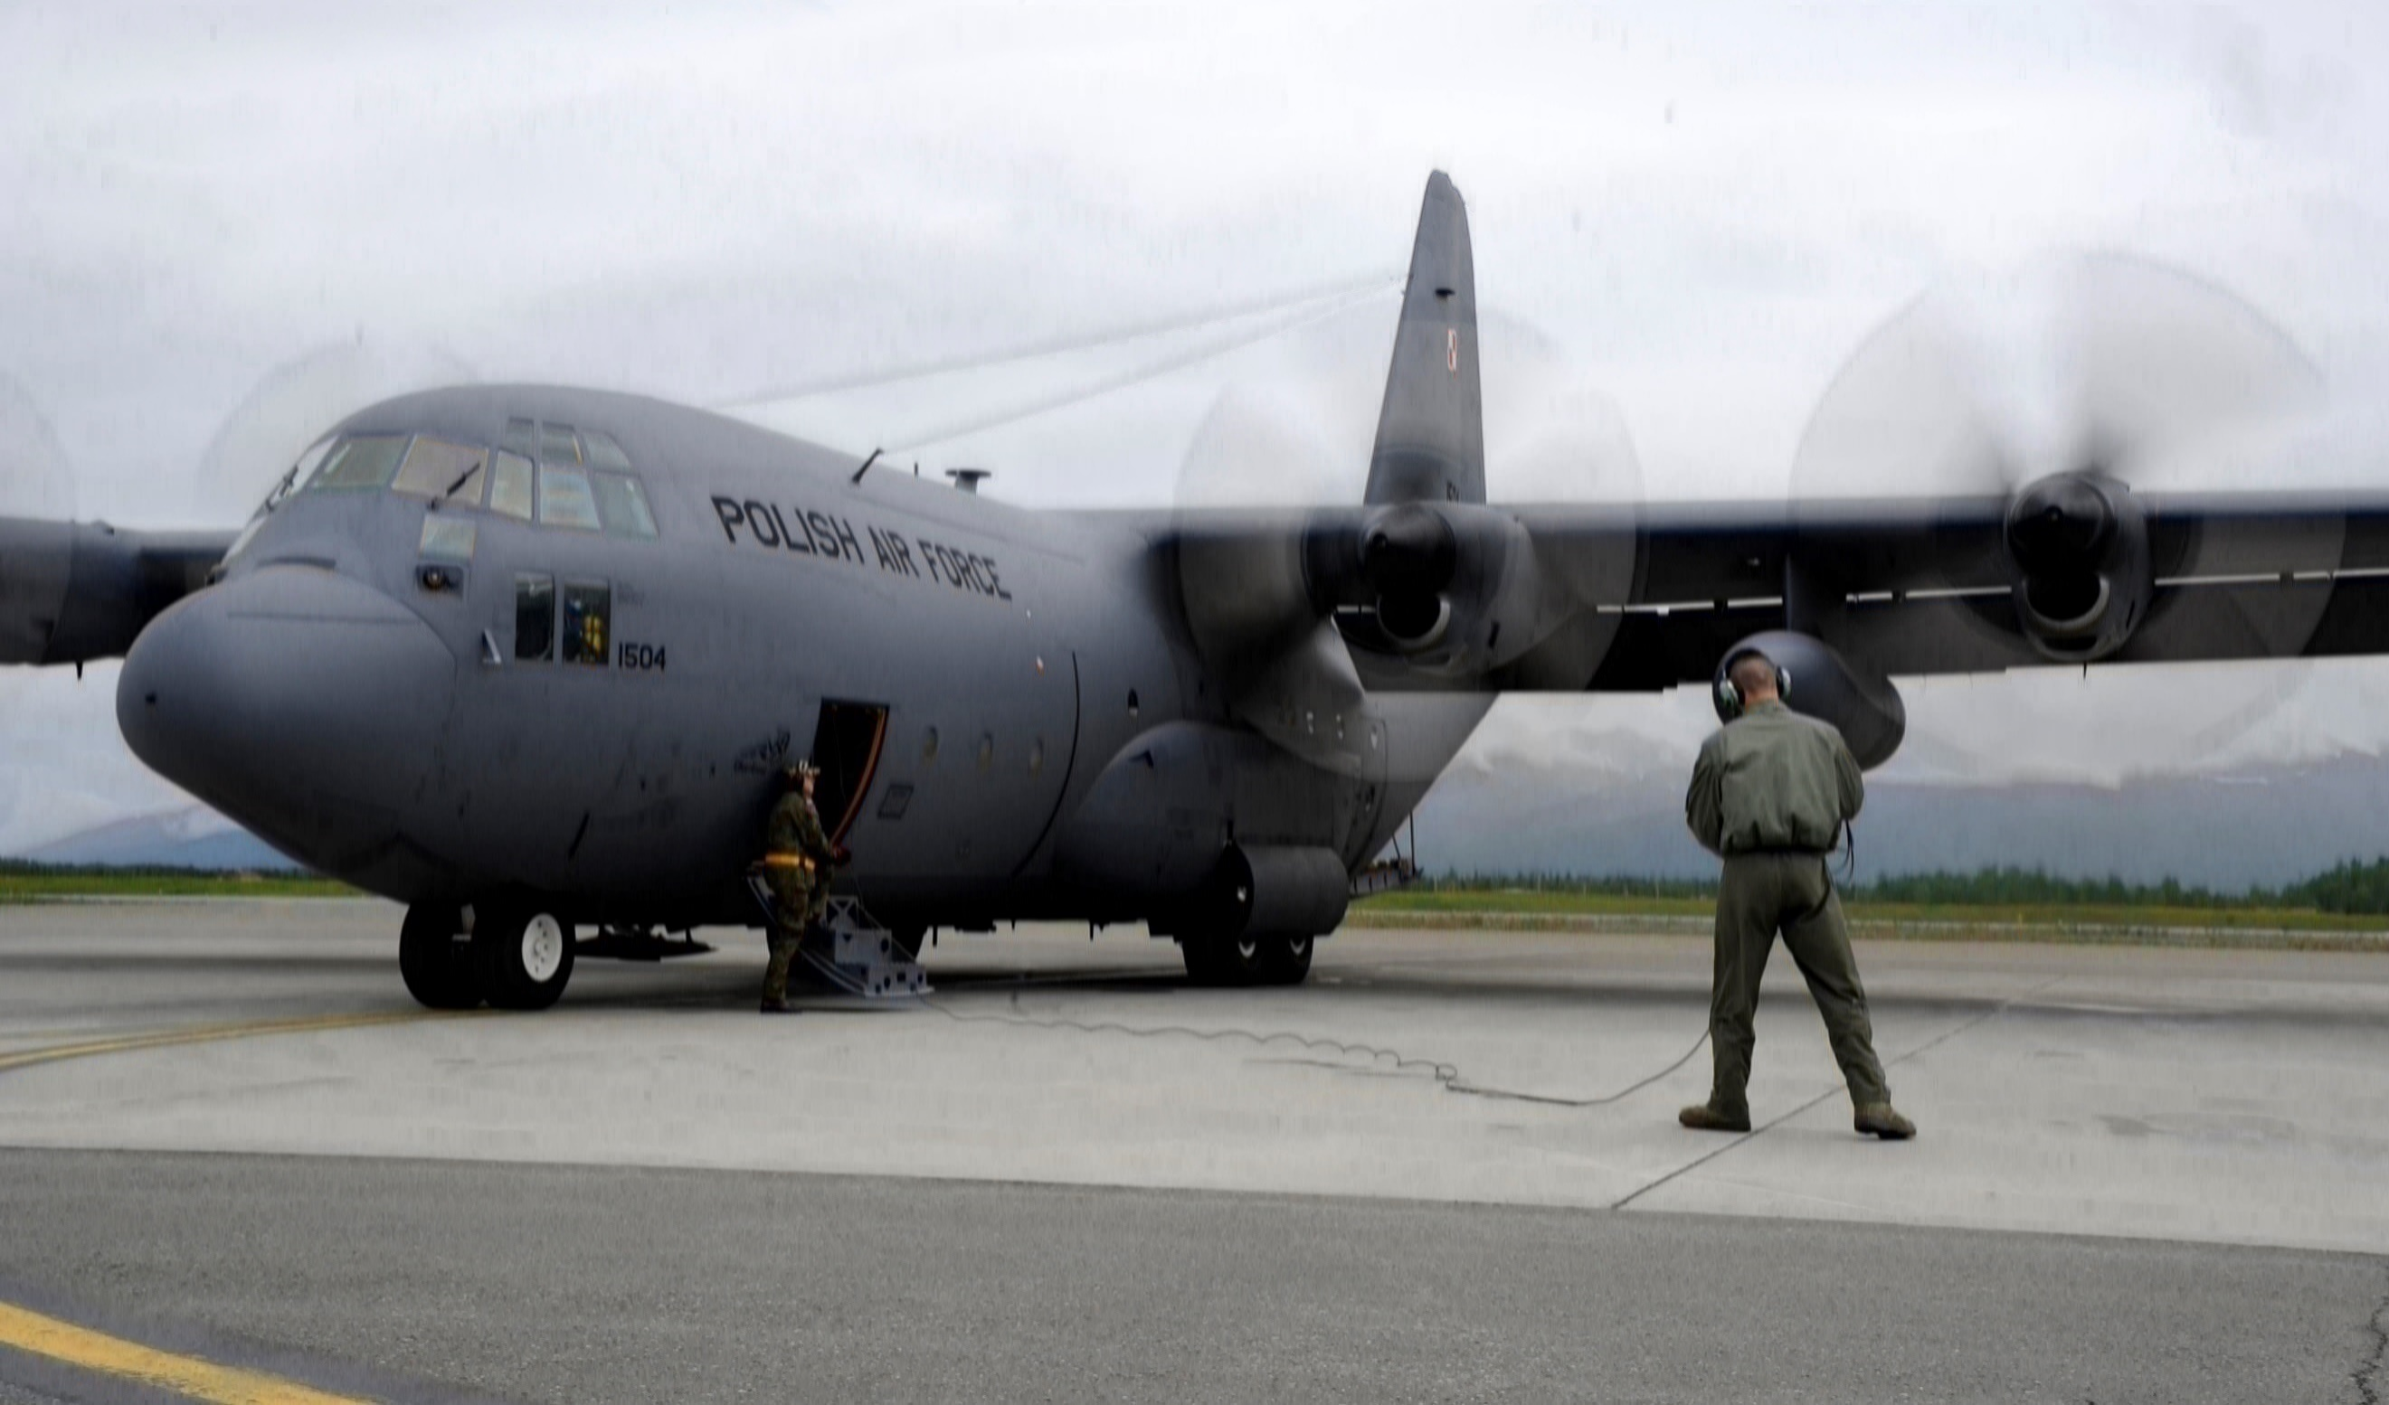  ‘Polish C-130 Hercules.jpg’ by Gornaj is licensed under CC-BY-SA-4.0. | C–130 Hercules  Fuel capacity: 100 000 L

Appendix B

Converting
For each measurement, convert to litres, kilolitres or megalitres.
- 0.3 kL
- 0.3 ML
- 3 000 L
- 30 000 L
- 30 000 kL
- 0.04 ML
- 0.04 kL
- 0.34 kL
- 3.4 ML
- 3 400 L

Sample solutions

Appendix A – planes
Aircraft | Fuel capacities (L) | Fuel capacities (kL)
Small | 300 L | 0.3 kL
Regional jets | 28 600 L | 28.6 kL
Narrow body airline | 26 000 L | 26 kL
Wide body airliners | 320 000 L | 320 kL or 0.36 ML
Cargo jet | 1 500 000 L | 1500 kL or 1.5 ML
Fighter jets | 9000 L | 9 kL
Military tanker aircraft | 100 000 L | 100 kL

Appendix B – converting
- 3000 L
- 300 kL
- 3 kL
- 30 kL
- 30 ML
- 40 kL
- 40 L
- 340 L
- 3400 kL
- 3.4 kL

References
This resource contains NSW Curriculum and syllabus content. The NSW Curriculum is developed by the NSW Education Standards Authority. This content is prepared by NESA for and on behalf of the Crown in right of the State of New South Wales. The material is protected by Crown copyright.
Please refer to the NESA Copyright Disclaimer for more information https://educationstandards.nsw.edu.au/wps/portal/nesa/mini-footer/copyright.
NESA holds the only official and up-to-date versions of the NSW Curriculum and syllabus documents. Please visit the NSW Education Standards Authority (NESA) website https://educationstandards.nsw.edu.au/ and the NSW Curriculum website https://curriculum.nsw.edu.au/.
Mathematics K–10 Syllabus © NSW Education Standards Authority (NESA) for and on behalf of the Crown in right of the State of New South Wales, 2022.

© State of New South Wales (Department of Education), 2024
The copyright material published in this resource is subject to the Copyright Act 1968 (Cth) and is owned by the NSW Department of Education or, where indicated, by a party other than the NSW Department of Education (third-party material).
Copyright material available in this resource and owned by the NSW Department of Education is licensed under a Creative Commons Attribution 4.0 International (CC BY 4.0) license.
This license allows you to share and adapt the material for any purpose, even commercially.
Attribution should be given to © State of New South Wales (Department of Education), 2024.
Material in this resource not available under a Creative Commons license:
- the NSW Department of Education logo, other logos and trademark-protected material
- material owned by a third party that has been reproduced with permission. You will need to obtain permission from the third party to reuse its material.
Links to third-party material and websites
Please note that the provided (reading/viewing material/list/links/texts) are a suggestion only and implies no endorsement, by the New South Wales Department of Education, of any author, publisher, or book title. School principals and teachers are best placed to assess the suitability of resources that would complement the curriculum and reflect the needs and interests of their students.
If you use the links provided in this document to access a third-party's website, you acknowledge that the terms of use, including licence terms set out on the third-party's website apply to the use which may be made of the materials on that third-party website or where permitted by the Copyright Act 1968 (Cth). The department accepts no responsibility for content on third-party websites.

