Ways of working – equations
Students use backtracking diagrams to develop their understanding of the order of operations required to solve linear equations up to 2 steps. A variety of ways of showing working out are explored to formalise students’ approaches to solving equations.

Visible learning

Learning intentions
- To be able to solve linear equations involving 2 steps.

Success criteria
- I can determine the order of operations to solve an equation.
- I can use backtracking diagrams to solve equations.
- I can solve equations involving 2 steps.

Syllabus outcomes
A student:
- develops understanding and fluency in mathematics through exploring and connecting mathematical concepts, choosing and applying mathematical techniques to solve problems, and communicating their thinking and reasoning coherently and clearly MAO-WM-01
- solves linear equations of up to 2 steps and quadratic equations of the form $ax^{2}=c$
MA4-EQU-C-01
Mathematics K–10 Syllabus © NSW Education Standards Authority (NESA) for and on behalf of the Crown in right of the State of New South Wales, 2022.
Table 1 – lesson summary
Section | Summary of activity | Teaching strategy | Teaching points
Launch | Display Polypad activity ‘Function machine’ (bit.ly/polypadequations) and play a game with students to find the rule of the function machine. | Think-Pair-Share | Activate prior knowledge of finding a rule and ascertaining which values give us the best information to find that rule.
Explore | Explain how to use backtracking diagrams on slide 3 of the PowerPoint Ways of working – equations and then how to transpose the diagram into an equation.  Distribute Appendix A to each student to find the values of $x$ and then find the equation that goes with each set of operations. | Think-Pair-Share  Notice and wonder | The purpose of the Explore is to develop students’ understanding of the order in which operations have occurred in an equation.
Summarise | Use slides 5–12 of the PowerPoint for explicit teaching of solving 2-step equations.  Display slide 13 of the PowerPoint to discuss different styles of working out equations.  Students solve each equation from Appendix A. | Worked examples (Your turn) (DOCX 420 KB)  Think-Pair-Share  Visibly random groups of 3  Vertical non-permanent surfaces  Gallery walk | Transition from the visual representation to students abstractly solving 2-step equations.
Apply | Distribute Appendix B for students to write and solve equations for the perimeter and area of triangles. | Visibly random groups of 3  Vertical non-permanent surfaces | Students connect solving equations with perimeter and area.

Activity structure
Please use the associated PowerPoint Ways of working – equations to display images in this lesson.

Launch
- Display the Polypad activity ‘Function machine’ (bit.ly/polypadequations). When a number tile is dragged into the function machine, it will apply a rule, for example multiply by, 2 then output the result.
- Explain the following rules of the game to students.
- A randomly selected student chooses a number from the left to be the input.
- The teacher will put that number through the function machine to get an output.
- The input and output will be recorded in the table below the function machine.
- When students think they have figured out the rule, they raise their hand. When called on, they state an input value that has not already been put through the machine and what its corresponding output value would be.
- The teacher puts that input value through the function machine to check the correct answer.
- For each function, the class will play until there are 3 students who correctly state an input and its output.
Select and copy number tiles (by selecting the overlapping rectangles icon) to drag into the function machine. Otherwise, you will need to replace numbers that have been used.
- Once a game has been completed, reveal the expression by selecting the function machine, selecting More tools (3 dots) and toggle Show expression.
You can change the rule by double clicking the expression $2x + 1$ and typing a new expression. Students will either need to face away or the projector/screen could be put on freeze while the rule is being changed. Function machines could also be prepared prior to the lesson.
- After playing the game several times, ask students to discuss the following questions in a Think-Pair-Share (bit.ly/thinkpairsharestrategy):
- Which value(s) give the most useful information?
- If you were given a $y$ value, how could you figure out the $x$ value?

Explore
- Draw or display Figure 1, on slide 3 of the PowerPoint Ways of working – equations. Explain that this is another way of showing a function machine. In this diagram, you can see the steps performed.
Figure 1: backtracking diagram
- Tell students that an $x$ value has already been entered into this function machine and resulted in an output of 14.
- Students discuss in a Think-Pair-Share, how they could use the backtracking diagram to find the value of $x$.
- Use student suggestions to model backtracking through the diagram. Figure 2 shows an example of what this might look like.
Figure 2: backtracking diagram 2
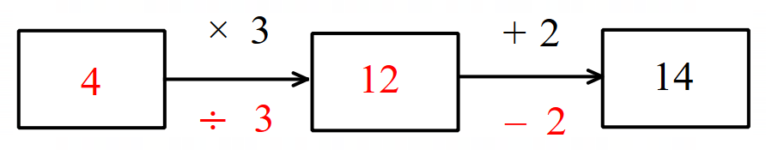
- Ask students to record what they notice and wonder (bit.ly/noticewonderstrategy) about the diagram.
- Model for students how to translate the backtracking diagram into an equation. The equation in Figures 1 and 2 can be written as $3x+2=14$.
- Distribute Appendix A ‘Backtracking’ to each student.
- Students first use the backtracking diagrams to find the value of $x$ for each set of operations. Students should compare answers with a partner.
- Use a questioning strategy such as Pose-Pause-Pounce-Bounce (PDF 557 KB) (bit.ly/posepausepouncebounce) to facilitate a class discussion around the backtracking diagrams. Ask questions such as:
- The inverse of addition is subtraction, so what is the inverse of multiplication?
- Why are there different values of $x$, when all the equations end in 21?
- How do the backtracking diagrams help to understand the order of operations applied to $x$?
- Students should then complete the table in Appendix A by translating from backtracking diagrams to writing equations. Students should compare equations with a partner.
- The bottom 2 rows are empty so that students can draw 2 backtracking diagrams of their own and then swap with a partner to find the equations that go with their diagrams.
- Explain to students that the purpose of this activity is to understand the order that operations were applied to $x$, so that we know what order to backtrack these operations.

Summarise
- Use slides 5–12 of the PowerPoint Ways of working – equations for explicit teaching of solving 2-step equations using the worked examples (Your turn) method (DOCX 420 KB).
- Display slide 13 of the PowerPoint. Students discuss in a Think-Pair-Share:
- Which style of working out is easier to understand?
- If you were going to teach someone to solve equations, which style would you use?

The purpose of this conversation is to highlight that how students demonstrate the steps taken to solve an equation can take a variety of forms and even teachers within the same school may use different working. Students should develop a strong enough understanding that they can interpret and use a variety of styles, ultimately choosing a method that makes the most sense to them.
- By working in visibly random groups of 3 (bit.ly/visiblegroups) on vertical non-permanent surfaces (bit.ly/VNPSstrategy), students are to use their completed Appendix A to solve each equation on their VNPS, using one of the styles demonstrated in the PowerPoint.
Students could use an alternate method that they or the teacher prefers, such as Algebra tiles.
- Students complete a gallery walk (bit.ly/DLSgallerywalk) after solving 3 to 4 equations to compare how each group is showing their working. They then go back to their groups to solve the rest of the equations.

Apply
- With students remaining in their groups at vertical non-permanent surfaces, distribute Appendix B ‘Triangle equations’ to each group.
- Students are to follow the instructions in Appendix B, constructing and solving an equation for each triangle.
- Students are to transfer their final agreed working out and solved equations to the worksheet Appendix B.

Assessment and differentiation

Suggested opportunities for differentiation
Launch
- Teachers could extend or reduce the number of values in the table to adjust the level of difficulty.
- Students could give the rule in words if they are not ready to provide the rule in terms of $x$ and $y$. For example, ‘double the number plus 1’ as opposed to $y=2x+1$. In this case it would be beneficial to then bounce to another student to also express the rule in terms of $x$ and $y$ so that students can hear and see both forms.
- A student who requires additional assistance could be given the role of creating a rule and controlling the Polypad activity. This means the student knows the rule and can internally predict values as they are entered.
- An alternative, more guided approach could be taken to this activity, in which pairs are given a horizontal table to fill in, with the $x$ values 0, 1, 2, 3, 4, 5 already filled in. Each student creates a secret rule. Students fill in the table of values using their rule before swapping with a partner, giving them a completed table of values. Students then use the completed table of values to guess their partner’s rule.
Explore
- Students who are not yet confident working with 2-step equations, could just work with single-step equations. Teachers could reduce the backtracking diagrams to just the first step.
- Students who are already confident solving 2-step equations could be challenged to represent equations involving negatives and fractions using backtracking diagrams. For example, $10-2x=5$ or $\frac{x}{2}+3=8$.
- Students could be challenged to create their own backtracking diagrams to translate to equations as opposed to completing the table of completed diagrams in Appendix A.

Summarise
- Students could also use algebra tiles or bar models to solve the equations.
- To support formal setting out, students could use the website Graspable Math (bit.ly/graspablemath) to solve the equations. Graspable Math allows students to select and drag operations to the other side of the equation, performing the inverse operation to both sides. For example, $2x+1=5$ will become $2x+1-1=5-1$.
- Throughout the lesson and beyond, students should be encouraged to use backtracking diagrams when they are unsure which operation to backtrack first in an equation.
Apply
- Challenge students to create equations for shapes other than a triangle that they can swap with a partner to complete. For example, students could draw a regular octagon with side length $x$ and perimeter 80 cm.

Suggested opportunities for assessment
Launch
- Use the activity in the Launch to assess students’ readiness to work with algebraic expressions. If students are consistently unable to identify the rule or relate a given rule to an algebraic expression, further teaching may be required before commencing with this learning episode.
Explore
- Observe students’ responses to Appendix A to identify common misconceptions. For example, students may write the operations $+2, ×3$ as $x+2×3=21$. As opposed to $3\left(x+2\right)=21$.
- Appendix A could be collected as evidence of learning.
Summarise
- Use the Summarise activities to identify and connect the ways students have previously been taught to solve equations.
- When placed in groups of 3, students provide and receive peer feedback on their understanding.
- Students will demonstrate their Working mathematically skills in discussions and justifications.
Apply
- Appendix B could be collected as evidence of learning.

Appendix A

Backtracking

Question | Backtracking diagrams | Equations
 |  | $$2x+3=21$$

Appendix B

Triangle equations
For each triangle:
- write an equation relating the side lengths to the perimeter
- solve the equation to find the unknown side lengths.
Equilateral triangle | Isosceles triangle | Scalene triangle
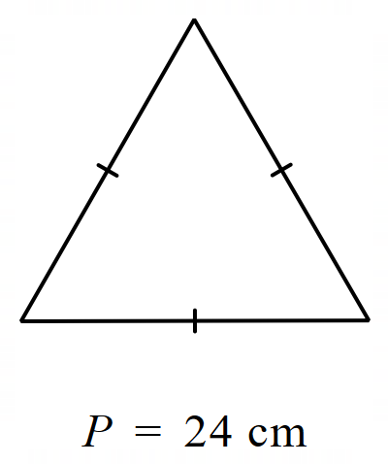 | 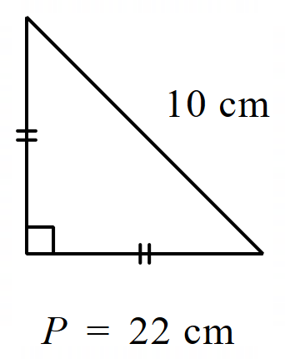 | 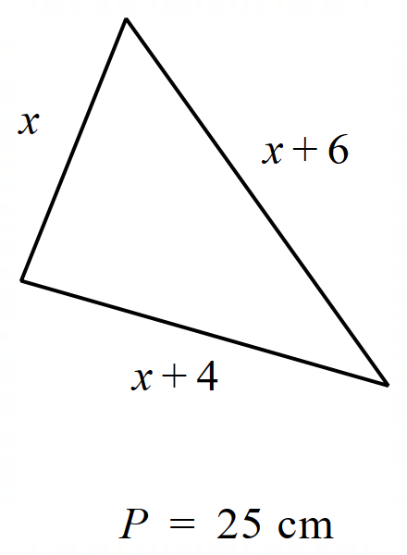

For each triangle:
- write an equation relating the side lengths to the area
- solve the equation to find the unknown side length.
Equilateral triangle | Isosceles triangle | Scalene triangle
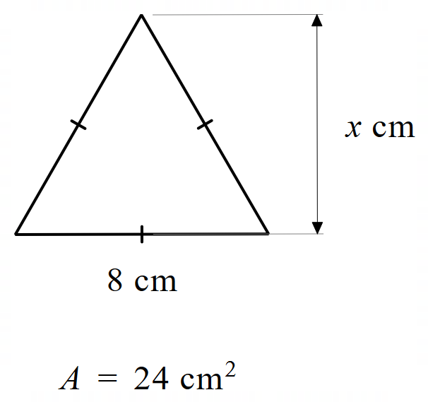 | 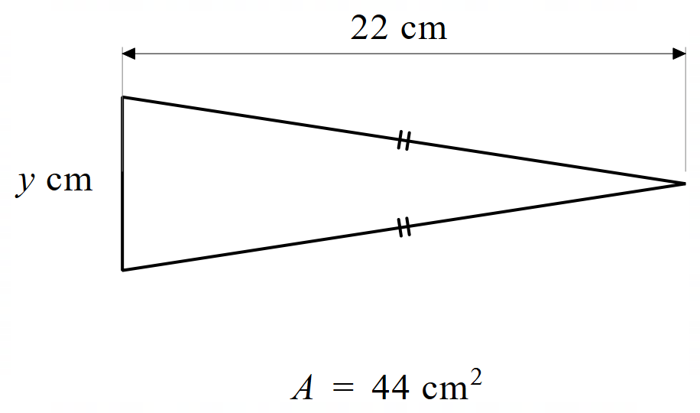 | 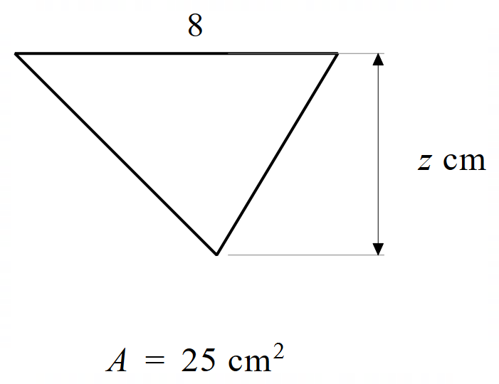

Sample solutions

Appendix A – backtracking
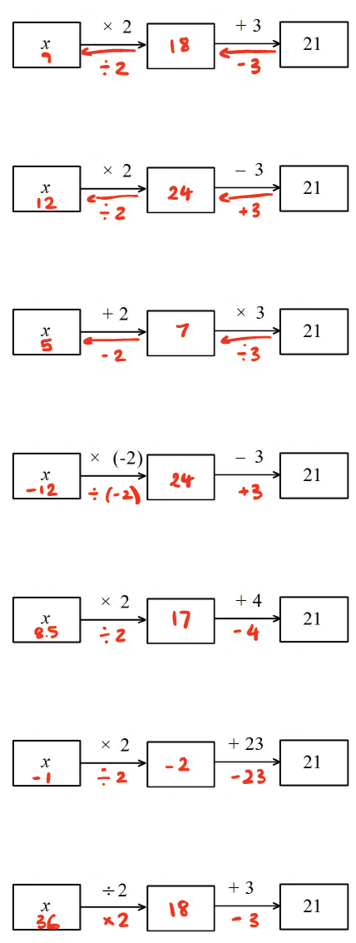
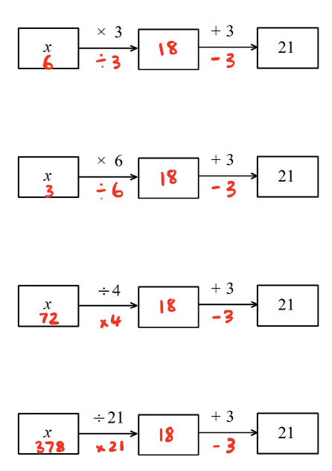

Backtracking diagrams | Equations
 | $$2x+3=21$$
 | $$2x-3=21$$
 | $$3\left(x+2\right)=21$$
 | $$-2x-3=21$$
 | $$2x+4=21$$
 | $$2x+23=21$$
 | $$\frac{x}{2}+3=21$$
 | $$3x+3=21$$
 | $$6x+3=21$$
 | $$\frac{x}{4}+3=21$$
 | $$\frac{x}{21}+3=21$$

Summarise – solving equations
1 | $$2x+3=21 \\ 2x=21-3 \\ 2x=18 \\ \frac{2x}{2}=\frac{18}{2} \\ x=9$$ | 6 | $$2x+23=21 \\ 2x=21-23 \\ 2x=-2 \\ \frac{2x}{2}=\frac{-2}{2} \\ x=-1$$
2 | $$2x-3=21 \\ 2x=21+3 \\ 2x=24 \\ \frac{2x}{2}=\frac{24}{2} \\ x=12$$ | 7 | $$\frac{x}{2}+3=21 \\ \frac{x}{2}=21-3 \\ \frac{x}{2}=18 \\ \frac{x}{2}×2=18×2 \\ x=36$$
3 | $$3\left(x+2\right)=21 \\ \frac{3\left(x+2\right)}{3}=\frac{21}{3} \\ x+2=7 \\ x=7-2 \\ x=5$$ | 8 | $$3x+3=21 \\ 3x=21-3 \\ 3x=18 \\ \frac{3x}{3}=\frac{18}{3} \\ x=6$$
4 | $$-2x-3=21 \\ -2x=21+3 \\ -2x=24 \\ \frac{-2x}{-2}=\frac{24}{-2} \\ x=-12$$ | 9 | $$6x+3=21 \\ 6x=21-3 \\ 6x=18 \\ \frac{6x}{6}=\frac{18}{6} \\ x=3$$
5 | $$2x+4=21 \\ 2x=21-4 \\ 2x=17 \\ \frac{2x}{2}=\frac{17}{2} \\ x=8\frac{1}{2}$$ | 10 | $$\frac{x}{4}+3=21 \\ \frac{x}{4}=21-3 \\ \frac{x}{4}=18 \\ \frac{x}{4}×4=18×4 \\ x=72$$
11 | $$\frac{x}{21}+3=21 \\ \frac{x}{21}=21-3 \\ \frac{x}{21}=18 \\ \frac{x}{21}×21=18×21 \\ x=378$$

Appendix B – triangle equations
Equilateral triangle | Isosceles triangle | Scalene triangle
$$3x=24 \\ \frac{3x}{3}=\frac{24}{3} \\ x=8 cm$$ | $$2x+10=22 \\ 2x=22-10 \\ 2x=12 \\ \frac{2x}{2}=\frac{12}{2} \\ x=6 cm$$ | $$x+(x+4)+(x+6)=25 \\ 3x+10=25 \\ 3x=15 \\ x=5 cm$$

Equilateral triangle | Isosceles triangle | Scalene triangle
$$\frac{1}{2}×8×x=24 \\ 4x=24 \\ \frac{4x}{4}=\frac{24}{4} \\ x=6 cm$$ | $$\frac{1}{2}×y×22=44 \\ 11y=44 \\ \frac{11y}{11}=\frac{44}{11} \\ y=4 cm$$ | $$\frac{1}{2}×8×z=25 \\ 4z=25 \\ \frac{4z}{4}=\frac{25}{4} \\ z=6.25 cm$$

References
This resource contains NSW Curriculum and syllabus content. The NSW Curriculum is developed by the NSW Education Standards Authority. This content is prepared by NESA for and on behalf of the Crown in right of the State of New South Wales. The material is protected by Crown copyright.
Please refer to the NESA Copyright Disclaimer for more information https://educationstandards.nsw.edu.au/wps/portal/nesa/mini-footer/copyright.
NESA holds the only official and up-to-date versions of the NSW Curriculum and syllabus documents. Please visit the NSW Education Standards Authority (NESA) website https://educationstandards.nsw.edu.au/ and the NSW Curriculum website https://curriculum.nsw.edu.au/.
Mathematics K–10 Syllabus © NSW Education Standards Authority (NESA) for and on behalf of the Crown in right of the State of New South Wales, 2022.

© State of New South Wales (Department of Education), 2024
The copyright material published in this resource is subject to the Copyright Act 1968 (Cth) and is owned by the NSW Department of Education or, where indicated, by a party other than the NSW Department of Education (third-party material).
Copyright material available in this resource and owned by the NSW Department of Education is licensed under a Creative Commons Attribution 4.0 International (CC BY 4.0) license.
This license allows you to share and adapt the material for any purpose, even commercially.
Attribution should be given to © State of New South Wales (Department of Education), 2024.
Material in this resource not available under a Creative Commons license:
- the NSW Department of Education logo, other logos and trademark-protected material
- material owned by a third party that has been reproduced with permission. You will need to obtain permission from the third party to reuse its material.
Links to third-party material and websites
Please note that the provided (reading/viewing material/list/links/texts) are a suggestion only and implies no endorsement, by the New South Wales Department of Education, of any author, publisher, or book title. School principals and teachers are best placed to assess the suitability of resources that would complement the curriculum and reflect the needs and interests of their students.
If you use the links provided in this document to access a third-party's website, you acknowledge that the terms of use, including licence terms set out on the third-party's website apply to the use which may be made of the materials on that third-party website or where permitted by the Copyright Act 1968 (Cth). The department accepts no responsibility for content on third-party websites.

