# Quadratic equations

Students are introduced to quadratic equations in the form $ax^{2}=c$ and explore why they have 2 solutions.

Students will need at least one digital device per pair to interact with Polypad during this lesson.

## Visible learning

### Learning intentions

* To understand why a quadratic equation may have 2 solutions.

### Success criteria

* I can find the square root of a number.
* I can solve quadratic equations in the form $ax^{2}=c$.
* I can justify why a quadratic equation in the form $ax^{2}=c$ has a positive and negative solution.
* I can identify when a quadratic equation has zero, one or 2 solutions

### Syllabus outcomes

A student:

* develops understanding and fluency in mathematics through exploring and connecting mathematical concepts, choosing and applying mathematical techniques to solve problems, and communicating their thinking and reasoning coherently and clearly **MAO-WM-01**
* solves linear equations of up to 2 steps and quadratic equations of the form $ax^{2}=c$  
  **MA4-EQU-C-01**

[Mathematics K–10 Syllabus](https://curriculum.nsw.edu.au/learning-areas/mathematics/mathematics-k-10-2022/overview) © NSW Education Standards Authority (NESA) for and on behalf of the Crown in right of the State of New South Wales, 2022.

Table 1 – lesson summary

|  |  |  |  |
| --- | --- | --- | --- |
| Section | Summary of activity | Teaching strategy | Teaching points |
| Warm up | The teacher displays slide 2 of the PowerPoint *Quadratic equations* for students to place square roots on a number line. | Visibly random groups of 3  Vertical non-permanent surfaces (VNPS)  Gallery walk | Activate and assess students’ prior knowledge of square roots. |
| Launch | Display slide 4 of the PowerPoint for students to discuss the statements on the number of solutions for a quadratic equation. | Think-Pair-Share | Assess initial understanding of the solutions of quadratic equations. |
| Explore | Function machines: students use Polypad to create function machines with different rules ([bit.ly/polypadfunction](https://bit.ly/polypadfunction)) and investigate the rule $x^{2}.$ Area models: students create a mind map for the meaning of the word square.  Display slides 6–7 of the PowerPoint to show and discuss the representation of a quadratic equation. | Pose-Pause-Pounce-Bounce  Notice and wonder  Think-Pair-Share | Students see that the positive and negative input for the same number will give the same positive output value which directly relates to not finding the square root of a negative number. |
| Summarise | Use slides 6–13 of the PowerPoint for explicit teaching of solving simple quadratic equations.  Distribute Appendix A for students to sort cards into categories. | [Worked examples (Your turn) (DOCX 420 KB)](https://education.nsw.gov.au/content/dam/main-education/documents/teaching-and-learning/curriculum/mathematics/mathematics-s4-supporting-strategies-worked-examples-your-turn.docx)  Pose-Pause-Pounce-Bounce | Students justify equations that result in 0, 1 or 2 solutions. |
| Apply | Distribute Appendix B to find missing lengths or areas in each maze. |  | Connections between quadratic equations and areas of squares. |

## Activity structure

Please use the associated PowerPoint *Quadratic equations* to display images in this lesson.

### Warm up

This activity presumes students have prior knowledge of finding the square and square root of numbers. Teachers can refer to Lesson 4 – the ants go marching and Lesson 6 – the magical factor trees of Unit 5 – multiplicative thinking.

1. Assign random groups of 3 ([bit.ly/visiblegroups](https://bit.ly/visiblegroups)) and position students at vertical non-permanent surfaces ([bit.ly/VNPSstrategy](https://bit.ly/VNPSstrategy)) around the room.
2. Write up the following list of square roots or display them using slide 2 of the PowerPoint *Quadratic equations*.

$\sqrt{4}, \sqrt{9}$, $\sqrt{16}$, $\sqrt{2}, \sqrt{25}$, $\sqrt{1}$, $\sqrt{100}, \sqrt{101}$, $\sqrt{10}$, $\sqrt{50}, \sqrt{49}$ and $\sqrt{0}$

1. Groups are to place the square roots on a number line.
2. When all groups have attempted the task, have students complete a gallery walk ([bit.ly/DLSgallerywalk](https://bit.ly/DLSgallerywalk)) to compare how other groups have ordered the square roots.
3. Use a questioning strategy such as Pose-Pause-Pounce-Bounce (PDF 557 KB) ([bit.ly/posepausepouncebounce](https://bit.ly/posepausepouncebounce)) to facilitate a class discussion, asking students:

* Which square roots did you place first and why?
* Which square roots were difficult to place and why?

This activity acts as an opportunity to assess students’ prior knowledge of square roots. It has a low floor, allowing students to compare perfect square roots such as 4 and 36, while providing opportunities for students to estimate where imperfect square roots may belong.

### Launch

1. Display slide 4 from the PowerPoint Quadratic equations, which shows the statements of 2 people seen in Figure 1.

Figure 1: quadratic equations statements

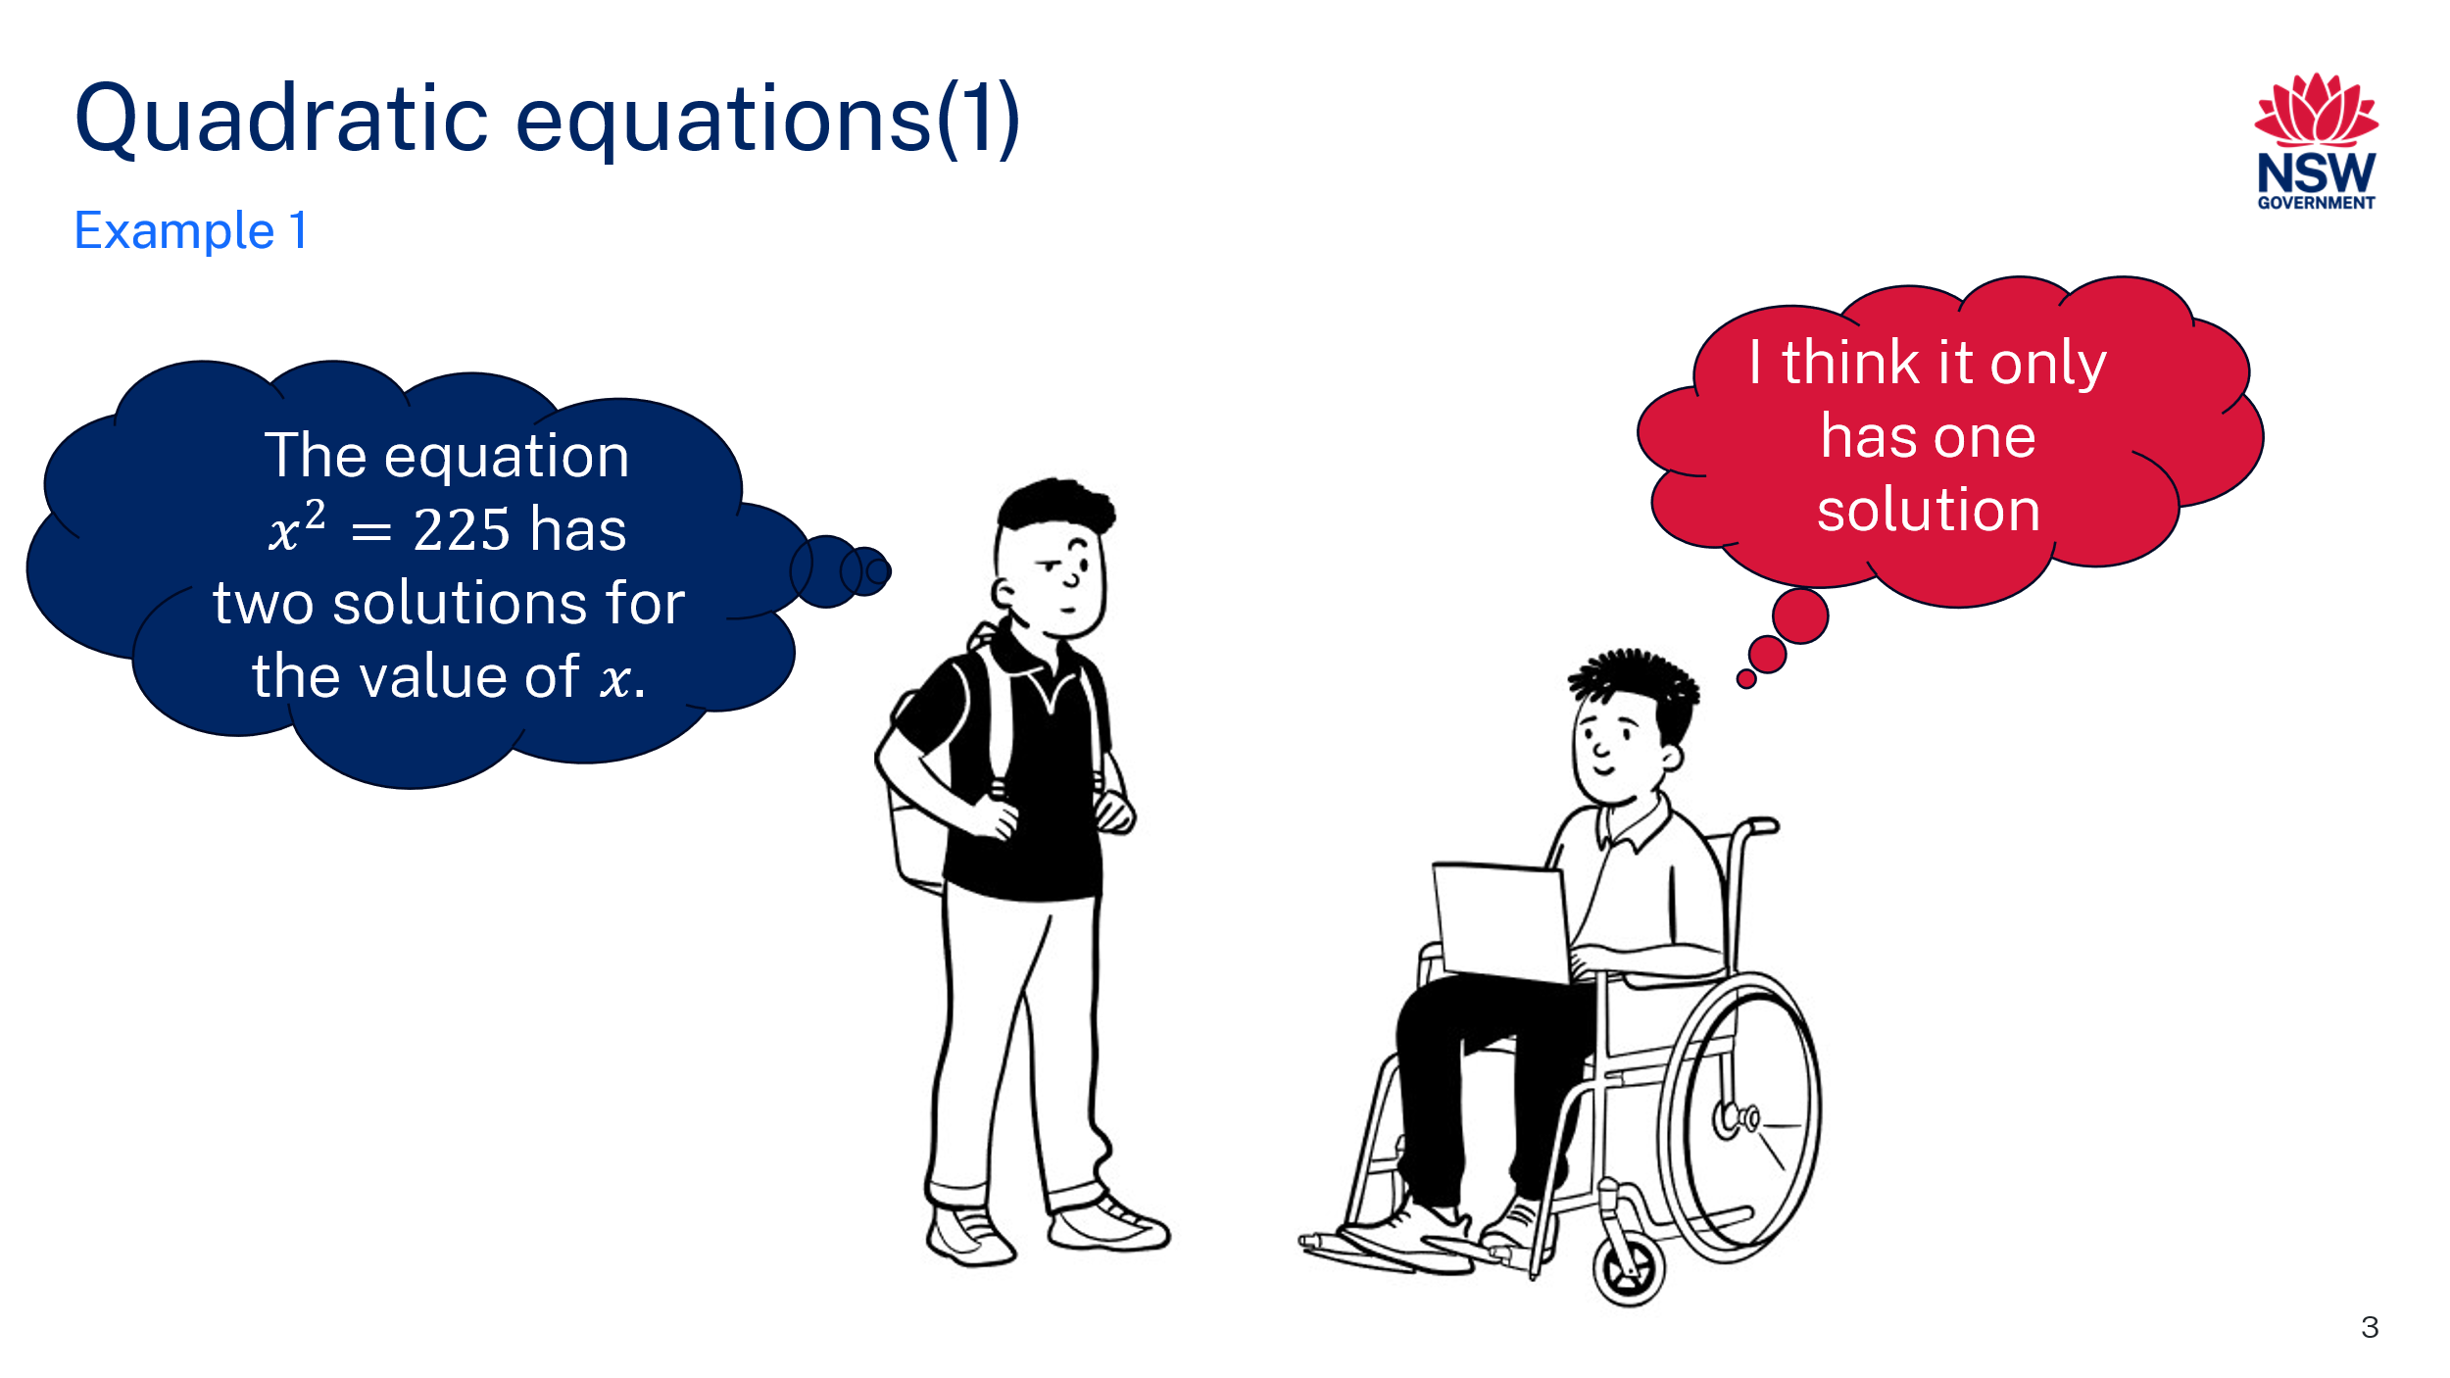

1. In a Think-Pair-Share ([bit.ly/thinkpairsharestrategy](https://bit.ly/thinkpairsharestrategy)), ask students to discuss the statements presented in the cartoon. Which student do they agree with and why?

### Explore

#### Function machines

1. With one device between pairs of students, direct students to the Polypad activity ‘Function machine’ ([bit.ly/polypadfunction](https://bit.ly/polypadfunction)).
2. Model for students how the function machine works.

* Select and drag a number tile into the machine. The machine will apply a rule such as $x + 1$  
   and output the resulting value.
* Change the expression by double clicking $x + 1$ on the function machine and entering a new expression $2x - 1$.
* Show or hide the expression of the function machine by selecting the function machine, selecting **More tools** (3 dots) and toggle **Show expression**.

Select and copy number tiles (by selecting the overlapping rectangles icon) to drag into the function machine. Otherwise, you will need to replace numbers that have been used.

You can also place output number tiles from the function machine as inputs back into the function machine.

1. One student in each pair should hide the screen from their partner as they change the rule and hide the expression. The other student then selects and drags number tiles into the machine to attempt to determine the rule.

Students can drag more numbers onto their screen area by selecting **Algebra** and then selecting **Function Machines** from the left-hand menu. Students can create numbers by entering them into the dark grey box below the yellow numbers and then dragging the blue coloured square that gets made onto the screen.

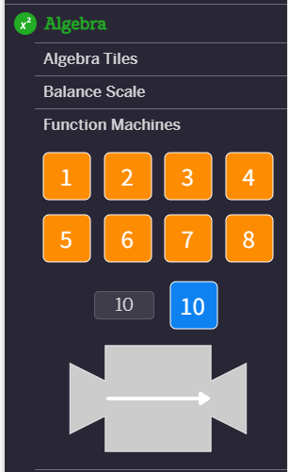   
 Image created using the free virtual manipulatives at [Polypad.org](https://mathigon.org/polypad/).

1. Have pairs alternate roles so that all students have an opportunity to create and determine a rule.
2. Use the Pose-Pause-Pounce-Bounce questioning strategy to facilitate a class discussion about the strategies students used to determine the rule.
3. Ask students to change the expression in the function machine to $x^{2}$, and drag the numbers (−3) to 3 into the machine.
4. Students can click on the function machine and then select **Tabulate** to see a table of their inputs and outputs.
5. Ask students to consider what they notice and wonder ([bit.ly/noticewonderstrategy](https://bit.ly/noticewonderstrategy))about the numbers as they go through the function machine~~.~~
6. In a Think-Pair-Share, ask students the following questions:

* How many different input $x$-values will give an output $y$-value of 4?
* Why did some input $x$-values give you the same output $y$-value?
* Can we get an output $y$-value of −9?

1. Conduct a class discussion by displaying the function machine with the rule $x^{2}$ and input the $x$-values 3 and −3 to show the output $y$-values are both 9. Ask students to explain why you can’t have the square root of −9.

#### Area models

1. Ask students to create a mind map of all the meanings of ‘square’ they can think of.

Students could think of square numbers, the shape, an open area surrounded by buildings in a town (town square) or common phrases such as ‘at right angles’ as used in construction.

1. Focus students’ attention on square numbers and the shape of a square by displaying slide 6 from the PowerPoint *Quadratic equations.* Ask students what they notice and what they wonder.

Students may need to be reminded that ‘A’ stands for the area. Students need to understand that an area of 25 can be represented as a square with side lengths of 5, while an area of $x^{2}$ can be represented by a square with side lengths of $x$. Students should notice that the squares look to be the same size.

1. Reveal the equation by displaying slide 7 from the PowerPoint *Quadratic equations.*
2. In a Think-Pair-Share, ask students to discuss the following questions:

* What is the equation saying?
* If these squares represent the equation as an area model, what would the solution be and why?
* Would the length of the square be the only solution to the equation? Why?

Students should remember from the previous activity that quadratic equations have 2 solutions. Students need to realise that in this scenario, a length of −5 does not make sense, so we disregard the negative solution.

An area model has previously been used to connect squares and square roots. (Lesson 7 – that’s about right of Unit 5 – multiplicative thinking). It is important that students realise that while they can still use this model to help them find the square roots of numbers, they need to remember that square roots can have 2 possible answers and they need to discern when the negative solution is appropriate and when it isn’t.

1. Discuss with students other scenarios where a negative answer may be appropriate and where it may not.

### Summarise

1. Use slides 9–16 of the PowerPoint *Quadratic equations* for explicit teaching of solving simple quadratic equations using the [worked examples (Your turn) method (DOCX 420 KB)](https://education.nsw.gov.au/content/dam/main-education/documents/teaching-and-learning/curriculum/mathematics/mathematics-s4-supporting-strategies-worked-examples-your-turn.docx)
2. Continuing in pairs, distribute Appendix A ‘How many solutions?’ and ask students to place the cards into categories of 0, 1 or 2 solutions, justifying their claims with calculations or showing reasoning as to why each card belongs in each category.
3. Using the Pose-Pause-Pounce-Bounce questioning strategy, ask students where they put each card and why.

### Apply

1. Distribute Appendix B ‘Area mazes’ to each student.
2. Students are to use their knowledge of area and squares to find the missing length or area in each maze.
3. Once students have completed the mazes, they should compare solutions and methods with a partner.

Area mazes will allow a variety of approaches. For example, the fourth puzzle can be solved by finding the side lengths of the rectangles or by adding the area of the rectangles inside the square to find an area of $144cm^{2}$ then finding the square root.

1. Challenge students to create an area maze with at least one square, swapping with a partner to complete each other’s mazes.

## Assessment and differentiation

### Suggested opportunities for differentiation

**Warm up**

* The warm up activity has a low floor, allowing students to compare perfect square roots such as 4 and 36, while providing opportunities for students to estimate where imperfect square roots may belong and explain why negative square roots are not possible.
* Students could be provided with further scaffolding to assist them to find the square root of imperfect squares and negative numbers through testing and exploring with their calculators.

**Launch**

* Students could be challenged to consider whether equations with powers of 3 and 4 would have 2 solutions.

**Explore**

* Students can create rules at an appropriate difficulty for them and their partner. Encourage students to be creative and consider rules such as $\frac{x}{2}-\frac{1}{2}$. Alternatively, students could limit the rules they create to one step, or the teacher can provide a list of rules for students to choose from.
* Students could explore the graph of $y=x^{2}$ to deepen their understanding of quadratic equations.
* Students could explore the graphs of $y=x^{3}$ and $y=x^{4}$ to determine which graphs will have multiple solutions and why.

##### Summarise

* Students should be encouraged to solve the equations using an area model.
* Students can be challenged to write their own scenarios or questions that fit in each category of Appendix A.
* Questions can be modified to only include whole number solutions.

##### Apply

* Students can work on Appendix B in pairs.
* Question 4 of Appendix B could be adjusted to remove the marks indicating that the larger shape is a square and pose to students the following question: Is the larger shape a rectangle or a square? Justify your answer.

### Suggested opportunities for assessment

**Warm up**

* Use the warm up activity as an opportunity to assess students’ prior knowledge of square roots. If students are not confident with the warm up activity, additional support should be provided before commencing with the lesson.

**Launch**

* Use the Launch activity as an opportunity to assess students’ prior knowledge of quadratic equations.

**Explore**

* Observe students’ conversations to assess their understanding of quadratic equations.
* Use Think-Pair-Share and Pose-Pause-Pounce-Bounce questioning strategies to draw out and assess students’ reasoning.
* In a Think-Pair-Share students will self and peer assess as they trial ideas and discuss their reasoning.

##### Summarise

* Discussions made when sorting cards should show students’ progression towards both the Working mathematically outcome and their ability to solve quadratic equations.

## Appendix A

### How many solutions?

Sort each card according to whether it has 0, 1 or 2 solutions, justifying your choices.

|  |  |
| --- | --- |
| $$x^{2}=100$$ | $$x^{2}=10$$ |
| $$x^{2}=-100$$ | $$x^{2}=0$$ |
| $$2x^{2}=100$$ | $$2x^{2}=0$$ |
| $$9x^{2}=9$$ | $$-9x^{2}=9$$ |
| $$-9x^{2}=-9$$ | $$9x^{2}=-9$$ |
| $$x^{2}+9=0$$ | $$x^{2}-9=0$$ |
| The area of a square is 100 square units. What is its length? | John said if he squares the value in his bank account, he is a millionaire. What is the value of his bank account? |
| Sarah has 2 square gardens of the same size that she wants to fence. The gardens’ area is $32 m^{2}$ combined, find the length of fence she needs. | A square bathroom floor is covered in tiles. The total area left to be tiled is $5 m^{2}$ as $4 m^{2}$ is already tiled. Find the length of the bathroom. |

## Appendix B

### Area mazes

1. 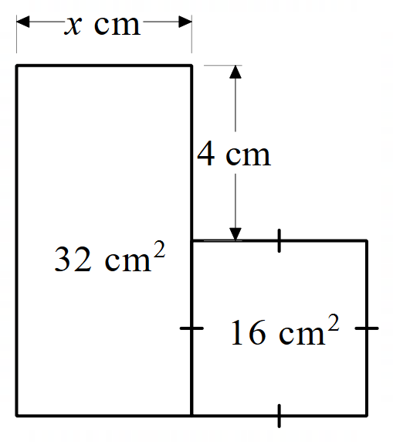
2. 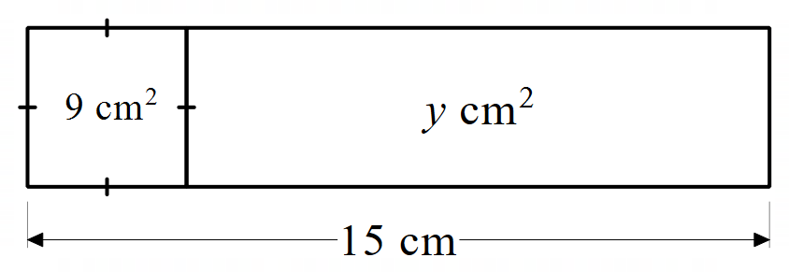
3. 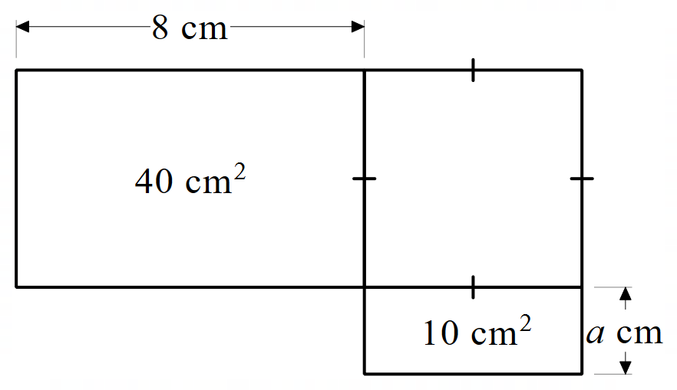
4. 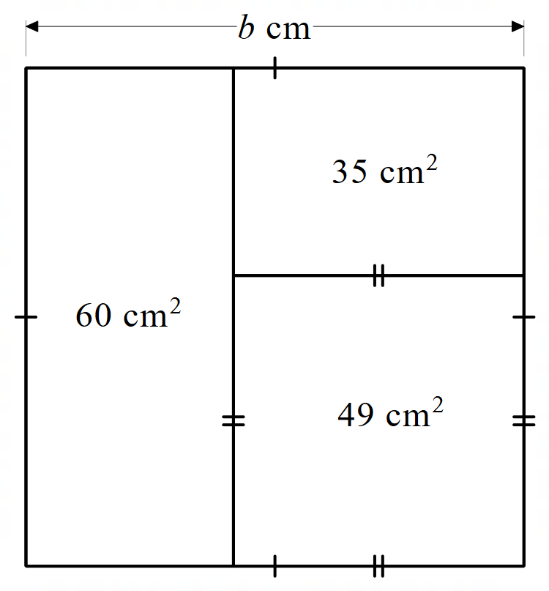

## Sample solutions

### Appendix A – How many solutions?

#### No solutions

$x^{2}=-100$

$-9x^{2}=9$

$9x^{2}=-9$

$x^{2}+9=0$

All of these equations result in $x^{2}=-c$, where there are no solutions as you cannot square any number and get a negative answer.

#### One solution

$x^{2}=0$

$2x^{2}=0$

These equations have only one answer as there isn’t a positive and negative zero. For both equations, the solution is $x=0$.

* The area of a square is 100 square units. What is its length?

$$x^{2}=100 \\ x=±\sqrt{100} \\ x=±10$$

This scenario only has one solution as length cannot be negative. The solution to this equation is the length is 10 units.

* Sarah has 2 square gardens of the same size that she wants to fence. The gardens’ area is $32 m^{2}$ combined, find the length of fence she needs.

$$2x^{2}=32 \\ x^{2}=16 \\ x=±\sqrt{16} \\ x=±4$$

This scenario only has one solution as length cannot be negative. Each garden bed as a side length of $4 m.$ Assuming the gardens are separate and do not share a common side, she will need $4×4×2=32 m$ of fencing.

* A square bathroom floor is covered in tiles. The total area left to be tiled is $5 m^{2}$ and $4 m^{2}$ is already tiled. Find the length of the bathroom.

$$x^{2}-5=4 \\ x^{2}=9 \\ x=±\sqrt{9} \\ x=±3$$

This scenario only has one solution as length cannot be negative. The solution to this equation is the length is 3 m.

#### Two solutions

$x^{2}=100$ $$x=±10$$

$x^{2}=10$ $$x=±\sqrt{10}$$

$2x^{2}=100$ $$x^{2}=50 \\ x=±\sqrt{50}$$

$9x^{2}=9$ $$x^{2}=1 \\ x=±1$$

$-9x^{2}=-9$ $$x^{2}=1 \\ x=±1$$

$x^{2}-9=0$ $$x^{2}=9 \\ x=±3$$

Each of these equations have 2 solutions as they are in the form $x^{2}=c$, and as long as $c$ is a positive number and not zero there is a positive and negative value we can square to get to the value of $c$.

* John said if he squares the value in his bank account, he is a millionaire. What is the value of his bank account?

$$x^{2}=1 000 000 \\ x=±1000$$

John has either $1000 dollars or –$1000 in his bank account.

Given that we associate millionaires with having money, John must have $1000 dollars in his bank account.

### Appendix B – area mazes

$x=4 cm$

$y=36 cm^{2}$

$a=2 cm$

$b=12 cm$

## References

This resource contains NSW Curriculum and syllabus content. The NSW Curriculum is developed by the NSW Education Standards Authority. This content is prepared by NESA for and on behalf of the Crown in right of the State of New South Wales. The material is protected by Crown copyright.

Please refer to the NESA Copyright Disclaimer for more information.

NESA holds the only official and up-to-date versions of the NSW Curriculum and syllabus documents. Please visit the NSW Education Standards Authority (NESA) website <https://educationstandards.nsw.edu.au/> and the NSW Curriculum website <https://curriculum.nsw.edu.au/>.

[Mathematics K–10 Syllabus](https://curriculum.nsw.edu.au/learning-areas/mathematics/mathematics-k-10-2022/overview) © NSW Education Standards Authority (NESA) for and on behalf of the Crown in right of the State of New South Wales, 2022.

**© State of New South Wales (Department of Education), 2024**

The copyright material published in this resource is subject to the *Copyright Act 1968* (Cth) and is owned by the NSW Department of Education or, where indicated, by a party other than the NSW Department of Education (third-party material).

Copyright material available in this resource and owned by the NSW Department of Education is licensed under a [Creative Commons Attribution 4.0 International (CC BY 4.0) license](https://creativecommons.org/licenses/by/4.0/).

[](https://creativecommons.org/licenses/by/4.0/)

This license allows you to share and adapt the material for any purpose, even commercially.

Attribution should be given to © State of New South Wales (Department of Education), 2024.

Material in this resource not available under a Creative Commons license:

* the NSW Department of Education logo, other logos and trademark-protected material
* material owned by a third party that has been reproduced with permission. You will need to obtain permission from the third party to reuse its material.

**Links to third-party material and websites**

Please note that the provided (reading/viewing material/list/links/texts) are a suggestion only and implies no endorsement, by the New South Wales Department of Education, of any author, publisher, or book title. School principals and teachers are best placed to assess the suitability of resources that would complement the curriculum and reflect the needs and interests of their students.

If you use the links provided in this document to access a third-party's website, you acknowledge that the terms of use, including licence terms set out on the third-party's website apply to the use which may be made of the materials on that third-party website or where permitted by the *Copyright Act 1968* (Cth). The department accepts no responsibility for content on third-party websites.