# Pythagoras’ theorem

Students explore a visual representation of Pythagoras’ theorem and then apply the theorem to find the hypotenuse of right-angled triangles.

## Visible learning

### Learning intentions

* To understand why Pythagoras’ theorem can be used to find the hypotenuse of right-angled triangles.

### Success criteria

* I can find the square root of a square.
* I can explain why $a^{2}+b^{2}=c^{2}$ using a visual representation.
* I can apply Pythagoras’ theorem to find the hypotenuse of a right-angled triangle.

### Syllabus outcomes

A student:

* develops understanding and fluency in mathematics through exploring and connecting mathematical concepts, choosing and applying mathematical techniques to solve problems, and communicating their thinking and reasoning coherently and clearly **MAO-WM-01**
* solves linear equations of up to 2 steps and quadratic equations of the form $ax^{2}=c$  
  **MA4-EQU-C-01**
* applies Pythagoras’ theorem to solve problems in various contexts **MA4-PYT-C-01**

[Mathematics K–10 Syllabus](https://curriculum.nsw.edu.au/learning-areas/mathematics/mathematics-k-10-2022/overview) © NSW Education Standards Authority (NESA) for and on behalf of the Crown in right of the State of New South Wales, 2022.

|  |  |  |  |
| --- | --- | --- | --- |
| Section | Summary of activity | Teaching strategy | Teaching points |
| Warm up | Display slide 3 of the PowerPoint *Pythagoras' theorem* for students to discuss which triangle doesn’t belong. | Think-Pair-Share  Which one doesn’t belong | Activate and connect students’ prior knowledge of triangle properties. |
| Launch | Display the Make math moments unit ‘Squares to triangles’ ([bit.ly/pythagorasunit](https://bit.ly/pythagorasunit)) and show students the video Spark Curiosity. | Notice and wonder | Connect Pythagoras’ theorem to area. |
| Explore | The teacher continues to display and work through the Make math moments unit, with the option to use the Polypad activity ‘MMM ST Day 1 #3’ ([bit.ly/polypadpythag](https://bit.ly/polypadpythag)).  Display or give students the Polypad activity ‘MMM ST Day 1 #4’ ([bit.ly/polypadpythag2](https://bit.ly/polypadpythag2)) to model the visual representation.  Distribute Appendix A to students to find the area of inside squares for similar diagrams. |  | Construct a visual representation of Pythagoras’ theorem. |
| Summarise | Use slides 6–13 of the PowerPoint for explicit teaching of finding the hypotenuse of right-angled triangles | [Worked examples (Your turn) (DOCX 420 KB)](https://education.nsw.gov.au/content/dam/main-education/documents/teaching-and-learning/curriculum/mathematics/mathematics-s4-supporting-strategies-worked-examples-your-turn.docx)  Notes to your future forgetful self | Transition from the visual representation to students abstractly solving problems with Pythagoras’ theorem. |
| Apply | Display slide 15 of the PowerPoint. Students measure the width and height of a classroom wall to calculate its diagonal length. | Notice and wonder | Students solve problems with Pythagoras’ theorem. |

## Activity structure

Please use the associated PowerPoint *Pythagoras’ theorem* to display images in this lesson.

### Warm up

1. Display Figure 1, which is available on slide 3 of the *Pythagoras’ theorem* PowerPoint.

Figure 1: Which one doesn't belong?

4 triangles.
Triangle 1 is right angled and has legs 4cm and 7cm and hypotenuse 6cm.
Triangle 2 is right angled and has legs 4cm and 4cm and hypotenuse 4cm.
Triangle 3 has an angle of 102 degrees opposite side length 11 cm. It also has side lengths of 4cm and 12 cm.
Triangle 4 is right angled and has legs 4cm and 3cm and hypotenuse 5cm.

1. Students discuss in a Think-Pair-Share ([bit.ly/thinkpairsharestrategy](https://bit.ly/thinkpairsharestrategy)), which triangle doesn’t belong ([bit.ly/wodb](https://bit.ly/wodb)).

Use this activity as an opportunity to formatively assess students, and if necessary, teach properties and naming conventions of triangles. For example, students should identify that the hypotenuse should be the longest side in a right-angled triangle as it is opposite the largest angle. Labelling triangles using appropriate text and symbols is covered in Lesson 2 – Is that a triangle? of Unit 6 – triangles and quadrilaterals.

### Launch

This activity is based on a unit of learning by Make math moments ([bit.ly/pythagorasunit](https://bit.ly/pythagorasunit)).

1. Explain to students that in today’s lesson they will be introduced to one of the most famous theorems in mathematics and that we will start by exploring why it works.
2. Display the Make math moments website ([bit.ly/pythagorasunit](https://bit.ly/pythagorasunit)) and show students the video under the heading Spark Curiosity.
3. In a Think-Pair-Share, ask students what they notice and wonder ([bit.ly/noticewonderstrategy](https://bit.ly/noticewonderstrategy)).

Students might notice:

* there is a square inside another square
* there are right-angled triangles in each corner
* there are 2 different sized triangles.

Students might wonder:

* Why are we watching this?
* How much smaller is the inside square?
* What does this have to do with Pythagoras’ theorem?

### Explore

1. Display the image under the heading Estimation: Prompt ([bit.ly/mmmestimation](https://bit.ly/mmmestimation)).
2. Pose the question to students:

How many of the small yellow squares will fit inside the inner square?

1. Ask students to discuss in a Think-Pair-Share, an estimate of how many small yellow squares would fit inside the inner square.
2. Display Image #2 under the heading Fuel Sense-making ([bit.ly/mmmsensemaking](https://bit.ly/mmmsensemaking)).
3. Students are to work in pairs to calculate how many of the small yellow squares will fit inside the inner square. They can approach the problem using a variety of strategies.

Students could use the Polypad activity ‘MMM ST Day 1 #3’ ([bit.ly/polypadpythag](https://bit.ly/polypadpythag)), to show their thinking. Student sample solutions are available on the Make math moments website ([bit.ly/pythagorasunit](https://bit.ly/pythagorasunit)).

Students should find that the inner square would contain 400 small yellow squares.

1. Show students the video under the heading Next Moves (0:29) ([bit.ly/mmmnextmoves](https://bit.ly/mmmnextmoves)). Replay the video, pausing at each transition to discuss the transition from visual to abstract representation.

Attention should be drawn to the empty space, as opposed to the orange triangles. The 2 squares $a^{2}$ and $b^{2}$ combine to take up the same space as $c^{2}$, hence $a^{2}+b^{2}=c^{2}$.

1. Explain to students that $a^{2}+b^{2}=c^{2}$ is Pythagoras’ theorem. Use the video to define Pythagoras’ theorem as the sum of the squares made from the smaller sides of a right-angled triangle is equal to the square made from the longest side of a right-angled triangle.

The following Polypad activity ‘MMM ST Day 1 #4’ ([bit.ly/polypadpythag2](https://bit.ly/polypadpythag2)) can either be provided to students or used to model the visual representation.

1. Distribute Appendix A ‘Visual representation’ to students. In this Appendix students are to find the area of the inside square to verify Pythagoras’ theorem.

### Summarise

1. Display slide 5 of the PowerPoint *Pythagoras’ theorem* to teach students the terminology used for right-angled triangles.

Students should note that the hypotenuse is the longest side and opposite the right angle.

1. Use slides 6–13 of the PowerPoint *Pythagoras’ theorem* for explicit teaching of finding the hypotenuse of right-angled triangles using the [worked examples (Your turn) method (DOCX 420 KB)](https://education.nsw.gov.au/content/dam/main-education/documents/teaching-and-learning/curriculum/mathematics/mathematics-s4-supporting-strategies-worked-examples-your-turn.docx).
2. Students write notes to their future forgetful selves ([bit.ly/notestofutureself](https://bit.ly/notestofutureself)) to summarise Pythagoras’ theorem for finding the hypotenuse of a right-angled triangle.

### Apply

1. Display Figure 2, which is available on slide 15 of the PowerPoint *Pythagoras’ theorem*.

Figure 2: wall frame

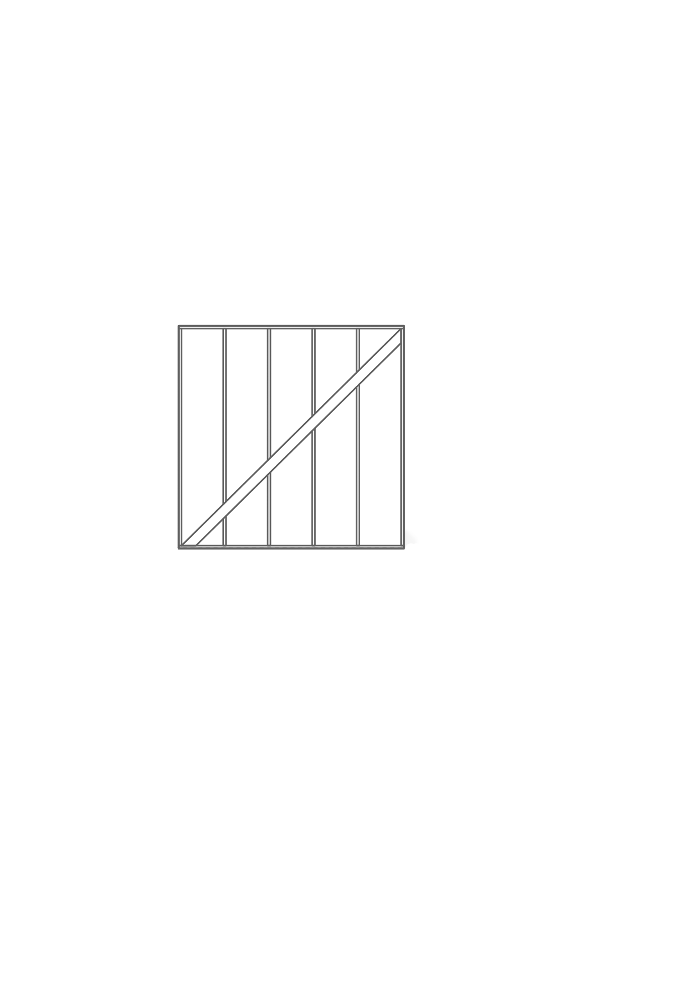

1. Ask students in a Think-Pair-Share, what they notice and wonder about the image of a wall frame.

Students may notice that the diagonal brace creates 2 right-angled triangles.

Students may wonder how builders know how long the diagonal brace should be.

1. In pairs, students select a wall to measure. They measure the width and height of the wall, then use these measurements to calculate the hypotenuse using Pythagoras’ theorem.
2. Pairs should exchange their work with another pair to check that they agree with their working out and answers.
3. Students should notice that the answers they obtain are irrational decimals, whereas all the examples explored in today’s lesson have resulted in integer solutions. Challenge students to consider which numbers give integer solutions and explore why.

At this point students may start to identify Pythagorean triads, as sets of lengths that give integer solutions.

## Assessment and differentiation

### Suggested opportunities for differentiation

**Warm up**

* **In a ‘Which one doesn’t belong’ students should find reasons for each triangle not belonging. This means that students can engage with the problem at a range of levels. The focus should be on students using correct terminology.**

**Explore**

* Students may benefit from constructing the visual representation with tiles that they can rearrange to find the area of the inside square.
* Challenge students to consider multiple strategies to find the area of the inside square.
* The Polypad activities can be edited to provide further scaffolding for students.
* Challenge students to consider the examples in Appendix A, and whether Pythagoras’ theorem would work for all right-angled triangles. Ask students to make their own example.
* There are many ways of proving Pythagoras’ theorem. Students could be challenged to explore other proofs.

**Summarise**

* Additional practice of finding the hypotenuse should be provided to complement this lesson.
* Challenge students to use a visual representation to support their working out in subsequent lessons.

**Apply**

* Students may benefit from modelling the steps on their calculators. Additional instruction of how to use calculators could be beneficial.
* Challenge students to consider other situations where they would know both shorter sides of a right-angled triangle and need to find the hypotenuse.
* Challenge students to explore which side lengths will result in an integer hypotenuse length using blocks or grid paper.
* Students could be provided with sets of lengths, in which some are triads, and some are not. Students could be asked to explain what this would mean in the context of a wall.

### Suggested opportunities for assessment

**Warm up**

* **Observe students’ reasoning to assess their prior learning of triangle properties. Additional teaching may be required before commencing with this lesson.**

**Explore**

* Collect students’ working to find the area of the inner square. Students’ various solutions could be posted in an online shared classroom space for students to observe their peers’ thinking.
* Appendix A could be collected as evidence that students understand Pythagoras’ theorem.

**Summarise**

* Observe students’ Your turn solutions to ensure they can apply Pythagoras’ solution to find the hypotenuse of a right-angled triangle.

**Apply**

* **Observe students’ reasoning in discussions and work samples to ensure students are confident finding the hypotenuse of right-angled triangles using Pythagoras’ theorem.**

## Appendix A

### Visual representation

Find the area of the inside squares, to show that $a^{2}+b^{2}=c^{2}$.

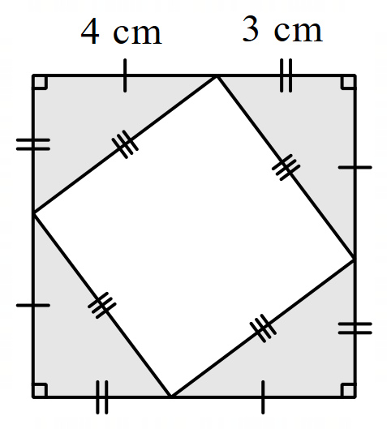

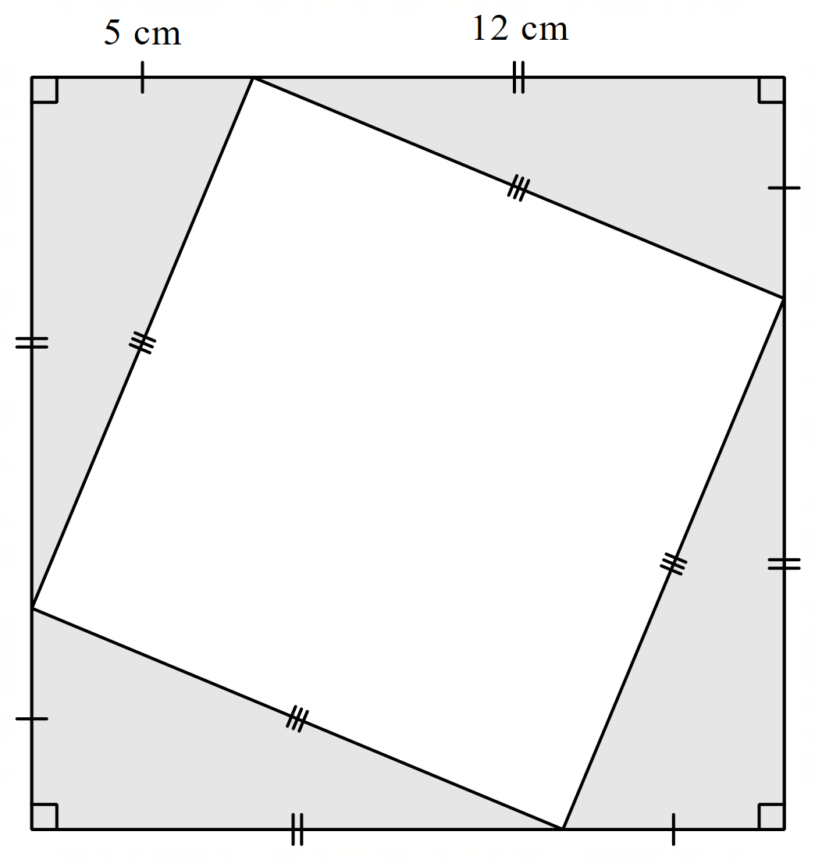

## Sample solutions

### Appendix A – visual representation



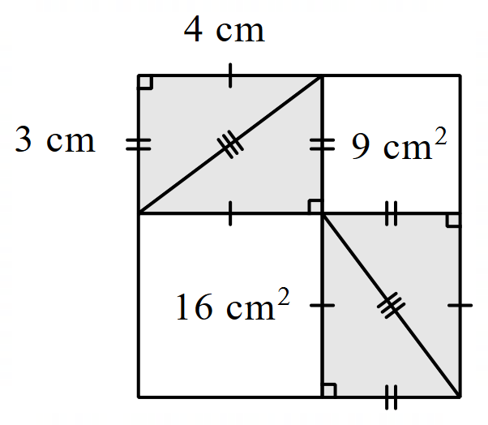

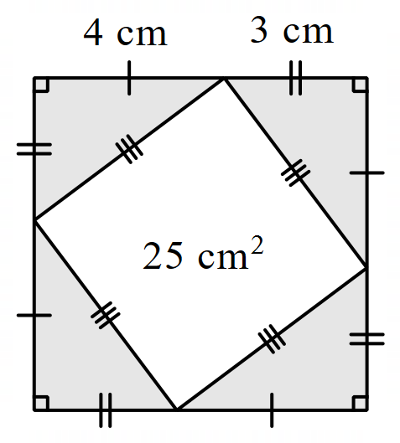

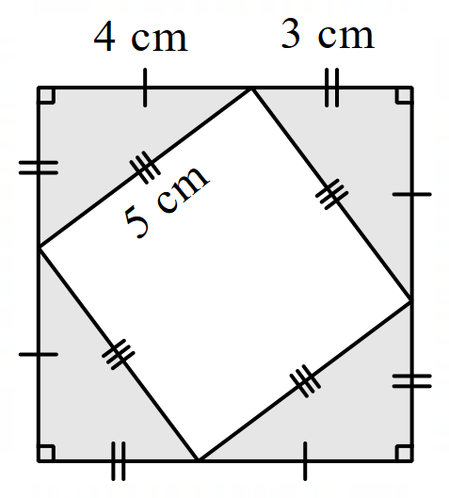

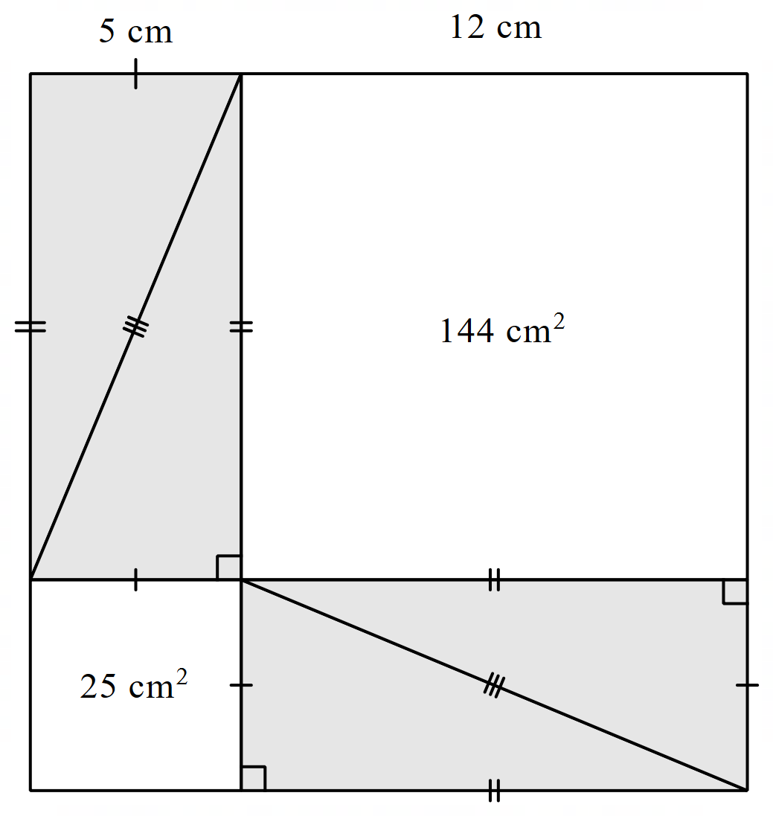

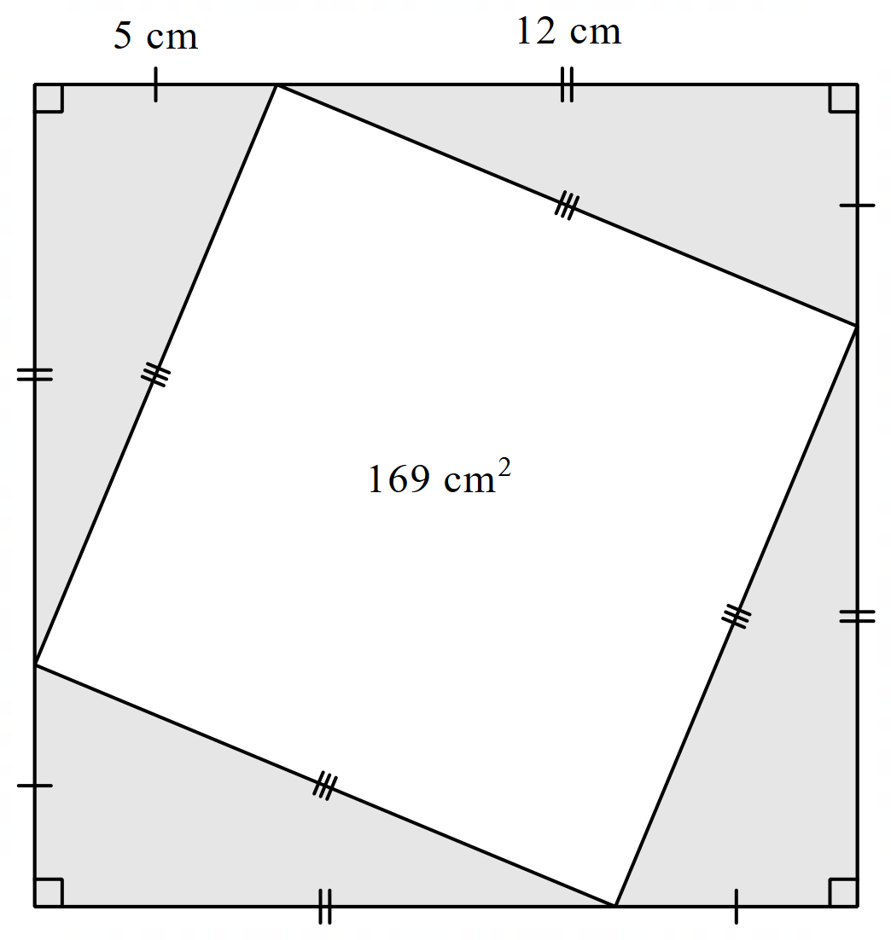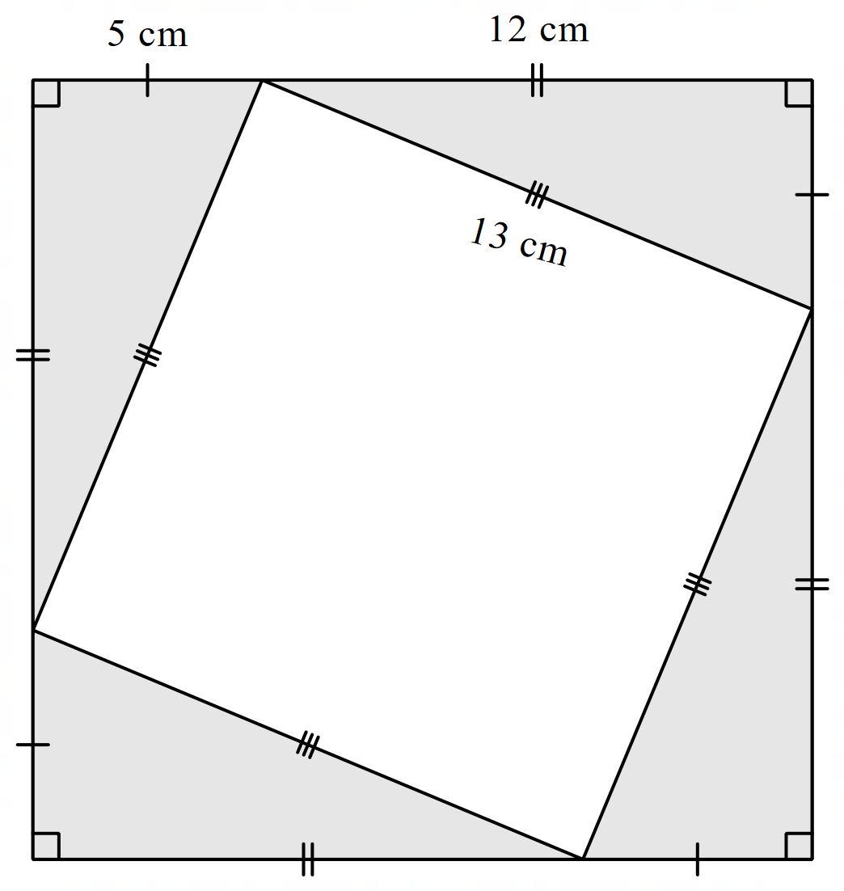

## References

This resource contains NSW Curriculum and syllabus content. The NSW Curriculum is developed by the NSW Education Standards Authority. This content is prepared by NESA for and on behalf of the Crown in right of the State of New South Wales. The material is protected by Crown copyright.

Please refer to the NESA Copyright Disclaimer for more information [https://educationstandards.nsw.edu.au/wps/portal/nesa/mini-footer/copyright](https://aus01.safelinks.protection.outlook.com/?url=https%3A%2F%2Feducationstandards.nsw.edu.au%2Fwps%2Fportal%2Fnesa%2Fmini-footer%2Fcopyright&data=05%7C01%7CCaitlin.Pace1%40det.nsw.edu.au%7C9c2c1a9f59c94d2df30708dafa7edb23%7C05a0e69a418a47c19c259387261bf991%7C0%7C0%7C638097720042599463%7CUnknown%7CTWFpbGZsb3d8eyJWIjoiMC4wLjAwMDAiLCJQIjoiV2luMzIiLCJBTiI6Ik1haWwiLCJXVCI6Mn0%3D%7C3000%7C%7C%7C&sdata=BzQh0UsffVZE3eO22b2Xba3p0VMOBZSHfS21FGHXtZM%3D&reserved=0).

NESA holds the only official and up-to-date versions of the NSW Curriculum and syllabus documents. Please visit the NSW Education Standards Authority (NESA) website <https://educationstandards.nsw.edu.au/> and the NSW Curriculum website <https://curriculum.nsw.edu.au/>.

[Mathematics K–10 Syllabus](https://curriculum.nsw.edu.au/learning-areas/mathematics/mathematics-k-10-2022/overview) © NSW Education Standards Authority (NESA) for and on behalf of the Crown in right of the State of New South Wales, 2022.

**© State of New South Wales (Department of Education), 2024**

The copyright material published in this resource is subject to the *Copyright Act 1968* (Cth) and is owned by the NSW Department of Education or, where indicated, by a party other than the NSW Department of Education (third-party material).

Copyright material available in this resource and owned by the NSW Department of Education is licensed under a [Creative Commons Attribution 4.0 International (CC BY 4.0) license](https://creativecommons.org/licenses/by/4.0/).

[](https://creativecommons.org/licenses/by/4.0/)

This license allows you to share and adapt the material for any purpose, even commercially.

Attribution should be given to © State of New South Wales (Department of Education), 2024.

Material in this resource not available under a Creative Commons license:

* the NSW Department of Education logo, other logos and trademark-protected material
* material owned by a third party that has been reproduced with permission. You will need to obtain permission from the third party to reuse its material.

**Links to third-party material and websites**

Please note that the provided (reading/viewing material/list/links/texts) are a suggestion only and implies no endorsement, by the New South Wales Department of Education, of any author, publisher, or book title. School principals and teachers are best placed to assess the suitability of resources that would complement the curriculum and reflect the needs and interests of their students.

If you use the links provided in this document to access a third-party's website, you acknowledge that the terms of use, including licence terms set out on the third-party's website apply to the use which may be made of the materials on that third-party website or where permitted by the *Copyright Act 1968* (Cth). The department accepts no responsibility for content on third-party websites.