Almost exactly
Students apply Pythagoras’ theorem to find the hypotenuse of right-angled triangles, giving answers in exact form or as decimal approximations. Students focus on why exact form can be beneficial in some instances.

Visible learning

Learning intention
- To understand the purpose of giving answers in exact form.

Success criteria
- I can define exact form and decimal approximations.
- I can explain when it is appropriate to give answers in exact form.
- I can use Pythagoras’ theorem to find the hypotenuse of a right-angled triangle, giving answers in an exact form.

Syllabus outcomes
A student:
- develops understanding and fluency in mathematics through exploring and connecting mathematical concepts, choosing and applying mathematical techniques to solve problems, and communicating their thinking and reasoning coherently and clearly MAO-WM-01
- solves linear equations of up to 2 steps and quadratic equations of the form $ax^{2}=c$
MA4-EQU-C-01
- applies Pythagoras’ theorem to solve problems in various contexts MA4-PYT-C-01
Mathematics K–10 Syllabus © NSW Education Standards Authority (NESA) for and on behalf of the Crown in right of the State of New South Wales, 2022.

Table 1 – lesson summary
Section | Summary of activity | Teaching strategy | Teaching points
Launch | Students draw the lengths 10 cm, 10.5 cm,  10.48808 cm and $\sqrt{110}$ cm and discuss which is the easiest length to draw. They then relate this to phone covers to talk about accuracy. | Pose-Pause-Pounce-Bounce | Students should note 10 cm and 10.5 cm were the easiest to measure using a ruler, but accuracy of answers depends on the situation.
Explore | Students explore and discuss decimal solutions and rounding when finding the length of the hypotenuse. Introduce students to leaving solutions in exact form.  Distribute Appendix A to each student. In pairs, one student answers in exact form, and the other rounds their answers. Students compare and discuss the benefits of each. | Pose-Pause-Pounce-Bounce  Think-Pair-Share | Students can access notes to their future selves from the previous lesson.  Students see the benefits of leaving solutions in exact form or as decimal approximations.
Summarise | Use slides 5–7 of the PowerPoint Almost exactly to highlight to students that the more times we round, the further the answer gets from the exact answer.  Use slides 6–13 of the PowerPoint for explicit teaching of giving answers in exact form. | Worked examples (Your turn) (DOCX 420 KB) | Students need to leave their answers in exact form if using the answer in a subsequent calculation.
Apply | Distribute Appendix B to each student to work in pairs. One partner is to find the length of each hypotenuse in exact form and the other partner to find the decimal approximation. |  | Students see the effect rounding has on the final answer.

Activity structure
Please use the associated PowerPoint Almost Exactly to display images in this lesson.

Launch
- Give each student a ruler and an A4 piece of paper.
- Ask each student to draw the following lengths using their rulers:
- 10 cm
- 10.5 cm
- 10.48808 cm
- $\sqrt{110}$ cm
- Using the Pose-Pause-Pounce-Bounce questioning strategy (PDF 557 KB) (bit.ly/posepausepouncebounce), ask students the following questions:
- Which length was the easiest to measure? Which was the hardest? Why do you think that was the case?
- If you were asked to create a mobile phone case that had a length of $\sqrt{110}$ cm, which measurement would you use to create it? Why?
The purpose of this activity is to highlight the need for accuracy in certain situations and when it is appropriate to round. Students explored approximating surds in Lesson 7 – that’s about right of Unit 5 – multiplicative thinking.

Explore
- Display Figure 1, which is available on slide 3 of the PowerPoint Almost Exactly.
Figure 1: right-angled triangle
- Ask students to find the length of the hypotenuse, showing each step in their books. Students may benefit from referring to their previously written notes to their future forgetful self (bit.ly/notestofutureself) on how to find the hypotenuse of a right-angled triangle.
- Using the Pose-Pause-Pounce-Bounce questioning strategy, ask students the following questions:
- Compare your solution with those around you. Are the solutions the same or different? How?
- So far the triangles we have worked with have had a whole number (integer) hypotenuse. Do you think there are more triangles with an integer hypotenuse or a decimal hypotenuse? Why?
Students may notice that some students left their answers in surd form while others rounded to different numbers of decimal places. Students may recognise that there are many more sets of sides in right-angled triangles that are surds.
- In their books, students are to write the length of hypotenuse $d$, with as many decimal places as their calculator shows.
For example, $d=16.1554944214$ cm.
- Model the calculation using an online calculator and highlight to students that calculators will give a different number of place values based on their settings and power.
Smart phones will usually give far more decimal places than a calculator because of how powerful phones can be. Remind students that the square root of any number that is not a perfect square will result in an irrational decimal, that will have an infinite number of decimal places.
Students may have access to recently released calculators which will automatically obtain simplified answers when entering surds. Use this as an opportunity to discuss why this is the case and ensure students know how to also obtain a decimal answer.
- Using the Pose-Pause-Pounce-Bounce questioning strategy, ask students the following questions:
- Why do we round answers?
- How many decimal places should we round to?
- Are there any potential issues with rounding?
- How could we write our answer without needing to round?
Decimal approximations were explored in Lesson 10 – approximate measurements of Unit 3 – representing numbers. If students are not confident rounding, explicit teaching of rounding may be required before commencing with this lesson.
- State to students that rather than entering the calculation $\sqrt{261}$ in their calculators to get a decimal answer, we can leave our answer as $\sqrt{261}$. This is called exact form.
- Ask randomly selected students to suggest a definition of exact form.
- Distribute Appendix A ‘Exact form or decimal approximation’ to each student. In pairs, one student is to leave their answers in exact form and the other student is to leave their answers as a decimal approximation, rounded to 2 decimal places.
- In a Think-Pair-Share (bit.ly/thinkpairsharestrategy), ask students what the benefits are of leaving answers in exact form.

Students may suggest:
- in exact form, the answer is the same no matter which calculator you use
- in exact form, the answer is more precise than if rounded
- as a decimal approximation, the number is easier to understand
- as a decimal approximation, the number is easier to operate with.

Summarise
- Use slides 5–7 of the PowerPoint Almost exactly to highlight to students that as subsequent calculations are performed with the decimal approximation, the answer gets further away from the exact form. Students can verify by entering each surd into their calculators to obtain the decimal equivalent.
- Explain to students that if an answer is going to be used to perform further calculations, they should use the exact form to avoid rounding errors.
- Use slides 8–15 of the PowerPoint Almost exactly for explicit teaching of answering in exact form using the worked examples (Your turn) method (DOCX 420 KB).

Apply
- Distribute Appendix B ‘Stacking triangles’ to each student. This can also be shown using slide 17 of the PowerPoint.
- Students are to continue to work in their pairs. One partner is to find the length of each hypotenuse in exact form. The other partner is to find the length of each hypotenuse, rounding answers to one decimal place.
Pairs should reverse their role from Appendix A. The partner that worked in exact form should now use decimal approximations.
- When both students have found the value of $x$, they should compare the result and discuss whether exact form or decimal approximations should have been used.

Assessment and differentiation

Suggested opportunities for differentiation
Launch
- To compare answers more confidently in exact form and decimal approximations, students may benefit from exploring the value of square roots from 1 to 20, before commencing with the lesson.
Explore
- Faded worked examples could be provided to assist students in using Pythagoras’ theorem for the triangles in Figure 1 and Appendix A.
- Challenge students to use their knowledge of square roots to estimate the approximate values of square roots that are not perfect squares.
Summarise
- Challenge students to consider other formulae or skills in mathematics that may result in answers that can be written in exact form.
- Challenge students to suggest contexts in which exact form would be more appropriate than decimal approximations.
Apply
- Students could be given each triangle in the stack individually, rounding the new side length to a whole number if necessary.
- Challenge students to create their own triangle stack with a greater difference between the final hypotenuses.
- Encourage students to consider if lengths should be written in exact form or as decimal approximations as they continue to explore Pythagoras’ theorem.

Suggested opportunities for assessment
Launch
- Students’ understanding of the purpose of rounding can be identified in their responses to question prompts.
Explore
- Observe students’ reasoning to assess their understanding of rounding.
Summarise
- Observe students’ ‘Your turn’ solutions to assess their use of exact values.
Apply
- Observe students’ discussions of Appendix B to ensure they understand how and why exact form can be used in mathematics.

Appendix A

Exact form or decimal approximation
Use Pythagoras’ theorem to find the value of each hypotenuse.
Partner A – find the exact form of each hypotenuse.
Partner B – find the decimal approximation of each hypotenuse, to 2 decimal places.
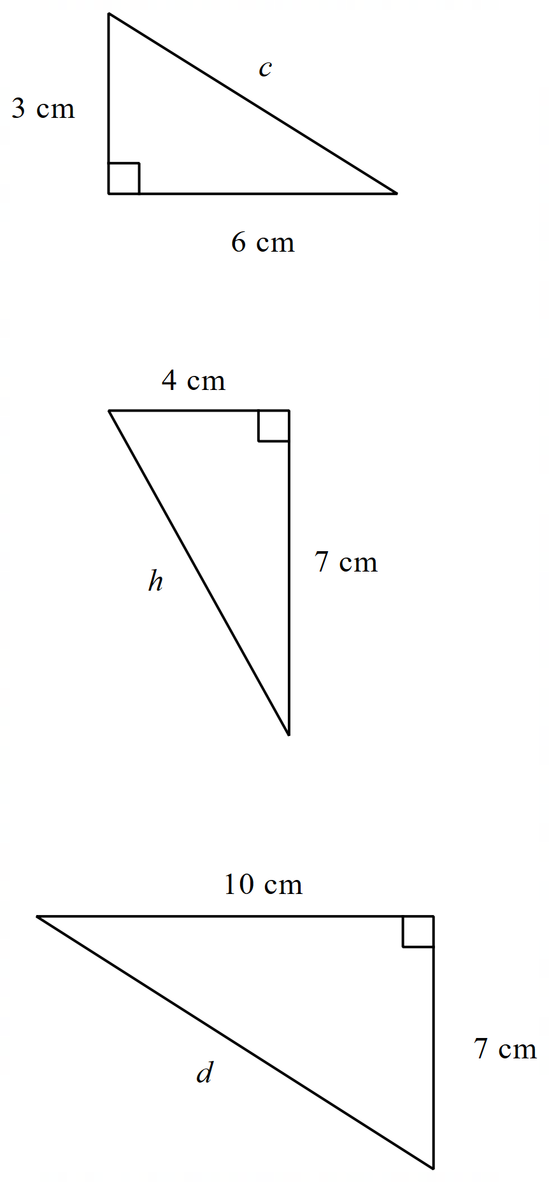

Appendix B

Stacking triangles
Use Pythagoras’ theorem to find the value of $x$.
Partner A – find the exact form of $x$.
Partner B – find the decimal approximation of $x$, to 1 decimal place.
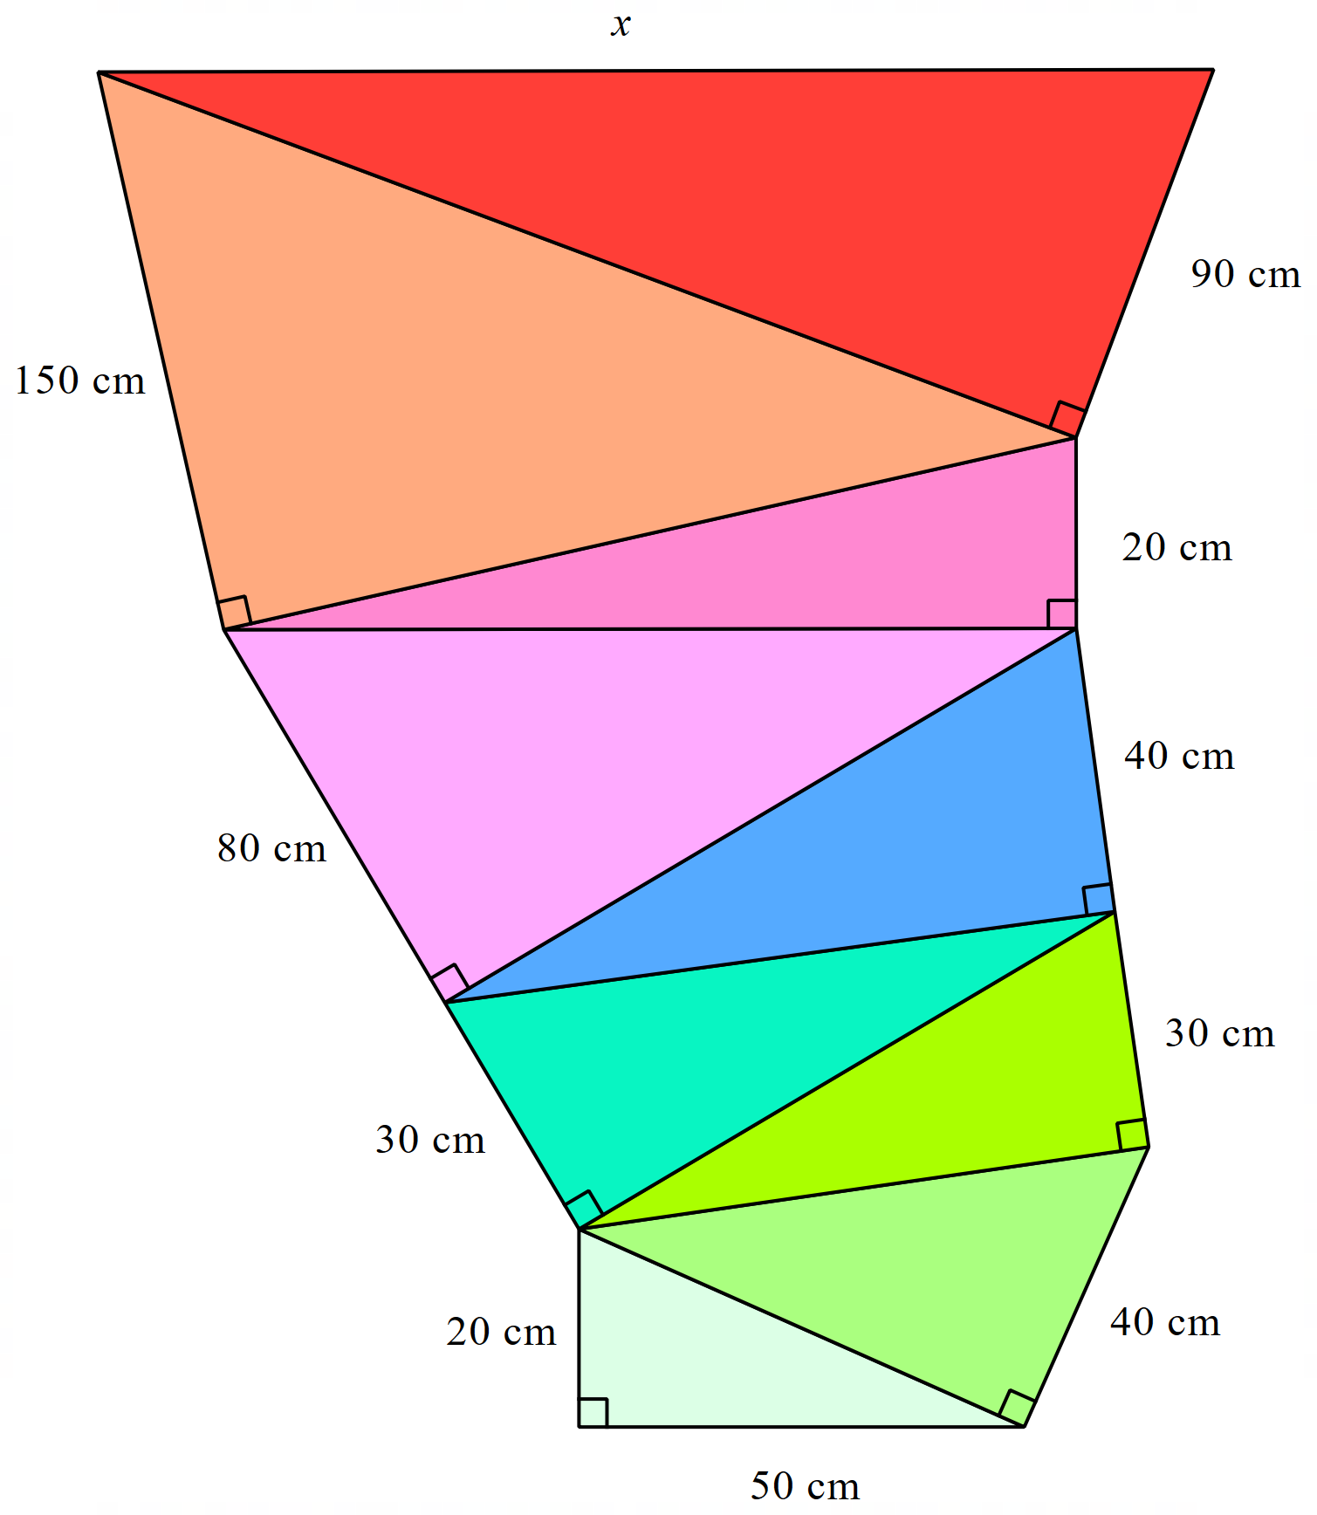

Sample solutions

Appendix A – exact form or decimal approximation
$$c^{2}=3^{2}+6^{2} \\ c^{2}=45 \\ c=\sqrt{45} cm \\ c=6.71 cm$$
$$h^{2}=4^{2}+7^{2} \\ h^{2}=65 \\ h=\sqrt{65 cm} \\ h=8.06 cm$$
$$d^{2}=7^{2}+{10}^{2} \\ d^{2}=149 \\ d=\sqrt{149} cm \\ d=12.21 cm$$

Appendix B – Stacking triangles
Exact form
$$a^{2}={20}^{2}+{50}^{2} \\ a=\sqrt{2900} \\ b^{2}={\sqrt{2900}}^{2}+{40}^{2} \\ b=\sqrt{4500} \\ c^{2}={\sqrt{4500}}^{2}+{30}^{2} \\ c=\sqrt{5400} \\ d^{2}={\sqrt{5400}}^{2}+{30}^{2} \\ d=\sqrt{6300} \\ f^{2}={\sqrt{6300}}^{2}+{40}^{2} \\ f=\sqrt{7900} \\ g^{2}={\sqrt{7900}}^{2}+{80}^{2} \\ g=\sqrt{14300} \\ h^{2}={\sqrt{14300}}^{2}+{20}^{2} \\ h=\sqrt{14700} \\ j^{2}={\sqrt{14700}}^{2}+{150}^{2} \\ j=\sqrt{37200} \\ x^{2}={\sqrt{37200}}^{2}+{90}^{2} \\ x=\sqrt{45300}$$

Decimal approximation (1 decimal place)
$$a^{2}={20}^{2}+{50}^{2} \\ a=53.9 \\ b^{2}={53.9}^{2}+{40}^{2} \\ b=67.1 \\ c^{2}={67.1}^{2}+{30}^{2} \\ c=73.5 \\ d^{2}={73.5}^{2}+{30}^{2} \\ d=79.4 \\ f^{2}={79.4}^{2}+{40}^{2} \\ f=88.9 \\ g^{2}={88.9}^{2}+{80}^{2} \\ g=119.6 \\ h^{2}={119.6}^{2}+{20}^{2} \\ h=121.3 \\ j^{2}={121.3}^{2}+{150}^{2} \\ j=192.9 \\ x^{2}={192.9}^{2}+{90}^{2} \\ x=212.9$$
$x$ in exact form is $\sqrt{45300}$ and $212.9$ as a decimal approximation (rounded to 1 decimal place). $\sqrt{45300}$ is $212.8$(rounded to 1 decimal place).

References
This resource contains NSW Curriculum and syllabus content. The NSW Curriculum is developed by the NSW Education Standards Authority. This content is prepared by NESA for and on behalf of the Crown in right of the State of New South Wales. The material is protected by Crown copyright.
Please refer to the NESA Copyright Disclaimer for more information https://educationstandards.nsw.edu.au/wps/portal/nesa/mini-footer/copyright.
NESA holds the only official and up-to-date versions of the NSW Curriculum and syllabus documents. Please visit the NSW Education Standards Authority (NESA) website https://educationstandards.nsw.edu.au and the NSW Curriculum website https://curriculum.nsw.edu.au.
Mathematics K–10 Syllabus © NSW Education Standards Authority (NESA) for and on behalf of the Crown in right of the State of New South Wales, 2022.

© State of New South Wales (Department of Education), 2024
The copyright material published in this resource is subject to the Copyright Act 1968 (Cth) and is owned by the NSW Department of Education or, where indicated, by a party other than the NSW Department of Education (third-party material).
Copyright material available in this resource and owned by the NSW Department of Education is licensed under a Creative Commons Attribution 4.0 International (CC BY 4.0) license.
This license allows you to share and adapt the material for any purpose, even commercially.
Attribution should be given to © State of New South Wales (Department of Education), 2024.
Material in this resource not available under a Creative Commons license:
- the NSW Department of Education logo, other logos and trademark-protected material
- material owned by a third party that has been reproduced with permission. You will need to obtain permission from the third party to reuse its material.
Links to third-party material and websites
Please note that the provided (reading/viewing material/list/links/texts) are a suggestion only and implies no endorsement, by the New South Wales Department of Education, of any author, publisher, or book title. School principals and teachers are best placed to assess the suitability of resources that would complement the curriculum and reflect the needs and interests of their students.
If you use the links provided in this document to access a third-party's website, you acknowledge that the terms of use, including licence terms set out on the third-party's website apply to the use which may be made of the materials on that third-party website or where permitted by the Copyright Act 1968 (Cth). The department accepts no responsibility for content on third-party websites.

