# Hole in one

Students discover how to find the length of the shorter side (leg) in a right-angled triangle by exploring how to find the shortest distance over an obstacle on a golf course.

Students will need at least one digital device per group of 3 to access Google Maps during this lesson.

## Visible learning

### Learning intention

* To be able to use Pythagoras’ theorem to find unknown lengths.

### Success criteria

* I can correctly substitute values into Pythagoras’ theorem.
* I can draw visual representations of equations.
* I can solve an equation to find a distance.

### Syllabus outcomes

A student:

* develops understanding and fluency in mathematics through exploring and connecting mathematical concepts, choosing and applying mathematical techniques to solve problems, and communicating their thinking and reasoning coherently and clearly **MAO-WM-01**
* solves linear equations of up to 2 steps and quadratic equations of the form $ax^{2}=c$  
  **MA4-EQU-C-01**
* applies Pythagoras’ theorem to solve problems in various contexts **MA4-PYT-C-01**

[Mathematics K–10 Syllabus](https://curriculum.nsw.edu.au/learning-areas/mathematics/mathematics-k-10-2022/overview) © NSW Education Standards Authority (NESA) for and on behalf of the Crown in right of the State of New South Wales, 2022.

Table 1: lesson summary

|  |  |  |  |
| --- | --- | --- | --- |
| Section | Summary of activity | Teaching strategy | Teaching points |
| Launch | Show the video ‘Pond to pin: Jon Rahm hits amazing water shot at Masters practice’ (0:48) ([bit.ly/holeinonerahm](https://bit.ly/holeinonerahm)), as well as a picture from slide 3 of the PowerPoint and ask how you could measure the distance across the water. | Think-Pair-Share | Highlight difficulty of measuring over an obstacle. |
| Explore | Use slide 5 of the PowerPoint *Hole in one* to show Hole 16 with a right-angled triangle on it.  Use slide 6 from the PowerPoint substituting values into Pythagoras’ theorem when the shorter side is the unknown. Talk about how this differs from questions they have answered previously.  Show the video ‘[Solving equations with the area model – Pythagoras’ theorem' (0:38)](https://players.brightcove.net/6197335233001/default_default/index.html?videoId=6360669921112). Use slides 7–10 to complete a worked example before sending pairs of students to complete Appendix A at vertical non-permanent surfaces. | Notice and wonder  Think-Pair-Share  Pose-Pause-Pounce-Bounce  [Worked examples (Your turn) (DOCX 420 KB)](https://education.nsw.gov.au/content/dam/main-education/documents/teaching-and-learning/curriculum/mathematics/mathematics-s4-supporting-strategies-worked-examples-your-turn.docx)  Vertical non-permanent surfaces | Students learn that the unknown is not always the hypotenuse.  Students learn how to create and solve an equation with an area model.  Focusing on problem-solving steps will help students transfer knowledge to other questions. |
| Summarise | Use slide 12 of the PowerPoint to connect the area model to solving equations using abstract methods, then complete Appendix B.  Students return to Appendix A and complete using abstract methods.  Students justify whether the length of 170 yards (155.4 m) is correct for Hole 16. | Think-Pair-Share  Faded worked examples  Pose-Pause-Pounce-Bounce | Focus is on moving from visual representations to abstract representations.  Students use calculations to justify their position on a statement. |
| Apply | Extension: Students complete Appendix C. | Visibly random groups of 3  Banner tasks | Interleaving practice with Perimeter, Area and Properties of geometrical figures. |

## Activity structure

Please use the associated PowerPoint *Hole in one* to display images in this lesson.

### Launch

1. Watch the video ‘Pond to pin: Jon Rahm hits amazing water shot at Masters practice (0:48)’ ([bit.ly/holeinonerahm](https://bit.ly/holeinonerahm)).
2. Display slide 3 from the PowerPoint *Hole in one*, which shows Figure 1. This figure shows an overview of hole 16 from the Augusta National Golf Course, where the US Masters golf tournament is played and where the shot was made in the video.

Figure 1: hole 16 Augusta National golf course



The tee off section is the light green box on the left-hand side. Players can choose to hit from any point in this box to start playing the hole. The flag shows the location of the hole.

1. In a Think-Pair-Share ([bit.ly/thinkpairsharestrategy](https://bit.ly/thinkpairsharestrategy)), ask students how you could determine the shortest distance between the tee off section and the hole. A further prompting question could be asked, such as:

* How could we measure the distance across the water?

### Explore

1. Display slide 5 from the PowerPoint *Hole in one*, which shows Figure 1 overlayed with a right-angled triangle and distances. Ask students what they notice and wonder ([bit.ly/noticewonderstrategy](https://bit.ly/noticewonderstrategy)).

Students may notice:

* that there is now a right-angled triangle over the diagram
* you could walk along the hypotenuse and a leg (shorter side) of the triangle without any obstructions.

Students may wonder:

* Could you find the distance across the water now?

1. State to students that when we see distances and right-angled triangles, Pythagoras’ theorem may be appropriate to solve the problem. Tell students that once we find out how to find the length of a leg (shorter side) in a right-angled triangle we will return to hole 16 from the Augusta National golf course.
2. Display slide 6 from the PowerPoint *Hole in one*, which shows a right-angled triangle with the values for one leg (shorter side) and the hypotenuse.
3. In a Think-Pair-Share, ask students to substitute the values on the diagram into Pythagoras’ theorem and then discuss this with a partner. The teacher should then randomly choose students to share how they have substituted the values.

This will show teachers if students understand where to substitute numbers into Pythagoras’ theorem before continuing the lesson. If students make the mistake of substituting the hypotenuse as either side ‘a’ or ‘b’, this is an opportunity to address the misconception.

1. Use the Pose-Pause-Pounce-Bounce questioning strategy (PDF 557 KB) ([bit.ly/posepausepouncebounce](https://bit.ly/posepausepouncebounce)) to ask students how this problem differs from Pythagoras’ theorem problems they have previously solved.

The difference is that we are trying to find a leg (or shorter side) of a right-angled triangle.

1. Show the video ‘[Solving equations with the area model – Pythagoras’ theorem (0:38)](https://players.brightcove.net/6197335233001/default_default/index.html?videoId=6360669921112)’. Ask students what they notice and wonder.

Teachers can pause the video at strategic points for students to notice and wonder. This will give students the time to connect prior learning and make sense of the representation. Students have not seen the proof of Pythagoras’ Theorem expressed in this representation before.

1. Use slides 7–10 from the PowerPoint Hole in one for explicit teaching of the area model using the Worked examples (your turn) method [worked examples (Your turn) method (DOCX 420 KB)](https://education.nsw.gov.au/content/dam/main-education/documents/teaching-and-learning/curriculum/mathematics/mathematics-s4-supporting-strategies-worked-examples-your-turn.docx)
2. Distribute Appendix A ‘Using the area model’ to pairs of students and ask them to create a visual representation and solve each equation on a vertical non-permanent surface ([bit.ly/VNPSstrategy](https://bit.ly/VNPSstrategy)). If students answer the questions confidently, ask them to verify their solutions by substituting the values back into the original equation.
3. Once students complete their visual representation for the second question in Appendix A ‘Using the area model’, they should combine with the pair next to them and share their work. If their solutions differ, then they are to work together to explain the correct visual representations.

Alternatively, students can use Polypad ([polypad.amplify.com](https://polypad.amplify.com/)) to draw their visual representations.

Since we don’t know if the unknown value is smaller or larger than the other leg (short side) provided, the size of the square drawn can differ between groups. It should be highlighted that both visual representations are correct.

1. Using the Pose-Pause-Pounce-Bounce questioning strategy, ask students how they approached the problem, focusing on the steps taken to arrive at a solution and the difficulties found when completing the questions.

The emphasis should not be on the solution. Focusing on the problem-solving strategies will help students transfer knowledge to other questions.

Question 2 uses large numbers which purposely makes the drawing of individual squares tedious.

Question 3 does not have a whole number answer, which makes using a visual representation difficult. Students can consider using fractional representations here.

### Summarise

1. Display slide 12 of the PowerPoint *Hole in one*, which shows the visual representation next to the abstract representation. In a Think-Pair-Share ask students to discuss how they are connected.
2. Distribute Appendix B ‘Finding a leg’ to each student. This appendix contains faded worked examples ([bit.ly/fadedexamplesstrategy](https://bit.ly/fadedexamplesstrategy)) that only show the abstract representation.
3. Students should compare answers with a partner, and if the answers are different, they should work out the correct answer together.
4. Using the Pose-Pause-Pounce-Bounce questioning strategy ask students the following questions:

* What concepts that we have learned previously helped you when approaching this problem?
* Do we expect all problems that involve right-angled triangles to follow the same procedure? Why or why not?

Students should understand that finding the missing side using Pythagoras’ theorem connects to solving linear and quadratic equations as well as substituting values into algebraic equations.

We do not expect all problems to involve the same procedure as it depends which side length is unknown, what the question is asking us to find and what information we have been provided.

1. Ask students to return to their pairs and go back to Appendix A ‘Using the area model’ to complete the questions using abstract equation notation.
2. Display slide 5 from the PowerPoint *Hole in one*. State that the website for the Augusta National golf course says that hole 16 is 170 yards (155.4 m). Ask students, to explain where the number may have come from and if it should be kept or changed, justifying their response using calculations.

Students may refute the statement by:

* noting that the hypotenuse is the longest side of the triangle so it cannot be longer than 100 m.
* using calculations that show that the shortest side is around 78 m which is less than 100 m.

### Apply

1. Assign students to visibly random groups of 3 and position groups at vertical non-permanent surfaces, with one marker between each group.
2. Instruct each group to draw a horizontal line approximately 10 cm from the top of their vertical non-permanent surfaces to create a banner, as shown in Figure 2.

Figure 2: banner

A blank white rectangle with a dotted horizontal line approximately 10cm form the top.


1. Read out the first problem from Appendix C ‘Banner problems’ and ask students to write it in their banner. Explain to students that only the question will go in the banner. All their working and the answer will go underneath the banner. Groups can then begin working on solving the problem in the space underneath their banner.

Actively monitor groups for misconceptions. If students make a mistake, have the group talk to another group that has the correct answer. Don’t tell the groups who is correct, just ask them to discuss their differing answers.

1. When a group has correctly answered the first problem, provide them with another problem from Appendix C ‘Banner problems’.

Encourage groups that have completed the problem they are working on, to look around the room and steal a different problem from another group’s banner. This will mean you aren’t continually being asked for the next question.

Students should be encouraged to revise the properties of triangles and quadrilaterals, perimeter and area.

1. Using the Pose-Pause-Pounce-Bounce questioning strategy ask students what knowledge they needed to complete the problems and what information in the question helped them to identify this knowledge.

## Assessment and differentiation

### Suggested opportunities for differentiation

**Launch**

* There are no correct answers during the launch and all students should be encouraged to participate and share their thoughts and reasoning.

**Explore**

* Noticing and wondering is used throughout the discussions in this lesson to allow all students to participate in a risk-free environment.
* Visual representations are used to assist students with their understanding of solving equations with quadratics.
* Challenge students to connect the visual representation to the Pythagoras’ theorem proof they explored in Lesson 2 – Pythagoras’ theorem.
* Challenge students to explain why it doesn’t matter which of the 2 shorter sides, you label as ‘a’ or ‘b’ in Pythagoras’ theorem.

**Summarise**

* Students may benefit from first revising visual representations with linear equations to check student understanding of inverse operations.
* Students may benefit from seeing the visual representation next to the abstract representation before completing the faded examples.
* To enable students who have issues with rounding, change the value of 63 on Hole 16 to 60 to make a Pythagorean triad and a whole number solution.

**Apply**

* Students may benefit from revising triangles and quadrilaterals, length, and area before attempting Appendix C ‘Banner tasks.’
* Students can be provided with diagrams for questions 5 and 6 of Appendix C ‘Banner tasks’.

### Suggested opportunities for assessment

**Launch**

* Students will demonstrate their working mathematically skills in discussions and justifications.

**Explore**

* Mini whiteboards can be used within the Think-Pair-Share to provide evidence that students know that the longest side, or highest value, should be substituted for c. If many students answer this incorrectly, it provides an opportunity for teachers to address before continuing the lesson.
* When placed in pairs, students provide and receive peer feedback on their understanding of solving equations with visual representations.
* Appendix A could be collected as evidence of learning.

**Summarise**

* The teacher could facilitate class discussions and observe students’ reasoning and justification in response to the provided prompts.
* Collect student responses to their position on changing the length of hole 16 as evidence and application of student learning.

**Apply**

* When placed in groups of 3, students provide and receive peer feedback on their understanding.
* Students will demonstrate their working mathematically skills in discussions and justifications.

## Appendix A

### Using the area model

Find the length of the missing side. The diagrams are not to scale.

1. 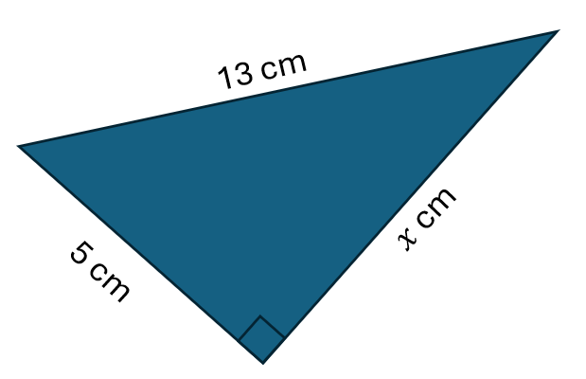
2. 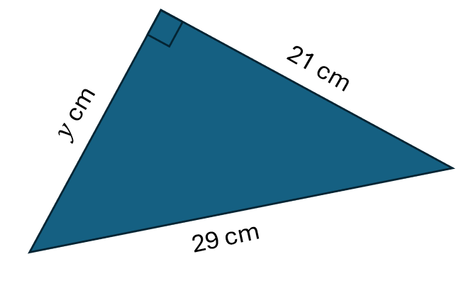
3. 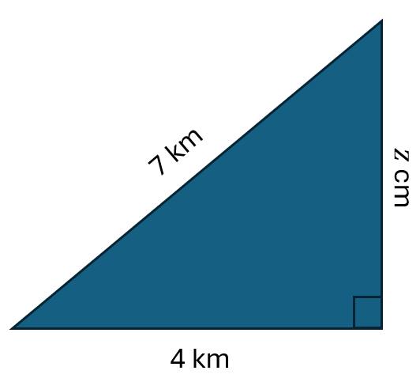

## Appendix B

### Finding a leg

|  |  |  |
| --- | --- | --- |
| Find the value of .  Right angle triangle with hypotenuse 13 cm and length 9cm and other length x. | Find the value of .  Right angle triangle with hypotenuse 20 cm and length 14cm and other length x. | Find the value of .  Right angle triangle with hypotenuse 7 cm and length 5 cm and other length x. |
|  |  |  |
| Find the value of .  Right angle triangle with hypotenuse 11 cm and length 6 cm and other length x. | Find the value of .  Right angle triangle with hypotenuse 9 cm and length 5 cm and other length x. | Find the value of .  Right angle triangle with hypotenuse 8 cm and length 2 cm and other length x. |
|  |  |  |

## Appendix C

### Banner problems

|  |  |
| --- | --- |
| 1. What is the perimeter of the triangle?   Right angled triangle with legs a and 7, and hypotenuse 20. | 1. What is the area of the triangle?   Right-angled triangle with leg  12, and hypotenuse 13. |
| 1. What is the perimeter and area of the triangle?   Isosceles triangle with base length 10 and slant heights 13. | 1. The area of the triangle is 120 , what is its perimeter?   Isosceles triangle with base length 10. |
| 1. Find the area and perimeter of a rhombus with side length of 8 cm and one diagonal length of 15 cm. | 1. Find the length of the longest diagonal of a kite with side lengths of 11 cm and 16 cm and shortest diagonal length of 10 cm. |

## Sample solutions

### Appendix A – using the area model

|  |  |  |
| --- | --- | --- |
|  | Area model showing: x squared plus 25 equals 169 x squared equals 144 x equals 12. |  |
|  | Area model showing: x squared plus 441 equals 841 x squared equals 400 x equals 20. |  |
|  | Area model showing: x squared plus 16 equals 49 x squared equals 33. |  |

### Appendix B – finding a leg

|  |  |  |
| --- | --- | --- |
| Find the value of .  Right angle triangle with hypotenuse 13 cm and length 9cm and other length x. | Find the value of .  Right angle triangle with hypotenuse 20 cm and length 14cm and other length x. | Find the value of .  Right angle triangle with hypotenuse 7 cm and length 5 cm and other length x. |
|  |  |  |
| Find the value of .  Right angle triangle with hypotenuse 11 cm and length 6 cm and other length x. | Find the value of .  Right angle triangle with hypotenuse 9 cm and length 5 cm and other length x. | Find the value of .  Right angle triangle with hypotenuse 8 cm and length 2 cm and other length x. |
|  |  |  |

### Appendix C – banner problems

|  |  |
| --- | --- |
| 1. What is the perimeter of the triangle? $$a^{2}+7^{2}={20}^{2} \\ a^{2}+49=400 \\ a^{2}=351 \\ a=\sqrt{351} \\ a≈18.7$$  Perimeter  units | 1. What is the area of the triangle? $$a^{2}+{12}^{2}={13}^{2} \\ a^{2}+144=169 \\ a^{2}=25 \\ a=\sqrt{25} \\ a=5$$  Area $\frac{1}{2}×5×12=30$ square units |
| 1. What is the perimeter and area of the triangle?   Perimeter $13+13+10=36$ units  Area $$a^{2}+5^{2}={13}^{2} \\ a^{2}+25=169 \\ a^{2}=144 \\ a=\sqrt{144} \\ a=12$$ $A=\frac{1}{2}×10×12=60$ square units | 1. The area of the triangle is 120 ${cm}^{2}$, what is its perimeter? $$A=\frac{1}{2}lh \\ 120=\frac{1}{2}×10×h \\ 120=5h \\ h=24$$ $$5^{2}+{24}^{2}=c^{2} \\ 25+576=c^{2} \\ 601=c^{2} \\ c=\sqrt{601} \\ c≈24.5$$ Perimeter |
| 1. Find the area and perimeter of a rhombus with side length of 8 cm and one diagonal length of 15 cm.   Perimeter $$8×4=32 cm$$ Area $$a^{2}+{7.5}^{2}=8^{2} \\ a^{2}+56.25=64 \\ a^{2}=7.75 \\ a=\sqrt{7.75}$$ Length of diagonal is  Area | 1. Find the length of the longest diagonal of a kite with side lengths of 11 cm and 16 cm and shortest diagonal length of 10 cm. $$a^{2}+5^{2}={11}^{2} \\ a^{2}+25=121 \\ a^{2}=96 \\ a=\sqrt{96} \\ a≈9.8 cm$$ $$b^{2}+5^{2}={16}^{2} \\ b^{2}+25=256 \\ b^{2}=231 \\ b=\sqrt{231} \\ b≈15.2 cm$$ Other diagonal length is $$9.8+15.2=25 cm$$ |

## References

This resource contains NSW Curriculum and syllabus content. The NSW Curriculum is developed by the NSW Education Standards Authority. This content is prepared by NESA for and on behalf of the Crown in right of the State of New South Wales. The material is protected by Crown copyright.

Please refer to the NESA Copyright Disclaimer for more information <https://educationstandards.nsw.edu.au/wps/portal/nesa/mini-footer/copyright>.

NESA holds the only official and up-to-date versions of the NSW Curriculum and syllabus documents. Please visit the NSW Education Standards Authority (NESA) website <https://educationstandards.nsw.edu.au> and the NSW Curriculum website <https://curriculum.nsw.edu.au>.

[Mathematics K–10 Syllabus](https://curriculum.nsw.edu.au/learning-areas/mathematics/mathematics-k-10-2022/overview) © NSW Education Standards Authority (NESA) for and on behalf of the Crown in right of the State of New South Wales, 2022.

**© State of New South Wales (Department of Education), 2024**

The copyright material published in this resource is subject to the Copyright Act 1968 (Cth) and is owned by the NSW Department of Education or, where indicated, by a party other than the NSW Department of Education (third-party material).

Copyright material available in this resource and owned by the NSW Department of Education is licensed under a [Creative Commons Attribution 4.0 International (CC BY 4.0) license](https://creativecommons.org/licenses/by/4.0/).

[](https://creativecommons.org/licenses/by/4.0/)

This license allows you to share and adapt the material for any purpose, even commercially.

Attribution should be given to © State of New South Wales (Department of Education), 2024.

Material in this resource not available under a Creative Commons license:

* the NSW Department of Education logo, other logos and trademark-protected material
* material owned by a third party that has been reproduced with permission. You will need to obtain permission from the third party to reuse its material.

**Links to third-party material and websites**

Please note that the provided (reading/viewing material/list/links/texts) are a suggestion only and implies no endorsement, by the New South Wales Department of Education, of any author, publisher, or book title. School principals and teachers are best placed to assess the suitability of resources that would complement the curriculum and reflect the needs and interests of their students.

If you use the links provided in this document to access a third-party's website, you acknowledge that the terms of use, including licence terms set out on the third-party's website apply to the use which may be made of the materials on that third-party website or where permitted by the Copyright Act 1968 (Cth). The department accepts no responsibility for content on third-party websites.