# Draw it out

Students explain how to draw geometrical diagrams to discover the need for naming conventions and definitions for lines, rays and intervals.

## Visible learning

Learning intentions and success criteria should be shared with students later in the learning episode.

### Learning intention

* To be able to use the terminology and conventions of geometrical diagrams.

### Success criteria

* I can explain the similarities and differences between a line, ray and interval.
* I can identify and describe lines, rays and intervals in diagrams.

### Syllabus outcomes

A student:

* develops understanding and fluency in mathematics through exploring and connecting mathematical concepts, choosing and applying mathematical techniques to solve problems, and communicating their thinking and reasoning coherently and clearly **MAO-WM-01**
* applies angle relationships to solve problems, including those related to transversals on sets of parallel lines **MA4-ANG-C-01**

[Mathematics K–10 Syllabus](https://curriculum.nsw.edu.au/learning-areas/mathematics/mathematics-k-10-2022/overview) © NSW Education Standards Authority (NESA) for and on behalf of the Crown in right of the State of New South Wales, 2022

Table 1: lesson summary

|  |  |  |  |
| --- | --- | --- | --- |
| Section | Summary of activity | Teaching strategy | Teaching points |
| Launch | Assign students a diagram from Appendix A and have them describe it to a partner. They then rate each other’s drawings compared to the original and discuss ‘What made this task difficult to achieve?’ | Pose-Pause-Pounce-Bounce | The activity encourages students to recognise the value of being able to use formal terms to describe the drawings. |
| Explore | Lines, rays and intervals – use slides 3–5 from the PowerPoint *Draw it out* for students to connect terminology with diagrams. Students fill in parts of the table from Appendix B.  Conventions – display slide 6 from the PowerPoint and ask students to name the rays, lines and intervals. Students are asked to consider how we differentiate between them. Use slide 7 from the PowerPoint for students to list everything they know from the diagram to explore decorations on intervals of equal length. | Think-Pair-Share  Pose-Pause-Pounce-Bounce | Reveal learning intentions and success criteria.  Students are provided formal definitions for the terms ‘ray’, ‘line’ and ‘interval’, and the naming conventions for rays, lines and intervals. |
| Summarise | Students return to Appendix B and complete their tables. They then return to Appendix A and try to describe the pictures again. Ask students if it was easier this time around. | Pose-Pause-Pounce-Bounce | Students should recognise that using the definitions and the naming conventions improves communication when they repeat the Launch activity. |
| Apply | Students use Appendix A to find all the lines, rays and intervals they can, before they draw their own diagrams to explain to each other. |  | Students should be able to identify lines, rays and intervals and be able to use appropriate language to describe them. |

## Activity structure

Please use the associated PowerPoint *Draw it out* to display images in this lesson.

### Launch

1. Working in pairs, ask students to determine who will be student 1 and student 2, based on who has the higher number in their street address.
2. Distribute Appendix A ‘Describing diagrams’, providing ‘Diagram 1’ to student 1 and ‘Diagram 2’ to student 2.
3. Explain to students that they will take turns describing their diagram to their partner, to try and make the most accurate drawing possible. Student 1 will start first.

This activity can help students revise naming angles, previously explored in Lesson 1 – strike a pose of Unit 6 – triangles and quadrilaterals.

Once the activity is finished, students are not to show their original diagram to their partner as they will use it again later to see if their descriptions improve.

1. After students have had their turn trying to draw the diagram, they are to reveal their drawing to their partner who will give the drawing a score out of 5, based on accuracy.
2. When asked by the teacher, students hold up fingers to show the score they gave their partner.
3. Using the Pose-Pause-Pounce-Bounce questioning strategy (PDF 557 KB) ([bit.ly/posepausepouncebounce](https://bit.ly/posepausepouncebounce)) start a class discussion using the following prompts:

* What was the average score for the class’s diagrams?
* What made this task difficult to achieve?

### Explore

#### Lines, rays and intervals

1. Reveal the learning intentions and success criteria to the class.
2. Display slide 3 from the PowerPoint *Draw it out*, which shows diagrams for a line, ray, and interval.
3. In a Think-Pair-Share ([bit.ly/thinkpairsharestrategy](https://bit.ly/thinkpairsharestrategy)) ask students to describe the similarities and differences between the diagrams.
4. Display slide 4 from the PowerPoint, which shows the diagrams and words used to define each one.
5. Continuing in their Think-Pair-Share, ask students to match the words to the diagrams.
6. Using the Pose-Pause-Pounce-Bounce questioning strategy, ask students why they assigned each word to each diagram.

Students may aid their matching by connecting other definitions they know for the words provided. These may include, but are not limited to:

* Intervals of time having a start and end point.
* Ray of light from a torch or the sun having an origin and continuing forever.

1. Reveal which word matches each diagram. These can be found on slide 5 of the PowerPoint.
2. Distribute Appendix B ‘Definitions’ to students which contains a table that includes the columns: word, diagram, definition and naming convention.
3. In a Think-Pair-Share, ask students to write each word, draw a diagram and write a definition for each word.

Students are to leave the column ‘naming convention’ blank, to be used in the following section. Syllabus definitions can be found in the sample solutions.

#### Conventions

1. Display slide 6 from the PowerPoint, which shows a diagram.
2. In a Think-Pair-Share, ask students how they would name every line, ray and interval they can see in the diagram using the points A and B.

Suggested solutions include:

* Interval AB or BA
* Rays AB and BA
* Lines AB or BA

1. Initiate a sharing of ideas and reasoning using the Pose-Pause-Pounce-Bounce questioning strategy to highlight what made this activity difficult. The following question prompts are suggested:

* How many lines, rays and intervals are there in this diagram?
* What could we call each of them? How could we differentiate between them?
* Does the order of the letters matter for lines, rays, and intervals? Why?
* How can we tell the difference between a ray where the endpoint is at A and one where the endpoint is at B when only referencing points?

Students should note that the lines, rays, and intervals all use the points AB so using the words would be beneficial.

When naming rays, the order of the points matters, with the endpoint being named first. Alternatively, we can place a line with or without arrowheads above the letters, to aid with communication.

1. Display slide 7 from the PowerPoint, which displays a triangle with an exterior angle.
2. Explain to students that there is one component in the diagram that is incorrect. In pairs, students are to list everything they know from the diagram.

Students may record the ray AD or ray CD should not have length as a ray will continue indefinitely.

Students may record that interval AB is equal in length to interval BC.

Students may record that angle BAC is equal to angle BCA or angle BCD is equal to the sum of angle BAC and angle ABC. Students may also record calculations referring to the angle sum of a triangle.

This provides an opportunity for students to recall knowledge from Unit 6 – triangles and quadrilaterals, such as denoting intervals that have the same length, as well as to show evidence of learning about how to reference lines, rays and intervals.

1. Ask random students to share one piece of information they wrote from the diagram.
2. Using the Pose-Pause-Pounce-Bounce questioning strategy, start a class discussion using the following prompts:

* How do you denote intervals of the same length? What if there are more than one set of intervals of equal length?
* Can we have intervals and rays that are equal? Why or why not?

Students should note that we use decorations (small intervals) to reference intervals of the same length. We use multiple of these intervals to represent more than one set, as seen in the diagram on slide 7 of the PowerPoint*.*

However, it is important to note that lines and rays cannot have length as they continue infinitely in one or both directions. The ray shown in this diagram is for Pose-Pause-Pounce-Bounce discussion purposes only. Teachers should ensure that students understand that the ray is incorrectly marked.

### Summarise

1. Ask students to return to Appendix B ‘Definitions’ to complete the final column ‘Naming convention’ and adjust their definitions from any new information they deem appropriate.

Sample solutions:

* Line AB, Line BA
* Ray AB
* Interval AB, Interval BA

1. Students return to their pairs again to describe the diagrams from Appendix A ‘Describing diagrams’. The aim is to see if they can improve from the first time.
2. Students reveal their diagrams to their partners and receive a score out of 5 based on accuracy. All students hold up fingers to show this score to the class and their partner.
3. Using the Pose-Pause-Pounce-Bounce questioning strategy, start a class discussion using the following prompts:

* What was the average score for the class’s diagrams? Did it improve?
* What made this task easier to achieve this time around?

### Apply

1. Students return to the diagrams from Appendix A ‘Describing diagrams’ and identify as many rays, lines, and intervals as possible in each.
2. Students are to compare with their partner and see if they can identify any that the other person could have missed.
3. Students are then to create their own diagrams to explain to a partner. Tell students their diagrams must include:

* A line, ray and interval.
* A triangle or quadrilateral.

## Assessment and differentiation

### Suggested opportunities for differentiation

**Launch**

* To build student confidence, give them some statements or keywords to describe the diagram to another student.

**Explore**

* Provide students time to connect the words ray, interval and line to their prior knowledge. This can be done through aids such as researching the words on the internet or providing dictionaries.
* Students from non-English speaking backgrounds could be encouraged to analyse what each word and their definition translates to in their own primary language.
* Challenge students by introducing interval notation with parenthesises and brackets to denote lines, rays and intervals. For example, a line AB would be (A, B), an interval AB would be [A, B] and a ray AB could be [A, B).
* Students should be challenged to make connections with the prior knowledge they have from Unit 6 – triangles and quadrilaterals.

**Summarise**

* To enable students, provide them with definitions and naming conventions to place into the correct part of the table in Appendix B.
* To build student confidence, give them some statements or keywords to describe the diagram to another student.

**Apply**

* Students can work in pairs to find intervals, lines and rays and compare with another group of 2.

### Suggested opportunities for assessment

**Launch**

* Students will demonstrate their Working mathematically skills in discussions and justifications.

**Explore**

* Students give each other peer feedback, before sharing with the class in a Think-Pair-Share.
* Monitor student responses to class discussions to observe students’ communication, reasoning and justification in response to the provided prompts.

**Summarise**

* Review students’ tables in Appendix B as evidence of learning.

**Apply**

* Collect student responses to identifying intervals, lines and rays from Appendix A as evidence of learning.
* Have students write instructions describing how to draw their diagrams and collect as an exit ticket.

## Appendix A

### Describing diagrams

#### Diagram 1

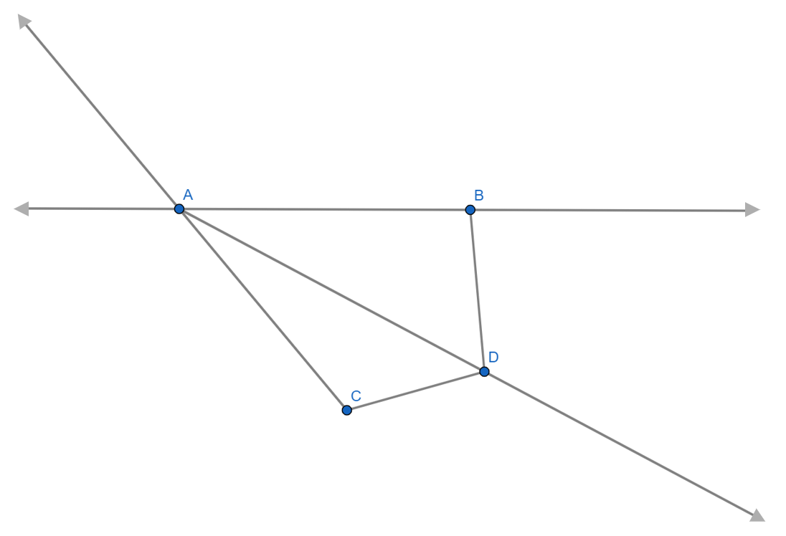

Image created using [GeoGebra](https://www.geogebra.org/calculator/ubksz4ew) and is licensed under the [GeoGebra Non-Commercial License Agreement](https://www.geogebra.org/license#NonCommercialLicenseAgreement).

#### Diagram 2

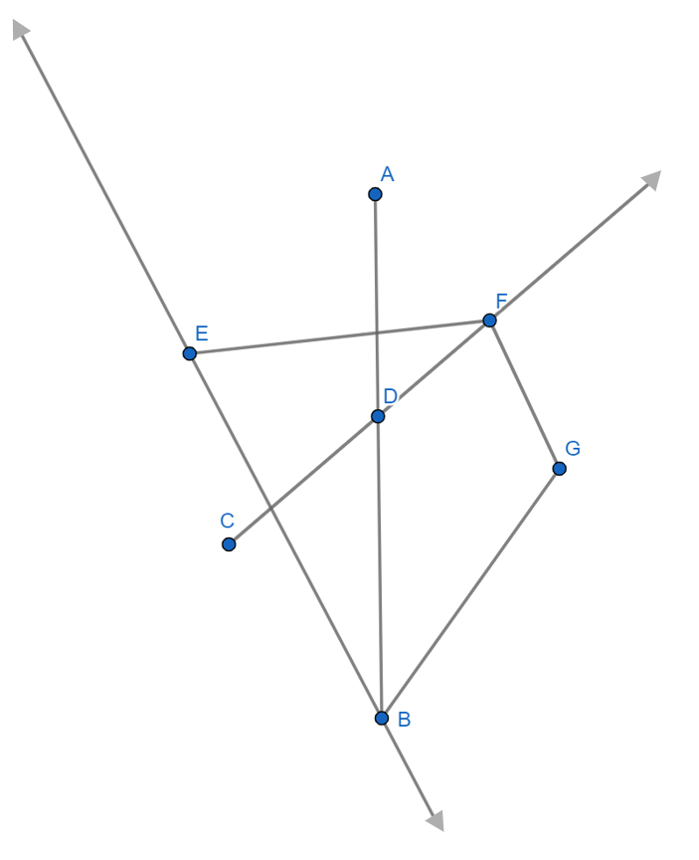

Image created using [GeoGebra](https://www.geogebra.org/calculator/yksggsbb) and is licensed under the [GeoGebra Non-Commercial License Agreement](https://www.geogebra.org/license#NonCommercialLicenseAgreement).

## 

## Appendix B

### Definitions

|  |  |  |  |
| --- | --- | --- | --- |
| Word | Diagram | Definition | Naming convention |
|  |  |  |  |
|  |  |  |  |
|  |  |  |  |

## Sample solutions

#### Appendix A – describing diagrams

##### Diagram 1

Lines: AB

Rays: AB, BA, AD and CA

Intervals: AB, AD, AC, BD and CD

##### Diagram 2

Lines: BE

Rays: BE, EB, CD, CF and DF

Intervals: AD, AB, DB, CD, CF, DF, EB, EF, FG and BG

Note that lines and intervals can be named in either direction. For example, the line AB could also be the line BA. These have not been included in the sample solutions but are still correct.

### Appendix B – definitions

|  |  |  |  |
| --- | --- | --- | --- |
| Word | Diagram | Definition | Naming convention |
| Line | Line AB. | A one-dimensional figure that is straight, has no thickness and extends endlessly. | Line AB  Line BA |
| Ray | Ray AB. | The part of a line that starts at a point and continues in a particular direction to infinity.  Name the letter representing the endpoint first, and then the letter representing any one point on the ray. | Ray AB |
| Interval | Interval AB. | A continuous subset of the real number line. For example, ‘the set of all real numbers greater than or equal to 10’.  These can include decoration lines to denote intervals of the same length. | Interval AB  Interval BA |

## References

This resource contains NSW Curriculum and syllabus content. The NSW Curriculum is developed by the NSW Education Standards Authority. This content is prepared by NESA for and on behalf of the Crown in right of the State of New South Wales. The material is protected by Crown copyright.

Please refer to the NESA Copyright Disclaimer for more information [https://educationstandards.nsw.edu.au/wps/portal/nesa/mini-footer/copyright](https://aus01.safelinks.protection.outlook.com/?url=https%3A%2F%2Feducationstandards.nsw.edu.au%2Fwps%2Fportal%2Fnesa%2Fmini-footer%2Fcopyright&data=05%7C01%7CCaitlin.Pace1%40det.nsw.edu.au%7C9c2c1a9f59c94d2df30708dafa7edb23%7C05a0e69a418a47c19c259387261bf991%7C0%7C0%7C638097720042599463%7CUnknown%7CTWFpbGZsb3d8eyJWIjoiMC4wLjAwMDAiLCJQIjoiV2luMzIiLCJBTiI6Ik1haWwiLCJXVCI6Mn0%3D%7C3000%7C%7C%7C&sdata=BzQh0UsffVZE3eO22b2Xba3p0VMOBZSHfS21FGHXtZM%3D&reserved=0).

NESA holds the only official and up-to-date versions of the NSW Curriculum and syllabus documents. Please visit the NSW Education Standards Authority (NESA) website <https://educationstandards.nsw.edu.au/> and the NSW Curriculum website <https://curriculum.nsw.edu.au/>.

[Mathematics K–10 Syllabus](https://curriculum.nsw.edu.au/learning-areas/mathematics/mathematics-k-10-2022/overview) © NSW Education Standards Authority (NESA) for and on behalf of the Crown in right of the State of New South Wales, 2022.

**© State of New South Wales (Department of Education), 2024**

The copyright material published in this resource is subject to the *Copyright Act 1968* (Cth) and is owned by the NSW Department of Education or, where indicated, by a party other than the NSW Department of Education (third-party material).

Copyright material available in this resource and owned by the NSW Department of Education is licensed under a [Creative Commons Attribution 4.0 International (CC BY 4.0) license](https://creativecommons.org/licenses/by/4.0/).

[](https://creativecommons.org/licenses/by/4.0/)

This license allows you to share and adapt the material for any purpose, even commercially.

Attribution should be given to © State of New South Wales (Department of Education), 2024.

Material in this resource not available under a Creative Commons license:

* the NSW Department of Education logo, other logos and trademark-protected material
* material owned by a third party that has been reproduced with permission. You will need to obtain permission from the third party to reuse its material.

**Links to third-party material and websites**

Please note that the provided (reading/viewing material/list/links/texts) are a suggestion only and implies no endorsement, by the New South Wales Department of Education, of any author, publisher, or book title. School principals and teachers are best placed to assess the suitability of resources that would complement the curriculum and reflect the needs and interests of their students.

If you use the links provided in this document to access a third-party's website, you acknowledge that the terms of use, including licence terms set out on the third-party's website apply to the use which may be made of the materials on that third-party website or where permitted by the *Copyright Act 1968* (Cth). The department accepts no responsibility for content on third-party websites.