# Supplementary seesaws

Students explore supplementary angles by finding the size of angles on a seesaw. They discover and use the terms ‘common arm’, ‘common vertex’ and ‘adjacent angles’.

Students will need at least one digital device per pair to interact with Desmos during this lesson.

## Visible learning

### Learning intention

* To understand the relationship between supplementary angles.

### Success criteria

* I can identify common arms, common vertices and adjacent angles.
* I can define supplementary angles.
* I can use supplementary angles to find unknown angles.

### Syllabus outcomes

A student:

* develops understanding and fluency in mathematics through exploring and connecting mathematical concepts, choosing and applying mathematical techniques to solve problems, and communicating their thinking and reasoning coherently and clearly **MAO-WM-01**
* applies angle relationships to solve problems, including those related to transversals on sets of parallel lines **MA4-ANG-C-01**
* identifies and applies the properties of triangles and quadrilaterals to solve problems   
  **MA4-GEO-C-01**

[Mathematics K–10 Syllabus](https://curriculum.nsw.edu.au/learning-areas/mathematics/mathematics-k-10-2022/overview) © NSW Education Standards Authority (NESA) for and on behalf of the Crown in right of the State of New South Wales, 2022.

Table 1: lesson summary

|  |  |  |  |
| --- | --- | --- | --- |
| Section | Summary of activity | Teaching strategy | Teaching points |
| Launch | Students consider how the angles change on a seesaw using slide 3 of the PowerPoint *Supplementing seesaws*. | Notice and wonder | The students should recognise that unless the angles are both $90°$, one angle is always obtuse while the other is acute. |
| Explore | Using slide 5 of the PowerPoint, students identify adjacent angles before being given the formal definition on slide 6. Students view slide 7 and use naming conventions to identify adjacent angles.  Students explore supplementary angles in the Desmos task ‘Supplementary Angles’ ([bit.ly/supplementarydesmos](https://bit.ly/supplementarydesmos)) or if devices aren’t available, complete Appendix A. | Think-Pair-Share  Pose-Pause-Pounce-Bounce  Variation theory | Students should be able to identify different combinations of adjacent angles and identify angles using naming conventions.  Students should be able to recognise supplementary angles and be able to determine the size of an unknown angle in a pair of supplementary angles. |
| Summarise | Students complete notes to their future forgetful selves, before giving peer feedback and adjusting their notes. They then create two truths and a lie. | TAG feedback | Students should show their understanding of terminology and concepts in notes and activities. |
| Apply | Students play the card matching game in Appendix B to identify pairs of supplementary angles. There are 15 pairs of angles to match. | Pose-Pause-Pounce-Bounce | Students should have recognised the need to find the supplement by subtracting the known angle from $180°$. |

## Activity structure

Please use the associated PowerPoint *Supplementary seesaws* to display images in this lesson.

### Launch

1. Display slide 3 of the PowerPoint *Supplementary seesaws*, which shows Figure 1. Ask students what they notice and wonder ([bit.ly/noticewonderstrategy](https://bit.ly/noticewonderstrategy)).

Figure 1: children on a seesaw in a playground

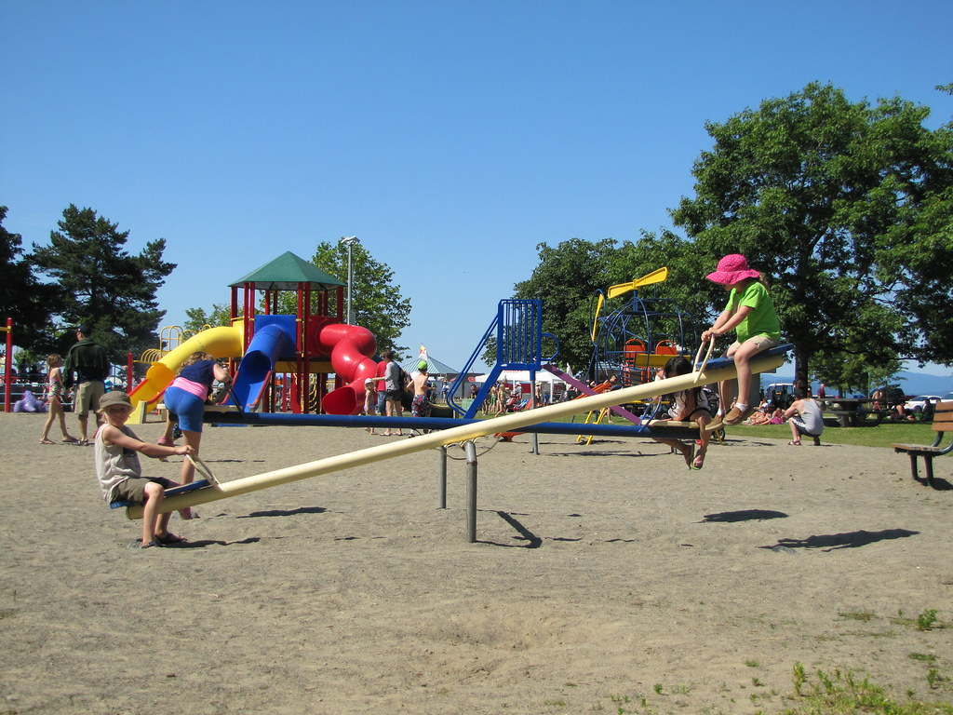

‘[Teeter Totter](https://www.flickr.com/photos/8306673@N02/8285285048)’ by [Paul Hamilton](https://www.flickr.com/photos/8306673@N02) is licensed under [CC BY-SA 2.0](https://creativecommons.org/licenses/by-sa/2.0/?ref=openverse).

Students might notice that:

* The seesaw has 2 children playing on it.
* The photo is called ‘Teeter Totter’
* One child is up high, the other is down low.
* The seesaw is a straight line.
* At the tipping point, there is one acute and one obtuse angle.

Students might wonder:

* Which child is heavier?
* What happens to the size of the angles as the seesaw tips?

If students do not notice how the angles change, it would be beneficial to ask students what they think is happening to the angles.

### Explore

#### Adjacent angles and common arms

1. Display slide 5 from the PowerPoint.
2. In a Think-Pair-Share ([bit.ly/thinkpairsharestrategy](https://bit.ly/thinkpairsharestrategy)), ask students to respond to the following questions, one after the other:

* How would you describe the position of $∠ABD$ in relation to $∠CBD$?
* What do you think the term ‘adjacent angles’ means?

Students should be familiar with straight angles from Stage 3 content and explored naming angles in Lesson 1 – strike a pose of Unit 6 – triangles and quadrilaterals.

Teachers should use students' answers from the prior question to help students understand the term ‘adjacent angles’. It is highlighted in the syllabus that adjacent can have different meanings depending on the context.

1. Display slide 6 from the PowerPoint, which displays the following definition for adjacent angles.

Adjacent angles are a pair of angles with a common arm and common vertex.

1. In a Think-Pair-Share, ask students to try and rephrase the definition, discussing what they think a common arm and common vertex is.

Students may identify that the word common can be used for shared. When replacing common with shared, students may notice that ‘common arm’ may mean a shared line and ‘common vertex’ may be a shared point or vertex.

1. Display slide 7 from the PowerPoint*,* which displays Figure 2.

Figure 2: angle diagram

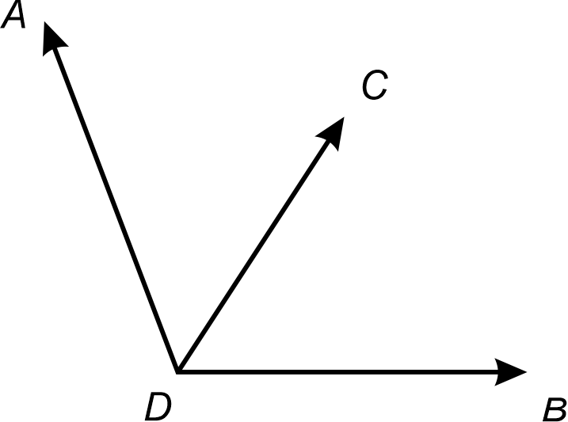

1. In a Think-Pair-Share, ask students to identify the common arm and common vertex of the adjacent angles.

There is more than one set of adjacent angles in the diagram. Challenge students to also consider the reflex $∠ADB$.  
Sample solution: $∠ADC$ and $∠BDC$ have a common arm $DC$ and common vertex $D$.

#### Supplementary angles

1. With one device between pairs of students, direct students to join the Desmos activity ‘Supplementary Angles’ ([bit.ly/supplementarydesmos](https://bit.ly/supplementarydesmos)).

Before students complete the Desmos activity, you will need to set up a Desmos classroom ([bit.ly/createdesmosclassroom](https://bit.ly/createdesmosclassroom)).

If devices are not available, display screens 1–5 of the Desmos activity for students, then distribute Appendix A ‘Seesaw angles’. Ask students to work in pairs to find the size of the unknown angles.

1. Use a Pause-Pose-Pounce-Bounce questioning strategy (PDF 557 KB) ([bit.ly/posepausepouncebounce](https://bit.ly/posepausepouncebounce)), or highlight student answers using the Desmos teacher dashboard, to discuss how students were able to determine the value of the pronumeral in the diagrams.
2. Ask students to define the term ‘supplementary’.

Supplementary means to add or serve as a supplement, a thing added to complete or enhance something, such as supplements people take for health or fitness benefits. For supplementary angles we are completing the angle to create a straight line.

1. Display slide 8 of the PowerPoint and ask students to read the question.
2. In a Think-Pair-Share, students are to discuss how they would solve the problem and what the answer to the question is.
3. Use a Pose-Pause-Pounce-Bounce questioning technique to share the strategies used to solve the problem. Useful question prompts may include:

* If we were to draw a diagram, what might it look like?
* Why might we not need to draw a diagram?
* How can we find the value of $∠MKL$?

A diagram is not necessary. If a diagram was drawn, it would show 2 adjacent angles, with a common vertex, $K$, and a common arm, $KL$. If the angles are supplementary, they have a sum of $180°$. Therefore, $∠MKL$ is $120°$.

### Summarise

1. Students are to write notes to their future forgetful selves ([bit.ly/notestofutureself](https://bit.ly/notestofutureself)), defining adjacent angles, common arms, common vertices and supplementary angles.
2. Students are to share their notes with a partner and give peer feedback using the TAG proforma ([bit.ly/TAGstrategy](https://bit.ly/TAGstrategy)).
3. Students are to return to their notes and adjust them, from the feedback.
4. Ask students to create two truths and one lie (<https://bit.ly/twotruthsoneliestrategy>) for supplementary angles by writing the values or by drawing 3 different pairs of angles. They should then swap them with a partner.

### Apply

1. Distribute Appendix B ‘Card match activity’, one set per pair and cut into individual cards.
2. To complete the activity:

* players should place the cards face down on the table in an array
* player A then turns 2 cards face up
* if the cards show a pair of supplementary angles, they are a match and Player A removes the matching cards from the game, keeping them in a pile in front of them
* if the cards are not a match, Player A turns the cards face down
* player B repeats the process
* the game continues until all cards have been matched. The player with the most cards is the winner.

The cards are in correct order so will need to be cut up before presenting to students.

1. Once students have finished playing the game, initiate a sharing of ideas and reasoning using the Pose-Pause-Pounce-Bounce questioning strategy to highlight the strategies used to match the pairs.

## Assessment and differentiation

### Suggested opportunities for differentiation

**Launch**

* Students may benefit from revisitingtypes of angles explored in Stage 3.

**Explore**

* Students may benefit from revisiting naming angles in Lesson 1 – strike a pose of Unit 6 – triangles and quadrilaterals.
* Students should be challenged to connect terms and definitions to their prior knowledge or experiences.
* The Desmos activity encourages students to play and explore. All students can participate and comment on their reasoning, knowing that only the teacher can see their responses.

**Summarise**

* Support students’ understanding of supplementary angles when completing their notes to their future forgetful selves with provided examples and non-examples. Students could choose to present their notes in a Frayer diagram.
* Challenge students to include supplementary angles that are mixed numerals or fractions in their two truths and a lie.

**Apply**

* Students may lay the cards out face up and collaborate to match the pairs.
* The last 5 pairs in the set may be removed to simplify the task.
* Students might glue the cards, in matching pairs, to supplement their notes to their future forgetful selves.

### Suggested opportunities for assessment

**Launch**

* Students’ responses to the Launch activity can be used as a formative assessment of the types of angles.

**Explore**

* A Think-Pair-Share provides students with the opportunity to reflect on their understanding.
* Students show their understanding of definitions when identifying common arms, common vertices and adjacent angles of Figure 2.
* Students’ reasoning can be monitored in real time or following the lesson, using the Desmos teacher dashboard. Student responses can be highlighted and displayed to facilitate class discussion.

**Summarise**

* Review students’ notes to future forgetful selves for their definitions of terminology used throughout the learning episode.
* Students will demonstrate their Working mathematically skills in discussions and justifications.
* Peer feedback is given on students’ notes to future forgetful selves using the TAG feedback strategy.

**Apply**

* Students give peer feedback by comparing solutions to the Apply problems.

## Appendix A

### Seesaw angles

Find the value of the pronumeral in the angle diagrams.

|  |  |  |
| --- | --- | --- |
| Diagram | Solution | How do you know? |
| A black and white diagram of a pair of supplementary angles, marked x and x. |  |  |
| A black and white diagram of a pair of supplementary angles, marked 72 degrees and x. |  |  |
| A black and white diagram of a pair of supplementary angles, marked 62 degrees and x. |  |  |
| A black and white diagram of a pair of supplementary angles, marked 52 degrees and x. |  |  |
| A black and white diagram of a pair of supplementary angles, marked 72 degrees and x. |  |  |

## Appendix B

### Card match activity

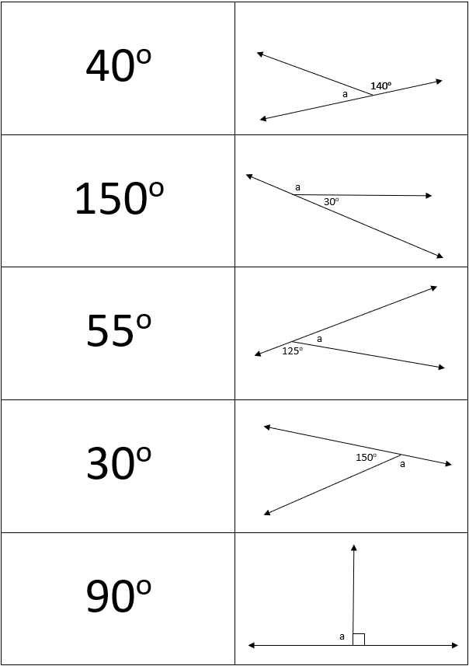

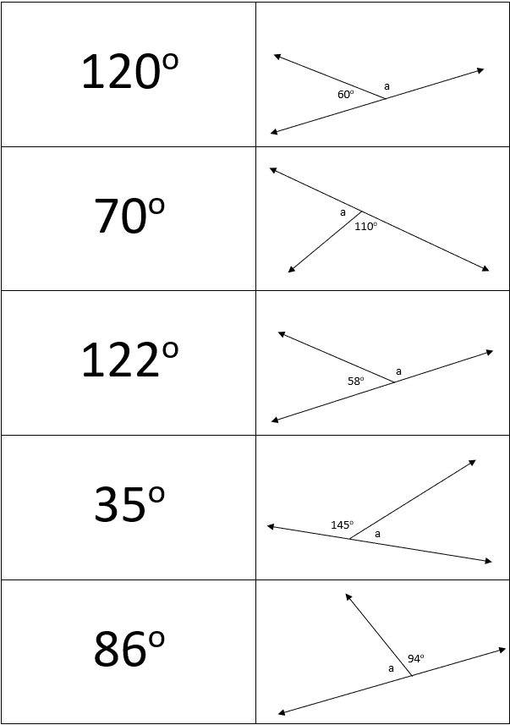

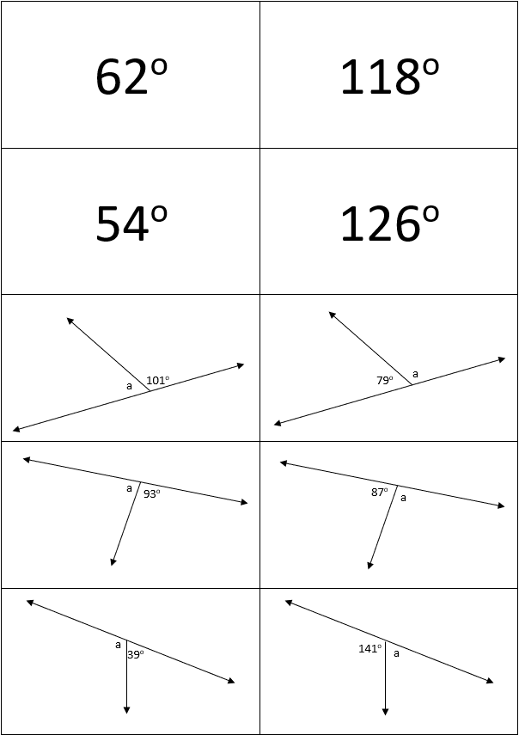

## Sample solutions

### Appendix A – seesaw angles

|  |  |  |
| --- | --- | --- |
| Diagram | Solution | How do you know? |
| A black and white diagram of a pair of supplementary angles, marked x and x. |  |  |
| A black and white diagram of a pair of supplementary angles, marked 72 degrees and x. |  |  |
| A black and white diagram of a pair of supplementary angles, marked 62 degrees and x. |  |  |
| A black and white diagram of a pair of supplementary angles, marked 52 degrees and x. |  |  |
| A black and white diagram of a pair of supplementary angles, marked 72 degrees and x. |  |  |

## References

This resource contains NSW Curriculum and syllabus content. The NSW Curriculum is developed by the NSW Education Standards Authority. This content is prepared by NESA for and on behalf of the Crown in right of the State of New South Wales. The material is protected by Crown copyright.

Please refer to the NESA Copyright Disclaimer for more information [https://educationstandards.nsw.edu.au/wps/portal/nesa/mini-footer/copyright](https://aus01.safelinks.protection.outlook.com/?url=https%3A%2F%2Feducationstandards.nsw.edu.au%2Fwps%2Fportal%2Fnesa%2Fmini-footer%2Fcopyright&data=05%7C01%7CCaitlin.Pace1%40det.nsw.edu.au%7C9c2c1a9f59c94d2df30708dafa7edb23%7C05a0e69a418a47c19c259387261bf991%7C0%7C0%7C638097720042599463%7CUnknown%7CTWFpbGZsb3d8eyJWIjoiMC4wLjAwMDAiLCJQIjoiV2luMzIiLCJBTiI6Ik1haWwiLCJXVCI6Mn0%3D%7C3000%7C%7C%7C&sdata=BzQh0UsffVZE3eO22b2Xba3p0VMOBZSHfS21FGHXtZM%3D&reserved=0).

NESA holds the only official and up-to-date versions of the NSW Curriculum and syllabus documents. Please visit the NSW Education Standards Authority (NESA) website <https://educationstandards.nsw.edu.au/> and the NSW Curriculum website <https://curriculum.nsw.edu.au/>.

[Mathematics K–10 Syllabus](https://curriculum.nsw.edu.au/learning-areas/mathematics/mathematics-k-10-2022/overview) © NSW Education Standards Authority (NESA) for and on behalf of the Crown in right of the State of New South Wales, 2022.

**© State of New South Wales (Department of Education), 2024**

The copyright material published in this resource is subject to the *Copyright Act 1968* (Cth) and is owned by the NSW Department of Education or, where indicated, by a party other than the NSW Department of Education (third-party material).

Copyright material available in this resource and owned by the NSW Department of Education is licensed under a [Creative Commons Attribution 4.0 International (CC BY 4.0) license](https://creativecommons.org/licenses/by/4.0/).

[](https://creativecommons.org/licenses/by/4.0/)

This license allows you to share and adapt the material for any purpose, even commercially.

Attribution should be given to © State of New South Wales (Department of Education), 2024.

Material in this resource not available under a Creative Commons license:

* the NSW Department of Education logo, other logos and trademark-protected material
* material owned by a third party that has been reproduced with permission. You will need to obtain permission from the third party to reuse its material.

**Links to third-party material and websites**

Please note that the provided (reading/viewing material/list/links/texts) are a suggestion only and implies no endorsement, by the New South Wales Department of Education, of any author, publisher, or book title. School principals and teachers are best placed to assess the suitability of resources that would complement the curriculum and reflect the needs and interests of their students.

If you use the links provided in this document to access a third-party's website, you acknowledge that the terms of use, including licence terms set out on the third-party's website apply to the use which may be made of the materials on that third-party website or where permitted by the *Copyright Act 1968* (Cth). The department accepts no responsibility for content on third-party websites.