# The cake thief

Students will investigate angles at a point and vertically opposite angles in circles and will solve equations to find the size of unknown angles.

## Visible learning

### Learning intention

* To understand the relationship between angles at a point and vertically opposite angles.

### Success criteria

* I can find an unknown angle at a point.
* I can identify vertically opposite angles.
* I can solve simple equations.

### Syllabus outcomes

A student:

* develops understanding and fluency in mathematics through exploring and connecting mathematical concepts, choosing and applying mathematical techniques to solve problems, and communicating their thinking and reasoning coherently and clearly **MAO-WM-01**
* **applies angle relationships to solve problems, including those related to transversals on sets of parallel lines MA4-ANG-C-01**

[Mathematics K–10 Syllabus](https://curriculum.nsw.edu.au/learning-areas/mathematics/mathematics-k-10-2022/overview) © NSW Education Standards Authority (NESA) for and on behalf of the Crown in right of the State of New South Wales, 2022.

Table 1: lesson summary

|  |  |  |  |
| --- | --- | --- | --- |
| Section | Summary of activity | Teaching strategy | Teaching points |
| Launch | Students work out how much cake is left, after people have helped themselves. (Slide 3) | Think-Pair-Share  Pose-Pause-Pounce-Bounce | Students should be able to find the remaining cake slice angle to make a total of ${360}^{°}$. |
| Explore | Students explore angles created by triangles in a circle to explore angles at a point using Appendix A and slide 5 from the PowerPoint *The cake thief*. Students then look at Appendix B and slide 6 from the PowerPoint to explore vertically opposite angles in circles. | Visibly random groups of 3  Vertical non-permanent surfaces  Pose-Pause-Pounce-Bounce  Think-Pair-Share | Students are linking their understanding of angles at a point to explore vertically opposite angles. |
| Summarise | Students complete a Frayer diagram in Appendix C and give peer feedback. In the PowerPoint they are shown how to use their knowledge to solve equations to find the size of angles, before identifying vertically opposite angles and estimating angles in Appendix D. | Two stars and a wish  Think-Pair-Share  Pose-Pause-Pounce-Bounce  Explicit teaching – Your turn | Students draw on their knowledge of angles at a point and vertically opposite angles to identify types of angles and to solve equations. |
| Apply | Complete angle problems from Appendix E. | Peer feedback | Students practise solving geometry problems involving angles at a point and vertically opposite angles. |

## Activity structure

Please use the associated PowerPoint *The cake thief* to display images in this lesson.

### Launch

1. Read the following scenario to students, which can be displayed using slide 3 of the PowerPoint *The cake thief*.

Jo baked a cake and put it in the fridge. When Jo went to cut the cake, they discovered that the cake thief had got to it first. Jo started asking questions and found that:

* Kai had cut a small piece for themself and 2 friends, estimating it was about ${30}^{°}$ per slice.
* Ash cut themself a slice for morning tea, estimating it was about ${50}^{°}$.
* Mack had taken a quarter of the cake to work.
* Jo cut a third of the cake to give to the neighbour.
* Jo was hoping to have a piece for afternoon tea.
* Has the cake thief left enough cake for Jo’s afternoon tea?

1. In a Think-Pair-Share ([bit.ly/thinkpairsharestrategy](https://bit.ly/thinkpairsharestrategy)), students are to decide if they believe there is enough cake for Jo.
2. Use the Pose-Pause-Pounce-Bounce questioning strategy (PDF 557 KB) ([bit.ly/posepausepouncebounce](https://bit.ly/posepausepouncebounce)) to discuss the scenario. Useful question prompts may include:

* How did you know how much cake Mack took?
* How did you know how much cake was intended for the neighbour?
* Why do you think there was enough, or not enough, cake left for Jo?

There will be approximately $10°$ of cake left for Jo’s afternoon tea. A mathematical discussion could include reference to the height or radius of the cake influencing the answer to whether there was enough cake left for Jo. A small height would suggest not, whilst a triple layer cake might mean that there was enough cake.

### Explore

1. Assign students into visibly random groups of 3 ([bit.ly/visiblegroups](https://bit.ly/visiblegroups)) at a vertical non-permanent surface ([bit.ly/VNPSstrategy](https://bit.ly/VNPSstrategy)).
2. Distribute a copy of Appendix A ‘Angles in a circle’ on A3 paper in a plastic pocket. This Appendix has a circle with 9 equidistant points in which students are challenged to create as many triangles as they can that include the centre point.
3. Students are to do a gallery walk ([bit.ly/DLSgallerywalk](https://bit.ly/DLSgallerywalk)) to see all the different triangles people found and determine how many different kinds there are.
4. Ask students to return to their vertical non-permanent surface and complete the questions provided in Appendix A.

Appendix A reminds students of the angle sum of a triangle and the size of a revolution. Challenge questions are included which provide the opportunity for students to discover patterns when we add or remove points on the circle.

1. Use the Pose-Pause-Pounce-Bounce questioning strategy to discuss the task and the results. Useful question prompts may include:

* How did you find the size of the angles?
* Would the size of the circle impact the size of the angles?

1. Display slide 5 of the PowerPoint, which displays Figure 1. Define the point where each segment meets, as angles at a point.

Figure 1: angles at a point in a circle

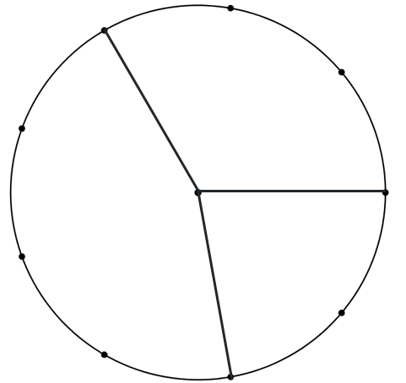

1. Ask random students to explain what they think angles at a point are.
2. Continuing in their groups, challenge students to find as many combinations as possible of angles at a point using the diagram in Appendix A and justify why they make angles at a point.
3. Assign students to new visibly random groups of 3 on vertical non-permanent surfaces
4. Distribute Appendix B ‘Vertically opposite angles’ to each group and ask them to complete.

Students should be able to recognise that the points are equally spaced on the circle, so that they can find the size of the angles without needing to measure them.

1. Use the Pose-Pause-Pounce-Bounce questioning strategy to discuss the task. Useful question prompts may include:

* What strategy did you think was effective to find the acute angles?
* How could you find the value of the obtuse angles?
* Would the angles change if we removed the circle? Why or why not?
* What would change if the lines weren’t equal in length?
* Why might the acute angles be called vertically opposite angles?
* Could the obtuse angles also be called vertically opposite angles?

Vertically opposite angles are the vertical angles which are opposite each other. These angles are always equal. The term ‘vertical’ in this case refers to the vertex shared between the angles formed by 2 intersecting lines. The vertical angles are not necessarily in an upright position.

1. Display slide 6 from the PowerPoint*,* which displays angles at a point. State to students that the first circle includes vertically opposite angles and the others do not.
2. In a Think-Pair-Share, ask students what conditions need to be met for angles to be considered vertically opposite.

Students should note that vertically opposite angles are only on intersecting straight lines, not any angles that just appear to be opposite to each other on a diagram.

### Summarise

1. Distribute Appendix C ‘Frayer diagram’ to each student and ask them to complete the Frayer diagram ([bit.ly/frayerdiagram](https://bit.ly/frayerdiagram)) provided.
2. Students are to swap Frayer diagrams and provide peer feedback in the form of Two stars and a wish ([bit.ly/DLSpeerfeedback](https://bit.ly/DLSpeerfeedback)).
3. Students then respond to the feedback to improve their Frayer diagrams.

Prompt students to use correct terminology on their Frayer diagrams, such as angles at a point, lines, intervals or rays. Rather than supply peer feedback, the teacher could display terminology used in the lesson to revise or improve students’ Frayer diagrams.

1. Use slides 8–15 from the PowerPoint for explicit teaching of angles at a point and vertically opposite angles using the Worked examples (your turn) method ([bit.ly/supportingstrategies](https://bit.ly/supportingstrategies))
2. Distribute a copy of Appendix D ‘Angles at a point’ to each student.
3. In a Think-Pair-Share, ask students to:

* estimate the size of the angles in each of the diagrams
* identify angles that are vertically opposite in each of the diagrams.

1. Using the Pose-Pause-Pounce-Bounce questioning strategy, facilitate a class discussion using the following question prompts:

* How did you identify the vertically opposite angles?
* What information did you use to estimate your angles?

Students should state that vertically opposite angles must be on 2 intersecting lines. Students may use their knowledge of benchmark angles to estimate the sizes of angles within each diagram and know they are a possibility if they all add to $360°$.

### Apply

1. Distribute a copy of Appendix E ‘Tangled angles questions’ to each pair and ask students to solve the problems.
2. Ask students to join with another pair to discuss their answers and explain how they came to each conclusion.

## Assessment and differentiation

### Suggested opportunities for differentiation

**Launch**

* **Students may benefit from reviewing simplifying fractions from Unit 3 – representing numbers.**
* **Enable students by providing them with a circle to represent the cake.**

**Explore**

* A calculator may be helpful for some students to calculate the size of angles and find numbers that add to $360°$.
* Students may need support to recognise that the triangles are isosceles and be reminded of the properties of isosceles triangles, explored in Lesson 2 – is that a triangle? of Unit 6 –triangles and quadrilaterals.
* Challenge students by letting them explore adding more or less points to the circle to determine a pattern.
* Students may need support to determine that one-third of a revolution is $120°$ by discussing fractions of a circle and $360°$.

**Summarise**

* To enable students, provide them with examples and non-examples in the Frayer diagram prior to completing.
* Students may benefit from being reminded about the benchmark angles to help estimate sizes.
* **Some students may benefit from measuring angles with a protractor to build confidence to estimate angles as they progress through Appendix D.**

**Apply**

* Students may need support to recognise that the diagram contains a rhombus and be reminded of the properties of a rhombus, explored in Lesson 7 – diamonds of geometry of Unit 6 – triangles and quadrilaterals.

### Suggested opportunities for assessment

**Explore**

* **Students will show their understanding of types of triangles, the size of an angle of revolution and fractions through discussions and justifications when completing Appendix A.**
* Students will demonstrate their working mathematically skills in discussions and justifications.
* Students will show their understanding of vertically opposite angles when stating what conditions need to be met to create them.

**Summarise**

* Review students’ Frayer diagrams to check their understanding of definitions for vertically opposite angles.
* Collect Appendix E ‘Tangled angles questions’ as an exit ticket for evidence of learning.

**Apply**

* Students provide peer feedback when pairing with another group to discuss their solutions.

## Appendix A

### Angles in a circle

Below is a circle with equally spaced points on the edge and one point in the centre.

Find as many different triangles as you can, by joining the centre dot and any 2 of the dots on the edge.

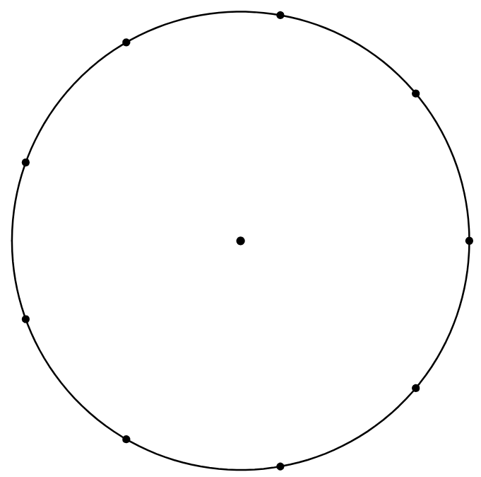

#### Questions

1. Classify the types of triangles you have created.
2. Find the size of the angles in your triangles.
3. Find the size of the reflex angle made at the centre for each triangle.

#### Challenge questions

Consider if we were to only make triangles by connecting 2 consecutive points and the centre.

1. Find the size of the angles in your triangles.
2. How would the size of the angles change if there were 6 points?
3. How would the size of the angles change if there were 12 points?
4. Is there a pattern as you increase the number of points?
5. Write an expression for the size of the angle at the centre, based on the number of points.

## Appendix B

### Vertically opposite angles

Below are circles with equally spaced points on the edge and straight lines intersecting at the centre.

Find the value of the acute angles at the centre of each circle.

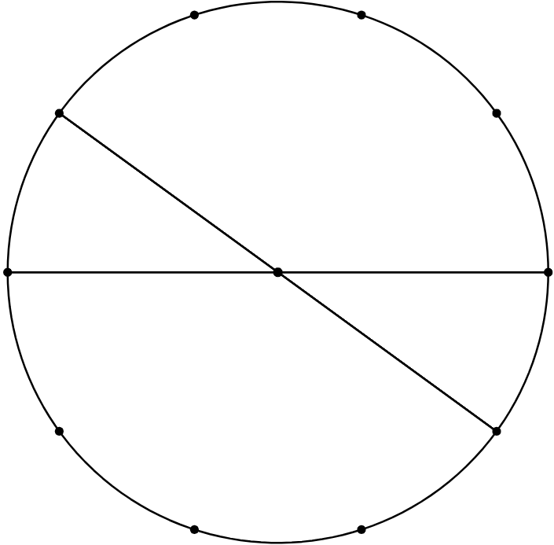 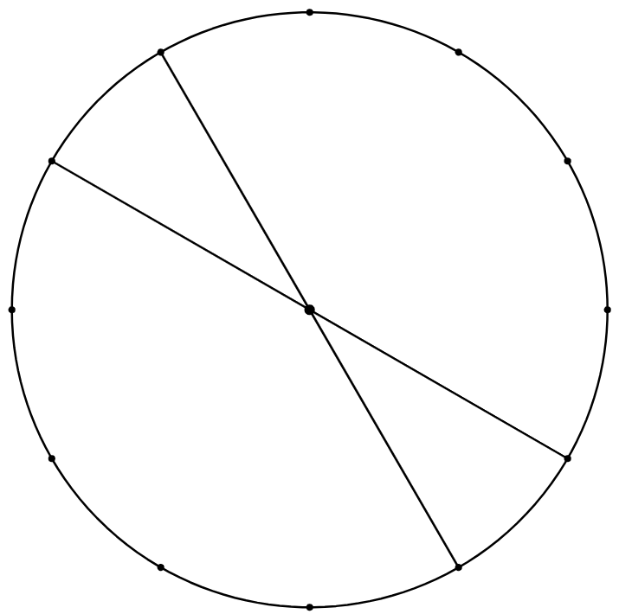

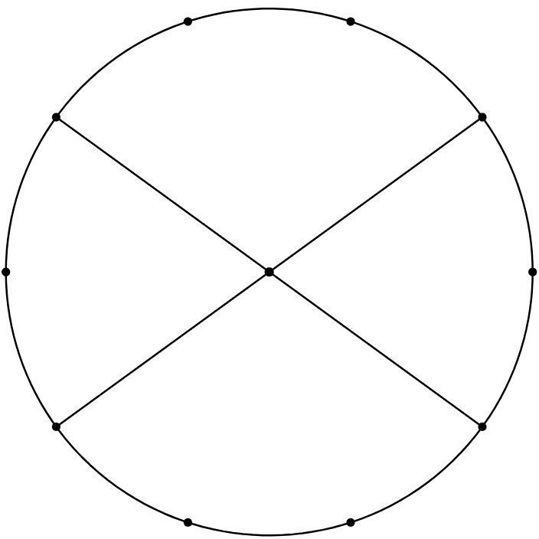 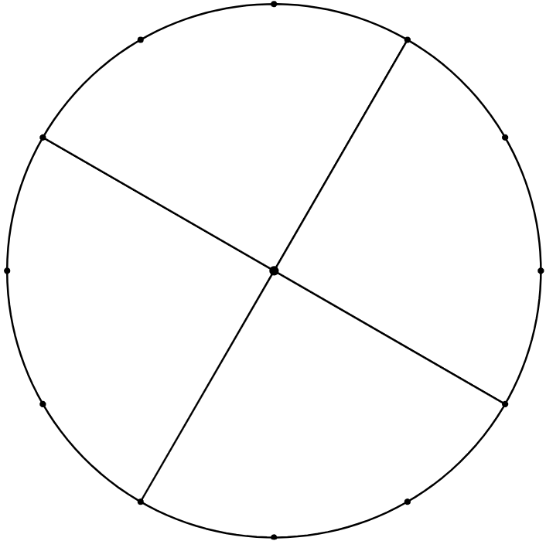

## Appendix C

### Frayer diagram

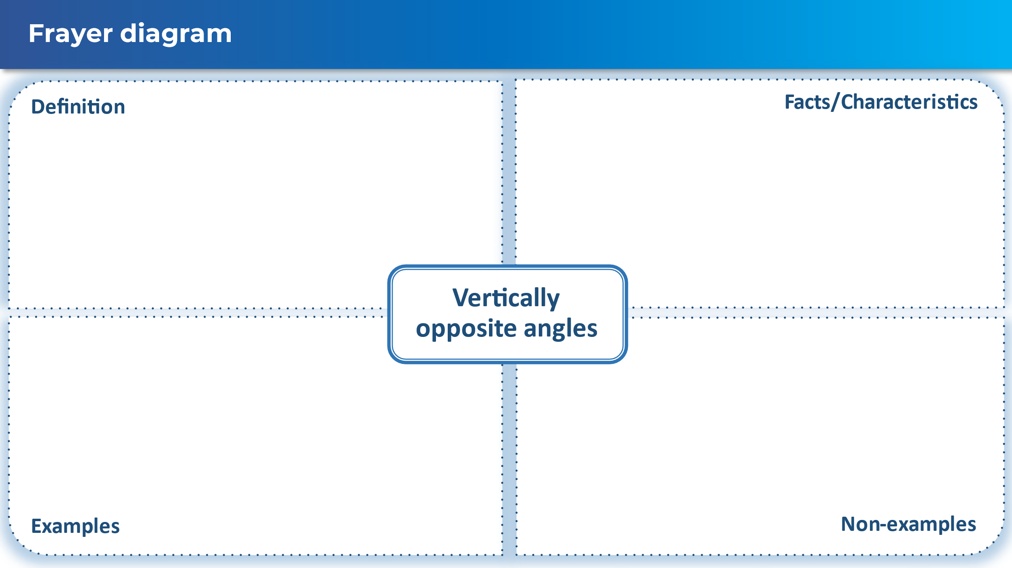

## Appendix D

### Angles at a point

* Estimate the size of the angles in each of the diagrams.
* Identify angles that are vertically opposite in each of the diagrams.

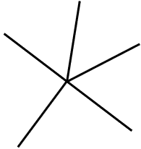 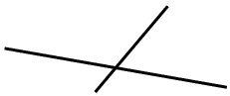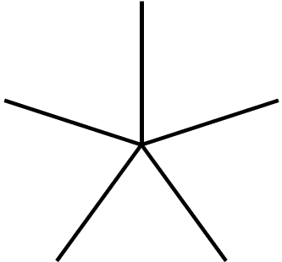 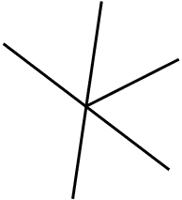 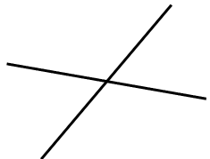 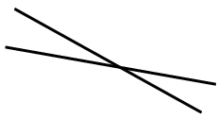

## Appendix E

### Tangled angles questions

1. Determine the size of the angle marked in each of the diagrams and explain how you knew.

|  |  |  |
| --- | --- | --- |
| Question | Solution | How do you know? |
| 1. Triangle ABC with angle ABC being 60 degrees, angle CAB being 70 degrees and angle BCA marked as x. |  |  |
| 1. A triangle with side CE and BD extending past the triangle. Angle DAE is marked as 70 degrees. Angle ACB is marked as x degrees and angle ABC is marked as 60 degrees. |  |  |
| 1. A triangle with sides CE and DG extending past the triangle. Angle DAE is 70 degrees and angle FBG is 60 degrees. Angle BCA is marked as x degrees. |  |  |
| 1. A triangle with all sides extending past the triangle. Angle DAE is 70 degrees. Angle JCH is x degrees and angle FBG is 60 degrees. |  |  |
| 1. 4 black lines, labelled A, B, C and D are meeting at a point labelled E. Angle sizes of 60, 70, 130 and x degrees are included. |  |  |
| 1. 4 black lines, labelled A, B, C and D are meeting at a point labelled E. Angle sizes of 60, 70, x and y degrees are included. |  |  |
| 1. 4 black lines, labelled A, B, C and D are meeting at a point labelled E. Angle sizes of 60, x, y and z degrees are included. |  |  |

## Sample solutions

### Appendix A – angles in a circle

|  |  |
| --- | --- |
| A black circle with 9 dots and a black point at the centre, There is an acute isosceles tringle joining the centre with 2 dots on the circumference.  Reflex angle is | A black circle with 9 dots and a black point at the centre, There is an acute isosceles tringle joining the centre with 2 dots on the circumference.  Reflex angle is |
| A black circle with 9 dots and a black point at the centre, There is an obtuse isosceles tringle joining the centre with 2 dots on the circumference.  Reflex angle is | A black circle with 9 dots and a black point at the centre, There is an obtuse isosceles tringle joining the centre with 2 dots on the circumference.  Reflex angle is $200°$ |

### Appendix B – vertically opposite angles

$36°, 30°, 72°$ and $90°$.

### Appendix C – Frayer diagram

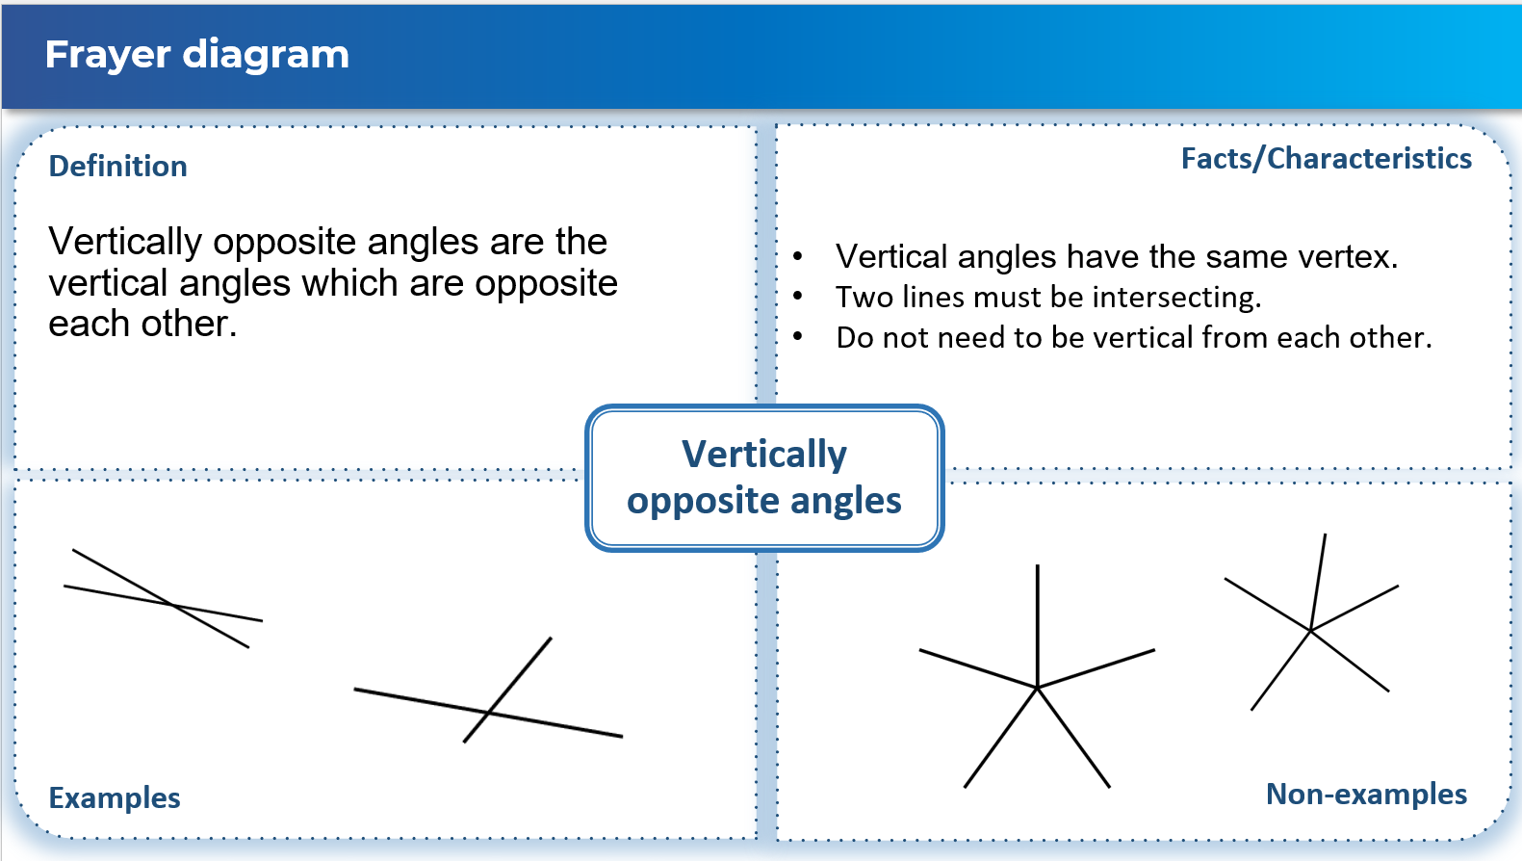

### Appendix D – angles at a point

Students are asked to estimate the size of the angles. The following solutions are approximate and may differ slightly from the estimates made by students.

Pairs of vertically opposite angles are marked with symbols.

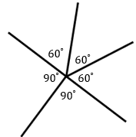 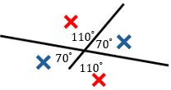 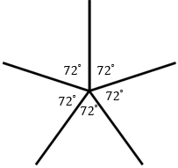

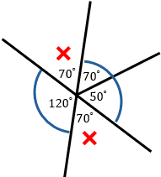 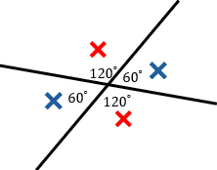 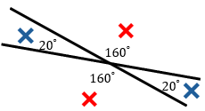

### Appendix E – tangled angles questions

|  |  |  |
| --- | --- | --- |
| Question | Solution | How do you know? |
| 1. Triangle ABC with angle ABC being 60 degrees, angle CAB being 70 degrees and angle BCA marked as x. |  | Angle sum of a triangle. |
| 1. A triangle with side CE and BD extending past the triangle. Angle DAE is marked as 70 degrees. Angle ACB is marked as x degrees and angle ABC is marked as 60 degrees. |  | Vertically opposite angles  Angle sum of a triangle |
| 1. A triangle with sides CE and DG extending past the triangle. Angle DAE is 70 degrees and angle FBG is 60 degrees. Angle BCA is marked as x degrees. |  | and  Vertically opposite angles  Angle sum of a triangle |
| 1. A triangle with all sides extending past the triangle. Angle DAE is 70 degrees. Angle JCH is x degrees and angle FBG is 60 degrees. |  | , and  Vertically opposite angles  Angle sum of a triangle |
| 1. 4 black lines, labelled A, B, C and D are meeting at a point labelled E. Angle sizes of 60, 70, 130 and x degrees are included. |  | Angles at a point |
| 1. 4 black lines, labelled A, B, C and D are meeting at a point labelled E. Angle sizes of 60, 70, x and y degrees are included. |  | is supplementary with $∠BEA$. $y$ is supplementary with |
| 1. 4 black lines, labelled A, B, C and D are meeting at a point labelled E. Angle sizes of 60, x, y and z degrees are included. |  | is opposite $∠DEA$. $y$ is supplementary with $∠DEA.$ $z$ is opposite $∠BEA$. |

### References

This resource contains NSW Curriculum and syllabus content. The NSW Curriculum is developed by the NSW Education Standards Authority. This content is prepared by NESA for and on behalf of the Crown in right of the State of New South Wales. The material is protected by Crown copyright.

Please refer to the NESA Copyright Disclaimer for more information [https://educationstandards.nsw.edu.au/wps/portal/nesa/mini-footer/copyright](https://aus01.safelinks.protection.outlook.com/?url=https%3A%2F%2Feducationstandards.nsw.edu.au%2Fwps%2Fportal%2Fnesa%2Fmini-footer%2Fcopyright&data=05%7C01%7CCaitlin.Pace1%40det.nsw.edu.au%7C9c2c1a9f59c94d2df30708dafa7edb23%7C05a0e69a418a47c19c259387261bf991%7C0%7C0%7C638097720042599463%7CUnknown%7CTWFpbGZsb3d8eyJWIjoiMC4wLjAwMDAiLCJQIjoiV2luMzIiLCJBTiI6Ik1haWwiLCJXVCI6Mn0%3D%7C3000%7C%7C%7C&sdata=BzQh0UsffVZE3eO22b2Xba3p0VMOBZSHfS21FGHXtZM%3D&reserved=0).

NESA holds the only official and up-to-date versions of the NSW Curriculum and syllabus documents. Please visit the NSW Education Standards Authority (NESA) website <https://educationstandards.nsw.edu.au/> and the NSW Curriculum website <https://curriculum.nsw.edu.au/>.

[Mathematics K–10 Syllabus](https://curriculum.nsw.edu.au/learning-areas/mathematics/mathematics-k-10-2022/overview) © NSW Education Standards Authority (NESA) for and on behalf of the Crown in right of the State of New South Wales, 2022.

**© State of New South Wales (Department of Education), 2024**

The copyright material published in this resource is subject to the *Copyright Act 1968* (Cth) and is owned by the NSW Department of Education or, where indicated, by a party other than the NSW Department of Education (third-party material).

Copyright material available in this resource and owned by the NSW Department of Education is licensed under a [Creative Commons Attribution 4.0 International (CC BY 4.0) license](https://creativecommons.org/licenses/by/4.0/).

[](https://creativecommons.org/licenses/by/4.0/)

This license allows you to share and adapt the material for any purpose, even commercially.

Attribution should be given to © State of New South Wales (Department of Education), 2024.

Material in this resource not available under a Creative Commons license:

* the NSW Department of Education logo, other logos and trademark-protected material
* material owned by a third party that has been reproduced with permission. You will need to obtain permission from the third party to reuse its material.

**Links to third-party material and websites**

Please note that the provided (reading/viewing material/list/links/texts) are a suggestion only and implies no endorsement, by the New South Wales Department of Education, of any author, publisher, or book title. School principals and teachers are best placed to assess the suitability of resources that would complement the curriculum and reflect the needs and interests of their students.

If you use the links provided in this document to access a third-party's website, you acknowledge that the terms of use, including licence terms set out on the third-party's website apply to the use which may be made of the materials on that third-party website or where permitted by the *Copyright Act 1968* (Cth). The department accepts no responsibility for content on third-party websites.