# Complements to you

Students start by exploring complementary angles before being introduced to how to denote perpendicular lines.

Students will need at least one digital device per pair to interact with GeoGebra during this lesson.

## Visible learning

Learning intentions and success criteria should be shared with students later in the learning episode.

### Learning intention

* To be able to use the terms perpendicular and complementary to describe angles.

### Success criteria

* I can explain what a complementary angle is.
* I can use complementary angles to find unknown values.
* I can describe and identify symbols that represent perpendicular lines.

### Syllabus outcomes

A student:

* develops understanding and fluency in mathematics through exploring and connecting mathematical concepts, choosing and applying mathematical techniques to solve problems, and communicating their thinking and reasoning coherently and clearly **MAO-WM-01**
* applies angle relationships to solve problems, including those related to transversals on sets of parallel lines **MA4-ANG-C-01**
* identifies and applies the properties of triangles and quadrilaterals to solve problems   
  **MA4-GEO-C-01**

[Mathematics K–10 Syllabus](https://curriculum.nsw.edu.au/learning-areas/mathematics/mathematics-k-10-2022/overview) © NSW Education Standards Authority (NESA) for and on behalf of the Crown in right of the State of New South Wales, 2022.

Table 1: lesson summary

|  |  |  |  |
| --- | --- | --- | --- |
| Section | Summary of activity | Teaching strategy | Teaching points |
| Launch | Use slide 3 from the PowerPoint *Complements to you* to show miter joints and ask students what they notice and wonder. | Pose-Pause-Pounce-Bounce | Students are introduced to 2 angles meeting to form a right angle. |
| Explore | Students complete the ‘Complementary & Supplementary Angles (Exploration)’ activity in the GeoGebra applet ([bit.ly/angle-exploration](https://bit.ly/angle-exploration)) before defining complementary angles. Students play the game ‘Closest to 250’ from Appendix A.  Students then look at the perpendicular symbol to denote lines. | Pose-Pause-Pounce-Bounce  Think-Pair-Share | Students use the terminology ‘complementary angles’ to describe angles that add to $90°$ then apply that knowledge.  Students should notice that calling angles that meet at right angles and lines that meet at right angles have different terms to describe them. |
| Summarise | Students complete the hinge point questions on perpendicular line on slides 6–11 of the PowerPoint before completing the Frayer diagrams in Appendix B. | Think-Pair-Share  Mini whiteboards | The purpose of section is the assess student understanding of complementary angles and perpendicular lines. |
| Apply | Complete tasks from the Starting Point Maths activity ([bit.ly/complementaryangles1](https://bit.ly/complementaryangles1)). | Talk moves | Students solve geometry problems involving complementary angles, with the problems increasing in complexity. |

## Activity structure

Please use the associated PowerPoint *Complements to you* to display images in this lesson.

### Launch

1. Display slide 3 of the PowerPoint *Complements to you*, which displays 2 images of miter joints. Ask students what they notice and wonder ([bit.ly/noticewonderstrategy](https://bit.ly/noticewonderstrategy)).

Students should notice that each joint creates a right angle and may wonder what angles are needed to make a miter joint.

1. Using the Pose-Pause-Pounce-Bounce questioning strategy (PDF 557 KB) ([bit.ly/posepausepouncebounce](https://bit.ly/posepausepouncebounce)), start a class discussion using the following prompts:

* What size do each of the angles need to add to, so the angles make a corner for a frame?
* Can you think of different angle combinations that would form a corner? How did you find them?

### Explore

1. With one digital device between pairs of students, have students open the GeoGebra applet ‘Complementary & Supplementary Angles (Exploration)’ ([bit.ly/angle-exploration](https://bit.ly/angle-exploration)).
2. Ask students to engage with the applet and complete the questions under the heading **Complementary angles**.

To collect student responses as evidence of learning you can set up a GeoGebra classroom or Google classroom. More advice on how to do this can be found on the website ‘Assign GeoGebra Resources’ ([bit.ly/geogebrahelp](https://bit.ly/geogebrahelp)).

1. Using the Pose-Pause-Pounce-Bounce questioning strategy, ask students to share their responses to the first question to help create a class definition for complementary angles.

The syllabus glossary states that complementary angles are 2 adjacent angles that form a right angle. That is, the sum of the angles measured in degrees is 90°.

1. In a Think-Pair-Share, ask students how we would know if 2 adjacent angles make a right angle*.*

Students should state that if the 2 angles add to 90°.

1. In pairs, distribute Appendix A ‘Closest to 250’ and 2 dice. Appendix A includes the following game instructions.

There are 2 columns provided for each player on the game sheet. One for the angle you rolled and the other for the complement of that angle.

Player 1 is the youngest person in the pair, Player 2 is the oldest.

Player 1 is to roll the 2 dice. These numbers will be used to represent the size of the angle.

Select what number you would like to use for your angle. For example, if you rolled a 5 and a 1, you could choose your angle to be either 15 or 51.

Once you have filled in your angle, write the complement of that angle in the next column.

Person 2 then takes their turn.

This process is repeated until each player has 5 rolls.

The aim after 5 rolls, is to see whose total for their complement column is closest to 250.

1. Using the Pose-Pause-Pounce-Bounce questioning strategy, ask students what the best strategy was to get closest to 250.
2. Display slide 5 from the PowerPoint *Complements to you*, which shows the perpendicular symbol.
3. Initiate a sharing of ideas and reasoning using the Pose-Pause-Pounce-Bounce questioning strategy and the following prompts:

* What do we think the symbol represents? How did we come to that conclusion?
* What would the size of $∠DCB$ be? Why?
* How does this relate to complementary angles?

Students should conclude that the symbol means that the lines meet at right angles or that they are perpendicular. Complementary angles are ones that add to 90 $°$. If students did not use the word perpendicular they should be reminded of the term.

The syllabus glossary states that perpendicular is when 2 lines, rays, line segments, vectors, planes, or other objects intersect at a 90° angle (a right angle).

Students should have explored recognising perpendicular lines in Stage 3 – Geometric measure B.

### Summarise

1. In a Think-Pair-Share ([bit.ly/thinkpairsharestrategy](https://bit.ly/thinkpairsharestrategy)), ask students where we may find perpendicular lines.

Students could link back to the shapes explored in Unit 6 – triangles and quadrilaterals, Unit 10 – investigating triangles or real-world scenarios such as a wall meeting the floor or the corner of a book.

1. Display slides 6–11 of the PowerPoint to show 6 multiple choice questions.
2. In a Think-Pair-Share, using mini whiteboards ([bit.ly/miniwhiteboards](https://bit.ly/miniwhiteboards)) between each pair, ask students to select an answer to each multiple-choice question reasoning their response.
3. Slide 6 can be used as an example before continuing the activity.
4. Some questions are included to draw on prior knowledge from Unit 6 – triangles and quadrilaterals and Unit 10 – investigating triangles, these can be omitted if not explored previously.
5. Ask random students to explain why they selected their answer or did not select one of the other answers.
6. Distribute Appendix B ‘Frayer diagrams’ for both perpendicular lines and complementary angles. Students are to individually complete the Frayer diagrams ([bit.ly/frayerdiagram](https://bit.ly/frayerdiagram)).

### Apply

1. Download, print and cut into tasks the Starting Points Maths activity ‘Complementary Angles’ ([bit.ly/complementaryangles1](https://bit.ly/complementaryangles1)).

Make sure you download the document as there are more tasks than what is given in the preview on the website. There are at least 6 tasks per colour, each consisting of 3 or more questions for students to complete.

1. Tell students to select the tasks they would like to attempt, completing at least one from each section (red, blue and green).

Alternatively, the teacher can select which questions students attempt or assign students random questions.

1. Students are to pair up with another student who has completed different tasks and alternate explaining their solutions to each other. Prompt students to ask their partner clarifying questions if they don’t understand.

If students struggle with making conversation it is suggested to provide them with prompts from the Talk moves flashcards ([bit.ly/classroomtalkmoves](https://bit.ly/classroomtalkmoves)).

## Assessment and differentiation

### Suggested opportunities for differentiation

**Launch**

* The Launch uses a notice and wonder so it has no correct answers. All students should be able to access the activity.
* To build their confidence, students could practice their answers before sharing with the class in a Think-Pair-Share.

**Explore**

* Students may benefit from first revising inverse operations and solving one step equations explored in Lesson 10 – inverse journeys of Unit 4 – additive thinking.
* **Challenge students to connect complementary angles to the angles made by diagonals in different size rectangles to relate back to miter joints.**

**Summarise**

* Students may need to be reminded about the difference between a line, ray and interval explored in Lesson 1 – draw it out of Unit 11 – geometrical relationships.
* Challenge students to explain why all other answers are incorrect in the multiple-choice questions.
* To enable students, provide them with examples and non-examples to form their definitions and characteristics in their Frayer diagrams.
* Challenge students to include non-examples in their Frayer diagrams that could be mistaken for complementary angles.

**Apply**

* Students can be given categories they can ask feedback on relating to the Working mathematically outcome, such as their use of terminology, the explanation of their answer to demonstrate their level understanding, or how well they justified their solution.

### Suggested opportunities for assessment

**Launch**

* Students will show their ability to recognise right angles in real life through their responses to the question prompts.

**Explore**

* Monitor student responses in Appendix A to check for understanding of finding a complementary angle.
* Students will demonstrate their Working mathematically skills in discussions and justifications.

**Summarise**

* Multiple choice questions show student understanding that the term perpendicular refers to lines and how to correctly write statements that use the symbol in a variety of contexts.
* Review students’ Frayer diagrams to check their understanding of definitions for perpendicular lines and complementary angles.

**Apply**

* Collect student responses to the Starting Point Maths activity as evidence of learning.
* Students provide each other with peer feedback in the guided feedback chat.

## Appendix A

### Closest to 250

#### Instructions

There are 2 columns provided for each player on the game sheet. One for the angle you rolled and the other for the complement of that angle.

Player 1 is the youngest person in the pair, Player 2 is the oldest.

Player 1 is to roll the 2 dice. These numbers will be used to represent the size of the angle.

Select what number you would like to use for your angle. For example, if you rolled a 5 and a 1, you could choose your angle to be either 15 or 51.

Once you have filled in your angle, write the complement of that angle in the next column.

Person 2 then takes their turn.

This process is repeated until each player has 5 rolls.

The aim after 5 rolls, is to see whose total for their complement column is closest to 250 wins.

#### Game board

|  |  |  |  |
| --- | --- | --- | --- |
| Player 1 – angle | Player 1 – complement | Player 2 – angle | Player 2 – complement |
|  |  |  |  |
|  |  |  |  |
|  |  |  |  |
|  |  |  |  |
|  |  |  |  |
| Total |  | Total |  |

## Appendix B

### Frayer diagrams

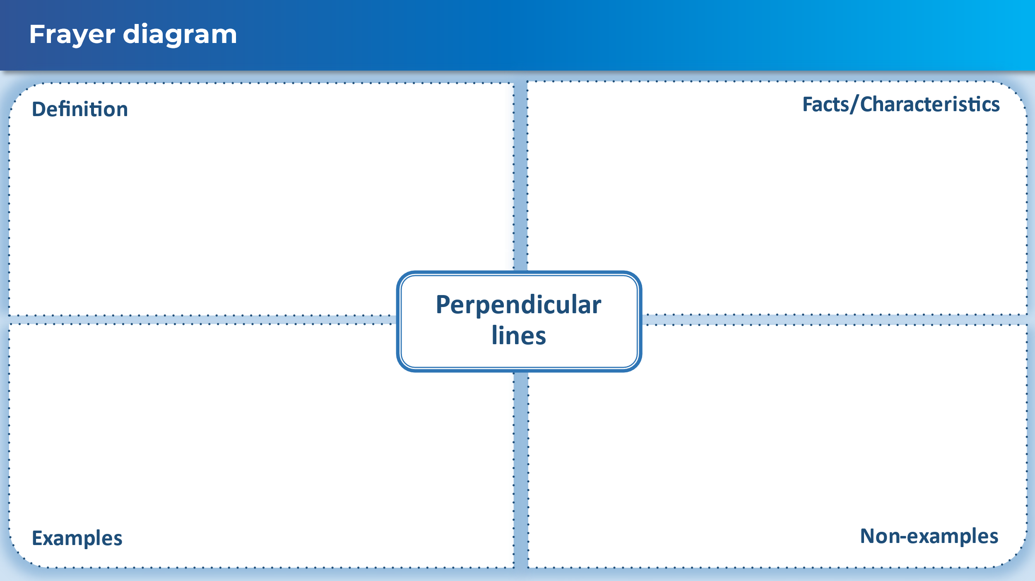

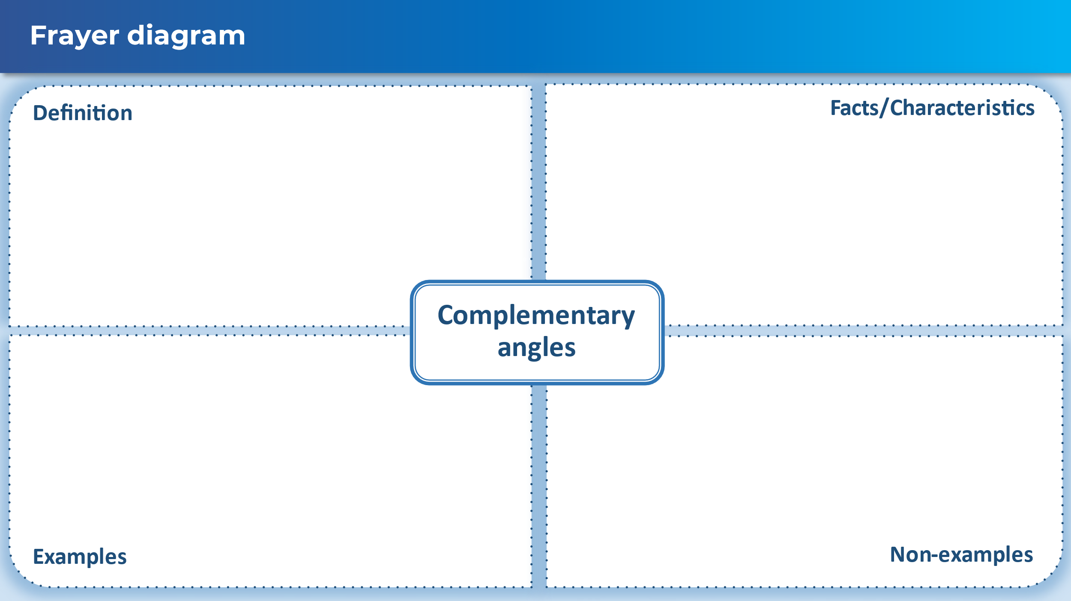

## Sample solutions

### Multiple choice questions

1. C – as both statements are correct, one written with symbols and the other with words.
2. B – as the perpendicular symbol is used with lines and must meet at 90 $°$.
3. C – as this is a Pythagorean triad which means there is a right angle opposite the longest side.
4. C – as angles on a straight line are 180 $°$, so $∠HEF+41°+49°=180°$, which means $∠HEF=90°$.
5. A – as diagonals of a kite meet at right angles/are perpendicular.
6. B – as $∠HEL+∠LEF=90°$ and are adjacent with a common arm.

### Appendix B – Frayer diagrams

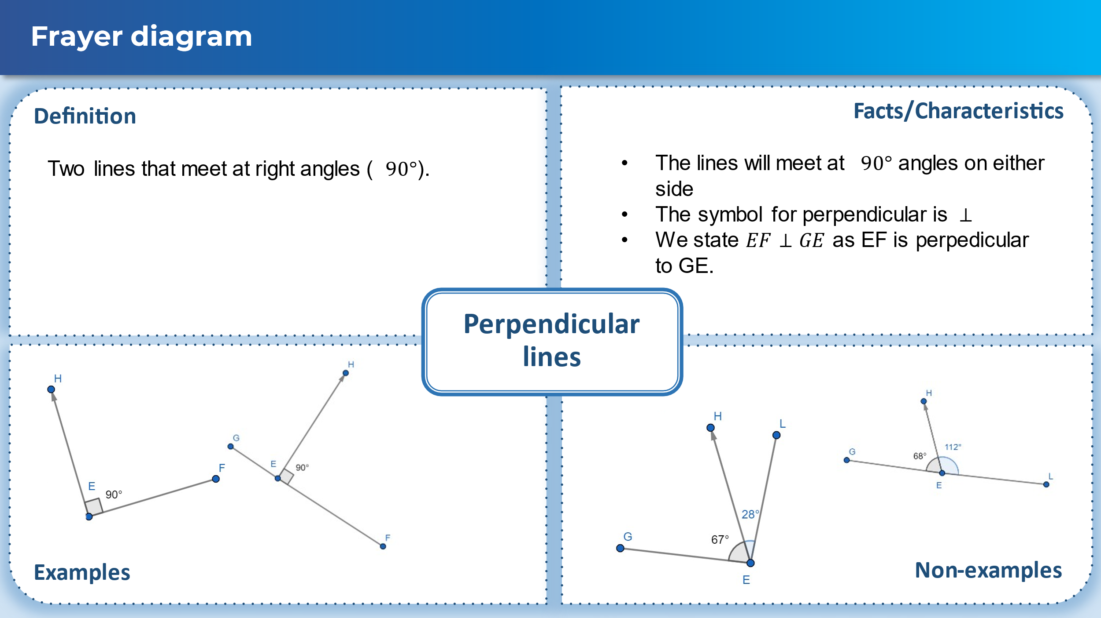

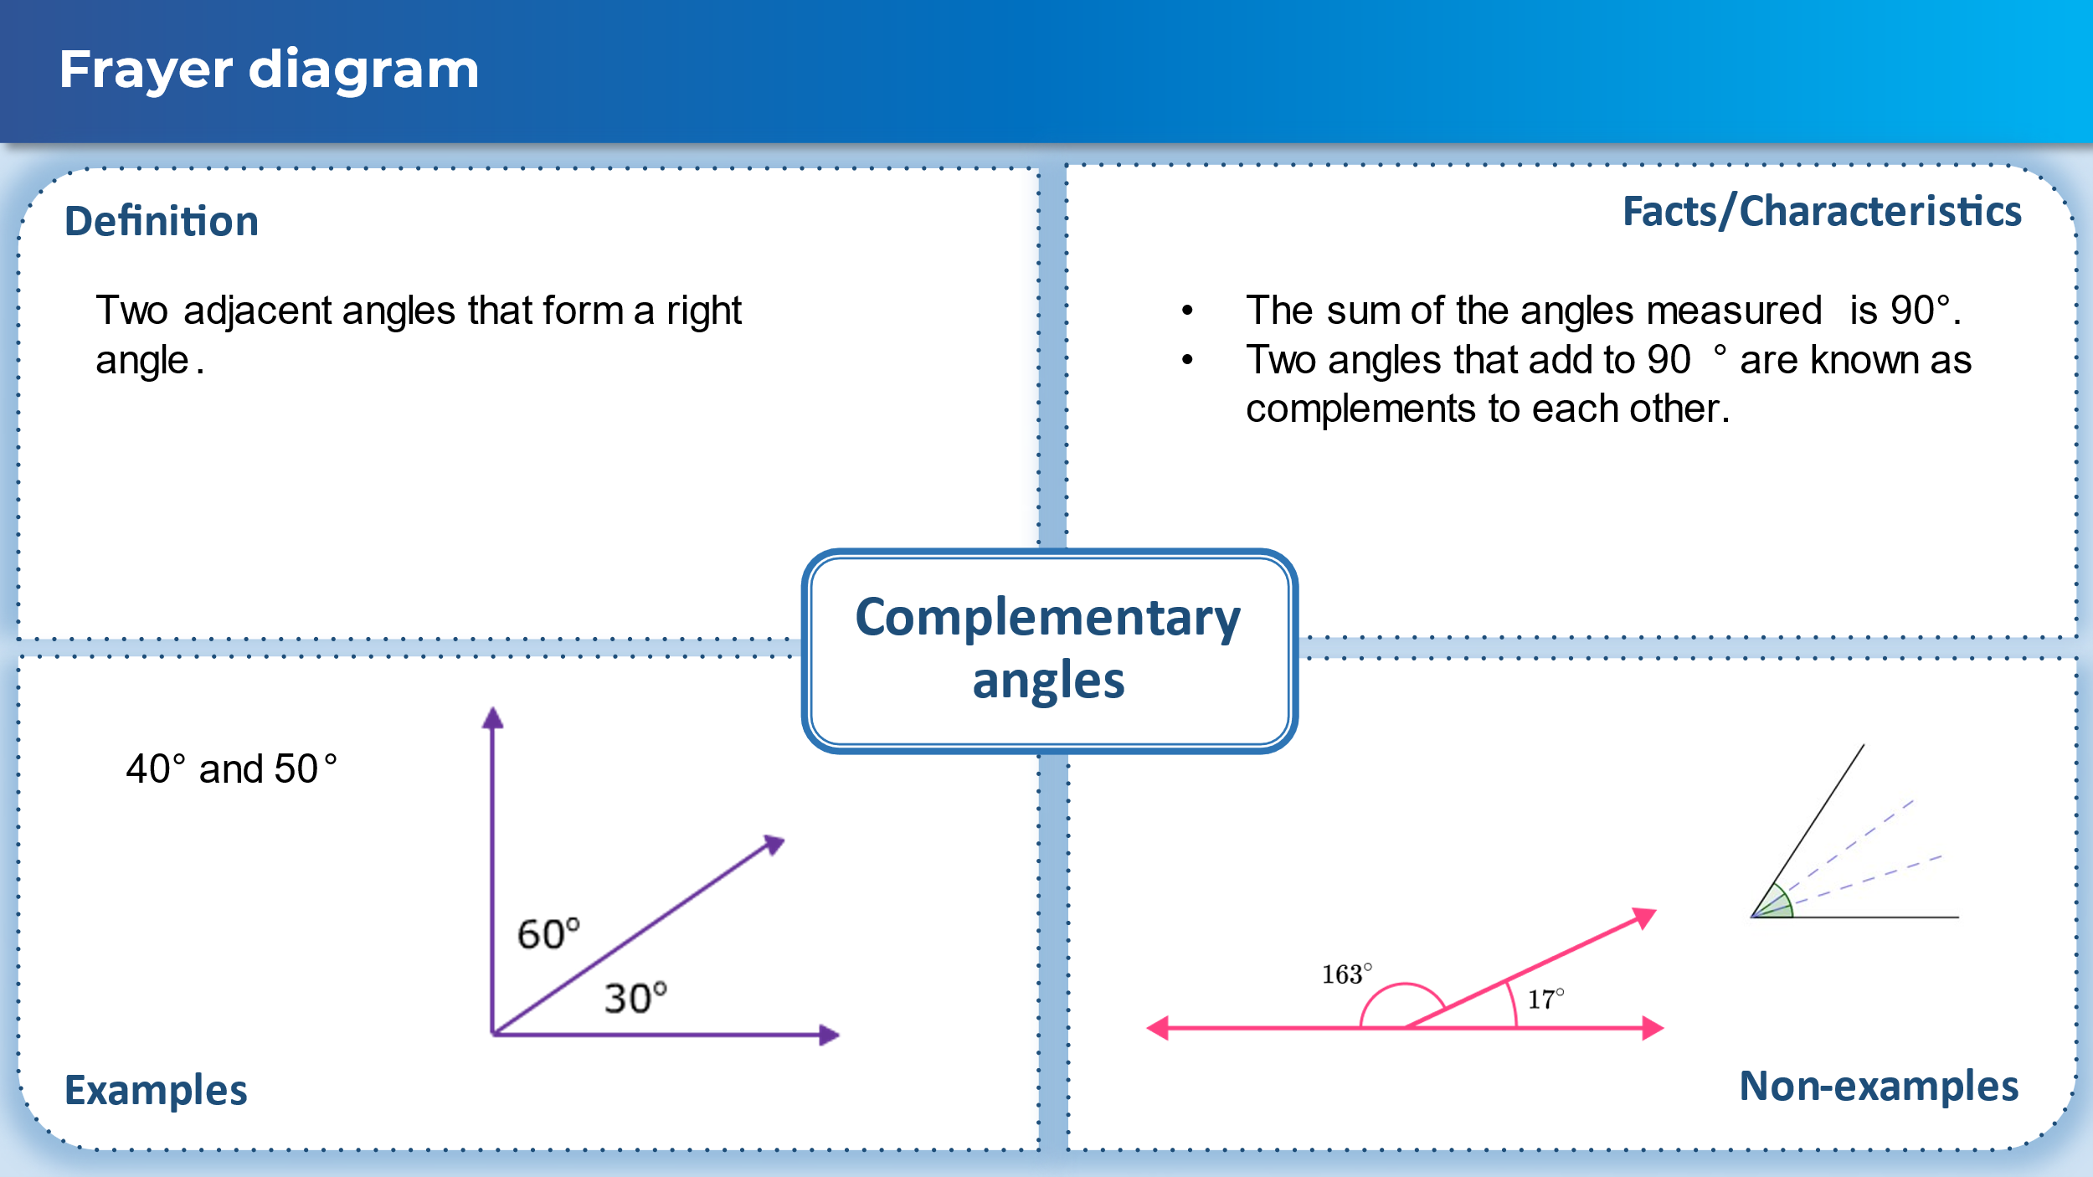

## References

This resource contains NSW Curriculum and syllabus content. The NSW Curriculum is developed by the NSW Education Standards Authority. This content is prepared by NESA for and on behalf of the Crown in right of the State of New South Wales. The material is protected by Crown copyright.

Please refer to the NESA Copyright Disclaimer for more information [https://educationstandards.nsw.edu.au/wps/portal/nesa/mini-footer/copyright](https://aus01.safelinks.protection.outlook.com/?url=https%3A%2F%2Feducationstandards.nsw.edu.au%2Fwps%2Fportal%2Fnesa%2Fmini-footer%2Fcopyright&data=05%7C01%7CCaitlin.Pace1%40det.nsw.edu.au%7C9c2c1a9f59c94d2df30708dafa7edb23%7C05a0e69a418a47c19c259387261bf991%7C0%7C0%7C638097720042599463%7CUnknown%7CTWFpbGZsb3d8eyJWIjoiMC4wLjAwMDAiLCJQIjoiV2luMzIiLCJBTiI6Ik1haWwiLCJXVCI6Mn0%3D%7C3000%7C%7C%7C&sdata=BzQh0UsffVZE3eO22b2Xba3p0VMOBZSHfS21FGHXtZM%3D&reserved=0).

NESA holds the only official and up-to-date versions of the NSW Curriculum and syllabus documents. Please visit the NSW Education Standards Authority (NESA) website <https://educationstandards.nsw.edu.au/> and the NSW Curriculum website <https://curriculum.nsw.edu.au/>.

[Mathematics K–10 Syllabus](https://curriculum.nsw.edu.au/learning-areas/mathematics/mathematics-k-10-2022/overview) © NSW Education Standards Authority (NESA) for and on behalf of the Crown in right of the State of New South Wales, 2022.

**© State of New South Wales (Department of Education), 2024**

The copyright material published in this resource is subject to the *Copyright Act 1968* (Cth) and is owned by the NSW Department of Education or, where indicated, by a party other than the NSW Department of Education (third-party material).

Copyright material available in this resource and owned by the NSW Department of Education is licensed under a [Creative Commons Attribution 4.0 International (CC BY 4.0) license](https://creativecommons.org/licenses/by/4.0/).

[](https://creativecommons.org/licenses/by/4.0/)

This license allows you to share and adapt the material for any purpose, even commercially.

Attribution should be given to © State of New South Wales (Department of Education), 2024.

Material in this resource not available under a Creative Commons license:

* the NSW Department of Education logo, other logos and trademark-protected material
* material owned by a third party that has been reproduced with permission. You will need to obtain permission from the third party to reuse its material.

**Links to third-party material and websites**

Please note that the provided (reading/viewing material/list/links/texts) are a suggestion only and implies no endorsement, by the New South Wales Department of Education, of any author, publisher, or book title. School principals and teachers are best placed to assess the suitability of resources that would complement the curriculum and reflect the needs and interests of their students.

If you use the links provided in this document to access a third-party's website, you acknowledge that the terms of use, including licence terms set out on the third-party's website apply to the use which may be made of the materials on that third-party website or where permitted by the *Copyright Act 1968* (Cth). The department accepts no responsibility for content on third-party websites.