# The corresponding connection

Students explore transversals in parallel lines and corresponding angles.

## Visible learning

Learning intentions and success criteria should be shared with students later in the learning episode.

### Learning intention

* To understand the relationship between corresponding angles in parallel lines.

### Success criteria

* I can represent sets of parallel lines in a diagram and by writing a statement.
* I can identify and define a transversal.
* I can identify and name corresponding angles in parallel lines.
* I can find the sizes of unknown angles, giving reasons.

### Syllabus outcomes

A student:

* develops understanding and fluency in mathematics through exploring and connecting mathematical concepts, choosing and applying mathematical techniques to solve problems, and communicating their thinking and reasoning coherently and clearly **MAO-WM-01**
* applies angle relationships to solve problems, including those related to transversals on sets of parallel lines **MA4-ANG-C-01**
* identifies and applies the properties of triangles and quadrilaterals to solve problems   
  **MA4-GEO-C-01**

[Mathematics K–10 Syllabus](https://curriculum.nsw.edu.au/learning-areas/mathematics/mathematics-k-10-2022/overview) © NSW Education Standards Authority (NESA) for and on behalf of the Crown in right of the State of New South Wales, 2022.

Table 1: lesson summary

|  |  |  |  |
| --- | --- | --- | --- |
| Section | Summary of activity | Teaching strategy | Teaching points |
| Warm up | Display slide 3 of the PowerPoint and ask students what they notice and what they wonder, focused on pairs of angles. | Think-Pair-Share  Pose-Pause-Pounce-Bounce | Students revisit vertically opposite angles, supplementary angles and angles at a point. |
| Launch | Using Appendix A students identify equal angles and parallel lines. | Think-Pair-Share | Students identify equal angles and parallel lines. |
| Explore | Students discuss and identify sets of parallel intervals in Appendix A and write statements for parallel intervals.  Students draw parallel lines using slide 9 of the PowerPoint to focus attention on equal angles in corresponding positions. | Think-Pair-Share  Pose-Pause-Pounce-Bounce | Students are introduced to the term transversal.  Drawing a pair of parallel intervals and a transversal on the colour adjusted diagram draws student attention to angles that are in corresponding positions. |
| Summarise | Students are formally introduced to corresponding angles and create a word web for the word corresponding. Students complete the Frayer diagram in Appendix B, then swap them to give feedback.  Students complete an exit ticket, on slide 10 of the PowerPoint. | Two stars and a wish  Pose-Pause-Pounce-Bounce | Formally define corresponding angles. The word web helps students create connections to remember terminology. |
| Apply | In pairs, students attempt Appendix C, giving reasons for why angles are certain sizes. Students view each other's work and discuss strategies. | Pose-Pause-Pounce-Bounce | Students use reasoning when explaining how they solved the angle problems. |

## Activity structure

Please use the associated PowerPoint *The corresponding connection* to display images in this lesson.

### Warm up

1. Display slide 3 of the PowerPoint *The corresponding connection*.
2. In a Think-Pair-Share ([bit.ly/thinkpairsharestrategy](https://bit.ly/thinkpairsharestrategy)), students are to identify what they know about the angles in the diagram.
3. Use the Pose-Pause-Pounce-Bounce questioning strategy (PDF 557 KB) ([bit.ly/posepausepouncebounce](https://bit.ly/posepausepouncebounce)), to discuss the angles. Useful question prompts may include:

* What type of angle is angle E?
* What type of angle is angle H?
* What do you know about angles E and G?
* What do you know about angles E and H?
* What do you know about angles A, B, C and D?

Students should be able to identify that angle E is an obtuse angle and angle H is an acute angle.

They should also be able to identify vertically opposite angles, supplementary angles and angles at a point.

### Launch

1. Display slide 5 from the PowerPoint *The corresponding connection* and distribute Appendix A ‘Tiling pattern’ in a plastic pocket to pairs of students, to stick on a wall around the classroom.
2. In a Think-Pair-Share, students are to identify all the angles equal to the angle with a dot, given all tiles are the same size. They are to discuss the following questions:

* How do we know the angles are equal?
* What types of angles can we see?
* How many parallel intervals are in the diagram?
* Why are we calling these intervals and not lines?

Teachers might notice that students use the word corresponding to talk about angles that are in the same position in each shape.

Teachers might suggest the word ‘congruent’ if students suggest that the shapes are all the same.

### Explore

1. Reveal the learning intentions and success criteria.
2. In a Think-Pair-Share, ask students:

* How could we show that certain intervals are parallel to each other?
* How could we represent different sets of parallel intervals?

1. Ask students to use a whiteboard marker to draw on their plastic pockets containing Appendix A, each parallel interval. They should include the points at the end of each interval and add decorations to represent sets of parallel intervals.
2. Display slide 7 from the PowerPoint which shows the same diagram with parallel intervals represented with arrows, and points on each line. Ask students to compare what they drew on their diagram.
3. Display slide 8 of the PowerPoint that shows the symbol for parallel.
4. In a Think-Pair-Share, ask students to write statements using the symbol for each set of parallel intervals in Appendix A.

Parallel intervals within the diagram are $XI∥VK∥TO$, $AP∥CO∥EN∥FJ$, $WB∥SD∥QF∥OH∥ML$.

1. Display slide 9 of the PowerPoint, which shows Figure 1.

Figure 1: pattern with lines in contrasting colour

Kites assembled in a tessellating pattern with a point denoted with a black dot.
A transversal is highlighted.

1. In a Think-Pair-Share, ask students to focus on the intervals they drew to discuss the following questions:

* What could we call the line that cuts through the 2 parallel intervals?
* What do we notice about the position of the green angles on each parallel interval?
* Why could we say that the green angles are corresponding? Could other angles in the diagram be corresponding? Why?

Students should notice that each of the kites and the angles is in the same position on the parallel intervals.

1. Display the GeoGebra applet ‘Parallel Lines – Corresponding Angles’ ([bit.ly/parallelcorrespondingangles](https://bit.ly/parallelcorrespondingangles)).
2. Select and drag point **B** to highlight that the position of corresponding angles remains the same regardless of their size.
3. State to students that there are 4 different pairs of corresponding angles on the diagram, one is currently displayed.
4. In a Think-Pair-Share, ask students to draw the diagram and find the other 3 pairs of corresponding angles.
5. Select the tick box for each pair of corresponding angles on the applet to confirm to students their position.

### Summarise

1. Explain that corresponding angles are created by a transversal crossing a set of parallel lines, intervals or rays.

A transversal is a line that crosses 2 or more other lines in a plane.

1. Ask students where they have heard the word corresponding before to create a word web ([bit.ly/wordwebsstrategy](https://bit.ly/wordwebsstrategy)) as a class.

Students may reference corresponding angles in shapes, which are angles in the same position in similar or congruent figures. Students may also relate to a correspondent on the news.

1. Using the Pose-Pause-Pounce-Bounce questioning strategy to discuss corresponding angles. Useful question prompts may include:

* How could the ways we use the word ‘corresponding’ in different contexts help us remember what corresponding angles in parallel lines are?
* Why might knowing about corresponding angles be useful in geometry?
* Why is it useful to be able to identify different types of angles?

1. Distribute Appendix B ‘Frayer diagram’ to each student and ask them to complete the Frayer diagram ([bit.ly/frayerdiagram](https://bit.ly/frayerdiagram)) provided.
2. Students are to swap Frayer diagrams and complete peer feedback in the form of Two stars and a wish ([bit.ly/DLSpeerfeedback](https://bit.ly/DLSpeerfeedback)).
3. Students then respond to the feedback to improve their Frayer diagrams.

Prompt students to use correct terminology on their Frayer diagrams, such as angles created by a transversal on parallel lines. Rather than supply peer feedback, the teacher could display terminology used in the lesson to revise or improve students’ Frayer diagrams.

## Apply

This activity has been modified from Don Steward’s Median blog post ‘parallel line angles’ ([bit.ly/parallellineangles](https://bit.ly/parallellineangles)).

1. Distribute Appendix C ‘Angle problems’ and ask students to work in pairs to complete, providing reasons for each value found.

Students may benefit from first identifying corresponding angles on each diagram.

1. Using the Pose-Pause-Pounce-Bounce questioning strategy, ask students to explain, using reasoning, how they answered the questions and what strategies they used. The following question prompts may be useful:

* What angle relationships did you mainly use to find the unknown angles?
* What made this activity difficult?
* Did we discover anything interesting?

1. Display slide 11 from the PowerPoint and ask students to complete the exit ticket ([bit.ly/exitticketstrategy](https://bit.ly/exitticketstrategy)) by identifying all pairs of corresponding angles in the diagram.

Sample solutions: A=E, B=F, C=G, D=H.

## Assessment and differentiation

### Suggested opportunities for differentiation

**Launch**

* Students may benefit from reviewing properties of a kite, explored in Lesson 10 – let’s go fly a kite of Unit 6 – triangles and quadrilaterals.
* Challenge students to identify each set of angles throughout the diagram that are equal using properties of a kite.

**Explore**

* To enable students, let them answer using informal language, before using correct terminology in explanations.

**Summarise**

* To enable students who are learning English as an additional language or dialect (EAL/D) to engage in class discussion, provide them with a dictionary or access to the internet to create a word wall or contribute words that have meaning in their language.
* Students can complete their Frayer diagrams in pairs.

**Apply**

* Challenge students to find all the angles they can on each diagram.
* More challenging diagrams can be found on Don Steward’s Median blog post ‘parallel line angles’ ([bit.ly/parallellineangles](https://bit.ly/parallellineangles)).
* Challenge students to justify their solutions in a more formal proof.

### Suggested opportunities for assessment

**Launch**

* Monitor responses in class discussions to check for student understanding of identifying parallel lines in diagrams.

**Explore**

* Students give each other peer feedback, before sharing with the class in a Think-Pair-Share.
* Teachers could facilitate class discussions and observe students’ reasoning and justification in response to why they would use a certain symbol for parallel lines.

**Summarise**

* Review students’ Frayer diagrams for their use of terminology and definitions.

**Apply**

* Student contributions to the class discussion should highlight the types of angles students recognise, and have used, to solve the angle problems.
* Collect responses to slide 11 from the PowerPoint as an exit ticket to show how well students can identify corresponding angles in a diagram.

## Appendix A

### Tiling pattern

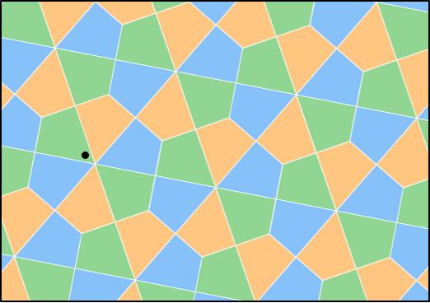

## Appendix B

### Frayer diagram

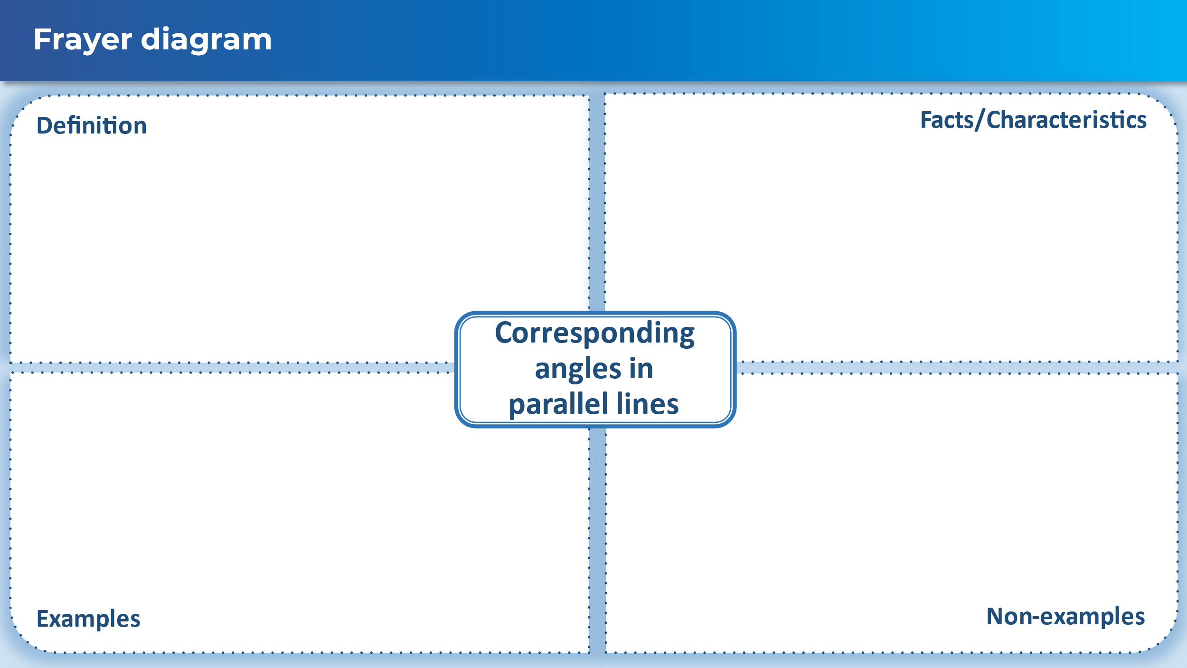

## Appendix C

### Angle problems

Find the value of each pronumeral. The diagrams are not to scale.

|  |  |
| --- | --- |
|  | Parallel lines AB and CD with transversal EF that intersects the line AB at G and CD at E. Angle FGB = 112 degrees and angle GEC=a. |
|  | Parallel lines HI and JK with transversal LM that intersects the line HI at N and JK at O. Angle LNI=118 degrees and angle JON=b. |
|  | Parallel lines RS and PQ with transversal TU that intersects the line RS at W and PQ at T and transversal VU that intersects the line RS at Z and PQ at V. Angle WUZ=c, angle UWZ=81 degrees and ZVT=71 degrees. |
|  | Parallel lines AC, DE and FG with transversal IH that intersects the line AC at I, DE at J and FG at H. Angle CIJ= d and angle JHG=110 degrees. |
|  | Parallel lines OP, QR and ST with transversal LK that intersects OP at U and QR at W, and transversal NM that intersects OP at V, QR at Z and ST at A. Angle UWZ = 70 degrees and angle ZAS=e. |
|  | Parallel lines BC and DE with transversal HI that intersects BC at J and DE at L and transversal FG that intersects BC at K and DE and M. Angle KJL = 109 degrees and angle JLM=f. |
|  | Parallel lines BC and DE with transversal HI that intersects BC at J and DE at L and transversal FG that intersects BC at K and DE at M. Angle KJL = 5c degrees and angle JLM=4c. |
|  | Parallel lines OP, QR and ST with transversal LK that intersects OP at U and QR at W, and transversal NM that intersects OP at V, QR at Z, and ST at A. Angle NVP = d and angle ZAS = 3d. |
|  | Parallel lines NO and PQ with transversal RS that intersects NO at T and PQ at U. Angle RTO = 14g and angle QUS = 6g. |
|  | Parallel lines VW and ZA with transversal BC that cuts VW at B and ZA at E and transversal DC that cuts VW at D and ZA at F. Angle FDB=n, BEF=2n and angle ECF = 54 degrees. |

## Sample solutions

### Appendix B – Frayer diagram

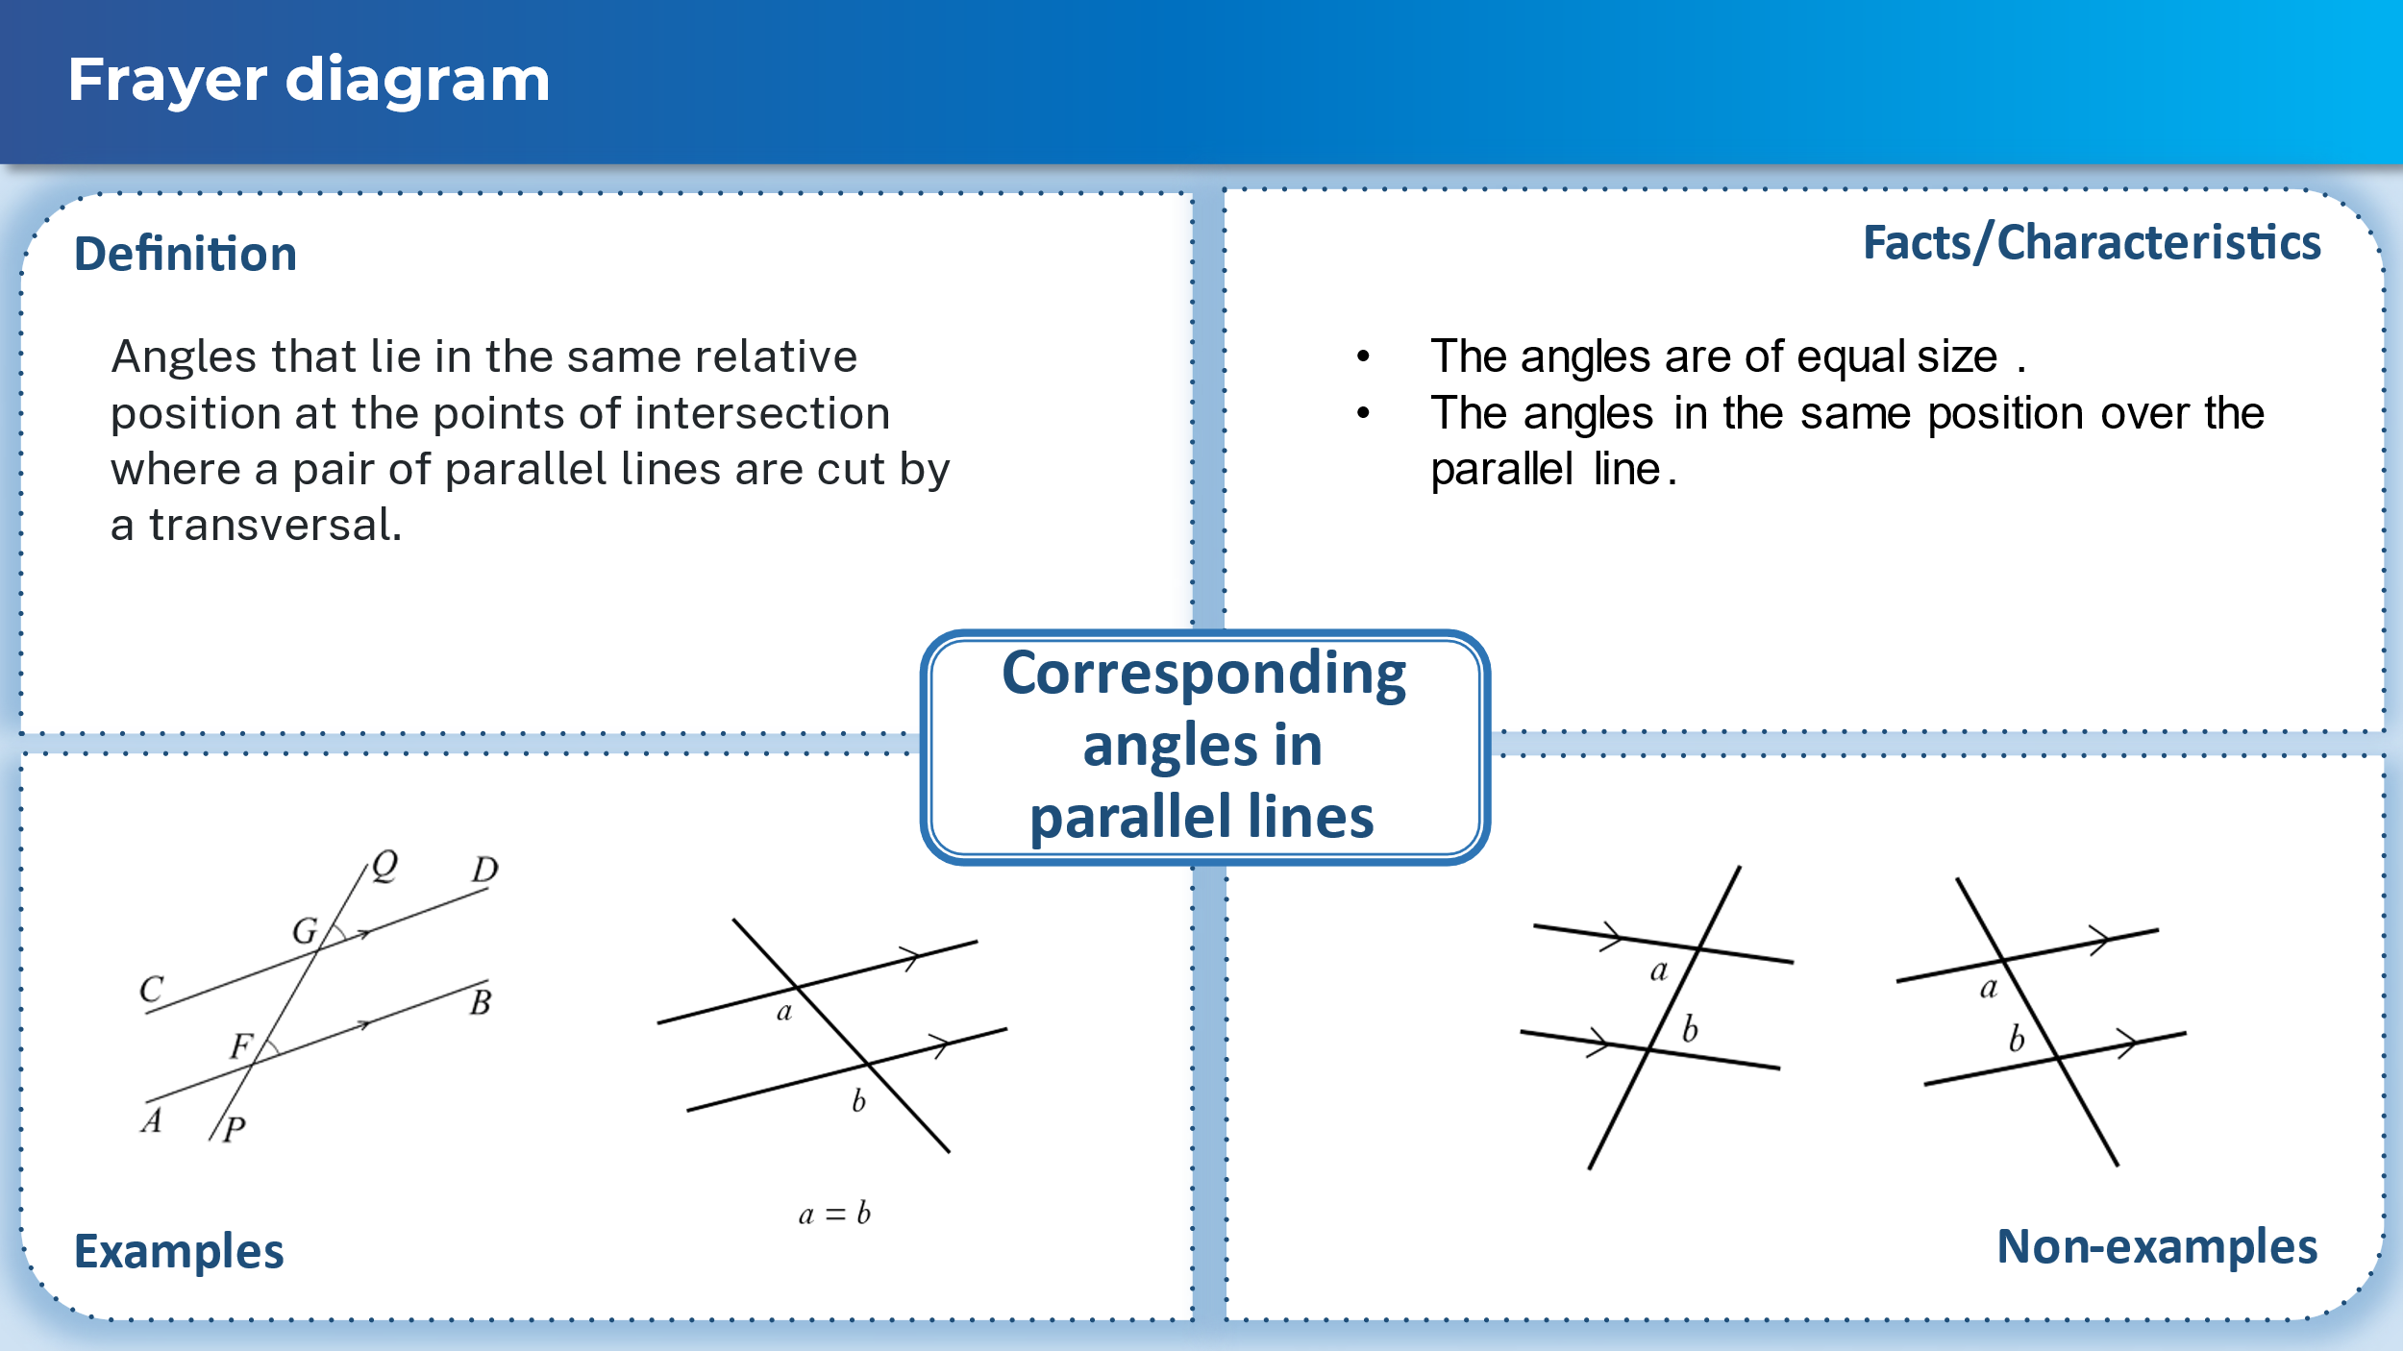

### Appendix C – angle problems

1. $∠FGA=68°$ as supplementary angles add to $180°$. $∠FGA=∠GEC=68°$ 
    as corresponding angles in parallel lines are equal.  
   Therefore $a=68°$
2. $∠HNL=62°$ as supplementary angles add to $180°$. $∠HNL=∠JON=62°$ 
    as corresponding angles in parallel lines are equal.  
   Therefore $b=62°$
3. $∠UZW=71°$ as corresponding angles in parallel lines are equal. $∠UZW+∠ZUW+∠UWZ=180°$ 
    as the angle sum of a triangle is $180°$  
   Therefore $71+81+c=180$ Therefore $c=28°$
4. $∠IJE=110°$ as corresponding angles in parallel lines are equal. $∠HJE=d$ 
    as corresponding angles in parallel lines are equal. $∠IJE$ 
   and $∠HJE$ are supplementary angles.  
   Therefore $180-110=70°$  
   So $d=70°$
5. $∠VZR=70°$ as corresponding angles in parallel lines are equal. $∠ZAT=70°$ 
    as corresponding angles in parallel lines are equal. $∠ZAS$ 
    and $∠ZAT$ are supplementary angles.  
   Therefore $180-70=110$  
   So $e=110°$
6. $∠MLI=109°$ as corresponding angles in parallel lines are equal. $∠MLI$ 
    and $∠JLM$ are supplementary angles.  
   Therefore $180-109=71$  
   So $e=71°$
7. $∠MLI=5c$ as corresponding angles in parallel lines are equal. $∠MLI$ 
    and $∠JLM$ are supplementary angles.  
   Therefore $5c+4c=180°$  
   So $9c=180°$  
   So $c=20°$
8. $∠VZR=d$ as corresponding angles in parallel lines are equal. $∠ZAT=d$ 
    as corresponding angles in parallel lines are equal. $∠ZAT$ 
    and $∠ZAS$ are supplementary angles.  
   Therefore $3d+d=180°$  
   So $4d=180°$  
   So $d=45°$
9. $∠OTU=6g$ as corresponding angles in parallel lines are equal. $∠OTU$ 
    and $∠OTR$ are supplementary angles.  
   Therefore $14g+6g=180°$  
   So $20g=180°$  
   So $d=9°$
10. $∠EFC=n$ as corresponding angles in parallel lines are equal. $n+54=2n$ 
     as the sum of the 2 interior angles of a triangle is equal to the opposite exterior angle.  
    Therefore $n=54°$

## References

This resource contains NSW Curriculum and syllabus content. The NSW Curriculum is developed by the NSW Education Standards Authority. This content is prepared by NESA for and on behalf of the Crown in right of the State of New South Wales. The material is protected by Crown copyright.

Please refer to the NESA Copyright Disclaimer for more information [https://educationstandards.nsw.edu.au/wps/portal/nesa/mini-footer/copyright](https://aus01.safelinks.protection.outlook.com/?url=https%3A%2F%2Feducationstandards.nsw.edu.au%2Fwps%2Fportal%2Fnesa%2Fmini-footer%2Fcopyright&data=05%7C01%7CCaitlin.Pace1%40det.nsw.edu.au%7C9c2c1a9f59c94d2df30708dafa7edb23%7C05a0e69a418a47c19c259387261bf991%7C0%7C0%7C638097720042599463%7CUnknown%7CTWFpbGZsb3d8eyJWIjoiMC4wLjAwMDAiLCJQIjoiV2luMzIiLCJBTiI6Ik1haWwiLCJXVCI6Mn0%3D%7C3000%7C%7C%7C&sdata=BzQh0UsffVZE3eO22b2Xba3p0VMOBZSHfS21FGHXtZM%3D&reserved=0).

NESA holds the only official and up-to-date versions of the NSW Curriculum and syllabus documents. Please visit the NSW Education Standards Authority (NESA) website <https://educationstandards.nsw.edu.au/> and the NSW Curriculum website <https://curriculum.nsw.edu.au/>.

[Mathematics K–10 Syllabus](https://curriculum.nsw.edu.au/learning-areas/mathematics/mathematics-k-10-2022/overview) © NSW Education Standards Authority (NESA) for and on behalf of the Crown in right of the State of New South Wales, 2022.

**© State of New South Wales (Department of Education), 2024**

The copyright material published in this resource is subject to the *Copyright Act 1968* (Cth) and is owned by the NSW Department of Education or, where indicated, by a party other than the NSW Department of Education (third-party material).

Copyright material available in this resource and owned by the NSW Department of Education is licensed under a [Creative Commons Attribution 4.0 International (CC BY 4.0) license](https://creativecommons.org/licenses/by/4.0/).

[](https://creativecommons.org/licenses/by/4.0/)

This license allows you to share and adapt the material for any purpose, even commercially.

Attribution should be given to © State of New South Wales (Department of Education), 2024.

Material in this resource not available under a Creative Commons license:

* the NSW Department of Education logo, other logos and trademark-protected material
* material owned by a third party that has been reproduced with permission. You will need to obtain permission from the third party to reuse its material.

**Links to third-party material and websites**

Please note that the provided (reading/viewing material/list/links/texts) are a suggestion only and implies no endorsement, by the New South Wales Department of Education, of any author, publisher, or book title. School principals and teachers are best placed to assess the suitability of resources that would complement the curriculum and reflect the needs and interests of their students.

If you use the links provided in this document to access a third-party's website, you acknowledge that the terms of use, including licence terms set out on the third-party's website apply to the use which may be made of the materials on that third-party website or where permitted by the *Copyright Act 1968* (Cth). The department accepts no responsibility for content on third-party websites.