Alternate views
Students explore alternate angles in parallel lines through their understanding and application of the angle sum of a triangle and supplementary angles.

Visible learning

Learning intentions
- To understand the relationship between alternate angles and parallel lines.
- To apply knowledge of alternate angles and other geometrical relationships to solve problems.

Success criteria
- I can identify and name alternate angles in parallel lines.
- I can calculate the size of unknown angles using knowledge of alternate angles in parallel lines.

Syllabus outcomes
A student:
- develops understanding and fluency in mathematics through exploring and connecting mathematical concepts, choosing and applying mathematical techniques to solve problems, and communicating their thinking and reasoning coherently and clearly MAO-WM-01
- applies angle relationships to solve problems, including those related to transversals on sets of parallel lines MA4-ANG-C-01
- identifies and applies the properties of triangles and quadrilaterals to solve problems
MA4-GEO-C-01
Mathematics K–10 Syllabus © NSW Education Standards Authority (NESA) for and on behalf of the Crown in right of the State of New South Wales, 2022.

Table 1: lesson summary
Section | Summary of activity | Teaching strategy | Teaching points
Launch | Show students an image of a braced farm gate from slide 3 of PowerPoint Alternate views and discuss the angles that can be observed. | Notice and wonder | Students look at a real-life example of a transversal crossing parallel lines and the angles it creates.
Explore | Students will replicate farm gate rails with parallel lines and use triangles to replicate the transversals. Students will use the angles from the triangle angle sum with supplementary angles to demonstrate that alternate angles are equal.  Students to do a card sort activity from Appendix A. | Visibly random groups of 3  Vertical non-permanent surface  Notice and wonder  Gallery walk | Students find alternate angles by connecting the angle sum of a triangle to the supplementary angles on a parallel line.
Summarise | Students complete worked examples from the PowerPoint, then complete the Frayer diagram in Appendix B, swap and give feedback.  Students respond to the launch question by calculating the size of the angles on the gate. Display slide 10 of PowerPoint. | Worked examples (Your turn)  Two stars and a wish | Students summarise the features of alternate angles and apply alternate angles to find information about the angles in the gate example from the Launch.
Apply | Students engage with Appendix C a scavenger hunt activity. Students are given a card and need to find their connection.  Students complete the activity from the PowerPoint on whether the lines are parallel as an exit ticket. | Visibly random groups of 3  Vertical non-permanent surface  Pose-Pause-Pounce-Bounce  Gallery walk  Exit ticket | Students should ensure they can explain their solution when solving the problems.

Activity structure
Please use the associated PowerPoint Alternate views to display images in this lesson.

Launch
Figure 1: farm gate
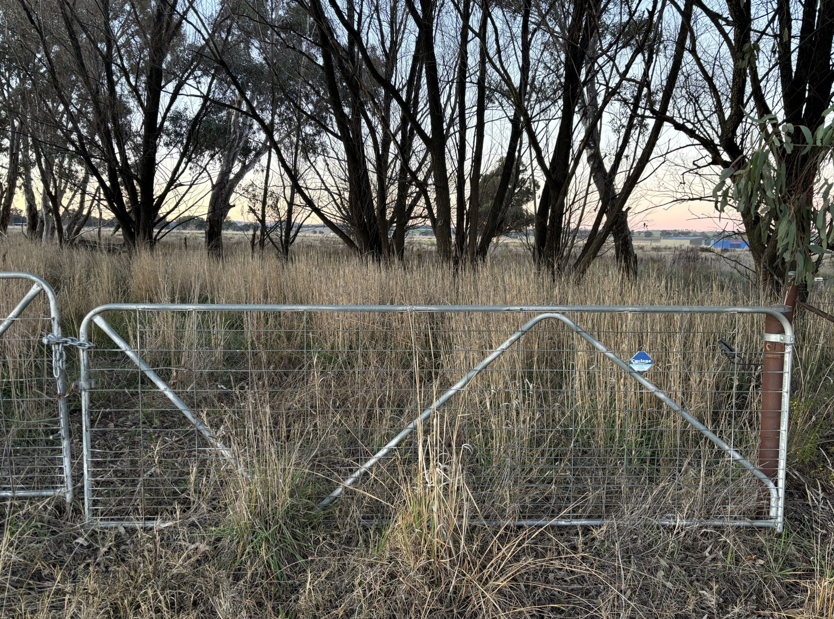
- Show students the image on slide 3 of the PowerPoint Alternate views, which is also displayed in Figure 1.
- Ask students to consider what they notice and wonder (bit.ly/noticewonderstrategy) about the farm gate.
Students may notice that the gate is rectangular, and the top and bottom rails are parallel, and the side rails are parallel. They may also notice that there are braces going from a bottom corner to the top rail, before dropping down and going back up again. Students may wonder why the braces are there or what purpose they serve. They may also wonder about the direction of the braces.
- To assist students in recognising the parallel rails and transversals, display slide 4 from the PowerPoint, where the gate has been replicated to show the parallel intervals and transversals that cut the parallel lines on the gate.

Explore
- Distribute a piece of A4 paper to each group.
- By working in visibly random groups of 3 (bit.ly/visiblegroups) on vertical non-permanent surfaces (bit.ly/VNPSstrategy), have students stick their A4 paper to their surface and draw 2 horizontal parallel lines on the whiteboard to simulate the upper and lower rails on the farm gate, as shown in Figure 2 and slide 6 of the PowerPoint Alternate views.
Diagrams from below are shown on the PowerPoint for students to reference.
Figure 2: whiteboard with A4 paper and parallel lines drawn in
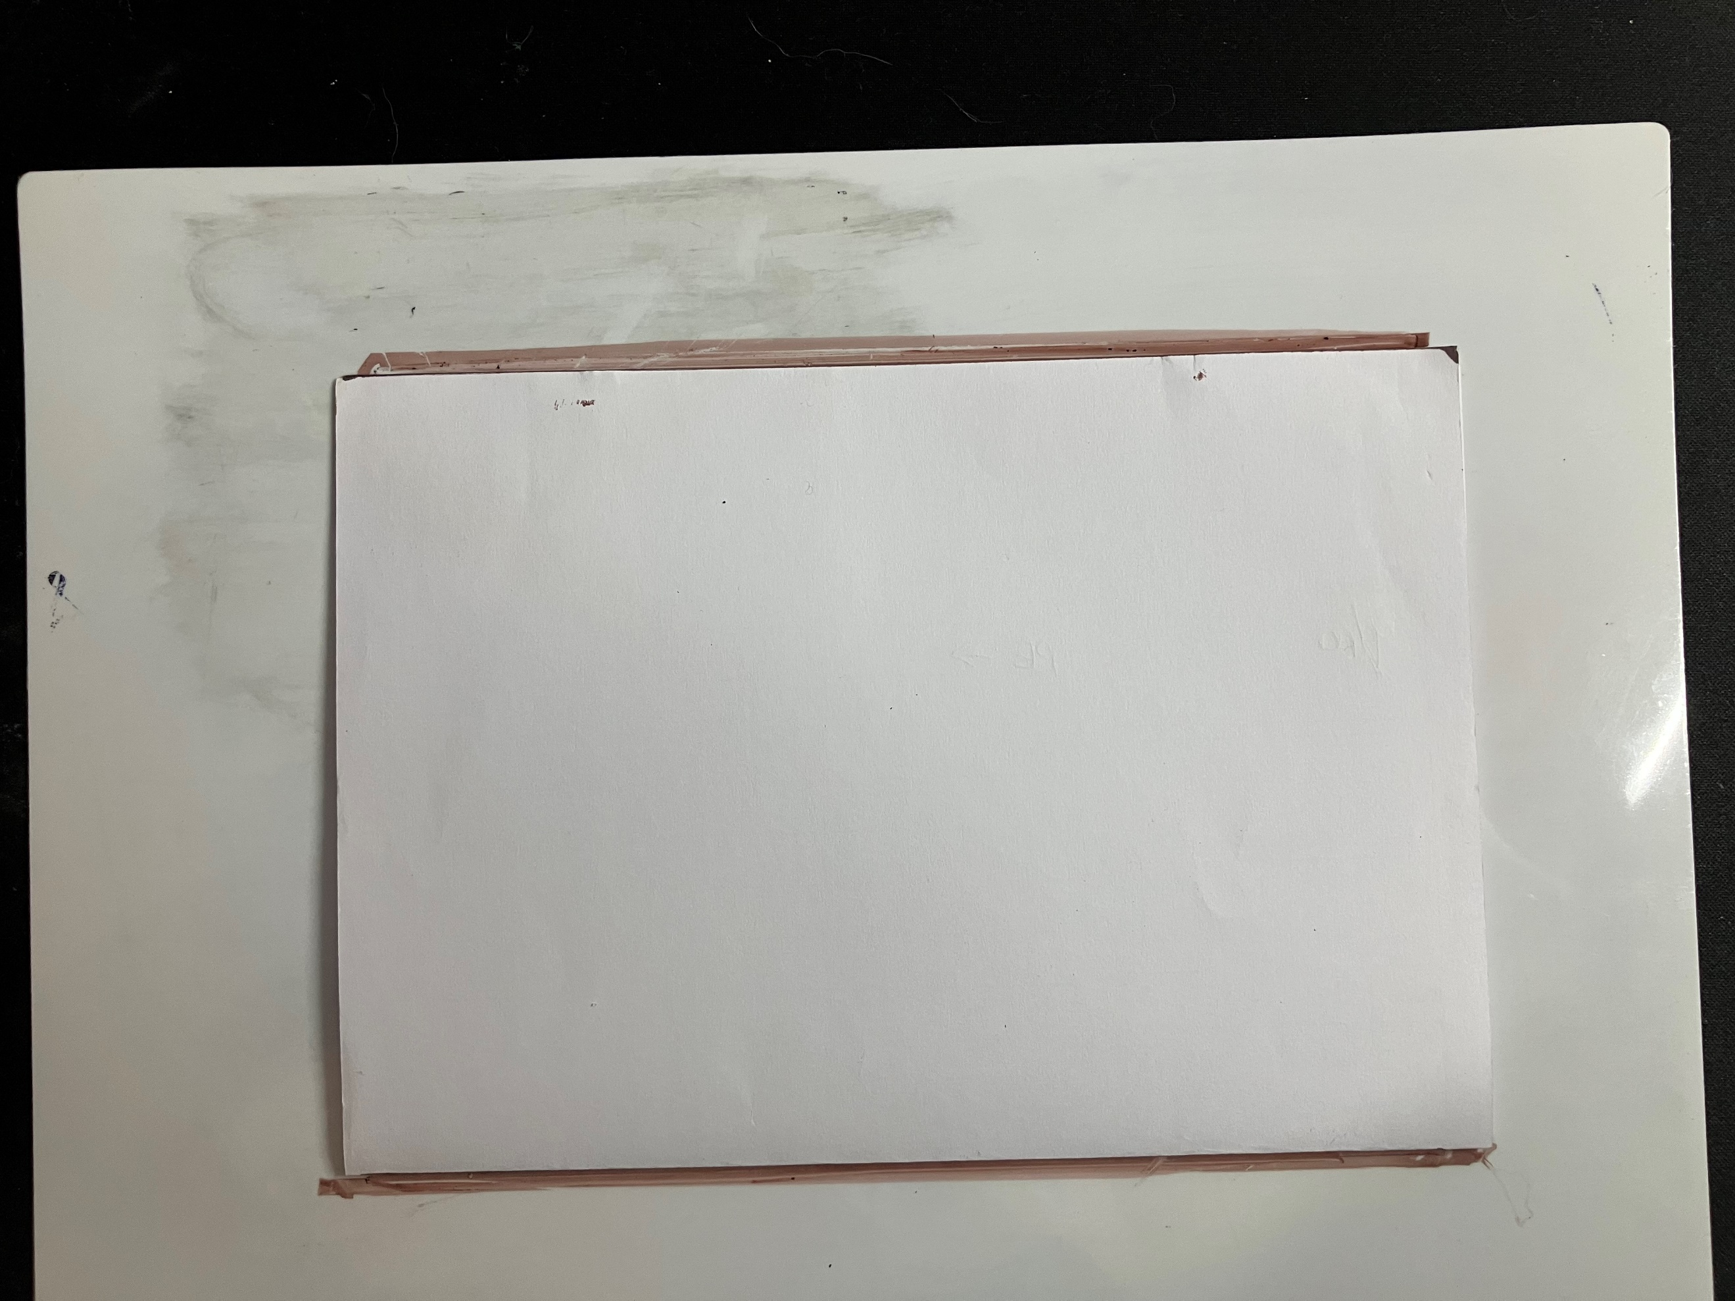
- Using one edge of the A4 paper as the base, construct a triangle with the apex on the top parallel line of the piece of paper as shown in Figure 3 and slide 6 of the PowerPoint Alternate views.
Figure 3: triangle on piece of A4 paper on whiteboard
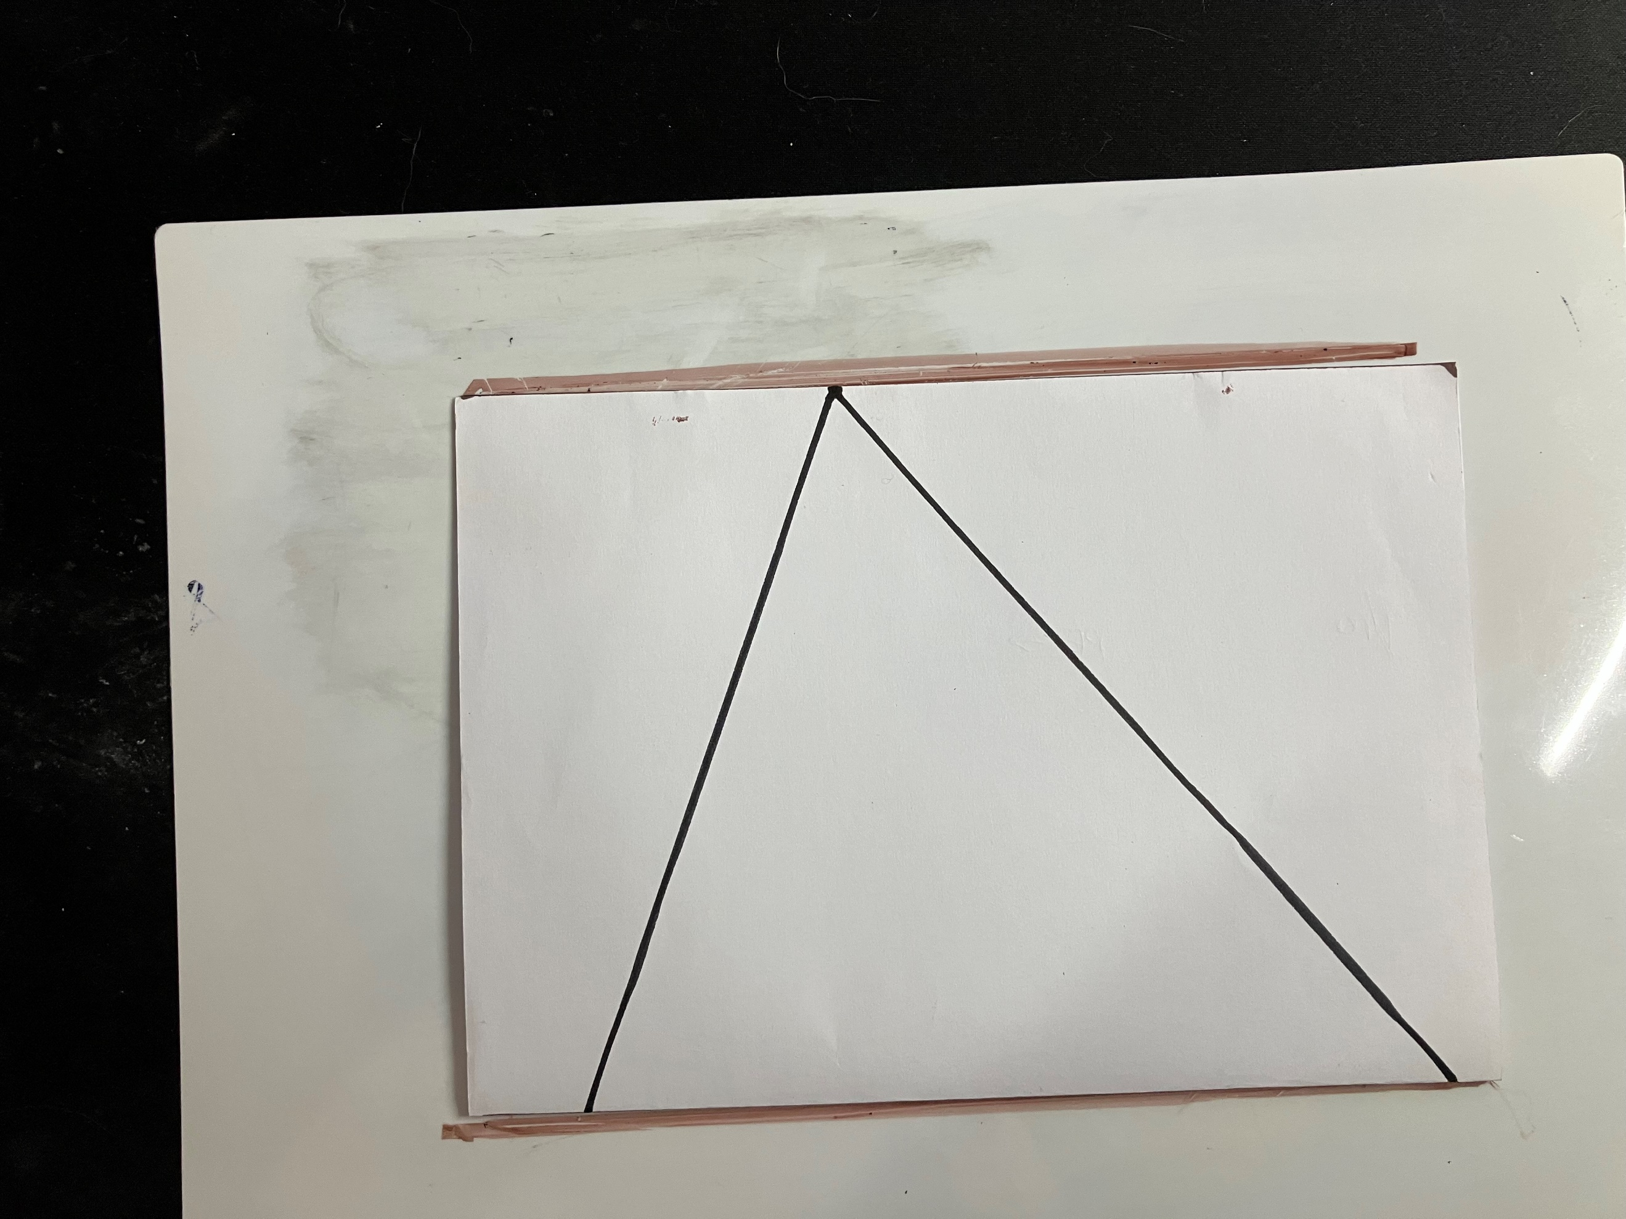
The triangle doesn’t need to go across the length of the A4 paper as shown above, but the activity will be more successful if the triangle uses a large portion of the paper.
- Students cut out their triangle and label the angles in the triangle A, B and C as shown in Figures 4 and 5 below and slide 6 and 7 of the PowerPoint Alternate views.
Figure 4: triangle ABC in between parallel lines
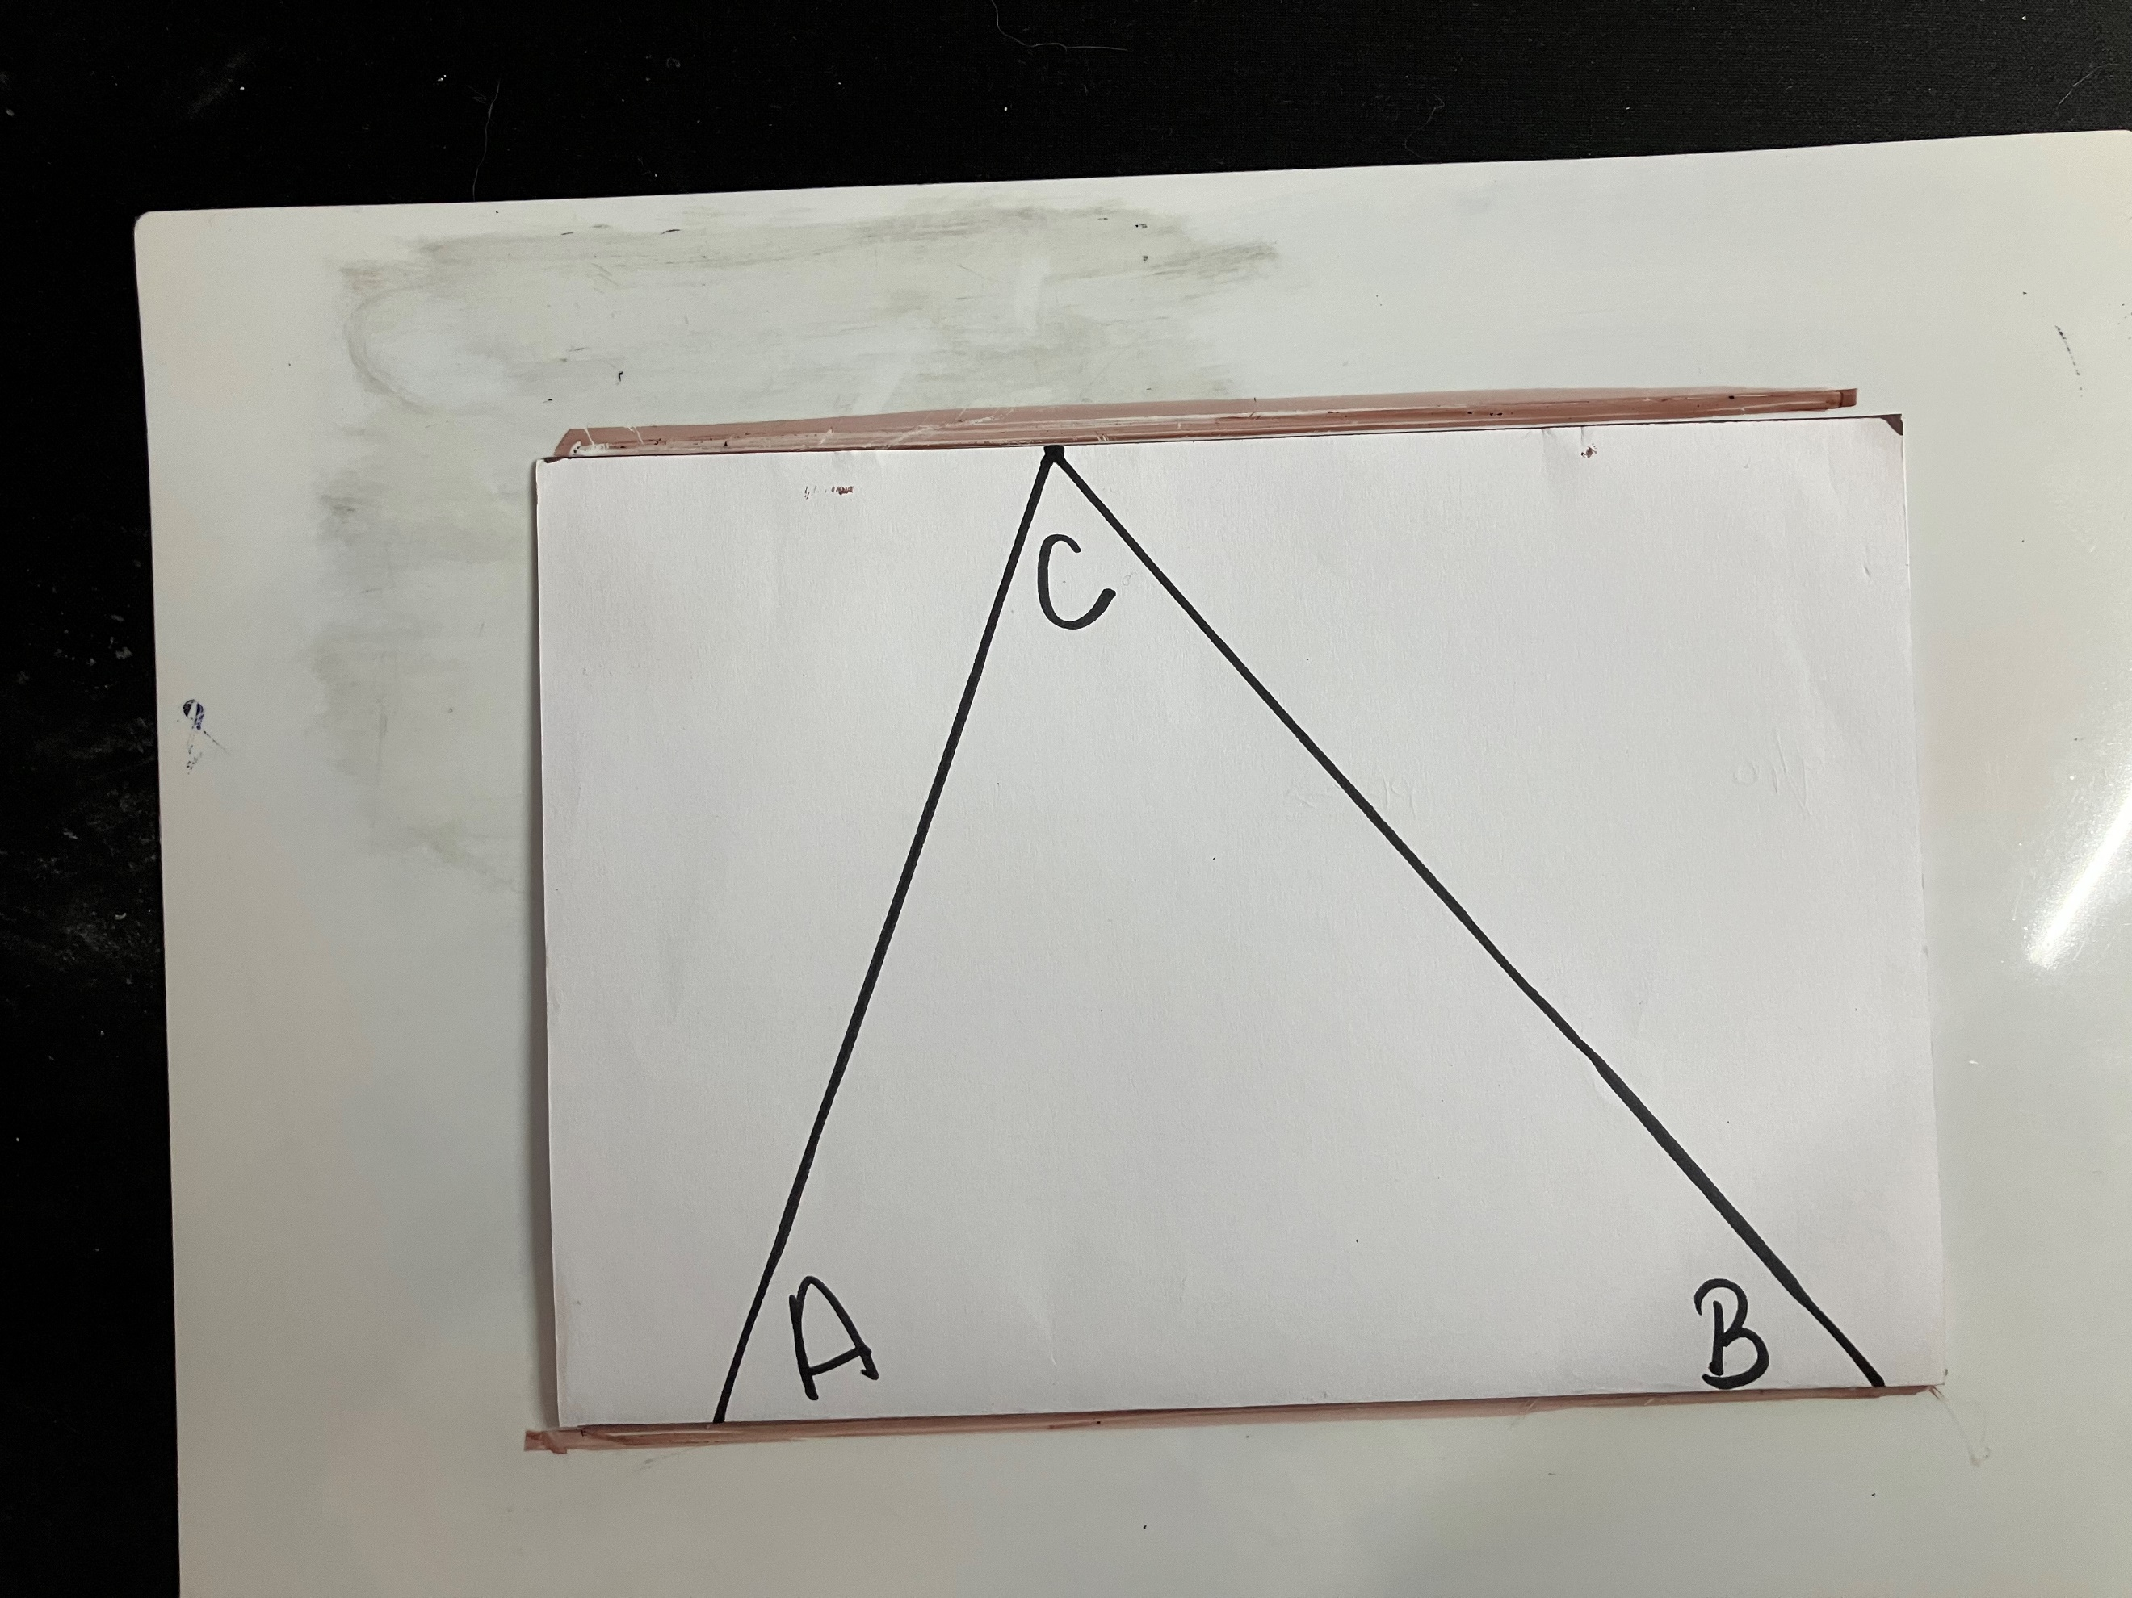
Figure 5: triangle ABC cut out
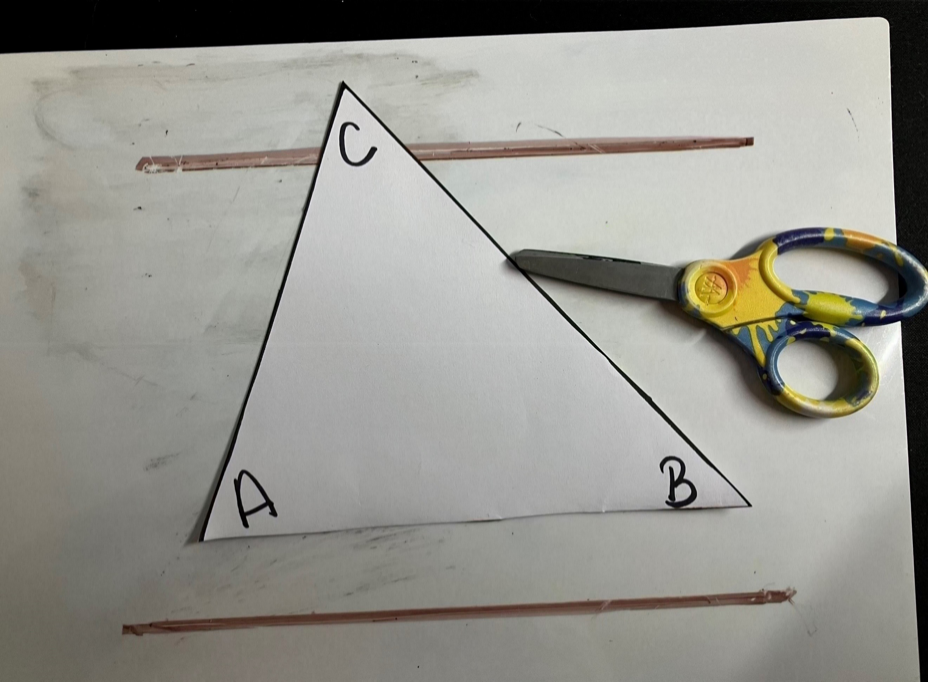
- Have students trace the sides of the triangle on to the vertical non-permanent surfaces as shown in Figure 6 and slide 7 of the PowerPoint Alternate views.
Figure 6: triangle ABC traced onto whiteboard
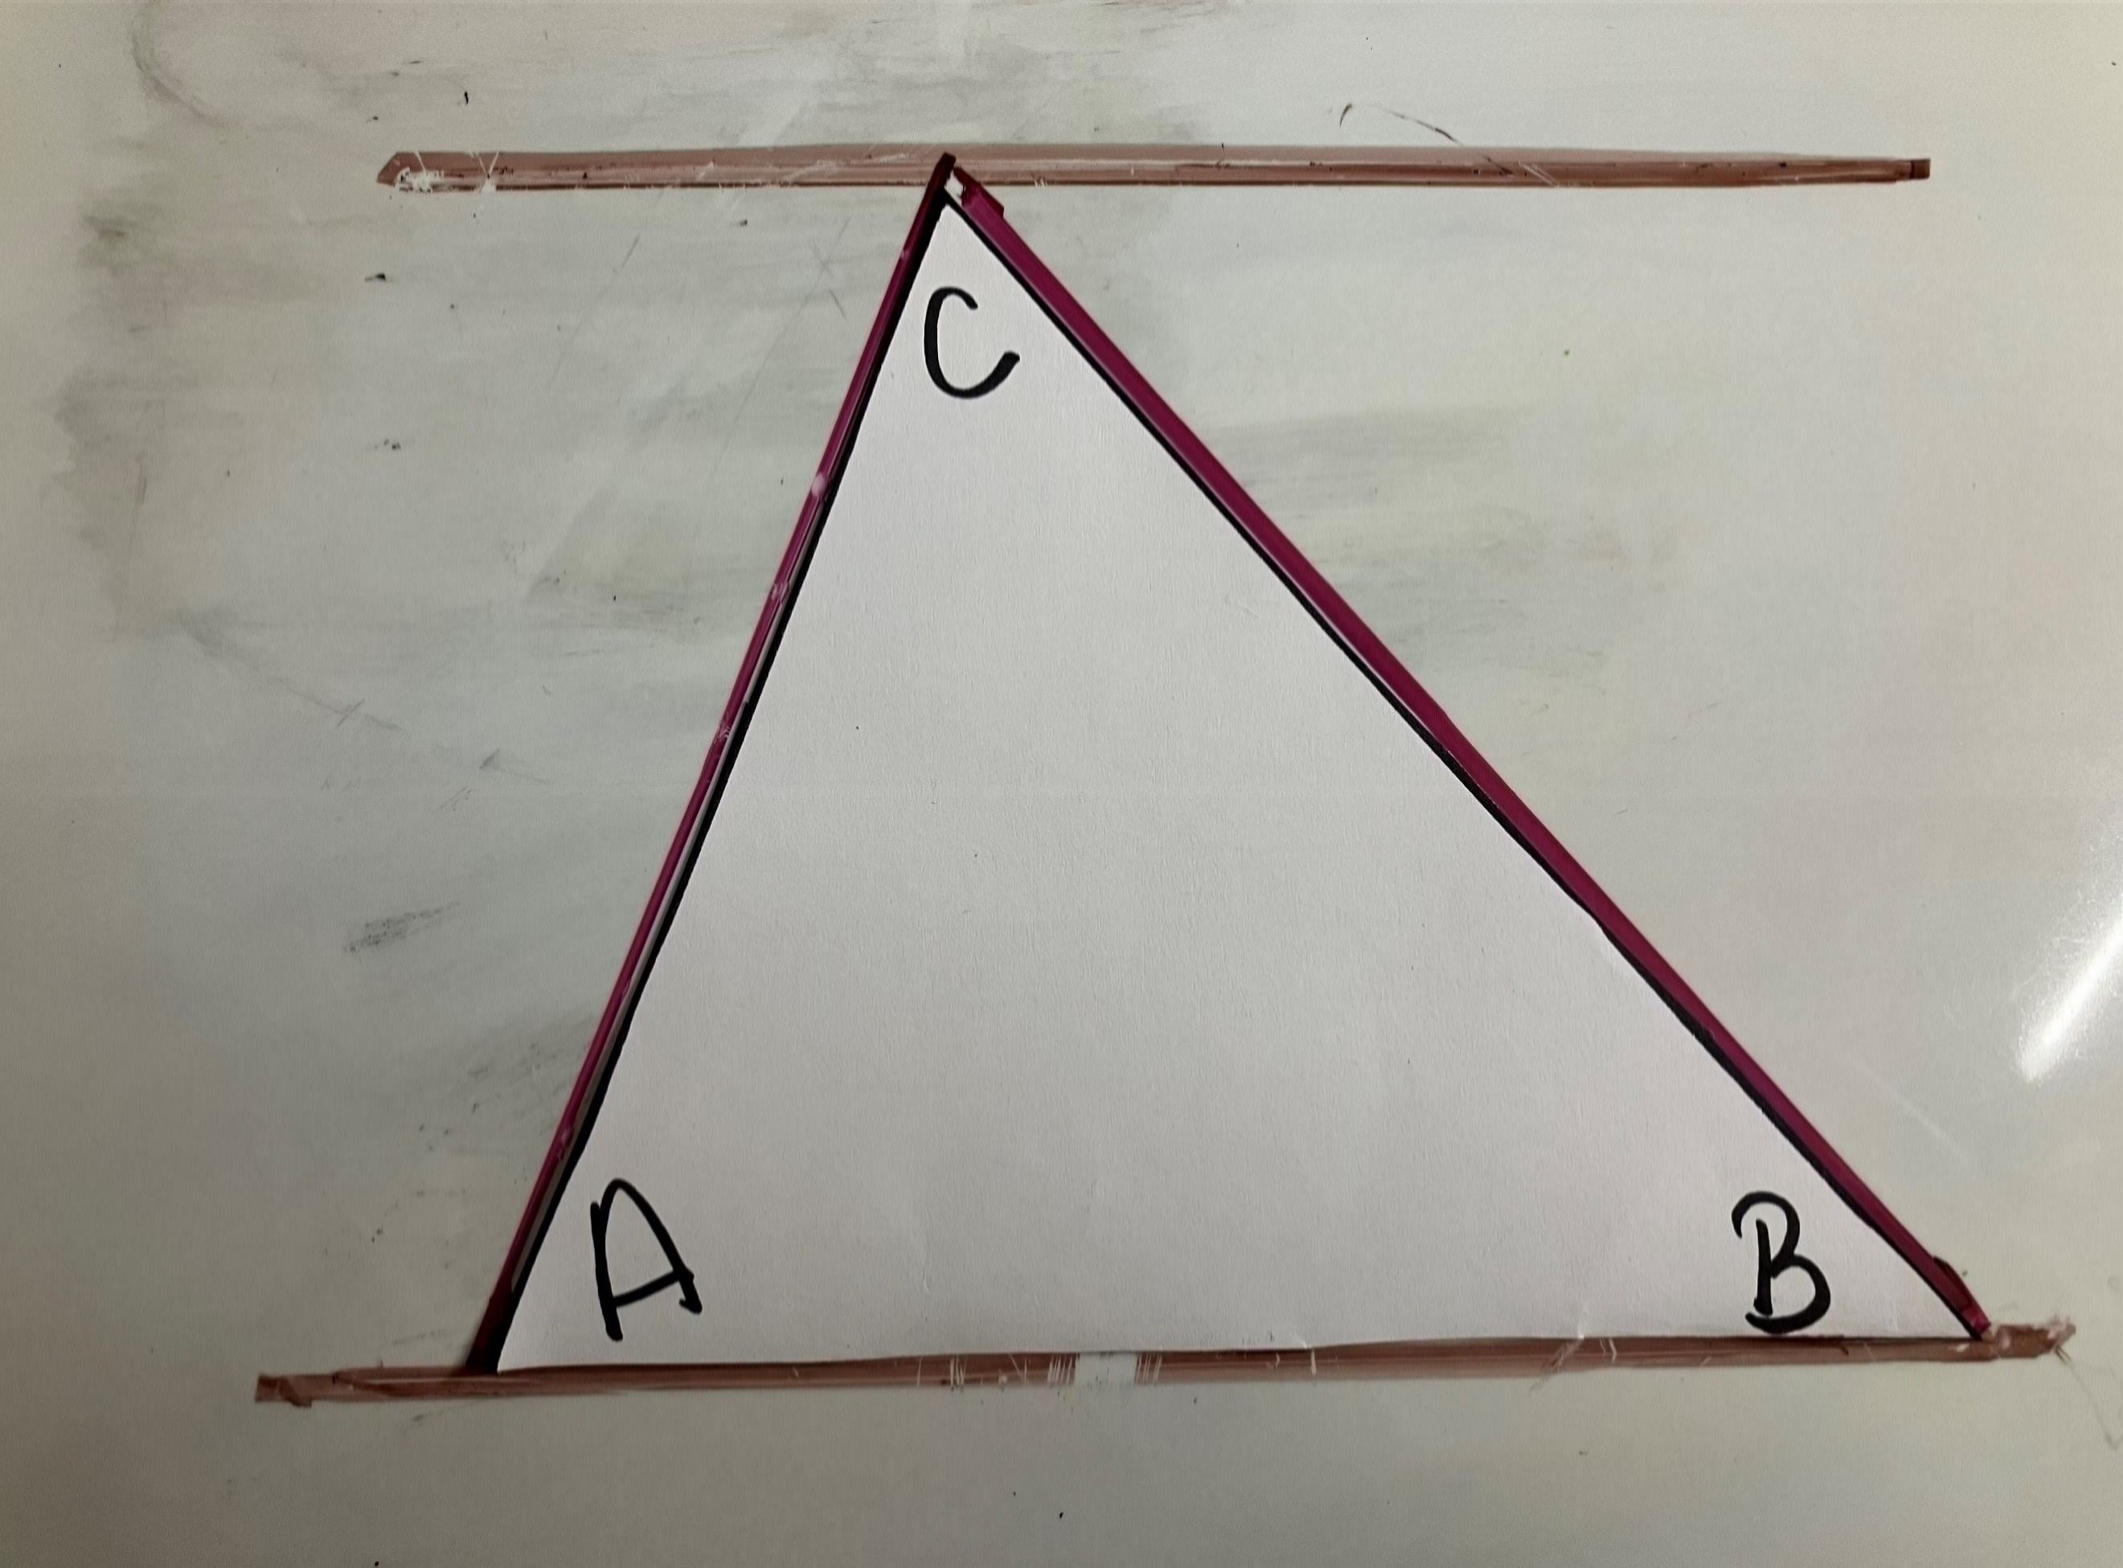
- Students tear off the corners of the triangle (at least 5 cm in length) as shown in Figures 7 and 8 and slide 7 of the PowerPoint Alternate views.
Figure 7: triangle with angles being torn
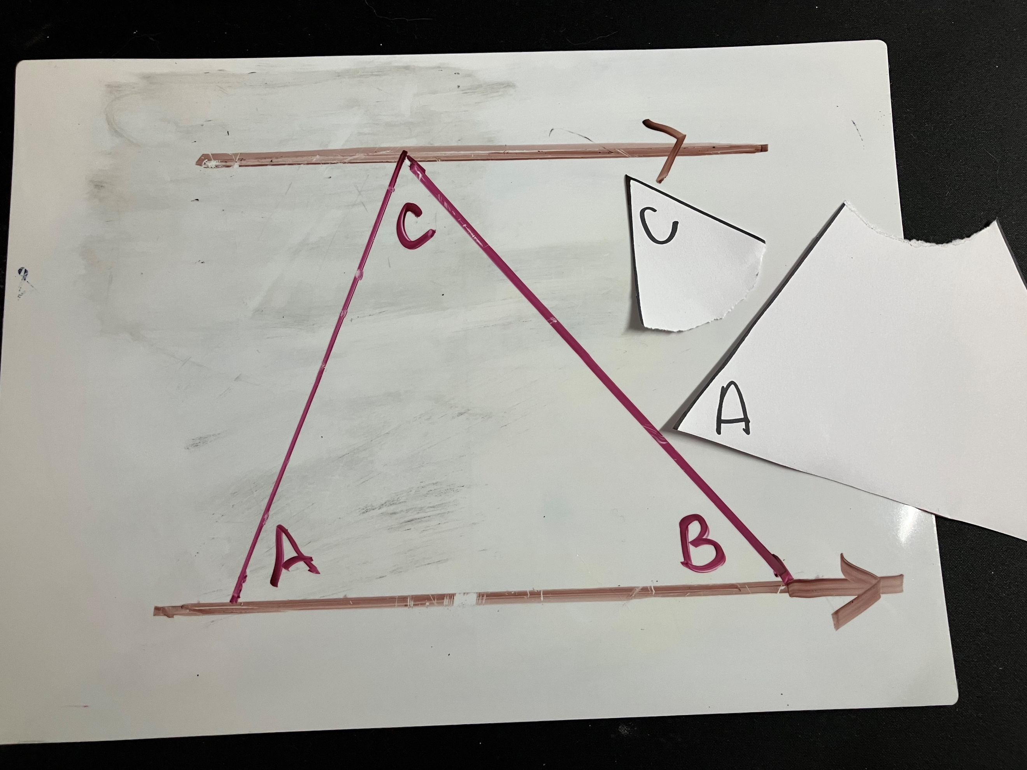
Figure 8: triangle with 3 angles torn off
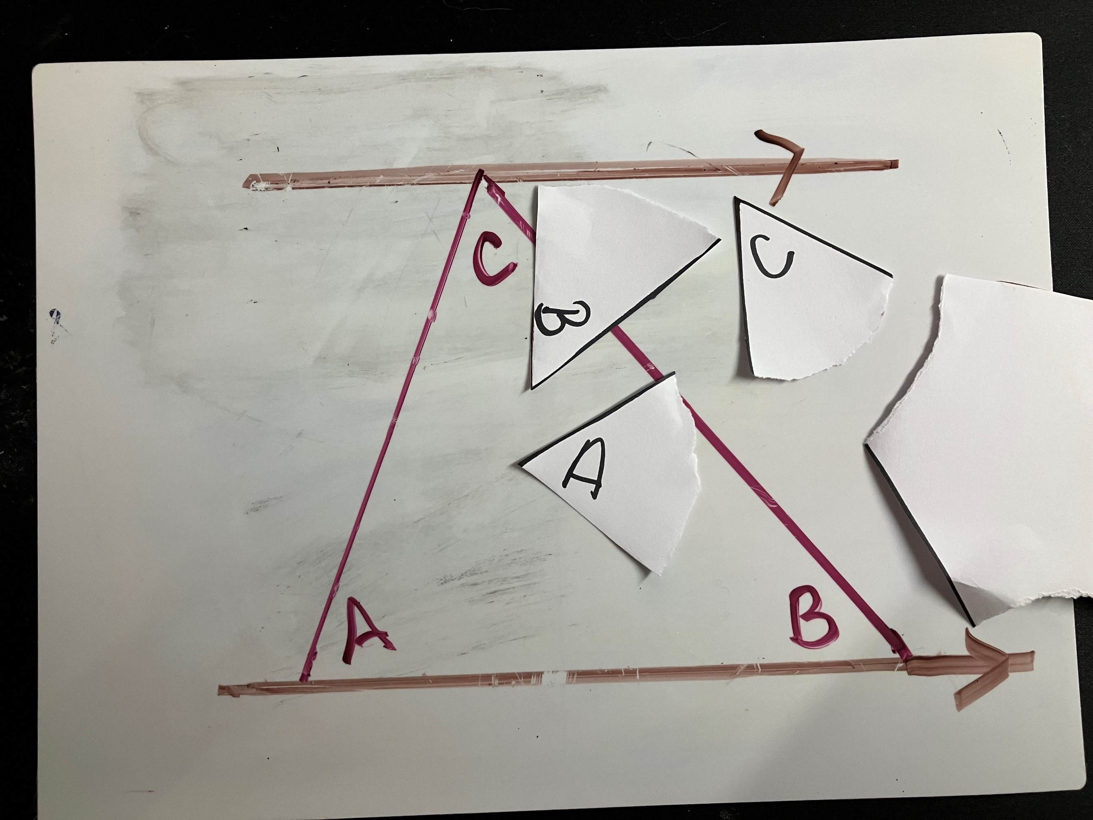
- Students use the 3 corners of the triangle to create a straight angle on the top parallel line as shown in Figure 9 and slide 8 of the PowerPoint Alternate views.
Figure 9: triangle on whiteboard with torn angles
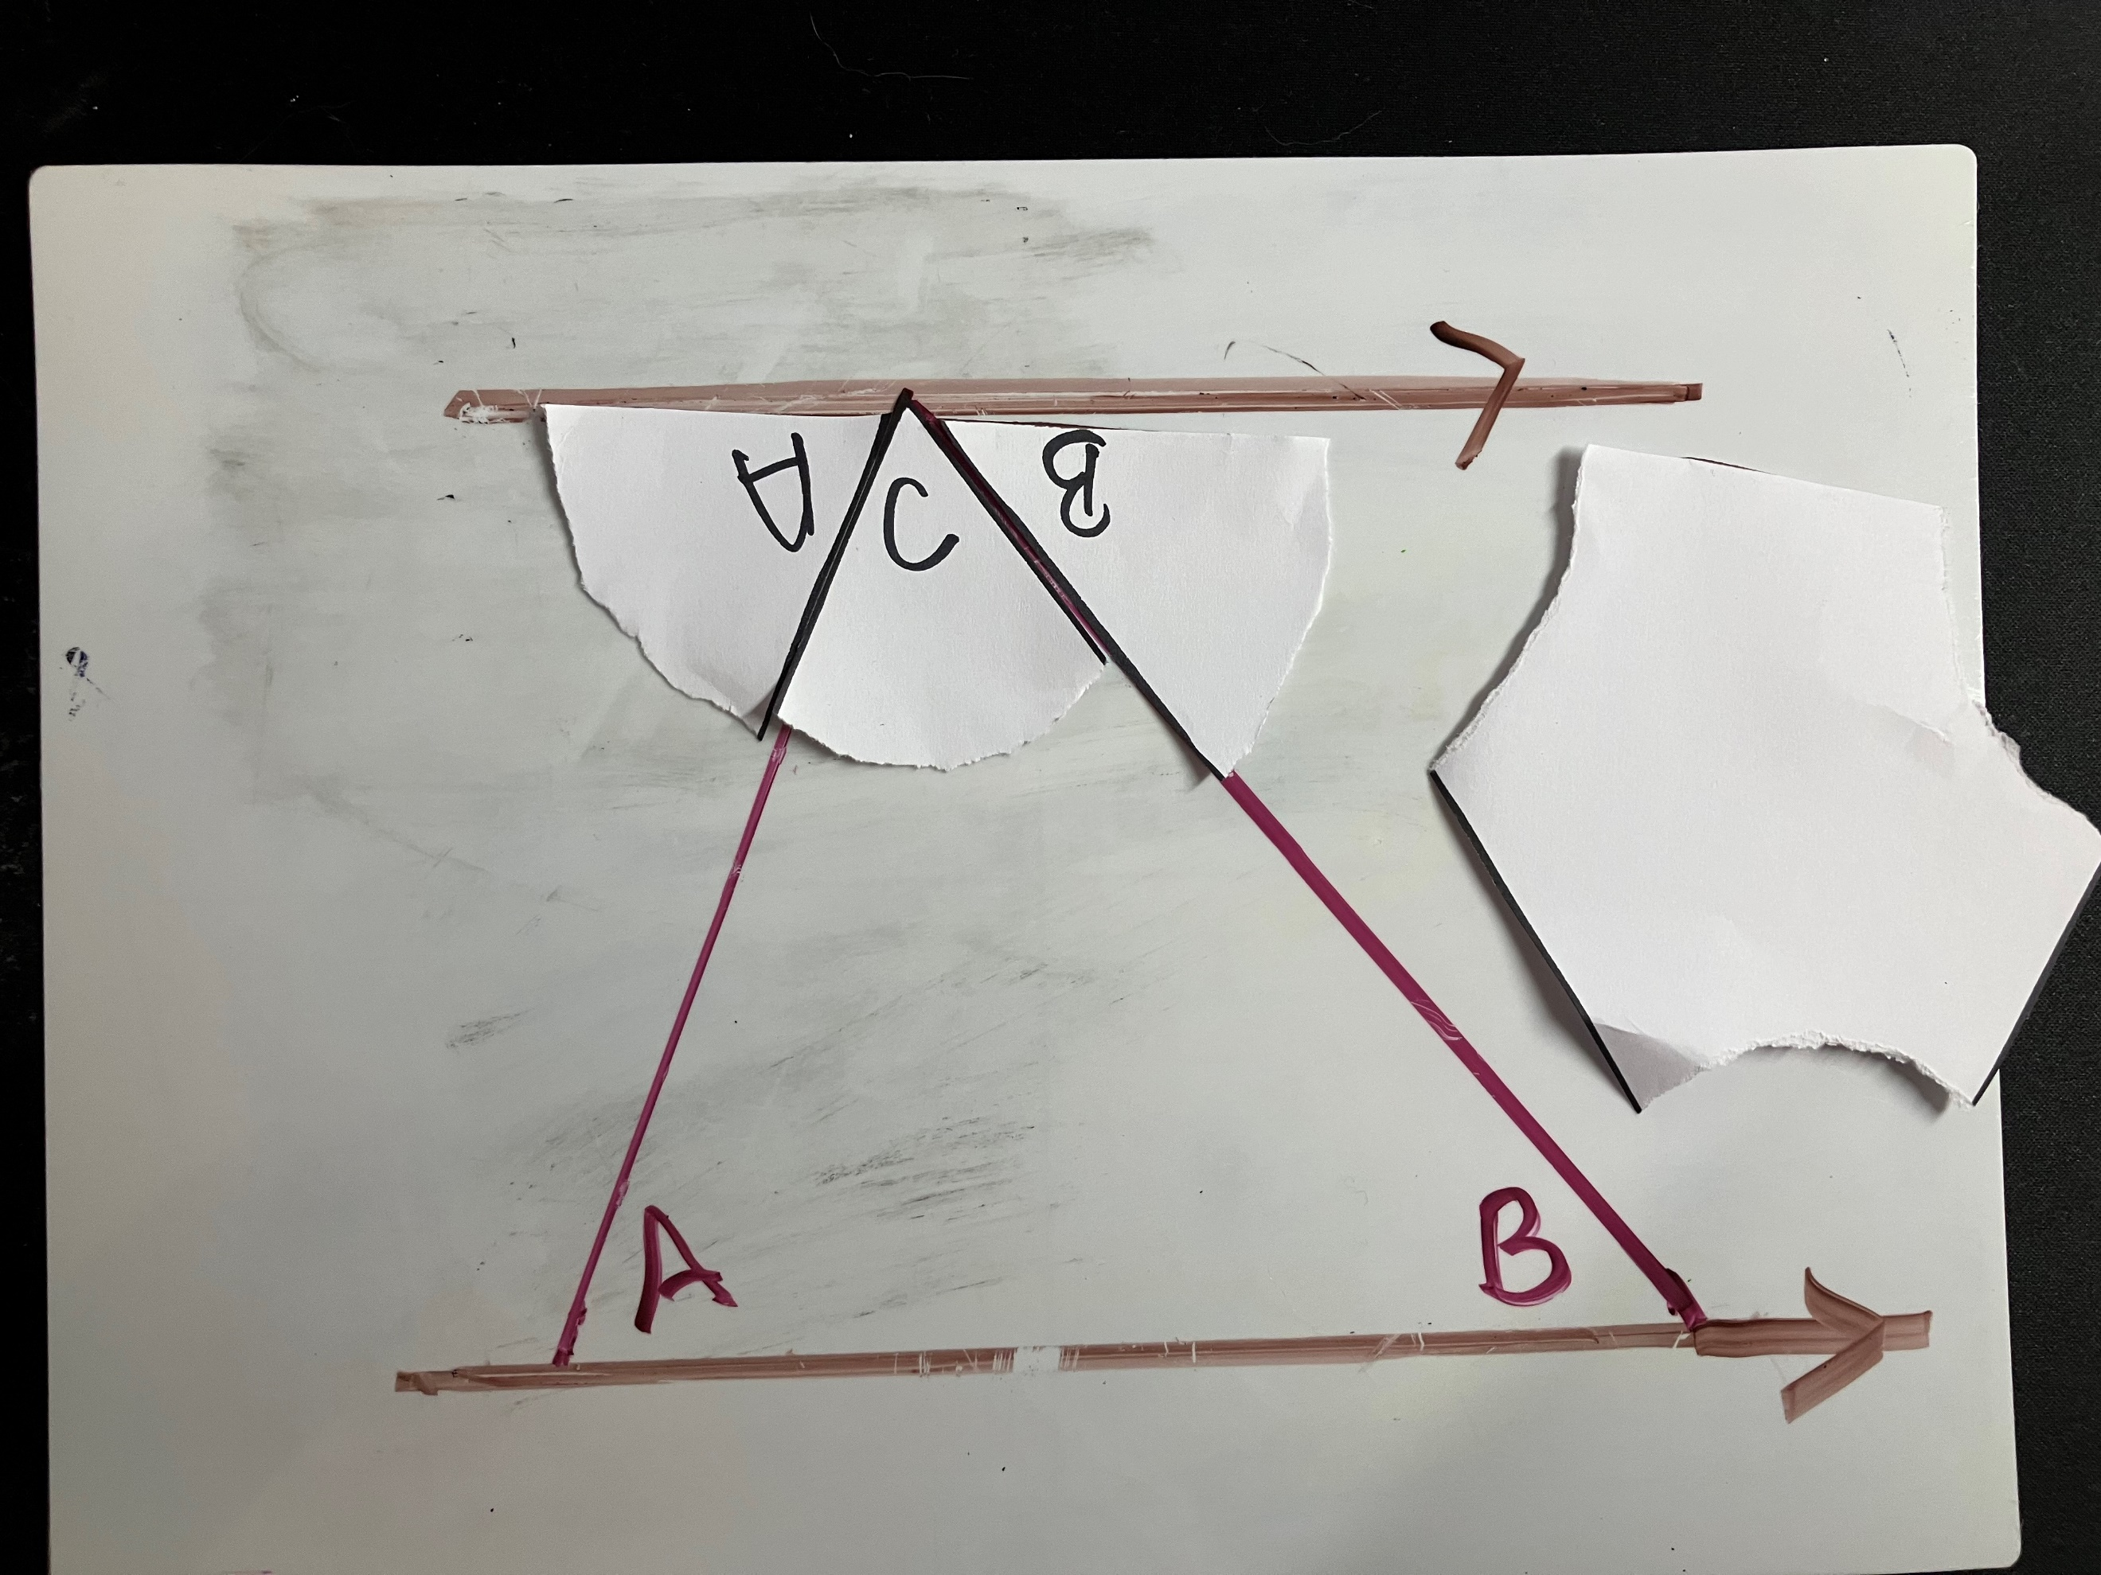
- Ask students to consider what they notice and what they wonder about the angles marked A, B and C.
Students may notice which angles are the same and where the equivalent angles are positioned in relation to each other.
- Challenge students to describe, by writing on their vertical non-permanent surfaces, the position of 2 equivalent angles.
- Students are to do a gallery walk (bit.ly/DLSgallerywalk) of the responses. Ask them to look at the way other groups described the positions of the equal angles.
Students should notice that each of the equal angles are on opposite sides, in opposite positions of the transversal in between the parallel lines. Some may use the term ‘alternate’ to describe this as they were describing the angles as alternate sides of the transversal.
- Distribute Appendix A ‘Card sort’ to each group of 3. Students are to group the cards into 2 columns on their vertical non-permanent surface using non-permanent adhesive, according to whether the angles shown are alternate angles or not.
Cards are already sorted in columns of alternate and non-alternate angles, so they must be cut up into individual cards sets before the lesson.

Summarise
- Use slides 10–13 from the PowerPoint for explicit teaching of alternate angles using the Worked examples (your turn) method (bit.ly/supportingstrategies). Distribute Appendix B ‘Frayer diagram’ to each student and ask them to complete the Frayer diagram (bit.ly/frayerdiagram) provided.
Students should look back at their Frayer model from Lesson 5 – the corresponding connection of Unit 11 – geometrical relationships and look at similarities and differences between the 2 angle types as they have the same value. The non-examples from alternate angles could be the examples from the previous lesson.
- Students are to swap Frayer diagrams and complete peer feedback in the form of Two stars and a wish (bit.ly/DLSpeerfeedback).
- Students are then to respond to the feedback to improve their Frayer diagrams.
Prompt students to use correct terminology on their Frayer diagrams, such as ‘angles created by a transversal on parallel lines’. Rather than supply peer feedback, the teacher could display terminology used in the lesson to revise or improve students’ Frayer diagrams.
- Display slide 14 from the PowerPoint which shows the original gate with angles marked on it.
- Students are to work in pairs to calculate the angles $a \text{and} b$ on the diagram by replicating the diagram and marking information they know about the angles on the diagram.
Solution to gate problem: $a=60°, b=45°$
It is at this point that students could be informed that gates such as this are made this way, with the brace directing into the bottom corner of the hinged edge to provide the most strength for the gate with the pressure and weight that gets placed on the open edge of the gate.

Apply
- Assign students to new visibly random groups of 3 to complete the scavenger hunt task from Appendix C ‘Scavenger hunt’.
- Print one set of question cards, separate each card, and place the cards around the room. A vertical non-permanent surface could be useful at each card to assist the groups with their calculations.
- Each group should start at one of the cards. The students work in their groups of 3 to solve the problem.
- Once a group has solved the problem, they need to move around the room to find the solution on another card. Once they have found their solution, they should solve the question attached to the solution and repeat the process.
- The activity is finished once the group returns to their original card.
Cards are printed in order so the solution to one question is the answer number on the next card.
- Students complete the exit ticket (bit.ly/exitticketstrategy) from slide 16 of the PowerPoint Alternate views.

Assessment and differentiation

Suggested opportunities for differentiation
Launch
- A notice and wonder strategy is used where there is no correct answer, so that all students can participate in the discussion.
- Challenge students to draw the rectangle, with the braces, and locate different angle types, such as vertically opposite angles, complementary angles, supplementary angles, corresponding angles and angles at a point.
Explore
- Students could be further challenged in the card sorting activity to identify all the angles that would be equal to a and b in the non-example cards.
- Students are working with peers in visibly random groups of 3 so can seek clarification and understanding from their peers.
Summarise
- Students can challenge themselves to use more unusual non-examples in the Frayer diagram.
- Students could be challenged to make a connection between the alternate angle and the other geometrical relationships they have studied. Students could demonstrate this by comparing notes from previous lessons.
- To enable students who are learning English as an additional language or dialect (EAL/D) to engage in class discussions, provide them with a dictionary or access to the internet to create a word wall or contribute words that have meaning in their language.
Apply
- The teacher can modify the questions in the scavenger hunt to more demanding or detailed questions if students need more challenging work.

Suggested opportunities for assessment
Explore
- The card sorting activity can provide feedback to teachers on a group’s understanding of what an alternate angle is.
Summarise
- The teacher could monitor students' written responses on the Frayer diagram to demonstrate understanding.
- The responses for the launch solution could be used as formative assessment for teachers.
Apply
- The exit ticket from slide 16 of the PowerPoint can be collected as evidence of learning.
- The teacher can monitor students’ progress and understanding as they work through the treasure hunt task by listening to how the students are developing their answers.

Appendix A

Card sort
Examples of alternate angles | Non-examples of alternate angles
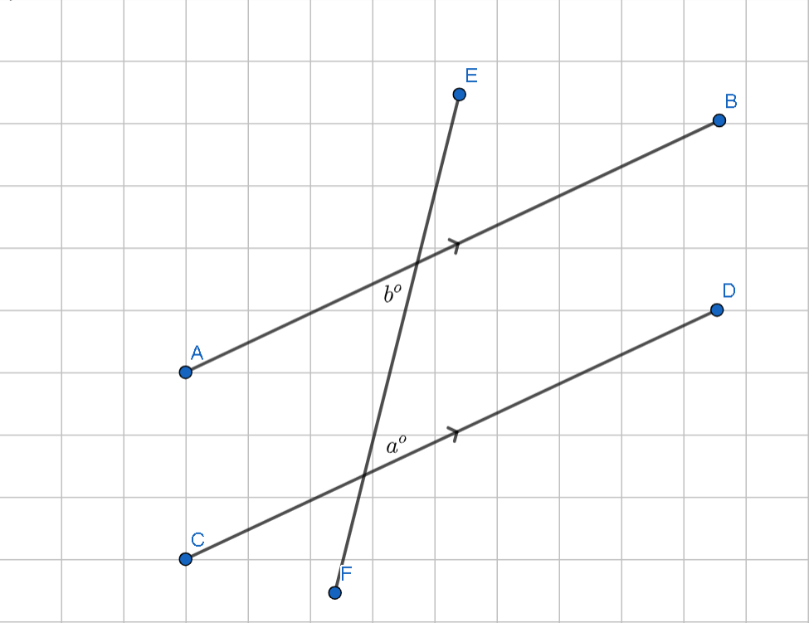 | 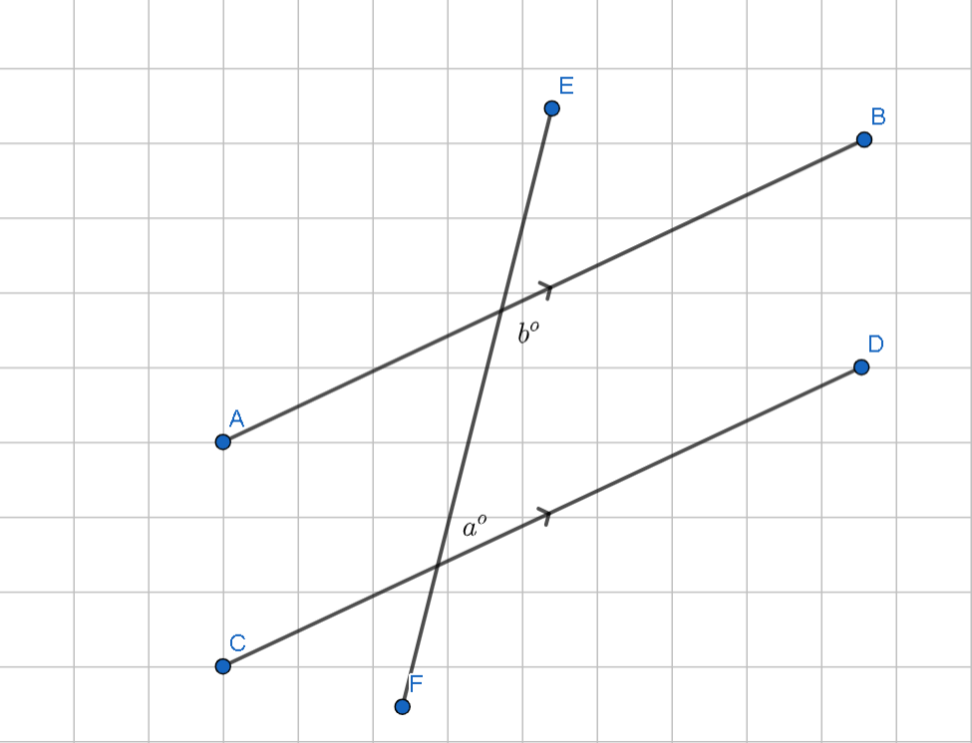
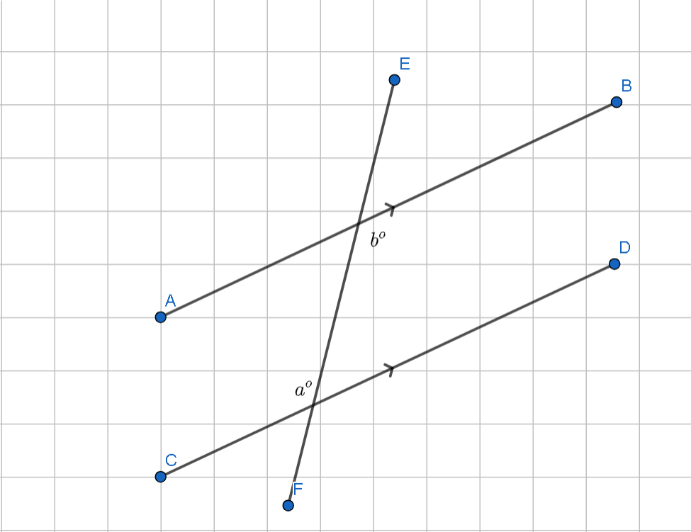 | 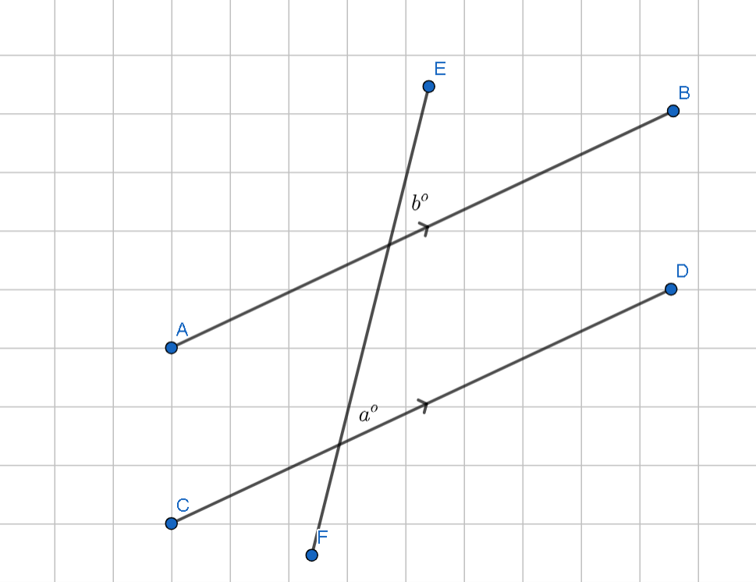
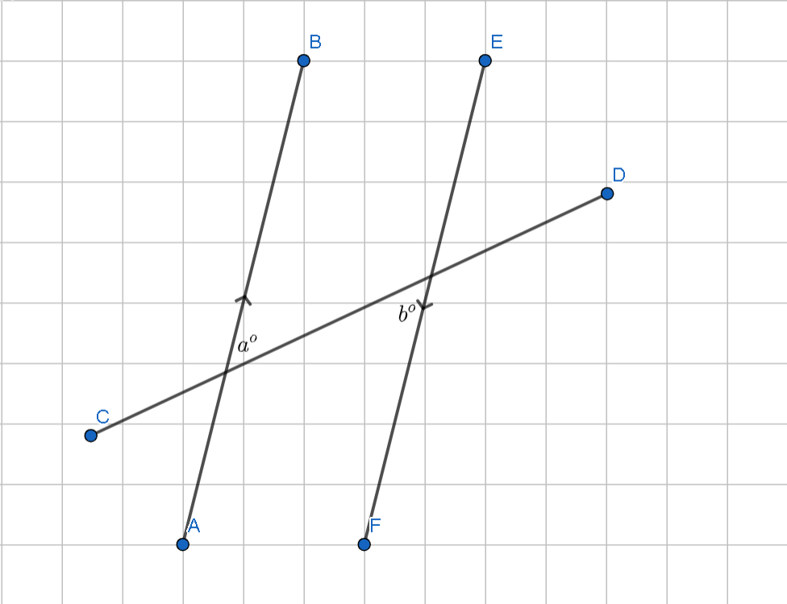 | 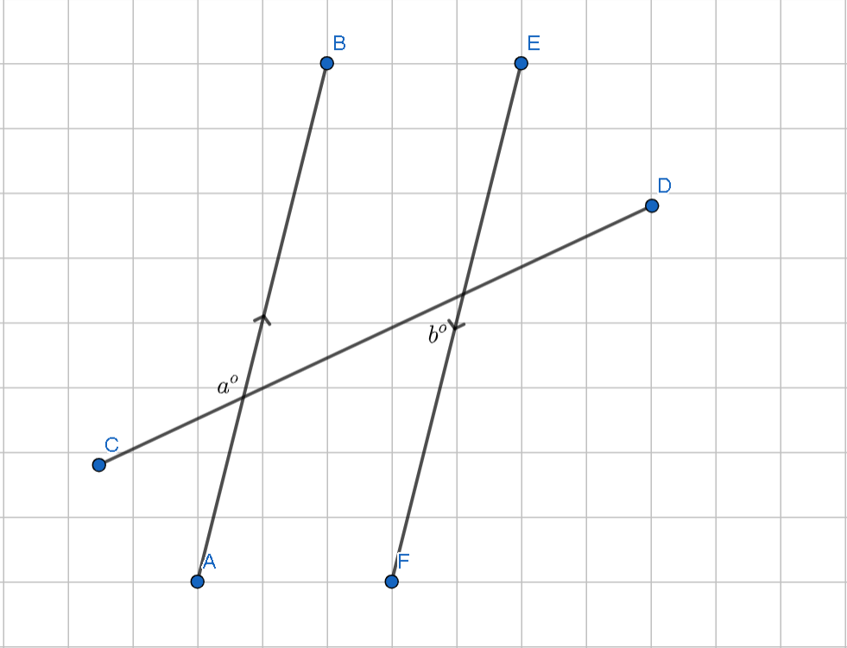
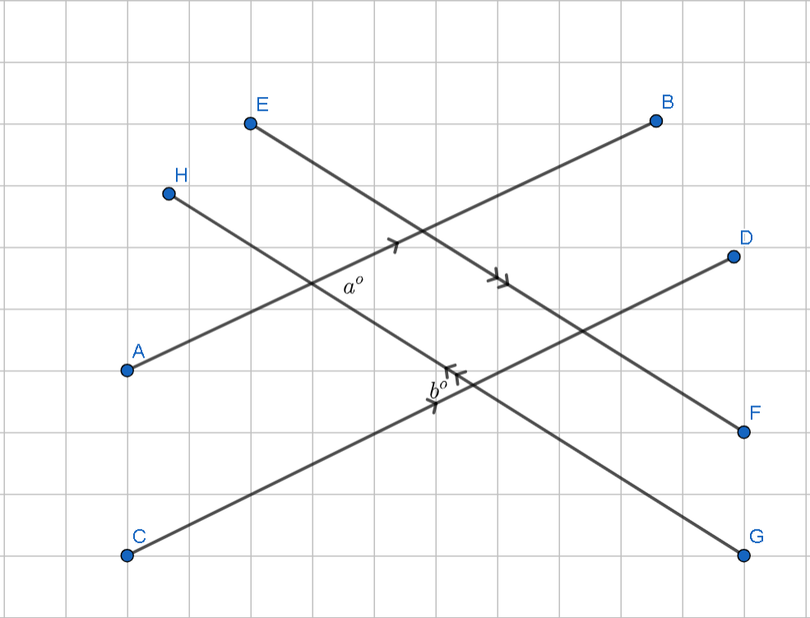 | 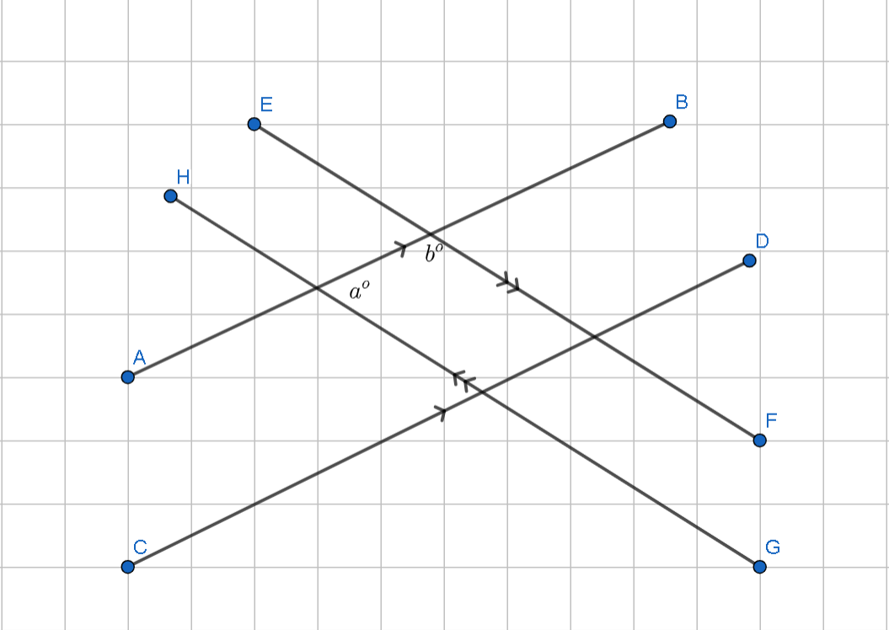
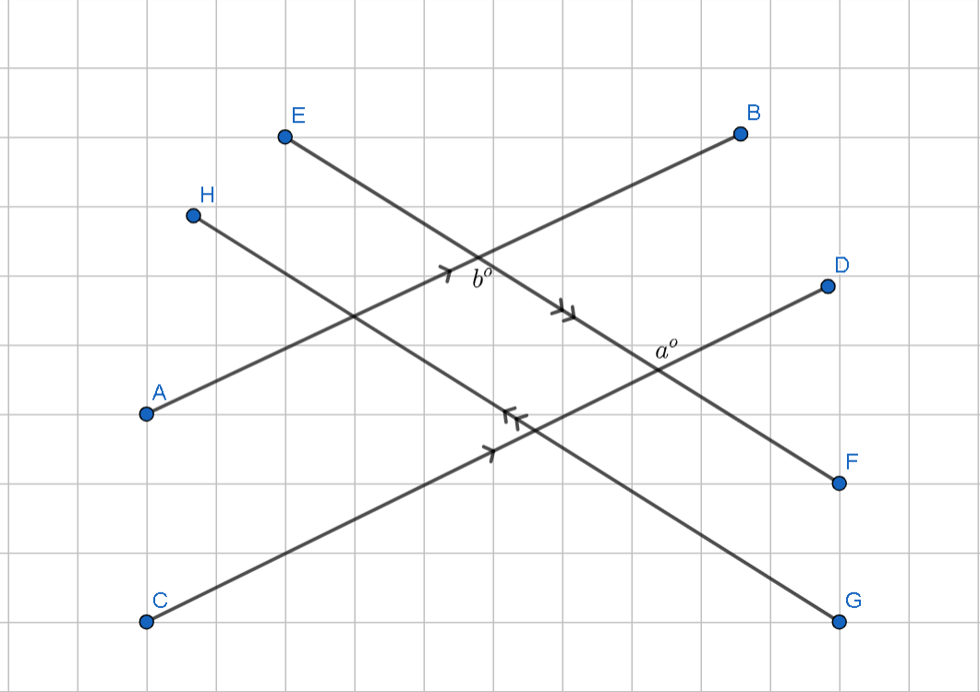 | 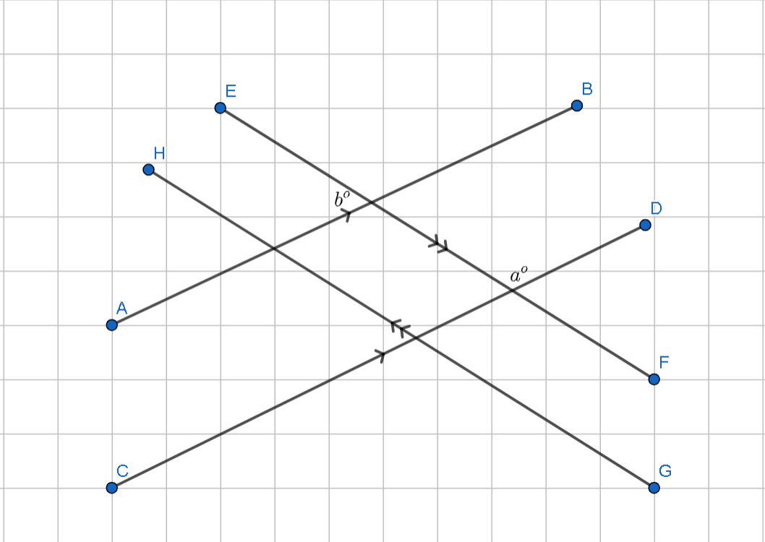
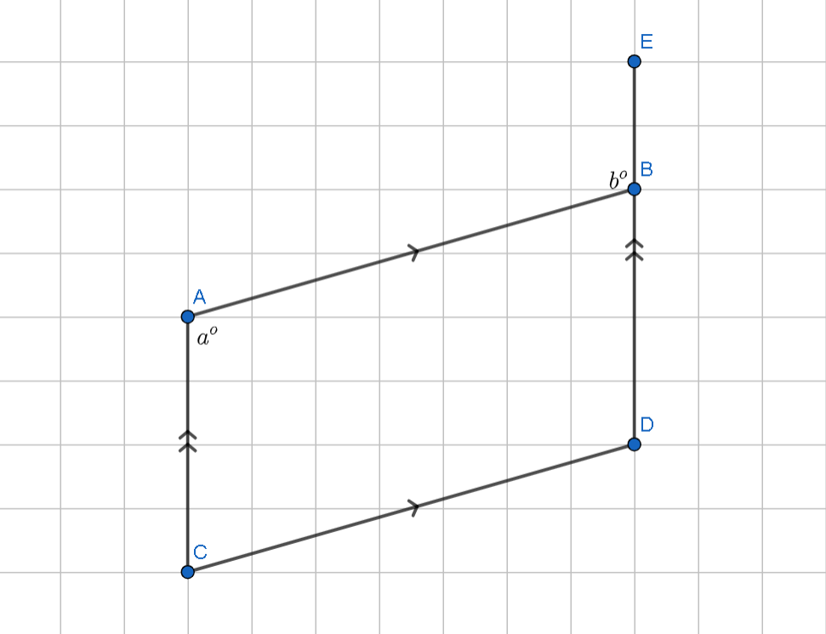 | 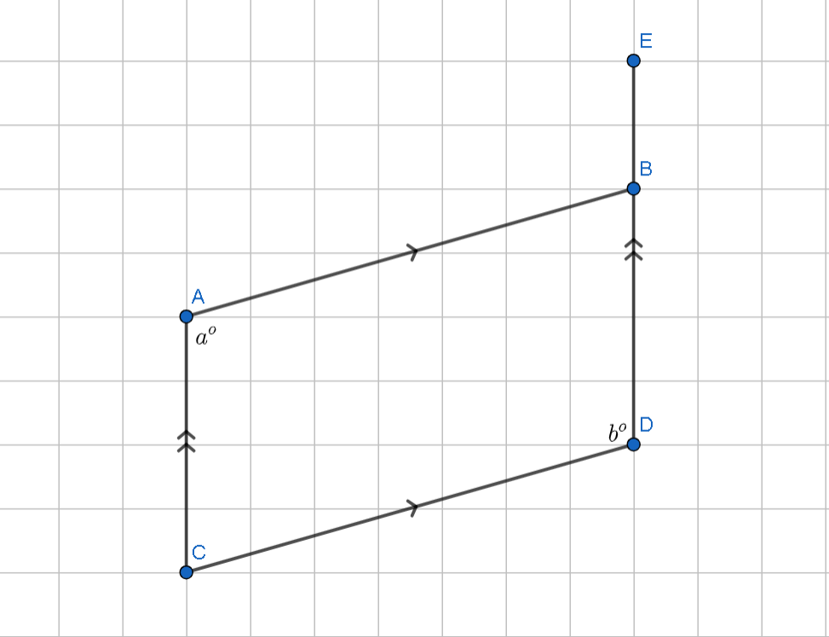
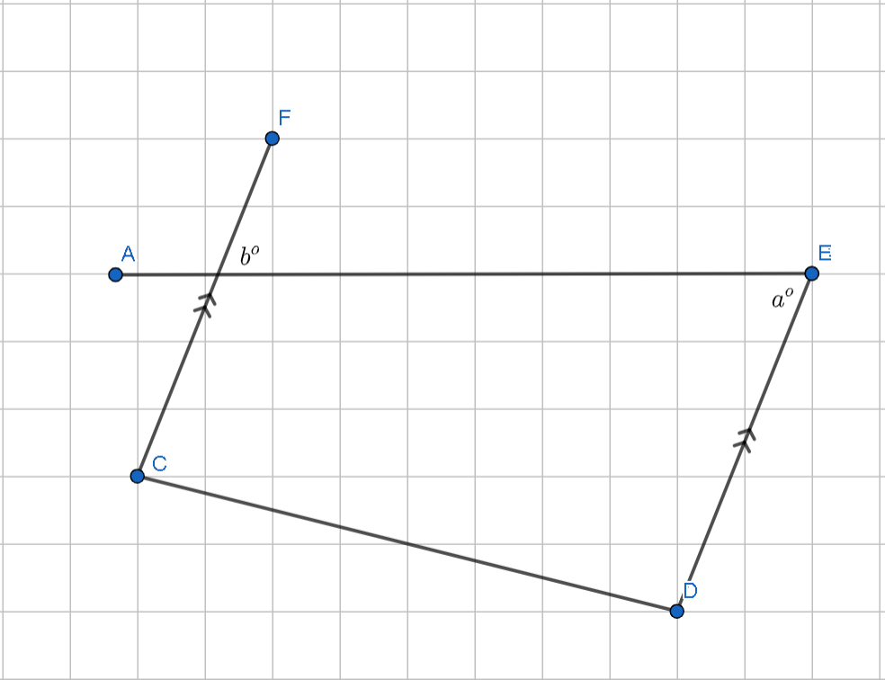 | 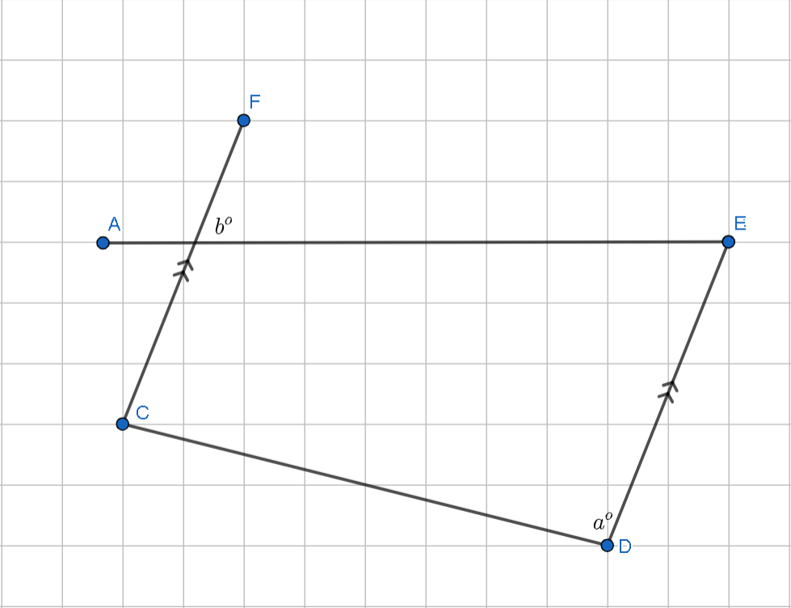
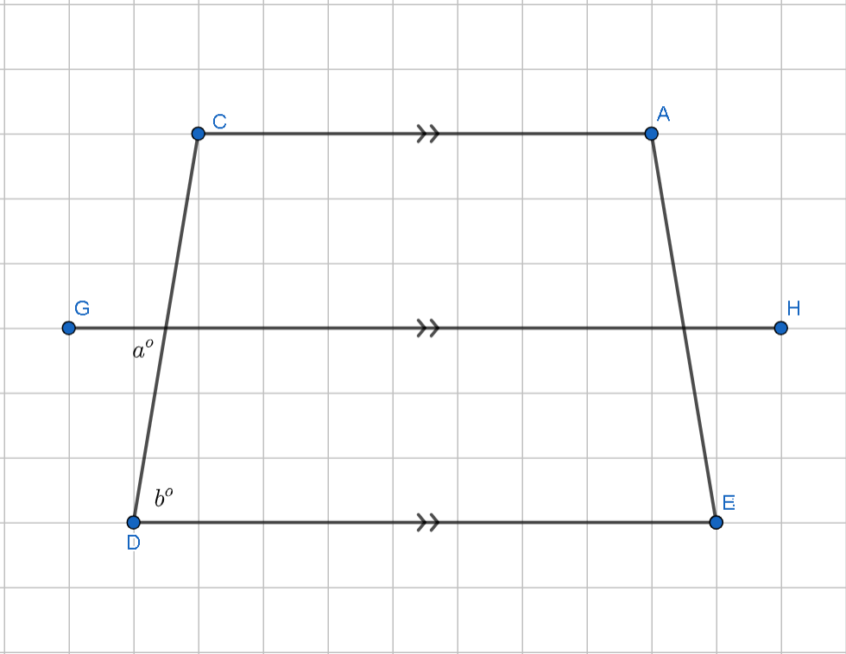 | 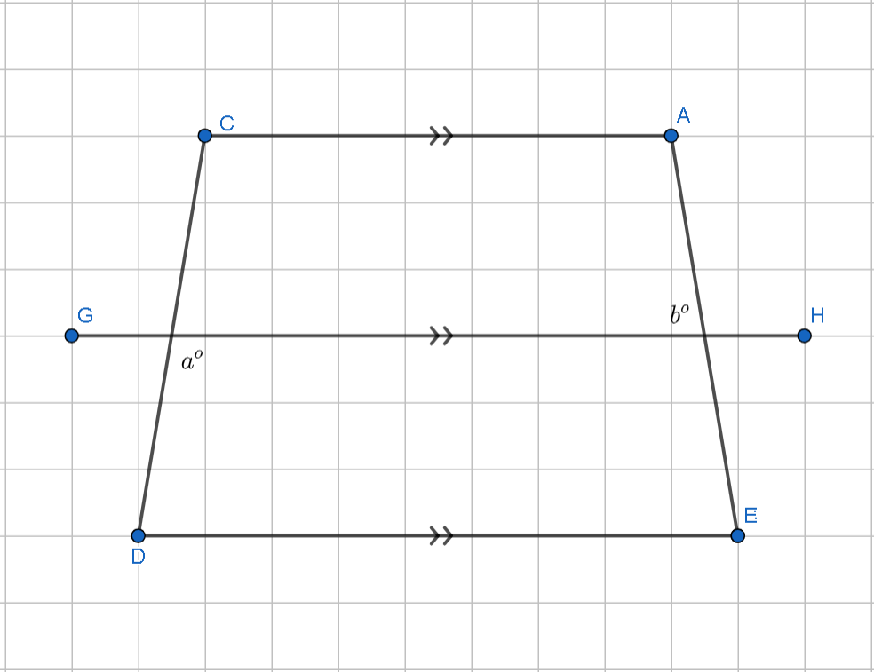
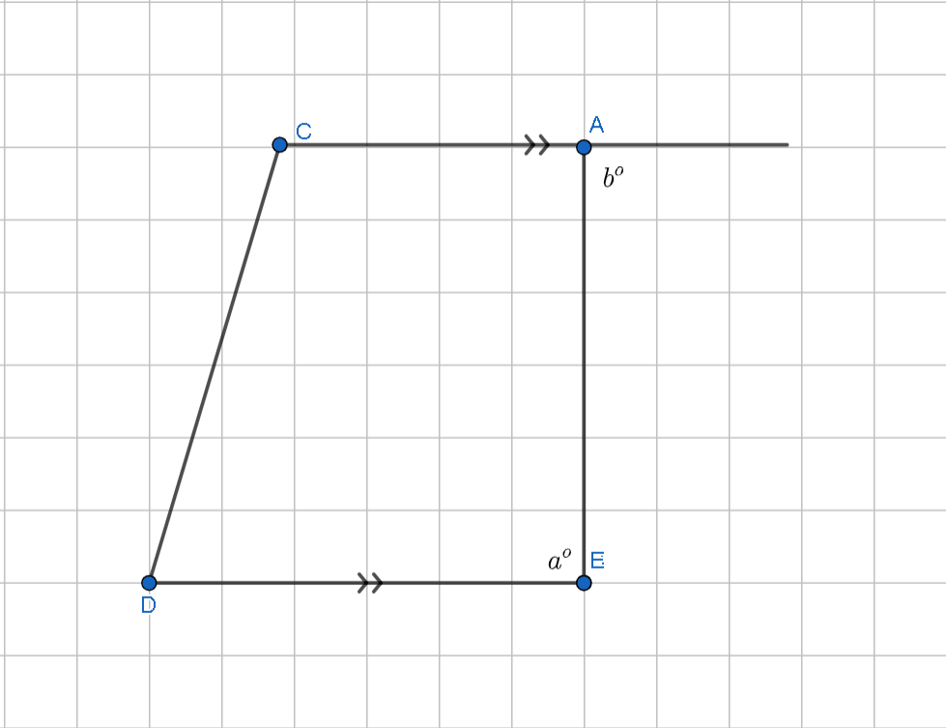 | 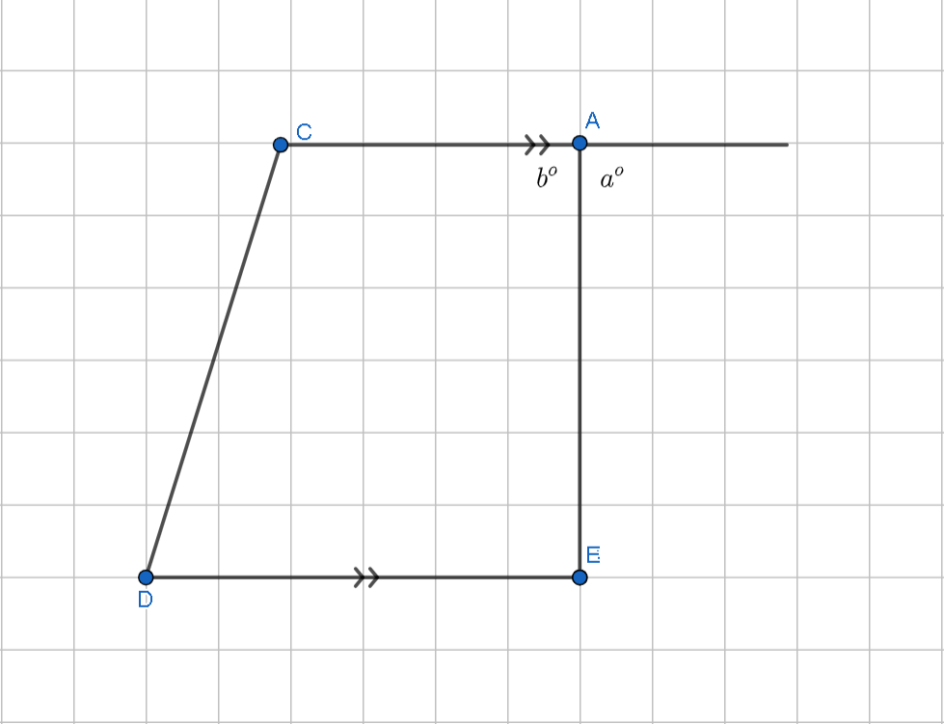

Appendix B

Frayer diagram
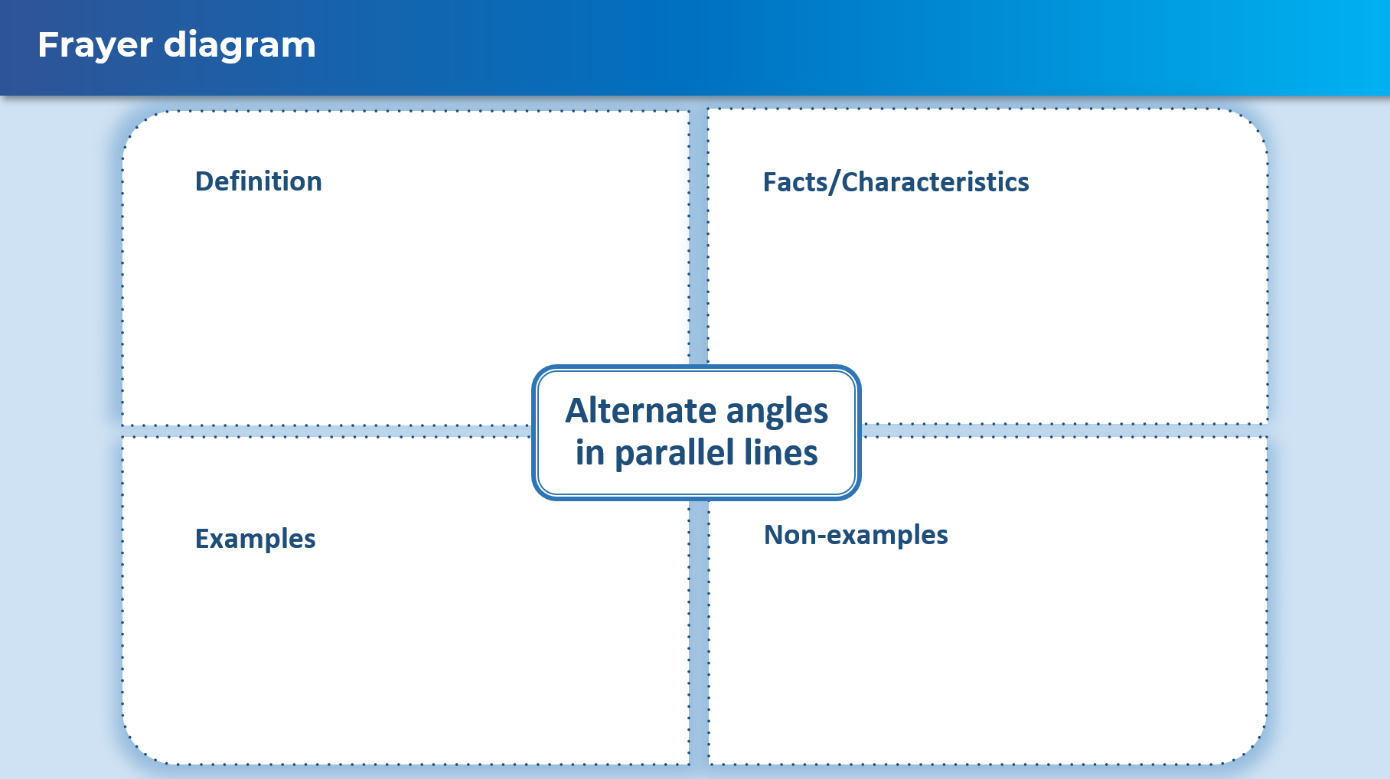

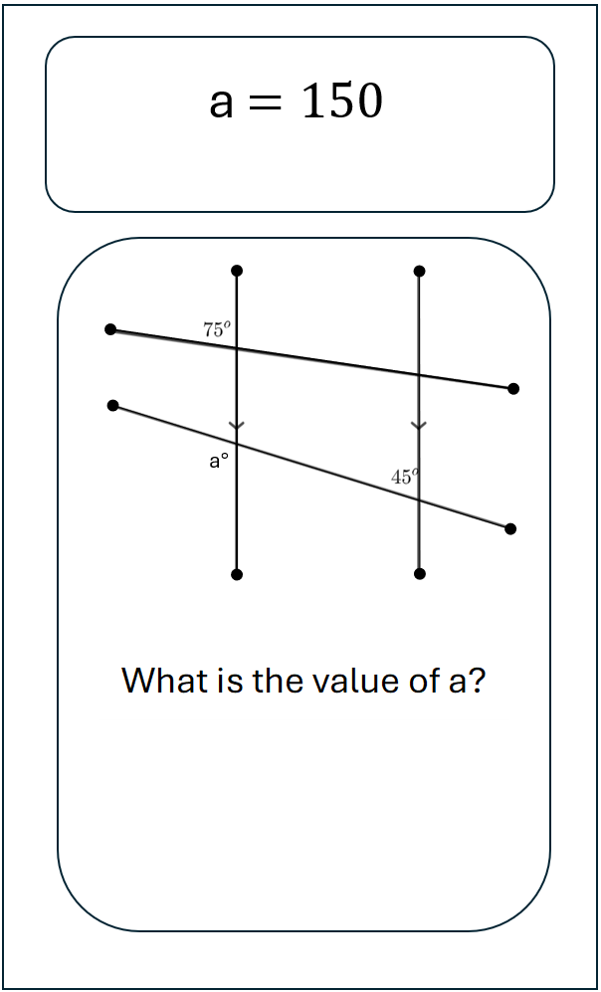
Appendix C

Scavenger hunt
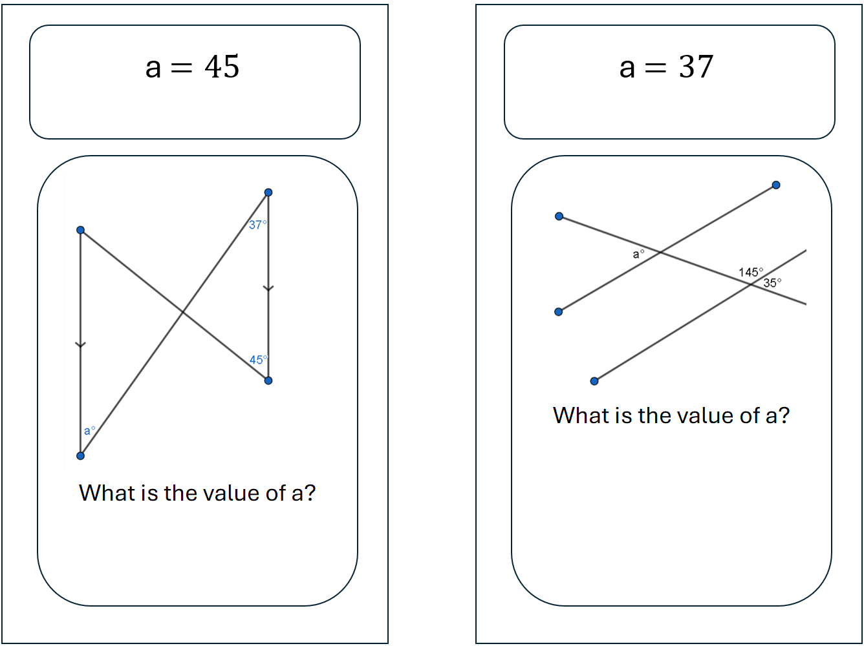
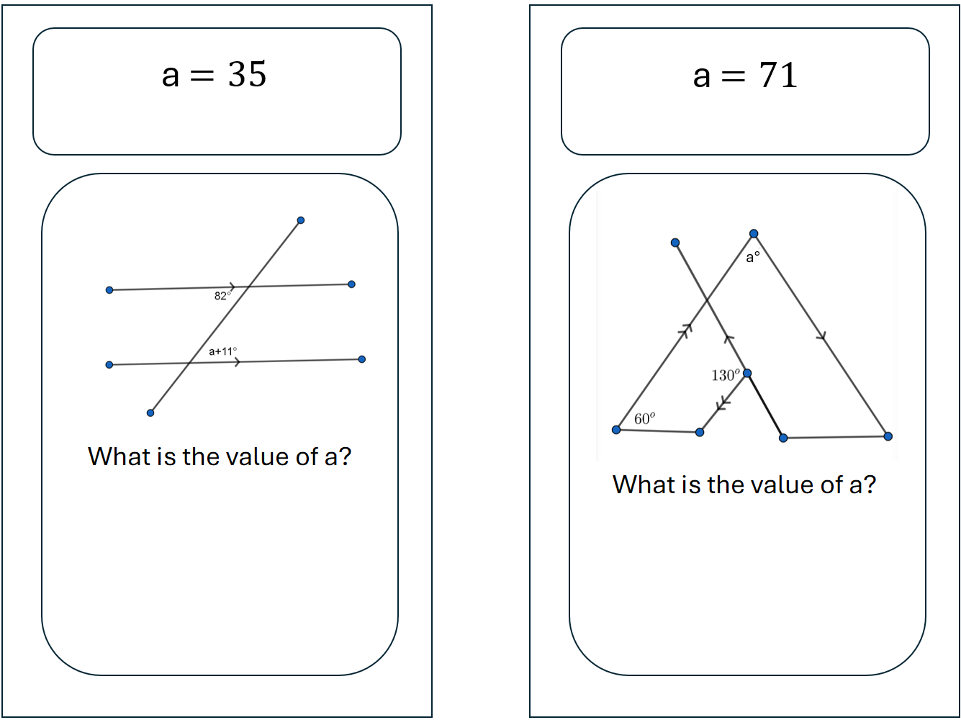
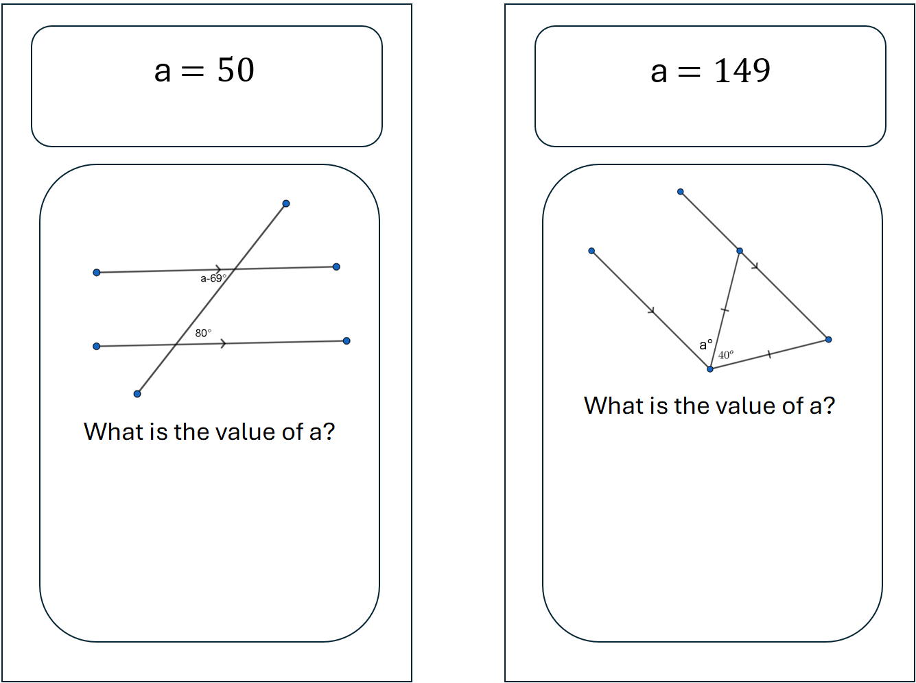
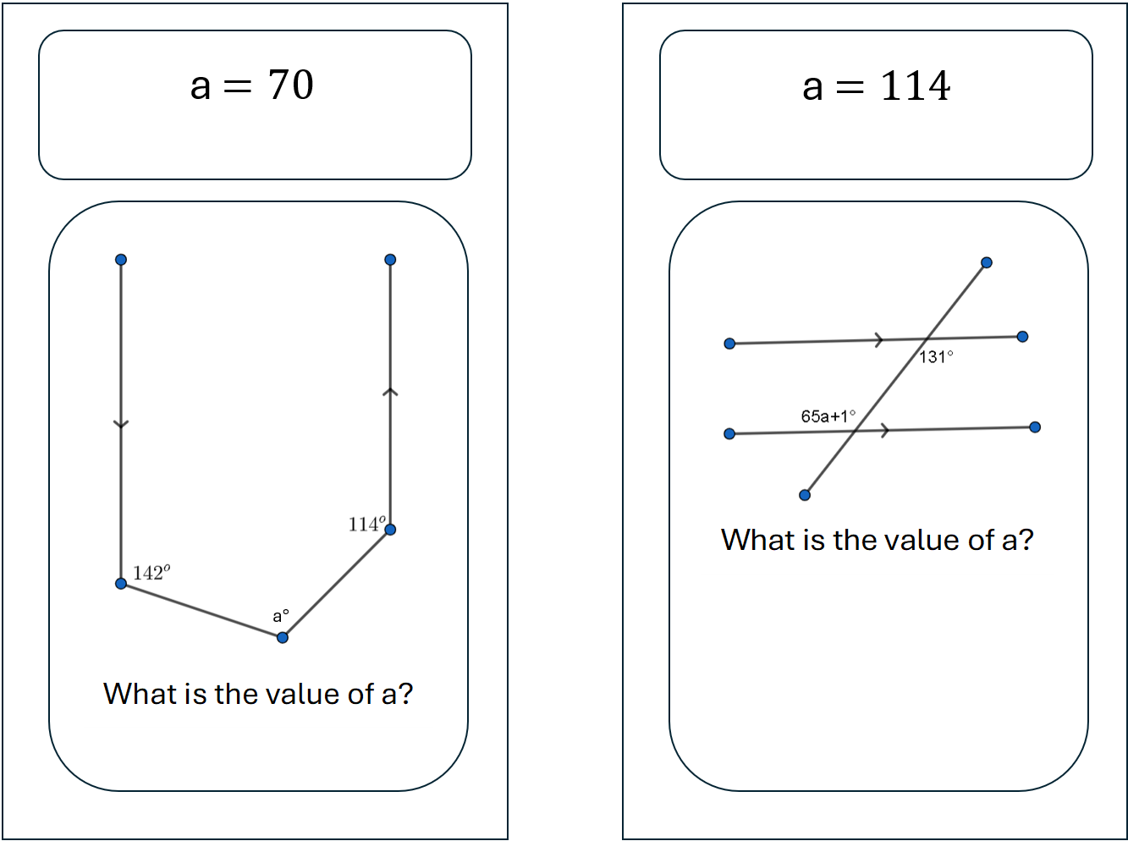
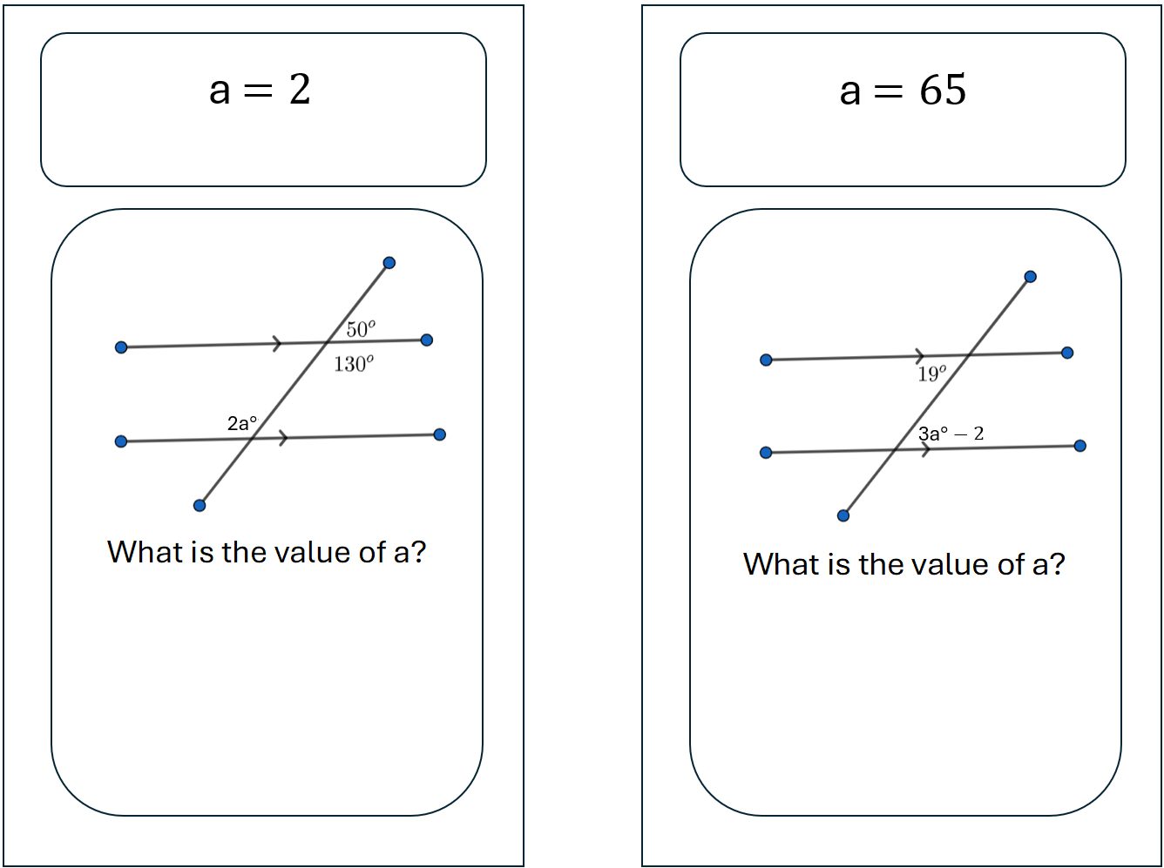
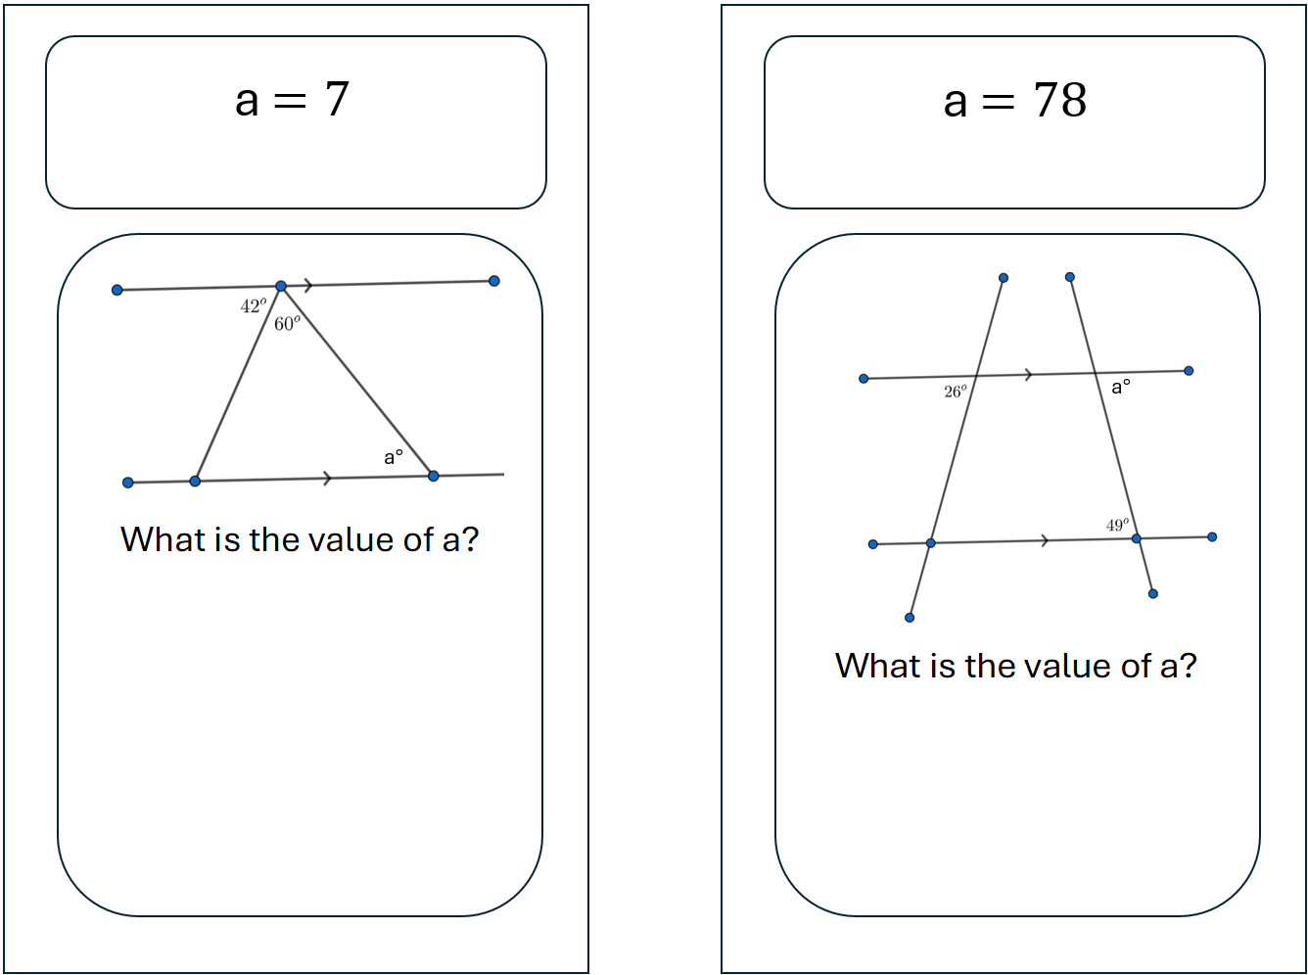
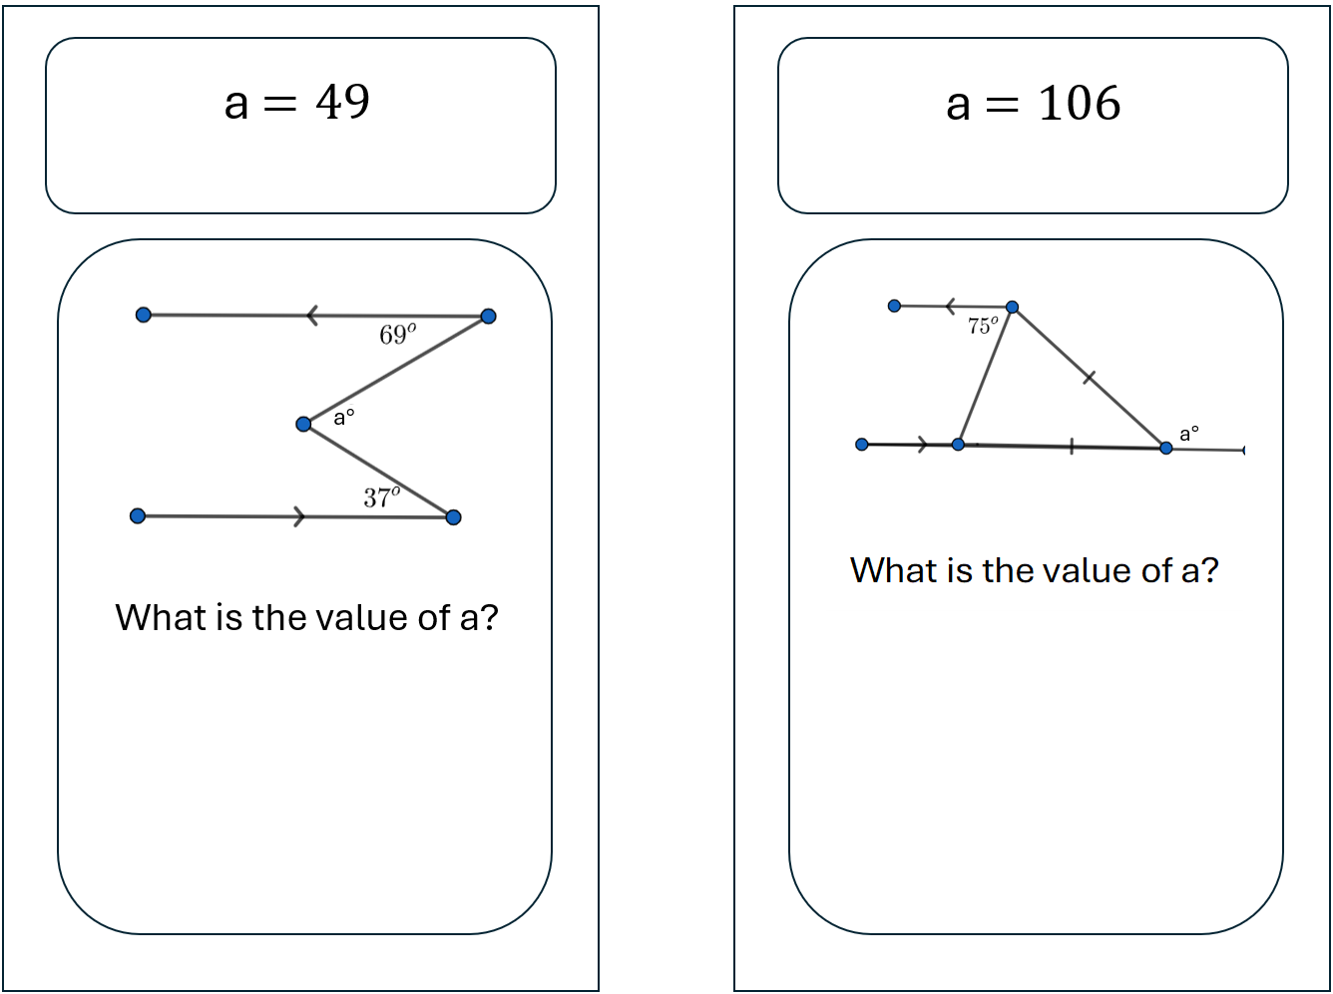

Sample solutions

Appendix B – Frayer diagram
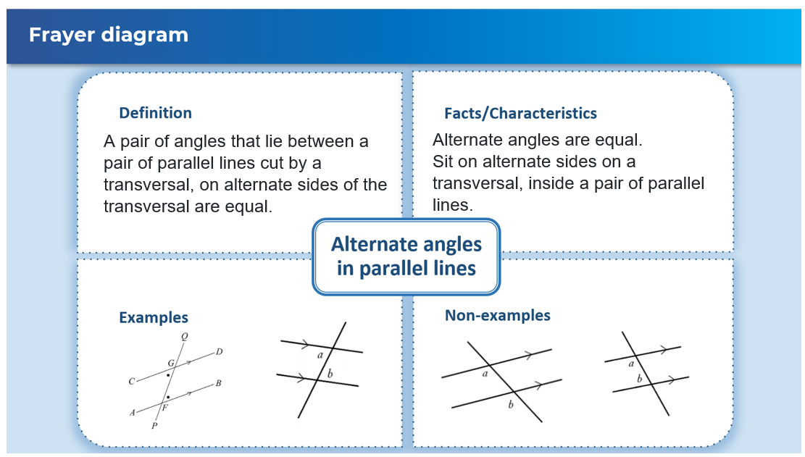

References
This resource contains NSW Curriculum and syllabus content. The NSW Curriculum is developed by the NSW Education Standards Authority. This content is prepared by NESA for and on behalf of the Crown in right of the State of New South Wales. The material is protected by Crown copyright.
Please refer to the NESA Copyright Disclaimer for more information https://educationstandards.nsw.edu.au/wps/portal/nesa/mini-footer/copyright.
NESA holds the only official and up-to-date versions of the NSW Curriculum and syllabus documents. Please visit the NSW Education Standards Authority (NESA) website https://educationstandards.nsw.edu.au/ and the NSW Curriculum website https://curriculum.nsw.edu.au/.
Mathematics K–10 Syllabus © NSW Education Standards Authority (NESA) for and on behalf of the Crown in right of the State of New South Wales, 2022.

© State of New South Wales (Department of Education), 2024
The copyright material published in this resource is subject to the Copyright Act 1968 (Cth) and is owned by the NSW Department of Education or, where indicated, by a party other than the NSW Department of Education (third-party material).
Copyright material available in this resource and owned by the NSW Department of Education is licensed under a Creative Commons Attribution 4.0 International (CC BY 4.0) license.

This license allows you to share and adapt the material for any purpose, even commercially.
Attribution should be given to © State of New South Wales (Department of Education), 2024.
Material in this resource not available under a Creative Commons license:
- the NSW Department of Education logo, other logos and trademark-protected material
- material owned by a third party that has been reproduced with permission. You will need to obtain permission from the third party to reuse its material.
Links to third-party material and websites
Please note that the provided (reading/viewing material/list/links/texts) are a suggestion only and implies no endorsement, by the New South Wales Department of Education, of any author, publisher, or book title. School principals and teachers are best placed to assess the suitability of resources that would complement the curriculum and reflect the needs and interests of their students.
If you use the links provided in this document to access a third-party's website, you acknowledge that the terms of use, including licence terms set out on the third-party's website apply to the use which may be made of the materials on that third-party website or where permitted by the Copyright Act 1968 (Cth). The department accepts no responsibility for content on third-party websites.

