# Come inside

Students look at situations where we need parallel lines to explore co-interior angles.

## Visible learning

### Learning intention

* To understand the relationship between co-interior angles and parallel lines.

### Success criteria

* I can identify a transversal.
* I can identify a set of parallel lines.
* I can identify and name co-interior angles in parallel lines.
* I can calculate the size of unknown angles, using knowledge of co-interior angles of parallel lines.

### Syllabus outcomes

A student:

* develops understanding and fluency in mathematics through exploring and connecting mathematical concepts, choosing and applying mathematical techniques to solve problems, and communicating their thinking and reasoning coherently and clearly **MAO-WM-01**
* applies angle relationships to solve problems, including those related to transversals on sets of parallel lines **MA4-ANG-C-01**
* identifies and applies the properties of triangles and quadrilaterals to solve problems   
  **MA4-GEO-C-01**

[Mathematics K–10 Syllabus](https://curriculum.nsw.edu.au/learning-areas/mathematics/mathematics-k-10-2022/overview) © NSW Education Standards Authority (NESA) for and on behalf of the Crown in right of the State of New South Wales, 2022.

Table 1: lesson summary

|  |  |  |  |
| --- | --- | --- | --- |
| Section | Summary of activity | Teaching strategy | Teaching points |
| Warm up | Display slide 3 from the PowerPoint *Come Inside* or distribute A3 copies of Appendix A for students to identify as much information as they can from the diagram. | Visibly random groups of 3  Vertical non-permanent surface | Aims to review angle calculations from previous lessons. |
| Launch | Students watch the video clip ‘What Do You Notice? What Do You Wonder? (0:29)’ from Make Math Moments, under the heading Spark Curiosity [(bit.ly/slidingshelves](https://bit.ly/slidingshelves)).  Students are to determine if each set of shelves are parallel. | Think-Pair-Share  Notice and wonder | Students begin to consider how they can prove if 2 or more lines are parallel. |
| Explore | Continue moving through the Sliding Shelves images on the website. Students consider the angles made between the lines and the transversal.  Students simulate how they would measure the angles.  Define transversals and co-interior angles. | Think-Pair-Share  Visibly random groups of 3  Vertical non-permanent surface | Students find co-interior angles through measuring before discovering the relationship. Introducing the term ‘transversal’ allows students to describe the position of the angles more easily. |
| Summarise | Explicit teaching with slides 5–12 of the PowerPoint.  Students complete Appendix B then swap and give feedback. | Two stars and a wish | Explicit teaching of co-interior angles. |
| Apply | Students respond to the Launch question about whether the shelves are parallel, using co-interior angles.  Students attempt Appendix C, explaining their answers. They then create their own problem before sharing it with their peers.  Students complete the exit ticket from the PowerPoint, to justify if the shape is a parallelogram. | Pose-Pause-Pounce-Bounce  Two truths and a lie | Highlight to students what angle relationships they used often or different solution paths. |

## Activity structure

Please use the associated PowerPoint *Come inside* to display images in this lesson.

### Warm up

1. Show slide 3 from the PowerPoint Come inside. This displays a diagram showing various triangles and quadrilaterals connected with some given information. Ask students to consider the diagram.
2. Distribute an A3 copy of the diagram from Appendix A ‘Angle stack’ along with an A3 plastic pocket to use as a vertical non-permanent surface. By working in visibly random groups of 3 ([bit.ly/visiblegroups](https://bit.ly/visiblegroups)) on vertical non-permanent surfaces ([bit.ly/VNPSstrategy](https://bit.ly/VNPSstrategy)), ask students to find as much information as they can from the diagram, giving reasons for each piece of information.
3. Students are to do a gallery walk ([bit.ly/DLSgallerywalk](https://bit.ly/DLSgallerywalk)) to see what information other groups were able to establish.

### Launch

This activity is based on a unit of learning by Make Math Moments ([bit.ly/sliding_shelves](https://bit.ly/sliding_shelves)).

1. Display ‘Sliding shelves, parallel lines and transversal lines’ [(bit.ly/slidingshelves](https://bit.ly/slidingshelves)) from the Make Math Moments website. Scroll to the heading **Spark Curiosity** and show students the video (0:29).
2. In a Think-Pair-Share ([bit.ly/thinkpairsharestrategy](https://bit.ly/thinkpairsharestrategy)), ask students what they notice and wonder ([bit.ly/noticewonderstrategy](https://bit.ly/noticewonderstrategy)).

Students might notice:

* that there are 4 shelves
* that some of the shelves look slanted.

Students might wonder:

* if the books would slide off any of the shelves
* if any of the shelves are level?

1. Display the image under the heading **Prompt: Set The Context & Estimate**, located further down the page, or pause the video at the image of the shelves.
2. In a Think-Pair-Share, students are to consider which of the shelves they believe are parallel and how they might determine whether 2 shelves are parallel.

Answers could include measuring between each shelf to see if the distance is the same or measuring an angle that the shelf makes with a reference line.

1. Display the image under the heading **Digging Deeper**, located further down the page.
2. Inform students that the blue shelf is parallel to the ground. In a Think-Pair-Share, ask students to discuss whether this changes how they would determine if the other shelves are parallel.

Students might say:

* use a level
* measure the height from the ground along different points on each shelf
* put the books on the shelf and see if they slide off
* measure the angles the shelves make compared to each other.

### Explore

1. Scroll to the title **Fuel Sensemaking**, located on the left of the page, and show the image of the shelves with a sloped line (transversal) added to each set of shelves.

**A transversal line** cuts a series of lines. The angles created by the transversal line cutting lines provide an opportunity to easily compare whether 2 or more lines are parallel.

1. Use the Pose-Pause-Pounce-Bounce questioning strategy (PDF 557 KB) ([bit.ly/posepausepouncebounce](https://bit.ly/posepausepouncebounce)) to discuss how to determine if the shelves are parallel to the blue shelf. Useful questions might include:

* How does the transversal help us to know if the shelves are parallel?
* What other information might be useful?
* What is needed to prove which shelves are parallel to the blue shelf and which are not?

1. Show the second and then the third image under the heading **Fuel Sensemaking**, located further down the page.
2. Students are to do a Think-Pair-Share to consider which shelves are parallel and justify why they are parallel based on the values included in the diagrams.
3. Using lines in their workbooks or lines on grid paper, have students draw a representation of 2 of the shelves by drawing 2 parallel lines and a transversal crossing the parallel lines. Ask students to identify the angles that are alternate or corresponding to each other.
4. Tell students we are going to look at co-interior angles in this learning episode. Ask students in a Think-Pair-Share to discuss what they think co-interior angles are.

The prefix ‘co’ means with, together and joint. The word interior means inside, so co-interior angles mean angles together inside (in between the parallel lines).

1. Have the students mark a pair of angles on their diagram they believe are co-interior. Name one angle $α$ and the other $β.$
2. Students should then compare their diagrams with neighbouring students to make sure they have the same understanding of co-interior angles. If students have different interpretations of what co-interior angles are, they should justify their reasoning.
3. In a Think-Pair-Share, ask students to predict a relationship between the co-interior angles. Distribute a protractor to each student. Students are then to measure the angles they have marked on their diagram.
4. As a class, students are to compile their measurements on the teacher’s whiteboard for discussion.
5. In a Think-Pair-Share, students discuss what they notice about the pairs of measurements.

Students may notice that the angles add up to $180°$. They may also notice that one angle is acute, and one is obtuse, unless both angles are right angles.

The aim of the activity is for students to notice that their angles add to 180o. Some students' pairs of angles may add to a number close to $180°$ due to inaccurate measurement. This could be raised as part of the ‘share’ class discussion.

1. Ask students to draw another pair of parallel lines with a transversal, labelling the lines and intersections with the transversal.
2. Students mark on their diagram a pair of co-interior angles, labelled α and β.
3. Ask students to mark all angles equivalent to α and β on their diagram.
4. In a Think-Pair-Share, discuss which angles were equivalent to each other and why.

Students should recognise equivalent angles that were corresponding, alternate, or vertically opposite to the original angle marked.

1. In a Think-Pair-Share, ask students about the relationship they can see in their diagram between α and β.

Students should notice that they are supplementary as they are on a straight angle.

Co-interior angles lie between 2 parallel lines on the same side of a transversal. If these angles are supplementary the lines must be parallel

### Summarise

1. Use slides 5–12 from the PowerPoint *Come inside* for explicit teaching of co-interior angles using the Worked examples (your turn) method ([bit.ly/supportingstrategies](https://bit.ly/supportingstrategies)).
2. Distribute Appendix B ‘Frayer diagram’ to each student and ask them to complete the Frayer diagram ([bit.ly/frayerdiagram](https://bit.ly/frayerdiagram)) provided.

Students should look back at their Frayer models from Lesson 5 – the corresponding connection and Lesson 6 – alternate views of Unit 11 – geometrical relationships and look at similarities and differences between the angle types. The non-examples for co-interior angles could be the examples from the previous lessons.

1. Students are to swap Frayer diagrams and complete peer feedback in the form of Two stars and a wish ([bit.ly/DLSpeerfeedback](https://bit.ly/DLSpeerfeedback)).
2. Students are then to respond to the feedback to improve their Frayer diagrams.

Prompt students to use correct terminology on their Frayer diagrams, such as angles created by a transversal on parallel lines. Rather than supply peer feedback, the teacher could display terminology used in the lesson to revise or improve students’ Frayer diagrams.

### Apply

1. Show slide 14 from the PowerPoint *Come inside*. This displays questions showing 2 sets of shelves.
2. Use a Pose-Pause-Pounce-Bounce questioning strategy to discuss the solution to the problems shown on the slide. Students should justify their responses using co-interior angles.

First set

$40°+140°=180°$ (co-interior angles) $$∴Shelves are parallel$$

Second set

$$25°+165°≠180° \\ ∴Shelves are not parallel$$

1. Working in pairs, students are to work through Two truths and a lie (<https://bit.ly/twotruthsoneliestrategy>) from Appendix C ‘Two truths and a lie’.
2. Students should then create their own Two truths and a lie and share it with their peers to attempt.
3. Students are to complete an exit ticket ([bit.ly/exitticketstrategy](https://bit.ly/exitticketstrategy)) by responding to the question on slide 15 from the PowerPoint *Come inside*.

## Assessment and differentiation

### Suggested opportunities for differentiation

**Warm up**

* **A simpler diagram could be used, or students could find information in just one section.**
* **Students could be challenged to complete all known information, not just angles.**

**Launch**

* **Students can show their knowledge as it is an open problem.**
* **By working in pairs, students can gain understanding from their peers.**

**Explore**

* **Students can challenge themselves to work out every angle in the diagram by drawing knowledge from multiple areas of past work.**
* **Ask students to consider how they might adjust each of the non-parallel shelves so that they become parallel?**

**Summarise**

* **Students can review other students’ Frayer diagrams to clarify understanding when they review neighbouring students' diagrams and give feedback through Two stars and a wish.**
* **Students can challenge themselves to find more unusual examples of non-examples in the Frayer diagram.**
* To enable students who are learning English as an additional language or dialect (EAL/D) to engage in class discussions, provide them with a dictionary or access to the internet to create a word wall or contribute words that have meaning in their language.

**Apply**

* Students could be challenged to list all geometrical information about the question in the exit ticket after establishing that the lines are parallel, and it was a parallelogram.
* More challenging diagrams can be found on Don Steward’s Median blog post ‘Parallel line angles’ ([bit.ly/parallellineangles](https://bit.ly/parallellineangles)).
* Challenge students to justify their solutions in a more formal proof.

### Suggested opportunities for assessment

**Launch**

* **Discussions from the Think-Pair-Share can be used as formative assessment.**

**Explore**

* Students give each other peer feedback, before sharing with the class in a Think-Pair-Share.

**Summarise**

* **Frayer diagrams can be collected as evidence of understanding of co-interior angles.**
* **Students give peer feedback in Two stars and a wish.**

**Apply**

* Exit ticket can be used as evidence of learning.
* By reviewing peer's work, students provide and receive feedback on their understanding.
* Peer feedback, such as Two stars and a wish, provide the opportunity for students to reflect on their own work while reviewing others.

## Appendix A

### Angle stack

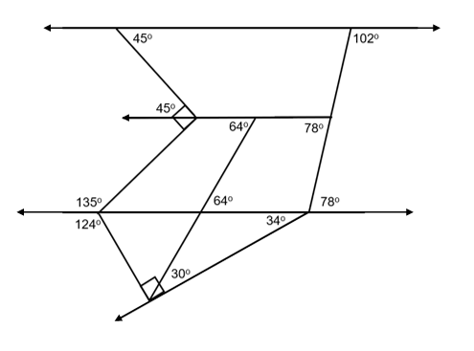

## Appendix B

### Frayer diagram

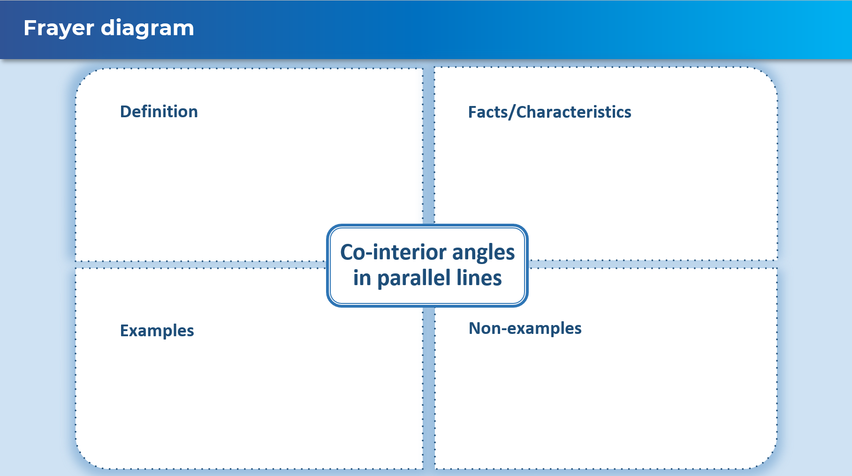

## Appendix C

### Two truths and a lie

Using the diagrams, decide which of these statements are truths and which are lies.

|  |  |
| --- | --- |
| Two truths and a lie | Diagram |
| $∠EFD$ is alternate to $∠FDB$ $∠EFD$ is co-interior to $∠HFD$ $∠EFD$ is corresponding to | Parallel lines EH and AB with transversal CG crossing it. |
| is alternate to  is co-interior to  is corresponding to | Parallel lines CE and FH with transversal AB crossing it. |
| is alternate to  is co-interior to  is corresponding to | Parallel lines EG and FH with transversal CD crossing it. |
| Your turn | Parallel lines EH and AB with transversal CG crossing it. |

## Sample solutions

### Appendix B – Frayer diagram

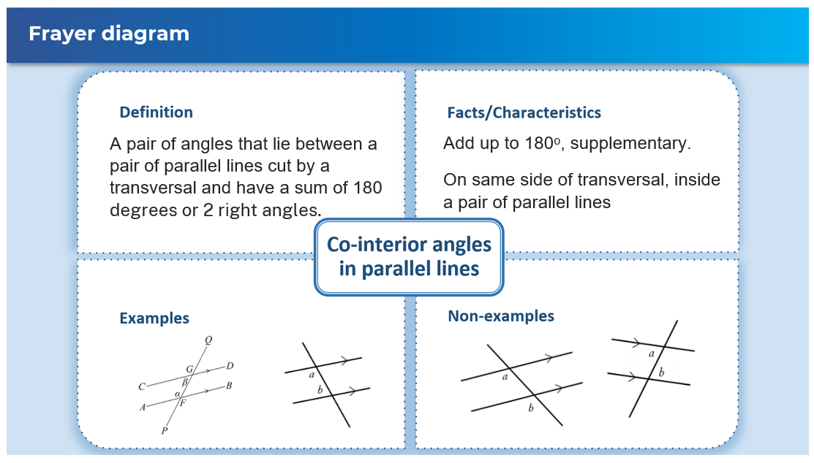

### Appendix C – Two truths and a lie

Lies

$∠EFD$ is co-interior to $∠HFD$.

$∠CDG$ is alternate to $∠FGB$.

$∠ABF$ is co-interior to $∠FBD$.

### Exit ticket

AD $∥$ BC as the angles $∠DAB$ and $∠ABC,$ add up to 180o, so are co-interior.

AB $∥$ CD as the angles $∠ABC$ and $∠BCD,$ add up to 180o, so are co-interior.

$∴$ ABCD is a parallelogram.

## References

This resource contains NSW Curriculum and syllabus content. The NSW Curriculum is developed by the NSW Education Standards Authority. This content is prepared by NESA for and on behalf of the Crown in right of the State of New South Wales. The material is protected by Crown copyright.

Please refer to the NESA Copyright Disclaimer for more information [https://educationstandards.nsw.edu.au/wps/portal/nesa/mini-footer/copyright](https://aus01.safelinks.protection.outlook.com/?url=https%3A%2F%2Feducationstandards.nsw.edu.au%2Fwps%2Fportal%2Fnesa%2Fmini-footer%2Fcopyright&data=05%7C01%7CCaitlin.Pace1%40det.nsw.edu.au%7C9c2c1a9f59c94d2df30708dafa7edb23%7C05a0e69a418a47c19c259387261bf991%7C0%7C0%7C638097720042599463%7CUnknown%7CTWFpbGZsb3d8eyJWIjoiMC4wLjAwMDAiLCJQIjoiV2luMzIiLCJBTiI6Ik1haWwiLCJXVCI6Mn0%3D%7C3000%7C%7C%7C&sdata=BzQh0UsffVZE3eO22b2Xba3p0VMOBZSHfS21FGHXtZM%3D&reserved=0).

NESA holds the only official and up-to-date versions of the NSW Curriculum and syllabus documents. Please visit the NSW Education Standards Authority (NESA) website <https://educationstandards.nsw.edu.au/> and the NSW Curriculum website <https://curriculum.nsw.edu.au/>.

[Mathematics K–10 Syllabus](https://curriculum.nsw.edu.au/learning-areas/mathematics/mathematics-k-10-2022/overview) © NSW Education Standards Authority (NESA) for and on behalf of the Crown in right of the State of New South Wales, 2022.

**© State of New South Wales (Department of Education), 2024**

The copyright material published in this resource is subject to the *Copyright Act 1968* (Cth) and is owned by the NSW Department of Education or, where indicated, by a party other than the NSW Department of Education (third-party material).

Copyright material available in this resource and owned by the NSW Department of Education is licensed under a [Creative Commons Attribution 4.0 International (CC BY 4.0) license](https://creativecommons.org/licenses/by/4.0/).

[](https://creativecommons.org/licenses/by/4.0/)

This license allows you to share and adapt the material for any purpose, even commercially.

Attribution should be given to © State of New South Wales (Department of Education), 2024.

Material in this resource not available under a Creative Commons license:

* the NSW Department of Education logo, other logos and trademark-protected material
* material owned by a third party that has been reproduced with permission. You will need to obtain permission from the third party to reuse its material.

**Links to third-party material and websites**

Please note that the provided (reading/viewing material/list/links/texts) are a suggestion only and implies no endorsement, by the New South Wales Department of Education, of any author, publisher, or book title. School principals and teachers are best placed to assess the suitability of resources that would complement the curriculum and reflect the needs and interests of their students.

If you use the links provided in this document to access a third-party's website, you acknowledge that the terms of use, including licence terms set out on the third-party's website apply to the use which may be made of the materials on that third-party website or where permitted by the *Copyright Act 1968* (Cth). The department accepts no responsibility for content on third-party websites.