# All in this together

Students apply their knowledge of transversals in parallel lines and angles at a point to find unknowns.

## Visible learning

### Learning intention

* To be able to apply knowledge of angle relationships to find unknowns.

### Success criteria

* I can identify alternate, corresponding and co-interior angles on a diagram.
* I can identify supplementary and vertically opposite angles on a diagram.
* I can justify the size of an angle using angle relationships.
* I can find the size of an unknown angle in multiple ways.

### Syllabus outcomes

A student:

* develops understanding and fluency in mathematics through exploring and connecting mathematical concepts, choosing and applying mathematical techniques to solve problems, and communicating their thinking and reasoning coherently and clearly **MAO-WM-01**
* applies angle relationships to solve problems, including those related to transversals on sets of parallel lines **MA4-ANG-C-01**
* identifies and applies the properties of triangles and quadrilaterals to solve problems   
  **MA4-GEO-C-01**

[Mathematics K–10 Syllabus](https://curriculum.nsw.edu.au/learning-areas/mathematics/mathematics-k-10-2022/overview) © NSW Education Standards Authority (NESA) for and on behalf of the Crown in right of the State of New South Wales, 2022

Table 1: lesson summary

|  |  |  |  |
| --- | --- | --- | --- |
| Section | Summary of activity | Teaching strategy | Teaching points |
| Launch | Students explore the NRICH activity ‘Angles Inside’ ([bit.ly/nrichanglesinside](https://bit.ly/nrichanglesinside)). | Think-Pair-Share  Notice and wonder | Students return to this activity at the end of the Explore section. They are not expected to be able to provide an explanation, but they should be able to identify the relationship between the angles. |
| Explore | Students create parallel line diagrams with tape and place cards from Appendix A to identify angle relationships. They then use this diagram to explore multiple solution methods to find missing angles and the minimum required information before applying that knowledge to create an explanation for the Launch activity. | Visibly random groups of 3  Vertical non-permanent surfaces | A second diagram is used that looks similar to the Launch problem with an extra parallel line. The purpose of this section is to put all known geometry facts about parallel lines together. |
| Summarise | Students justify why angles are a particular size in Appendix B.  Students complete Appendix C as an exit ticket. | Visibly random groups of 3  Vertical non-permanent surfaces  Pose-Pause-Pounce-Bounce | Students use all geometrical properties to find missing angles and justify if lines are parallel. |
| Apply | Students complete Appendix D before creating their own diagrams. |  | Students realise the minimum angles needed on different diagrams to be about to calculate the size of all angles. |

## Activity structure

Please use the associated PowerPoint *All in this together* to display images in this lesson.

### Launch

Parts of this lesson have been modified from the NRICH activity ‘Angles Inside’ ([bit.ly/nrichanglesinside](https://bit.ly/nrichanglesinside)).

1. Display slide 3 from the PowerPoint *All in this together*, which displays Figure 1.
2. In a Think-Pair-Share ([bit.ly/thinkpairsharestrategy](https://bit.ly/thinkpairsharestrategy)) ask students what they notice and wonder ([bit.ly/noticewonderstrategy](https://bit.ly/noticewonderstrategy)).

Figure 1: angles inside a rectangle

There are 2 rectangles. The first rectangle ABDE has a point (C) inside. Point C is connected to 2 vertices A and B. The angles at A, B and C are shown.
Angle CAE = 55 degrees, DBC = 32 degrees and angle ACB = 87 degrees.
The second rectangle ABDE has a point (C) inside. Point C is connected to 2 vertices A and B. The angles at A, B and C are shown.
Angle CAE = 10 degrees, DBC = 38 degrees and angle ACB = 48 degrees.

Students may notice that the $∠ACB$ is equal to the addition of the 2 other given angles. They may wonder if this happens for all rectangles and if we can move the point to different positions inside the rectangle.

1. Provide each student with a protractor and ask students to use the protractor to draw a rectangle.
2. Ask students to place a point inside the rectangle, like the rectangles shown on slide 3 of the PowerPoint.
3. Ask students to label the point and the vertices of their rectangle and to connect the point to 2 vertices of the rectangle, similar to the rectangles on slide 3 of the PowerPoint.
4. Ask students to measure the angles to see if 2 of the angles also add to be the same as the other angle.
5. Ask students to raise their hand if it worked for their rectangle.
6. Display the GeoGebra applet from the NRICH activity ‘Angles Inside’ ([bit.ly/nrichanglesinside](https://bit.ly/nrichanglesinside)). Select **Show angles** to display the angles. Select and drag the point at the red angle to show several examples.

Figure 2: sample screen from NRICH activity

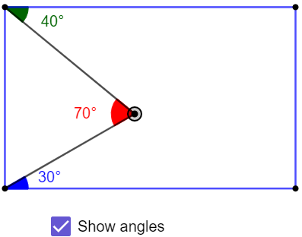

Students should discover that the red angle is always the sum of the green and blue angle seen in Figure 2.

1. Explain to students that they will revisit this task later in the lesson and explore why this is the case.

Students may already be able to explain why this works using complementary angles and the angle sum of a triangle. This learning episode will explore an additional explanation using further angle properties.

### Explore

1. Assign students to visibly random groups of 3 ([bit.ly/visiblegroups](https://bit.ly/visiblegroups)) to work at vertical non-permanent surface ([bit.ly/VNPSstrategy](https://bit.ly/VNPSstrategy)).
2. Ask students to draw a pair of parallel lines with a transversal.
3. Give students a copy of Appendix A ‘Angle types’.
4. One student is to mark an angle on the diagram with a cross.
5. Another student is to read out loud each of the instructions. As each of the instructions is read out, the group need to decide which angle they should mark, using a different coloured marker.

Students may need clarification of what an arc is when marking an angle. The angles in the diagrams on slide 3 of the PowerPoint have been marked with arcs.

The aim is to mark the original angle in a position so that all the instructions can be followed.

1. If the group reaches an instruction that can’t be followed, they should erase the marks and begin again.
2. When students have finished the activity, use a Pose-Pause-Pounce-Bounce questioning strategy (PDF 557 KB) ([bit.ly/posepausepouncebounce](https://bit.ly/posepausepouncebounce)) to discuss which angle was the best one to start with to be able to follow all the instructions.
3. Display slide 5 of the PowerPoint and ask students to clear the VNPS and draw on their board 3 parallel lines and 2 transversals, similar to the diagram.

Figure 4: 3 parallel lines

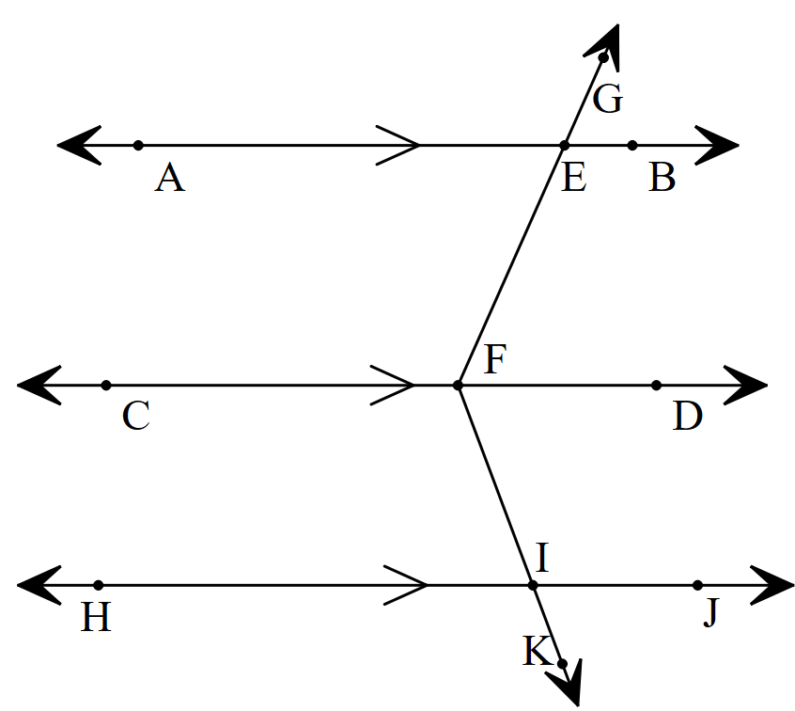

1. Ask students to determine how many angles they would need to mark with a cross so that every angle in the diagram is marked with a dot or arc after following the instructions in Appendix A.

That is, students mark one angle, follow all the instructions in Appendix A, and then mark another angle, without erasing the previous marks. They then repeat the process until all angles are marked.

To aid students, giving them different coloured markers may be beneficial. Students may need to be prompted to remove just one angle at a time and justify why they are able to remove it.

1. Groups are to discuss with a nearby group how many angles are needed and justify why, giving reasons.

Students should recognise that an interior angle below the top parallel line and an interior angle above the bottom parallel line need to be marked to be able to mark all other angles.

1. Continuing in their groups of 3, ask students to find how many ways they could calculate the size of $∠EFI$, given they can pick which angles are provided.
2. Use a Pose-Pause-Pounce-Bounce questioning strategy to discuss the different ways to determine the size of $∠EFI$, focusing on student reasoning and using appropriate geometrical language.
3. Display slide 6 from the PowerPoint and ask students what they notice and wonder.

Students should notice that the diagrams are similar but the one on the left has an extra parallel line through the point that is within the rectangle.

1. Students are to return to the Launch activity to explain why we can add the 2 angles to find the size of the angle at a point.

Sample solutions for the NRICH problem used in the Launch activity can be found on the NRICH activity ‘Angles Inside’ ([bit.ly/nrichanglesinside](https://bit.ly/nrichanglesinside)).

1. Select random students to share their explanations with the class.

### Summarise

1. Distribute Appendix B ‘Angle chase’ to each group. In this goal-free problem ([bit.ly/goalfreeproblems](https://bit.ly/goalfreeproblems)), ask students to find all the information they can, giving reasons.
2. Students are to do a gallery walk ([bit.ly/DLSgallerywalk](https://bit.ly/DLSgallerywalk)) to observe the information found by other groups.
3. Use the Pose-Pause-Pounce-Bounce questioning strategy (PDF 557 KB) ([bit.ly/posepausepouncebounce](https://bit.ly/posepausepouncebounce)) to initiate a sharing of the ideas and reasoning students used to find unknown angles.
4. Students are to complete an exit ticket ([bit.ly/exitticketstrategy](https://bit.ly/exitticketstrategy)) using Appendix C ‘Are these parallel?’ to justify which of the provided diagrams are parallel.

Students may need to be reminded that they can use their reasons listed earlier in the Summarise section as a valid justification.

### Apply

1. Students are to individually complete Appendix D ‘Another angle chase’ giving reasons for each angle they find.

The angle size for $∠FAE$ and $∠AEF$ cannot be calculated as there is not enough information. For students who find all the other angles, there is a challenge to reproduce the activity with enough information given to calculate all angles. Alternatively, you could ask students to justify which angle they could supply so they could calculate $∠FAE$ and $∠AEF$.

1. Ask students to create their own diagrams and challenge them to identify the minimum number of angles they need to provide to be able to find all the others.
2. Once students have completed their diagrams and given their angles, they are to swap with a partner to find the missing ones and test they have given enough information to find all the other angles.

## Assessment and differentiation

### Suggested opportunities for differentiation

**Launch**

* Assist students by letting them create their rectangles using the GeoGebra applet or using geoboards.
* Students may benefit from being reminded how to measure with a protractor.
* Students can be challenged to find more than one way to explain why an angle is a certain size.
* Modify the problem for students by having them explore:
* If the same thing occurs in a parallelogram or trapezium.
* What happens if the point they select is outside the rectangle and why this occurs.

**Explore**

* Low readiness students should start with the card that states ‘I am the given angle’.
* Students may benefit from returning to Frayer diagrams from previous lessons to remind them of angle relationships.
* Encourage students to provide multiple ways to explain why the Launch scenario works.

**Summarise**

* Challenge students to add reasons to their list that include the properties of geometrical shapes explored in Unit 6 – triangles and quadrilaterals.
* Assist students by giving them fill-in-the-blanks for the reasons they could provide.
* Challenge students to find multiple ways to show the size of angles in Appendix B ‘Angle chase’.

**Apply**

* Students can pick the level of difficulty when drawing their own diagrams to find the angles.
* Challenge students to include special triangles or quadrilaterals in their diagrams.

### Suggested opportunities for assessment

**Launch**

* Students’ responses to the Launch activity can be used as a formative assessment of angle relationships previously explored.
* Students will demonstrate their Working mathematically skills in discussions and justifications.

**Explore**

* When placed in groups of 3, students provide and receive peer feedback on their understanding.
* Teachers could facilitate class discussions and observe students’ reasoning and justification in response to why there are multiple solution methods.

**Summarise**

* Review students’ reasons from Appendix B ‘Angle chase’ for their use of terminology.
* Gallery walks provide the opportunity for students to reflect on their own work while reviewing others.

**Apply**

* Collect solutions to Appendix D ‘Another angle chase’ as evidence of learning.
* Teachers could ask students to explain and justify the minimum number of angles needed to find the rest.

## Appendix A

### Angle types

1. Draw a diagram of a pair of parallel lines with a transversal.
2. Mark an angle on the diagram with a cross.
3. Read each of the instructions out loud.
4. As each of the instructions is read out, decide which angle should be marked,
5. Use a different coloured marker to mark the angle, as per the instruction.
6. Keep going until you have followed all the instructions. If you reach a point where you cannot mark that type of angle, erase all the markings and begin again.

#### Angle instructions

* Mark the alternate angle with a dot.
* Mark the corresponding angle with a dot.
* Mark the co-interior angle with an arc.
* Mark the vertically opposite angle with a dot.
* Mark the supplementary angle with an arc.

## Appendix B

### Angle chase

Find all the information you can from this diagram, given that all the horizontal intervals are parallel.

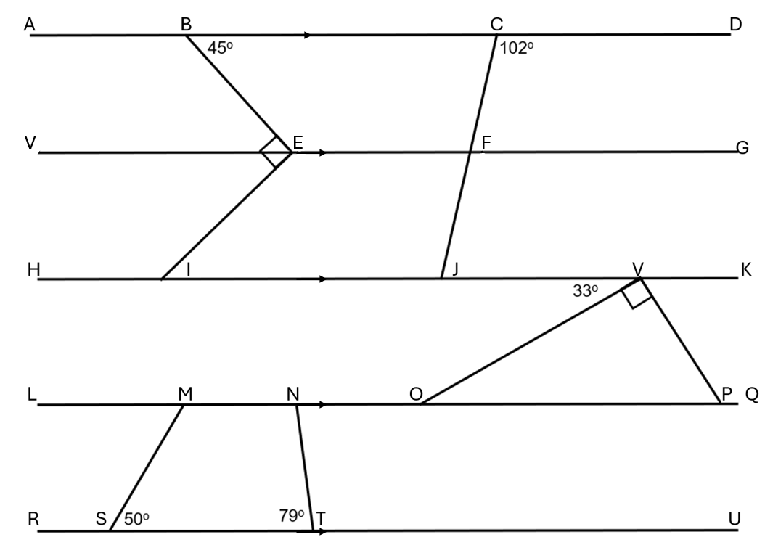

## Appendix C

### Are these parallel?

Justify if $AB∥CD$.

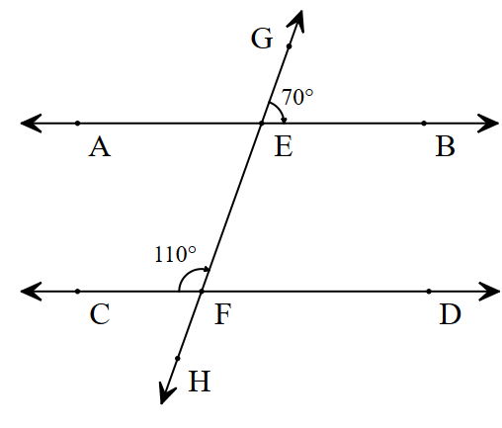

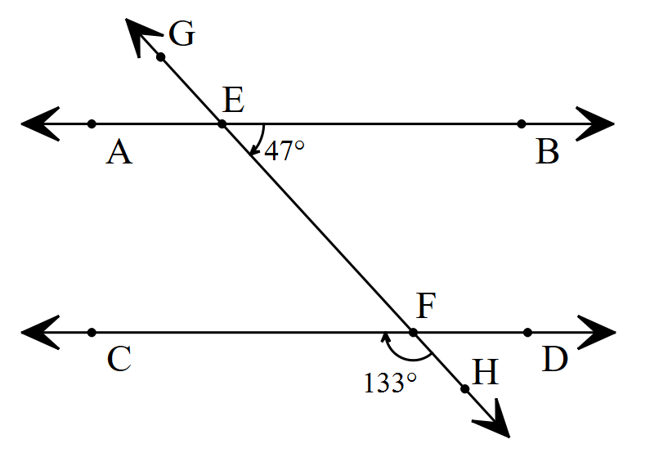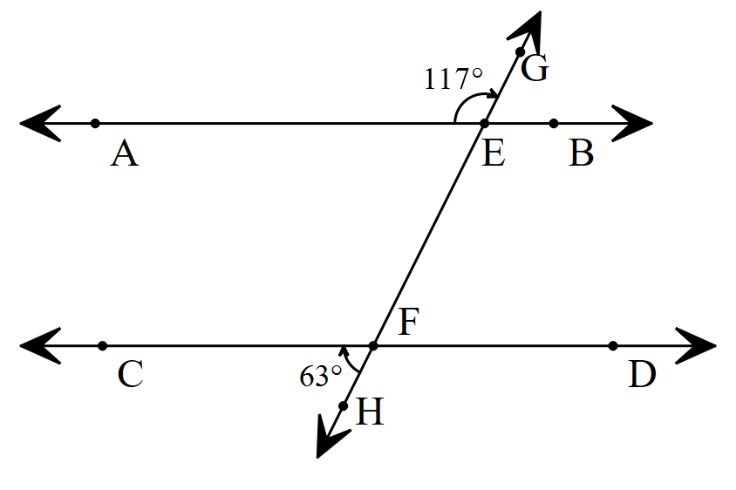

## Appendix D

### Another angle chase

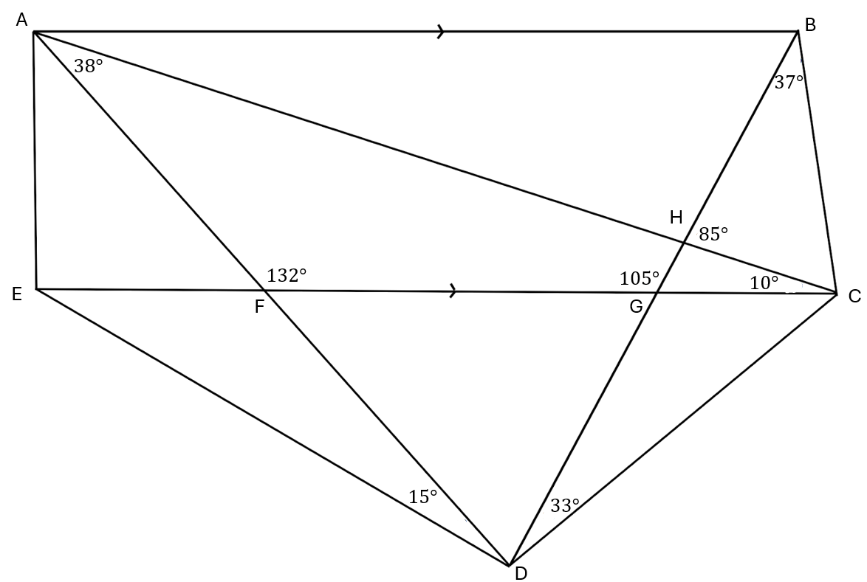

This activity has been modified from the Starting Points Maths activity ‘Another angle chase’ ([bit.ly/appendixd-anotheranglechase](https://bit.ly/appendixd-anotheranglechase)).

## Sample solutions

### Appendix B – angle chase

$∠GFI=102°$ as corresponding angles in parallel lines are equal.

$∠CFG=78°$ as supplementary angles add to $180°$.

$∠FJK=78°$ as co-interior angles in parallel lines add to $180°$.

$∠CFE=102°$ as alternate angles in parallel lines are equal.

$∠BCF=78°$ as supplementary angles add to $180°$.

$∠EFJ=78°$ as vertically opposite angles are equal.

$∠FJI=102°$ as co-interior angles in parallel lines add to $180°$.

$∠ABE=135°$ as supplementary angles add to $180°$.

$∠BEV=45°$ as alternate angles in parallel lines are equal.

$∠VEI=45°$ as complementary angles add to $90°$.

$∠BEF=135°$ as alternate angles in parallel lines are equal.

$∠FEI=135°$ as supplementary angles add to $180°$.

$∠EIH=135°$ as alternate angles in parallel lines are equal.

$∠EIJ=45°$ as co-interior angles in parallel lines add to $180°$.

$∠VON=147°$ as co-interior angles in parallel lines add to $180°$.

$∠VOP=33°$ as alternate angles in parallel lines are equal.

$∠VOP=57°$ as the angle sum of a triangle is $180°$.

$∠KVP=57°$ as alternate angles in parallel lines are equal.

$∠VPQ=123°$ as co-interior angles in parallel lines add to $180°$.

$∠LMS=50°$ as alternate angles in parallel lines are equal.

$∠MSR=130°$ as supplementary angles add to $180°$.

$∠SMN=130°$ as supplementary angles add to $180°$.

$∠MNT=101°$ as the angle sum of a quadrilateral is $360°$.

$∠ONT=79°$ as alternate angles in parallel lines are equal.

$∠NTU=101°$ as alternate angles in parallel lines are equal.

### Appendix C – Are they parallel?

There are many solutions for each question, only one has been provided for each.

1. $∠AEG=110°$ as supplementary angles add to $180°$. $∠AEG=∠CFE=110°$ 
    are in the corresponding positions, so $AB∥CD$ as corresponding angles in parallel lines are equal.
2. $∠EFD=133°$ as vertically opposite angles are equal. $∠BEF+∠EFD=47+133=180$ 
    therefore $AB∥CD$ as $∠BEF$ and $∠EFD$ are co-interior angles and they add to $180°$ which only happens if they are parallel.
3. $∠AEF=63°$ as supplementary angles add to $180°$. $∠AEF=∠CFH$ 
    as they are in corresponding positions, so AB is parallel to CD.

### Appendix D – another angle chase

$∠AHG=85°$ as it is vertically opposite to $∠BHC$.

$∠CHG=95°$ as it is supplementary angles with $∠BHC.$

$∠BHA=95°$ as it is vertical opposite to $∠CHG.$

$∠ABG=75°$ as it is a co-interior angle in parallel lines with $∠BGE.$

$∠BAH=10°$ as it is the angle sum of $∆ABH$.

$∠BCH=58°$ as it is the angle sum of $∆BHC$.

$∠HGC=75°$ as it is supplementary angles with $∠HGF.$

$∠CGD=105°$ as it is vertically opposite to $∠HGF$.

$∠FGD=75°$ as it it vertically opposite to $∠HCG$.

$∠GCD=42°$ as it is the angle sum of $∆GCD$.

$∠EFD=132°$ as it is vertically opposite to $∠AFG.$

$∠AFE=48°$ as it is supplementary angles with $∠AFG.$

$∠GFD=48°$ as it is vertically opposite to $∠AFE$.

$∠FDG=57°$ as it is the angle sum of $∆FGD$.

$∠FED=33°$ as it is in the angle sum of $∆EFD.$

$∠FAE=$ unable to calculate.

$∠AEF=$ unable to calculate.

Though $∠FAE+∠AEF=132°$ from the angle sum of $∆FAE$.

## References

This resource contains NSW Curriculum and syllabus content. The NSW Curriculum is developed by the NSW Education Standards Authority. This content is prepared by NESA for and on behalf of the Crown in right of the State of New South Wales. The material is protected by Crown copyright.

Please refer to the NESA Copyright Disclaimer for more information [https://educationstandards.nsw.edu.au/wps/portal/nesa/mini-footer/copyright](https://aus01.safelinks.protection.outlook.com/?url=https%3A%2F%2Feducationstandards.nsw.edu.au%2Fwps%2Fportal%2Fnesa%2Fmini-footer%2Fcopyright&data=05%7C01%7CCaitlin.Pace1%40det.nsw.edu.au%7C9c2c1a9f59c94d2df30708dafa7edb23%7C05a0e69a418a47c19c259387261bf991%7C0%7C0%7C638097720042599463%7CUnknown%7CTWFpbGZsb3d8eyJWIjoiMC4wLjAwMDAiLCJQIjoiV2luMzIiLCJBTiI6Ik1haWwiLCJXVCI6Mn0%3D%7C3000%7C%7C%7C&sdata=BzQh0UsffVZE3eO22b2Xba3p0VMOBZSHfS21FGHXtZM%3D&reserved=0).

NESA holds the only official and up-to-date versions of the NSW Curriculum and syllabus documents. Please visit the NSW Education Standards Authority (NESA) website <https://educationstandards.nsw.edu.au/> and the NSW Curriculum website <https://curriculum.nsw.edu.au/>.

[Mathematics K–10 Syllabus](https://curriculum.nsw.edu.au/learning-areas/mathematics/mathematics-k-10-2022/overview) © NSW Education Standards Authority (NESA) for and on behalf of the Crown in right of the State of New South Wales, 2022.

**© State of New South Wales (Department of Education), 2024**

The copyright material published in this resource is subject to the *Copyright Act 1968* (Cth) and is owned by the NSW Department of Education or, where indicated, by a party other than the NSW Department of Education (third-party material).

Copyright material available in this resource and owned by the NSW Department of Education is licensed under a [Creative Commons Attribution 4.0 International (CC BY 4.0) license](https://creativecommons.org/licenses/by/4.0/).

[](https://creativecommons.org/licenses/by/4.0/)

This license allows you to share and adapt the material for any purpose, even commercially.

Attribution should be given to © State of New South Wales (Department of Education), 2024.

Material in this resource not available under a Creative Commons license:

the NSW Department of Education logo, other logos and trademark-protected material

material owned by a third party that has been reproduced with permission. You will need to obtain permission from the third party to reuse its material.

**Links to third-party material and websites**

Please note that the provided (reading/viewing material/list/links/texts) are a suggestion only and implies no endorsement, by the New South Wales Department of Education, of any author, publisher, or book title. School principals and teachers are best placed to assess the suitability of resources that would complement the curriculum and reflect the needs and interests of their students.

If you use the links provided in this document to access a third-party's website, you acknowledge that the terms of use, including licence terms set out on the third-party's website apply to the use which may be made of the materials on that third-party website or where permitted by the *Copyright Act 1968* (Cth). The department accepts no responsibility for content on third-party websites.