Mathematics Stage 4   
(Year 8) – peer review sample solutions

Geometrical relationships

Contents

Sample solutions 2

Feedback on Mary’s work 2

Category 1 solutions 4

Question 1 4

Question 2 6

Question 3 7

Question 4 9

Category 2 solutions 11

Question 1 11

Question 2 13

Question 3 15

Question 4 17

References 19

# Sample solutions

These sample solutions are not intended to be an exemplar response. They should be used to guide decisions when grading, by considering errors that students may show when completing this task.

Marking guidelines have been provided for each question, including the students’ peer review of Mary’s work. It is not an expectation of this assessment to assign a grade to each task. The marking guidelines should only be used once, using a holistic view of the work provided by the students when assigning a grade and providing feedback.

# Feedback on Mary’s work

**Assigned grade:** Developed

**Justification and feedback:** Mary used some incorrect geometrical facts. She has mistakenly called complementary angles, supplementary angles, but her working out is still correct. She also says $∠FGP$ is co-interior to $∠GFP$, which is incorrect as they are not creating the desired C shape with the parallel lines that co-interior angles need.

To improve, Mary should use the correct reasoning and highlighters, like she did when finding the alternate angles, to check she is using the right angles. Each of the parallel lines are to be included when using the highlighter. Mary could also improve by saying ‘in parallel lines’ when referring to corresponding, alternative and co-interior angles, as you can have corresponding angles that aren’t in parallel lines.

Table 1 – marking guidelines for peer review

|  |  |  |
| --- | --- | --- |
| Criteria | Grade | Justification |
| Applies properties of angles at a point | Developed | The student has not been given the opportunity to find the sizes of unknown angles but has noted that Mary has correct working when finding the unknown angle but used the wrong reasoning. |
| Applies properties of angles on a transversal in parallel lines | Working towards developing | No evidence has been provided that the student can apply corresponding, alternate and co-interior angles in parallel lines to find the size of unknown angles. Though they have identified in their feedback that co-interior angles provide a C shape in parallel lines. The student may show further evidence of their application in Part 2. |
| Applies properties of triangles and quadrilaterals | n/a | No evidence has been provided towards properties of triangles and quadrilaterals. Though there may be evidence toward this in Part 2. |
| Solves numerical problems involving multiple steps | n/a | No evidence has been provided towards this grade for this part of the assessment. |
| Communicating and reasoning | Well developed | In their feedback, the student has provided corrections to Mary’s work including the use of ‘in parallel lines’ as you can have these types of angles not in parallel lines. They have also used the correct angle notations in their response. |

# Category 1 solutions

## Question 1

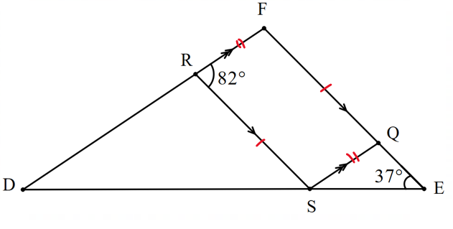

Table 2 – Category 1 question 1 solution

|  |  |
| --- | --- |
| Angle size | Reasons |
| $$∠FQS=82°$$ | opposite angles in parallelograms are equal |
| $$∠QSR=98°$$ | co-interior angles in parallel lines with $∠FRS$ |
| $$∠RFQ=98°$$ | co-interior angles in parallel lines with $∠FRS$ |
| $$∠SQE=98°$$ | supplementary angles with $∠FQS$ |
| $$∠QSE=45°$$ | angle sum of triangle $∆QSE$ |
| $$∠SRD=98°$$ | alternate angles in parallel lines with $∠QSR$ |
| $$∠RSD=43°$$ | angles on a straight line $$∠RSD+∠QSR+∠QSE=180° \\ ∠RSD+98°+45°=180° \\ ∠RSD=43°$$ |
| $$∠RDS=39°$$ | angle sum of $∆DRS$ |
| Reflex $∠RDS=321°$ | angle of complete revolution |

Table 3 – marking guidelines for Category 1 question 1

|  |  |  |
| --- | --- | --- |
| Criteria | Grade | Justification |
| Applies properties of angles at a point | Developed | The student has correctly applied supplementary angles, angles on a straight line and angles of complete revolution to find the size of an unknown angle. |
| Applies properties of angles on a transversal in parallel lines | Developed | The student has correctly used co-interior and alternate angles in parallel lines to find the size of unknown angles. |
| Applies properties of triangles and quadrilaterals | Developed | The student has used equal angles in a parallelogram. They have also identified and used information such as $∆QSE$ for the angle sum of a triangle. |
| Solves numerical problems involving multiple steps | Well developed | The student has found the size of unknown angles that involve at least 3 steps by finding the size of $∠RDS$. |
| Communicating and reasoning | Well developed | The student has used formal mathematical language and appropriate conventions such as their reference to angles using $∠$, and using the words supplementary and co-interior angles in parallel lines. |

## Question 2

|  |  |
| --- | --- |
| Category 1 question 2 diagram with sets of parallel lines and transversals highlighted. | opposite  Obtuse $∠Y=118°$ straight line $∠A=33°$ Z angles $$∠Y=33° \text{Z angles}$$ $∠D=85°$ F angles $$∠B=85° \text{Z angles}$$ |

Table 4 – marking guidelines for Category 1 question 2

|  |  |  |
| --- | --- | --- |
| Criteria | Grade | Justification |
| Applies properties of angles at a point | Developed | Student has correctly applied angles on a straight line and vertically opposite angles to find unknowns, though they have not referred to them correctly. |
| Applies properties of angles on a transversal in parallel lines | Developing | The student has correctly applied alternate angles in parallel lines but has made errors when applying corresponding angles to find unknowns. They have not referred to angles correctly. |
| Applies properties of triangles and quadrilaterals | Working towards developing | The student has labelled a triangle not using appropriate conventions. |
| Solves numerical problems involving multiple steps | Developed | The student has found unknown angles that involved 2 steps with $∠DAY$ and $∠AYX$. |
| Communicating and reasoning | Developing | The student has used informal language when referring to angle properties and has incorrectly used conventions when referring to angles. |

## Question 3

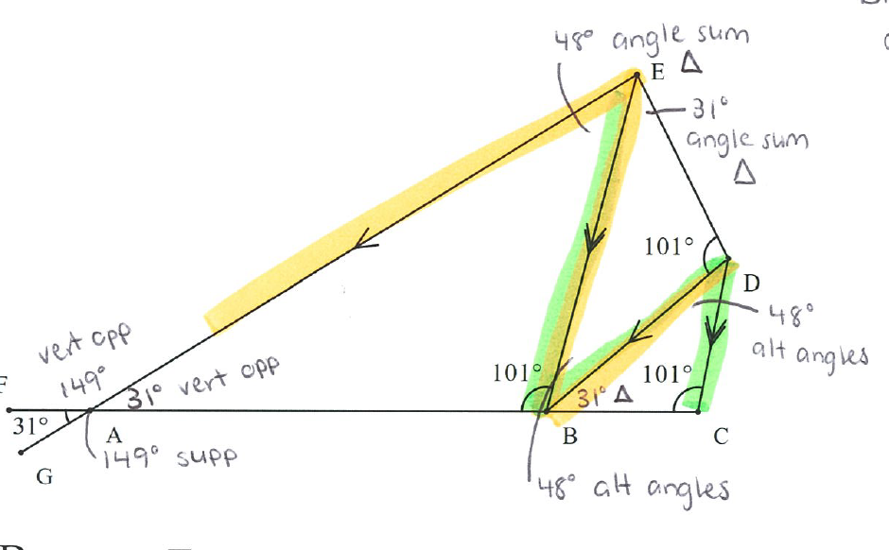

Table 5 – marking guidelines for Category 1 question 3

|  |  |  |
| --- | --- | --- |
| Criteria | Grade | Justification |
| Applies properties of angles at a point | Developed | The student has correctly applied supplementary angles and vertically opposite angles to find the size of an unknown angle. |
| Applies properties of angles on a transversal in parallel lines | Developed | The student has correctly applied alternate angles in parallel lines to find unknown angles. Category 2 may provide more information about the student’s knowledge of corresponding angles and co-interior angles in parallel lines. |
| Applies properties of triangles and quadrilaterals | Developed | The student has applied the angle sum of a triangle to find unknowns. |
| Solves numerical problems involving multiple steps | Well developed | The student has found the size of unknown angles that involve at least 3 steps by finding the size of $∠BDC$. |
| Communicating and reasoning | Developing | The student has used some informal language when referring to angle properties. They have also not used conventions when referring to angles on their diagram. |

## Question 4

|  |  |
| --- | --- |
| Category 1 question 4 diagram with parallel lines and transversal highlighted as well as a parallelogram. | given on the diagram $∠PBA=40°$ shown on diagram as equal $∠EBA=80°$ because 40 + 40= 80 $$BA∥EF$$ $∠BEP=100°$ because they areco-interior angles to $∠EBA$ in parallel lines $∠BPE=40°$ because they are alternate angles to $∠ABP$ in parallel lines $∠PEC=80°$ because they are corresponding angles to $∠EBA$ in parallel lines $∠BAE=100°$ because opposite to angle $∠BEP$ in parallelogram $ABEF$ |

Table 6 – marking guidelines for Category 1 question 4

|  |  |  |
| --- | --- | --- |
| Criteria | Grade | Justification |
| Applies properties of angles at a point | n/a | This response provides no evidence towards properties of angles at a point such as right angles, straight angles, angles of complete revolution, complementary angles, supplementary angles and vertically opposite angles. Though there may be evidence in their response to a question in Category 2 or their review of Mary’s work. |
| Applies properties of angles on a transversal in parallel lines | Developed | The student has correctly applied corresponding, alternate or co-interior angles in parallel lines to find the size of unknown angles. |
| Applies properties of triangles and quadrilaterals | Developed | The student has correctly applied the property that opposite sides in a parallelogram are equal to find $∠EBA$. |
| Solves numerical problems involving multiple steps | Well developed | The student has used 3 steps to calculate the size of $∠EBA$. |
| Communicating and reasoning | Well developed | The student has used precise mathematical language, such as indicating that the angles are in parallel lines, and correctly used conventions to refer to angles and parallel lines. |

# Category 2 solutions

## Question 1

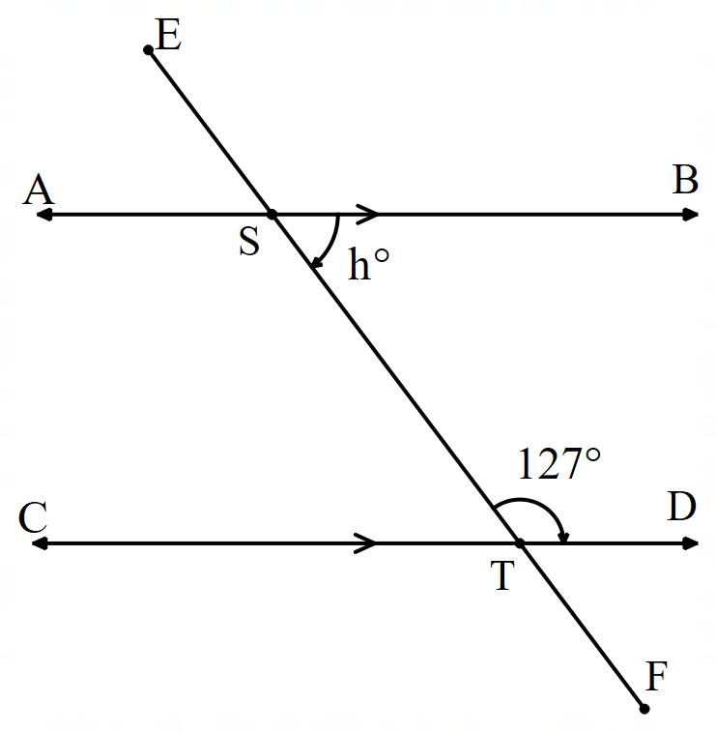

Table 7 – Category 2 question 1 solution

|  |  |  |
| --- | --- | --- |
| Solution 1 | Solution 2 | Solution 3 |
| $∠BST=180°-127°=53°$ $$h=53°$$ | $∠DTF=53°$ $∠BST=53°$ $$h=53°$$ | $∠AST=127°$ $∠BST=180°-127°=53°$ $$h=53°$$ |
| $∠BST$ and $∠DTS$ are co-interior angles in parallel lines | $∠DTS$ and $∠DTF$ are supplementary angles, and $∠DTF$ is corresponding in parallel lines with $∠BST$ | $∠AST$ and $∠DTS$ are alternate angles in parallel lines and then $∠AST$ and $∠BST$ are supplementary angles |

Table 8 – marking guidelines for Category 2 question 1

|  |  |  |
| --- | --- | --- |
| Criteria | Grade | Justification |
| Applies properties of angles at a point | Developed | Student has correctly used supplementary angles to find the size of unknown angles. |
| Applies properties of angles on a transversal in parallel lines | Developed | The student has correctly applied corresponding, alternate or co-interior angles in parallel lines to find the size of unknown angles. |
| Applies properties of triangles and quadrilaterals | n/a | Student has provided no evidence towards applying properties of triangles or quadrilaterals in this response. |
| Solves numerical problems involving multiple steps | Developed | The student has solved the problem in multiple ways but with no more than 2 steps. |
| Communicating and reasoning | Well developed | The student has used precise mathematical language and conventions consistently and effectively to communicate reasoning. |

## Question 2

|  |  |
| --- | --- |
| Category 2 question 2 diagram with sample solution. Parallel lines and transversal have been highlighted to show the Z shape. | Triangle $∠Q=54°$ supplementary angles  Triangle $∠P=54$ base angles in isosceles triangle $∠Q=126°$ as it is vertically opposite angles $∠P=126°$ alternate angles in parallel lines |
| Category 2 question 2 diagram with sample solution. Parallel lines and transversal have been highlighted to show the C shape. | Triangle $∠Q=54°$ supplementary angles  Triangle $∠P=54$ base angles in isosceles triangle $∠P=126°$ because they are corresponding angles in parallel lines |
| Category 2 question 2 diagram with sample solution. Parallel lines and transversal have been highlighted to show the Z shape. | Triangle $∠Q=54°$ supplementary angles  Triangle $∠P=54$ base angles in isosceles triangle $∠B=72°$ because of angle sums $x=72°$ because they are alternate angles in parallel lines |

Table 9 – marking guidelines for Category 2 question 2

|  |  |  |
| --- | --- | --- |
| Criteria | Grade | Justification |
| Applies properties of angles at a point | Developed | Students have correctly used supplementary angles and vertically opposite angles to find the size of unknown angles. |
| Applies properties of angles on a transversal in parallel lines | Developed | The student has correctly applied corresponding, alternate or co-interior angles in parallel lines to find the size of unknown angles. |
| Applies properties of triangles and quadrilaterals | Developed | The student has applied the angle sum of a triangle and equal angles of an isosceles triangle to find unknowns. |
| Solves numerical problems involving multiple steps | Well developed | The student has correctly found the size of unknown angles that involve at least 3 steps. |
| Communicating and reasoning | Developing | The student has used mathematical language when referring to properties but has incorrectly only used one letter when referring to angles. Though they used the correct conventions for denoting angles of the same size on their diagrams. |

## Question 3

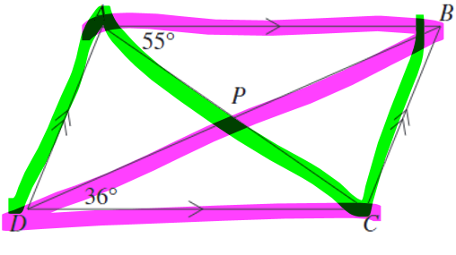

Table 10 – Category 2 question 3 solution

|  |  |
| --- | --- |
| Solution 1 | Solution 2 |
| $$∠CAB=55°$$ $∠ACD=55°$ alternate angles $$∠BDC=36°$$ $∠DPC=89°$ because the angle sum of a triangle | $$∠BDC=36°$$ $∠ABD=36°$ alternate angles $$∠CAB=55°$$ $∠APB=89°$ angle sum of a triangle $∠DPC=89°$ vertically opposite angles |

Table 11 – marking guidelines for Category 2 question 3

|  |  |  |
| --- | --- | --- |
| Criteria | Grade | Justification |
| Applies properties of angles at a point | Developed | The student has correctly used vertically opposite angles to find unknowns. |
| Applies properties of angles on a transversal in parallel lines | Developing | The student has correctly used alternate angles in parallel lines to find unknowns but provides no further evidence towards other corresponding or co-interior angles in parallel lines, though this may be evident in their response to their Category 1 question. |
| Applies properties of triangles and quadrilaterals | Developing | The student has correctly used the angle sum of a triangle to find unknowns but provides no further evidence towards other properties of triangles and quadrilaterals, though this may be evident in their response to their Category 1 question. |
| Solves numerical problems involving multiple steps | Well developed | The student has found the size of an unknown angle in at least 3 steps in Solution 2. |
| Communicating and reasoning | Developed | Mathematical language used is not precise as you can have alternate angles not in parallel lines, without stating that the angles are in parallel lines we cannot assume they are equal. |

## Question 4

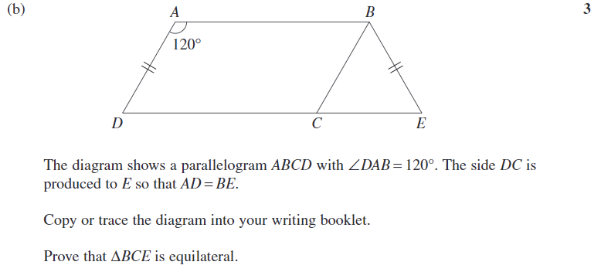

$ABCD$ is a parallelogram with $AB∥DC$ and $AD∥BC$, $∠DAB=120°$ and $AD=BE$.

Table 12 – Category 2 question 4 solution

|  |  |  |
| --- | --- | --- |
| Solution 1 | Solution 2 | Solution 3 |
| $∠BCD=120°$ because opposite angles in a parallelogram are equal. $∠BCE=60°$ because supplementary angles with $∠BCD.$ | $∠ADC=60°$ because co-interior angles in parallel lines add to $180°$ and $∠DAB=120°.$ $∠BCE=60°$ because corresponding angles in parallel lines are equal. | $∠ABC=60°$ co-interior angles in parallel lines add to $180°$ and $∠DAB=120°.$ $∠BCE=60°$ because alternate angles in parallel lines are equal. |

$AD=BC$ because opposite sides in a parallelogram.

Therefore, $BC=BE$.

$∆BCE$ is isosceles triangle as 2 sides are of equal length.

Therefore, $∠BEC=60°$ because the base angles in an isosceles triangle are equal.

$∠CBE=60°$ because the angle sum of $∆BCE$ is $180°$.

Therefore, $∆BCE$ is equilateral as all the angles are $60°.$

Table 13 – marking guidelines for Category 2 question 4

|  |  |  |
| --- | --- | --- |
| Criteria | Grade | Justification |
| Applies properties of angles at a point | Developed | The student has correctly applied vertically opposite angles to find the size of an unknown angle. |
| Applies properties of angles on a transversal in parallel lines | Developed | The student has correctly applied corresponding, alternate or co-interior angles in parallel lines to find the size of unknown angles. |
| Applies properties of triangles and quadrilaterals | Developed | The student has correctly used properties or quadrilaterals and triangles to find the size of unknown angles, such as equal sides and angles in an isosceles triangle and parallelogram. |
| Solves numerical problems involving multiple steps | Well developed | The student has found the size of an unknown angle in at least 3 steps in all their solution paths. |
| Communicating and reasoning | Well developed | The student has used formal mathematical language and conventions, including the symbol $∥$ to denote parallel lines, consistently and effectively to communicate reasoning. |

# References

This resource contains NSW Curriculum and syllabus content. The NSW Curriculum is developed by the NSW Education Standards Authority. This content is prepared by NESA for and on behalf of the Crown in right of the State of New South Wales. The material is protected by Crown copyright.

Please refer to the NESA Copyright Disclaimer for more information <https://educationstandards.nsw.edu.au/wps/portal/nesa/mini-footer/copyright>.

NESA holds the only official and up-to-date versions of the NSW Curriculum and syllabus documents. Please visit the NSW Education Standards Authority (NESA) website <https://educationstandards.nsw.edu.au/> and the NSW Curriculum website <https://curriculum.nsw.edu.au>.

[Mathematics K–10 Syllabus](https://curriculum.nsw.edu.au/learning-areas/mathematics/mathematics-k-10-2022/overview) © NSW Education Standards Authority (NESA) for and on behalf of the Crown in right of the State of New South Wales, 2022.

**© State of New South Wales (Department of Education), 2024**

The copyright material published in this resource is subject to the *Copyright Act 1968* (Cth) and is owned by the NSW Department of Education or, where indicated, by a party other than the NSW Department of Education (third-party material).

Copyright material available in this resource and owned by the NSW Department of Education is licensed under a [Creative Commons Attribution 4.0 International (CC BY 4.0) license](https://creativecommons.org/licenses/by/4.0/).

[](https://creativecommons.org/licenses/by/4.0/)

This license allows you to share and adapt the material for any purpose, even commercially.

Attribution should be given to © State of New South Wales (Department of Education), 2024.

Material in this resource not available under a Creative Commons license:

* the NSW Department of Education logo, other logos and trademark-protected material
* material owned by a third party that has been reproduced with permission. You will need to obtain permission from the third party to reuse its material.

**Links to third-party material and websites**

Please note that the provided (reading/viewing material/list/links/texts) are a suggestion only and implies no endorsement, by the New South Wales Department of Education, of any author, publisher, or book title. School principals and teachers are best placed to assess the suitability of resources that would complement the curriculum and reflect the needs and interests of their students.

If you use the links provided in this document to access a third-party's website, you acknowledge that the terms of use, including licence terms set out on the third-party's website apply to the use which may be made of the materials on that third-party website or where permitted by the *Copyright Act 1968* (Cth). The department accepts no responsibility for content on third-party websites.