Mathematics Stage 4   
(Year 8) – peer review – teacher information

Geometrical relationships

Contents

Teacher advice 2

Running the task 2

Expectations 2

Unpacking the marking rubric 2

Task modifications 3

Modifying the student sample 3

Modifications to the question bank 3

Task description 4

Submission details 5

What is the teacher looking for? 5

Marking guidelines 6

Student support material 9

Task 1 – Mary’s work 9

Question 9

Mary’s answer 9

Task 2 – question bank 11

Category 1 – find as many angles as you can 11

Category 2 – find as many solution strategies as you can 13

Task 3 - Self-reflection 15

References 17

# Teacher advice

## Running the task

It is suggested that students take one lesson to complete Task 1 – Mary’s work, and then another to complete Tasks 2 and 3. To ensure the task is a true representation of what students know and can do, it is suggested that test conditions are used, possibly allowing students reading time.

## Expectations

Students are not expected to be able to write a formal proof by the end of Stage 4. Students are only expected to apply the language, notation and conventions of geometry to solve numerical problems involving angles, providing reasons. If students are providing their reasoning in some format, they are meeting the criteria for this task.

This task can be modified if students have been extended into the Path content of Properties of geometrical figures B and C (**MA5-GEO-P-01** and **MA5-GEO-P-02**). Students could be expected to apply geometrical facts, properties and relationships related to finding the sizes of unknown sides and angles of plane shapes in diagrams, providing appropriate reasons more formally.

## Unpacking the marking rubric

The marking rubric should be unpacked as a class when distributing the assessment notification. This provides students with the opportunity to ask questions about terms that may confuse them or the expectations of each criterion if it is not clear. For example, if students do not understand what mathematical conventions are, this provides the opportunity to explain this to students.

Sample solutions have been provided with a range of responses and an assigned grade from the marking rubric. Note that these sample responses do not contain all solution paths.

## Task modifications

### Modifying the student sample

Mary’s work sample contains errors and opportunities to provide feedback for improvement, such as mistakenly calling supplementary angles ‘complementary’. These errors have been purposely selected from observed common misconceptions.

Mary’s work sample could be changed each year. It is advised to use anonymised work samples provided by students in previous years.

When searching for a new student work sample to provide students with the best opportunity to reflect and provide feedback, the sample should not be an exemplar response. It is suggested to use common misconceptions that were observed during teaching to provide the opportunity to see if the misconception still exists.

### Modifications to the question bank

Students can be given variations of the questions in the question bank by:

* modifying the angles given in each diagram so the solution path requires less steps
* changing the size of the angles and asking students to determine if the diagram is possible.

You can also increase the question bank to include more questions that align with your scope and sequence which may include interleaving of other mathematical concepts.

# Task description

**Type of task**: Peer review

**Outcomes being assessed**

A student:

* develops understanding and fluency in mathematics through exploring and connecting mathematical concepts, choosing and applying mathematical techniques to solve problems, and communicating their thinking and reasoning coherently and clearly **MAO-WM-01**
* applies angle relationships to solve problems, including those related to transversals on sets of parallel lines **MA4-ANG-C-01**
* identifies and applies the properties of triangles and quadrilaterals to solve problems   
  **MA4-GEO-C-01**

[Mathematics K–10 Syllabus](https://curriculum.nsw.edu.au/learning-areas/mathematics/mathematics-k-10-2022/overview) © NSW Education Standards Authority (NESA) for and on behalf of the Crown in right of the State of New South Wales, 2022.

During class time, you will perform 3 tasks:

1. Peer review of another student’s work.
2. Complete 2 questions to show your knowledge and understanding.
3. Complete a self-reflection of your work.

## Submission details

Students should submit:

* corrections of Mary’s work, including grade and feedback
* working and calculations for 2 questions from the question bank
* self-reflection sheet.

## What is the teacher looking for?

This outline highlights what is expected in your peer review, chosen question responses and self-assessment.

The teacher is looking to see how well you:

* determine unknown values in geometric problems
* choose appropriate mathematical techniques to find unknown values or properties
* communicate your thinking and reasoning
* read and interpret information from a geometric diagram
* use terminology such as ray, interval, line, angle, vertex, arms, parallel and perpendicular
* refer to angles, points, lines and intervals using appropriate symbols and capital letters
* identify and apply corresponding, alternate and co-interior angles in parallel lines to find unknown values
* identify and apply relationships of angles at a point such as complementary, supplementary, angles of complete revolution and vertically opposite angles to find unknown values
* identify and apply the properties of triangles and quadrilaterals to find unknown values such as equal sides, equal angles and angle sums.

# Marking guidelines

The following marking guidelines will provide the teacher with the opportunity to give feedback on responses to **all** tasks within this assessment. The table will be used to assign an **overall grade**.

Table 1 – assessment marking guidelines

|  |  |  |  |  |
| --- | --- | --- | --- | --- |
| Criteria | Working towards developing | Developing | Developed | Well developed |
| Applies properties of angles at a point  MAO-WM-01 MA4-ANG-C-01 | **Identifies properties** of angles at a point such as right angles, straight angles, angles of complete revolution, complementary angles, supplementary angles and vertically opposite angles. | **Correctly applies** **some** **properties** of angles at a point to find the size of unknown angles. | **Correctly applies a variety of** **properties** of angles at a point to find the size of unknown angles. |  |
| Applies properties of angles on a transversal in parallel lines  MAO-WM-01 MA4-ANG-C-01 | **Identifies properties** of angles on a transversal in parallel lines, such as parallel lines, corresponding, alternate and co-interior angles from a given diagram. | Correctly **applies either** corresponding, alternate or co-interior angles in parallel lines to find the size of unknown angles. | Correctly **applies a variety of** corresponding, alternate and co-interior angles in parallel lines to find the size of unknown angles. |  |
| Applies properties of triangles and quadrilaterals  MAO-WM-01 MA4-GEO-C-01 | **Refers** to special triangles and quadrilaterals from a given diagram. | Correctly **applies some properties** of triangles and quadrilaterals such as equal sides and angles, parallel lines and angle sums to find the size of unknown angles. | Correctly **applies a variety of the properties** of triangles and quadrilaterals to find the size of unknown angles. |  |
| Solves numerical problems involving multiple steps  MAO-WM-01 MA4-ANG-C-01 MA4-GEO-C-01 | **Attempts** to find the size of unknown angles that involve **one step**. | Finds the size of unknown angles that involve **one step**. | Finds the size of unknown angles that involve **at least 2 steps.** | **Consistently** finds the size of unknown angles that involve **at least 3 steps**. |
| Communicating and reasoning  MAO-WM-01 MA4-ANG-C-01 MA4-GEO-C-01 | Uses very **limited informal** mathematical language **or** conventions. | Uses **informal** mathematical language **or** conventions to communicate reasoning. | Uses mathematical language and conventions to communicate reasoning. | Uses **precise** mathematical language and correct conventions to communicate reasoning. |

# Student support material

## Task 1 – Mary’s work

You are Mary’s teacher. You are to correct Mary’s work, assign her a grade using the marking criteria and write some feedback for her, telling her how she could improve.

### Question

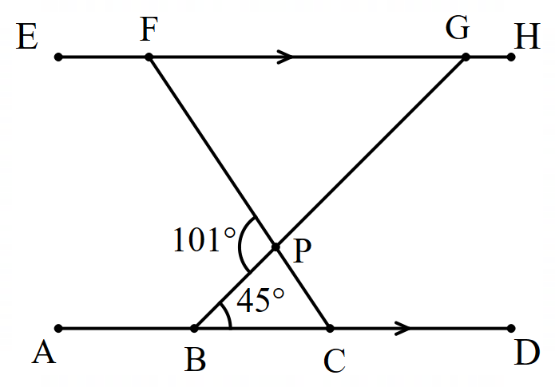

Find the size of as many angles as you can. Justify with calculations and reasoning.

### Mary’s answer

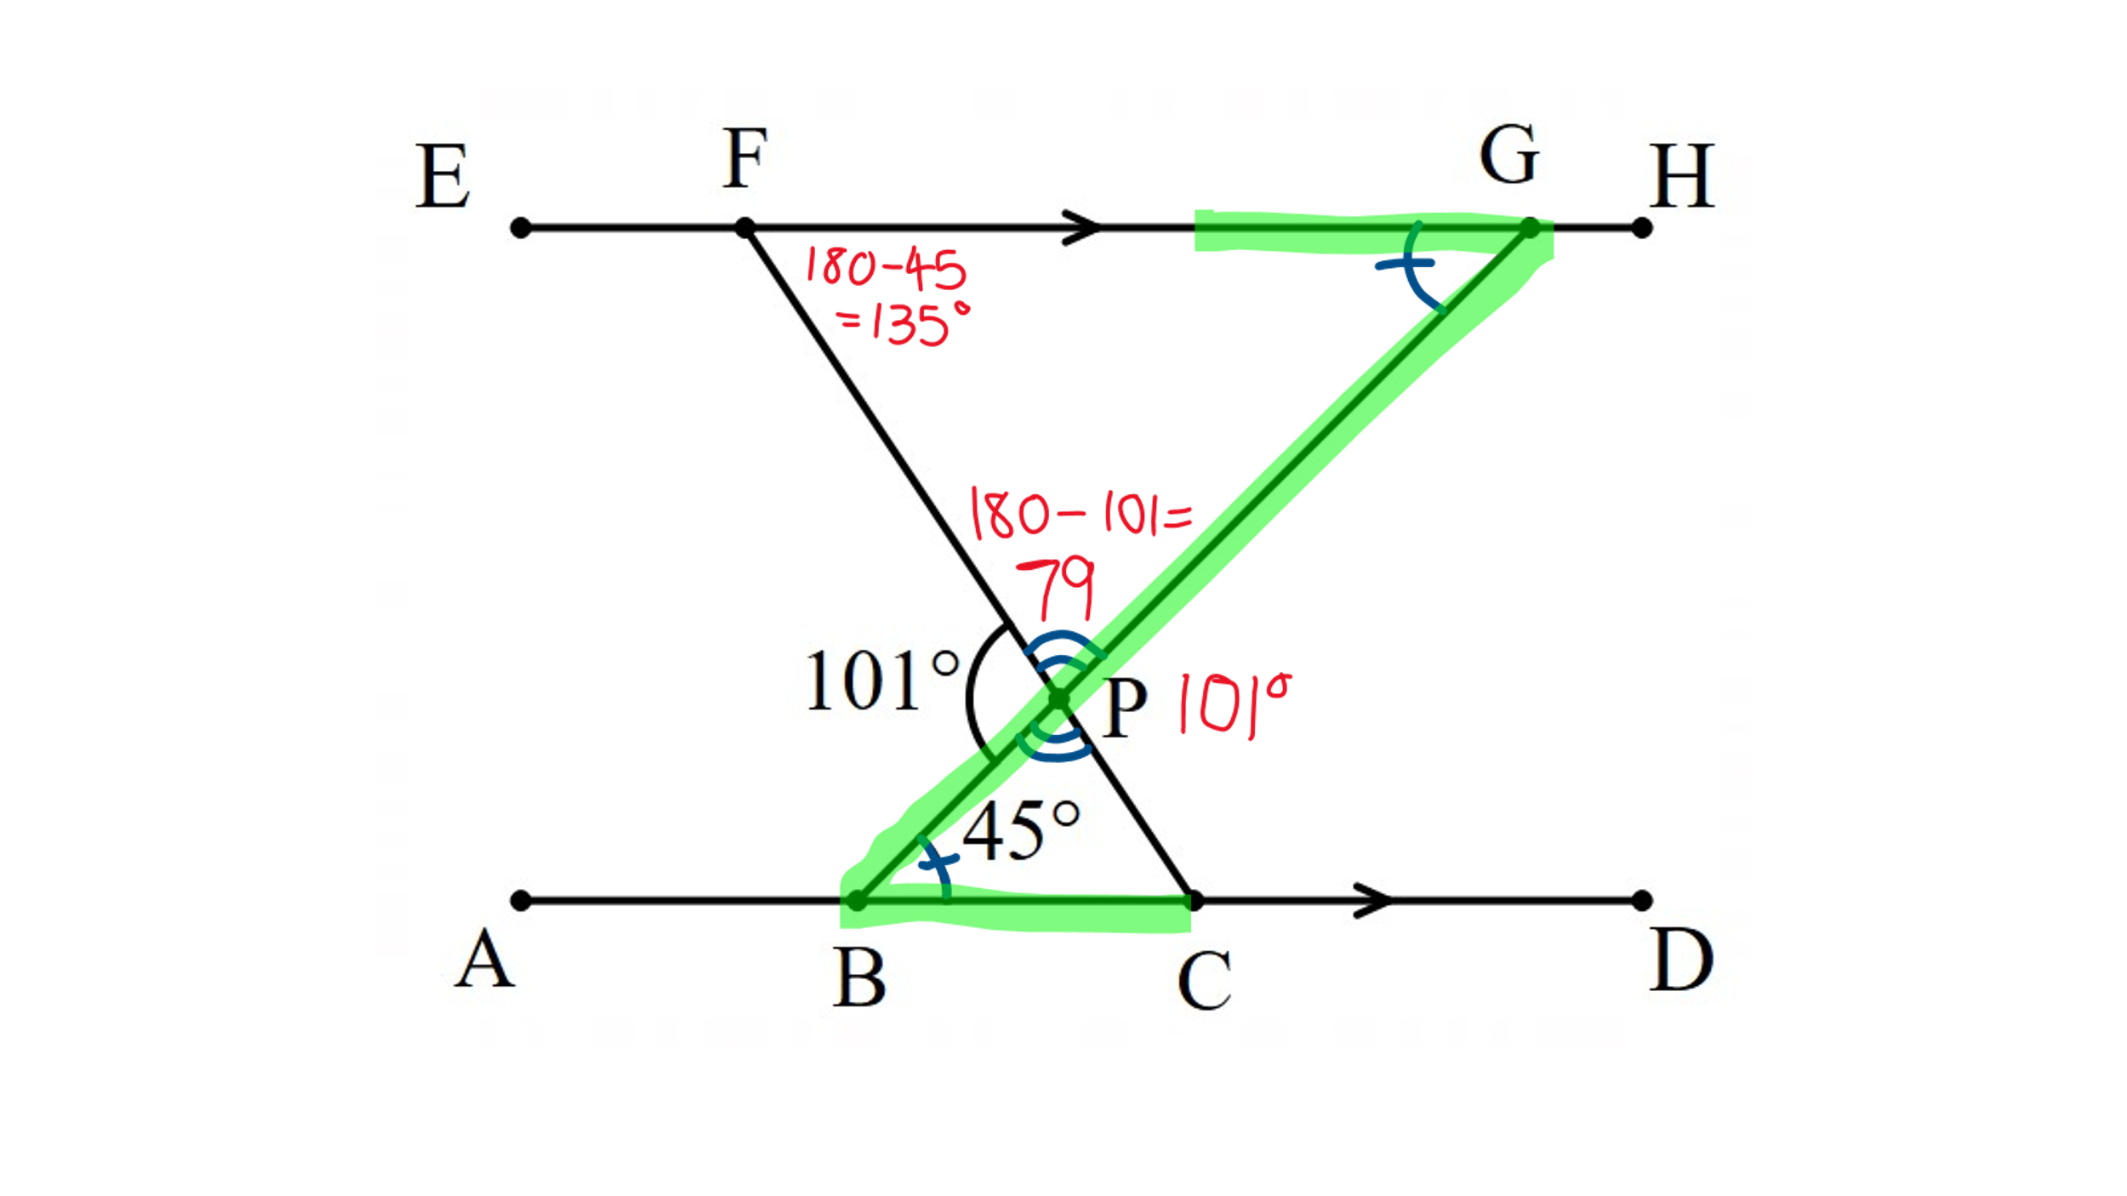

$∠FPG=79°$ because it is complementary angles with $∠FPB$.

$∠FGB=45°$ because they are alternate angles to $∠PBC$.

$∠GFP=135°$ because they are cointerior angles to $∠FGP$.

$∠PCB=135°$ because they are alternate angles to $∠GFP$.

#### Marking criteria for Mary’s work

|  |  |
| --- | --- |
| Criteria | Grade |
| * Correctly finds at least 3 angles with correct reasoning | Well developed |
| * Correctly finds 3 angles with some correct reasoning | Developed |
| * Correctly finds 2 correct angles or one correct angle with correct reasoning | Developing |
| * Finds one correct angle | Working towards developing |

**Justification and feedback:**

## Task 2 – question bank

You need to choose one question from Category 1 and one question from Category 2.

All diagrams provided are not to scale.

### Category 1 – find as many angles as you can

Select one of the following diagrams and find as much information as you can. Justify your answers with **calculations**, where necessary, **and reasoning**.

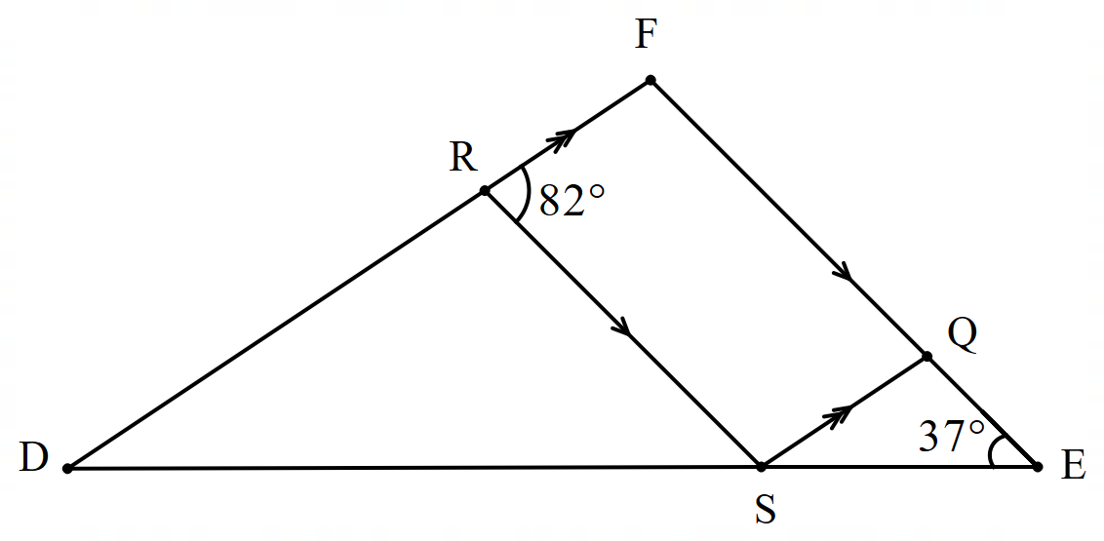

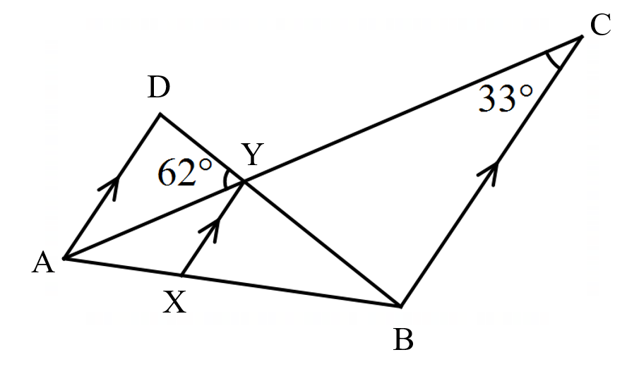

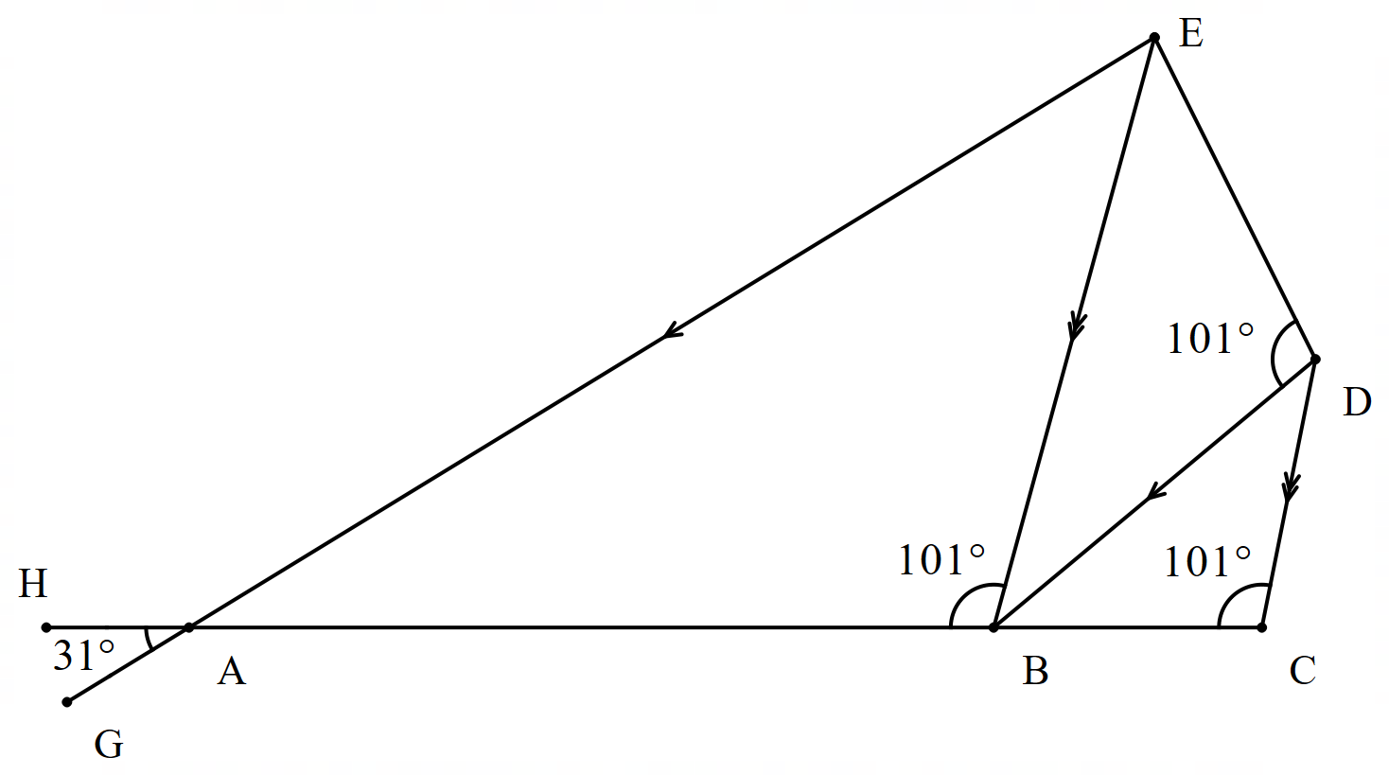

1. In the diagram, AD is parallel to BC, FE is parallel to AB, $∠EBP=∠PBA=40°$ and $∠PAB=∠PAF$. The lines AC, BD, EF intersect at P.

In the diagram, AD is parallel to BC, FE is parallel to AB, 
∠EBP=∠PBA=40° and ∠PAB=∠PAF. The lines AC, BD, EF intersect at P.


### Category 2 – find as many solution strategies as you can

Select one question from the following and find as many ways of solving the problem as possible. Each strategy should justify the answer using **calculations**, where necessary, **and reasoning**.

1. Find the value of $h$.

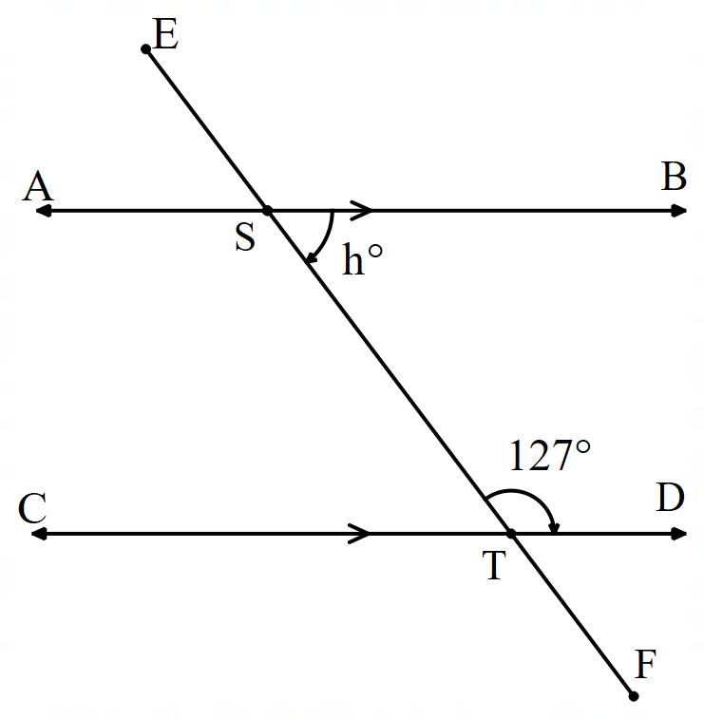

1. Find the value of $x$.

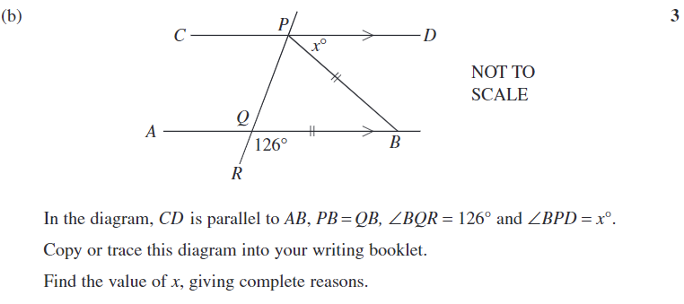

1. In the diagram, $ABCD$ is a parallelogram. Find the size of $∠DPC$.

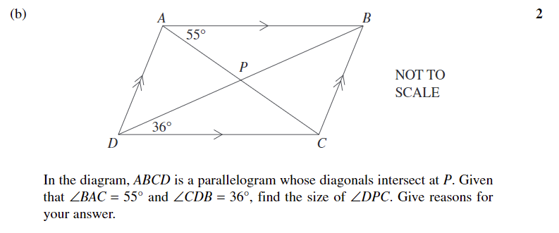

1. The diagram shows a parallelogram $ABCD$. Find the size of $∠BEC.$

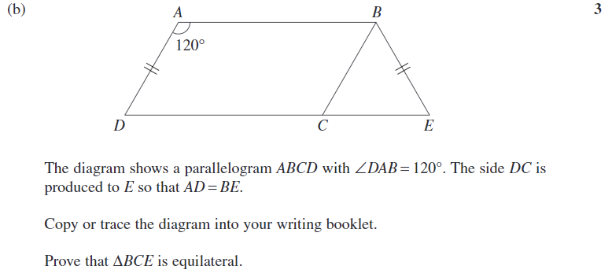

## Task 3 - Self-reflection

Use the following checklist to reflect on your answers to your selected questions. State how you have shown you have met the criteria.

|  |  |  |
| --- | --- | --- |
| Criteria | Check | Reflection/adjustments |
| Use of angle relationships |  |  |
| I have correctly referred to and applied corresponding, alternate and co-interior angles in parallel lines. |  |  |
| I have correctly referred to and applied angles at a point such as complementary, supplementary, angles of complete revolution and vertically opposite angles. |  |  |
| Properties of triangles and quadrilaterals |  |  |
| I have correctly referred to properties of triangles and quadrilaterals to find unknown values such as side lengths, angles and angle sums. |  |  |
| Communicating and reasoning |  |  |
| I have used appropriate symbols and naming conventions to refer to triangles, quadrilaterals, angles, lines and parallel lines. |  |  |
| I have provided reasons and calculations, where necessary, for each piece of information found. |  |  |

# References

This resource contains NSW Curriculum and syllabus content. The NSW Curriculum is developed by the NSW Education Standards Authority. This content is prepared by NESA for and on behalf of the Crown in right of the State of New South Wales. The material is protected by Crown copyright.

Please refer to the NESA Copyright Disclaimer for more information <https://educationstandards.nsw.edu.au/wps/portal/nesa/mini-footer/copyright>.

NESA holds the only official and up-to-date versions of the NSW Curriculum and syllabus documents. Please visit the NSW Education Standards Authority (NESA) website <https://educationstandards.nsw.edu.au> and the NSW Curriculum website <https://curriculum.nsw.edu.au>.

[Mathematics K–10 Syllabus](https://curriculum.nsw.edu.au/learning-areas/mathematics/mathematics-k-10-2022/overview) © NSW Education Standards Authority (NESA) for and on behalf of the Crown in right of the State of New South Wales, 2022.

**© State of New South Wales (Department of Education), 2024**

The copyright material published in this resource is subject to the *Copyright Act 1968* (Cth) and is owned by the NSW Department of Education or, where indicated, by a party other than the NSW Department of Education (third-party material).

Copyright material available in this resource and owned by the NSW Department of Education is licensed under a [Creative Commons Attribution 4.0 International (CC BY 4.0) license](https://creativecommons.org/licenses/by/4.0/).

[](https://creativecommons.org/licenses/by/4.0/)

This license allows you to share and adapt the material for any purpose, even commercially.

Attribution should be given to © State of New South Wales (Department of Education), 2024.

Material in this resource not available under a Creative Commons license:

* the NSW Department of Education logo, other logos and trademark-protected material
* material owned by a third party that has been reproduced with permission. You will need to obtain permission from the third party to reuse its material.

**Links to third-party material and websites**

Please note that the provided (reading/viewing material/list/links/texts) are a suggestion only and implies no endorsement, by the New South Wales Department of Education, of any author, publisher, or book title. School principals and teachers are best placed to assess the suitability of resources that would complement the curriculum and reflect the needs and interests of their students.

If you use the links provided in this document to access a third-party's website, you acknowledge that the terms of use, including licence terms set out on the third-party's website apply to the use which may be made of the materials on that third-party website or where permitted by the *Copyright Act 1968* (Cth). The department accepts no responsibility for content on third-party websites.