# Ratios versus rates

Students explore the similarities and differences between ratios and rates before using double number lines to explore simplifying rates.

## Visible learning

### Learning intentions

* To know the difference between ratios and rates.
* To be able to simplify a rate.

### Success criteria

* I can explain the similarities and differences between a ratio and a rate.
* I can express a rate in its simplest form.
* I can solve problems involving rates.

### Syllabus outcomes

A student:

* develops understanding and fluency in mathematics through exploring and connecting mathematical concepts, choosing and applying mathematical techniques to solve problems, and communicating their thinking and reasoning coherently and clearly **MAO-WM-01**
* solves problems involving ratios and rates, and analyses distance–time graphs   
  **MA4-RAT-C-01**

[Mathematics K–10 Syllabus](https://curriculum.nsw.edu.au/learning-areas/mathematics/mathematics-k-10-2022/overview) © NSW Education Standards Authority (NESA) for and on behalf of the Crown in right of the State of New South Wales, 2022

Table 1: lesson summary

|  |  |  |  |
| --- | --- | --- | --- |
| Section | Summary of activity | Teaching strategies | Teaching points |
| Launch | Show slide 3 of the *Ratios versus rates* PowerPoint with an image of a flight plan. Ask students what they notice and wonder about the flight plan image. Discuss ratios vs rates: Define ratios (comparing same units) and rates (comparing different units). Clarify that speed is a rate (distance/time). | Think-Pair-Share  Notice and wonder | Introduce students to the concept of ratios vs rates by exploring a real-world context (flight speed) and clarifying the difference in unit comparison. |
| Explore | Show slide 5 (double number line of distance vs time) and ask students to notice and wonder. Students discuss why speed is km/h, why there are 21 parts, and the importance of unit order. Ask students to use the double number line to find distances for 20 hours, 1 hour, 42 hours. Show the simplified rate on slide 6 (800 km/h) and discuss unit rates, asking where 800 and 1 came from. Distribute Appendix A to practise determining speed and distances using double number lines, followed by a discussion matching modes of transport to each number line. | Notice and wonder  Pose-Pause-Pounce-Bounce | Deepen understanding of rates through visual representation (double number line) and encourage students to articulate reasoning about units and multiplicative relationships. |
| Summarise | Students use Appendix B to fill in a Venn diagram to compare ratios and rates, discussing symbols, unit requirements and order. Students review each other’s work, add notes to their diagrams and record findings in workbooks. Hand out Appendix C for students to practise simplifying rates, then discuss in groups. | Gallery walk | Compare ratios and rates side by side, focusing on how they’re written and why units are important. |
| Apply | Students solve problems from Appendix D. Groups compare answers, focusing on language cues (for example, ‘to’ for ratios, ‘per’ for rates) and discuss nuances of units. Provide Appendix E for additional practise. | Peer feedback (Two stars and a wish) | Give students a chance to practise distinguishing between ratios and rates through hands-on problems and sharing ideas with each other. |

.

## Activity structure

Please use the associated PowerPoint *Ratios versus rates* (RVR PPT) to display images in this lesson.

### Launch

1. Display slide 3 of the PowerPoint (RVR PPT)*,* which displays Figure 1.
2. In a Think-Pair-Share ([bit.ly/thinkpairsharestrategy](https://bit.ly/thinkpairsharestrategy)), ask students what they notice and wonder ([bit.ly/noticewonderstrategy](https://bit.ly/noticewonderstrategy)) about the picture.

Figure 1: Flight plan

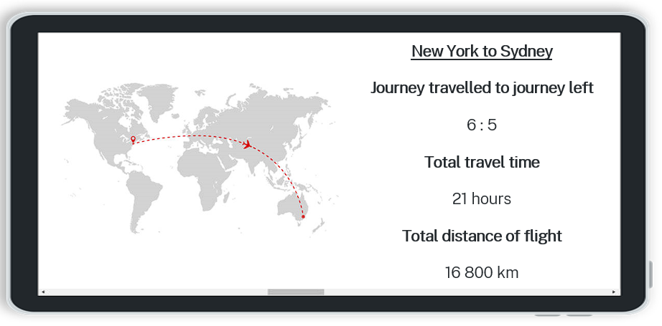

Students may notice that the image includes the ratio of where they are on the journey and the total travel time and distance. They may also notice the position of the plane on the map and that it is a journey from New York to Sydney.

Students may wonder how fast the plane is travelling.

1. Discuss with students that 6:5 is a ratio because a ratio is a comparison of quantities of the same units. In this case, hours.
2. In a Think-Pair-Share ask students if the speed the plane is travelling would be a ratio.

Speed is the comparison of distance and time which are not quantities of the same kind.

Students may benefit from being told the speed of the plane is 800 kilometres per hour.

1. Define a rate to students to be a comparison of quantities measured in different units.

### Explore

1. Display slide 5 of the PowerPoint (RVR PPT) which displays a double number line representing the distance the plane has travelled and the time taken, and ask students what they notice and wonder ([bit.ly/noticewonderstrategy](https://bit.ly/noticewonderstrategy)).

Students may notice that the time and distance of the plane’s journey is represented on each of the number lines broken up into 21 parts, which is representative of the total amount of time.

1. State to students that the double number line represents the speed of the plane. In a Think-Pair-Share ask students why this would be considered a rate rather than a ratio.
2. Use the Pose-Pause-Pounce-Bounce questioning strategy (PDF 557 KB) ([bit.ly/posepausepouncebounce](https://bit.ly/posepausepouncebounce)) to ask students:

* Why do you think we talk about speed as kilometres per hour rather than hours per kilometre?
* Why do you think that the bar is broken into 21 parts, rather than 16 800 parts?

1. Write the speed on the board as a rate of 16 800 km/21 h, explaining to students that this is the speed of the plane written as a rate.
2. In a Think-Pair-Share ask students what the forward slash means in the rate and if the units with each of the numbers are important and why.

The forward slash in the speed means ‘per’. In this example the plane travels 16 800 kilometres per 21 hours.

The units are important, as well as their order as it shows which units are being compared.

1. In a Think-Pair-Share ask students to discuss how the double number line could be used to find the distance travelled during each of the following times: 20 hours, 1 hour and 42 hours.

Students may share that they counted the boxes to find the value for 20 or went one less on the double number line to see what distance was travelled in that time.

Some students may have doubled the distance to find 42 hours as it is double 21.

1. Display slide 6 of the PowerPoint which shows the unit rate for the plane on the double number line (this can also be referred to as the average speed).
2. In a Think-Pair-Share ask students to use the double number line to find the distance travelled in 30 hours, $\frac{1}{2}$ hour and 1 week, explaining their thinking.

Prompt students to explain their reasoning. This can assess if students are considering rates as a multiplicative relationship or using the double number line as an additive relationship by adding distance covered by each hour travelled.

1. Ask students to recall what we classified as a unit when they previously explored the unitary method.

Students have explored the unitary method in Unit 12 – Further multiplicative thinking and Lesson 4 – Bears and Balloons of Unit 13 – Ratios and rates.

A unit can be described as the value of 1 part.

1. Animate slide 6 to show the simplified rate for students as 800 km/1 h and then 800 km/h. State to students that this is the simplified rate or unit rate.

Students would benefit from reading the rate aloud as 800 kilometres per hour, connecting again that the forward slash stands for the word per.

1. In a Think-Pair-Share ask students to state where the numbers 800 and 1 came from and why the second unit (in this example, hours) does not have a number.

Students should recognise that 1 hour can just be represented by an hour as it assumes it is one unit.

1. Distribute Appendix A ‘Keen for speed’ to pairs of students. Students use the double number line to determine the speed and distances travelled for each example. The first row is completed as an example for students.
2. Once students have completed Appendix A, reveal that the double number lines in Appendix A represent 5 modes of transport: motorboat, train, walking, car, bullet train. Pairs assign each mode of transport to a double number line, discussing answers with a neighbouring pair.

### Summarise

1. Assign student to visibly random groups of 3 ([bit.ly/visiblegroups](https://bit.ly/visiblegroups)) on vertical non-permanent surfaces ([bit.ly/VNPSstrategy](https://bit.ly/VNPSstrategy)), distribute Appendix B ‘Venn diagram’ printed on A3 paper and ask students to fill in the diagram.

Some prompts to help students complete their Venn diagram can include:

* What are we comparing in a ratio and a rate?
* How is a ratio or rate written?
* Does the order matter for ratios or rates?
* How do we communicate ratios and rates? What symbols and what words?
* Do either have to be whole numbers? Do we need to write the units?

1. Students are to do a gallery walk ([bit.ly/DLSgallerywalk](https://bit.ly/DLSgallerywalk)) of each other’s responses and then return to their Venn diagrams and add any extra information they found.
2. Ask students to copy the Venn diagram and the notes made on their vertical non-permanent surface into their workbooks or similar.
3. Distribute Appendix C ‘Variation problems’ to each student, which uses variation theory ([variationtheory.com/introduction](https://variationtheory.com/introduction/)) to simplify rates.
4. Ask students to compare their answers in their groups of 3.

### Apply

#### Comparing rates and ratios

1. Continue in groups of 3 on vertical non-permanent surfaces.
2. State to students that the questions they will be given involve either ratios or rates. Give each group one question at a time from Appendix D ‘Problem set’. Ask students to write their solutions, in words and using units, to each problem on their surface, and to not erase.

Appendix D is broken into a table of ratio problems and rates problems. The ratio problems are in the first column and the rates in the second.

It is suggested that the teacher print a class set of Appendix D, cut and distribute one question at a time, in any order.

1. Have students pair with another group to state and compare their answers in words.
2. Use the Pose-Pause-Pounce-Bounce questioning strategy to discuss:

* The similarities and differences between the questions.
* Which questions involve rates and which ones involve ratios?

Students should notice when they are writing their answer in words that for ratios, they use the words ‘to’ and for rates they use the word ‘per’ or similarly ‘for an’ or ‘in an’. This could be highlighted when students are talking about speeds, if not brought up through the discussion.

Students may argue that question 5 is a rates problem as it is comparing centimetres and kilometres. This would still be considered a ratio as they are both units of length and could be converted to the same unit.

#### Optional – further rates problems

1. Returning to their visibly random groups of 3 on vertical non-permanent surfaces, distribute Appendix E ‘Rates problems’ for each group to select at least one question to complete.
2. Ask students to do a gallery walk to view what questions other students chose to solve and how they approached them, giving peer feedback in the form of Two stars and a wish ([bit.ly/DLSpeerfeedback](https://bit.ly/DLSpeerfeedback)).

## Assessment and differentiation

### Suggested opportunities for differentiation

**Launch**

* The numbers for the flight plan could be modified to enable students access to the problem.

**Explore**

* A Think-Pair-Share is used so students can rehearse before sharing with the class.
* To assist students with discussions, provide them with prompts before doing a Think-Pair-Share or class discussion to promote their engagement.
* Visual representations are used to assist student understanding of simplifying rates.
* Students can be challenged to solve problems that involve finding the time taken to travel a certain distance given a rate.
* Students could add to Appendix A by creating their own double number line to represent another means of travel.

**Summarise**

* All students will be able to fill in something in each section of the Venn diagram but may provide different depths of understanding.
* Prompt students to use visual representations to assist with understanding and fluency when solving problems.

**Apply**

* There are no correct answers when finding similarities and differences throughout this section of the learning episode so all students should be encouraged to participate and share their thoughts and reasoning.
* Challenge students to create their own simplifying rates problems that include one unit that is different to what is expected in the rate. For example, the rate was specified in metres per second, but one measurement was given in kilometres.

### Suggested opportunities for assessment

**Explore**

* Students will demonstrate their working mathematically skills in discussions and justifications, such as the relationship between mathematical concepts.
* Think-Pair-Share allows students to receive peer feedback on their answers before sharing with the class.

**Summarise**

* Review students’ Venn diagrams to assess understanding of the difference between ratios and rates.
* Appendix C could be collected as evidence of learning how to simplify rates.

**Apply**

* When placed in groups of 3, students provide and receive peer feedback on their understanding.
* **Students working at vertical non-permanent surfaces means the teacher can assess student progress and provide support where appropriate.**
* Collect Appendix D as summative assessment of simplifying rates and solving ratio problems.
* The teacher could facilitate class discussions and observe students’ reasoning and justification in response to the problems in Appendix E.

## Appendix A

### Keen for speed

|  |  |  |  |  |
| --- | --- | --- | --- | --- |
| Visual representation | Speed | Distance travelled in 1 hour | Distance travelled in 2 hours | Distance travelled in 10 hours |
| Double number line for the speed of a person walking 5 km/h. | 5 km/h | 5 km | 10 km | 50 km |
| Double number line for the speed of a car travelling 100 km/h. |  |  |  |  |
| Double number line for the speed of a train travelling 160 km/h. |  |  |  |  |
| Double number line for the speed of a motorboat travelling 20 km/h. |  |  |  |  |
| Double number line for the speed of a bullet train travelling 320 km/h. |  |  |  |  |

## Appendix B

### Venn diagram

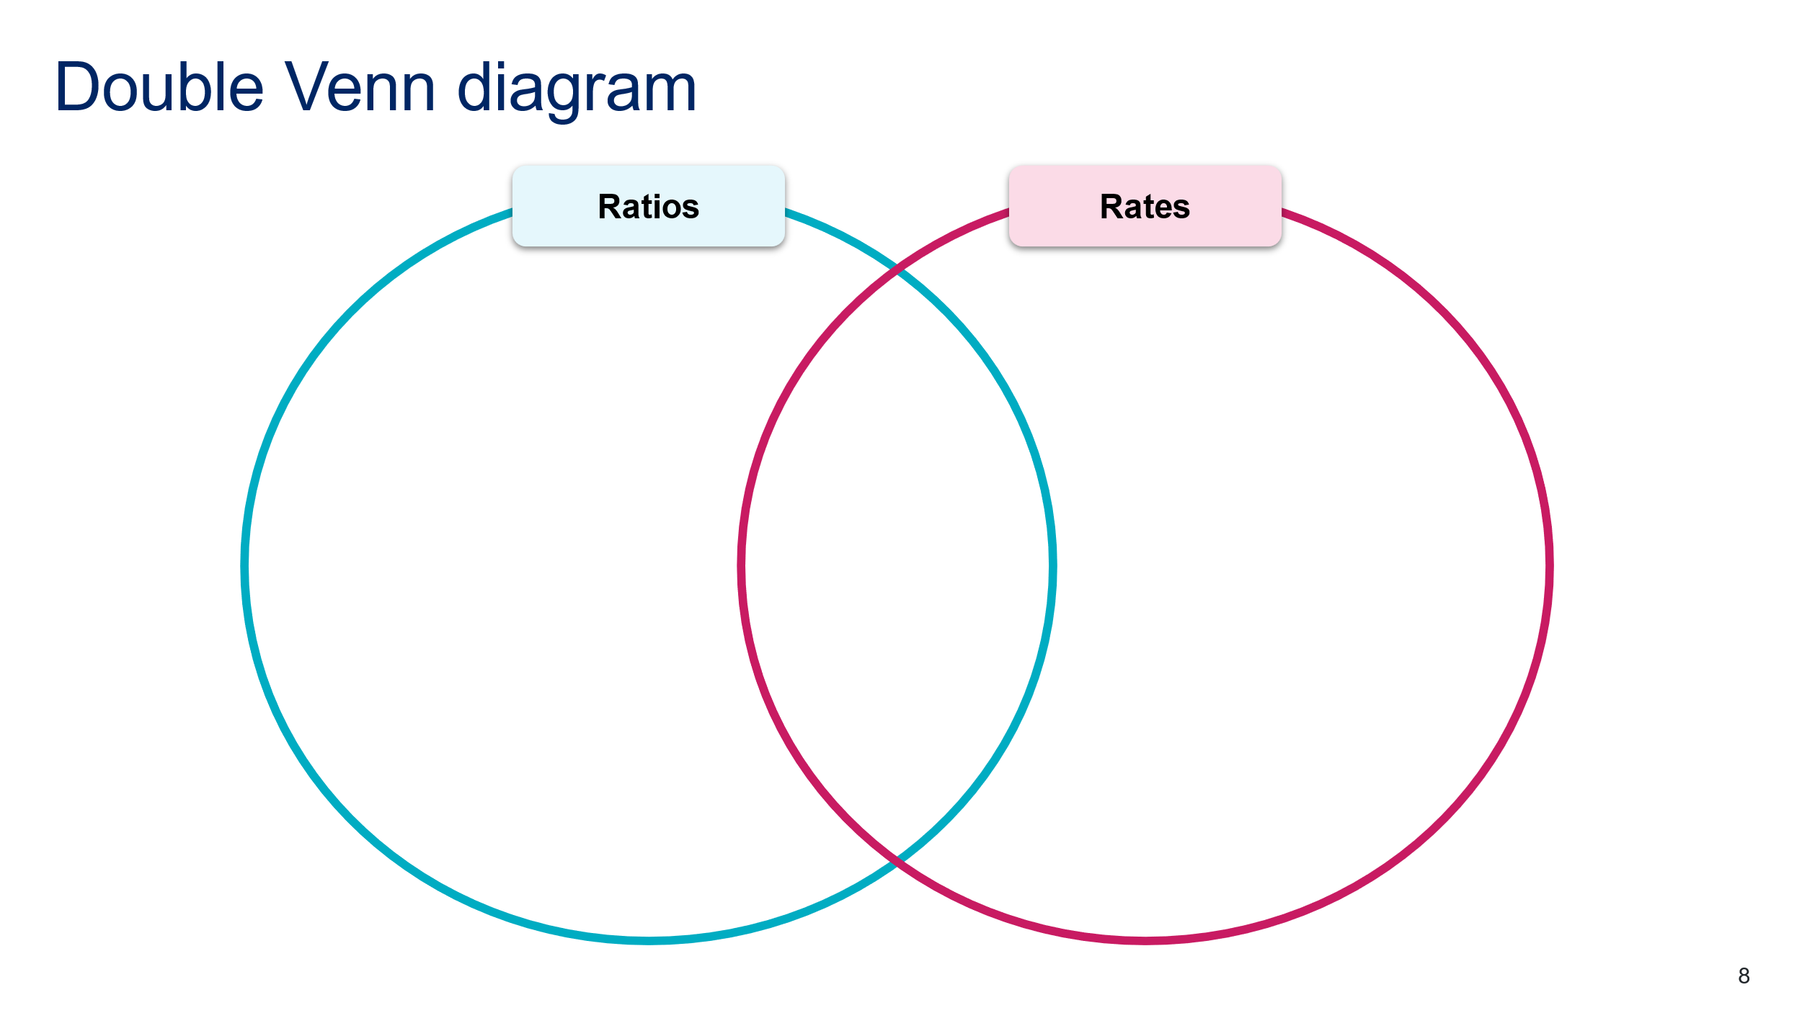

## Appendix C

### Variation problems

1. An object travels 60 kilometres in one hour. Find its speed.
2. An object travels 60 kilometres in 2 hours. Find its speed.
3. An object travels 60 kilometres in 3 hours. Find its speed.
4. An object travels 60 kilometres in 4 hours. Find its speed.
5. An object travels 60 kilometres in 8 hours. Find its speed.
6. An object travels 120 kilometres in 8 hours. Find its speed.
7. An object travels 240 kilometres in 8 hours. Find its speed.
8. An object travels 360 kilometres in 8 hours. Find its speed.
9. An object travels 36 kilometres in 8 hours. Find its speed.
10. An object travels 36 kilometres in one hour. Find its speed.
11. An object travels 36 kilometres in 30 minutes. Find its speed.
12. An object travels 36 kilometres in 20 minutes. Find its speed.
13. An object travels 36 kilometres in 10 minutes. Find its speed.
14. An object travels 36 kilometres in 15 minutes. Find its speed.
15. An object travels 36 kilometres in 25 minutes. Find its speed.

This activity has been adapted from the Variation theory activity ‘Compound measures: Speed’ ([variationtheory.com/2018/05/22/finding-speed/](https://variationtheory.com/2018/05/22/finding-speed/)).

## Appendix D

### Problem set

|  |  |
| --- | --- |
| Ratio problems | Rates problems |
| 1. Divide $60 between 2 people in the ratio . | 1. A person earned $60 for a 5-hour shift.  What is their hourly rate? |
| 1. A recipe has 3 cups of flour to 1.5 cups of cocoa. If I only have one cup of flour, how much cocoa do I need? | 1. I can make 16 cupcakes with 2 litres of cake batter. How much batter is used per cupcake? |
| 1. Every centimetre on a map represents 5 kilometres. How many centimetres are in 1 kilometre? | 1. A car travels 180 kilometres in 3 hours. Find its average speed. |
| 1. John was comparing 2 cars. One car had a fuel capacity of 58 litres and the other was 50 litres. For every one litre the second car can store, how much can the first car store? | 1. A car travels 750 kilometres on a 58 L tank. How much fuel does the car use per 100 kilometres? |

## Appendix E

### Rates problems

Select at least one of the following questions to complete.

1. A group of students are making posters to advertise a bake sale. Twelve large signs and 60 small signs are needed. It takes 10 minutes to paint a small sign and 30 minutes to paint a large sign. How many students will be needed to paint all the signs in 2 hours or less?
2. Jason is driving across the country. For the first 3 hours, he travels 60 km/h. For the next 2 hours, he travels 72 km/h. Assuming that he has not stopped, what is his average travelling speed in kilometres per hour?
3. Tom runs a 100 m race in a certain amount of time. If John runs the same race, he takes 2 seconds longer. If John ran at 8 m/s, approximately how fast did Tom run?
4. One morning, both Jim and Julia left at 9:00, but in different cars. Jim arrived at 10:10; Julia arrived 10 minutes later. If Jim’s average speed was 54 kilometres per hour, what was Julia’s average speed (to the nearest whole number)?

These problems have been adapted from Varsity tutors ‘Example questions’ ([bit.ly/ratesproblems](https://bit.ly/ratesproblems)).

## Sample solutions

### Appendix A – keen for speed

|  |  |  |  |  |
| --- | --- | --- | --- | --- |
| Transport | Speed | Distance travelled in 1 hour | Distance travelled in 2 hours | Distance travelled in 10 hours |
| Walking | 5 km/h | 5 km | 10 km | 50 km |
| Car | 100 km/h | 100 km | 200 km | 1000 km |
| Train | 160 km/h | 160 km | 160 km | 1600 km |
| Motorboat | 20 km/h | 20 km | 40 km | 200 km |
| Bullet train | 320 km/h | 320 km | 640 km | 3200 km |

### Appendix B – Venn diagram

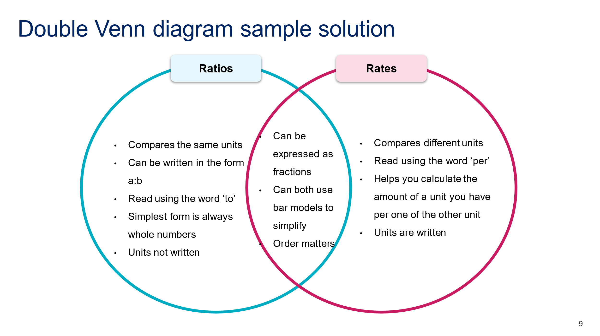

### Appendix C – variation problems

1. 60 km/h
2. 30 km/h
3. 20 km/h
4. 15 km/h
5. 7.5 km/h
6. 15 km/h
7. 30 km/h
8. 45 km/h
9. 4.5 km/h
10. 36 km/h
11. 1.2 km/min or 72 km/h
12. 1.8 km/min or 108 km/h
13. 3.6 km/min or 216 km/h
14. 2.4 km/min or 144 km/h
15. 1.44 km/min or 86.4 km/h

### Appendix D – problem set

1. $24:$36, 24 dollars to 36 dollars
2. $12/h, 12 dollars per hour
3. 0.5 cups or half a cup
4. 125 ml/cupcake, 125 millilitres per cupcake
5. 0.2 cm or 2 mm in a kilometre
6. 60 km/h, 60 kilometres per hour
7. 1.16 litres for every one litre
8. $7\frac{11}{15}$ litres per 100 kilometres

### Appendix E – rates problems

1. In 2 hours, one student can paint 4 large signs or 12 small signs. Therefore, 3 students are required to paint the large signs ($4×3=12$), and 5 students are required to paint the small signs ($12×5=60$). In total, 8 students are required.
2. In the first 3 hours, he travels 180 kilometres. $$3×60=180$$ 
   In the next 2 hours, he travels 144 kilometres. $$2×72=144$$ 
   For a total of 324 kilometres. $$180+144=324$$ 
   Divide by the total number of hours to obtain the average travelling speed. $$324÷5=64.8 km/h$$
3. Let $x$  denote the amount of time that it took Tom to run the race.  
   Then it took John $x+2$  seconds to run the same race going 8 m/s.  
   At 8 m/s, it takes 12.5 seconds to finish a 100 m race.  
   This means it took Tom 10.5 seconds to finish. Running 100 m in 10.5 seconds is the same as $100÷10.5≈9.5m/s$
4. Jim arrived at the common destination in 70 minutes or $1\frac{1}{6}$ hours. His average speed was 54 kilometres per hour, so their workplace is $1\frac{1}{6}×54=63$ kilometres away from Jim and Julia’s home. Julia travelled those 63 kilometres in 80 minutes, or $1\frac{1}{3}$ hours, so her average speed was $63÷1\frac{1}{3}=47\frac{1}{4}$ or, approximately 47 kilometres per hour.

## References

This resource contains NSW Curriculum and syllabus content. The NSW Curriculum is developed by the NSW Education Standards Authority. This content is prepared by NESA for and on behalf of the Crown in right of the State of New South Wales. The material is protected by Crown copyright.

Please refer to the NESA Copyright Disclaimer for more information <https://educationstandards.nsw.edu.au/wps/portal/nesa/mini-footer/copyright>.

NESA holds the only official and up-to-date versions of the NSW Curriculum and syllabus documents. Please visit the NSW Education Standards Authority (NESA) website <https://educationstandards.nsw.edu.au/> and the NSW Curriculum website <https://curriculum.nsw.edu.au/>.

[Mathematics K–10 Syllabus](https://curriculum.nsw.edu.au/learning-areas/mathematics/mathematics-k-10-2022/overview) © NSW Education Standards Authority (NESA) for and on behalf of the Crown in right of the State of New South Wales, 2022.

**© State of New South Wales (Department of Education), 2024**

The copyright material published in this resource is subject to the *Copyright Act 1968* (Cth) and is owned by the NSW Department of Education or, where indicated, by a party other than the NSW Department of Education (third-party material).

Copyright material available in this resource and owned by the NSW Department of Education is licensed under a [Creative Commons Attribution 4.0 International (CC BY 4.0) license](https://creativecommons.org/licenses/by/4.0/).

[](https://creativecommons.org/licenses/by/4.0/)

This license allows you to share and adapt the material for any purpose, even commercially.

Attribution should be given to © State of New South Wales (Department of Education), 2024.

Material in this resource not available under a Creative Commons license:

* the NSW Department of Education logo, other logos and trademark-protected material
* material owned by a third party that has been reproduced with permission. You will need to obtain permission from the third party to reuse its material.

**Links to third-party material and websites**

Please note that the provided (reading/viewing material/list/links/texts) are a suggestion only and implies no endorsement, by the New South Wales Department of Education, of any author, publisher, or book title. School principals and teachers are best placed to assess the suitability of resources that would complement the curriculum and reflect the needs and interests of their students.

If you use the links provided in this document to access a third-party's website, you acknowledge that the terms of use, including licence terms set out on the third-party's website apply to the use which may be made of the materials on that third-party website or where permitted by the *Copyright Act 1968* (Cth). The department accepts no responsibility for content on third-party websites.