# Distance–time graphs

Students explore distance–time graphs by comparing the speeds of animals, exploring stories of people at school and work, and investigating heart rate zone training.

## Visible learning

### Learning intention

* To be able to interpret and draw distance–time graphs.

### Success criteria

* I can describe straight-line segments as having a negative, zero or positive slope.
* I can calculate speed from a distance–time graph.
* I can create a distance–time graph.

### Syllabus outcomes

A student:

* develops understanding and fluency in mathematics through exploring and connecting mathematical concepts, choosing and applying mathematical techniques to solve problems, and communicating their thinking and reasoning coherently and clearly **MAO-WM-01**
* solves problems involving ratios and rates, and analyses distance–time graphs   
  **MA4-RAT-C-01**

[Mathematics K–10 Syllabus](https://curriculum.nsw.edu.au/learning-areas/mathematics/mathematics-k-10-2022/overview) © NSW Education Standards Authority (NESA) for and on behalf of the Crown in right of the State of New South Wales, 2022.

Table 1: lesson summary

|  |  |  |  |
| --- | --- | --- | --- |
| Section | Summary of activity | Teaching strategies | Teaching points |
| Warm up | Students read Appendix A which is a glossary page of important terms for the lesson. |  | Provides terminology for students and the opportunity to ask questions before being used in the learning episode. |
| Launch | Show students the video ‘Animals Speed Comparison | Present and Prehistoric’ (6:01) ([bit.ly/animalspeedcomparison](https://bit.ly/animalspeedcomparison)), pausing at 0:58. Students predict which animal will be the fastest, before watching the remainder of the video. | Think-Pair-Share  Notice and wonder | The launch provides a fun activity to engage students in the lesson. Students will have opportunities to compare the speeds of a variety of animals. |
| Explore | Use slide 3 of the PowerPoint Distance–time graphs to compare graphs of 3 animals from the video. Use slides 4 to 5 to have students determine which story matches the distance–time graph provided. Students cut out and match cards from Appendix B. | Finger voting  Pose-Pause-Pounce-Bounce  Think-Pair-Share  Gallery walk | Students match animals to their distance–time graphs representing speed as km/hr. Students match written descriptions to distance–time graphs to demonstrate an understanding of slope in the given context. |
| Summarise | Use slides 7 to 15 for explicit teaching of interpreting distance–time graphs. Use slide 16 to discuss the slope of the distance–time graph. Students complete Appendix C. | Think-Pair-Share  Pose-Pause-Pounce-Bounce  Worked examples (Your turn) | Students calculate speed from distance–time graphs and provide reasoning to support conclusions based on distance–time graphs. |
| Apply | Use slide 18 to discuss heart rate zone training. Use slide 19 to introduce the task and have pairs complete Appendix D. | Pose-Pause-Pounce-Bounce | Students apply their understanding to create distance–time graphs made up of straight-line segments. |

## Activity structure

Please use the associated PowerPoint *Distance*–*time graphs* (DTG PPT) to display images in this lesson.

### Warm up

1. Print and distribute Appendix A ‘Glossary’ to students. Appendix A is a glossary with a list of keywords that students will need to be familiar with for this learning episode.

A class discussion could be facilitated to build definitions with students rather than using the definitions provided. Empty rows are provided for students to add more words throughout the lesson.

### Launch

1. Show students the beginning of the video ‘Animals Speed Comparison | Present and Prehistoric’ (6:01) ([bit.ly/animalspeedcomparison](https://bit.ly/animalspeedcomparison)), pausing at 0:58.
2. Students discuss in a Think-Pair-Share ([bit.ly/thinkpairsharestrategy](https://bit.ly/thinkpairsharestrategy)), what they noticed and wondered ([bit.ly/noticewonderstrategy](https://bit.ly/noticewonderstrategy)) during the video.

* Students may notice that the animals seem to be ordered by size.
* Students may wonder which animal is fastest, which animal is slowest and where the human will place.

1. In a Think-Pair-Share, have students predict which animal will be the fastest and which animal will be the slowest.
2. Play the remainder of the video.

### Explore

1. Use slide 3 of the PowerPoint (DTG PPT) to display 3 graphs, representing the speed of a tortoise, a T-rex and a cheetah.
2. Students discuss in a Think-Pair-Share:

* Which graph represents which animal?
* What information did you use to make your decision?

Use student discussions to draw out important features of the graphs such as:

* the axes titles
* the axes scale
* each graph is linear
* each graph represents the distance travelled in one hour
* the slope of the cheetah’s graph will be steep because it travels further in one hour whereas the slope of the tortoise’s graph will be flat because it does not travel far in one hour
* the slope of each line represents the rate at which the animal is travelling over time.

1. Use slide 4 of the PowerPoint (DTG PPT) to display a graph comparing ‘Distance from den’ and ‘Time’, along with 3 story cards.
2. Establish with students which straight-line segments of the distance–time graph have positive and negative slopes.

Students have not yet encountered the terms slope or gradient, but these terms could be connected to their real-life experience of walking uphill or downhill.

The segments with positive slope represent that the lion is moving away from the den, the steeper the slope, the more quickly the lion is moving.

The segment with negative slope represents that the lion is moving towards the den.

The gradient will be explored explicitly in Unit 14 – Analysing patterns.

1. With a partner, students discuss which story the graph is showing. Conduct a finger vote ([bit.ly/hingepointquestionsstrategy](https://bit.ly/hingepointquestionsstrategy)) for students to share which story they believe the graph is showing; one finger for the first story, 2 fingers for the second story and 3 fingers for the third.
2. Use slide 5 of the PowerPoint (DTG PPT) to reveal that the correct answer is the second story.
3. Use a Pose-Pause-Pounce-Bounce questioning strategy (PDF 557 KB ([bit.ly/posepausepouncebounce](https://bit.ly/posepausepouncebounce)) to discuss what the slope of each line segment ($AB$, $BC$ and $CD$) tell us about the lion’s movement.

In this graph and story, there are no units, so students must speak more generally about slope and speed. For example, the lion is moving the fastest from point $A$ to point $B$ because it travels more distance in less time than the other segments.

1. In a Think-Pair-Share, ask students to draw a straight-line segment representing the lion sleeping in his den.
2. Have students share their answer by drawing their straight-line segment in the air with their finger.

Students should note that a line that is neither increasing nor decreasing or has a gradient of zero, would mean the lion is not moving at all during that period of time.

1. Print and distribute Appendix B ‘Card sort’ to pairs of students. Students are to cut out each card.
2. Pairs work together to match each graph to its corresponding story.
3. Students complete a gallery walk ([bit.ly/DLSgallerywalk](https://bit.ly/DLSgallerywalk)) to compare how their peers matched the graphs and stories.
4. Randomly select students to explain their reasoning behind the pairing of a graph and story. Use a questioning strategy such as Pose-Pause-Pounce-Bounce to facilitate a class discussion.

### Summarise

1. Use slide 7 of the PowerPoint (DTG PPT) to display the previously used graph showing the lion’s distance from den (km) and time (mins). Explain to students that speed can be calculated by considering how far something has moved over time. Model calculating the speed for straight-line segment AB.

Students can use the unitary method to calculate how far the lion has travelled in one minute to calculate the speed.

Students used the unitary method with rates in Lesson 7 – best buys.

1. In a Think-Pair-Share, students calculate the speeds of BC and CD.

BC = $\frac{3 km}{30 mins}=0.1 km/min$  
CD = $\frac{15 km}{20 mins}=0.75 km/min$  
Students may suggest that CD should have a negative speed as it has negative slope. In this example we are considering distance travelled so this number will always be positive as the lion will always be adding to his distance travelled whether moving towards or away from his den. This could also be an opportunity to discuss the difference between distance and displacement.

1. Use slides 8 to 15 of the PowerPoint (DTG PPT) for explicit teaching of interpreting distance–time graphs using the Worked examples (Your turn) method ([bit.ly/supportingstrategies](https://bit.ly/supportingstrategies)).
2. Use slide 16 of the PowerPoint (DTG PPT) to display a distance–time graph. Read the following context to students.

Every morning, Bob walks along a straight road from his home to his school, a distance of 160 metres. The graph shows his journey on one day.

1. In a Think-Pair-Share, have students discuss which straight-line segments of the distance–time graph have a positive, zero or negative slope.
2. Distribute Appendix C ‘Bob’s journey to school’ to each student. Students complete the appendix, writing their responses in the space provided.

Encourage students to describe the speed at which Bob travelled. A speed of 2 m/s is a brisk walk, a speed of 4 m/s is likely a run.

1. Students discuss their responses with a partner, if they disagree, have them combine and discuss with another pair.
2. Using a questioning strategy such as Pose-Pause-Pounce-Bounce, discuss possible responses as a class, emphasising students’ observations of speed, such as where the speed is constant, fastest and slowest.

### Apply

1. Use slide 18 of the PowerPoint (DTG PPT) to display a table with column headings ‘Heart rate zone’ and ‘% of maximum heart rate’, and some benefits of heart rate zone training. There is further information about training with heart rate zones provided below.

By using heart rate zones to guide training, athletes can better target specific intensities. For example, zones 1 and 2 are ideal for building endurance and burning fat, whereas zones 4 and 5 are best for increasing speed, power and performance at high intensities.

1. Distribute Appendix D ‘Heart rate zone training’ to pairs of students.
2. Display slide 19 of the PowerPoint (DTG PPT) and read aloud the task to students.

It may be important to note that this set of axes is comparing distance run not distance from a starting point.

1. Once students have completed their reflection questions, conduct a class discussion using the Pose-Pause-Pounce-Bounce questioning strategy to discuss the following prompts:

* How does the graph help us interpret the athlete’s run?
* How would you describe the shape of the graph and how does this relate to the athlete’s speed?

## Assessment and differentiation

### Suggested opportunities for differentiation

**Warm up**

* Glossary page provided to remove barriers to understanding due to vocabulary.

**Launch**

* In a notice and wonder activity, all thoughts and opinions are valid as there are no correct answers, encouraging student participation.

**Explore**

* **Challenge students by adjusting the scale of the graphs provided. For example, the time axis could be provided in minutes rather than decimal hours. The 3 graphs could be made to look identical by adjusting the scale of the time axis.**
* **Students could benefit from the speeds being adjusted from km/h to m/s, which can be modelled in the classroom and may be easier for students to relate to their prior knowledge.**
* **Relate speeds to real-world contexts to help students build connections. For example, a cheetah running at 120 km/h is faster than cars travelling on the freeway.**
* **Challenge students to create their own stories for the lion and draw a corresponding graph.**

**Summarise**

* **If the units used in the Worked examples are too large for students to relate to their own understanding, the contexts and graphs could be replaced with stories about walking. Students could be involved in the construction of the graphs before answering questions.**
* **Challenge students to refer to the gradients of line segments when describing Bob’s speed.**

**Apply**

* Slide 18 of the PowerPoint (DTG PPT) is provided so that small group modelling can be completed for students that require additional support.
* Students could calculate their own heart rate and subsequently, their heart rate zones.
* Students could be provided an authentic graph of a person’s heart rate on a run, that they could find averages for, recreating this activity with real data.
* Students could be challenged to consider contexts where data would be non-linear. For example, have students draw a graph of the position of a flag as it is raised up a pole.
* Conversations could be facilitated as to why only straight-line segments were explored in this lesson, even though movement is not linear.

### Suggested opportunities for assessment

**Launch**

* Use the launch activity to gain an understanding of students’ prior knowledge of speed.

**Explore**

* **Use the finger vote strategy to assess if students can generally interpret a graph based on approximate shape. Additional support may need to be provided to some students before continuing with the next activity.**
* **Observe how students have matched cards in the card sort activity to assess if they can construct a straight-line graph from a written context and if they can interpret distance**–**time graphs. Use the following class discussion to further draw out any misconceptions or errors.**

**Summarise**

* **Observe student responses to Your turn problems to ensure they can make calculations from a provided distance**–**time graph.**
* **Appendix C could be collected to assess how students interpreted the shape of the graph and the speed of each segment.**
* **Observe how students use reasoning to justify their answers.**

**Apply**

* **Appendix D could be collected to assess students’ ability to construct a distance**–**time graph.**

## Appendix A

### Glossary

|  |  |
| --- | --- |
| Key term | Definition |
| speed | Speed is how fast an object is moving. |
| slope | Slope is a measure of how steep a line is on a graph. |
| graph | A graph is a visual representation of data that shows the relationship between different variables. |
|  |  |
|  |  |
|  |  |
|  |  |

## Appendix B

### Card sort

|  |  |
| --- | --- |
| 1. The lion sees some prey in the distance and runs off to chase it. He then loses the prey and decides to head back to his den. On his way back he spots the prey again and turns back to run after it. | 1. Opposite the lion’s den is a hill. The lion climbed slowly up the hill, walked across the top and then ran quickly down the other side. |
| 1. The lion walked to a tree to rest in the shade for a while, then ran back to his den. | 1. The lion walked slowly away from his den, stopped to drink some water, then was startled by a hippopotamus and started running further away from the den. |
| 1. The lion left his den for a walk, then a storm came so he ran back to his den and stayed inside. | 1. This graph is incorrect. Can you figure out why? |
| 1. After waking up in the jungle, the lion walked slowly back to his den. | 1. The lion walked just outside of his den, rested in the sun, then walked back to his den. |

|  |  |
| --- | --- |
| A  A linear graph that is increasing, decreasing, then quickly increasing. | B  A linear graph that is increasing, flat, then increasing. |
| C  A linear graph that is increasing in 3 segments, each more steep than the previous. | D  A linear graph that is increasing, flat, then decreasing. |
| E  A linear graph that is increasing, vertical, then increasing. | F  A linear graph that is increasing, then decreasing. |
| G  A linear graph that is decreasing. | H  A linear graph that is increasing, flat, then decreasing. |

## Appendix C

### Bob’s journey to school

Straight line graph showing Time in seconds and Distance from home in meters.
Segment 1: (0,0) to (50,100)
Segment 2: (50, 100) to (70, 30)
Segment 3: (70, 30) to (100, 160)
Segment 4: (100, 160) to (120, 160).

1. Describe what may have happened on Bob’s journey.

|  |
| --- |
|  |

1. Are all sections of the graph realistic? Explain your reasoning.

|  |
| --- |
|  |

## Appendix D

### Heart rate zone training

An athlete tracked their run on a 5-kilometre straight racetrack, broken into phases at each kilometre. Their time taken to complete each phase (rounded to the nearest minute) and their average heart rate zone for each lap is provided in the table below.

|  |  |  |
| --- | --- | --- |
| Phase | Time taken (nearest minute) | Average heart rate zone |
| Phase 1 | 6 | Zone 5 |
| Phase 2 | 7 | Zone 4 |
| Phase 3 | 7 | Zone 4 |
| Phase 4 | 8 | Zone 2 |
| Phase 5 | 10 | Zone 1 |

Use the information provided to construct a distance–time graph of the athlete’s run on the axes provided below.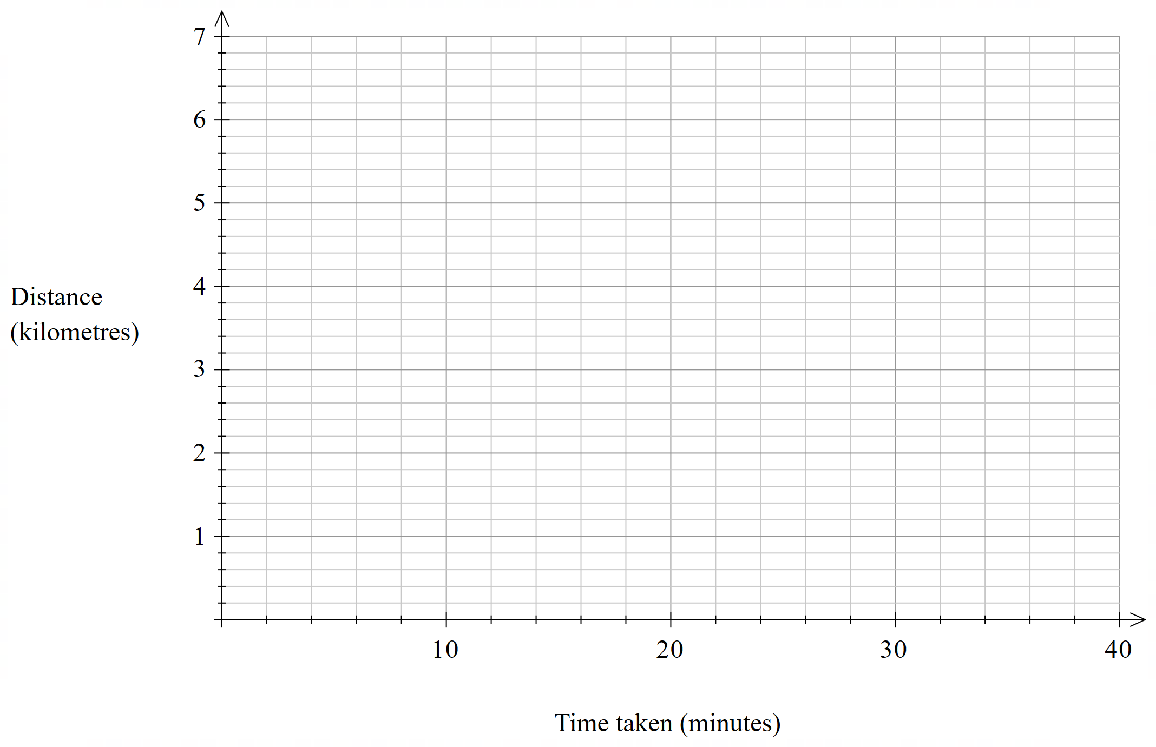

#### Reflection questions

How might the athlete use this data to inform their approach?

|  |
| --- |
|  |

Describe the shape of the graph.

|  |
| --- |
|  |

If the runner was to increase their endurance, what might happen to the shape of the graph?

|  |
| --- |
|  |

## Sample solutions

### Appendix B – card sort

1A

2C

3D

4B

5F

6E

7G

8H

### Appendix C – Bob’s journey to school

1. Bob walked to his grandparents to pick up his bike he left there from the day before. Once he got it, he rode to a friend’s house, which was closer to home, so they could ride together to school. Once they got to school, they tied up their bikes and had a drink.
2. I feel all parts of the graph are realistic as it depends on what transport you are using to know how fast you are going in each section. A bike is faster, as well as a car, so you could meet the speeds seen on the graphs in those ways.

### Appendix D – heart rate zone training

A graph increasing by a distance of 1 km over each of the following time intervals
6 minutes
7 minutes
7 minutes
8 minutes
10 minutes.

## References

This resource contains NSW Curriculum and syllabus content. The NSW Curriculum is developed by the NSW Education Standards Authority. This content is prepared by NESA for and on behalf of the Crown in right of the State of New South Wales. The material is protected by Crown copyright.

Please refer to the NESA Copyright Disclaimer for more information <https://educationstandards.nsw.edu.au/wps/portal/nesa/mini-footer/copyright>.

NESA holds the only official and up-to-date versions of the NSW Curriculum and syllabus documents. Please visit the NSW Education Standards Authority (NESA) website <https://educationstandards.nsw.edu.au/> and the NSW Curriculum website <https://curriculum.nsw.edu.au/>.

[Mathematics K–10 Syllabus](https://curriculum.nsw.edu.au/learning-areas/mathematics/mathematics-k-10-2022/overview) © NSW Education Standards Authority (NESA) for and on behalf of the Crown in right of the State of New South Wales, 2022.

**© State of New South Wales (Department of Education), 2024**

The copyright material published in this resource is subject to the *Copyright Act 1968* (Cth) and is owned by the NSW Department of Education or, where indicated, by a party other than the NSW Department of Education (third-party material).

Copyright material available in this resource and owned by the NSW Department of Education is licensed under a [Creative Commons Attribution 4.0 International (CC BY 4.0) license](https://creativecommons.org/licenses/by/4.0/).

[](https://creativecommons.org/licenses/by/4.0/)

This license allows you to share and adapt the material for any purpose, even commercially.

Attribution should be given to © State of New South Wales (Department of Education), 2024.

Material in this resource not available under a Creative Commons license:

* the NSW Department of Education logo, other logos and trademark-protected material
* material owned by a third party that has been reproduced with permission. You will need to obtain permission from the third party to reuse its material.

**Links to third-party material and websites**

Please note that the provided (reading/viewing material/list/links/texts) are a suggestion only and implies no endorsement, by the New South Wales Department of Education, of any author, publisher, or book title. School principals and teachers are best placed to assess the suitability of resources that would complement the curriculum and reflect the needs and interests of their students.

If you use the links provided in this document to access a third-party's website, you acknowledge that the terms of use, including licence terms set out on the third-party's website apply to the use which may be made of the materials on that third-party website or where permitted by the *Copyright Act 1968* (Cth). The department accepts no responsibility for content on third-party websites.