Mathematics Stage 4   
(Year 8) – sample assessment task notification

Rolling cylinders investigation

Contents

Task description 2

Part 1 – identifying the pattern 3

Part 2 – designing a cylinder 4

Part 3 – applying the pattern 4

Student support material 5

Introductory activity 5

Part 1 6

Total rolling distance and number of rotations 6

Submission details 7

What is the teacher looking for? 7

Marking guidelines 8

# Task description

**Type of task**: Investigation

**Outcomes being assessed**:

A student:

* develops understanding and fluency in mathematics through exploring and connecting mathematical concepts, choosing and applying mathematical techniques to solve problems, and communicating their thinking and reasoning coherently and clearly **MAO-WM-01**
* applies knowledge of the perimeter of plane shapes and the circumference of circles to solve problems **MA4-LEN-C-01**
* generalises number properties to operate with algebraic expressions including expansion and factorisation **MA4-ALG-C-01**
* solves linear equations of up to 2 steps and quadratic equations of the form $ax^{2}=c$  
  **MA4-EQU-C-01**
* creates and displays number patterns and finds graphical solutions to problems involving linear relationships **MA4-LIN-C-01**

[Mathematics K**–**10 Syllabus](https://curriculum.nsw.edu.au/learning-areas/mathematics/mathematics-k-10-2022/overview) © NSW Education Standards Authority (NESA) for and on behalf of the Crown in right of the State of New South Wales, 2022.

You will be exploring how many civilisations in history used log rolling to move large objects.

Log rolling has been theorised to have been used to:

* transport massive limestone and granite blocks for pyramid construction in ancient Egypt
* transport the iconic Moai statues on Easter Island
* transport massive stone monoliths to the Stonehenge site
* transport large stones and logs for Medieval castles in Europe.

Before starting this assessment, you will complete an introductory activity with your teacher.

## Part 1 – identifying the pattern

Choose one of your measured cylinders from the introductory activity to use for Part 1 of the investigation.

1. On the Cartesian plane ‘Total rolling distance and number of rotations’, provided in the student support material, plot the total rolling distance on the $y$-axis against the number of rotations on the $x$-axis for one of your measured cylinders and draw a line through the points.
2. Use your graph to construct a linear equation that represents the relationship between the total distance travelled ($d$) and the number of rotations ($n$) for the cylinder.
3. Describe what each variable or value in your equation represents in the context of this investigation.
4. Describe the relationship between the number of rotations and the rolling distance of each cylinder.

## Part 2 – designing a cylinder

Now that you have explored the relationship between the number of rotations and the rolling distance for a cylinder, you will use this knowledge to design cylinders to meet specific criteria.

1. You are helping to design a rolling mechanism to move a heavy object over specific distances. Design a cylinder that will move the object:
2. exactly 15 rotations to cover a total distance of 30 metres
3. exactly 10 rotations to cover a total distance of 25 metres
4. exactly 3 rotations to cover a total distance of 11 metres.
5. Answer the following questions, providing clear reasoning based on your calculations and observations:
6. How does the circumference of the cylinder affect the total rolling distance for a given number of rotations?
7. How does the size of the cylinder affect its practicality for moving objects? Are there any real-life constraints that should be considered?

## Part 3 – applying the pattern

1. Investigate if an object always moves exactly one rotation when using the log rolling method, as shown in the image below. Design an experiment to test this question using one of your cylindrical objects and record your observations and data.

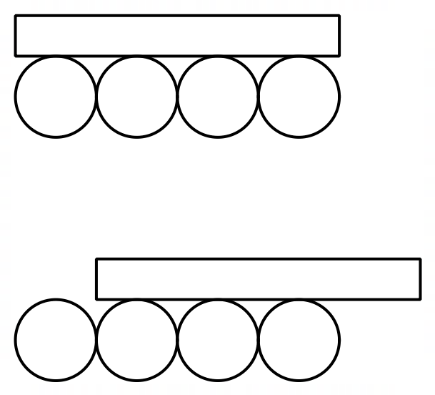

1. Did the actual distance match the predicted distance based on the cylinder's circumference? Why or why not?

# Student support material

## Introductory activity

Table 1

|  |  |  |  |  |
| --- | --- | --- | --- | --- |
| ****Cylindrical object**** | ****Diameter**** | ****Radius**** | ****Circumference**** | ****Depth**** |
|  |  |  |  |  |
|  |  |  |  |  |
|  |  |  |  |  |

Table 2

|  |  |  |  |
| --- | --- | --- | --- |
| ****Cylindrical object**** | ****Rotation 1**** | ****Rotation 2**** | ****Rotation 3**** |
|  |  |  |  |
|  |  |  |  |
|  |  |  |  |

## Part 1

### Total rolling distance and number of rotations

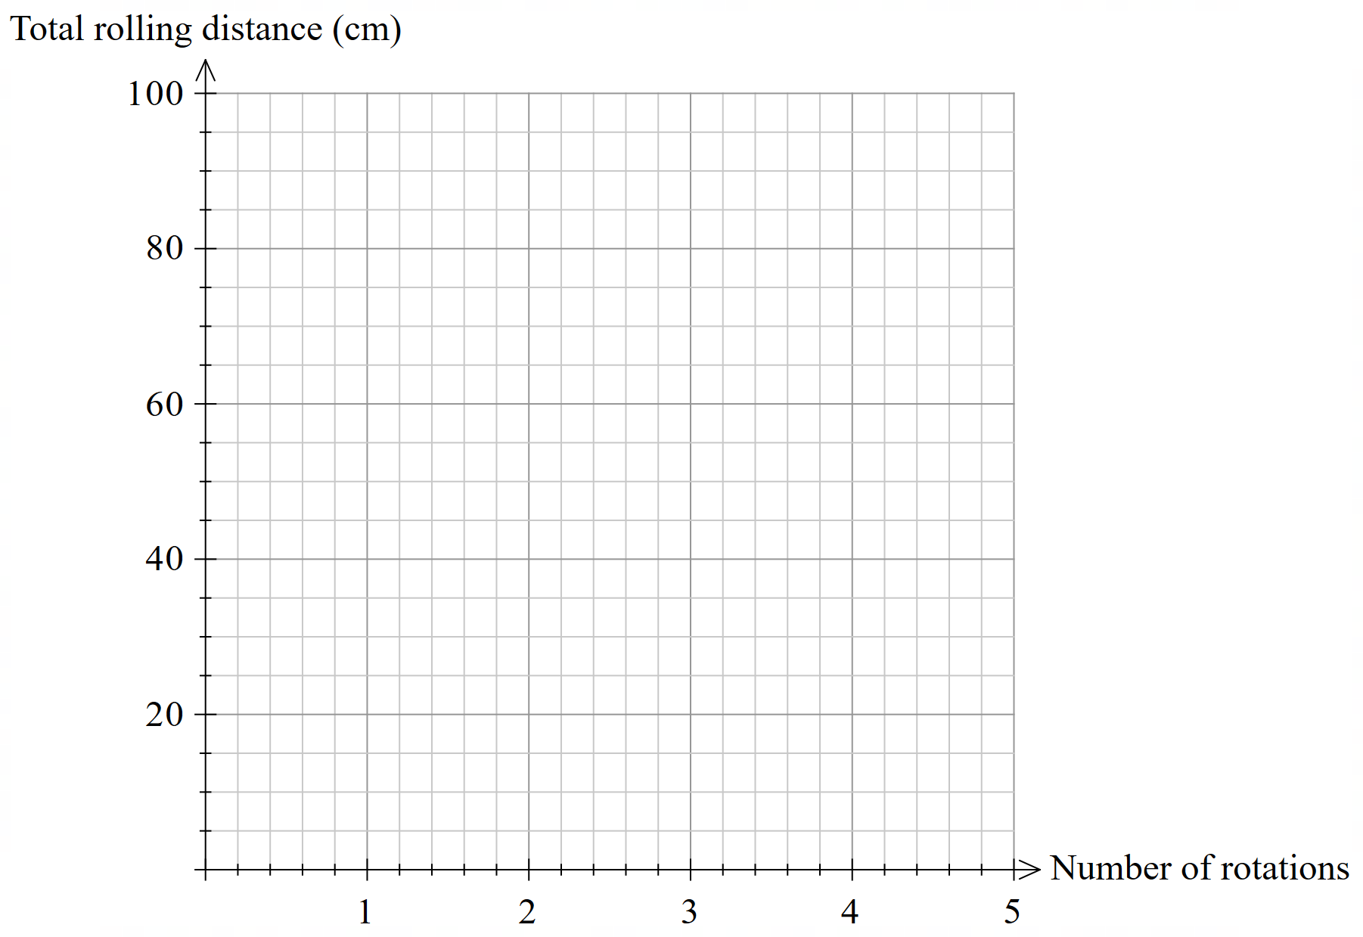

## Submission details

A written response is expected for this task. It should contain answers to the questions provided, as well as graphs, tables, calculations and reasoning to support your findings. Images and/or drawings may be used to support your explanations. Your submission may include subheadings to assist with the organisation of your response.

## What is the teacher looking for?

The teacher is looking for you to show how you:

* draw on connections between algebra, equations and linear patterns to approach the investigation
* select the best methods to carry out the investigation and use them fluently
* clearly show and explain how you worked through the investigation and the reasons behind your choices.

All solutions and explanations should be supported by reasoning and calculations.

# Marking guidelines

Table 2 – assessment marking guidelines (Part 1)

|  |  |  |  |  |
| --- | --- | --- | --- | --- |
| ****Criteria**** | ****Working towards developing**** | ****Developing**** | ****Developed**** | ****Well developed**** |
| ****Part 1**** | I attempted to plot my collected measurements on the Cartesian plane with limited accuracy and/or some errors.  I have provided a description of the relationship using limited mathematical language. | I can accurately plot my collected measurements on the Cartesian plane.  I have identified and explained some connections between my graph and an equation, such as identifying a variable.  My description of the relationship utilises some appropriate mathematical language and some explanations are supported with reasoning. | I can use my graph to construct an equation and explain what each variable or value represents in the context of this investigation.  I can use the evidence I have collected, including measurements, my graph, and the equation to describe the relationship between the number of rotations and the rolling distance of each cylinder.  My description of the relationship utilises precise mathematical language and reasoning. |  |

**Feedback**:

Table 3 – assessment marking guidelines (Part 2)

|  |  |  |  |  |
| --- | --- | --- | --- | --- |
| ****Criteria**** | ****Working towards developing**** | ****Developing**** | ****Developed**** | ****Well developed**** |
| ****Part 2**** | I have attempted to calculate the dimensions for cylinders to meet each scenario.  I have attempted to answer the questions with limited connection to calculations and/or limited reasoning.  My reasoning and explanations use very limited mathematical language. | I have provided calculations supporting the design of the cylinders to meet each scenario.  I have identified some connections between the circumference and the total rolling distance of a cylinder.  I have explained how the dimensions of a cylinder affect its suitability for moving objects.  I have listed some real-life constraints related to the size of cylinders.  My reasoning and explanations use limited mathematical language. | I have provided calculations and some reasoning in the design of the cylinders to meet each scenario.  I can explain how circumference relates to the relationship between the total rolling distance and the number of rotations.  I have explained which dimensions of the cylinder affect its suitability for moving objects and how the dimensions relate to the relationship determined in Part 1. I have listed some real-life constraints that should be considered.  My reasoning and explanations use appropriate mathematical language and some connections between measurement and algebra. | I have provided clear and concise calculations and strong reasoning in the design of the cylinders to meet each scenario.  I can clearly and concisely explain how circumference relates to the relationship between the total distance and the number of rotations.  I have explained which dimensions of the cylinder affect its suitability for moving objects and how the dimensions relate to the relationship determined in Part 1. I have clearly explained a comprehensive set of real-life constraints that should be considered.  My reasoning and explanations use precise mathematical language and clear connections between measurement and algebra. |

**Feedback**:

Table 4 – assessment marking guidelines (Part 3)

|  |  |  |  |  |
| --- | --- | --- | --- | --- |
| ****Criteria**** | ****Working towards developing**** | ****Developing**** | ****Developed**** | ****Well developed**** |
| ****Part 3**** | I have made progress towards designing an experiment to test if an object moves a distance equal to one cylinder's circumference per rotation, with some aspects needing further clarity or consideration of errors and variables.  I am beginning to make connections between the experiment results and the relationship between the number of rotations and the distance travelled. | I have designed an experiment to test if an object moves a distance equal to one cylinder's circumference per rotation, with a basic set-up and limited consideration of errors or variables.  I can describe, with minimal reasoning or evidence, how the experiment results relate to the relationship between the number of rotations and the distance travelled. | I have designed an experiment to test if an object moves a distance equal to one cylinder's circumference per rotation, with a clear set-up and some consideration of minimising errors and controlling variables.  I can explain, with some reasoning and evidence, how the experiment results relate to the relationship between the number of rotations and the distance travelled. | I have designed a detailed and logical experiment to test if an object moves a distance equal to one cylinder's circumference per rotation, using a set-up that minimises errors and controls variables effectively.  I can clearly and concisely explain how the experiment results confirm, refine, or challenge the relationship between the number of rotations and the distance travelled. |

**Feedback**:

**© State of New South Wales (Department of Education), 2025**

The copyright material published in this resource is subject to the Copyright Act 1968 (Cth) and is owned by the NSW Department of Education or, where indicated, by a party other than the NSW Department of Education (third-party material).

Copyright material available in this resource and owned by the NSW Department of Education is licensed under a [Creative Commons Attribution 4.0 International (CC BY 4.0) license](https://creativecommons.org/licenses/by/4.0/).

[](https://creativecommons.org/licenses/by/4.0/)

This license allows you to share and adapt the material for any purpose, even commercially.

Attribution should be given to © State of New South Wales (Department of Education), 2025.

Material in this resource not available under a Creative Commons license:

* the NSW Department of Education logo, other logos and trademark-protected material
* material owned by a third party that has been reproduced with permission. You will need to obtain permission from the third party to reuse its material.

**Links to third-party material and websites**

Please note that the provided (reading/viewing material/list/links/texts) are a suggestion only and implies no endorsement, by the New South Wales Department of Education, of any author, publisher, or book title. School principals and teachers are best placed to assess the suitability of resources that would complement the curriculum and reflect the needs and interests of their students.

If you use the links provided in this document to access a third-party's website, you acknowledge that the terms of use, including licence terms set out on the third-party's website apply to the use which may be made of the materials on that third-party website or where permitted by the Copyright Act 1968 (Cth). The department accepts no responsibility for content on third-party websites.