Mathematics Stage 4   
(Year 8) – assessment task sample solutions

Rolling cylinders investigation

Contents

Sample solutions 2

Introductory activity 2

Part 1 – identifying the pattern 3

Part 2 – designing a cylinder 4

Part 3 – applying the pattern 6

Marking guidelines 8

Support and alignment 11

Evidence base 12

# Sample solutions

## Introductory activity

Table 1

|  |  |  |  |  |
| --- | --- | --- | --- | --- |
| ****Cylindrical object**** | ****Diameter**** | ****Radius**** | ****Circumference**** | ****Depth**** |
| ****Soft drink can**** | 5.3 cm | 2.65 cm | 18.1 cm | 14.5 cm |
| ****Drink bottle**** | 10 cm | 5 cm | 31.5 cm | 19 cm |
| ****Speaker**** | 8.4 cm | 4.2 cm | 26.5 cm | 24 cm |

Table 2

|  |  |  |  |
| --- | --- | --- | --- |
| ****Cylindrical object**** | ****Rotation 1**** | ****Rotation 2**** | ****Rotation 3**** |
| Soft drink can | 18.1 cm | 36.2 cm | 54.5 cm |
| Drink bottle | 31.5 cm | 63 cm | 95 cm |
| Speaker | 8.4 cm | 16.9 cm | 25.3 cm |

## Part 1 – identifying the pattern

|  |  |
| --- | --- |
| 1 | Figure 1 – solution graph  Graph of distance travelled by rolling cylinders versus the number of rotations of the cylinder. Points are marked at (1, 18), (2, 36) and (3, 54). A line of best fit is drawn and goes through the point (0, 0). |
| 2 | The linear equation is $d=18×n$ |
| 3 | The distance that the can rolled is $d$ and $n$ is how many times it rotated.  18.1 cm is the distance it rolled during one rotation which is the circumference. |
| 4 | The number of rotations makes the distance the can travels increase by the circumference each time it rolls. The graph shows a linear relationship between the number of rotations and the rolling distance. |

## Part 2 – designing a cylinder

|  |  |
| --- | --- |
| 1 | 1. If the cylinder goes 30metres with 15 rotations, then 30 m ÷ 15 = 2 m per rotation.   That means the circumference is 2 metres.  Cylinder with diameter 0.6 m and height 2 m.   1. If the cylinder goes 25 metres with 10 rotations, then 25 m ÷ 10 = 2.5 m per rotation.   That means the circumference is 2.5 metres.  Cylinder with diameter 0.8 m and height 3 m.   1. If the cylinder goes 11 metres with 3 rotations, then 11 m ÷ 3 = 3.666 … m per rotation.   That means the circumference is 3.7 metres.  Cylinder with diameter 1.2 m and height 8 m. |
| 2 | 1. The circumference of the cylinder affects the rolling distance for each rotation, as the bigger the circumference the further the cylinder will travel in one rotation. Using the relationship that was established, $d=18×n$, 18 was the circumference, so the more rotations, the more multiples of 18 to find the distance. 2. The larger the radius and diameter of the cylinder, the further it will travel in one rotation. A cylinder with a small radius like the pipes shown in the video don’t move the rock very far on each rotation because its circumference is small. A cylinder with a larger radius might be better as it could move the rock quicker. However, if the radius of the cylinder is too big, it might be too high to get the rock on top of the cylinder to move it. |

## Part 3 – applying the pattern

1. The log will always move exactly the length of one circumference.

I rolled a fly spray can with a diameter of 6.2 cm and it went a distance of 19 cm on one rotation. I made a mark on the base of the can and on a piece of paper and then made another mark on the paper when the mark on the can came back to the paper.

I then considered what would happen if I had an object I was trying to move and multiple cans on a roller. I expected the object to move the distance of one circumference if the cans were all the same size.

I used the cans from earlier and tried several experiments. I lined up 5 cans and marked the start and one circumference along (see Figure 2).

Figure 2 – cans rolling start

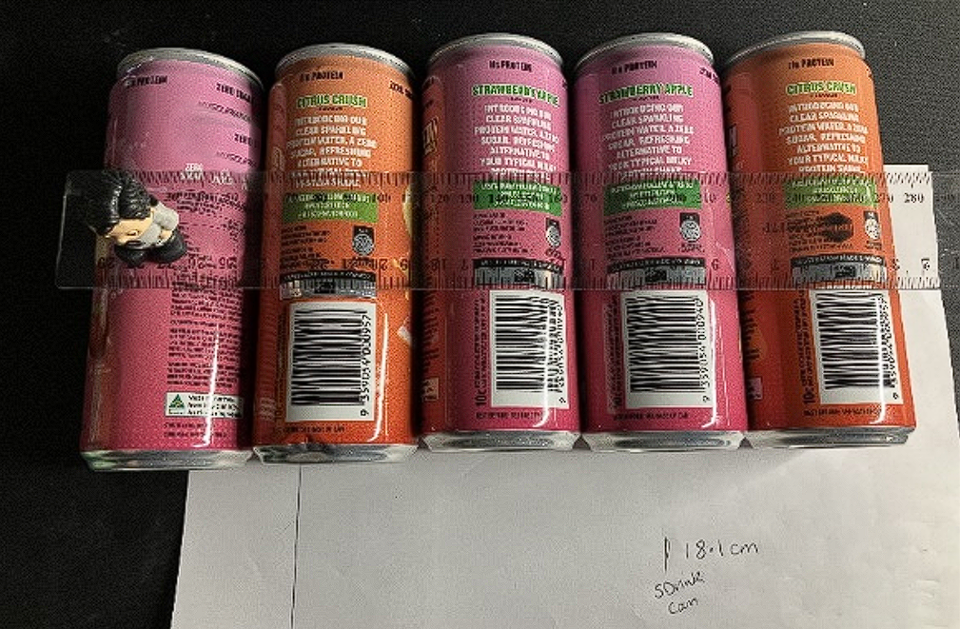

I found that the object (figure) moved more than one circumference – it was closer to 2 circumferences. It also travelled across the cans to the fourth can (see Figure 3).

Figure 3 – cans rolling after one rotation

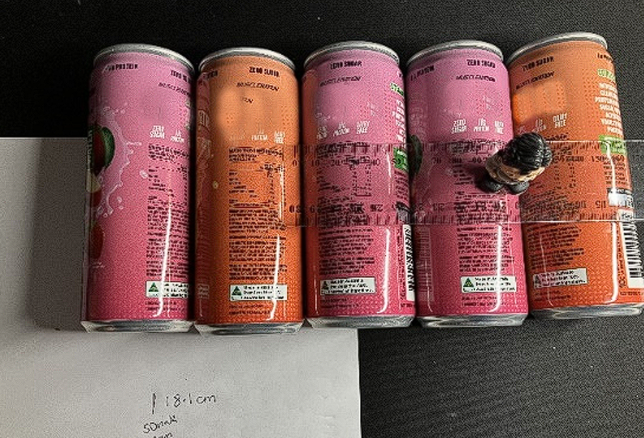

1. The actual distance was not what was predicted, as the object travelled more than one circumference. This could be because the cans slipped against each other as they were empty.

# Marking guidelines

Table 3 – assessment marking guidelines (Part 1)

|  |  |  |  |  |
| --- | --- | --- | --- | --- |
| ****Criteria**** | ****Working towards developing**** | ****Developing**** | ****Developed**** | ****Well developed**** |
| ****Part 1**** | I attempted to plot my collected measurements on the Cartesian plane with limited accuracy and/or some errors.  I have provided a description of the relationship using limited mathematical language. | I can accurately plot my collected measurements on the Cartesian plane.  I have identified and explained some connections between my graph and an equation, such as identifying a variable.  My description of the relationship utilises some appropriate mathematical language and some explanations are supported with reasoning. | I can use my graph to construct an equation and explain what each variable or value represents in the context of this investigation.  I can use the evidence I have collected, including measurements, my graph, and the equation to describe the relationship between the number of rotations and the rolling distance of each cylinder.  My description of the relationship utilises precise mathematical language and reasoning. |  |

**Feedback**: **the student has taken the data collected from one of the cylinders during the class activity, plotted the points clearly and drawn a clear and accurate line. The student then established the equation of the line. The student was able to demonstrate their understanding of the connection between the number of rotations, the distance travelled and the circumference and make the connection to the equation established. The student has also shown the ratio between the circumference and the number of rotations.**

Table 4 – assessment marking guidelines (Part 2)

|  |  |  |  |  |
| --- | --- | --- | --- | --- |
| ****Criteria**** | ****Working towards developing**** | ****Developing**** | ****Developed**** | ****Well developed**** |
| ****Part 2**** | I have attempted to calculate the dimensions for cylinders to meet each scenario.  I have attempted to answer the questions with limited connection to calculations and/or limited reasoning.  My reasoning and explanations use very limited mathematical language. | I have provided calculations supporting the design of the cylinders to meet each scenario.  I have identified some connections between the circumference and the total rolling distance of a cylinder.  I have explained how the dimensions of a cylinder affect its suitability for moving objects.  I have listed some real-life constraints related to the size of cylinders.  My reasoning and explanations use limited mathematical language. | I have provided calculations and some reasoning in the design of the cylinders to meet each scenario.  I can explain how circumference relates to the relationship between the total rolling distance and the number of rotations.  I have explained which dimensions of the cylinder affect its suitability for moving objects and how the dimensions relate to the relationship determined in Part 1. I have listed some real-life constraints that should be considered.  My reasoning and explanations use appropriate mathematical language and some connections between measurement and algebra. | I have provided clear and concise calculations and strong reasoning in the design of the cylinders to meet each scenario.  I can clearly and concisely explain how circumference relates to the relationship between the total distance and the number of rotations.  I have explained which dimensions of the cylinder affect its suitability for moving objects and how the dimensions relate to the relationship determined in Part 1. I have clearly explained a comprehensive set of real-life constraints that should be considered.  My reasoning and explanations use precise mathematical language and clear connections between measurement and algebra. |

**Feedback**: **the student used the relationship from Part 1 to create 3 designs that met the specifications. They clearly showed their logic and reasoning in the design of those cylinders. The student was able to provide some relevant information about the use of these cylinders in real life. To further develop this solution, the student should have given a more detailed reasoning for their choice of cylinder and given a more comprehensive set of real-life constraints.**

Table 5 – assessment marking guidelines (Part 3)

|  |  |  |  |  |
| --- | --- | --- | --- | --- |
| ****Criteria**** | ****Working towards developing**** | ****Developing**** | ****Developed**** | ****Well developed**** |
| ****Part 3**** | I have made progress towards designing an experiment to test if an object moves a distance equal to one cylinder's circumference per rotation, with some aspects needing further clarity or consideration of errors and variables.  I am beginning to make connections between the experiment results and the relationship between the number of rotations and the distance travelled. | I have designed an experiment to test if an object moves a distance equal to one cylinder's circumference per rotation, with a basic set-up and limited consideration of errors or variables.  I can describe, with minimal reasoning or evidence, how the experiment results relate to the relationship between the number of rotations and the distance travelled. | I have designed an experiment to test if an object moves a distance equal to one cylinder's circumference per rotation, with a clear set-up and some consideration of minimising errors and controlling variables.  I can explain, with some reasoning and evidence, how the experiment results relate to the relationship between the number of rotations and the distance travelled. | I have designed a detailed and logical experiment to test if an object moves a distance equal to one cylinder's circumference per rotation, using a set-up that minimises errors and controls variables effectively.  I can clearly and concisely explain how the experiment results confirm, refine, or challenge the relationship between the number of rotations and the distance travelled. |

**Feedback**: **the student presented an experiment and some of the results. They considered some ideas as to what the results mean but didn’t clearly use mathematical reasoning. To further develop their answer, the student could have given a more detailed plan for the experiment, taking into consideration factors that may affect the results, such as whether the cans were hollow. The student could have also presented a more detailed explanation of the results using more mathematical language and solidifying their arguments by linking the algebraic and measurement results..**

# Support and alignment

**Resource evaluation and support**: all curriculum resources are prepared through a rigorous process. Resources are periodically reviewed as part of our ongoing evaluation plan to ensure currency, relevance and effectiveness. For additional support or advice, or to provide feedback, contact the Mathematics Curriculum team by emailing [mathematics7-12@det.nsw.edu.au](mailto:mathematics7-12@det.nsw.edu.au).

**Differentiation**: further advice to support Aboriginal and Torres Strait Islander students, EALD students, students with a disability and/or additional needs and High Potential and gifted students can be found on the [Planning, programming and assessing 7–12](https://education.nsw.gov.au/teaching-and-learning/curriculum/planning-programming-and-assessing-k-12/planning-programming-and-assessing-7-12) webpage. This includes the [Inclusion and differentiation advice 7–10](https://education.nsw.gov.au/teaching-and-learning/curriculum/planning-programming-and-assessing-k-12/planning-programming-and-assessing-7-12/inclusion-and-differentiation-advice-7-10) webpage.

**Assessment**: further advice to support formative assessment is available on the [Planning programming and assessing 7–12](https://education.nsw.gov.au/teaching-and-learning/curriculum/planning-programming-and-assessing-k-12/planning-programming-and-assessing-7-12) webpage. This includes the [Classroom assessment advice 7–10](https://education.nsw.gov.au/teaching-and-learning/curriculum/planning-programming-and-assessing-k-12/planning-programming-and-assessing-7-12/classroom-assessment-advice-7-10-). For summative assessment tasks, the [Assessment task advice 7–10](https://education.nsw.gov.au/teaching-and-learning/curriculum/planning-programming-and-assessing-k-12/planning-programming-and-assessing-7-12/assessment-task-advice-7-10) webpage is available.

**Explicit teaching:** further advice to support explicit teaching is available on the [Explicit teaching](https://education.nsw.gov.au/teaching-and-learning/curriculum/explicit-teaching) webpage. This includes the CESE [Explicit teaching – Driving learning and engagement](https://education.nsw.gov.au/about-us/education-data-and-research/cese/publications/research-reports/what-works-best-2020-update/explicit-teaching-driving-learning-and-engagement) webpage.

**Consulted with**: Mathematics Growth Team, Strategic Delivery, HSC Strategy, Numeracy, Aboriginal Outcomes and Partnerships and subject matter experts.

**Alignment to system priorities and/or needs**: [School Excellence Policy](https://education.nsw.gov.au/policy-library/policies/pd-2016-0468), [Our Plan for NSW Public Education](https://education.nsw.gov.au/about-us/strategies-and-reports/plan-for-nsw-public-education).

**Alignment to the School Excellence Framework**: this resource supports the [School Excellence Framework](https://education.nsw.gov.au/about-us/strategies-and-reports/school-excellence-and-accountability/school-excellence/about-sef) elements of curriculum (curriculum provision) and effective classroom practice (lesson planning, explicit teaching).

**Alignment to Australian Professional Teaching Standards**: this resource supports teachers to address [Australian Professional Teaching Standards](https://educationstandards.nsw.edu.au/wps/portal/nesa/teacher-accreditation/meeting-requirements/the-standards/proficient-teacher) [5.1.2,5.4.2].

**Creation date: 10 December 2024**

# Evidence base

This resource contains NSW Curriculum and syllabus content. The NSW Curriculum is developed by the NSW Education Standards Authority. This content is prepared by NESA for and on behalf of the Crown in right of the State of New South Wales. The material is protected by Crown copyright.

Please refer to the NESA Copyright Disclaimer for more information <https://educationstandards.nsw.edu.au/wps/portal/nesa/mini-footer/copyright>.

NESA holds the only official and up-to-date versions of the NSW Curriculum and syllabus documents. Please visit the NSW Education Standards Authority (NESA) website <https://educationstandards.nsw.edu.au> and the NSW Curriculum website <https://curriculum.nsw.edu.au>.

[Mathematics K**–**10 Syllabus](https://curriculum.nsw.edu.au/learning-areas/mathematics/mathematics-k-10-2022/overview) © NSW Education Standards Authority (NESA) for and on behalf of the Crown in right of the State of New South Wales, 2022.

Brookhart SM (2018) ‘[Appropriate Criteria: Key to Effective Rubrics](https://www.frontiersin.org/journals/education/articles/10.3389/feduc.2018.00022/full)’, Frontiers in Education, volume 3(22):1–12, doi:10.3389/feduc.2018.00022, accessed 17 January 2025.

CESE (Centre for Education Statistics and Evaluation) (2020) [*What works best 2020 update*](https://education.nsw.gov.au/about-us/educational-data/cese/publications/research-reports/what-works-best-2020-update), NSW Department of Education, accessed 17 January 2025.

——(2020) [*What works best in practice*](https://education.nsw.gov.au/about-us/educational-data/cese/publications/practical-guides-for-educators-/what-works-best-in-practice), NSW Department of Education, accessed 17 January 2025.

——(2021) [*Growth goal setting – what works best in practice*](https://education.nsw.gov.au/about-us/educational-data/cese/publications/practical-guides-for-educators/growth-goal-setting), NSW Department of Education, accessed 17 January 2025.

Fisher D and Frey N (1 November 2009) ‘[Feed Up, Back, Forward](https://www.ascd.org/el/articles/feed-up-back-forward)’, ASCD (Association for Supervision and Curriculum Development): Educational Leadership magazine, 67(3), accessed 17 January 2025.

Griffin P (2017) Assessment for Teaching, Cambridge University Press, Port Melbourne, Victoria.

Hattie J and Timperley H (2007) ‘The Power of Feedback’, Review of Educational Research, 77(1): 81–112, doi:10.3102/003465430298487.

NESA (NSW Education Standards Authority) (2024) ‘[Proficient Teacher Standard Descriptors’](https://www.nsw.gov.au/education-and-training/nesa/teacher-accreditation/proficient-teacher/standard-descriptors), Achieve Proficient Teacher accreditation, NSW government website, accessed 17 January 2025.

Panadero E and Jonsson A (2013) ‘[The use of scoring rubrics for formative assessment purposes revisited: A review](https://www.sciencedirect.com/science/article/abs/pii/S1747938X13000109?via%3Dihub)’, Educational Research Review, 9:129–144, doi:10.1016/j.edurev.2013.01.002, accessed 17 January 2025.

Sherrington T (2019) Rosenshine’s Principles in Action, John Catt Educational Limited, Melton, Woodbridge.

Wiliam D (2017) Embedded Formative Assessment, 2nd edn, Solution Tree Press, Bloomington, IN.

**© State of New South Wales (Department of Education), 2025**

The copyright material published in this resource is subject to the Copyright Act 1968 (Cth) and is owned by the NSW Department of Education or, where indicated, by a party other than the NSW Department of Education (third-party material).

Copyright material available in this resource and owned by the NSW Department of Education is licensed under a [Creative Commons Attribution 4.0 International (CC BY 4.0) license](https://creativecommons.org/licenses/by/4.0/).

[](https://creativecommons.org/licenses/by/4.0/)

This license allows you to share and adapt the material for any purpose, even commercially.

Attribution should be given to © State of New South Wales (Department of Education), 2025.

Material in this resource not available under a Creative Commons license:

* the NSW Department of Education logo, other logos and trademark-protected material
* material owned by a third party that has been reproduced with permission. You will need to obtain permission from the third party to reuse its material.

**Links to third-party material and websites**

Please note that the provided (reading/viewing material/list/links/texts) are a suggestion only and implies no endorsement, by the New South Wales Department of Education, of any author, publisher, or book title. School principals and teachers are best placed to assess the suitability of resources that would complement the curriculum and reflect the needs and interests of their students.

If you use the links provided in this document to access a third-party's website, you acknowledge that the terms of use, including licence terms set out on the third-party's website apply to the use which may be made of the materials on that third-party website or where permitted by the Copyright Act 1968 (Cth). The department accepts no responsibility for content on third-party websites.