Mathematics Stage 4   
(Year 8) – teacher information

Rolling cylinders investigation

Contents

Task description 2

Task details 3

In class demonstration 3

Part 1 – identifying the pattern 5

Part 2 – designing a cylinder 6

Part 3 – applying the pattern 6

Student support material 8

Introductory activity 8

Part 1 9

Total rolling distance and number of rotations 9

Submission details 10

What is the teacher looking for? 10

Marking guidelines 11

Suggested opportunities for differentiation 14

Part 1 – identifying the pattern 14

Part 2 – designing a cylinder 14

Part 3 – applying the pattern 14

Support and alignment 15

Evidence base 16

# Task description

**Type of task**: Investigation

**Outcomes being assessed**:

A student:

* develops understanding and fluency in mathematics through exploring and connecting mathematical concepts, choosing and applying mathematical techniques to solve problems, and communicating their thinking and reasoning coherently and clearly **MAO-WM-01**
* applies knowledge of the perimeter of plane shapes and the circumference of circles to solve problems **MA4-LEN-C-01**
* generalises number properties to operate with algebraic expressions including expansion and factorisation **MA4-ALG-C-01**
* solves linear equations of up to 2 steps and quadratic equations of the form $ax^{2}=c$  
  **MA4-EQU-C-01**
* creates and displays number patterns and finds graphical solutions to problems involving linear relationships **MA4-LIN-C-01**

[Mathematics K**–**10 Syllabus](https://curriculum.nsw.edu.au/learning-areas/mathematics/mathematics-k-10-2022/overview) © NSW Education Standards Authority (NESA) for and on behalf of the Crown in right of the State of New South Wales, 2022.

You will be exploring how many civilisations in history used log rolling to move large objects.

Log rolling has been theorised to have been used to:

* transport massive limestone and granite blocks for pyramid construction in ancient Egypt
* transport the iconic Moai statues on Easter Island
* transport massive stone monoliths to the Stonehenge site
* transport large stones and logs for Medieval castles in Europe.

## Task details

### In class demonstration

This investigation should start with an in-class demonstration to ensure that all students have a common understanding of the required context and content. Below is an example of how the investigation could be introduced. Afterwards, teachers may decide how students complete the task, whether in class, outside of class or a combination of both.

#### Setting the scene

Before starting the following activity, briefly review the concepts of circumference, diameter and radius to ensure all students are comfortable with these foundational ideas.

1. Show students the video ‘How To Move a Small Boulder by Yourself’ (0:40) ([bit.ly/logrollingvideo](https://bit.ly/logrollingvideo)).
2. In a Think-Pair-Share ([bit.ly/thinkpairsharestrategy](https://bit.ly/thinkpairsharestrategy)) ask students what they notice and wonder ([bit.ly/noticewonderstrategy](https://bit.ly/noticewonderstrategy)) about the video.

Students might notice that cylindrical pipes are used to move the stone, that as the stone moved forward, pipes were left behind and that the pipes were not neatly organised.

Students might wonder if this is the most efficient method for moving a heavy stone, if larger pipes would move the stone further and if that many pipes were needed.

1. Explain to students that many civilisations in history are believed to have used log rolling to move large objects.

Log rolling has been theorised to have been used to:

* transport massive limestone and granite blocks for pyramid construction in ancient Egypt
* transport the iconic Moai statues on Easter Island
* transport massive stone monoliths to the Stonehenge site
* transport large stones and logs for Medieval castles in Europe.

1. Draw or display Figure 1, to show a block on 4 logs.

Figure 1 – block on logs

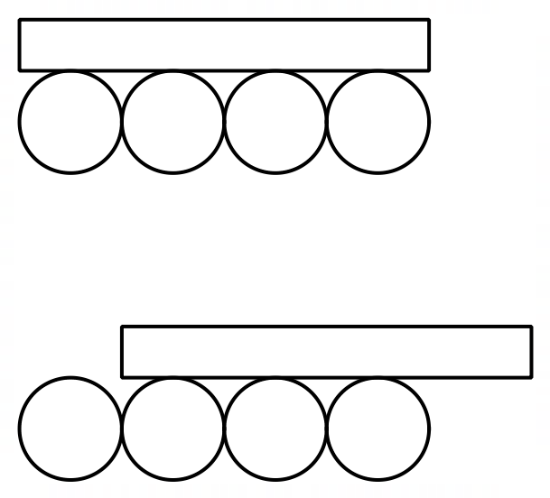

1. In a Think-Pair-Share, ask students how far the block will move in one rotation. For example, when the last log is no longer under the block.
2. Use students’ responses to ensure that all students understand that one rotation will be the same length as the circumference of the log or roller.

#### Hands-on exploration

1. Assign students to visibly random groups of 3 ([bit.ly/visiblegroups](https://bit.ly/visiblegroups)), and provide each group with a cylindrical object (representing a ‘rolling log’) and measuring tools.

Cylindrical objects could include, cans of drink, tins, toilet paper rolls or paper towel rolls.

1. For their cylindrical object, students are to record the dimensions of the cylinder in Table 1, provided in the student support material section.

Students may use a flexible measuring tape or string to find the circumference of each circle.

1. Students complete Table 2, provided in the student support material section, recording the total rolling distance for 1, 2 and 3 rotations of their cylinder.
2. Groups are to complete steps 2–3 for 2 more cylindrical objects, swapping objects with other groups if necessary.

Students will complete the rest of the investigation independently.

### Part 1 – identifying the pattern

Choose one of your measured cylinders from the introductory activity to use for Part 1 of the investigation.

1. On the Cartesian plane ‘Total rolling distance and number of rotations’, provided in the student support material, plot the total rolling distance on the $y$-axis against the number of rotations on the $x$-axis for one of your measured cylinders and draw a line through the points.
2. Use your graph to construct a linear equation that represents the relationship between the total distance travelled ($d$) and the number of rotations ($n$) for the cylinder.
3. Describe what each variable or value in your equation represents in the context of this investigation.
4. Describe the relationship between the number of rotations and the rolling distance of each cylinder.

### Part 2 – designing a cylinder

Now that you have explored the relationship between the number of rotations and the rolling distance for a cylinder, you will use this knowledge to design cylinders to meet specific criteria.

1. You are helping to design a rolling mechanism to move a heavy object over specific distances. Design a cylinder that will move the object:
2. exactly 15 rotations to cover a total distance of 30 metres
3. exactly 10 rotations to cover a total distance of 25 metres
4. exactly 3 rotations to cover a total distance of 11 metres.
5. Answer the following questions, providing clear reasoning based on your calculations and observations:
6. How does the circumference of the cylinder affect the total rolling distance for a given number of rotations?
7. How does the size of the cylinder affect its practicality for moving objects? Are there any real-life constraints that should be considered?

### Part 3 – applying the pattern

1. Investigate if an object always moves exactly one rotation when using the log rolling method, as shown in the image below. Design an experiment to test this question using one of your cylindrical objects and record your observations and data.

Figure 2 – block on logs



1. Did the actual distance match the predicted distance based on the cylinder's circumference? Why or why not?

# Student support material

## Introductory activity

Table 1

|  |  |  |  |  |
| --- | --- | --- | --- | --- |
| ****Cylindrical object**** | ****Diameter**** | ****Radius**** | ****Circumference**** | ****Depth**** |
|  |  |  |  |  |
|  |  |  |  |  |
|  |  |  |  |  |

Table 2

|  |  |  |  |
| --- | --- | --- | --- |
| ****Cylindrical object**** | ****Rotation 1**** | ****Rotation 2**** | ****Rotation 3**** |
|  |  |  |  |
|  |  |  |  |
|  |  |  |  |

## Part 1

### Total rolling distance and number of rotations

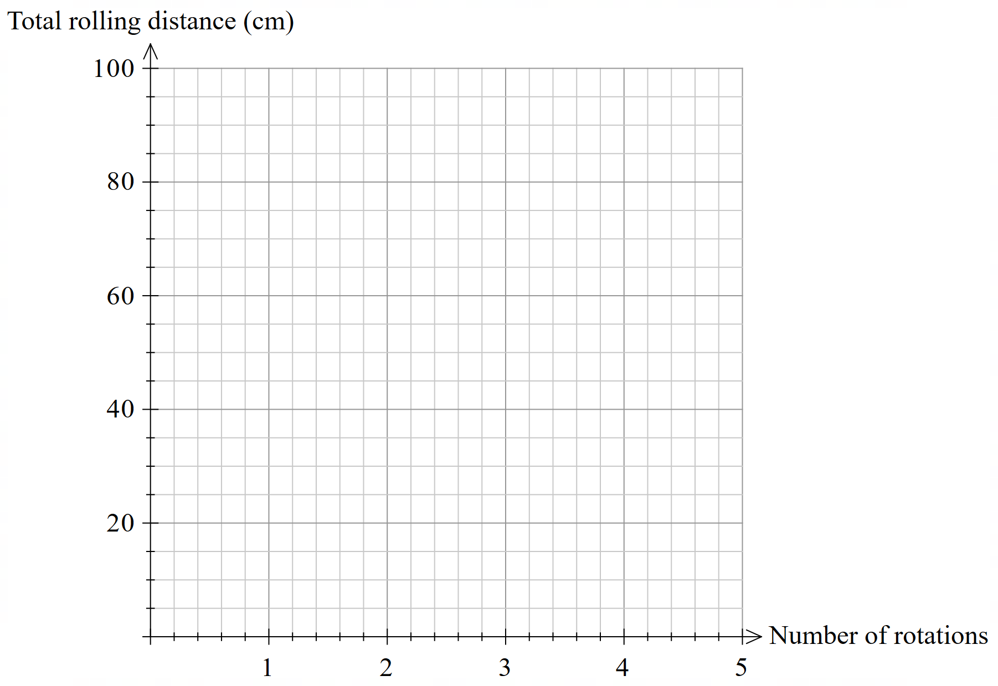

## Submission details

A written response is expected for this task. It should contain answers to the questions provided, as well as graphs, tables, calculations and reasoning to support your findings. Images and/or drawings may be used to support your explanations. Your submission may include subheadings to assist with the organisation of your response.

## What is the teacher looking for?

The teacher is looking for you to show how you:

* draw on connections between algebra, equations and linear patterns to approach the investigation
* select the best methods to carry out the investigation and use them fluently
* clearly show and explain how you worked through the investigation and the reasons behind your choices.

All solutions and explanations should be supported by reasoning and calculations.

# Marking guidelines

Table 3 – assessment marking guidelines (Part 1)

|  |  |  |  |  |
| --- | --- | --- | --- | --- |
| ****Criteria**** | ****Working towards developing**** | ****Developing**** | ****Developed**** | ****Well developed**** |
| ****Part 1**** | I attempted to plot my collected measurements on the Cartesian plane with limited accuracy and/or some errors.  I have provided a description of the relationship using limited mathematical language. | I can accurately plot my collected measurements on the Cartesian plane.  I have identified and explained some connections between my graph and an equation, such as identifying a variable.  My description of the relationship utilises some appropriate mathematical language and some explanations are supported with reasoning. | I can use my graph to construct an equation and explain what each variable or value represents in the context of this investigation.  I can use the evidence I have collected, including measurements, my graph, and the equation to describe the relationship between the number of rotations and the rolling distance of each cylinder.  My description of the relationship utilises precise mathematical language and reasoning. |  |

**Feedback**:

Table 4 – assessment marking guidelines (Part 2)

|  |  |  |  |  |
| --- | --- | --- | --- | --- |
| ****Criteria**** | ****Working towards developing**** | ****Developing**** | ****Developed**** | ****Well developed**** |
| ****Part 2**** | I have attempted to calculate the dimensions for cylinders to meet each scenario.  I have attempted to answer the questions with limited connection to calculations and/or limited reasoning.  My reasoning and explanations use very limited mathematical language. | I have provided calculations supporting the design of the cylinders to meet each scenario.  I have identified some connections between the circumference and the total rolling distance of a cylinder.  I have explained how the dimensions of a cylinder affect its suitability for moving objects.  I have listed some real-life constraints related to the size of cylinders.  My reasoning and explanations use limited mathematical language. | I have provided calculations and some reasoning in the design of the cylinders to meet each scenario.  I can explain how circumference relates to the relationship between the total rolling distance and the number of rotations.  I have explained which dimensions of the cylinder affect its suitability for moving objects and how the dimensions relate to the relationship determined in Part 1. I have listed some real-life constraints that should be considered.  My reasoning and explanations use appropriate mathematical language and some connections between measurement and algebra. | I have provided clear and concise calculations and strong reasoning in the design of the cylinders to meet each scenario.  I can clearly and concisely explain how circumference relates to the relationship between the total distance and the number of rotations.  I have explained which dimensions of the cylinder affect its suitability for moving objects and how the dimensions relate to the relationship determined in Part 1. I have clearly explained a comprehensive set of real-life constraints that should be considered.  My reasoning and explanations use precise mathematical language and clear connections between measurement and algebra. |

**Feedback**:

Table 5 – assessment marking guidelines (Part 3)

|  |  |  |  |  |
| --- | --- | --- | --- | --- |
| ****Criteria**** | ****Working towards developing**** | ****Developing**** | ****Developed**** | ****Well developed**** |
| ****Part 3**** | I have made progress towards designing an experiment to test if an object moves a distance equal to one cylinder's circumference per rotation, with some aspects needing further clarity or consideration of errors and variables.  I am beginning to make connections between the experiment results and the relationship between the number of rotations and the distance travelled. | I have designed an experiment to test if an object moves a distance equal to one cylinder's circumference per rotation, with a basic set-up and limited consideration of errors or variables.  I can describe, with minimal reasoning or evidence, how the experiment results relate to the relationship between the number of rotations and the distance travelled. | I have designed an experiment to test if an object moves a distance equal to one cylinder's circumference per rotation, with a clear set-up and some consideration of minimising errors and controlling variables.  I can explain, with some reasoning and evidence, how the experiment results relate to the relationship between the number of rotations and the distance travelled. | I have designed a detailed and logical experiment to test if an object moves a distance equal to one cylinder's circumference per rotation, using a set-up that minimises errors and controls variables effectively.  I can clearly and concisely explain how the experiment results confirm, refine, or challenge the relationship between the number of rotations and the distance travelled. |

**Feedback**:

# Suggested opportunities for differentiation

## Part 1 – identifying the pattern

* Encourage students to analyse data for all 3 measured cylinders, instead of selecting only one. This allows for comparisons and a deeper understanding of the relationship between cylinder size, circumference and rolling distance.
* Students could explore if the model is more accurate for a range of diameters.
* Ask students to explore the differences in behaviour between hollow and solid cylinders. Students could investigate how mass distribution might affect the relationship between the rotations and rolling distance.
* Provide scaffolded questions such as: ‘What do you notice about the pattern between the number of rotations and the distance travelled?’ and ‘How does the circumference of the cylinder relate to its rolling distance?’

## Part 2 – designing a cylinder

* Provide a template to guide students in organising their designs, calculations and justifications for the specified criteria.

## Part 3 – applying the pattern

* Allow students to submit their experiment and results as a video presentation. This accommodates diverse learning styles and provides an opportunity for students to explain their reasoning verbally and visually.
* Provide additional prompts to extend students' thinking:
* discuss what other variables could influence the accuracy of the relationship, for example, surface friction or the material of the cylinder
* reflect on whether the log rolling method is an efficient way to move heavy objects and encourage students to justify their opinion with evidence from the task.

# Support and alignment

**Resource evaluation and support**: all curriculum resources are prepared through a rigorous process. Resources are periodically reviewed as part of our ongoing evaluation plan to ensure currency, relevance and effectiveness. For additional support or advice, or to provide feedback, contact the Mathematics Curriculum team by emailing [mathematics7-12@det.nsw.edu.au](mailto:mathematics7-12@det.nsw.edu.au).

**Differentiation**: further advice to support Aboriginal and Torres Strait Islander students, EALD students, students with a disability and/or additional needs and High Potential and gifted students can be found on the [Planning, programming and assessing 7–12](https://education.nsw.gov.au/teaching-and-learning/curriculum/planning-programming-and-assessing-k-12/planning-programming-and-assessing-7-12) webpage. This includes the [Inclusion and differentiation advice 7–10](https://education.nsw.gov.au/teaching-and-learning/curriculum/planning-programming-and-assessing-k-12/planning-programming-and-assessing-7-12/inclusion-and-differentiation-advice-7-10) webpage.

**Assessment**: further advice to support formative assessment is available on the [Planning, programming and assessing 7–12](https://education.nsw.gov.au/teaching-and-learning/curriculum/planning-programming-and-assessing-k-12/planning-programming-and-assessing-7-12) webpage. This includes the [Classroom assessment advice 7–10](https://education.nsw.gov.au/teaching-and-learning/curriculum/planning-programming-and-assessing-k-12/planning-programming-and-assessing-7-12/classroom-assessment-advice-7-10-). For summative assessment tasks, the [Assessment task advice 7–10](https://education.nsw.gov.au/teaching-and-learning/curriculum/planning-programming-and-assessing-k-12/planning-programming-and-assessing-7-12/assessment-task-advice-7-10) webpage is available.

**Explicit teaching**: further advice to support explicit teaching is available on the [Explicit teaching](https://education.nsw.gov.au/teaching-and-learning/curriculum/explicit-teaching) webpage. This includes the CESE [Explicit teaching – Driving learning and engagement](https://education.nsw.gov.au/about-us/education-data-and-research/cese/publications/research-reports/what-works-best-2020-update/explicit-teaching-driving-learning-and-engagement) webpage.

**Consulted with**: Mathematics Growth Team, Strategic Delivery, HSC Strategy, Numeracy, Aboriginal Outcomes and Partnerships and subject matter experts.

**Alignment to system priorities and/or needs**: [School Excellence Policy](https://education.nsw.gov.au/policy-library/policies/pd-2016-0468), [Our Plan for NSW Public Education](https://education.nsw.gov.au/about-us/strategies-and-reports/plan-for-nsw-public-education).

**Alignment to the School Excellence Framework**: this resource supports the [School Excellence Framework](https://education.nsw.gov.au/about-us/strategies-and-reports/school-excellence-and-accountability/school-excellence/about-sef) elements of curriculum (curriculum provision) and effective classroom practice (lesson planning, explicit teaching).

**Alignment to Australian Professional Teaching Standards**: this resource supports teachers to address [Australian Professional Teaching Standards](https://educationstandards.nsw.edu.au/wps/portal/nesa/teacher-accreditation/meeting-requirements/the-standards/proficient-teacher) [5.1.2,5.4.2].

**Creation date:** **10 December 2024**

# Evidence base

This resource contains NSW Curriculum and syllabus content. The NSW Curriculum is developed by the NSW Education Standards Authority. This content is prepared by NESA for and on behalf of the Crown in right of the State of New South Wales. The material is protected by Crown copyright.

Please refer to the NESA Copyright Disclaimer for more information <https://educationstandards.nsw.edu.au/wps/portal/nesa/mini-footer/copyright>.

NESA holds the only official and up-to-date versions of the NSW Curriculum and syllabus documents. Please visit the NSW Education Standards Authority (NESA) website <https://educationstandards.nsw.edu.au> and the NSW Curriculum website <https://curriculum.nsw.edu.au>.

[Mathematics K–10 Syllabus](https://curriculum.nsw.edu.au/learning-areas/mathematics/mathematics-k-10-2022/overview) © NSW Education Standards Authority (NESA) for and on behalf of the Crown in right of the State of New South Wales, 2022.

Brookhart SM (2018) ‘[Appropriate Criteria: Key to Effective Rubrics](https://www.frontiersin.org/journals/education/articles/10.3389/feduc.2018.00022/full)’, Frontiers in Education, volume 3(22):1–12, doi:10.3389/feduc.2018.00022, accessed 17 January 2025.

CESE (Centre for Education Statistics and Evaluation) (2020) [*What works best 2020 update*](https://education.nsw.gov.au/about-us/educational-data/cese/publications/research-reports/what-works-best-2020-update), NSW Department of Education, accessed 17 January 2025.

——(2020) [*What works best in practice*](https://education.nsw.gov.au/about-us/educational-data/cese/publications/practical-guides-for-educators-/what-works-best-in-practice), NSW Department of Education, accessed 17 January 2025.

——(2021) [*Growth goal setting – what works best in practice*](https://education.nsw.gov.au/about-us/educational-data/cese/publications/practical-guides-for-educators/growth-goal-setting), NSW Department of Education, accessed 17 January 2025.

Fisher D and Frey N (1 November 2009) ‘[Feed Up, Back, Forward](https://www.ascd.org/el/articles/feed-up-back-forward)’, ASCD (Association for Supervision and Curriculum Development): Educational Leadership magazine, 67(3), accessed 17 January 2025.

Griffin P (2017) Assessment for Teaching, Cambridge University Press, Port Melbourne, Victoria.

Hattie J and Timperley H (2007) ‘The Power of Feedback’, Review of Educational Research, 77(1): 81–112, doi:10.3102/003465430298487.

NESA (NSW Education Standards Authority) (2024) ‘[Proficient Teacher Standard Descriptors’](https://www.nsw.gov.au/education-and-training/nesa/teacher-accreditation/proficient-teacher/standard-descriptors), Achieve Proficient Teacher accreditation, NSW government website, accessed 17 January 2025.

Panadero E and Jonsson A (2013) ‘[The use of scoring rubrics for formative assessment purposes revisited: A review](https://www.sciencedirect.com/science/article/abs/pii/S1747938X13000109?via%3Dihub)’, Educational Research Review, 9:129–144, doi:10.1016/j.edurev.2013.01.002, accessed 17 January 2025.

Sherrington T (2019) Rosenshine’s Principles in Action, John Catt Educational Limited, Melton, Woodbridge.

Wiliam D (2017) Embedded Formative Assessment, 2nd edn, Solution Tree Press, Bloomington, IN.

**© State of New South Wales (Department of Education), 2025**

The copyright material published in this resource is subject to the Copyright Act 1968 (Cth) and is owned by the NSW Department of Education or, where indicated, by a party other than the NSW Department of Education (third-party material).

Copyright material available in this resource and owned by the NSW Department of Education is licensed under a [Creative Commons Attribution 4.0 International (CC BY 4.0) license](https://creativecommons.org/licenses/by/4.0/).

[](https://creativecommons.org/licenses/by/4.0/)

This license allows you to share and adapt the material for any purpose, even commercially.

Attribution should be given to © State of New South Wales (Department of Education), 2025.

Material in this resource not available under a Creative Commons license:

* the NSW Department of Education logo, other logos and trademark-protected material
* material owned by a third party that has been reproduced with permission. You will need to obtain permission from the third party to reuse its material.

**Links to third-party material and websites**

Please note that the provided (reading/viewing material/list/links/texts) are a suggestion only and implies no endorsement, by the New South Wales Department of Education, of any author, publisher, or book title. School principals and teachers are best placed to assess the suitability of resources that would complement the curriculum and reflect the needs and interests of their students.

If you use the links provided in this document to access a third-party's website, you acknowledge that the terms of use, including licence terms set out on the third-party's website apply to the use which may be made of the materials on that third-party website or where permitted by the Copyright Act 1968 (Cth). The department accepts no responsibility for content on third-party websites.