# Plotting points

Students create their own chess pieces to move along the Cartesian plane, as a way of reading and plotting points.

Students will need a digital device to interact with Desmos during this lesson.

## Visible learning

### Learning intentions

* To be able to identify and record the coordinates of points on the Cartesian plane.
* To be able to plot points on the Cartesian plane.

### Success criteria

* I can identify and record the coordinates of points on the Cartesian plane.
* I can plot points with integer coordinates on the Cartesian plane.
* I can plot points with non-integer coordinates on the Cartesian plane.
* I can explain why axes are useful for describing location.

### Syllabus outcomes

A student:

* develops understanding and fluency in mathematics through exploring and connecting mathematical concepts, choosing and applying mathematical techniques to solve problems, and communicating their thinking and reasoning coherently and clearly **MAO-WM-01**
* creates and displays number patterns and finds graphical solutions to problems involving linear relationships **MA4-LIN-C-01**

[Mathematics K–10 Syllabus](https://curriculum.nsw.edu.au/learning-areas/mathematics/mathematics-k-10-2022/overview) © NSW Education Standards Authority (NESA) for and on behalf of the Crown in right of the State of New South Wales, 2022.

Table 1: lesson summary

|  |  |  |  |
| --- | --- | --- | --- |
| Section | Summary of activity | Teaching strategies | Teaching points |
| Warm up | Students create a glossary page with terms such as ‘pattern’, ‘coordinates’, ‘point’, ‘Cartesian plane’ and ‘axes/axis’. In pairs, students write definitions for each term and share definitions to create a class definition. Students then complete the Desmos activity ([bit.ly/patternspreassess](https://bit.ly/patternspreassess)) to assess plotting points and understanding coordinates. |  | Revise key vocabulary and formatively assess students’ ability to plot points and understand integer coordinates. |
| Launch | Display slide 3 of the PowerPoint *Plotting points* (PP PPT) and ask students to find the best move for black in the chess scenario. Introduce the use of coordinates in chess and ask students to consider other real-world examples of coordinate use. | Gallery walk  Pose-Pause-Pounce-Bounce  Think-Pair-Share | Highlight the need for a coordinate system to describe location and movement. Emphasise clear communication using coordinates. |
| Explore | Display a Cartesian plane, using slide 7 of the PowerPoint (PP PPT). Remind students of the naming of axes and how to read coordinates. In pairs, students identify the coordinates of unlabelled points and share with the class. Students design a chess piece, describe its movement, and complete a table of moves starting from (0,0) using Appendix A and Appendix B. | Gallery walk  Think-Pair-Share | Remind students how to read coordinates on a Cartesian plane. |
| Summarise | Students complete a Desmos activity ([bit.ly/desmostargetpractice](https://bit.ly/desmostargetpractice)) to practise plotting points and discuss strategies for locating specific coordinates. Discuss how students located the coordinates of the bullseye in the Desmos activity. | Think-Pair-Share | Reflect on strategies for locating coordinates through group discussions. |
| Apply | Distribute Appendix C. Students write a list of points connecting the blue point to the green point without crossing red points. |  | Extend understanding of coordinates, apply coordinate knowledge in a problem-solving task. |

## Activity structure

Please use the associated PowerPoint *Plotting points* (PP PPT) to display images in this lesson.

### Warm up

1. Ask students to create a glossary page for this unit of learning and write the following words:

* pattern
* coordinates
* point
* Cartesian plane
* axes/axis.

The glossary can be a page in their notes where they will add new words throughout the unit of learning.

1. In pairs, students write a definition for each word. Randomly select students to share their definitions and create a class definition using students’ contributions.

Before completing this activity, you will need to set up a Desmos Classroom ([bit.ly/createdesmosclassroom](https://bit.ly/createdesmosclassroom)) and use the pacing feature to restrict the students to screen 2.

1. With one device per student, direct students to the Desmos activity ‘Analysing patterns pre-assessment’ ([bit.ly/patternspreassess](https://bit.ly/patternspreassess)).
2. Explain the task to students:

You are to select and move each shape to the directed coordinates. When finished, signal with a thumbs up.

1. Once all students have completed screen 2, pace students to screen 3 and explain the task:

You are to write the approximate coordinates for each icon from the treasure map.

Students’ responses can be monitored in real-time or following this activity through the Desmos teacher dashboard.

Use this to assess if students can plot points in the 4 quadrants and on axes, including negative regions.

Assess students on how they write coordinates, if they use brackets and if they know that the $x$-coordinate comes before the $y$-coordinate.

This information should be used to determine the level of differentiation required before commencing with this learning episode.

Students have engaged with plotting points on the Cartesian plane in Lesson 13 – describing locations of Unit 3 – representing numbers.

### Launch

The purpose of this Launch activity is to highlight the need for a coordinate system to describe location and movement.

1. Assign visibly random groups of 3 ([bit.ly/visiblegroups](https://bit.ly/visiblegroups)) and position groups at vertical non-permanent surfaces ([bit.ly/VNPSstrategy](https://bit.ly/VNPSstrategy)).
2. Display Figure 1, which is on slide 3 of the PowerPoint (PP PPT), along with a key explaining how each piece moves.

Figure 1: best move for black

A chess board with black and white chess pieces.


1. Pose the challenge to students: ‘Find the best move for black’.

Challenge students to justify why their answer is the best move by considering alternatives. Emphasise to students that they need to communicate their answer so that their peers will be able to interpret their move.

If students are not familiar with the rules of chess, this task could be adapted in multiple ways, such as:

* instead of finding the best move for black, students are asked to describe the location of the knight (horse) pieces
* begin the lesson by introducing the rules of chess and allowing students to play. The video ‘How to Play Chess’ (2:23) by wikiHow ([bit.ly/chesshowtoplay](https://bit.ly/chesshowtoplay)) may be useful.

1. Once groups have decided their best move, conduct a gallery walk ([bit.ly/DLSgallerywalk](https://bit.ly/DLSgallerywalk)), prompting students to consider how each group has communicated their answer. For example, have they drawn a picture, used words or drawn symbols?
2. Display slide 4 of the PowerPoint (PP PPT) which shows the correct answer. Use a questioning strategy such as Pose-Pause-Pounce-Bounce (PDF 557 KB) ([bit.ly/posepausepouncebounce](https://bit.ly/posepausepouncebounce)), to ask students how they would say the correct move aloud.
3. Use slide 5 of the PowerPoint (PP PPT) to display numbers and letters along the sides of the chessboard. Explain to students that in chess, a horizontal axis of letters and a vertical axis of numbers is used to be able to communicate where pieces are moving from and to. In this instance, the queen is moving from d6 to d3.
4. In a Think-Pair-Share ([bit.ly/thinkpairsharestrategy](https://bit.ly/thinkpairsharestrategy)), ask students to consider:

* if the axes make it easier to communicate their suggested move
* other times they have seen coordinates used to describe location or movement.

Students may suggest maps of real-world locations or video games such as Minecraft.

### Explore

1. Display an image of a Cartesian plane with only positive values using slide 7 of the PowerPoint (PP PPT).
2. Explain that the Cartesian plane uses numbers along both axes, unlike a chessboard which uses letters along the horizontal axis. Remind students that the axes are typically labelled $x$ for horizontal and $y$ for vertical.

Discuss that $x$ and $y$ are used because they are letters that rarely represent real-life variables. If we used $h$ for horizontal it could be confusing as we also use $h$ for height.

1. Remind students how to read the point (4,5) by guiding with a pointer or finger to 4 on the $x$-axis and 5 on the $y$-axis.
2. In a Think-Pair-Share have students determine the coordinates for the unlabelled points. Randomly select students to model how they read each point using a pointer or finger.

Depending on diagnostic assessment from the Warm up, there may be a need to adjust or deliver at different levels or have an alternate activity available.

1. Explain that in this lesson, students will be playing a new maths variation of chess called ‘Cartesian chess’.
2. Display the rules for Cartesian chess using slide 8 of the PowerPoint (PP PPT):

Pieces move along the grid lines or diagonally.

A piece is ‘captured’ when another piece lands on the same point.

#### Positive axes

The Explore section is divided into 3 developmental stages: positive axes only, all axes and decimal coordinates. Students could be advanced through these stages or provided additional support based on formative assessment.

1. Students return to their groups of 3, with Appendix A ‘Cartesian chess – positive axes’ printed on A3 paper and placed inside a plastic pocket.
2. Use slides 9–10 of the PowerPoint (PP PPT) to display an example of how Appendix A could be completed.
3. Students create their chess pieces by completing Appendix A.

Examples of movement patterns could include:

* move diagonally exactly 2 spaces
* move 2 spaces horizontally or vertically
* move one space in any direction, increasing the number of spaces by one space with each move. (For instance, one space in the first move, 2 spaces in the second move and so on).

1. Have students complete a gallery walk. During their walk, each student is to choose a piece from another group to talk about.
2. Randomly select students to describe their chosen piece and how it moved.

#### All axes

1. Distribute Appendix B ‘Cartesian chess – all axes’, printed on A3 paper. Have students insert it into their plastic pocket and clear relevant areas. Students are to use their piece created in the positive axes section to determine if they can reach the point, (−7,−6), in exactly 5 moves, starting from (0,0).
2. If students cannot reach the point in 5 moves, they should change how their piece moves. Successful students should be challenged to create a piece that does not work.

#### Decimal coordinates

If students are starting at this point without having completed the previous 2 activities, they will need to create a chessboard piece and choose how it will move.

1. Ask students to clear Appendix B and then label the point (−2,1.5). Have groups check that their neighbouring groups placed the point in the same location.
2. Ask groups to consider if their own or any piece they’ve seen could land on this point.

Unless students created a piece that moved a decimal number of spaces, then no pieces will be able to land on this point.

1. Challenge each group to amend how their original piece moves to be able to land on the point (−2,1.5) within 5 moves.
2. Students complete a gallery walk to observe how each group completed this challenge.
3. Randomly select students to describe how they amended their piece to achieve the challenge.

### Summarise

1. With one device per student, direct students to the Desmos activity ‘Cartesian plane activity’ ([bit.ly/desmostargetpractice](https://bit.ly/desmostargetpractice)).

Before completing this activity, you will need to set up a Desmos Classroom ([bit.ly/createdesmosclassroom](https://bit.ly/createdesmosclassroom)) and use the pacing feature to restrict the students to screen 2.

1. Explain the goal of the activity to students:

You will be plotting points, attempting to hit the centre of the target.

1. Use the Desmos teacher dashboard to snapshot students’ responses from screen 8.
2. In a Think-Pair-Share, ask students to discuss how they located the coordinates of the bullseye.

Further advice on features of Desmos Classroom, such as snapshots, can be found at the website ‘Desmos Help Center’ ([help.desmos.com](https://help.desmos.com/)).

### Apply

1. Distribute Appendix C ‘Cartesian mazes’ to pairs of students.
2. Use slides 12–14 of the PowerPoint (PP PPT) to model an example maze.

The goal is to write a list of points that connects the blue point to the green point, without passing through any red points.

Write the coordinates of a new point underneath the maze, for example (9,−9) then use a ruler to draw a straight-line segment connecting the blue point’s previous location to the new point.

1. After completing each maze, have each pair compare solutions with a neighbouring pair.

A digital alternative is available via ([bit.ly/coordinatemazegame](https://bit.ly/coordinatemazegame)).

## Assessment and differentiation

### Suggested opportunities for differentiation

**Warm up**

* If students can confidently read and plot points in all 4 quadrants, then consider skipping to the decimal coordinates activity in the Explore section.

**Launch**

* A hint could be provided to enable students, such as the best move uses the queen piece.
* Challenge students to consider further challenges, such as the best move for white, worst move for black or if they would bet $100 that it is the best move.

**Explore**

* The Explore section is divided into 3 developmental stages: positive axes only, all axes and decimal coordinates. Students could be advanced through these stages or provided with additional support based on formative assessment.
* Challenge students by providing coordinates that include proper and improper fractions or mixed numerals.
* Explain that there are many variations of chess around the world. The following link could be shared to display some variations ([bit.ly/chessvariations](https://bit.ly/chessvariations)).
* Challenge students to consider the distance of a piece’s movements. For example, consider if moving diagonally 2 spaces is the same distance as horizontally.
* Students may benefit from access to manipulatives, such as small figures or counters, to manually move pieces on a physical Cartesian plane.

**Summarise**

* Pacing can be used to restrict the screens students can access, to allow for additional modelling and instruction.

**Apply**

* Challenge students to use as few moves as possible to solve each maze.
* Challenge students to use decimal coordinates to solve each maze.
* Challenge students to find multiple ways of solving each maze.
* Students could be provided with blank Cartesian planes and challenged to create their own mazes.

### Suggested opportunities for assessment

**Warm up**

* Formative assessment of students’ definitions and progress through the Desmos activity should be used to make decisions about how the learning episode is adjusted and delivered.

**Launch**

* Observe how students communicate their chess move. They may use concrete, pictorial or abstract representations or a combination.

**Explore**

* Use the Think-Pair-Share activity at step 4 as a hinge-point question ([bit.ly/hingepointquestionsstrategy](https://bit.ly/hingepointquestionsstrategy)) before commencing with the Cartesian chess activity.
* Observe and correct errors and misconceptions at each developmental stage before progressing to the next activity.

**Summarise**

* Use the Desmos teacher dashboard to assess students’ ability to plot and read points in each of the developmental stages: positive axes only, all axes, decimal coordinates, comparing their results to the Warm up task.

**Apply**

* Observe which coordinates students use to solve each maze. Monitor if students are confident using positive, negative and decimal coordinates.
* An exit ticket, such as asking students to plot points spelling out their initials, could be used as evidence that students can plot points on the Cartesian plane.

## Appendix A

### Cartesian chess – positive axes

|  |  |
| --- | --- |
| Piece name:  Describe how it moves: | Space to draw chess piece. |

Complete the Cartesian plane and table showing the points your piece would move from and to for 5 moves, starting from (0,0).

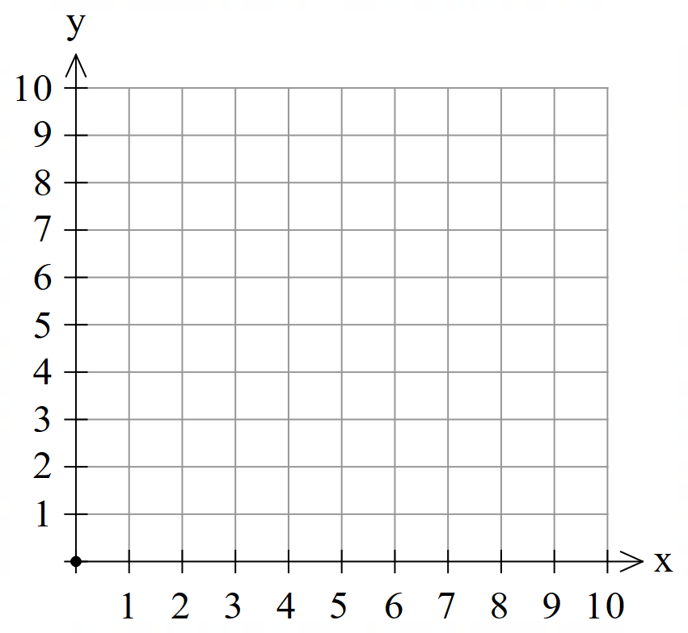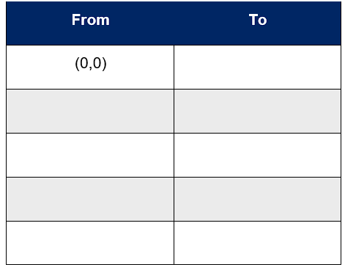

## Appendix B

### Cartesian chess – all axes

|  |  |
| --- | --- |
| Piece name:  Describe how it moves: | Space to draw chess piece. |

Complete the Cartesian plane and table, listing the points your piece would move from and to for 5 moves, starting from (0,0).

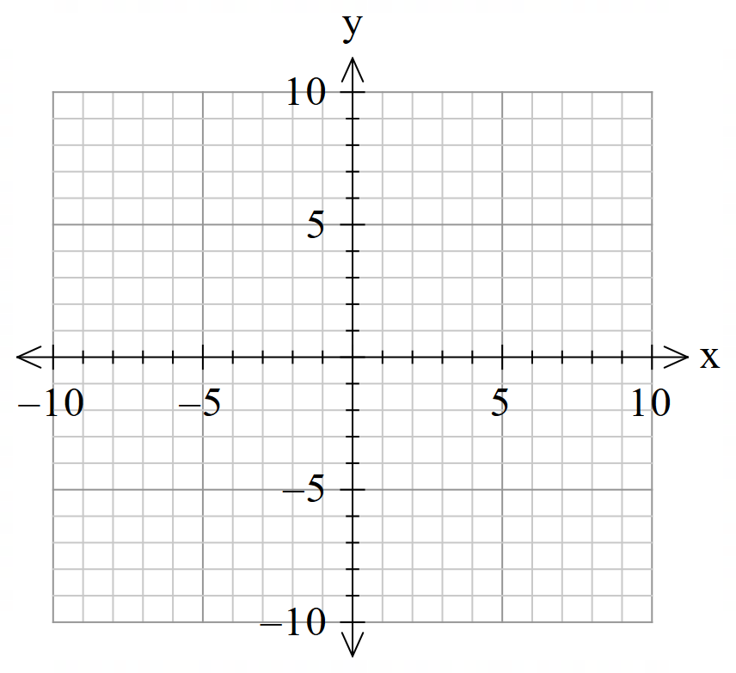 

## Appendix C

### Cartesian mazes

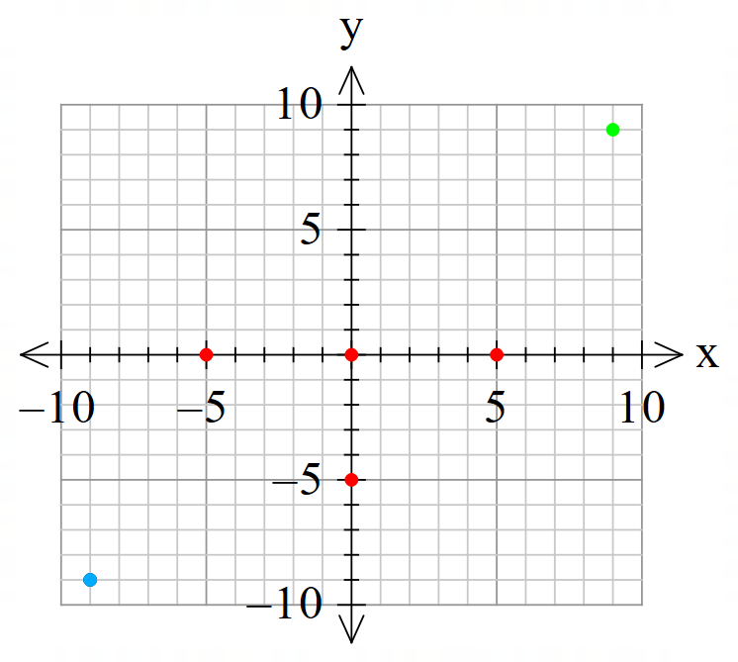

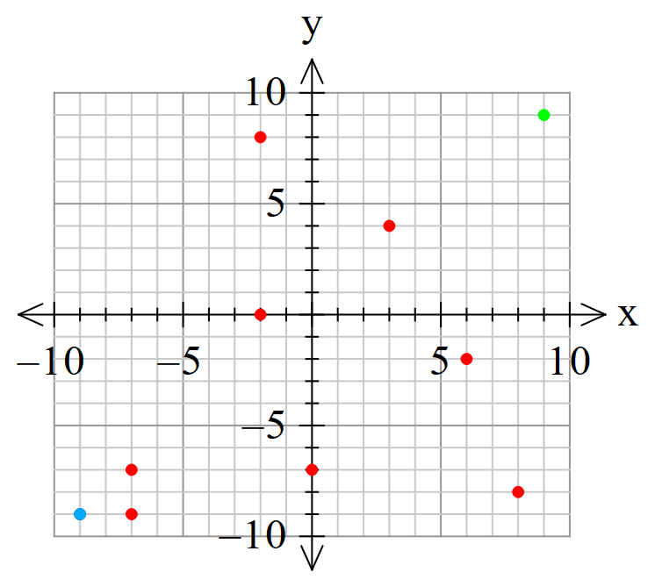

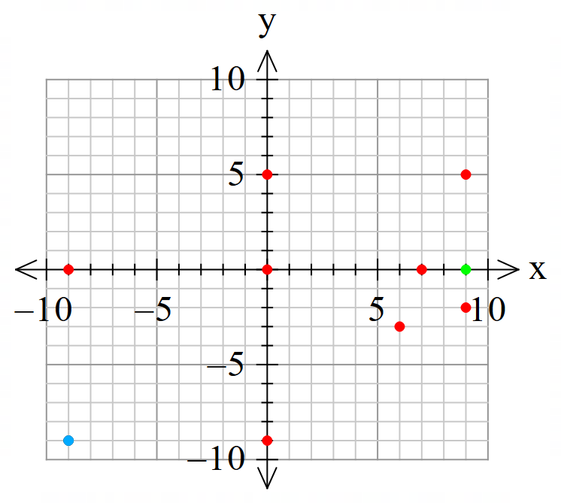

## References

This resource contains NSW Curriculum and syllabus content. The NSW Curriculum is developed by the NSW Education Standards Authority. This content is prepared by NESA for and on behalf of the Crown in right of the State of New South Wales. The material is protected by Crown copyright.

Please refer to the NESA Copyright Disclaimer for more information <https://educationstandards.nsw.edu.au/wps/portal/nesa/mini-footer/copyright>.

NESA holds the only official and up-to-date versions of the NSW Curriculum and syllabus documents. Please visit the NSW Education Standards Authority (NESA) website <https://educationstandards.nsw.edu.au/> and the NSW Curriculum website <https://curriculum.nsw.edu.au/>.

[Mathematics K–10 Syllabus](https://curriculum.nsw.edu.au/learning-areas/mathematics/mathematics-k-10-2022/overview) © NSW Education Standards Authority (NESA) for and on behalf of the Crown in right of the State of New South Wales, 2022.

**© State of New South Wales (Department of Education), 2024**

The copyright material published in this resource is subject to the *Copyright Act 1968* (Cth) and is owned by the NSW Department of Education or, where indicated, by a party other than the NSW Department of Education (third-party material).

Copyright material available in this resource and owned by the NSW Department of Education is licensed under a [Creative Commons Attribution 4.0 International (CC BY 4.0) license](https://creativecommons.org/licenses/by/4.0/).

[](https://creativecommons.org/licenses/by/4.0/)

This license allows you to share and adapt the material for any purpose, even commercially.

Attribution should be given to © State of New South Wales (Department of Education), 2024.

Material in this resource not available under a Creative Commons license:

* the NSW Department of Education logo, other logos and trademark-protected material
* material owned by a third party that has been reproduced with permission. You will need to obtain permission from the third party to reuse its material.

**Links to third-party material and websites**

Please note that the provided (reading/viewing material/list/links/texts) are a suggestion only and implies no endorsement, by the New South Wales Department of Education, of any author, publisher, or book title. School principals and teachers are best placed to assess the suitability of resources that would complement the curriculum and reflect the needs and interests of their students.

If you use the links provided in this document to access a third-party's website, you acknowledge that the terms of use, including licence terms set out on the third-party's website apply to the use which may be made of the materials on that third-party website or where permitted by the *Copyright Act 1968* (Cth). The department accepts no responsibility for content on third-party websites.