# Describing linear relationships

Students explore number patterns using tables of values and the Cartesian plane. They identify patterns as increasing, decreasing, linear or non-linear.

Students will need at least one digital device per pair to interact with Desmos during this lesson.

## Visible learning

### Learning intention

* To be able to describe linear relationships.

### Success criteria

* I can use a table of values to plot points on the Cartesian plane.
* I can correctly use the words increasing, decreasing, linear and non-linear to describe a number pattern.
* I can explain the relationship between a table of values and the Cartesian plane.

### Syllabus outcomes

A student:

* develops understanding and fluency in mathematics through exploring and connecting mathematical concepts, choosing and applying mathematical techniques to solve problems, and communicating their thinking and reasoning coherently and clearly **MAO-WM-01**
* creates and displays number patterns and finds graphical solutions to problems involving linear relationships **MA4-LIN-C-01**

[Mathematics K–10 Syllabus](https://curriculum.nsw.edu.au/learning-areas/mathematics/mathematics-k-10-2022/overview) © NSW Education Standards Authority (NESA) for and on behalf of the Crown in right of the State of New South Wales, 2022.

Table 1: lesson summary

|  |  |  |  |
| --- | --- | --- | --- |
| Section | Summary of activity | Teaching strategies | Teaching points |
| Launch | Students decide which pattern doesn’t belong on slide 3 of the PowerPoint *Describing linear relationships* (DLR PPT). | Think-Pair-Share  Which one doesn’t belong? | Identifying similarities and differences with number patterns. |
| Explore | Students explore increasing, decreasing, linear and non-linear patterns in Desmos ([bit.ly/DescribingPatterns](https://bit.ly/DescribingPatterns)). They complete and read tables of values, plot points onto the Cartesian plane and describe relationships in words. |  | Linear patterns increase or decrease by a constant amount and can be represented in multiple ways (visual pattern, table of values and graph). |
| Summarise | Students complete the card sort from screen 14 of the Desmos activity, matching patterns with their descriptions, graphs and table of values. They define a linear pattern using slide 5 of the PowerPoint (DLR PPT) and the Frayer diagram in Appendix A. | Think-Pair-Share | Identify linear and non-linear relationships represented in multiple ways.  Define a linear relationship. |
| Apply | Students apply strategies to a real-life context involving tables and chairs. Show video ([bit.ly/WorldLongestTable](https://bit.ly/WorldLongestTable)) and display slide 7 of the PowerPoint (DLR PPT). Provide Cartesian planes to each group ([bit.ly/Grid_Paper_mathlinks](https://bit.ly/Grid_Paper_mathlinks)) as a support resource in finding solutions. Display slide 9 of the PowerPoint (DLR PPT) to apply the strategy to a different scenario. | Visibly random groups of 3  Vertical non-permanent surfaces  Pose-Pause-Pounce-Bounce | Apply linear patterns to real-life contexts. |

## Activity structure

Please use the associated PowerPoint *Describing linear relationships* (DLR PPT) to display images in this lesson.

### Launch

1. Display slide 3 of the PowerPoint (DLR PPT).

Table 2: slide 3 – Which one doesn't belong?

|  |  |
| --- | --- |
| A  0, 3, 6, 9, 12 | B  79.5, 82.5, 85.5, 90.5, 93.5 |
| C  200, 197, 194, 191, 188 | D  1, 3, 9, 27, 81, 243 |

1. In a Think-Pair-Share ([bit.ly/thinkpairsharestrategy](https://bit.ly/thinkpairsharestrategy)), ask students to discuss and decide which number pattern doesn’t belong ([bit.ly/wodb](https://bit.ly/wodb)).

Possible answers include:

* A as it begins at 0
* B as the numbers are decimals
* C as it is decreasing
* D as it is not increasing or decreasing by 3.

1. Use the Pose-Pause-Pounce-Bounce questioning strategy (PDF 557 KB) ([bit.ly/posepausepouncebounce](https://bit.ly/posepausepouncebounce)) to allow students to share their reasoning.

### Explore

The algebraic rule for patterns has been included in teacher notes for reference if students are ready to move towards using an algebraic rule. The focus of the lesson is on describing linear relationships using the representations of a table of values and straight-line graphs on a Cartesian plane.

1. Display screen 2 of the Desmos Classroom activity ‘Describing patterns’ ([bit.ly/DescribingPatterns](https://bit.ly/DescribingPatterns)).

Students have seen this pattern in Lesson 2 – describing geometrical patterns.

1. Show students how to complete the table for the first 3 terms, verbalising your thinking out loud as you are calculating the numbers.
2. With one device between pairs of students, instruct students to access the Desmos Classroom activity ‘Describing patterns’ ([bit.ly/DescribingPatterns](https://bit.ly/DescribingPatterns)).

Before using this activity, you will need to set up a Desmos classroom ([bit.ly/createdesmosclassroom](https://bit.ly/createdesmosclassroom)) and use the pacing feature to restrict the students to screens 2 and 3.

Teachers may choose an alternative to using technology by displaying the patterns on the board from the Desmos activity and having students, in groups of 3 on vertical non-permanent surfaces, complete tables of values and graphs using a Cartesian plane ([bit.ly/Grid_Paper_mathlinks](https://bit.ly/Grid_Paper_mathlinks)).

1. Students complete screens 2 and 3 and in a Think-Pair-Share discuss ‘What did you observe happening on the Cartesian plane when you entered the number of matchsticks into the table of values?’

Students should have observed the inputs from their table of values produced coordinate points that went in a straight line that was increasing.

If students continue the pattern in the right side of the table without observing the term number, they will get an incorrect number of matchsticks for the tenth term. This will display as a point on the Cartesian plane that is not in line with the other points.

1. Ask students to consider what they notice and wonder ([bit.ly/noticewonderstrategy](https://bit.ly/noticewonderstrategy))aboutthe links between the table of values and the Cartesian plane.

Students might notice and wonder:

* The series of points produced on the Cartesian plane follows an increasing linear pattern.
* The $x$-axis has been labelled with t for the term number and the $y$-axis has been labelled m for the number of matchsticks.
* The first column in our table of values always goes with the horizontal axis on our Cartesian plane, no matter what we choose to name it.

1. Pace students so that they can now complete up to screen 12.

Using the teacher dashboard, monitor students’ progress and responses for further discussion once students have completed up to screen 12.

1. Initiate a sharing of ideas and reasoning using the Pose-Pause-Pounce-Bounce questioning strategy to discuss multiple representations of a linear relationship. Useful question prompts could include:

* What strategies did you use to complete the table of values?
* What did you notice about the different representations of geometric patterns, tables of values and the Cartesian plane?
* How would you explain the difference between an increasing and a decreasing relationship?
* How would you explain the difference between a linear and non-linear relationship?

Students might have chosen strategies such as continuing the geometric pattern and counting, noticing how much the pattern increased or decreased by and then adding or subtracting onto the numbers in the table of values, or finding the algebraic rule for the pattern.

* Pattern 1 increases by 2 each term.
* Pattern 2 increases by 5 each term and has the algebraic rule $M=5t+1.$
* Pattern 3 grows increasingly faster, by one more with each iteration.
* Pattern 4 decreases by 7 each term and has the algebraic rule $y=-7x+30$.

Students might have noticed that pattern 4 has been labelled differently in the table of values and on the Cartesian plane and that the Cartesian plane has been extended to include negative numbers on our $y$-axis.

Students may describe linear relationships as constantly increasing or decreasing by the same amount each time and non-linear relationships change by different amounts each time.

1. Pace students to screen 13 and provide time for them to complete the table of values and observe the graph.
2. Highlight to students that the term number, 1, is the $x$-value on the horizontal $x$-axis and the pattern number, 23, is the $y$-value on the vertical $y$-axis. Explain that these numbers can be written as the coordinate point (1,23).

Students will plot points from a table of values later in the lesson.

### Summarise

1. Pace students to screen 14 where they will complete a card sort, matching the pattern description with its table of values and corresponding graph.

The card sort on screen 14 of the Desmos activity could be produced as a physical card sort on paper as an alternative to using technology.

1. Display slide 5 of the PowerPoint (DLR PPT) and in a Think-Pair-Share ask students to explain what makes a pattern linear.

Students should be able to communicate that a linear pattern is increasing or decreasing by the same amount each time, and this can be seen by the change in the number of matchsticks in the visual pattern, the change in the numbers in the table of values as the term increases by 1 and in the linear pattern seen by the plotted points on the Cartesian plane.

1. Ask students to read from the graph on slide 5 of the PowerPoint (DLR PPT), how many matchsticks would be in the sixth and ninth terms of the pattern? What would they predict for the eleventh term in the pattern?

Answers: the sixth term is 14, the ninth term is 19 and the eleventh term is 23.

1. Students are to complete Appendix A ‘Frayer diagram’ ([bit.ly/frayerdiagram](http://bit.ly/frayerdiagram)) by filling in examples and non-examples of a linear pattern from the Desmos activity.

### Apply

1. Assign students into visibly random groups of 3 ([bit.ly/visiblegroups](https://bit.ly/visiblegroups)) at vertical non-permanent surfaces ([bit.ly/VNPSstrategy](https://bit.ly/VNPSstrategy)).
2. Show students the video ‘Guiness Record | The World's Longest Table’ (0:42) ([bit.ly/WorldLongestTable](https://bit.ly/WorldLongestTable)) from the Mojiang twins festival, China 2017.
3. Display slide 7 of the PowerPoint (DLR PPT) which shows Figure 1 and read out the following scenario:

The school is hosting a world’s longest table fundraising event. You are part of the team that will be gathering all the tables and chairs from the classrooms and setting them up in one big, long line on the school oval.

Figure 1: tables and chairs pattern



1. Distribute an A3 sheet of ‘0 to 10 blank Coordinate Grid’ grid paper ([bit.ly/Grid_Paper_mathlinks](https://bit.ly/Grid_Paper_mathlinks)) for students to place into a plastic sleeve and adhesive putty.
2. Instruct students to use the pattern of tables and chairs on slide 8 of the PowerPoint (DLR PPT) to answer the following questions, shown on the slide:

* What is the maximum seating capacity for the event if the school has 720 tables?
* There are 721 people who have currently paid for the event. How many tables and chairs do we need to set up?

1. Ask students assessing and advancing questions ([bit.ly/supportingstrategies](https://bit.ly/supportingstrategies)) to further student thinking. Some suggestions are provided in the following table:

Table 3: assessing and advancing questions

|  |  |
| --- | --- |
| Assessing questions | Advancing questions |
| What do you know about the pattern of tables? | How can you find the number of chairs by using the pattern? |
| Can you describe the pattern? | Can a table of values help to identify the pattern? |
| What strategies have you tried so far? | Could you use a backtracking strategy to work out the number of tables that are needed? |

Students should notice that the number of tables is the same as the number of the term in the pattern and can set out their table of values and grids with the labels number of tables ($x$) and number of seats ($y$). Students may also choose to find and use the algebraic rule for the pattern.

1. Initiate a sharing of ideas and reasoning using the Pose-Pause-Pounce-Bounce questioning technique to discuss different strategies and solutions.
2. Display and read out the scenario from slide 9 of the PowerPoint (DLR PPT), using the same tables and chairs pattern:

In Egypt in 2019, approximately 7000 people sat at a Ramadan feast table just over 3000 m long. How many tables would we need to seat 7000 people?

Teachers may choose to show the video ‘Country creates world's longest dining table, promotes new capital’ (2:44) ([bit.ly/EgyptLongestTable](https://bit.ly/EgyptLongestTable)) up to 0:41 seconds.

## Assessment and differentiation

### Suggested opportunities for differentiation

**Launch**

* A geometrical pattern could also be included as an option for students to consider.
* Challenge students to find a reason why each pattern does not belong.

**Explore**

* The pacing of the Desmos activity can be adjusted to suit the class.
* Enable students by providing matchsticks or counters as a concrete representation to support completing the tables of values for the geometrical patterns in the Desmos activity.
* Further patterns such as ones involving fractions or decimals, which can be found on this website ‘Visual Patterns’ ([www.visualpatterns.org/](http://www.visualpatterns.org/)), could be added to the Desmos activity for students to explore and compare.

**Summarise**

* Students could work in pairs or groups to complete their Frayer diagrams.

**Apply**

* The tables and chairs scenario and pattern can be physically constructed in your classroom to provide students with a physical immersion into the scenario.
* The tables and chairs scenario could be adapted to fit in smaller spaces such as the school hall or basketball courts to provide students with smaller numbers to calculate.
* A discussion about why negative values for $x$ and $y$ may not make sense in certain contexts may be useful.
* Students could be challenged to express the pattern algebraically.
* Students could explore different table and chair patterns.

### Suggested opportunities for assessment

**Launch**

* ‘Which one doesn’t belong?’ allows students to communicate their reasons for their choices.

**Explore**

* Students give each other peer feedback when working in pairs.
* Monitor responses in the Desmos activity to check for student understanding of increasing, decreasing, linear and non-linear patterns.
* Students will demonstrate their Working mathematically skills in discussions and justifications.

**Summarise**

* Monitor students’ responses from the Desmos card sort activity to check for student understanding of representing patterns in multiple ways.
* Collect students’ Frayer models as an assessment of learning about linear patterns.

**Apply**

* Students working at vertical non-permanent surfaces means the teacher can assess student progress and provide support where appropriate.
* When placed in groups of 3, students provide and receive peer-feedback on their understanding.

## Appendix A

### Frayer diagram

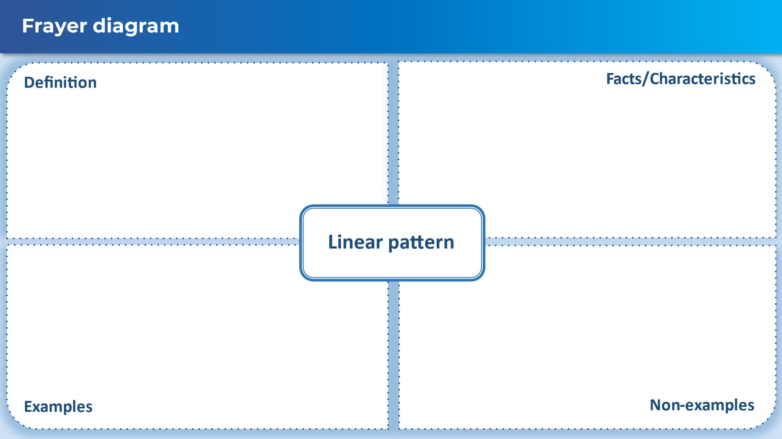

## Sample solutions

### Appendix A – Frayer diagram

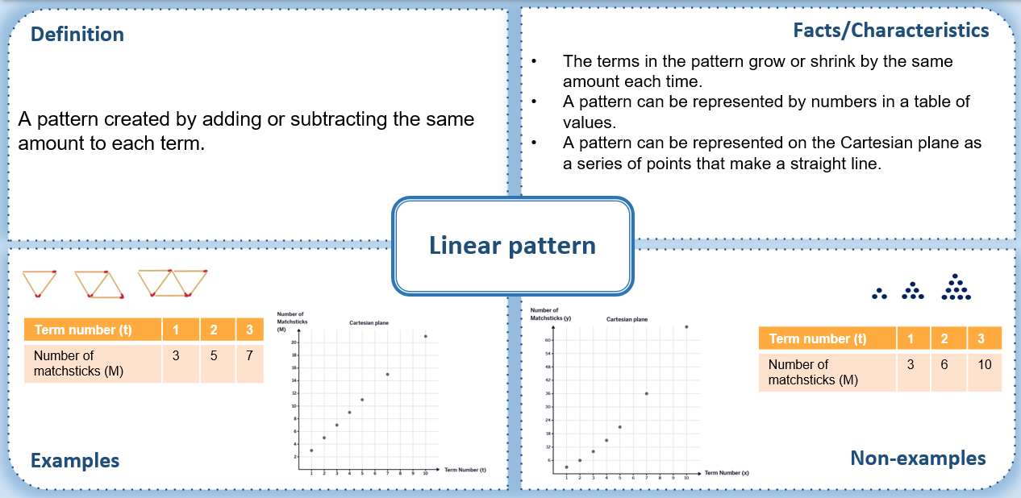

### Apply

|  |  |  |  |
| --- | --- | --- | --- |
| **Number of tables (x)** | 1 | 2 | 3 |
| **Number of chairs (y)** | 4 | 6 | 8 |

Students should notice the pattern is increasing by 1 table and 2 chairs each time. The number pattern is 2 times the number of tables plus 2.

**What is the maximum seating capacity for the event if the school has 720 tables?**

The maximum capacity for 720 tables is $2×720+2=1442$

**721 people have currently paid for the event. How many tables and chairs do we need to set up?**

721 people have paid, so we need 721 chairs.

Students may recognise that 721 is half of 1442 and substitute for half the amount of tables – 360.

360 tables is $2×360+2=722$

Alternatively, you could use the information from the pattern that we double the number of chairs and add 2 more, so to work backward we need to subtract 2 from the number of people and then halve. This will give the result 359.5. Students then need to recognise we can’t have half a table and round up to 360.

**How many tables would we need to seat 7000 people?**

$\left(7000-2\right)÷2=3499$

## References

This resource contains NSW Curriculum and syllabus content. The NSW Curriculum is developed by the NSW Education Standards Authority. This content is prepared by NESA for and on behalf of the Crown in right of the State of New South Wales. The material is protected by Crown copyright.

Please refer to the NESA Copyright Disclaimer for more information [https://educationstandards.nsw.edu.au/wps/portal/nesa/mini-footer/copyright](https://aus01.safelinks.protection.outlook.com/?url=https%3A%2F%2Feducationstandards.nsw.edu.au%2Fwps%2Fportal%2Fnesa%2Fmini-footer%2Fcopyright&data=05%7C01%7CCaitlin.Pace1%40det.nsw.edu.au%7C9c2c1a9f59c94d2df30708dafa7edb23%7C05a0e69a418a47c19c259387261bf991%7C0%7C0%7C638097720042599463%7CUnknown%7CTWFpbGZsb3d8eyJWIjoiMC4wLjAwMDAiLCJQIjoiV2luMzIiLCJBTiI6Ik1haWwiLCJXVCI6Mn0%3D%7C3000%7C%7C%7C&sdata=BzQh0UsffVZE3eO22b2Xba3p0VMOBZSHfS21FGHXtZM%3D&reserved=0).

NESA holds the only official and up-to-date versions of the NSW Curriculum and syllabus documents. Please visit the NSW Education Standards Authority (NESA) website <https://educationstandards.nsw.edu.au/> and the NSW Curriculum website <https://curriculum.nsw.edu.au/>.

[Mathematics K–10 Syllabus](https://curriculum.nsw.edu.au/learning-areas/mathematics/mathematics-k-10-2022/overview) © NSW Education Standards Authority (NESA) for and on behalf of the Crown in right of the State of New South Wales, 2022.

**© State of New South Wales (Department of Education), 2024**

The copyright material published in this resource is subject to the *Copyright Act 1968* (Cth) and is owned by the NSW Department of Education or, where indicated, by a party other than the NSW Department of Education (third-party material).

Copyright material available in this resource and owned by the NSW Department of Education is licensed under a [Creative Commons Attribution 4.0 International (CC BY 4.0) license](https://creativecommons.org/licenses/by/4.0/).

[](https://creativecommons.org/licenses/by/4.0/)

This license allows you to share and adapt the material for any purpose, even commercially.

Attribution should be given to © State of New South Wales (Department of Education), 2024.

Material in this resource not available under a Creative Commons license:

* the NSW Department of Education logo, other logos and trademark-protected material
* material owned by a third party that has been reproduced with permission. You will need to obtain permission from the third party to reuse its material.

**Links to third-party material and websites**

Please note that the provided (reading/viewing material/list/links/texts) are a suggestion only and implies no endorsement, by the New South Wales Department of Education, of any author, publisher, or book title. School principals and teachers are best placed to assess the suitability of resources that would complement the curriculum and reflect the needs and interests of their students.

If you use the links provided in this document to access a third-party's website, you acknowledge that the terms of use, including licence terms set out on the third-party's website apply to the use which may be made of the materials on that third-party website or where permitted by the *Copyright Act 1968* (Cth). The department accepts no responsibility for content on third-party websites.