# Comparing straight-line graphs

Students explore the slope of mountain bike trails when represented as a straight-line graph. They explore the similarities and differences of line graphs and consider which trail would suit different riders.

## Visible learning

### Learning intention

* To be able to compare straight-line graphs.

### Success criteria

* I can identify parallel lines using a graph.
* I can identify similarities and differences between graphs of straight lines.
* I can describe the graph of a straight line using mathematical language.

### Syllabus outcomes

A student:

* develops understanding and fluency in mathematics through exploring and connecting mathematical concepts, choosing and applying mathematical techniques to solve problems, and communicating their thinking and reasoning coherently and clearly **MAO-WM-01**
* creates and displays number patterns and finds graphical solutions to problems involving linear relationships **MA4-LIN-C-01**

[Mathematics K–10 Syllabus](https://curriculum.nsw.edu.au/learning-areas/mathematics/mathematics-k-10-2022/overview) © NSW Education Standards Authority (NESA) for and on behalf of the Crown in right of the State of New South Wales, 2022.

Table 1: lesson summary

|  |  |  |  |
| --- | --- | --- | --- |
| Section | Summary of activity | Teaching strategies | Teaching points |
| **Launch** | Students view a video, ‘Dungog Blue Flow trail with Dad’ (3:05) ([bit.ly/DungogBluewithDad](https://bit.ly/DungogBluewithDad)). They are shown the trail profile on slide 3 of the PowerPoint Comparing straight-line graphs (CSG PPT) and asked to identify features of the graph. They are then shown 4 profiles to compare on slide 4 and asked to determine which one doesn’t belong. | Notice and wonder  Think-Pair-Share | Recognise that graphs are read from left to right and that the slope of a line indicates whether the trail is going uphill, downhill or flat. |
| **Explore** | Display slide 6 of the PowerPoint (CSG PPT) showing the overall slope of some trails. Students are given some terms on slide 7. The meaning of the terms is discussed before students are asked to use the terms to describe the trails. | Notice and wonder  Pose-Pause-Pounce-Bounce  Think-Pair-Share | Understand the meaning of the terms increasing, decreasing and parallel when referring to linear graphs. |
| **Summarise** | Students make notes to their future forgetful selves. They complete Appendix A by completing a table and comparing straight lines on a graph. | Vertical non-permanent surfaces  Two stars and a wish | Practise describing linear graphs using mathematical terminology. |
| **Apply** | Display slide 9 of the PowerPoint (CSG PPT) and complete Appendix B in which students are asked to provide a recommendation of a trail based on riding preferences and then draw a graph with different sections of a trail. |  | Use the terms to describe graphs of straight lines and draw a straight line when provided with the terms. |

## Activity structure

Please use the associated PowerPoint *Comparing straight-line graphs* (CSG PPT) to display images in this lesson.

### Launch

1. Show students the video ‘Dungog Blue flow trail with Dad’ (3:05) ([bit.ly/DungogBluewithDad](https://bit.ly/DungogBluewithDad)).
2. In a class discussion, ask students what they notice and wonder ([bit.ly/noticewonderstrategy](https://bit.ly/noticewonderstrategy)).

Students might notice that the rider is going downhill quickly, there are many twists and turns, the rider is breathing hard by the end and there are a few moments when the rider seems out of control.

They might wonder how steep the trail is and what the speed is.

1. Display slide 3 of the PowerPoint *(*CSG PPT) and use a Think-Pair-Share ([bit.ly/thinkpairsharestrategy](https://bit.ly/thinkpairsharestrategy)) to answer the question prompts on the slide.

The graph shows an overview of a mountain bike trail called ‘Blue flow’.

1. The horizontal axis represents the length of the trail, which is the distance a rider would travel. The vertical axis represents the altitude of the trail. The hills and troughs of the dark blue line represent the changes in altitude of the trail. Display slide 4 of the PowerPoint (CSG PPT) and ask students to decide which one doesn’t belong ([bit.ly/wodb](https://bit.ly/wodb)), giving reasons.

Possible reasons might include:

* the Rifle Range is the only downhill trail shaded blue
* Inny and Outy has straight horizontal sections
* Jacks Blue is the only uphill trail
* Easy Street – Green Flow doesn’t have a red square to show the end of the trail.

### Explore

1. Display slide 6 of the PowerPoint (CSG PPT) and ask students what they notice and wonder.

Students should be encouraged to recognise that the graphs of the trails are a representation of the overall descent compared to the distance travelled, rather than the profile of the trails as shown in the Launch.

Students may notice that there are 6 graphs and that the graphs represent the overall slope of different mountain bike trails at Dungog Common riding area. They might notice that some of the graphs are steeper than others and that only one trail is going uphill. They might notice that the Inny and Outy trail is a mix of 3 linear sections.

They might wonder about the speed of riders and the level of difficulty of the trails.

1. Display slide 7 of the PowerPoint (CSG PPT) and use the Pose-Pause-Pounce-Bounce questioning strategy (PDF 557 KB) ([bit.ly/posepausepouncebounce](https://bit.ly/posepausepouncebounce)) to discuss the terms shown on the slide. Some useful question prompts may include:

* What do the terms ‘increasing’ and ‘decreasing’ mean?
* How can we tell when lines are parallel?
* What happens when 2 lines decrease at different rates?
* What do we say about a line that is neither increasing nor decreasing?

1. Ask students to use a Think-Pair-Share to discuss which terms could be used to describe each graph.

Lines that are increasing or decreasing may be referred to as ‘going up’ or ‘going down’. Ensure that students recognise that the terms increasing and decreasing refer to the path of the line as it moves from left to right.

Students may describe lines that are neither increasing nor decreasing as ‘flat’, or as having no slope.

Remind students that they may wish to revisit their unit glossary to add words or adjust their definitions.

Teachers may wish to link to the word gradient when discussing the concept of slope or discussing positive and negative slopes.

### Summarise

1. In pairs, students are to create notes to their future forgetful self ([bit.ly/notestofutureself](https://bit.ly/notestofutureself)) on comparing straight-line graphs on vertical non-permanent surfaces ([bit.ly/VNPSstrategy](https://bit.ly/VNPSstrategy)).
2. Students are to do a gallery walk and give peer feedback using the Two stars and a wish strategy ([bit.ly/DLSpeerfeedback](https://bit.ly/DLSpeerfeedback)).
3. Students are to use the peer feedback they received to help them to write their own individual notes.
4. Distribute Appendix A ‘Comparing straight-line graphs’ to pairs of students and ask them to complete.

Students may benefit from accessing the Desmos graphing calculator on a digital device to graph the lines and compare the lines in pairs.

1. Students are to compare their solutions with another pair. If they differ, they are to discuss why.

### Apply

1. Display slide 9 of the PowerPoint (CSG PPT) and distribute Appendix B ‘Thredbo Mountain biking trails’ for students to complete.

The slide shows the graphs used in Appendix B ‘Thredbo Mountain biking trails’. Displaying the graphs on the screen may give students an opportunity to notice the features of the graph more easily.

1. Ask students to share their recommendations, their proposed trail and the name of their trail with other students, justifying their recommendations and explaining their proposed graph.

## Assessment and differentiation

### Suggested opportunities for differentiation

**Launch**

* A notice and wonder activity has no correct answers and is subject to opinion, so all students should be able to access the lesson content.
* **A ‘Which one doesn’t belong?’ activity is a low floor activity as there is no single correct answer. The aim of the activity is for students to identify similarities and differences between the prompts and justify their opinion about which one doesn’t belong.**

**Explore**

* Provide written definitions for the terms ‘increasing’, ‘decreasing’, ‘parallel’ and ‘non-parallel’, to support student understanding of what the terms mean.
* When discussing gradient, teachers may like to encourage students to reference positive or negative gradient and zero gradient for a line with no slope.

**Summarise**

* **Students can be asked to graph the pairs of lines using the Desmos graphing calculator (**[desmos.com/calculator](https://www.desmos.com/calculator)**) so they only see 2 straight-line graphs at a time to compare from Appendix A.**
* **The terms ‘positive gradient’ and ‘negative gradient’ may be referenced when the class is in the share phase of the Think-Pair-Share.**

**Apply**

* Mountain biking trails and ski slopes are generally coded using the colours green, blue and black to indicate the level of difficulty. Extend students by investigating the criteria for the coding of trails and slopes.

### Suggested opportunities for assessment

**Launch**

* Monitor student use of language to describe the mountain bike trail profiles and to assess student understanding of distance-time graphs.

**Explore**

* Observe and correct errors and misconceptions when using the terms to describe the graph.

**Summarise**

* Collect students notes to their future forgetful selves for evidence of learning how to compare straight-line graphs.
* Teachers can monitor completion of the table for understanding of how to compare the graphs of straight lines.

**Apply**

* Observe which trails students recommend for each rider. Monitor if students are confident using the terms ‘increasing’, ‘decreasing’ and ‘parallel’.
* An exit ticket could be used as summative assessment that students can compare straight-line graphs by identifying common features of the graphs of straight lines using parallel, non-parallel, increasing and decreasing.

## Appendix A

### Comparing straight-line graphs

Use the table to identify which descriptions are appropriate when comparing each pair of straight-line graphs on the following page.

|  |  |  |  |  |  |  |
| --- | --- | --- | --- | --- | --- | --- |
| Equations | Lines are increasing | Lines are decreasing | One line is increasing and one line is decreasing | Lines are parallel | Lines are non-parallel | Lines pass through the same point |
| $$y=x+ 1$$ $$y=x+2$$ |  |  |  |  |  |  |
| $$y=3x- 2$$ $$y=x+2$$ |  |  |  |  |  |  |
| $$y=-2x+ 1$$ $$y=x+ 1$$ |  |  |  |  |  |  |
| $$y=-2x+ 1$$ $$y=3x- 2$$ |  |  |  |  |  |  |
| $$y=-2x+ 1$$ $$y=-x+ 1$$ |  |  |  |  |  |  |
| $$y=-x+ 1$$ $$y=x+ 1$$ |  |  |  |  |  |  |

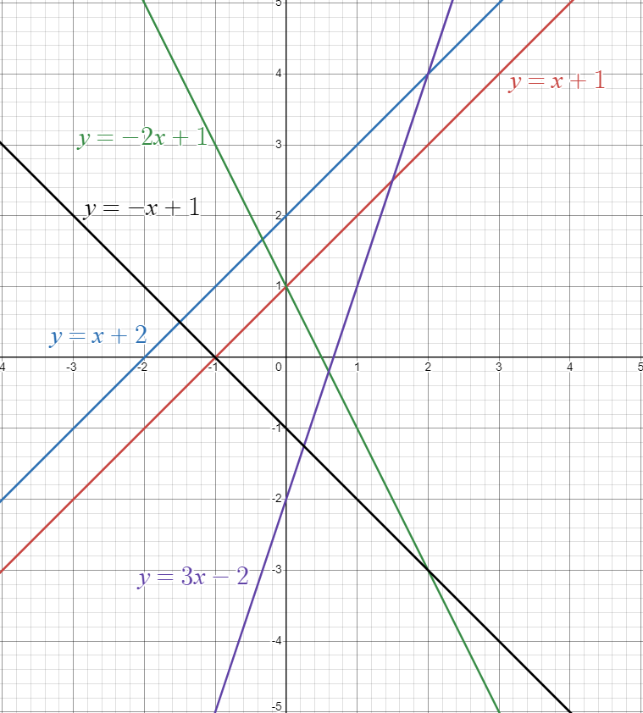

## Appendix B

### Thredbo mountain biking trails

The graph shows the average slope profile of Thredbo Mountain bike trails. A group of riders is planning their ride. Use the graphs to make a recommendation of which trail they should ride.

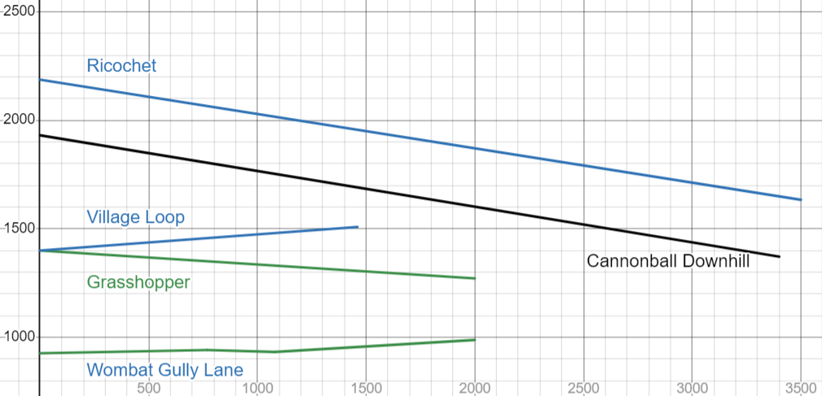

Data source: Trailforks, [The Best Mountain Biking Trails in Thredbo Bike Park | Trailforks](https://www.trailforks.com/region/thredbo-bike-park/trails/), accessed 11 November 2024.

|  |  |  |  |
| --- | --- | --- | --- |
| Rider | Riding preferences | Recommendation | Reasons |
| Andy | A beginner who would prefer to try a little uphill and downhill. |  |  |
| Blake | Would like to practise riding uphill. |  |  |
| Charlie | Enjoys a long downhill ride. |  |  |
| Danni | Enjoys riding downhill, but not too much slope. |  |  |

The trail building team are planning a new trail. The trail will include a slowly increasing section, parallel to the Village Loop trail, a flat section and a quickly decreasing section.

Draw a trail on the graph above which meets the guidelines and give the new trail a name.

## Sample solutions

### Appendix A – comparing straight-line graphs

|  |  |  |  |  |  |  |
| --- | --- | --- | --- | --- | --- | --- |
| Equations | Lines are increasing | Lines are decreasing | One line is increasing and one line is decreasing | Lines are parallel | Lines are non-parallel | Lines pass through the same point |
|  | **✓** |  |  | **✓** |  |  |
|  | **✓** |  |  |  | **✓** | **✓** |
|  |  |  | **✓** |  | **✓** | **✓** |
|  |  |  | **✓** |  | **✓** | **✓** |
|  |  | **✓** |  |  | **✓** | **✓** |
|  |  |  | **✓** |  | **✓** | **✓** |

### Appendix B – Thredbo mountain biking trails

The red line shows a sample solution.

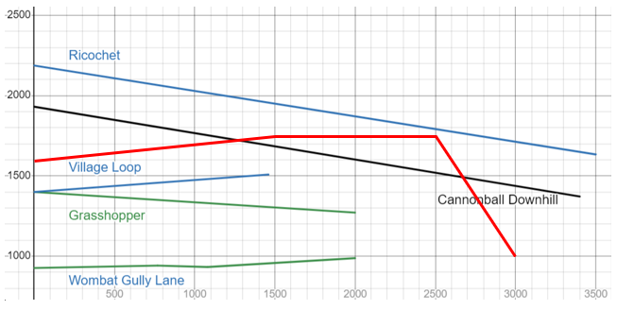

|  |  |  |  |
| --- | --- | --- | --- |
| Rider | Riding preferences | Recommendation | Reasons |
| Andy | A beginner who would prefer to try a little uphill and downhill. | Wombat Gully Lane | The slope is slowly increasing, before decreasing slightly and then increasing again. |
| Blake | Would like to practise riding uphill. | Village Loop | The slope is increasing. |
| Charlie | Enjoys a long downhill ride. | Ricochet or Cannonball Downhill | The slopes are parallel and are both decreasing, so either would do. |
| Danni | Enjoys riding downhill, but not too much slope. | Grasshopper | The graph is slowly decreasing. |

## References

This resource contains NSW Curriculum and syllabus content. The NSW Curriculum is developed by the NSW Education Standards Authority. This content is prepared by NESA for and on behalf of the Crown in right of the State of New South Wales. The material is protected by Crown copyright.

Please refer to the NESA Copyright Disclaimer for more information <https://educationstandards.nsw.edu.au/wps/portal/nesa/mini-footer/copyright>.

NESA holds the only official and up-to-date versions of the NSW Curriculum and syllabus documents. Please visit the NSW Education Standards Authority (NESA) website <https://educationstandards.nsw.edu.au> and the NSW Curriculum website <https://curriculum.nsw.edu.au>.

[Mathematics K–10 Syllabus](https://curriculum.nsw.edu.au/learning-areas/mathematics/mathematics-k-10-2022/overview) © NSW Education Standards Authority (NESA) for and on behalf of the Crown in right of the State of New South Wales, 2022.

**© State of New South Wales (Department of Education), 2024**

The copyright material published in this resource is subject to the Copyright Act 1968 (Cth) and is owned by the NSW Department of Education or, where indicated, by a party other than the NSW Department of Education (third-party material).

Copyright material available in this resource and owned by the NSW Department of Education is licensed under a [Creative Commons Attribution 4.0 International (CC BY 4.0) license](https://creativecommons.org/licenses/by/4.0/).

[](https://creativecommons.org/licenses/by/4.0/)

This license allows you to share and adapt the material for any purpose, even commercially.

Attribution should be given to © State of New South Wales (Department of Education), 2024.

Material in this resource not available under a Creative Commons license:

* the NSW Department of Education logo, other logos and trademark-protected material
* material owned by a third party that has been reproduced with permission. You will need to obtain permission from the third party to reuse its material.

**Links to third-party material and websites**

Please note that the provided (reading/viewing material/list/links/texts) are a suggestion only and implies no endorsement, by the New South Wales Department of Education, of any author, publisher, or book title. School principals and teachers are best placed to assess the suitability of resources that would complement the curriculum and reflect the needs and interests of their students.

If you use the links provided in this document to access a third-party's website, you acknowledge that the terms of use, including licence terms set out on the third-party's website apply to the use which may be made of the materials on that third-party website or where permitted by the Copyright Act 1968 (Cth). The department accepts no responsibility for content on third-party websites.