# Irrational numbers

Students explore and discover irrational numbers such as $π$ and $\sqrt{2}$.

## Visible learning

### Learning intention

* To know what irrational numbers are.

### Success criteria

* I can define an irrational number.
* I can approximate the size of an irrational number.
* I can approximate where irrational numbers are on a number line.

### Syllabus outcomes

A student:

* develops understanding and fluency in mathematics through exploring and connecting mathematical concepts, choosing and applying mathematical techniques to solve problems, and communicating their thinking and reasoning coherently and clearly **MAO-WM-01**
* represents and operates with fractions, decimals and percentages to solve problems   
  **MA4-FRC-C-01**
* applies knowledge of the perimeter of plane shapes and the circumference of circles to solve problems **MA4-LEN-C-01**

[Mathematics K–10 Syllabus](https://curriculum.nsw.edu.au/learning-areas/mathematics/mathematics-k-10-2022/overview) © NSW Education Standards Authority (NESA) for and on behalf of the Crown in right of the State of New South Wales, 2022.

Table 1: lesson summary

|  |  |  |  |
| --- | --- | --- | --- |
| Section | Summary of activity | Teaching strategies | Teaching points |
| Launch | Use slide 3 of the PowerPoint *Irrational numbers* (IN PPT*)* to start a class discussion about approximations for the relationship between the circumference and diameter of a circle. | Notice and wonder  Pose-Pause-Pounce-Bounce | Students think about why we might use an approximation, and which would be the most accurate. |
| Explore | Show students $C=πd$ to introduce students to $π$. Use slide 5 of the PowerPoint to show the definition of a rational number and ask students to define an irrational number given $π$ is one. Using Appendix A, pairs order the approximations of $π$ before deciding which is the most accurate. Pairs use Appendix B to place $π$ and $\sqrt{2}$ on a number line. | Think-Pair-Share | Students use approximations to place irrational numbers on number lines. |
| Summarise | Using slides 7–15, students are shown different numbers and engage in a discussion about whether the numbers are rational or irrational. Students then complete Appendix C to form their notes. Challenge pairs to plot the irrational numbers found in the PowerPoint on a number line. | Frayer diagram  Think-Pair-Share  Finger vote | Students consolidate and practise identifying and approximating irrational numbers. |
| Apply | In pairs, students write a script of a conversation between themselves and another student who states ‘If $2×4=8$ then $\sqrt{2}×4=\sqrt{8}$’. | Assessing and advancing questions  Two stars and a wish  Exit ticket | Students show their knowledge of irrational numbers and how we approximate them. |

## Activity structure

Please use the associated PowerPoint *Irrational numbers* (IN PPT) to display images in this lesson.

### Launch

1. Display slide 3 of the PowerPoint *Irrational numbers* (IN PPT) which shows how ancient civilisations approximated the circumference of a circle given its diameter. Ask students what they notice and wonder ([bit.ly/noticewonderstrategy](https://bit.ly/noticewonderstrategy)).
2. Use the Pose-Pause-Pounce-Bounce questioning strategy (PDF 557 KB) ([bit.ly/posepausepouncebounce](https://bit.ly/posepausepouncebounce)) to start a class discussion. Suggested prompts include:

* How do you think different civilisations discovered their equations? Why are they different?
* Why would someone use an equation that only approximates the circumference of a circle?

One may use an equation that results in an approximation to simplify their calculations or if they lack enough information to obtain an accurate representation.

### Explore

1. Display the formula $C=πd$, and state that this formula represents the relationship between the circumference of a circle and its diameter.

Students might benefit from referring to their glossary definitions of diameter and circumference from Lesson 1 – diameter and circumference.

1. In a Think-Pair-Share ([bit.ly/thinkpairsharestrategy](https://bit.ly/thinkpairsharestrategy)), ask students what they think the symbol $π$ represents.

Pi is the ratio of the circumference of any circle to its diameter. It is denoted by the Greek letter $π$ (pi).

1. Ask students to locate the $π$ button on their calculators and press equals. Ask random students to share what their calculator equated $π$ to be.
2. In another Think-Pair-Share, ask students why they got slightly different numbers.

It is assumed that students would have a variety of different calculators. If not, show at least one other online calculator, such as Google’s built-in calculator, that would show a different decimal approximation to the calculators in the classroom.

1. State to students that people are still finding more and more decimal places for $π$ and because of this, when represented as a fraction like shown in the Launch, it is only an approximation. Define numbers that can’t be written as a fraction as irrational numbers.

You could show students an online calculator, such as ‘y-cruncher - A Multi-Threaded Pi-Program’ ([numberworld.org/y-cruncher/](http://www.numberworld.org/y-cruncher/)), that states how many decimal places of $π$ mathematicians have computed.

1. Display slide 5 of the PowerPoint (IN PPT) which shows the definition of a rational number and some examples.
2. State that $π$ is called an irrational number.

An irrational number is a number that cannot be expressed as a fraction.

1. Distribute Appendix A ‘Approximations’ which has $π$ rounded to 20 decimal places and the fractional approximations from the ancient civilisations in the Launch of the lesson.
2. In pairs, ask students to order the approximations and $π$ from largest to smallest.
3. In another Think-Pair-Share, ask students to decide which approximation is the closest to $π$ and explain their thinking.
4. Distribute Appendix B ‘Number line’ to students in a plastic pocket and ask each pair to try and place where $π$ would sit on a number line.
5. Ask random students to display their work and justify why they placed it in that position on the number line.

Students should use an approximation to get an estimated location of the irrational number, whether it be from a decimal or fraction.

1. Give pairs of students a new irrational number, $\sqrt{2}$, and ask them to estimate where it might belong on the same number line. Do not allow them to use their calculator at this point.

Students estimated the value of square roots in Lesson 7 – that’s about right of Unit 5 – multiplicative thinking.

1. Use the Pose-Pause-Pounce-Bounce questioning strategy to ask students where they put $\sqrt{2}$ and why.
2. Have students verify their position on the number line by entering $\sqrt{2}$ into their calculator to determine an approximation.
3. Ask random students to share how close their approximation was to $\sqrt{2}$.

### Summarise

1. Show students slides 7–15 from the PowerPoint (IN PPT). In a Think-Pair-Share, students are to discuss whether the number shown is rational or irrational.
2. Ask students to share their decision by giving a thumbs up or thumbs down:

* thumbs up: rational
* thumbs down: irrational.

**Rational**: $\frac{1}{9}$, $\sqrt{100}$, $0.\dot{8}$, $\frac{15}{2}, 15\%$ and $2.\overline{56}$

**Irrational**: $\sqrt{3}, \sqrt{8}$ and $π$

Students have explored rational numbers in Unit 3 – representing numbers, where they classified recurring decimals as rational numbers.

1. Distribute Appendix C ‘Frayer model’ ([bit.ly/frayerdiagram](https://bit.ly/frayerdiagram)) to each student to complete for irrational numbers.

Encourage students to use examples from the card sort activity to complete their Frayer model.

1. Challenge pairs to plot irrational numbers from the PowerPoint on the number line from Appendix B explaining their reasoning.

Any natural number that is not a square number under a surd is irrational. Students can be challenged to explore cube roots or higher powers to find when they are irrational. Other numbers like $π$ that currently exist that are irrational but not surds are Euler’s number ($e$) and the golden ratio ($φ$).

### Apply

1. Display slide 17 of the PowerPoint (IN PPT) that shows a person incorrectly stating   
   ‘If $2×4=8$ then $\sqrt{2}×4=\sqrt{8}$’.
2. In pairs, ask students to create a script between themselves and the person on the slide to help them understand why they are incorrect.
3. Ask students assessing and advancing questions ([bit.ly/supportingstrategies](https://bit.ly/supportingstrategies)) to further student thinking. Some suggestions are provided in the following table.

Table 2: assessing and advancing questions

|  |  |
| --- | --- |
| Assessing questions | Advancing questions |
| In your own words can you explain what the person is stating? | How can we find the approximate values for $\sqrt{2}$ and $\sqrt{8}$? |
| Could you explain to me why the statement is incorrect? | Could we use a number line to show 4 groups of $\sqrt{2}$? |
| Explain how the visual representation helped you explain why the statement was incorrect. | How else could we represent the numbers? Could you draw a visual representation? |

1. Students are to perform their script to another pair and give peer feedback using Two stars and a wish ([bit.ly/DLSpeerfeedback](https://bit.ly/DLSpeerfeedback)).
2. Students can adjust their script based on the feedback they received before submitting it as an exit ticket ([bit.ly/exitticketstrategy](https://bit.ly/exitticketstrategy)).

## Assessment and differentiation

### Suggested opportunities for differentiation

**Launch**

* Challenge students to justify their choice for the equation that would be closest to the correct solution.

**Explore**

* Students might benefit from revising converting fractions into decimals, decimals into fractions and mixed numerals into improper fractions.
* Visual representations could be used to assist students when comparing fractions and decimals.
* Enable students by allowing them to use a calculator to convert fractions and decimals.
* The number line has been provided in a plastic pocket so students can modify their answer and enable them to feel more confident to engage with the activity.
* Students might benefit from revising approximating square roots.
* Challenge students to justify their estimate for $\sqrt{2}$.

**Summarise**

* Enable students by providing them with a Frayer model that has examples and non-examples completed.
* Students could complete the Frayer model in pairs or groups before creating their own for their personal notes.
* Teachers can formatively assess students’ understanding of rational and irrational numbers from the finger vote.
* Challenge students to explore the golden ratio by completing the NRICH activity ‘The golden ratio’ ([nrich.maths.org/projects/golden-ratio](https://nrich.maths.org/projects/golden-ratio)) to plot on a number line and find approximations for.

**Apply**

* **All students should be able to use a calculator to approximate the value of the surds but will explain why the statement is incorrect at different depths.**
* **Challenge students to explore other cases to clarify if similar statements are incorrect.**

### Suggested opportunities for assessment

**Launch**

* Students will demonstrate their Working mathematically skills in discussions and justifications.

**Explore**

* A Think-Pair-Share provides students with the opportunity to reflect on their understanding.
* Monitor responses in class discussions to check for student understanding of what an irrational number is.
* Collect Appendix B as a summative assessment of plotting an irrational number on a number line.

**Summarise**

* Collect students’ Frayer models as an assessment of learning about irrational numbers.
* Teachers could ask students to explain and justify their strategy for finding more irrational surds.
* Create an exit ticket for students to provide an irrational number, an approximation for it and where it is plotted on a number line.

**Apply**

* **Students provide peer feedback on each other’s scripts.**
* Pairs’ scripts are collected as an exit ticket as evidence of learning how to approximate irrational numbers.

## Appendix A

### Approximations

|  |  |
| --- | --- |
| Civilisation | Approximation |
| Modern to 20 decimal places | 3.14159265358979323846 |
| Babylonian | $$\frac{25}{8}$$ |
| Egyptian | $$\frac{256}{81}$$ |
| Hindu | $$\frac{339}{108}$$ |
| Greek | $$\frac{223}{71}$$ |
| Chinese | $$\frac{3927}{1250}$$ |
| Indian | $$\frac{62 832}{20 000}$$ |

## Appendix B

### Number line



## Appendix C

### Frayer model

Frayer diagram for irrational numbers with headings:
Definition
Facts/Characteristics
Examples
Non-examples.

## Sample solutions

### Appendix A – approximations

Order from smallest to largest

$\frac{25}{8}≈3.125$

$\frac{339}{108}≈3.13888888889339$

$\frac{223}{71}≈3.14084507042223$

$π≈3.14159265359$

$\frac{3927}{1250}≈3.14163927$

1. $\frac{62832}{20000}≈3.141662832$/20000
2. $\frac{256}{81}≈3.16049382716256$/81

The closest approximation is $\frac{3927}{1250}$ from the Chinese.

### Appendix B – number line



### Appendix C – Frayer model

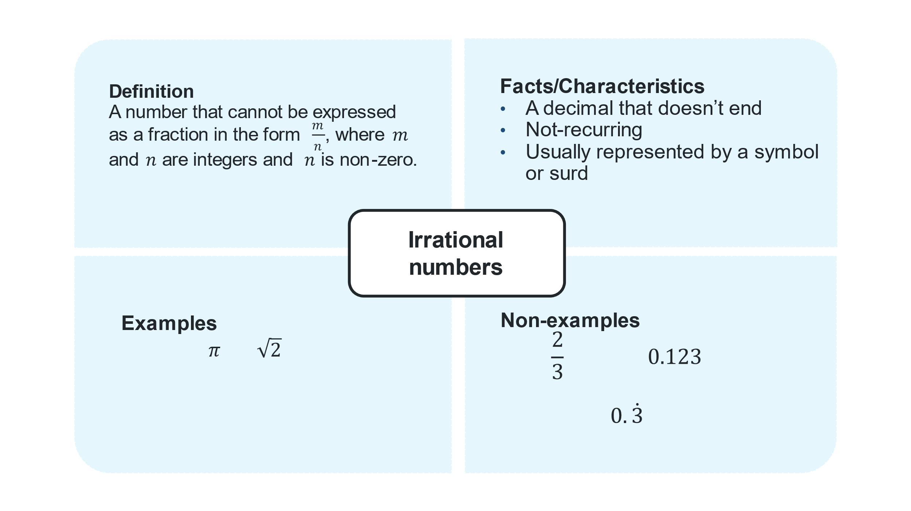

## References

This resource contains NSW Curriculum and syllabus content. The NSW Curriculum is developed by the NSW Education Standards Authority. This content is prepared by NESA for and on behalf of the Crown in right of the State of New South Wales. The material is protected by Crown copyright.

Please refer to the NESA Copyright Disclaimer for more information <https://educationstandards.nsw.edu.au/wps/portal/nesa/mini-footer/copyright>.

NESA holds the only official and up-to-date versions of the NSW Curriculum and syllabus documents. Please visit the NSW Education Standards Authority (NESA) website <https://educationstandards.nsw.edu.au/> and the NSW Curriculum website <https://curriculum.nsw.edu.au/>.

[Mathematics K–10 Syllabus](https://curriculum.nsw.edu.au/learning-areas/mathematics/mathematics-k-10-2022/overview) © NSW Education Standards Authority (NESA) for and on behalf of the Crown in right of the State of New South Wales, 2022.

**© State of New South Wales (Department of Education), 2025**

The copyright material published in this resource is subject to the *Copyright Act 1968* (Cth) and is owned by the NSW Department of Education or, where indicated, by a party other than the NSW Department of Education (third-party material).

Copyright material available in this resource and owned by the NSW Department of Education is licensed under a [Creative Commons Attribution 4.0 International (CC BY 4.0) license](https://creativecommons.org/licenses/by/4.0/).

[](https://creativecommons.org/licenses/by/4.0/)

This license allows you to share and adapt the material for any purpose, even commercially.

Attribution should be given to © State of New South Wales (Department of Education), 2025.

Material in this resource not available under a Creative Commons license:

* the NSW Department of Education logo, other logos and trademark-protected material
* material owned by a third party that has been reproduced with permission. You will need to obtain permission from the third party to reuse its material.

**Links to third-party material and websites**

Please note that the provided (reading/viewing material/list/links/texts) are a suggestion only and implies no endorsement, by the New South Wales Department of Education, of any author, publisher, or book title. School principals and teachers are best placed to assess the suitability of resources that would complement the curriculum and reflect the needs and interests of their students.

If you use the links provided in this document to access a third-party's website, you acknowledge that the terms of use, including licence terms set out on the third-party's website apply to the use which may be made of the materials on that third-party website or where permitted by the *Copyright Act 1968* (Cth). The department accepts no responsibility for content on third-party websites.