# Applying circumference formula

## Students use bicycle mechanics to explore the relationship between circumference, diameter and radius, and apply the circumference formula.

## Visible learning

### Learning intention

* To understand the formulas for calculating circumference.

### Success criteria

* I can define the terms ‘radius’ and ‘tangent’.
* I can explain what $r$ and $d$ represent in the circumference formulas.
* I can calculate circumference when given the diameter or radius of a circle.

### Syllabus outcomes

A student:

* develops understanding and fluency in mathematics through exploring and connecting mathematical concepts, choosing and applying mathematical techniques to solve problems, and communicating their thinking and reasoning coherently and clearly **MAO-WM-01**
* solves linear equations of up to 2 steps and quadratic equations of the form $ax^{2}=c$   **MA4-EQU-C-01**
* applies knowledge of the perimeter of plane shapes and the circumference of circles to solve problems **MA4-LEN-C-01**

[Mathematics K–10 Syllabus](https://curriculum.nsw.edu.au/learning-areas/mathematics/mathematics-k-10-2022/overview) © NSW Education Standards Authority (NESA) for and on behalf of the Crown in right of the State of New South Wales, 2022.

Table 1: lesson summary

|  |  |  |  |
| --- | --- | --- | --- |
| Section | Summary of activity | Teaching strategies | Teaching points |
| Launch | Show students the video ‘A Brief History of Bicycle Engineering’ (8:29) ([bit.ly/YTBikeHistory](https://bit.ly/YTBikeHistory)) until 0:40, then discuss differences in bicycle designs and how pedal rotations relate to wheel circumference. | Notice and wonder | Develop an appreciation of the language of circles being used in the practical context of bicycles. |
| Explore | Students will view additional video clips and examine prompt images from slides 3–11 of the PowerPoint *Applying circumference formula* (ACF PPT) to spark discussion on applying the terms ‘circumference’, ‘diameter’, ‘radius’ and ‘tangent’. Through guided dialogue, they will explore the use of the different circumference formulas, using mini whiteboards to check for understanding throughout the activity. | Pose-Pause-Pounce-Bounce  Mini whiteboards  Think-Pair-Share | Develop an understanding of the terms ‘circumference’, ‘radius’ and ‘diameter’, through the circumference formula, with students using their substitution skills to find the circumference of circles. |
| Summarise | Students create notes defining key terms like ‘radius’ and ‘tangent’ and reflect on how to apply the circumference formula to a mixture of questions using Variation Theory in Appendix A. | Notes to future forgetful selves  Variation Theory  Pose-Pause-Pounce-Bounce | Consolidate understanding of $C=πd and C=2πr$ and the new language before applying it, clearly identifying how questions vary. |
| Apply | Students continue watching the video from the launch to explore how gears impact bicycle speed and distance travelled, then discuss and apply ratio concepts to understand the relationship between gears and movement, before completing Appendix B. | Think-Pair-Share  Visibly random groups of 3  Vertical non-permanent surfaces | Apply the formula for circumference of a circle, in both forms, in questions that include ratios. |

## Activity structure

Please use the associated PowerPoint *Applying circumference formula* (ACF PPT) to display images in this lesson.

### Launch

1. Show students the video ‘A Brief History of Bicycle Engineering’ (8:29) ([bit.ly/YTBikeHistory](https://bit.ly/YTBikeHistory)) up to 0:40.
2. Ask students to consider what they notice and wonder ([bit.ly/noticewonderstrategy](https://bit.ly/noticewonderstrategy)) about the bicycles mentioned.

Students might notice that older bicycles do not have gears, that there is diversity in frames, handlebars and wheels and that the distance the bicycle travelled was one circumference for one pedal rotation.

Students might wonder how technology has advanced to make modern bicycles.

### Explore

1. Display slide 3 of the PowerPoint (ACF PPT) and use the Pose-Pause-Pounce-Bounce questioning strategy (PDF 557 KB) ([bit.ly/posepausepouncebounce](https://bit.ly/posepausepouncebounce)) to initiate a class discussion on how we can use the information on the slide to determine how far the bike would travel with one 360° rotation of the front wheel. Possible question prompts include:

* What information do you know?
* What mathematical language was used to describe the movement of this bicycle?
* How could you calculate the distance covered by the front wheel?
* How could the formula be used to calculate the circumference of the front wheel? How does this help?

In Lesson 2 – irrational numbers, the relationship between circumference and diameter is established and the formula $C=πd$ was introduced but not used. Alternatively, slide 4 of the PowerPoint (ACF PPT) displays the formula with question prompts.

1. Distribute a mini whiteboard ([bit.ly/miniwhiteboards](https://bit.ly/miniwhiteboards)) and a marker to each pair of students. Instruct the students to use the mini whiteboard to attempt to calculate the circumference of the wheel and hence how far the bicycle would travel with one full wheel rotation.

Teachers should use the activity to formatively assess whether students can solve problems involving substituting values into formulas. Students might require explicit teaching interventions if misconceptions are evident. Substitution into equations was taught during Lesson 9 – Which number goes here? of Unit 4 – additive thinking. The solution to the problem is: $$C=πd \\ C=π×76 \\ C≈238.76 cm$$

1. Show slide 5 of the PowerPoint (ACF PPT) and pose the question, if the pedals were on the back wheel, how much less distance would be covered during each rotation. Ask students to answer this on the mini whiteboards.

$$C=πd \\ C=π×51 \\ C≈160.22 cm$$ The bicycle would travel $78.54 cm$ less per rotation.

1. Continue to use the mini whiteboards to check for understanding and ask students to calculate the circumference of each wheel shown on slide 6 of the PowerPoint (ACF PPT).

Slide 7 shows the solution.

1. Continue watching the video ‘A Brief History of Bicycle Engineering’ (from 0:43–1:07).
2. In a Think-Pair-Share ([bit.ly/thinkpairsharestrategy](https://bit.ly/thinkpairsharestrategy)), ask students what could be meant by the term ‘radius’ and brainstorm how the circumference formula could be adapted to use a radius instead of diameter.

The syllabus glossary defines radius as the distance from the centre of a circle to any point on its perimeter. It is equal to half of the circle’s diameter.   
The formula changes from $C=πd$ to $C=2πr$.

(NESA 2022)

1. Ask students to add ‘radius’ to the glossary that they started in Lesson 1 – diameter and circumference.
2. Show slide 8 of the PowerPoint (ACF PPT) and in a Think-Pair-Share, ask students to predict what they think the difference in circumference will be and to explain their thinking.
3. Ask students to use their mini whiteboards to calculate each circumference and determine how much further one wheel rotation will take you on the larger bicycle.

Slide 9 shows the solution.

Students should identify that the difference between radii was 15 cm, so the difference should be approximately 90 cm or 6 × 15, as $2π$ is close to 6. This is attempting to develop students’ abilities to check for reasonableness and to reinforce $π$ is a number.

1. Continue watching the video ‘A Brief History of Bicycle Engineering’ (from 1:07–1:30).
2. In a Think-Pair-Share, ask students what they notice and wonder from the newly revealed information.

* Students might notice that the larger wheel offers a smoother ride.
* Students might wonder how large of a wheel is possible for a bicycle.

1. Explain to students that the line drawn to represent the bicycles moving over the bumps is known in mathematics as a tangent.

A tangent is a line that intersects a circle at just one point. It touches the circle at that point of contact but does not pass inside it.

1. Ask students to add ‘tangent’ to their glossary.
2. Display slide 10 of the PowerPoint (ACF PPT) and tell the students a wheel diameter of less than 130 cm will be too small to safely go over the rocks. In a Think-Pair-Share, ask students how they could find out the wheel diameter from the information given.

Students should identify that given they need to find the diameter; they will need to use the formula $C=πd.$ They will also need to identify that they need to work backwards or rearrange the formula. The suggestion of bar models might occur, due to this being a common strategy used to visually represent the solving of equations. The bar model is inappropriate for this equation, due to pi being irrational. Students could be encouraged to use the method of backtracking, which was explored in Lesson 1 – ways of working (equations) of Unit 10 – investigating triangles.

1. Ask students to use their mini whiteboards to calculate each diameter and determine whether each person’s wheel diameter is sufficient to safely pass over the rocks.

Slide 11 contains the solutions. The lady’s wheel diameter will not be enough to safely pass over the rock.

### Summarise

1. Students are to create notes to their future forgetful selves ([bit.ly/notestofutureself](https://bit.ly/notestofutureself)) including how to apply the circumference formula to find an unknown circumference, diameter and radius.
2. Distribute Appendix A ‘Variation Theory’ to each student which uses Variation Theory ([variationtheory.com/introduction/](https://variationtheory.com/introduction/)) to highlight changes in what is required when given radius, diameter and circumference.
3. Use the Pose-Pause-Pounce-Bounce questioning strategy to ask students how each question was different and how they adapted their strategies to answer each question.

### Apply

1. Continue watching the video ‘A Brief History of Bicycle Engineering’ (from 1:47–4:19).
2. In a Think-Pair-Share, ask students what they notice and wonder from the newly revealed information.

Students might notice that the gears and chains help bicycles to move faster.

Students might wonder how far the bicycle will travel now with one full rotation of the pedals or how different gears work.

At this point, if there is appropriate access to a bicycle in the school and someone able to ride it, the class could be taken outside to see how far the bicycle travels with each rotation of the wheels.

1. Assign students into visibly random groups of 3 ([bit.ly/visiblegroups](https://bit.ly/visiblegroups)) at vertical non-permanent surfaces ([bit.ly/VNPSstrategy](https://bit.ly/VNPSstrategy)).
2. Distribute one copy of Appendix B ‘Bicyclegears’ to each group and ask students to attempt question 1.
3. Conduct a class discussion on whether the chain is a tangent.

The chain is not a tangent, but it shares the properties of a tangent if we only consider it from each gear.

1. Groups are to complete the remaining questions on the vertical non-permanent surfaces.

## Assessment and differentiation

### Suggested opportunities for differentiation

**Launch**

* A notice and wonder strategy is used where there is no correct answer so that all students can participate in the discussion.
* Sentence prompts could be used to support students to engage with the class discussion.
* Students could be challenged to develop hypotheses about why certain bicycle features have changed.

**Explore**

* Students might need to be reminded of how to substitute into a formula.
* Students might need to be reminded of how to type $π$ on a calculator.
* More checking for understanding questions could be added if required.
* Students could be supported with further scaffolding of the steps for working out.
* Students could be challenged to consider how many tyre rotations would be required to cover specific distances or to compare the number of rotations of different wheels on the penny-farthing bicycle.
* Students could be challenged to find the radius from the circumference in one step.

**Summarise**

* Some students could be provided with a pre-written glossary or with sentence starters.

**Apply**

* Scaffolding could be provided for some students.
* More questions involving ratios could be provided.
* Students could be challenged to work out the difference between distances covered per rotation on different gears. Plausible ratios could range from 0.5:1 to 5:1.

### Suggested opportunities for assessment

**Launch**

* Monitor responses in class discussion to assess understanding of how pedal rotations relate to circumference.

**Explore**

* A Think-Pair-Share provides students with the opportunity to reflect on their understanding.
* The mini whiteboard strategy gives the teacher a consistent opportunity to assess student understanding of applying the circumference formula.

**Summarise**

* Check the accuracy and completeness of students’ notes to their future forgetful selves, focusing on definitions and correct applications of the circumference formula.
* Assess students’ ability to apply their understanding when completing Appendix A tasks that require them to calculate different values using the circumference formula.

**Apply**

* When placed in groups of 3, students provide and receive peer feedback on their understanding.
* A Think-Pair-Share provides students with the opportunity to reflect on their understanding.

## Appendix A

### Variation Theory

Calculate the unknown circumference, radius or diameter from the following circles, correct to 2 decimal places.

|  |  |  |
| --- | --- | --- |
|  | A circle with a radius of 50 cm. | Circumference = |
|  | A circle with a diameter of 50 cm. | Circumference = |
|  | A circle with a diameter of 5 cm. | Circumference = |
|  | A circle with a circumference of 5 cm. | Diameter = |
|  | A circle with a diameter of 12.5 cm. | Circumference = |
|  | A circle with a diameter of 125 cm. | Circumference = |
|  | A circle with a radius of 1.25 cm. | Circumference = |
|  | A circle with a circumference of 2.5 cm. | Diameter = |
|  | A circle with a radius of 2.5 cm. | Circumference = |
|  | A circle with a radius of 25 cm. | Circumference = |

## Appendix B

### Bicycle gears

1. Label the image of gears with the terms ‘tangent’, ‘radius’, ‘circumference’ and ‘diameter’.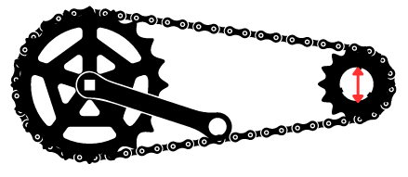
2. Calculate the circumference of each chainring below.  
   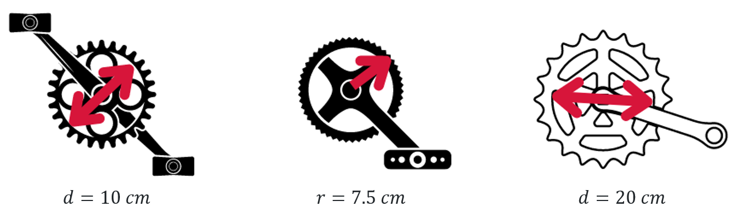
3. The front gear has 50 teeth, and the rear gear has 25 teeth. This means that for every pedal rotation, the rear wheel turns twice. The bike below has a rear tyre with a radius of 35 cm and the chainring has a diameter of 8 cm. If a rider of the bike completes 15 pedal rotations, how far will it travel?

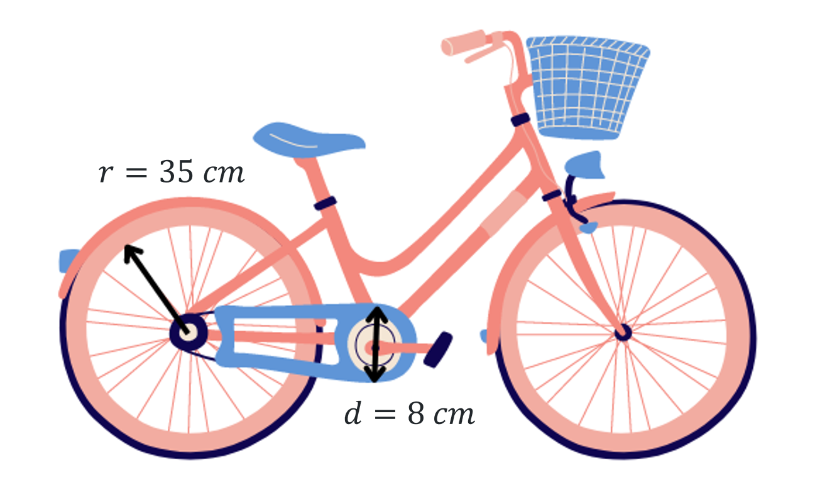

## Sample solutions

### Appendix A – Variation Theory

|  |  |  |
| --- | --- | --- |
|  | A circle with a radius of 50 cm. |  |
|  | A circle with a diameter of 50 cm. |  |
|  | A circle with a diameter of 5 cm. |  |
|  | A circle with a circumference of 5 cm. |  |
|  | A circle with a diameter of 12.5 cm. |  |
|  | A circle with a diameter of 125 cm. |  |
|  | A circle with a radius of 1.25 cm. |  |
|  | A circle with a circumference of 2.5 cm. |  |
|  | A circle with a radius of 2.5 cm. |  |
|  | A circle with a radius of 25 cm. |  |

### Appendix B – bicycle gears

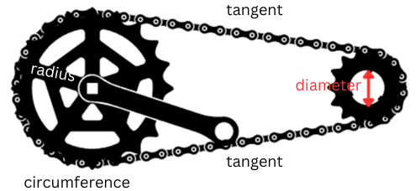



|  |  |  |
| --- | --- | --- |
|  |  |  |

|  |  |
| --- | --- |
| A pink bicycle with a blue basket. The gear has a diameter of 8 cm and the back wheel has a radius of 35 cm. | Circumference of the rear wheel $$C=2πr \\ C=2×π×35 \\ C≈219.9114858 cm$$ Ratio of gears $$25:50 \\ 1:2$$ This means every rotation moves the bicycle $219.9114858× 2 cm$.  After 15 rotations. $$15×2×219.91145858=6597.344573 cm \\ ≈65.97 m$$ |

## References

This resource contains NSW Curriculum and syllabus content. The NSW Curriculum is developed by the NSW Education Standards Authority. This content is prepared by NESA for and on behalf of the Crown in right of the State of New South Wales. The material is protected by Crown copyright.

Please refer to the NESA Copyright Disclaimer for more information <https://educationstandards.nsw.edu.au/wps/portal/nesa/mini-footer/copyright>.

NESA holds the only official and up-to-date versions of the NSW Curriculum and syllabus documents. Please visit the NSW Education Standards Authority (NESA) website <https://educationstandards.nsw.edu.au/> and the NSW Curriculum website <https://curriculum.nsw.edu.au/>.

[Mathematics K–10 Syllabus](https://curriculum.nsw.edu.au/learning-areas/mathematics/mathematics-k-10-2022/overview) © NSW Education Standards Authority (NESA) for and on behalf of the Crown in right of the State of New South Wales, 2022.

NESA (NSW Education Standards Authority (2022) [‘Glossary’](https://curriculum.nsw.edu.au/learning-areas/mathematics/mathematics-k-10-2022/glossary), Mathematics K–10, NESA website, accessed 14 January 2025.

**© State of New South Wales (Department of Education), 2025**

The copyright material published in this resource is subject to the *Copyright Act 1968* (Cth) and is owned by the NSW Department of Education or, where indicated, by a party other than the NSW Department of Education (third-party material).

Copyright material available in this resource and owned by the NSW Department of Education is licensed under a [Creative Commons Attribution 4.0 International (CC BY 4.0) license](https://creativecommons.org/licenses/by/4.0/).

[](https://creativecommons.org/licenses/by/4.0/)

This license allows you to share and adapt the material for any purpose, even commercially.

Attribution should be given to © State of New South Wales (Department of Education), 2025.

Material in this resource not available under a Creative Commons license:

* the NSW Department of Education logo, other logos and trademark-protected material
* material owned by a third party that has been reproduced with permission. You will need to obtain permission from the third party to reuse its material.

**Links to third-party material and websites**

Please note that the provided (reading/viewing material/list/links/texts) are a suggestion only and implies no endorsement, by the New South Wales Department of Education, of any author, publisher, or book title. School principals and teachers are best placed to assess the suitability of resources that would complement the curriculum and reflect the needs and interests of their students.

If you use the links provided in this document to access a third-party's website, you acknowledge that the terms of use, including licence terms set out on the third-party's website apply to the use which may be made of the materials on that third-party website or where permitted by the *Copyright Act 1968* (Cth). The department accepts no responsibility for content on third-party websites.