# Perimeter of composite shapes

Students investigate the distance around different running track lanes before calculating which sporting field requires the most line markings.

## Visible learning

### Learning intention

* To knowhow to calculate the perimeter of composite shapes involving circles.

### Success criteria

* I can break upcomposite shapes into smaller, simpler shapes.
* I can calculate the arc length of a circle.
* I can calculate the perimeter of composite shapes.

### Syllabus outcomes

A student:

* develops understanding and fluency in mathematics through exploring and connecting mathematical concepts, choosing and applying mathematical techniques to solve problems, and communicating their thinking and reasoning coherently and clearly **MAO-WM-01**
* applies knowledge of the perimeter of plane shapes and the circumference of circles to solve problems **MA4-LEN-C-01**

[Mathematics K–10 Syllabus](https://curriculum.nsw.edu.au/learning-areas/mathematics/mathematics-k-10-2022/overview) © NSW Education Standards Authority (NESA) for and on behalf of the Crown in right of the State of New South Wales, 2022.

Table 1: lesson summary

|  |  |  |  |
| --- | --- | --- | --- |
| Section | Summary of activity | Teaching strategies | Teaching points |
| Launch | Students are shown a video of Cathy Freeman’s 400 m race ([bit.ly/400mrace](https://bit.ly/400mrace)) (1:21) and are asked to share what they notice and wonder. | Notice and wonder | This section aims to spark interest in the distance around a running track. |
| Explore | Students are given an image of an athletics track in Appendix A and are asked to find the distance around each lane. They are asked to justify the staggered start used in the 400 m race. Slide 3 of the PowerPoint *Perimeter of composite* shapes (POCS PPT) shows the dimensions of the track. | Visibly random groups of 3  Vertical non-permanent surfaces  Pose-Pause-Pounce-Bounce  Gallery walk  Two stars and a wish | This section draws on students' knowledge of perimeter and circumference to explore composite shapes. |
| Summarise | Students complete 4 perimeter questions in Appendix B before making notes. | Notes to future forgetful selves | This section allows students time to practise and consolidate their learning. |
| Apply | Students watch a short video ‘Painting the lines’ (0:46) ([bit.ly/linemarker](https://bit.ly/linemarker)) before considering which sporting field has the most markings. Students calculate the marking length of various sporting fields in Appendix C. | Pose-Pause-Pounce-Bounce  Visibly random groups of 3  Vertical non-permanent surfaces  Gallery walk | This section aims for students to apply their skills of perimeter to answer the driving question ‘Which sporting field uses the most paint?’ |

## Activity structure

Please use the associated PowerPoint *Perimeter of composite shapes* (POCS PPT) to display images in this lesson.

### Launch

1. Show students the video ‘Cathy Freeman 400 m Sydney Olympics with Bruce McAvaney commentating’ (1:21) ([bit.ly/400mrace](https://bit.ly/400mrace)).
2. In a Think-Pair-Share ([bit.ly/thinkpairsharestrategy](https://bit.ly/thinkpairsharestrategy)) ask students to consider what they notice and what they wonder ([bit.ly/noticewonderstrategy](https://bit.ly/noticewonderstrategy)) about the 400 m race.

Students might notice that the runners do a lap of the track, they don’t start in a straight line but then finish in a straight line and the runners stay in their lanes.

Students might wonder if the lane choice matters or how they know that each lane is actually 400 m.

### Explore

1. Assign students to visibly random groups of 3 ([bit.ly/visiblegroups](https://bit.ly/visiblegroups)) at vertical non-permanent surfaces ([bit.ly/VNPSstrategy](https://bit.ly/VNPSstrategy)).
2. Distribute Appendix A ‘Athletics track’ to each group of students.
3. Ask students to discuss in their groups ‘What information do you need to calculate the distance around lane 1 of the track?’
4. Use the Pose-Pause-Pounce-Bounce questioning strategy (PDF 557 KB) ([bit.ly/posepausepouncebounce](https://bit.ly/posepausepouncebounce)) to initiate a sharing of ideas.

Students might suggest the length of the straight, the shapes involved, and the radius of the track.

1. Display slide 3 of the PowerPoint (POCS PPT) and tell students that the track consists of 2 straights and a semicircle at each end.
2. Allow groups time to calculate the perimeter of the inside lane. Have students check their answers with a group near them and negotiate which answer is correct if the answers differ.
3. Pose the question ‘What is wrong with my answer?’ and generate a class discussion.

Students might realise that the length around the inside of the line is 398.11 m and the race is 400 m. It may be suggested that the athlete would not run on the inside line but rather the middle of the lane. Students could calculate this value to check using half the width of the lanes.

1. Use the Pose-Pause-Pounce-Bounce questioning strategy to ask students ‘What information do you need to calculate the distance around the other lanes on the track?’
2. Tell students that each lane is 1.22 m wide.
3. Allow groups time to calculate the length of each lane.
4. Generate a class discussion around different methods students used to calculate the perimeter of each track.

The lengths of each lane are provided in the sample solutions. Students may have found the length of each semicircle then doubled it or found the length of the whole circle. Students may have used their knowledge of applying patterns from the previous unit and constructed a table of values and an equation. Teachers may like to revisit linear relationships by modelling this method if no student has used it.

1. Remind students that in a 400 m race, the athletes do not start in a straight line but are staggered. Ask students to justify how much each lane needs to be staggered by to ensure the race is fair and allow groups time to calculate their answers.
2. Students are to go on a gallery walk ([bit.ly/DLSgallerywalk](https://bit.ly/DLSgallerywalk)) observing different approaches to calculating the lane stagger.

Each circle is $2×π×1.22= 7.67 m$ longer than the previous.

### Summarise

1. Distribute Appendix B ‘Find the perimeter’ to each student.
2. Once students have found each perimeter, they should check answers with the student next to them. If answers differ students are to work together to find the correct solution.
3. Students are to create notes to their future forgetful selves ([bit.ly/notestofutureself](https://bit.ly/notestofutureself)) on how to calculate the perimeter of composite shapes involving curved surfaces.

### Apply

1. Show students the video ‘Painting the lines’ (0:45) ([bit.ly/linemarker](https://bit.ly/linemarker)).
2. Ask students to brainstorm a list of sporting fields, then ask them to vote on which sporting field uses the most paint.
3. Use the Pose-Pause-Pounce-Bounce questioning strategy for students to explain their thinking.
4. Inform students that they will be calculating the length of the lines for various sporting fields.
5. Back in their random groups of 3 at vertical non-permanent surfaces, distribute one of the 7 sporting field diagrams, from Appendix C ‘Sporting fields’ to each group and have groups calculate the length of the line markings.

An AFL field is provided as a circle, as the mathematics involved with ellipses is beyond the scope of Stage 4. This conversation could be had with students, or the AFL field excluded if this is likely to lead to confusion.

1. Allow students time to do a gallery walk to observe other students' work. Groups with the same fields should pair up and if their solutions differ, they are to work together to find the correct solution.
2. Redistribute the playing fields and allow groups time to calculate the markings for a second field.
3. Regroup as a class once the distances have been confirmed by the second group's calculations. Answer the question ‘Which sporting field requires the most markings?’.

## Assessment and differentiation

### Suggested opportunities for differentiation

**Launch**

* There are no correct answers during the launch and all students should be encouraged to participate and share their thoughts and reasoning.

**Explore**

* Students may need to be reminded of how to calculate the perimeter of shapes.
* Students could be given the length of the inside lane as 400 m and either the length of the straight or radius of the circle to find the missing dimension.
* To challenge students, have them calculate the length of the stagger for a 200 m race.
* Measurements are to 2 decimal places; these can be simplified if required but will affect the calculations.
* Challenge students to write their answers in exact form.
* Encourage students to draw labelled diagrams for each lane before calculating the perimeter.

**Summarise**

* Questions could be scaffolded to assist students.
* Students may work in pairs to complete questions.
* Students could be encouraged to research logos that contain curved shapes and determine their perimeter.

**Apply**

* The complexity of each field varies. This could be considered when distributing Appendix C to groups.

### Suggested opportunities for assessment

**Launch**

* Students give each other peer feedback, before sharing with the class in a Think-Pair-Share.

**Explore**

* When placed in groups of 3, students provide and receive peer feedback on their understanding.
* Students working at vertical non-permanent surfaces means the teacher can assess student progress and provide support where appropriate.
* Students will demonstrate their Working mathematically skills when justifying the staggering distance for the start of the 400 m race.

**Summarise**

* The teacher could collect the perimeter questions from Appendix B to form part of the summative assessment of this unit.
* Create an exit ticket containing a new composite shape.

**Apply**

* The teacher monitors students' contributions to the group to check for individual understanding of perimeter.

## Appendix A – Athletics track

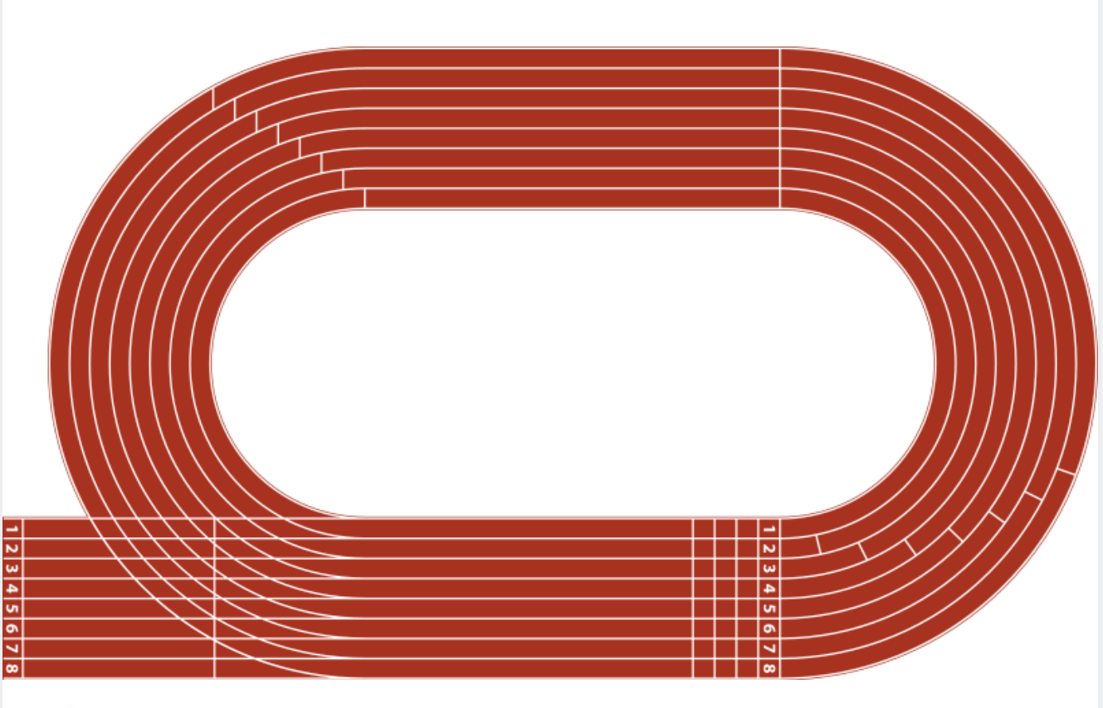

## Appendix B

### Find the perimeter

|  |  |
| --- | --- |
| 1.  Rectangle of dimensions 25 centimetres and 40 centimetres with a semicircle of diameter 20 centimetres in top of one half of the 40 centimetre length of the rectangle and another semicircle cut into the rectangle beside it. | 2.  A rectangle 25 centimetres by 60 centimetres with 2 semicircles of diameter 20 centimetres cut into either end of the 60 centimetre length and a semicircle on top of the rectangle between them. |
| 3.  Three quarters of a circle with radius 4 centimetres. A square of length 7 centimetres is wedged into the remaining right angle of the circle. | 4.  A heart. The straight sides of the heart have a length of 12 metres. The overall width of the heart is 16 metres. |

## Appendix C

### Sporting fields

#### Netball

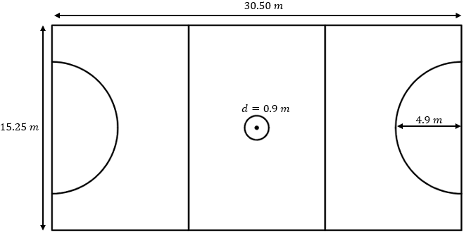

#### **Tennis**

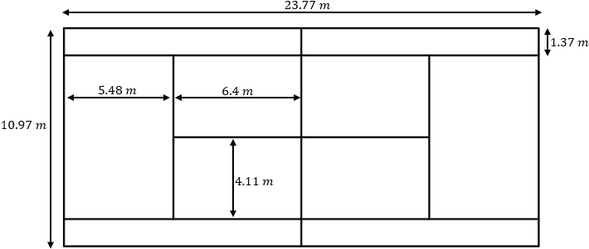

#### Soccer

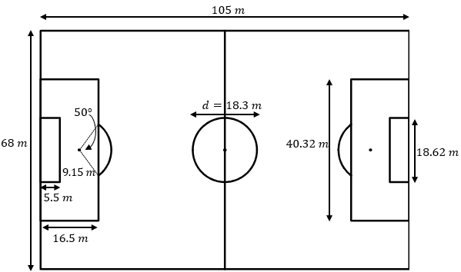

#### Hockey

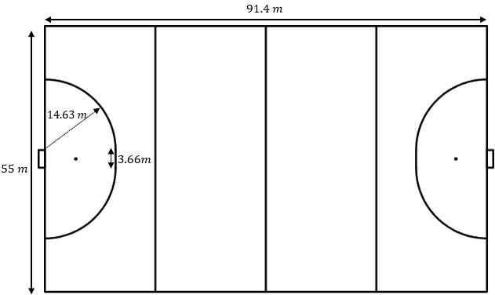

#### AFL

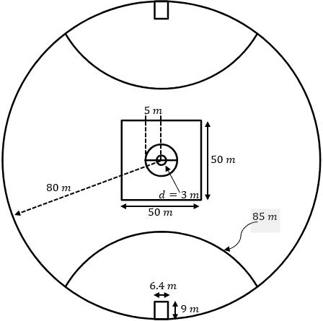

#### Futsal

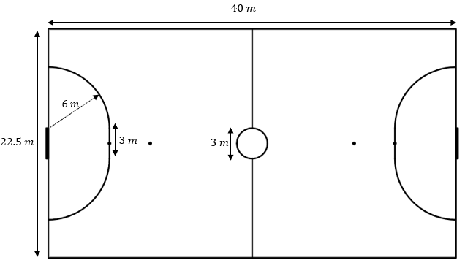

#### Rugby league

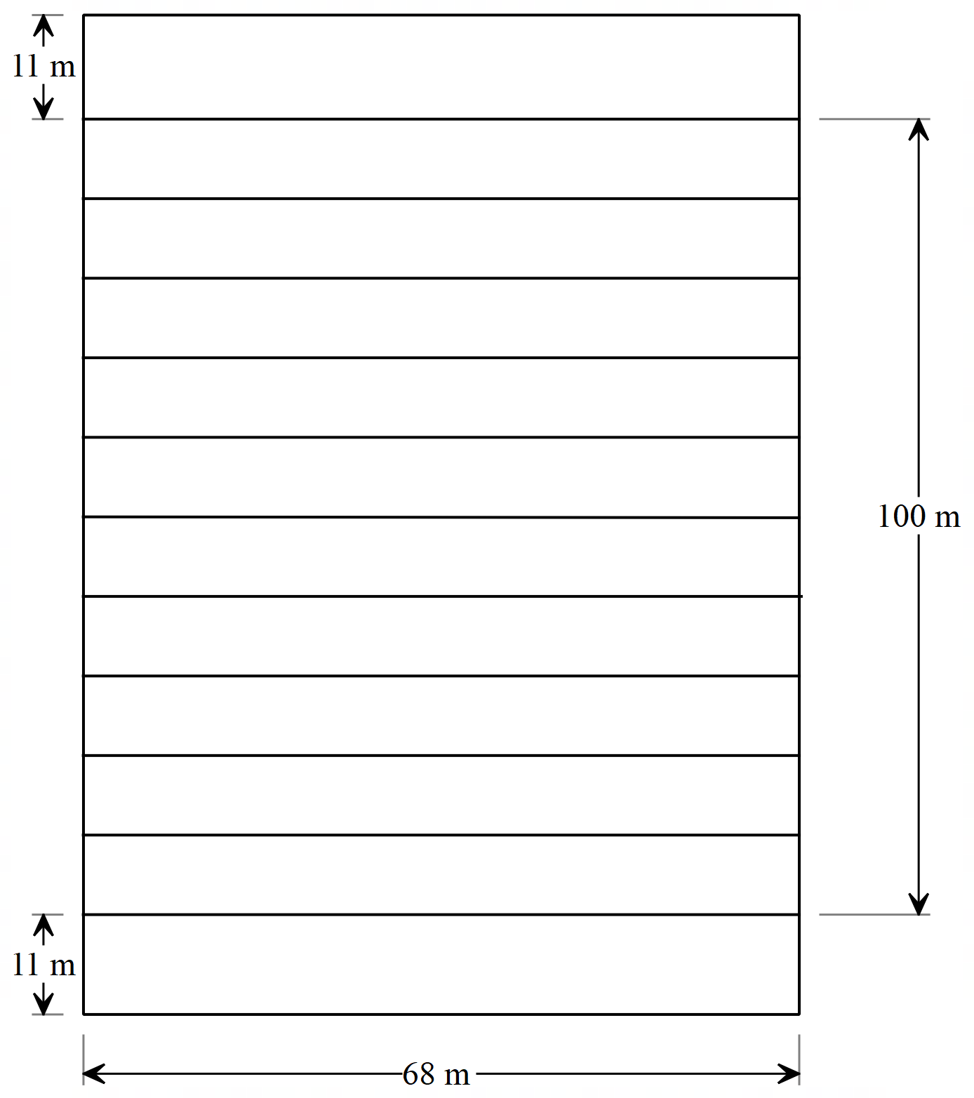

## Sample solutions

### Explore

|  |  |  |
| --- | --- | --- |
| Lane 1 | $$P=2πr \\ =2×π×36.50 \\ =229.3362…. \\ ≈229.33 m$$ | **Total distance $$=229.33+84.39+84.39 \\ ≈398.11 m$$** |
| Lane 2 | Radius $=36.50+1.22=37.72 m$ $$P=2πr \\ =2×π×37.72 \\ =237.0017…. \\ ≈237.00 m$$ | **Total distance $$=237.00+84.39+84.39 \\ ≈405.78 m$$** |
| Lane 3 | Radius $=36.50+1.22×2=38.94 m$ $$P=2πr \\ =2×π×38.94 \\ =244.6672…. \\ ≈244.67 m$$ | **Total distance $$=244.67+84.39+84.39 \\ ≈413.45 m$$** |
| Lane 4 | Radius $=36.50+1.22×3=40.16 m$ $$P=2πr \\ =2×π×40.16 \\ =252.3327…. \\ ≈ 252.33 m$$ | **Total distance $$=252.33+84.39+84.39 \\ ≈421.11 m$$** |
| Lane 5 | Radius $=36.50+1.22×4=41.38 m$ $$P=2πr \\ =2×π×41.38 \\ =259.9982…. \\ ≈ 260.00 m$$ | **Total distance $$=260.00+84.39+84.39 \\ ≈428.78 m$$** |
| Lane 6 | Radius $=36.50+1.22×5=42.60 m$ $$P=2πr \\ =2×π×42.60 \\ =267.6636…. \\ ≈267.66 m$$ | **Total distance $$=267.66+84.39+84.39 \\ ≈436.44 m$$** |
| Lane 7 | Radius $=36.50+1.22×6=43.82 m$ $$P=2πr \\ =2×π×43.82 \\ =275.3291…. \\ ≈275.33 m$$ | **Total distance $$=275.33+84.39+84.39 \\ ≈444.11 m$$** |
| Lane 8 | Radius $=36.50+1.22×7=45.04 m$ $$P=2πr \\ =2×π×45.04 \\ =282.9946…. \\ ≈282.99 m$$ | **Total distance $$=282.99+84.39+84.39 \\ ≈451.77 m$$** |

### Appendix B – find the perimeter

|  |  |
| --- | --- |
| 1. $$C=πd \\ =π×20 \\ =62.8318…. cm \\ ≈62.83 cm \\ P=62.83+25+25+40 \\ ≈152.83 cm$$ | 2. $$C=πd \\ =π×20 \\ =62.8318…. cm \\ ≈62.83 cm \\ P=1\frac{1}{2}×62.83+25+25+60 \\ ≈203.42 cm$$ |
| 3. $$C=πd \\ =π×8 \\ =25.1327…. cm \\ ≈25.13 cm \\ P≈\frac{3}{4}×25.13+3+3+7+7 \\ ≈38.85 cm$$ | 4. $$C=πd \\ =π×8 \\ =25.1327…. cm \\ ≈25.13 cm \\ P=25.13+12+12 \\ ≈49.13 cm$$ |

### Appendix C – sporting fields

#### Netball

$$C=πd \\ =π×0.9 \\ =2.8274…. m \\ ≈2.83 m \\ C=2πr \\ =2×π×4.9 \\ =30.7876…. m \\ ≈30.79 m \\ Total =2.83+30.79+4×15.25+2×30.50 \\ ≈155.62 m$$

#### Tennis

$$P=23.77×4+10.97×3 \\ =127.99 \\ P=2×6.40+4×4.11 \\ =29.24 m \\ Total=127.99+29.24 \\ =157.23 m$$

#### Soccer

$$Outside P=105×2+68×2 \\ =346 m \\ Centre line=68 m \\ Boxes P=16.5×2+40.32+5.5×2+18.62 \\ =102.94 m \\ Centre=πd \\ =π×18.3 \\ =57.4911 m \\ ≈57.49 m \\ Goal circle=\frac{50}{360}×2πr \\ =\frac{50}{360}×2×π×9.15 \\ =7.9848….m \\ ≈7.98 m \\ Total= 346+68+102.94×2+57.49+7.98×2 \\ ≈693.33 m$$

Hockey

$$Outside P=91.4×2+55×5 \\ =457.8 m \\ C=2πr \\ =2×π×14.63 \\ =91.9230….m \\ ≈91.92 m \\ Total P=91.92+457.8+3.66×2 \\ ≈557.04 m$$

#### AFL

$$C=2πr \\ =2×π×80 \\ =502.6548….m \\ ≈502.65 m \\ C=2πr \\ =2×π×5 \\ =31.4159….m \\ ≈31.42 m \\ C=πd \\ =π×3 \\ =9.4247….m \\ ≈9.42 m \\ P=9×2+6.4 \\ =24.4 m \\ P=50×4 \\ =200 m \\ Total=502.65+31.42+9.42+24.4×2+200+2×85 \\ ≈962.29 m$$

#### Futsal

$$P=40×2+22.5×2 \\ =125 m$$

$$C=2πr \\ =2×π×6 \\ =37.6991….m \\ ≈31.7 m \\ line at top of circle=3×2 \\ =6 m$$

$$centre circle=πd \\ =π×3 \\ =9.42477…m \\ ≈9.4 m$$

$$centre lines=22.5-3 \\ =19.5 m \\ Total=125+31.7+6+9.4+19.5 \\ =191.6$$

#### Rugby league

$$P=68×13+122×2 \\ =1128 m$$

## References

This resource contains NSW Curriculum and syllabus content. The NSW Curriculum is developed by the NSW Education Standards Authority. This content is prepared by NESA for and on behalf of the Crown in right of the State of New South Wales. The material is protected by Crown copyright.

Please refer to the NESA Copyright Disclaimer for more information [https://educationstandards.nsw.edu.au/wps/portal/nesa/mini-footer/copyright](https://aus01.safelinks.protection.outlook.com/?url=https%3A%2F%2Feducationstandards.nsw.edu.au%2Fwps%2Fportal%2Fnesa%2Fmini-footer%2Fcopyright&data=05%7C01%7CCaitlin.Pace1%40det.nsw.edu.au%7C9c2c1a9f59c94d2df30708dafa7edb23%7C05a0e69a418a47c19c259387261bf991%7C0%7C0%7C638097720042599463%7CUnknown%7CTWFpbGZsb3d8eyJWIjoiMC4wLjAwMDAiLCJQIjoiV2luMzIiLCJBTiI6Ik1haWwiLCJXVCI6Mn0%3D%7C3000%7C%7C%7C&sdata=BzQh0UsffVZE3eO22b2Xba3p0VMOBZSHfS21FGHXtZM%3D&reserved=0).

NESA holds the only official and up-to-date versions of the NSW Curriculum and syllabus documents. Please visit the NSW Education Standards Authority (NESA) website <https://educationstandards.nsw.edu.au/> and the NSW Curriculum website <https://curriculum.nsw.edu.au/>.

[Mathematics K–10 Syllabus](https://curriculum.nsw.edu.au/learning-areas/mathematics/mathematics-k-10-2022/overview) © NSW Education Standards Authority (NESA) for and on behalf of the Crown in right of the State of New South Wales, 2022.

**© State of New South Wales (Department of Education), 2025**

The copyright material published in this resource is subject to the *Copyright Act 1968* (Cth) and is owned by the NSW Department of Education or, where indicated, by a party other than the NSW Department of Education (third-party material).

Copyright material available in this resource and owned by the NSW Department of Education is licensed under a [Creative Commons Attribution 4.0 International (CC BY 4.0) license](https://creativecommons.org/licenses/by/4.0/).

[](https://creativecommons.org/licenses/by/4.0/)

This license allows you to share and adapt the material for any purpose, even commercially.

Attribution should be given to © State of New South Wales (Department of Education), 2025.

Material in this resource not available under a Creative Commons license:

* the NSW Department of Education logo, other logos and trademark-protected material
* material owned by a third party that has been reproduced with permission. You will need to obtain permission from the third party to reuse its material.

**Links to third-party material and websites**

Please note that the provided (reading/viewing material/list/links/texts) are a suggestion only and implies no endorsement, by the New South Wales Department of Education, of any author, publisher, or book title. School principals and teachers are best placed to assess the suitability of resources that would complement the curriculum and reflect the needs and interests of their students.

If you use the links provided in this document to access a third-party's website, you acknowledge that the terms of use, including licence terms set out on the third-party's website apply to the use which may be made of the materials on that third-party website or where permitted by the *Copyright Act 1968* (Cth). The department accepts no responsibility for content on third-party websites.