# Solving problems with circles

Students use different techniques to solve problems related to the circumference and area of a circle and the arc length and area of a sector.

## Visible learning

### Learning intention

* To be able to use reasoning to justify statements about circles.

### Success criteria

* I can calculate and compare the area and circumference of a circle.
* I can represent relationships visually on a graph.
* I can select an appropriate problem-solving strategy.

### Syllabus outcomes

A student:

* develops understanding and fluency in mathematics through exploring and connecting mathematical concepts, choosing and applying mathematical techniques to solve problems, and communicating their thinking and reasoning coherently and clearly **MAO-WM-01**
* solves linear equations of up to 2 steps and quadratic equations of the form $ax^{2}=c$   **MA4-EQU-C-01**
* applies knowledge of the perimeter of plane shapes and the circumference of circles to solve problems **MA4-LEN-C-01**
* applies knowledge of area and composite area involving triangles, quadrilaterals and circles to solve problems **MA4-ARE-C-01**
* creates and displays number patterns and finds graphical solutions to problems involving linear relationships **MA4-LIN-C-01**

[Mathematics K–10 Syllabus](https://curriculum.nsw.edu.au/learning-areas/mathematics/mathematics-k-10-2022/overview) © NSW Education Standards Authority (NESA) for and on behalf of the Crown in right of the State of New South Wales, 2022.

Table 1: lesson summary

|  |  |  |  |
| --- | --- | --- | --- |
| Section | Summary of activity | Teaching strategies | Teaching points |
| Launch | Students share their initial thoughts on the statement, ‘A circle’s area is equal to its circumference’ through a finger vote and questioning. | Pose-Pause-Pounce-Bounce | Prompt prior knowledge to evaluate a mathematical statement. |
| Explore | Using Appendix A, students calculate the area and circumference of circles with varying radii and graph these values to represent the relationship visually. | Think-Pair-Share | Develop fluency in applying the area and circumference formulas and connecting the results to graphical representations to support and communicate reasoning effectively. |
| Summarise | Students use the PowerPoint *Solving problems with circles* (SPWC PPT) to discuss question prompts from the Explore before discussing what graphs could look like if a statement was always true or never true. | Think-Pair-Share | Develop reasoning on how to use graphical representations to justify statements. |
| Apply | Students work in random groups of 3 to classify mathematical statements from Appendix B as ‘always true’, ‘sometimes true’ or ‘never true’. | Random groups of 3  Vertical non-permanent surfaces  Gallery walk  Two stars and a wish | Build fluency in reasoning skills and discuss different mathematical statements with peers. |

## Activity structure

Please use the associated PowerPoint *Solving problems with circles* (SPWC PPT) to display images in this lesson.

### Launch

1. Inform students that today’s lesson will focus on examining different statements to determine whether they are always true, sometimes true or never true.
2. Present the statement: ‘A circle’s area is equal to its circumference’.
3. Allow students time to think about their answer, then ask them to vote by showing their fingers:

* 1 finger: always
* 2 fingers: sometimes
* 3 fingers: never true.

1. Use the Pose-Pause-Pounce-Bounce questioning strategy (PDF 557 KB) ([bit.ly/posepausepouncebounce](https://bit.ly/posepausepouncebounce)) for students to share their reasoning and to discuss how we could verify this statement. Some suggested question prompts include:

* What formulas will we need to use to verify this statement?
* What measurements would we need to know?
* How could we verify our answer to the statement?

### Explore

1. Ask students to individually calculate the circumference and area of circles with a radius of 1, 2, 3, 4 and 5 centimetres, recording their answers in the table of values in Appendix A ‘Circumference = area?’
2. Instruct students to verify their solutions with a peer.
3. Distribute to each student, a piece of A4 square centimetre graph paper.

Graph paper can be found on the website ‘Free Online Graph Paper’ ([print-graph-paper.com/](https://print-graph-paper.com/)).

1. Ask students to graph 2 lines on their paper:

* radius versus circumference
* radius versus area.

1. Ask students to examine the graphs and identify where the point of intersection is and what that means for the statement ‘A circle’s area is equal to its circumference’.

Students could share that one line is linear and the other is not linear, and their point of intersection is when the radius is equal to 2. Students could suggest that the statement is only true when the radius is 2.

### Summarise

1. Use slides 3–4 of the PowerPoint (SPWC PPT) to display the table of values and graphs that students should have drawn in Appendix A.
2. In a Think-Pair-Share ask students to discuss the prompt questions.

Students should identify that when the radius is 2 cm the values for circumference and area in the table are the same, which matches their point of intersection from the graph. The circumference line is linear, because the radius is being multiplied by 2 and $π$, which are both constants.

1. In a Think-Pair-Share, ask students to discuss what the graphs would look like if the statement was always true or never true.

The pair of graphs would have no point of intersection if it was never true and would sit on top of each other if it was always true.

### Apply

1. Assign students to visibly random groups of 3 ([bit.ly/visiblegroups](https://bit.ly/visiblegroups)) at vertical non-permanent surfaces ([bit.ly/VNPSstrategy](https://bit.ly/VNPSstrategy)).
2. Ask students to divide their surface into 3 sections labelled ‘Always true’, ‘Sometimes true’ and ‘Never true’.
3. Distribute to each group Appendix B ‘Card sort’ cut into cards and some adhesive putty.
4. Students are to work in their groups to decide if each statement is always true, never true or sometimes true and use the adhesive putty to stick each card under the appropriate heading.

Cards are not in order, so students could be issued with scissors to cut the cards themselves. Students should be encouraged to use the glossary they have developed during this unit of learning to assist with choices.

1. Students are to do a gallery walk ([bit.ly/DLSgallerywalk](https://bit.ly/DLSgallerywalk)) and give peer feedback using the Two stars and a wish strategy ([bit.ly/DLSpeerfeedback](https://bit.ly/DLSpeerfeedback)) on their examples.
2. Conduct a class discussion on which cards they could and could not show using graphs and tables.

The 2 cards that include the term ‘chord’ must be categorised based on definitions of terms only, rather than using graphs and tables.

## Assessment and differentiation

### Suggested opportunities for differentiation

**Launch**

* A word bank could be provided on the board as word prompts for the Pose-Pause-Pounce-Bounce activity.
* The formulas that have been covered in this topic could be displayed for students to select as part of the Pose-Pause-Pounce-Bounce.

**Explore**

* The calculations in Appendix A could be provided as faded examples.

**Summarise**

* Language from Unit 14 – analysing patterns, such as ‘parallel’, ‘perpendicular’, ‘points of intersection’ and ‘slope’, could be written on the board as a word bank to support the class discussion.
* As part of the Think-Pair-Share, students could be encouraged to consider unique graphs from Lesson 7 – points of intersection of Unit 14 – number patterns.
* The teacher should monitor student’s attempts at Appendix A, and if question 4 has had minimal engagement, the second Think-Pair-Share could be modified to be a class discussion.

**Apply**

* Cards could be modified, extended or reduced to adapt to the learning needs of students.
* If a group has a misconception, 2 groups of 3 could be temporarily joined and the students could be challenged to justify the placement of that card.

### Suggested opportunities for assessment

**Launch**

* **A finger vote is used so all students can give an answer, and the teacher can look around at students to assess their confidence in responding to the statement.**

**Explore**

* **Students have opportunities to contribute to and hear from pair and class discussions, these act as opportunities for self- and peer-reflection.**
* Students’ graphical representations could be collected as a work sample for assessment.

**Summarise**

* Monitor responses in class discussions to check for student understanding of linear relationships and how they relate to their work on circles.

**Apply**

* **Students working at vertical non-permanent surfaces means the teacher can assess student progress and provide support where appropriate.**
* **Students receive peer feedback through Two stars and a wish**

## Appendix A

### Circumference = area?

1. Complete the table of values by calculating the circumference and area for circles with a radius of 1, 2, 3, 4 and 5 centimetres.

|  |  |  |  |  |  |
| --- | --- | --- | --- | --- | --- |
| Radius (cm) | 1 | 2 | 3 | 4 | 5 |
| Circumference |  |  |  |  |  |

|  |  |  |  |  |  |
| --- | --- | --- | --- | --- | --- |
| Radius (cm) | 1 | 2 | 3 | 4 | 5 |
| Area |  |  |  |  |  |

1. Plot the radius versus circumference, and radius versus area on the graph paper provided by your teacher.
2. Identify the point of intersection of the 2 graphs. What does this point mean in relation to the statement ‘A circle’s area is equal to its circumference’.
3. What would the graphs look like if the statement was always true, never true or sometimes true?

## Appendix B

### Card sort

|  |  |
| --- | --- |
| If the area of a circle doubles, then its circumference doubles. | If the radius of a circle doubles, so does its diameter. |
| If the circumference of a circle doubles, so does its diameter. | The arc length of a semicircle is the same as the area of a semicircle. |
| If the length of the arc is doubled, but the radius remains the same, then the angle doubles too. | If the area of a sector is doubled, but the radius remains the same, then the angle doubles too. |
| Every radius is twice as long as the diameter. | The circumference divided by the diameter is equal to $π$. |
| Every chord is a diameter. | Every diameter is a chord. |

## Sample solutions

### Appendix A – circumference = area?

1. Complete the table of values by calculating the circumference and area for circles with a radius of 1, 2, 3, 4 and 5 centimetres.

|  |  |  |  |  |  |
| --- | --- | --- | --- | --- | --- |
| Radius (cm) | 1 | 2 | 3 | 4 | 5 |
| Circumference |  |  |  |  |  |

|  |  |  |  |  |  |
| --- | --- | --- | --- | --- | --- |
| Radius (cm) | 1 | 2 | 3 | 4 | 5 |
| Area |  |  |  |  |  |

1. Plot the radius versus circumference, and radius versus area on the graph paper provided by your teacher.

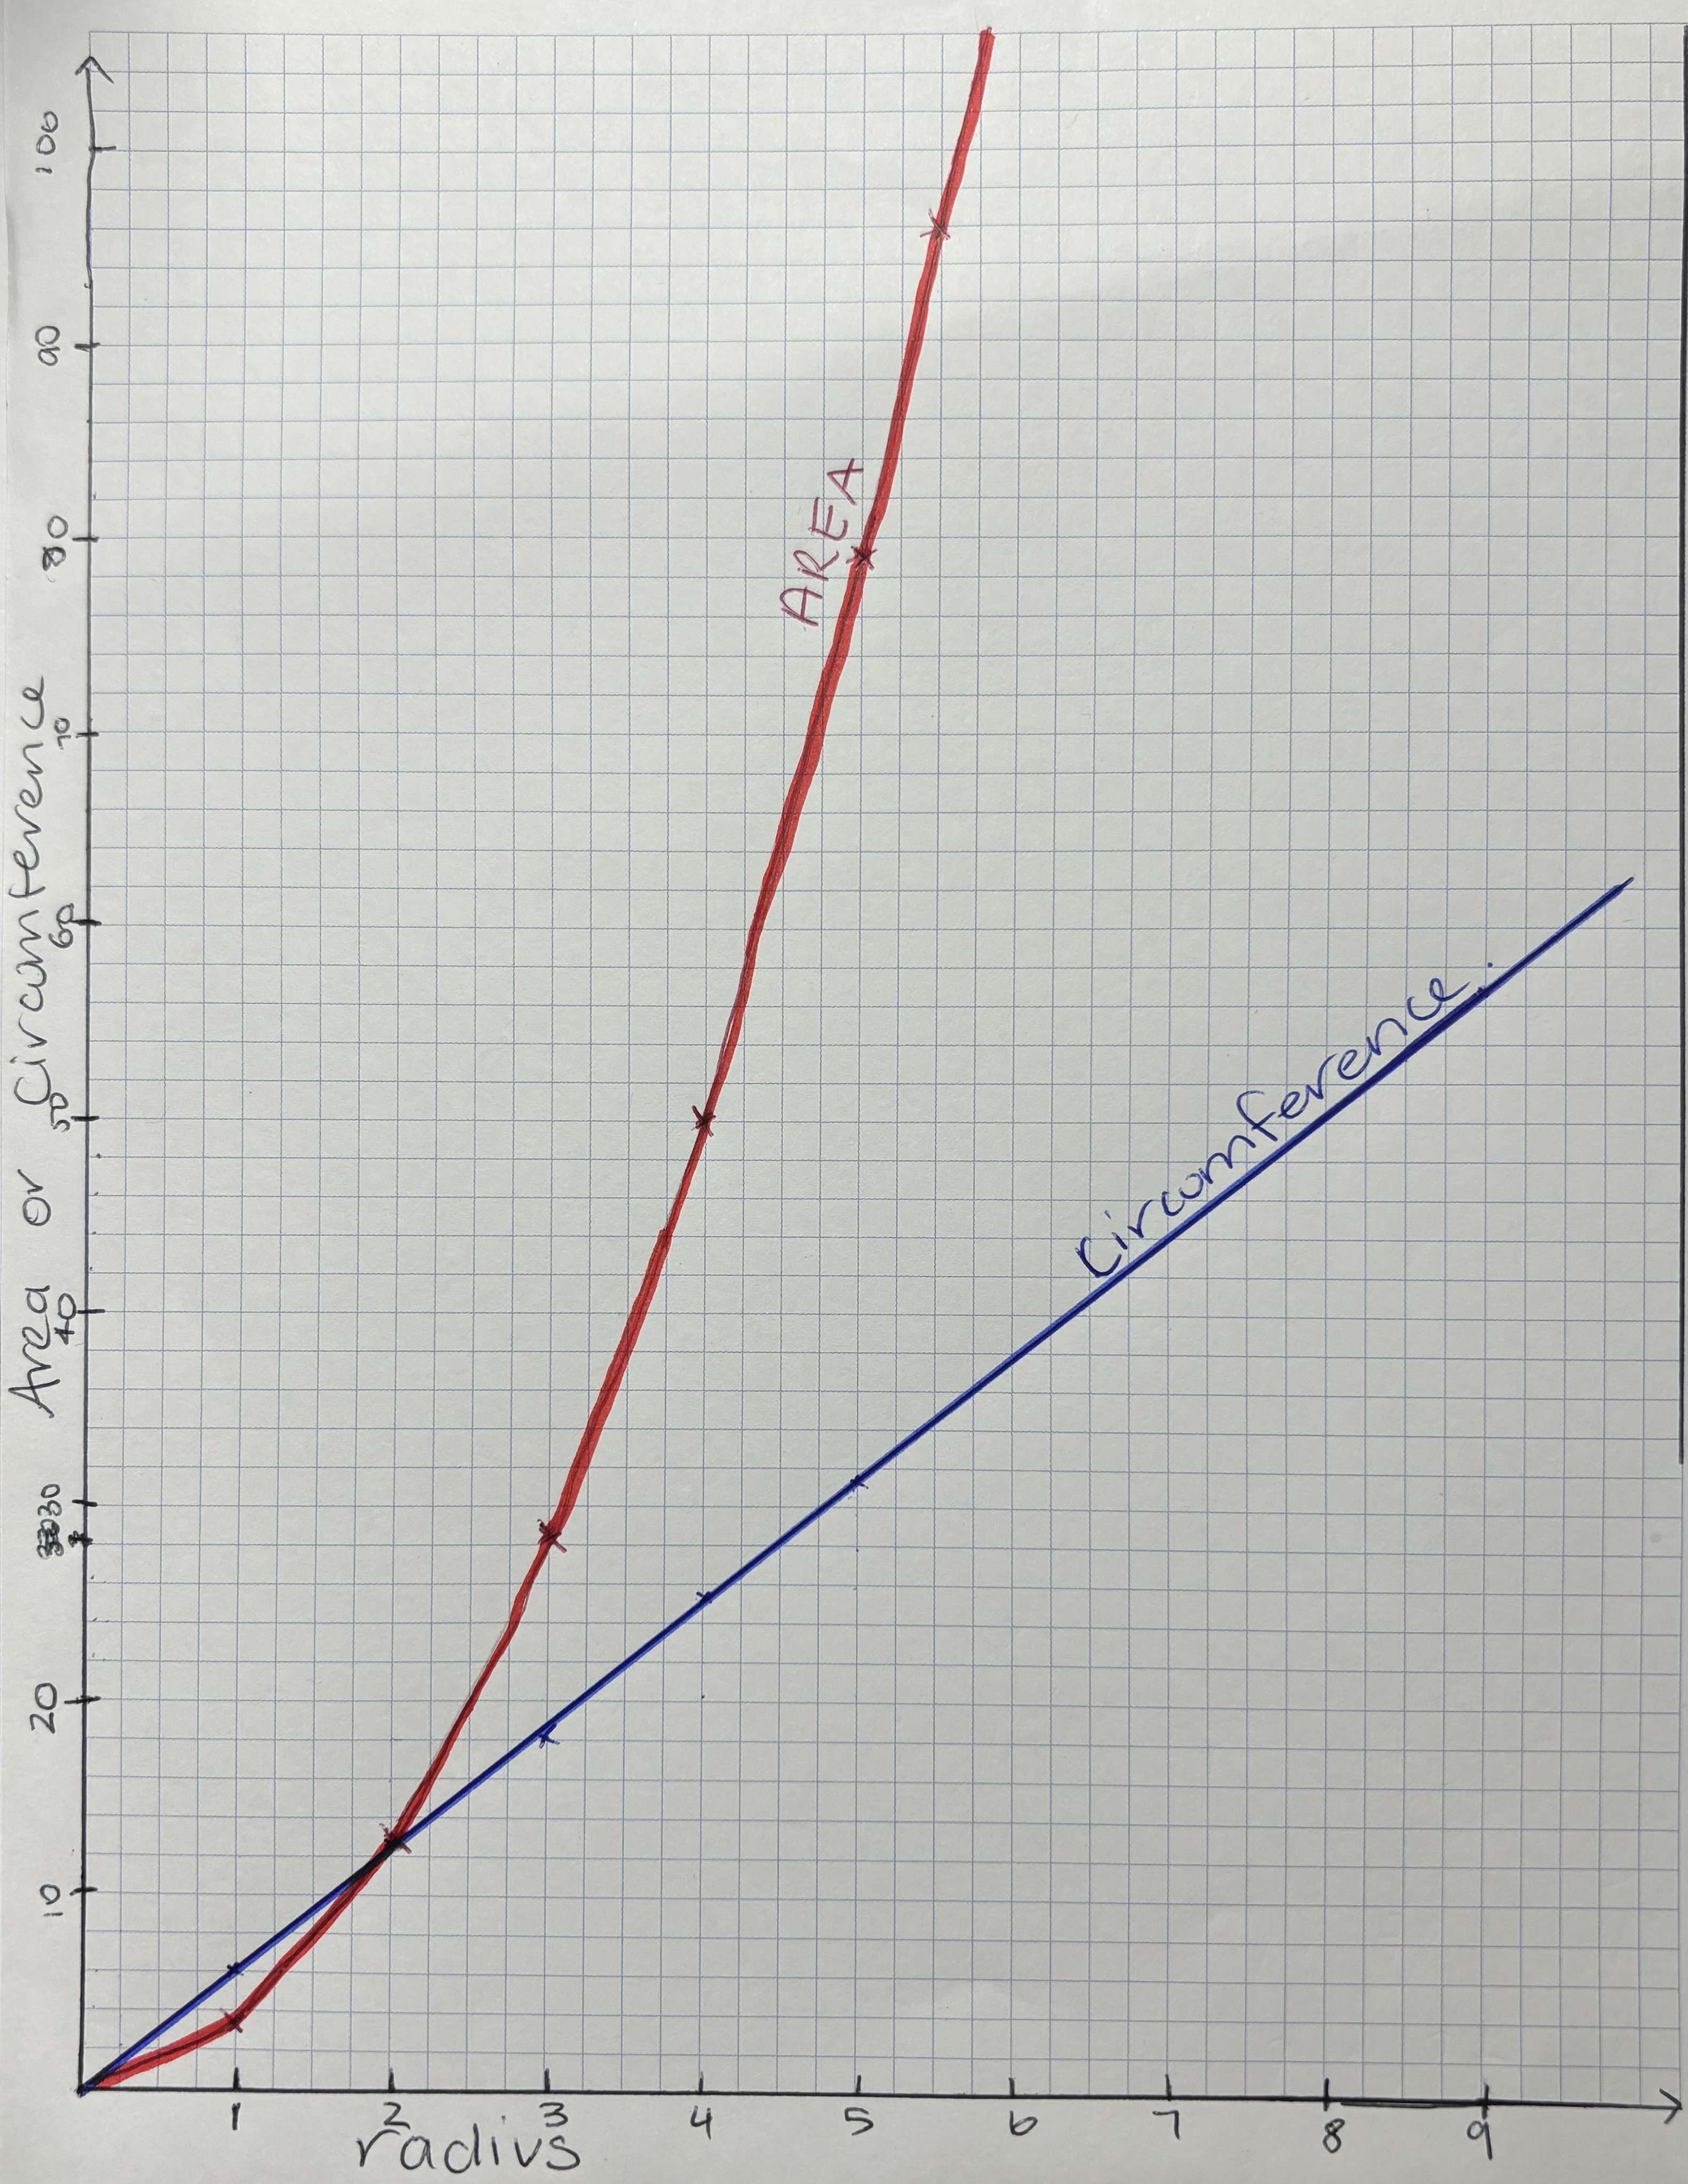

1. Identify the point of intersection of the 2 graphs. What does this point mean in relation to the statement ‘A circle’s area is equal to its circumference’.

**The statement is only true when the radius is 2.**

1. What would the graphs look like if the statement was always true, never true or sometimes true?

**The graphs would be the same if it was always true, have points of intersection if it is sometimes true and have no points of intersection if it is never true.**

## Appendix B – card sort

### Always true

|  |  |
| --- | --- |
| Every radius is twice as long as the diameter. | Every diameter is a chord. |
| If the radius of a circle doubles, so does its diameter. | If the circumference of a circle doubles, so does its diameter. |
| The circumference divided by the diameter is equal to $π$. | If the length of the arc is doubled, but the radius remains the same, then the angle doubles too. |
| If the area of a sector is doubled, but the radius remains the same, then the angle doubles too. |  |

### Sometimes true

|  |  |
| --- | --- |
| The arc length of a semicircle is the same as the area of a semicircle. |  |

### Never true

|  |  |
| --- | --- |
| If the area of a circle doubles, then its circumference doubles. | Every chord is a diameter. |

## References

This resource contains NSW Curriculum and syllabus content. The NSW Curriculum is developed by the NSW Education Standards Authority. This content is prepared by NESA for and on behalf of the Crown in right of the State of New South Wales. The material is protected by Crown copyright.

Please refer to the NESA Copyright Disclaimer for more information <https://educationstandards.nsw.edu.au/wps/portal/nesa/mini-footer/copyright>.

NESA holds the only official and up-to-date versions of the NSW Curriculum and syllabus documents. Please visit the NSW Education Standards Authority (NESA) website <https://educationstandards.nsw.edu.au/> and the NSW Curriculum website <https://curriculum.nsw.edu.au/>.

[Mathematics K–10 Syllabus](https://curriculum.nsw.edu.au/learning-areas/mathematics/mathematics-k-10-2022/overview) © NSW Education Standards Authority (NESA) for and on behalf of the Crown in right of the State of New South Wales, 2022.

**© State of New South Wales (Department of Education), 2025**

The copyright material published in this resource is subject to the *Copyright Act 1968* (Cth) and is owned by the NSW Department of Education or, where indicated, by a party other than the NSW Department of Education (third-party material).

Copyright material available in this resource and owned by the NSW Department of Education is licensed under a [Creative Commons Attribution 4.0 International (CC BY 4.0) license](https://creativecommons.org/licenses/by/4.0/).

[](https://creativecommons.org/licenses/by/4.0/)

This license allows you to share and adapt the material for any purpose, even commercially.

Attribution should be given to © State of New South Wales (Department of Education), 2025.

Material in this resource not available under a Creative Commons license:

* the NSW Department of Education logo, other logos and trademark-protected material
* material owned by a third party that has been reproduced with permission. You will need to obtain permission from the third party to reuse its material.

**Links to third-party material and websites**

Please note that the provided (reading/viewing material/list/links/texts) are a suggestion only and implies no endorsement, by the New South Wales Department of Education, of any author, publisher, or book title. School principals and teachers are best placed to assess the suitability of resources that would complement the curriculum and reflect the needs and interests of their students.

If you use the links provided in this document to access a third-party's website, you acknowledge that the terms of use, including licence terms set out on the third-party's website apply to the use which may be made of the materials on that third-party website or where permitted by the *Copyright Act 1968* (Cth). The department accepts no responsibility for content on third-party websites.