# Prisms and cylinders

By estimating the number of beans in a tin, students develop the formula for a cylinder's volume and explore how its uniform cross-section can help them understand its volume.

## Visible learning

### Learning intention

* To be able to describe a cylinder and its volume.

### Success criteria

* I can define a prism.
* I can define a cylinder.
* I can draw the net of a cylinder.
* I can explain where the formula for the volume of a cylinder comes from.

### Syllabus outcomes

A student:

* develops understanding and fluency in mathematics through exploring and connecting mathematical concepts, choosing and applying mathematical techniques to solve problems, and communicating their thinking and reasoning coherently and clearly **MAO-WM-01**
* applies knowledge of volume and capacity to solve problems involving right prisms and cylinders **MA4-VOL-C-01**

[Mathematics K–10 Syllabus](https://curriculum.nsw.edu.au/learning-areas/mathematics/mathematics-k-10-2022/overview) © NSW Education Standards Authority (NESA) for and on behalf of the Crown in right of the State of New South Wales, 2022.

Table 1: lesson summary

|  |  |  |  |
| --- | --- | --- | --- |
| Section | Summary of activity | Teaching strategy | Teaching points |
| **Warm up** | Students complete Appendix A, sorting cards of 3D shapes into 2 groups, prisms and not prisms. Discuss if a cylinder is a prism. | Visibly random groups of 3  Vertical non-permanent surfaces  Gallery walk  Pose-Pause-Pounce-Bounce | Review prior knowledge of the definition of a prism. |
| **Launch** | Display slide 3 of the PowerPoint Prisms and cylinders (PAC PPT*)* andpose the question, ‘Why should we learn about cylinders?’ Students discuss different products packaged in cylinders. | Think-Pair-Share | Students conclude that cylinders are used in everyday life and maths and it's important to know how to perform calculations with them. |
| **Explore** | Display slide 5 of the PowerPoint and ask students to draw the net of a cylinder. Display the GeoGebra applet ([bit.ly/CylinderNet](https://bit.ly/CylinderNet)) for students to identify the shapes that make the net of a cylinder. | Turn and talk | Students know what the net of a cylinder looks like and recognise it is made up of a rectangle and 2 identical circles. |
| **Summarise** | Display slide 7 of the PowerPoint for students to determine which nets won’t fold to make a cylinder and explain why. Students draw the net of an open cylinder. Students complete a Frayer diagram for a cylinder in Appendix B. | Think-Pair-Share  Turn and talk | Students understand the difference between the nets of open and closed cylinders. |
| **Apply** | Show students a video counting baked beans in a tin ([bit.ly/taskmasterbeans](https://bit.ly/taskmasterbeans)). Display slides 9–14 of the PowerPoint and the GeoGebra applet ([bit.ly/cylindercross](https://bit.ly/cylindercross)) for students to develop the process of finding the number of beans in the cross-section of the tin and multiplying it by the number of layers, and relating this to the concept of finding the volume of a cylinder. | Think-Pair-Share  Notice and wonder  Pose-Pause-Pounce-Bounce | Students develop the formula for the volume of a cylinder. |

## Activity structure

Please use the associated PowerPoint *Prisms and cylinders* (PAC PPT) to display images in this lesson.

### Warm up

1. Remind students of the definition of a prism.

A prism is a solid shape with a uniform cross-section and flat sides.

1. Assign students to visibly random groups of 3 ([bit.ly/visiblegroups](https://bit.ly/visiblegroups)) and position groups at vertical non-permanent surfaces (VNPS) ([bit.ly/VNPSstrategy](https://bit.ly/VNPSstrategy)).
2. Distribute Appendix A ‘Card sort’ cut into cards for each group and some adhesive putty, enough to place on each card.
3. Ask groups to use adhesive putty to organise each card into one of 2 categories, ‘prism’ or ‘not a prism’.
4. Students conduct a gallery walk ([bit.ly/DLSgallerywalk](https://bit.ly/DLSgallerywalk)) to compare how each group has organised the cards.
5. Use a questioning strategy such as Pose-Pause-Pounce-Bounce (PDF 557 KB) ([bit.ly/posepausepouncebounce](https://bit.ly/posepausepouncebounce)) to facilitate a class discussion focusing on whether a cylinder is a prism.

This activity is from Stage 4 – Unit 8 – constructing prisms, Lesson 2 – cross-sections, where students first learned about cross-sections and the definition of a prism. We are revisiting this activity to connect to students’ prior learning and enter this learning episode with a common understanding of prisms.

A cylinder is not a prism, it is an object that has parallel circular discs of equal radius at the ends that are joined by a **curved** surface.

### Launch

1. Display Figure 1, which is on slide 3 of the PowerPoint (PAC PPT) and use a questioning strategy such as Pose-Pause-Pounce-Bounce to facilitate a class discussion, asking ‘Why should we learn about cylinders?’

Figure 1: cylinders on slide 3

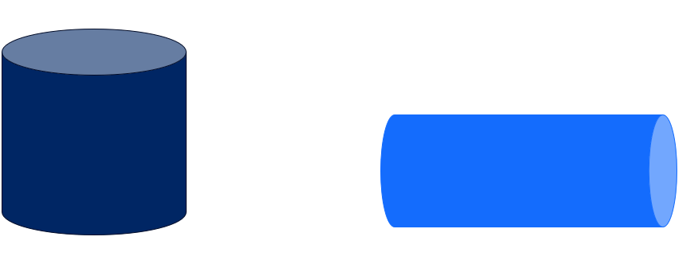

Some possible discussion points may include:

* Companies use cylinders for packaging because of their efficiency and ease of stacking. Learning about cylinders helps students appreciate design choices in the products they use.
* Cylinders are essential in higher-level math topics, including calculus, where they are used in concepts like volume of a solid of revolution.
* Cylindrical shapes appear in nature, such as tree trunks, animal bodies and plant stems.
* Cylinders help in understanding how fluids flow through pipes, which is essential in biology and environmental science.

1. In a Think-Pair-Share ([bit.ly/thinkpairsharestrategy](https://bit.ly/thinkpairsharestrategy)), ask students to consider:

* What are some products that are packaged in cylinders?
* Are there any commonalities between these products?
* What could be some benefits of packaging in a cylinder?

1. Read the following list of products aloud, one at a time. In a Think-Pair-Share, students discuss the reasons behind the product’s cylindrical packaging. The reasoning displayed after each example can be shared with students after they have discussed in their pairs.

* Cans of drink   
  Cylindrical cans withstand internal pressure from carbonation, keeping the drink fresh. The shape also makes it easier to hold, store and transport in packs.
* Round chips stacked in a cylindrical container  
  The cylindrical shape allows chips to be stacked neatly, preventing them from breaking. It also keeps them fresh by minimizing air exposure inside the can.
* Rolled posters or artwork  
  Cylindrical tubes prevent creasing or bending of the paper, keeping posters and artwork in good condition during transport.
* Lip balm sticks  
  A cylindrical shape allows the balm to twist up and apply easily on lips. It’s also compact and fits neatly in pockets or bags.
* Tennis balls  
  Tennis balls are packaged in a cylinder to maintain their internal pressure, protect their shape, and allow for convenient storage and transport.

1. Conclude that cylinders are everywhere in mathematics and life outside of the classroom, so talking about them and performing calculations about cylinders is important.

### Explore

1. Continue with students in pairs.
2. Display Figure 2, which is on slide 5 of the PowerPoint (PAC PPT), and ask pairs to draw the net of a cylinder if we were to cut the cylinder down the curved surface and flatten it out to make a 2D shape.

Figure 2: cutting cylinder slide 5

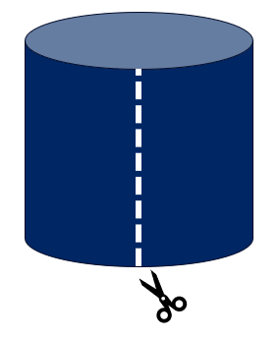

The term ‘net’ has been introduced previously in Stage 3.

1. Have pairs complete a turn and talk ([bit.ly/classroomtalkmoves](https://bit.ly/classroomtalkmoves)) to compare and discuss their drawings.
2. Display the GeoGebra applet ‘Net of a Cylinder’ ([bit.ly/CylinderNet](https://bit.ly/CylinderNet)). Select and drag the slider to model for students what one possible net of a cylinder looks like.
3. Ask pairs to revise their drawing of the net, if necessary, and ask them to write on the net what shapes make up the net of a cylinder.

Students should name 2 circles and a rectangle.

### Summarise

1. Display slide 7 of the PowerPoint (PAC PPT) and in a Think-Pair-Share, ask students to determine which nets will not fold to make a cylinder and explain why.

The incorrect nets are A as both circles are on the same side of the rectangle, and E as the circles aren’t the same size.

1. Ask students to individually draw what they think an open cylinder would look like as a net.

Teachers may need to explain what is meant by ‘open’. Students should draw the same net with one of the circles missing or both circles missing.

1. Have pairs complete a turn and talk to compare and discuss their drawings.
2. Students are to then complete Appendix B ‘Frayer diagram’ ([bit.ly/frayerdiagram](http://bit.ly/frayerdiagram)), which includes examples and non-examples of cylinders and their nets.

### Apply

1. Show students the video ‘Josh Widdicombe gets given a special task | Taskmaster’ (3:53) up to 0:53 ([bit.ly/taskmasterbeans](https://bit.ly/taskmasterbeans)).

Taskmaster is a challenge-based show that originated in the UK. It has spin-offs in many countries, including Australia, which students may have seen. In this clip, one of the contestants, Josh, is tasked with counting the number of beans in a tin of baked beans.

You may wish to play the video up to 1:50 to see Josh count the number of spaghetti hoops in a tin and grains of rice in a bag.

1. Display Figure 3, which is available on slide 9 of the PowerPoint (PAC PPT). Alternatively, bring in a tin of beans to facilitate this activity.

Figure 3: beans closed

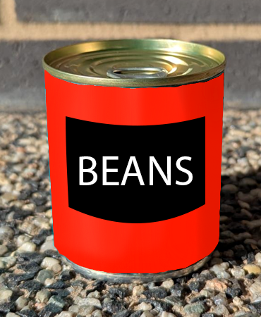

1. In a Think-Pair-Share ask students to discuss what they notice and wonder ([bit.ly/noticewonderstrategy](https://bit.ly/noticewonderstrategy)) about the tin of beans.

Students might notice that this tin of beans has a net weight of 220 g $,$ that the tin is a cylinder, that the top of the tin is a circle, and that this tin is smaller than the tin in the video.

Students might wonder how many beans are in this tin, how this is related to the learning intention of the lesson, and if there is a faster way to count the number of beans.

1. Use student responses to lead the class to the guiding question of this activity ‘How many beans are in the tin?’
2. Use a questioning strategy such as Pose-Pause-Pounce-Bounce to ask students what information, if any, they would need to be able to answer the question.

Students might suggest knowing the dimensions of the tin, knowing how many beans are in one layer, and knowing how much one bean weighs.

1. Acknowledge all methods as viable but inform students that we will be focusing on a method that utilises the features of the shape of the tin, a cylinder.
2. Display Figure 4, which is on slide 10 of the PowerPoint (PAC PPT).

Figure 4: open tin

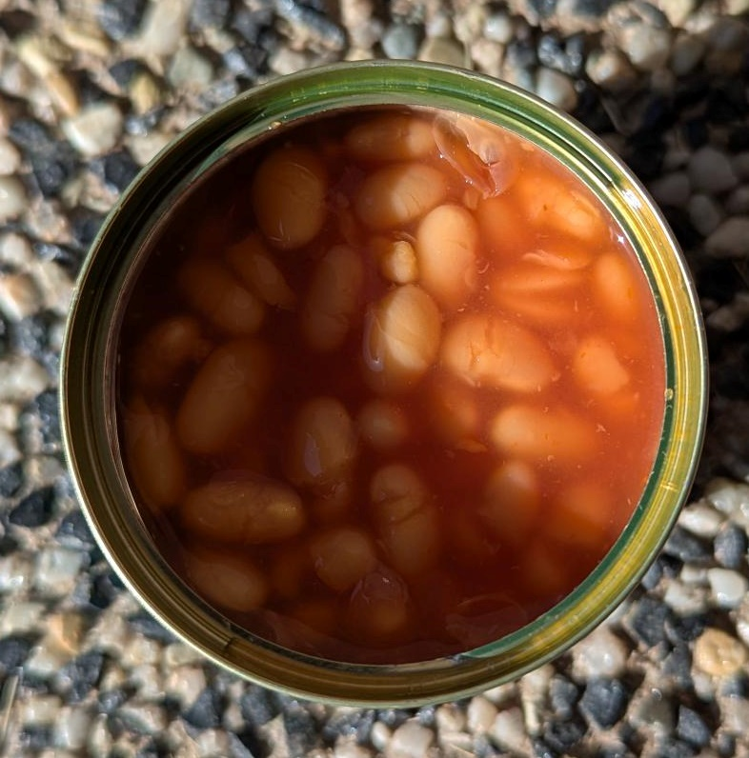

1. In a Think-Pair-Share, students discuss how Figure 4 could be used to find the number of beans in the tin.
2. If students do not volunteer that the view is a uniform cross-section of the cylinder, then explain how this could be useful.
3. Display the GeoGebra applet ‘Making Cross Sections of a Cylinder’ ([bit.ly/cylindercross](https://bit.ly/cylindercross)). Select and drag the slider to model for students how the cross-section of a cylinder, taken parallel to the base is uniform, so it acts like a prism but does not fit the definition as it does not have flat sides.
4. Placing students back into their groups of 3, have students count the number of beans they can see in the cross-section and use this to estimate the number of beans in the tin.

There are approximately 31 beans in the cross-section.

**Spoiler:** there will be approximately 6–7 layers in the tin.

1. Once students have had a chance to explore the problem, conduct a gallery walk to compare solutions between groups.
2. Display Figure 5, which is on slide 11 of the PowerPoint (PAC PPT), to reveal that the number of beans in the tin is 211. Slide 12 can be displayed to show how the beans were counted.

Figure 5: flat container

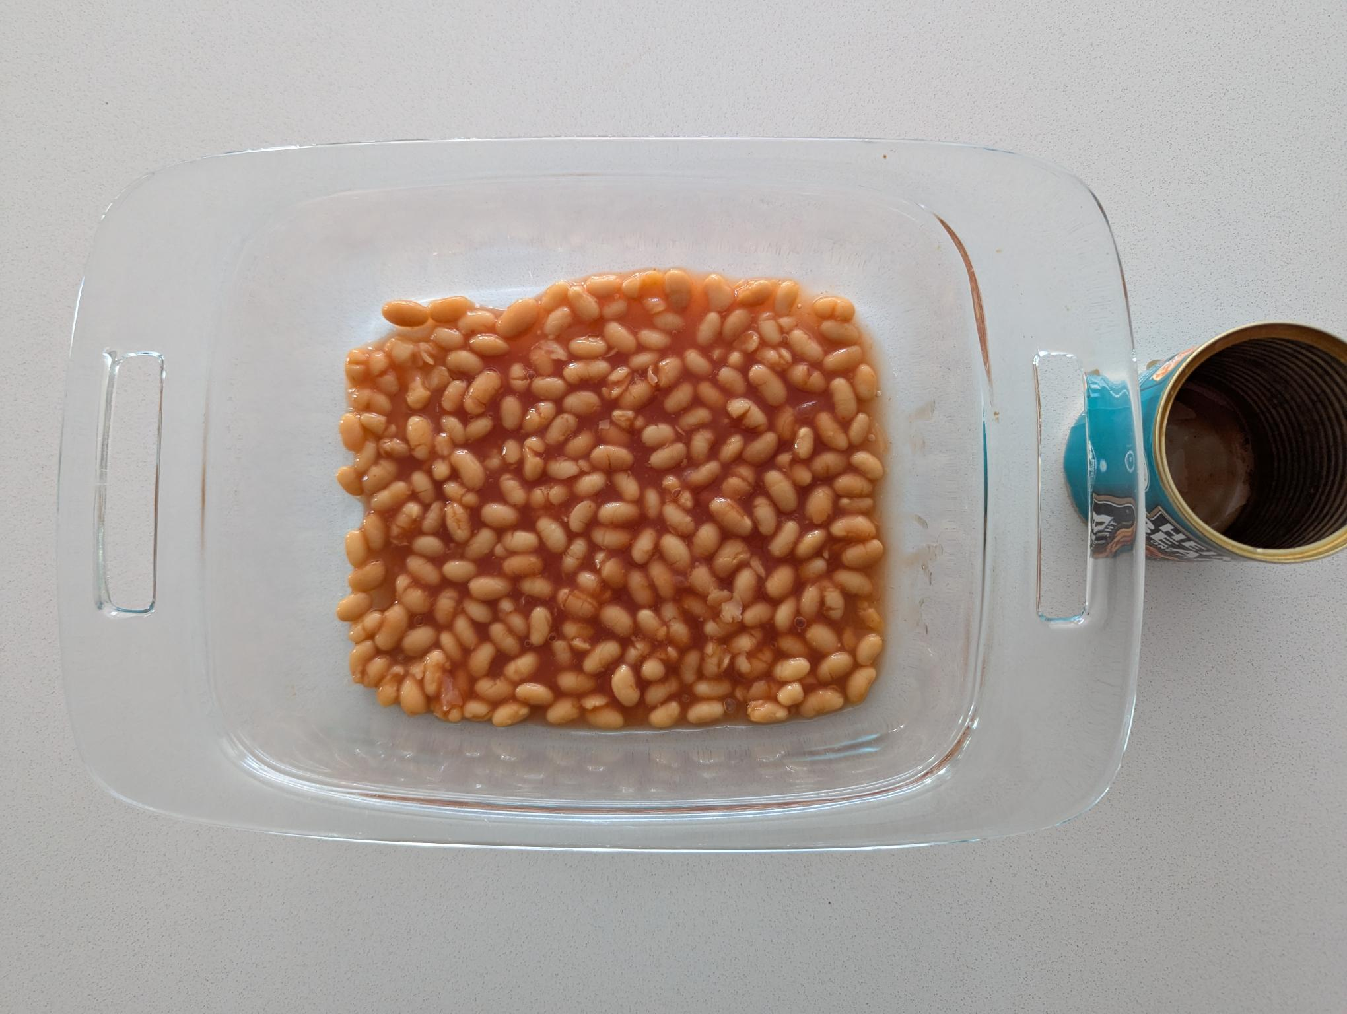

1. Use a questioning strategy such as Pose-Pause-Pounce-Bounce to facilitate a class discussion of students’ approaches and solutions. Question prompts may include:

* If the tin was a rectangular prism, would you use a similar or different approach?
* If the tin was a pyramid shape, would you use a similar or different approach?
* How does the cross-section of a cylinder help us to understand its volume?

1. Display slide 13 of the PowerPoint (PAC PPT), and allow students in their groups to discuss the following question prompts on the slide:

* How does this information relate to finding the volume of a cylinder?
* How can I write the volume of a cylinder as a formula?

In their discussions, students should be able to compare the words cross-section, layers and bean total with the volume formula in words, and identify that they need to include the formula for the area of a circle in the volume of a cylinder.

1. Conduct a class discussion comparing different groups’ formulas for finding the volume of a cylinder.
2. Display slide 14 of the PowerPoint (PAC PPT) to explicitly explain the volume of a cylinder in both words and formula.

## Assessment and differentiation

### Suggested opportunities for differentiation

**Warm up**

* **Provide 3D solids, packaging or objects for students to hold and discuss which of them are prisms.**
* **If students are not confident describing prisms or cross-sections, revisiting these concepts before continuing with this learning episode may be beneficial.**
* **Challenge students to draw solids to add to each category.**

**Launch**

* Show students how cylinders are applied in senior mathematics, for example, compound solids, 3D modelling, volumes of a solid of revolution.
* Provide cards with each product and its reasoning for students to match.
* Provide further prompts, such as ‘Where do we see cylinders in real life?’ to help students start contributing to the discussion.

**Explore**

* Students could explore further drawings of cylinders looking at top and side views.

**Summarise**

* Students could be advised to use the cards from the Warm up activity to help create their examples and non-examples for their Frayer diagrams.

**Apply**

* Bring in a variety of tins or other products so that students can compare methods for different tins.
* Provide students with modelling clay to roll and cut into cylinders or use cylinder moulds. Students then use dental floss to cut cross-sections, discussing the shape of the cross sections.
* Provide further information for students to compare different methods for calculating the number of beans. For example, the dimensions of the tin or the weight of a single bean.

### Suggested opportunities for assessment

**Warm up**

* Observe how students group the cards and listen to discussions to assess students’ prior knowledge of prisms.

**Launch**

* Observe students’ responses to assess their ability to describe a cylinder and compare cylinders to other prisms and solids.

**Explore**

* Observe students’ drawing of nets of cylinders and their pair discussions.

**Summarise**

* Collect students' Frayer diagrams as evidence of student understanding of a cylinder.

**Apply**

* Use student contributions to determine what students know about cylinders, prisms and volume.
* Observe students’ reasoning recorded on vertical non-permanent surfaces and through discussions to assess their geometrical reasoning and understanding of the properties of a cylinder.

## Appendix A

### Card sort

|  |  |
| --- | --- |
| A  Cone. | B |
| C  **Triangular isosceles prism.** | D  An L shaped prism. |
| E  A right angled triangular prism. | F  Rectangular prism. |
| G  A hemi-sphere. | H  Trapezoidal prism. |
| I  A rectangular prism that has a half-cylinder removed from the top. | J  Hexagonal prism. |
| K  Pyramid shape outline. | L  Rectangular prism. |
| M  Trapezoidal prism. | N  Cylinder outline. |
| O  Sphere outline. | P |

## Appendix B

### Frayer diagram

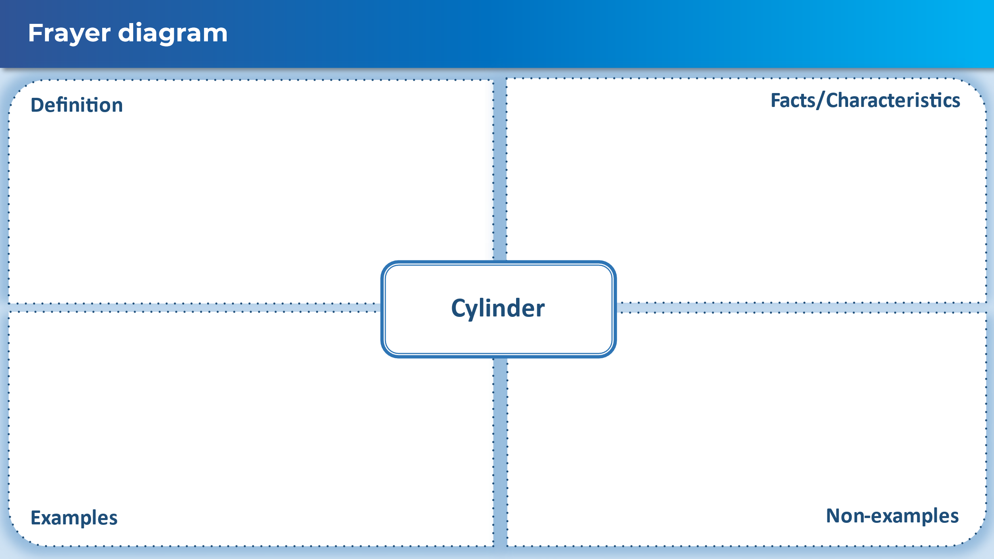

## Sample solutions

### Appendix B – Frayer diagramCompleted Frayer diagram.

## References

This resource contains NSW Curriculum and syllabus content. The NSW Curriculum is developed by the NSW Education Standards Authority. This content is prepared by NESA for and on behalf of the Crown in right of the State of New South Wales. The material is protected by Crown copyright.

Please refer to the NESA Copyright Disclaimer for more information <https://educationstandards.nsw.edu.au/wps/portal/nesa/mini-footer/copyright>.

NESA holds the only official and up-to-date versions of the NSW Curriculum and syllabus documents. Please visit the NSW Education Standards Authority (NESA) website <https://educationstandards.nsw.edu.au/> and the NSW Curriculum website <https://curriculum.nsw.edu.au/>.

[Mathematics K–10 Syllabus](https://curriculum.nsw.edu.au/learning-areas/mathematics/mathematics-k-10-2022/overview) © NSW Education Standards Authority (NESA) for and on behalf of the Crown in right of the State of New South Wales, 2022.

**© State of New South Wales (Department of Education), 2025**

The copyright material published in this resource is subject to the *Copyright Act 1968* (Cth) and is owned by the NSW Department of Education or, where indicated, by a party other than the NSW Department of Education (third-party material).

Copyright material available in this resource and owned by the NSW Department of Education is licensed under a [Creative Commons Attribution 4.0 International (CC BY 4.0) license](https://creativecommons.org/licenses/by/4.0/).

[](https://creativecommons.org/licenses/by/4.0/)

This license allows you to share and adapt the material for any purpose, even commercially.

Attribution should be given to © State of New South Wales (Department of Education), 2025.

Material in this resource not available under a Creative Commons license:

* the NSW Department of Education logo, other logos and trademark-protected material
* material owned by a third party that has been reproduced with permission. You will need to obtain permission from the third party to reuse its material.

**Links to third-party material and websites**

Please note that the provided (reading/viewing material/list/links/texts) are a suggestion only and implies no endorsement, by the New South Wales Department of Education, of any author, publisher, or book title. School principals and teachers are best placed to assess the suitability of resources that would complement the curriculum and reflect the needs and interests of their students.

If you use the links provided in this document to access a third-party's website, you acknowledge that the terms of use, including licence terms set out on the third-party's website apply to the use which may be made of the materials on that third-party website or where permitted by the *Copyright Act 1968* (Cth). The department accepts no responsibility for content on third-party websites.