# Volume versus capacity

Students investigate the difference between volume and capacity.

## Visible learning

### Learning intention

* To understand the difference between volume and capacity.

### Success criteria

* I can explain the difference between volume and capacity.
* I can calculate the volume of water in a cylinder.
* I can convert between units of volume and capacity.

### Syllabus outcomes

A student:

* develops understanding and fluency in mathematics through exploring and connecting mathematical concepts, choosing and applying mathematical techniques to solve problems, and communicating their thinking and reasoning coherently and clearly **MAO-WM-01**
* applies knowledge of volume and capacity to solve problems involving right prisms and cylinders **MA4-VOL-C-01**

[Mathematics K–10 Syllabus](https://curriculum.nsw.edu.au/learning-areas/mathematics/mathematics-k-10-2022/overview) © NSW Education Standards Authority (NESA) for and on behalf of the Crown in right of the State of New South Wales, 2022

Table 1: lesson summary

|  |  |  |  |
| --- | --- | --- | --- |
| Section | Summary of activity | Teaching strategies | Teaching points |
| Warm up | Students complete Appendix A to practise converting between units and compare their answers with another student. |  | Students review conversions between units of volume and units of capacity. |
| Launch | Display slide 3 of the PowerPoint *Volume versus capacity* (VVC PPT). Students discuss what they notice and wonder. Ask students what the volume of the object is and what the capacity is. | Think-Pair-Share  Pose-Pause-Pounce-Bounce | Students learn that volume is the amount of space occupied by an object and capacity is the maximum amount a container can hold. |
| Explore | Display slide 5 of the PowerPoint (VVC PPT) and ask students to order the tanks according to the volume of water they contain. Display slide 6 of the PowerPoint (VVC PPT) and use Appendix B for students to calculate the volume of water in each tank. Slide 7 can be used to revise converting between cubic metres and kilolitres. | Think-Pair-Share  Pose-Pause-Pounce-Bounce | Students revise the conversion between volume and capacity using cylinders, particularly when our measurements are in metres. |
| Summarise | Students make notes to their future forgetful selves about the difference between volume and capacity and how to convert between the 2. Students complete the table in Appendix C, drawing cylinders that satisfy the requirements of each cell when compared to the given cylinder. | Notes to future forgetful selves | Students summarise their knowledge of converting between volume and capacity. |
| Apply | In groups students complete Appendix D. | Visibly random groups of 3  Vertical non-permanent surfaces  Two stars and a wish  Pose-Pause-Pounce-Bounce | Students apply their knowledge to a problem that involves composite areas. |

## Activity structure

Please use the associated PowerPoint *Volume versus capacity* (VVC PPT) to display images in this lesson.

### Warm up

1. Distribute Appendix A ‘Volume and capacity conversions’ to each student and ask them to complete the tables provided.
2. Students should compare their solutions with a partner. If they differ, they should discuss what the correct solution is and why.

This Warm up provides the opportunity for students to revise conversions between units and the prefixes for units of measurement. Students first encountered converting between units in Lesson 6 – volume and capacity of Unit 8 – constructing prisms.

### Launch

1. Display slide 3 of the PowerPoint (VVC PPT) which shows a water feature.
2. In a Think-Pair-Share ([bit.ly/thinkpairsharestrategy](https://bit.ly/thinkpairsharestrategy)) ask students to discuss what they notice and what they wonder.

Students might notice that the water does not fill the entire object. They might notice that there appears to be something in the middle of the object and wonder what it is.

1. Explain to students that this is a water feature in the shape of a hemisphere (half of a sphere). The centre of the water feature contains a sundial.
2. In a Think-Pair-Share, ask students what they can tell you about the volume and capacity of the water feature.
3. Use the Pose-Pause-Pounce-Bounce questioning strategy (PDF 557 KB) ([bit.ly/posepausepouncebounce](https://bit.ly/posepausepouncebounce)) for students to share their thoughts and reasoning.

The NSW Mathematics K–10 syllabus defines volume as the amount of space occupied by an object and capacity as the amount a container can hold (NESA 2022).

In this case the volume would be larger than the capacity, as the whole object is not hollow and not all of the object can be filled with water.

This activity acts as formative assessment to determine if students remember the difference between volume and capacity.

### Explore

1. Display slide 5 from the PowerPoint (VVC PPT).
2. In a Think-Pair-Share ask students to discuss what the volume and capacity might be for each of the containers.
3. Use the Pose-Pause-Pounce-Bounce questioning strategy for students to share their thoughts and reasoning.

The capacity of each container is the same as the volume of the container in each case. Each container has the potential to be completely filled with liquid. Students should note that we refer to the volume of water in the containers; how much space the water is taking up.

1. Working in pairs, ask students to order the containers according to which container has the largest volume of water in it. Students should record their predictions in their books or on a mini whiteboard.
2. Display slide 6 of the PowerPoint (VVC PPT) which shows the cylinders with measurements. Distribute Appendix B ‘Changing heights and diameters’ to each student.
3. Working in pairs, students are to calculate the volume of water in each container and compare their results with their predicted order.
4. Students are to complete questions 2–4 from Appendix B.

Students will need to be able to convert between kilolitres and cubic metres in question 4 of Appendix B. Slide 7 of the PowerPoint (VVC PPT) may be used as a visual reminder of the necessary conversion.

### Summarise

1. Use the Pose-Pause-Pounce-Bounce questioning strategy to share student responses to questions 2–4 from Appendix B.
2. Students are to create notes to their future forgetful selves ([bit.ly/notestofutureself](https://bit.ly/notestofutureself)) on the difference between volume and capacity and how to convert between them.
3. Assign students to visibly random groups of 3 ([bit.ly/visiblegroups](https://bit.ly/visiblegroups)) at vertical non-permanent surfaces ([bit.ly/VNPSstrategy](https://bit.ly/VNPSstrategy)) and distribute the ‘Less, same, more’ activity from Appendix C. Students need to draw a cylinder that would meet the criteria of each cell when compared to the given cylinder. They will need to use their knowledge from the ‘Changing heights and diameters’ activity in Appendix B.

In the top left cell, students will need to draw a cylinder with a smaller diameter and a smaller volume than the one given. In the top middle cell, they will need to keep the volume the same but have a smaller diameter.

Teachers could allow students to use the GeoGebra file ‘Volume of cylinders – changing dimensions’ ([bit.ly/Vol-Cylinder](https://bit.ly/Vol-Cylinder)) to assist them.

### Apply

1. Still working on their vertical non-permanent surfaces, distribute Appendix D ‘Three cylinders’ to each group of 3. Ask students to find the solution to the problem.
2. Walk around the room and look at student work. Join groups together that have produced different solutions and state ‘At least one of you is incorrect’. Leave students to discuss which of their solutions is incorrect.
3. Ask students to do a gallery walk and give feedback to students on their mathematical communication using the peer feedback proforma, Two stars and a wish ([bit.ly/DLSpeerfeedback](https://bit.ly/DLSpeerfeedback)).

Students should be prompted to focus on the working of each group, including the conventions used and how they have communicated their working so that others can follow their thoughts when approaching the problem.

1. Use the Pose-Pause-Pounce-Bounce questioning strategy to ask students what approaches to the problem were most used and if any group had a strategy they liked.

## Assessment and differentiation

### Suggested opportunities for differentiation

**Warm up**

* **Students could be provided with the conversions for each of the units.**
* **Students could be reminded about what happens to the place value of numbers when multiplied or divided by powers of 10.**

**Launch**

* There is no correct answer for this activity, so all students should be encouraged to share what they notice and wonder.
* When asked what the volume and capacity might be, the teacher is purely looking to see whether students understand that the capacity must be less than the volume.
* Students could be encouraged to consider items they are familiar with, such as milk bottles, to help them determine how much water the feature might hold.

**Explore**

* **All students should be encouraged to make a prediction as to the order of the containers. This prediction does not need to be seen by other students, so students should feel comfortable to attempt the task.**
* **Teachers could print slide 5 from the PowerPoint (VVC PPT) for students to cut up and physically order the tanks.**
* **For students who are not yet ready to work with cylinders, the activity could be adapted to consider rectangular prisms. Students could be given centimetre cubes to build the prisms and determine the volume of each.**

**Summarise**

* Students could be provided with sentence starters to assist them in writing their notes. Students could also write their notes as a pair.
* Support students to complete the ‘Less, same, more’ activity by getting them to initially focus on the middle row or column, before moving to the corner cells.
* If students choose to use the GeoGebra app to assist them, they will need to assign a starting diameter and height to the given cylinder in the middle cell.
* The ‘Less, same, more’ activity could be modified by changing the cylinder to a rectangular prism. Students could be further supported by providing them with centimetre cubes to build the prisms and calculate their volume.

**Apply**

* Students could be provided with physical cylinders that sit within each other instead of Appendix D. Students could fill these with water to visualise the amount of water in each container.

### Suggested opportunities for assessment

**Warm up**

* Appendix A could be used as evidence of student understanding of conversion of units.

**Launch**

* Students may demonstrate their Working mathematically skills in discussions and justifications.

**Explore**

* Students have opportunities to contribute to and hear from pair and class discussions, these act as opportunities for self- and peer-reflection.
* Students are tested on their understanding of volume and capacity in their responses to the objects on slide 5 of the PowerPoint (VVC PPT).
* Student responses to Appendix B could be collected as evidence that students can successfully find the volume or a cylinder.

**Summarise**

* Review student's notes to their future forgetful selves about the difference between volume and capacity and how to calculate them.
* Monitor student discussions and reasoning when completing Appendix C ‘Less, same, more’ for understanding of the effect on volume when increasing the diameter of a cylinder.

**Apply**

* Monitor student responses to Appendix D as evidence of learning of how to find the volume of a composite shape.
* Students provide peer feedback to each other when working in groups of 3.
* Students provide peer feedback on students' mathematical communication in the form of Two stars and a wish.

## Appendix A

### Volume and capacity conversions

1. Complete the following table by converting the units of capacity.

|  |  |  |
| --- | --- | --- |
| Millilitres (mL) | Litres (L) | Kilolitres (kL) |
| 1000 mL | 1000 mL $÷$ 1000 = 1 L | 1 L $÷$ 1000 = 0.001 kL |
|  | 3.5 L |  |
|  |  | 1 kL |
|  |  | 13.2 kL |
|  | 2 000 000 L |  |

1. Complete the following table by converting the units of volume.

|  |  |  |
| --- | --- | --- |
| Cubic millimetres (mm3) | Cubic centimetres (cm3) | Cubic metres (m3) |
| 1000 mm3 |  |  |
|  | 2 cm3 |  |
|  |  | 1 m3 |
|  | 3 000 000 cm3 |  |

## Appendix B

### Changing heights and diameters

This activity has been modified from Daniel Mentrard’s GeoGebra applet ‘Challenge on volume of a cylinder’ (<https://www.geogebra.org/m/pthxqjpa>).

1. Each of the following cylindrical water tanks is partially filled with water. Order the tanks from the largest volume of water to the least. Measurements are all in metres.

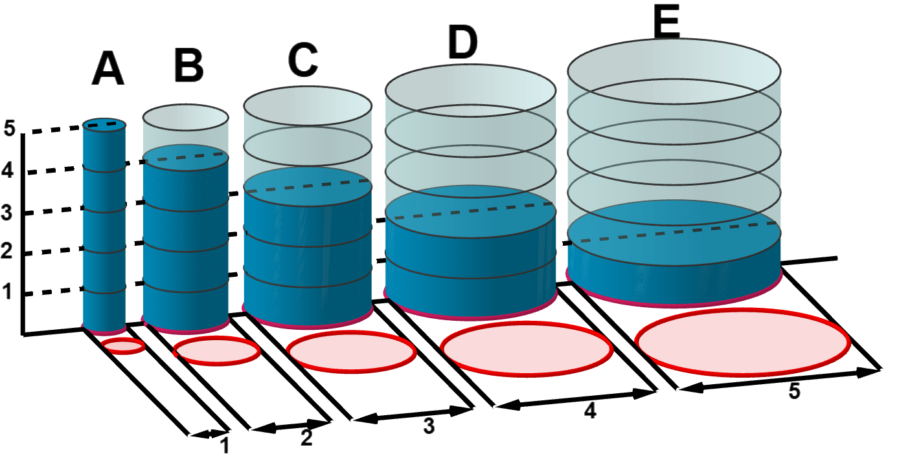

|  |  |  |  |  |  |
| --- | --- | --- | --- | --- | --- |
| Cylinder | Tank A | Tank B | Tank C | Tank D | Tank E |
| Volume of water |  |  |  |  |  |
| Order |  |  |  |  |  |

1. What do you notice about the amount of water as the cylinders change in diameter and the height of the water decreases?
2. Can you make a generalised predication about the type of containers which will hold the most water?
3. What height would the water in each container need to be, if each container held 3 kilolitres of water?

## Appendix C

### Less, same, more

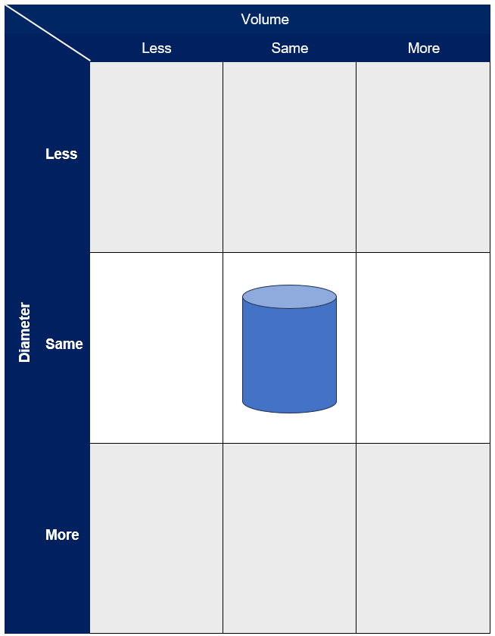

## Appendix D

### Three cylinders

This activity has been modified from Don Steward’s Median blog post ‘three cylinders’ (<https://donsteward.blogspot.com/2014/12/three-cylinders.html>)

Three cylinders are placed one inside the other and then the space remaining in each is filled with water.

1. Predict which cylinder contains the most water, in litres.
2. Calculate the volume of water in each cylinder.

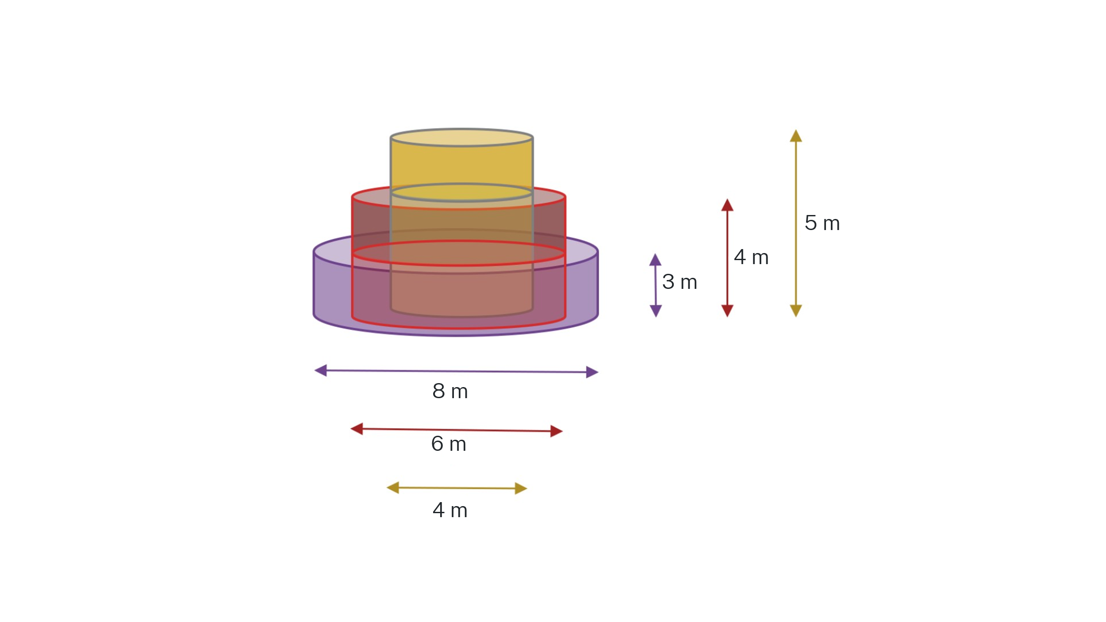

## Sample solutions

### Appendix A – volume and capacity conversions

1. Complete the following table by converting the units of capacity.

|  |  |  |
| --- | --- | --- |
| Millilitres (mL) | Litres (L) | Kilolitres (kL) |
| 1000 mL | 1 L | 0.001 kL |
| 3500 mL | 3.5 L | 0.0035 kL |
| 1 000 000 mL | 1000 L | 1 kL |
| 13 200 000 mL | 13 200 L | 13.2 kL |
| 2 000 000 000 mL | 2 000 000 L | 2 000 kL |

1. Complete the following table by converting the units of volume.

|  |  |  |
| --- | --- | --- |
| Cubic millimetres (mm3) | Cubic centimetres (cm3) | Cubic metres (m3) |
| 1000 mm3 | 1 cm3 | 0.000001 m3 |
| 2000 mm3 | 2 cm3 | 0.000002 m3 |
| 1 000 000 000 mm3 | 1 000 000 cm3 | 1 m3 |
| 3 000 000 000 mm3 | 3 000 000 cm3 | 3 m3 |

### Appendix B – changing heights and diameters

1. Each of the following cylindrical water tanks is partially filled with water. Order the tanks from the largest volume of water to the least. Measurements are all in metres.

|  |  |  |  |  |  |
| --- | --- | --- | --- | --- | --- |
| Cylinder | Tank A | Tank B | Tank C | Tank D | Tank E |
| Volume of water | $$V=π×{0.5}^{2}×5 \\ V≈3.9269m^{3} \\ V≈ 3.9kL$$ | $$V=π×1^{2}×4 \\ V≈12.56637m^{3} \\ V≈ 12.57kL$$ | $$V=π×{1.5}^{2}×3 \\ V≈21.205m^{3} \\ V≈ 21.21kL$$ | $$V=π×2^{2}×2 \\ V≈25.1327m^{3} \\ V≈ 25.13kL$$ | $$V=π×{2.5}^{2}×1 \\ V≈19.63495 \\ V≈ 19.63kL$$ |
| Order | 5 | 4 | 2 | 1 | 3 |

1. What do you notice about the amount of water as the cylinders change in diameter and the height of the water decreases?

**In general, as the diameter increases, the volume of water increases too. The diameter has more impact on the volume than the height, as the radius is squared. As the diameter becomes larger, the square of the radius becomes larger and thus the volume becomes larger.**

1. Can you make a generalised predication about the type of containers which will hold the most water?

**Containers that are wide will hold more water than containers that are tall and skinny.**

1. What height would the water in each container need to be, if each container held 3 kL of water?

|  |  |  |  |  |  |
| --- | --- | --- | --- | --- | --- |
| Cylinder | Tank A | Tank B | Tank C | Tank D | Tank E |
| Volume of water | $$3=π×{0.5}^{2}×h \\ h≈\frac{3}{π×{0.5}^{2}}m^{3}$$ $h≈3.82m$ | $$3=π×1^{2}×h \\ h≈\frac{3}{π×1^{2}}m^{3}$$ $h≈0.95m$ | $$3=π×{1.5}^{2}×h \\ h≈\frac{3}{π×{1.5}^{2}}m^{3}$$ $h≈0.42m$ | $$3=π×2^{2}×h \\ h≈\frac{3}{π×2^{2}}m^{3}$$ $h≈0.24m$ | $$3=π×{2.5}^{2}×h \\ h≈\frac{3}{π×{2.5}^{2}}m^{3}$$ $h≈0.15m$ |

### Appendix D – three cylinders

**Yellow cylinder**

$$V=π×2^{2}×5$$ $V≈62.83$ $m^{3}$ $V≈62.83$ $kL$

**Red cylinder**

$$V=\left(π×3^{2}-π×2^{2}\right)×4 \\ V≈62.83 m^{3} \\ V≈62.83 kL$$

**Purple cylinder $$V=\left(π×4^{2}-π×3^{2}\right)×3 \\ V≈65.97 m^{3} \\ V≈65.97 kL$$**

## References

This resource contains NSW Curriculum and syllabus content. The NSW Curriculum is developed by the NSW Education Standards Authority. This content is prepared by NESA for and on behalf of the Crown in right of the State of New South Wales. The material is protected by Crown copyright.

Please refer to the NESA Copyright Disclaimer for more information [https://educationstandards.nsw.edu.au/wps/portal/nesa/mini-footer/copyright](https://aus01.safelinks.protection.outlook.com/?url=https%3A%2F%2Feducationstandards.nsw.edu.au%2Fwps%2Fportal%2Fnesa%2Fmini-footer%2Fcopyright&data=05%7C01%7CCaitlin.Pace1%40det.nsw.edu.au%7C9c2c1a9f59c94d2df30708dafa7edb23%7C05a0e69a418a47c19c259387261bf991%7C0%7C0%7C638097720042599463%7CUnknown%7CTWFpbGZsb3d8eyJWIjoiMC4wLjAwMDAiLCJQIjoiV2luMzIiLCJBTiI6Ik1haWwiLCJXVCI6Mn0%3D%7C3000%7C%7C%7C&sdata=BzQh0UsffVZE3eO22b2Xba3p0VMOBZSHfS21FGHXtZM%3D&reserved=0).

NESA holds the only official and up-to-date versions of the NSW Curriculum and syllabus documents. Please visit the NSW Education Standards Authority (NESA) website <https://educationstandards.nsw.edu.au/> and the NSW Curriculum website <https://curriculum.nsw.edu.au/>.

[Mathematics K–10 Syllabus](https://curriculum.nsw.edu.au/learning-areas/mathematics/mathematics-k-10-2022/overview) © NSW Education Standards Authority (NESA) for and on behalf of the Crown in right of the State of New South Wales, 2022.

Mentrard D (2025) [*Challenge on volume of a cylinder*](https://www.geogebra.org/m/pthxqjpa), GeoGebra website, accessed 20 January 2025.

Steward D (19 December 2014) ‘[Three cylinders’](https://donsteward.blogspot.com/2014/12/three-cylinders.html), Don Steward blogspot, accessed 20 January 2025.

**© State of New South Wales (Department of Education), 2025**

The copyright material published in this resource is subject to the *Copyright Act 1968* (Cth) and is owned by the NSW Department of Education or, where indicated, by a party other than the NSW Department of Education (third-party material).

Copyright material available in this resource and owned by the NSW Department of Education is licensed under a [Creative Commons Attribution 4.0 International (CC BY 4.0) license](https://creativecommons.org/licenses/by/4.0/).

[](https://creativecommons.org/licenses/by/4.0/)

This license allows you to share and adapt the material for any purpose, even commercially.

Attribution should be given to © State of New South Wales (Department of Education), 2025.

Material in this resource not available under a Creative Commons license:

* the NSW Department of Education logo, other logos and trademark-protected material
* material owned by a third party that has been reproduced with permission. You will need to obtain permission from the third party to reuse its material.

**Links to third-party material and websites**

Please note that the provided (reading/viewing material/list/links/texts) are a suggestion only and implies no endorsement, by the New South Wales Department of Education, of any author, publisher, or book title. School principals and teachers are best placed to assess the suitability of resources that would complement the curriculum and reflect the needs and interests of their students.

If you use the links provided in this document to access a third-party's website, you acknowledge that the terms of use, including licence terms set out on the third-party's website apply to the use which may be made of the materials on that third-party website or where permitted by the *Copyright Act 1968* (Cth). The department accepts no responsibility for content on third-party websites.