# Volume of trees

Students will explore the volume of wood necessary to make various timber products. They will explore a variety of formulas used in the Forestry industry, including the volume of a cylinder.

## Visible learning

### Learning intentions

* To be able to solve equations.
* To be able to find the volume of objects.

### Success criteria

* I can substitute values into a formula.
* I can verify solutions to an equation by substitution.
* I can find the volume of a prism and cylinder.

### Syllabus outcomes

A student:

* develops understanding and fluency in mathematics through exploring and connecting mathematical concepts, choosing and applying mathematical techniques to solve problems, and communicating their thinking and reasoning coherently and clearly. **MAO-WM-01**
* Solves linear equations of up to 2 steps and quadratic equations of the form $ax^{2}=c$  
  **MA4-EQU-C-01**
* Applies knowledge of volume and capacity to solve problems involving right prisms and cylinders **MA4-VOL-C-01**

[Mathematics K–10 Syllabus](https://curriculum.nsw.edu.au/learning-areas/mathematics/mathematics-k-10-2022/overview) © NSW Education Standards Authority (NESA) for and on behalf of the Crown in right of the State of New South Wales, 2022.

Table 1: lesson summary

|  |  |  |  |
| --- | --- | --- | --- |
| Section | Summary of activity | Teaching strategies | Teaching points |
| **Launch** | Display the dining setting on slide 3 of the PowerPoint *Volume of Trees* (VOT PPT). Students estimate how many trees it would take to build the dining setting. Students then brainstorm what they would need to know to make a more accurate estimate. | Turn and talk  Finger voting  Mini whiteboards  Pose-Pause-Pounce-Bounce | Activate prior knowledge of volume, and in particular volume of prisms, compared with volume of cylinders. |
| **Explore** | Using Appendix A, which has the measurements for the dining setting shown in the Launch, students calculate the volume of wood in the dining setting. Students measure the circumference of 5 different trees and use the formula $h=\frac{15d}{2}$ to aid in calculating the volume of wood in the tree. They record their results in Appendix B. | Visibly random groups of 3  Vertical non-permanent surfaces  Gallery walk | Students revise formulas for finding the volume of prisms and cylinders. |
| **Summarise** | Students revise their estimate of how many trees it would take to build the dining setting from the Launch, based on their calculations of the volume of wood in a tree. | Gallery walk | Students use calculations to support their reasoning and decision making. |
| **Apply** | Display slide 5 from the PowerPoint which shows the formula $V=\frac{πd^{2}h}{4}$. This formula caters to the fact that a tree isn’t a perfect cylinder. Students recalculate the volume of wood in their trees and revise their estimate for the number of trees needed to build the dining setting. |  | Students further refine their estimate and reasoning as they adapt their model for determining the volume of wood in a tree. |

## Activity structure

Please use the associated PowerPoint *Volume of trees* (VOT PPT) to display images in this lesson.

### Launch

1. Display slide 3 of the PowerPoint (VOT PPT) and pose the question ‘How many trees would you need to make this dining setting?’
2. Use a turn and talk ([bit.ly/classroomtalkmoves](https://bit.ly/classroomtalkmoves)) for students to discuss their thoughts and reasoning.
3. Use finger voting or mini whiteboards for students to share their answers.
4. Use the Pose-Pause-Pounce-Bounce questioning strategy (PDF 557 KB) ([bit.ly/posepausepouncebounce](https://bit.ly/posepausepouncebounce)) to ask pairs to share their reasoning.
5. Brainstorm with students what information they would require to make a more accurate estimate.

### Explore

1. Assign students to visibly random groups of 3 ([bit.ly/visiblegroups](https://bit.ly/visiblegroups)) at vertical non-permanent surfaces ([bit.ly/VNPSstrategy](https://bit.ly/VNPSstrategy)).
2. Provide a copy of Appendix A – ‘Dining setting’ to each group. Ask students to use the given measurements to calculate the volume of wood required to make the dining setting.
3. Students can perform a gallery walk ([bit.ly/DLSgallerywalk](https://bit.ly/DLSgallerywalk)) to compare their volume and strategy with those of other groups. Allow students time to return to their own group and correct any errors as necessary.
4. Advise students that they are going to investigate the volume of wood in an average tree.
5. Working in their groups of 3, students are to use a tape measure and 5 m of string to find the circumference of 5 different trees. The circumference should be measured at a height of approximately 1 m from the ground.

If schools do not have large enough trees for this activity, it is suggested that you supply students with the circumference of trees from the local area.

1. Students should record their measurements in Appendix B ‘Dimensions of trees’.
2. After returning inside, inform students that the timber industry uses the formula $h=\frac{15d}{2}$ to estimate the height of a tree. Where *d* is the diameter of the tree in metres.
3. Working in their groups of 3, students should determine the diameter of each of their 5 trees, before finding the heights and the volume of wood in each tree.

Students will be able to use the formula $C=πd$ or $C=2πr$ to find the diameter of their trees.

1. Ask groups to consider the reasonableness of their answers and to discuss how they can determine if they have calculated correctly.

Students may require prompting to remind them that they can substitute their diameters back into the circumference formula to check their answers.

### Summarise

1. Students should return to the Launch question and revise their estimate of how many trees it would take to create the dining setting, justifying their response.

Students may consider the height and width of trees, as well as their volume in determining their answer. This question was posed on page 2 of Appendix B.

1. Students are to perform a gallery walk to view other group’s solutions and reasoning.

### Apply

1. Inform students that trees have a similar shape to a cylinder but because they taper off (get smaller at the top) the volume of a cylinder formula is not very accurate when calculating the volume of wood each tree contains.
2. Display slide 5 from the PowerPoint (VOT PPT) which shows the formula $V=\frac{πd^{2}h}{4}$, where $d$ is the diameter of the tree in centimetres and $h$ is the length of the tree in centimetres.
3. Explain that this formula is used to give a more accurate estimate of the volume of wood in a tree.
4. Students will use page 2 of Appendix B to use this formula to calculate the volume of wood in their 5 trees. They will need to copy the diameter and height of their trees from the initial table on page 1.
5. Using the Pose-Pause-Pounce-Bounce questioning strategy ask students:

* How does this compare to the volumes they calculated using the volume of a cylinder formula?
* How does this new estimate of volume affect how many trees they will need to make the dining setting?

## Assessment and differentiation

### Suggested opportunities for differentiation

**Launch**

* There is no correct answer for the number of trees required to build the dining setting so students should be encouraged to practise their estimating and reasoning skills.

**Explore**

* Teachers can strategically assign different parts of the dining setting to different students to calculate the volume. The design of the chairs could be simplified to enable simpler calculations.
* Measurements could be converted to metres before calculating the volume.
* Students could be supplied with 1 cm cubes for them to build the dining setting to assist them in determining its volume.
* Students may need to be prompted to use the circumference formula to find the diameter of the trees.
* Students may need to be reminded of backtracking, to help them find the diameter from the circumference.
* By working in groups, if students are not yet comfortable with finding the diameter from the circumference, they can use the diameter calculated by other members of their group to determine the volume.

**Apply**

* Students may need to be reminded that $\frac{πd^{2}h}{4}$ can be entered into their calculator as $π×d^{2}×h÷4$

### Suggested opportunities for assessment

**Launch**

* Observe students' reasoning skills when discussing the number of trees required to make the dining setting and the information required to accurately calculate the volume of wood.

**Explore**

* Students working at vertical non-permanent surfaces means the teacher can assess student progress and provide support where appropriate.
* When placed in groups of 3, students provide and receive peer feedback on their understanding
* Student work from Appendix A could be collected as evidence of being able to calculate the volume of prisms.
* Student work from Appendix B could be collected as evidence of substituting into a formula and solving equations.

**Summarise**

* A gallery walk allows students to self- and peer-assess following the activity.

**Apply**

* Students will again demonstrate their ability to substitute values into a formula.

## Appendix A

### Dining setting

1. Use the given measurements to calculate the volume of wood in the dining table.

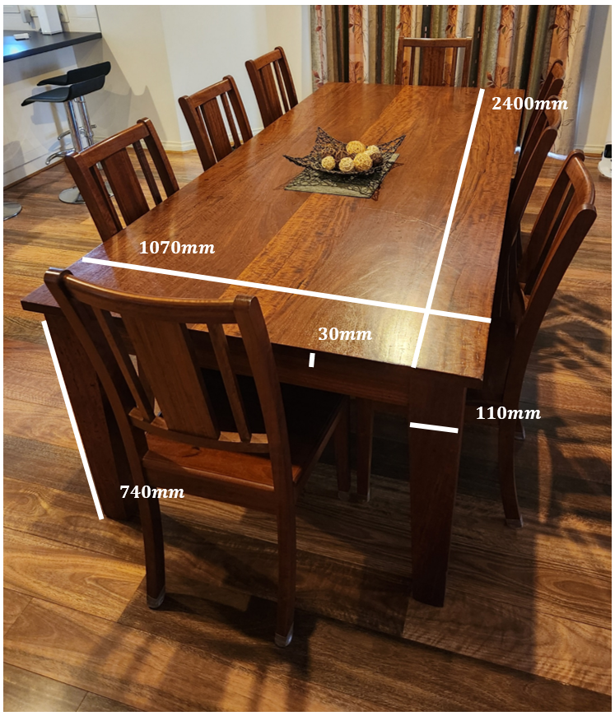

1. Use the given measurements to calculate the volume of wood in the chairs.A chair with measurements:
   Height: 1000 mm.
   Width: 390 mm.
   Depth: 420 mm.

   The chair's legs are 380 mm high with a width of 30 mm, the base of the seat is 80 mm.

   The chair's back is 350 mm high, with 3 sections. The large centre section is 115 mm wide, and the 2 smaller sections are 20 mm wide. The height of the top panel is 40 mm and the width is 25 mm. 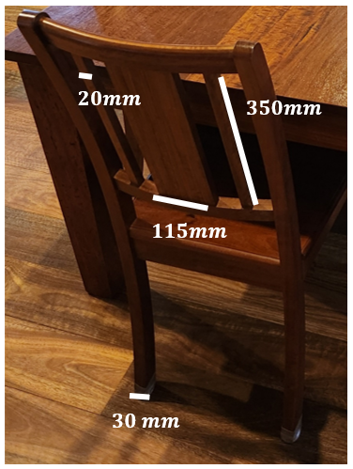
2. What is the total volume of wood required to build the dining setting?

## Appendix B

### Dimensions of trees

1. Find the circumference of 5 different trees. You should measure the circumference at a height of approximately one metre from the ground.

|  |  |  |  |  |
| --- | --- | --- | --- | --- |
| Tree | Circumference | Diameter | Height, $h=\frac{15d}{2}$ | Volume of wood |
| 1 |  |  |  |  |
| 2 |  |  |  |  |
| 3 |  |  |  |  |
| 4 |  |  |  |  |
| 5 |  |  |  |  |

1. How many trees would you need to build the dining setting? Justify your answer.
2. Use the formula $V=\frac{πd^{2}h}{4}$ to calculate a more accurate estimate of the volume of wood in each of your 5 trees.

|  |  |  |  |
| --- | --- | --- | --- |
| Tree | Diameter | Height | Volume of wood, $V=\frac{πd^{2}h}{4}$ |
| 1 |  |  |  |
| 2 |  |  |  |
| 3 |  |  |  |
| 4 |  |  |  |
| 5 |  |  |  |

1. How do these volumes compare to the volumes you calculated when you treated the trees as cylinders? How does this affect how many trees you need to build the dining setting?

## Sample solutions

### Appendix A – dining setting

Students could convert measurements to metres first to avoid having to convert between cubic millimetres and cubic centimetres.

#### Table

1. Volume of table top:

$$V= 2400 × 1070 × 30 \\ =77040000{mm}^{3} \\ =77040{cm}^{3}$$

Volume of table leg:

$$V=740×110×110 \\ =8954000{mm}^{3} \\ =8954{cm}^{3}$$

Total volume of table:

$$77040+8954×4=112856{cm}^{3}$$

#### Chairs

1. Volume of back chair legs:

$$V_{}=1000×30×25 \\ =750000{mm}^{3} \\ V=750×2=1500{cm}^{3}$$

Volume of front chair legs:

$$V_{}=380×30×25 \\ =285000{mm}^{3}$$

$$V=285×2=570{cm}^{3}$$

Volume of seat:

$$V=420 ×390×80 \\ =13104000{mm}^{3} \\ =13104{cm}^{3}$$

Volume of horizontal top bar:

$$V=390×40×25 \\ =390000{mm}^{3} \\ =390{cm}^{3}$$

Volume of horizontal bottom bar:

$$V=390×30×25 \\ =292500{mm}^{3} \\ =292.5{cm}^{3}$$

Volume of left and right vertical bars:

$$V_{}=350×20×25 \\ =175000{mm}^{3} \\ V=175×2=350{cm}^{3}$$

Volume of middle vertical bar:

$$V=350×115×25 \\ =1006250{mm}^{3} \\ =1006.25{cm}^{3}$$

Total volume of chair:

$$V=1500+570+13104+390+292.5+350+1006.25 \\ =17212.75{cm}^{3}$$

#### Dining setting

1. Total volume of dining setting:

$$V=112856{cm}^{3}+17212.75{cm}^{3}×8 \\ =250558{cm}^{3}$$

## References

This resource contains NSW Curriculum and syllabus content. The NSW Curriculum is developed by the NSW Education Standards Authority. This content is prepared by NESA for and on behalf of the Crown in right of the State of New South Wales. The material is protected by Crown copyright.

Please refer to the NESA Copyright Disclaimer for more information [https://educationstandards.nsw.edu.au/wps/portal/nesa/mini-footer/copyright](https://aus01.safelinks.protection.outlook.com/?url=https%3A%2F%2Feducationstandards.nsw.edu.au%2Fwps%2Fportal%2Fnesa%2Fmini-footer%2Fcopyright&data=05%7C01%7CCaitlin.Pace1%40det.nsw.edu.au%7C9c2c1a9f59c94d2df30708dafa7edb23%7C05a0e69a418a47c19c259387261bf991%7C0%7C0%7C638097720042599463%7CUnknown%7CTWFpbGZsb3d8eyJWIjoiMC4wLjAwMDAiLCJQIjoiV2luMzIiLCJBTiI6Ik1haWwiLCJXVCI6Mn0%3D%7C3000%7C%7C%7C&sdata=BzQh0UsffVZE3eO22b2Xba3p0VMOBZSHfS21FGHXtZM%3D&reserved=0).

NESA holds the only official and up-to-date versions of the NSW Curriculum and syllabus documents. Please visit the NSW Education Standards Authority (NESA) website <https://educationstandards.nsw.edu.au/> and the NSW Curriculum website <https://curriculum.nsw.edu.au/>.

[Mathematics K–10 Syllabus](https://curriculum.nsw.edu.au/learning-areas/mathematics/mathematics-k-10-2022/overview) © NSW Education Standards Authority (NESA) for and on behalf of the Crown in right of the State of New South Wales, 2022.

**© State of New South Wales (Department of Education), 2025**

The copyright material published in this resource is subject to the *Copyright Act 1968* (Cth) and is owned by the NSW Department of Education or, where indicated, by a party other than the NSW Department of Education (third-party material).

Copyright material available in this resource and owned by the NSW Department of Education is licensed under a [Creative Commons Attribution 4.0 International (CC BY 4.0) license](https://creativecommons.org/licenses/by/4.0/).

[](https://creativecommons.org/licenses/by/4.0/)

This license allows you to share and adapt the material for any purpose, even commercially.

Attribution should be given to © State of New South Wales (Department of Education), 2025.

Material in this resource not available under a Creative Commons license:

* the NSW Department of Education logo, other logos and trademark-protected material
* material owned by a third party that has been reproduced with permission. You will need to obtain permission from the third party to reuse its material.

**Links to third-party material and websites**

Please note that the provided (reading/viewing material/list/links/texts) are a suggestion only and implies no endorsement, by the New South Wales Department of Education, of any author, publisher, or book title. School principals and teachers are best placed to assess the suitability of resources that would complement the curriculum and reflect the needs and interests of their students.

If you use the links provided in this document to access a third-party's website, you acknowledge that the terms of use, including licence terms set out on the third-party's website apply to the use which may be made of the materials on that third-party website or where permitted by the *Copyright Act 1968* (Cth). The department accepts no responsibility for content on third-party websites.