# Simplifying surds

Students learn how to simplify surds visually and algebraically.

## Visible learning

This lesson incorporates Path content.

Learning intentions and success criteria should be shared with students later in the learning episode.

### Learning intention

* To know how to simplify surds.

### Success criteria

* I can explain what a surd is.
* I can identify surds that can be simplified.
* I can express surds in their simplest form.
* I can compare values that contain surds.

### Syllabus outcomes

A student:

* develops understanding and fluency in mathematics through exploring and connecting mathematical concepts, choosing and applying mathematical techniques to solve problems, and communicating their thinking and reasoning coherently and clearly **MAO-WM-01**
* **describes and performs operations with surds and fractional indices (Path)   
  MA5-IND-P-02**

[Mathematics K–10 Syllabus](https://curriculum.nsw.edu.au/learning-areas/mathematics/mathematics-k-10-2022/overview) © NSW Education Standards Authority (NESA) for and on behalf of the Crown in right of the State of New South Wales, 2022.

Table 1: lesson summary

|  |  |  |  |
| --- | --- | --- | --- |
| Section | Summary of activity | Teaching strategies | Teaching points |
| **Warm up** | Students identify which numbers have square number factors from the following list: 256, 180, 377, 540, 300, 323, 210, 425 and 288. | Visibly random groups of 3  Vertical non-permanent surfaces | Students are reminded of square numbers and how to find factors. |
| **Launch** | Students find diagonal lengths in a 9-dot grid and then order them from smallest to largest (Appendix A) before completing a gallery walk to compare solutions. The learning intentions and success criteria are then revealed to students. | Visibly random groups of 3  Vertical non-permanent surfaces  Assessing and advancing questions  Pose-Pause-Pounce-Bounce | Students discover that $2\sqrt{2}$ and $\sqrt{8}$ represent the same length. |
| **Explore** | Students find the diagonal lengths in a 16-dot grid (Appendix A), showing their solutions as both a simplified and unsimplified surd. Students are asked to compare the lengths of surd values on slide 5 of the PowerPoint Simplifying surds (SS PPT) before using slide 6 to generalise the surd law $\sqrt{a}×\sqrt{b}=\sqrt{ab}$. | Visibly random groups of 3  Vertical non-permanent surfaces  Pose-Pause-Pounce-Bounce  Turn and talk | Students explore more surds that are equivalent. |
| **Summarise** | Students complete worked examples for simplifying surds using slides 8-11 before completing the questions on slide 12 of the PowerPoint and writing notes to their future forgetful selves. | Worked examples (Your turn)  Notes to future forgetful selves | Students consolidate and practise simplifying surds. |
| **Apply** | Use slides 14–18 to compare surds before ordering a set of simplified surd values on slide 19 of the PowerPoint. | Mini whiteboards  Visibly random groups of 3  Vertical non-permanent surfaces  Pose-Pause-Pounce-Bounce | Students apply their knowledge of surds to problems. |

## Activity structure

Please use the associated PowerPoint *Simplifying surds* (SS PPT) to display images in this lesson.

### Warm up

1. Assign students to visibly random groups of 3 ([bit.ly/visiblegroups](https://bit.ly/visiblegroups)) at vertical non-permanent surfaces ([bit.ly/VNPSstrategy](https://bit.ly/VNPSstrategy)) and, in a banner task ([bit.ly/supportingstrategies](https://bit.ly/supportingstrategies)), ask students to identify which numbers have square number factors from the following list: 256, 180, 377, 540, 300, 323, 210, 425 and 288.
2. Ask students from selected groups to share how they found the square factors of each number.

Strategies might include:

* determining the highest factor you need to consider to ensure all square factors have been accounted for, or
* using prime factor trees to break down factors into pairs to systematically find all square factors.

This skill will be useful as students must identify square factors to simplify surds in this lesson.

### Launch

1. Still in their groups at the vertical non-permanent surfaces, distribute the 9-dot grid from Appendix A ‘Dot grids’, printed on A3 paper and placed in a plastic pocket.
2. State to students that there are 5 different lengths you can find on a 9-dot grid. Ask students to find all the lengths, in exact form, and arrange the lengths in ascending order.

The distance between 2 points vertically or horizontally is one unit. Students should be able to find the vertical and horizontal lengths by counting and using Pythagoras’ theorem to find the lengths of the diagonals.

1. Use assessing and advancing questions ([bit.ly/supportingstrategies](https://bit.ly/supportingstrategies)) to prompt student thinking.

Table 2: assessing and advancing questions

|  |  |
| --- | --- |
| Assessing questions | Advancing questions |
| What is the length between each point going diagonally or vertically? | Are these all the lengths you need to find? |
| How did you know the length across 3 dots vertically or horizontally was 2 units? | How could you systematically identify all the lengths you need to find? |
| How did you find the length of the diagonals? | What values would we expect to find in a 16-dot grid? |

1. Define a surd to students as ‘a numerical expression involving one or more irrational roots of numbers’.

Students are introduced to surds in Stage 4 Unit 4 – representing numbers and Unit 10 – investigating triangles.

1. Instruct students to circle any surds they see in their working.
2. Students are to do a gallery walk ([bit.ly/DLSgallerywalk](https://bit.ly/DLSgallerywalk)), counting the number of different solutions that have been found across the class, noting if any differed from their group and how many were surds.
3. Use the Pose-Pause-Pounce-Bounce questioning strategy (PDF 557 KB) ([bit.ly/posepausepouncebounce](https://bit.ly/posepausepouncebounce)) to discuss the different approaches to finding the lengths and if groups found different lengths on their gallery walk to those that they had calculated. Some suggested questions include:

* How did you find the 5 different lengths?
* How many different solutions did you see on your gallery walk? Why did we have more than 5?
* Why do we think some groups had $\sqrt{8}$ and others had $2\sqrt{2}$? For those who found these values, how did you find them?

For the diagonal across the middle of the 9-dot grid, there are 2 solutions. One using Pythagoras’ theorem to find $\sqrt{8}$ units and the other multiplying the diagonal of the smaller square by 2 to find $2\sqrt{2}$ units.

If students did not find these 2 solutions use slide 3 of the PowerPoint (SS PPT)to display 2 students' explanations of how they calculated those 2 different answers. Use the notice and wonder ([bit.ly/noticewonderstrategy](https://bit.ly/noticewonderstrategy)) strategy and this slide for students to compare the solutions.

1. State to students that the length from corner to corner could be represented by $\sqrt{8}$ or $2\sqrt{2}$, where $2\sqrt{2}$ is the surd in a simpler form.
2. Reveal the learning intentions and success criteria for the lesson.

### Explore

1. Continuing with students in their groups of 3 at vertical non-permanent surfaces, distribute the 16-dot grid from Appendix A ’Dot grids’ printed on A3 paper and placed in a plastic pocket.
2. Ask students to identify all the different lengths in a 16-dot grid, in order of length. Students should use both strategies discussed in the Launch for all possible lengths.
3. Ask random students what surd values, which represented the lengths, were equivalent in the grid and write these where students can see them.
4. Use the Pose-Pause-Pounce-Bounce questioning strategy to ask students what they notice and wonder about the 2 different ways to represent the lengths.

Students should notice that the value inside the unsimplified surd is equal to the square of the coefficient multiplied by the value inside the surd.   
For example, $\sqrt{8}=\sqrt{4×2}=\sqrt{2^{2}×2}=2\sqrt{2}$.

They might wonder if this is the same for all surds.

1. Display slide 5 of the PowerPoint (SS PPT), which displays the 2 values, $3\sqrt{2}$ or $2\sqrt{3}$. In a turn and talk ([bit.ly/classroomtalkmoves](https://bit.ly/classroomtalkmoves)), ask students to discuss which is larger and to justify why without using a calculator.
2. Ask randomly selected students to share their thoughts and reasoning.

Students could approach this by either:

* considering the magnitude of $\sqrt{2}$ and $\sqrt{3}$ if they placed them on a number line.
* converting the values to unsimplified surds, meaning all numbers are under the square root sign.

1. Display slide 6 of the PowerPoint (SS PPT) which shows a collection of surds for students to evaluate using their calculators.
2. In a turn and talk, ask students to discuss what they notice and wonder about each of the solutions and what they could assume.
3. Use the Pose-Pause-Pounce-Bounce questioning strategy to ask students to determine an equivalent surd to $\sqrt{a}×\sqrt{b}$, justifying their answers.

This activity is designed to show students the surd law of $\sqrt{a}×\sqrt{b}=\sqrt{ab}$, by showing their equivalence numerically. To deepen this idea with students you can revisit index laws to prove this surd law.

### Summarise

1. Use slides 8–11 from the PowerPoint (SS PPT) to show students how to convert the surds to simplified surds using the Worked examples (Your turn) method ([bit.ly/supportingstrategies](https://bit.ly/supportingstrategies)).
2. Ask students to return to their groups of 3 at vertical non-permanent surfaces and display slide 12 of the PowerPoint (SS PPT).
3. Have students do a gallery walk of different groups to see if other groups found any representations that were different to the ones they found.
4. Students are to individually create notes to their future forgetful selves ([bit.ly/notestofutureself](https://bit.ly/notestofutureself)) on how to simplify surds.

### Apply

1. In a turn and talk, ask students to discuss how simplifying surds could be useful.

Keeping a number as a surd means it is in its most accurate form. By simplifying a surd, it makes it easier to estimate its magnitude, length or position on a number line, it also shows us its rational factors so we may be able to simplify expressions.

It may be beneficial to students to point this out prior to beginning this activity.

1. Tell students that we are going to play a game of heads or tails. Heads are for the surd on the left, and tails are for the surd on the right. Students are to choose the value they think is the highest.
2. Use slides 14–18 of the PowerPoint (SS PPT) to play the game ‘Which is larger?’ Each slide has 2 simplified surds. Students must pick which one is larger. After each question ask random students to justify their answers.

As you progress through the slides they will animate to show the correct answer.

1. Assign new visibly random groups of 3 at vertical non-permanent surfaces and display slide 19 of the PowerPoint (SS PPT).
2. Ask students to order the surds from smallest to largest. Challenge students to justify the order in different ways.
3. Use the Pose-Pause-Pounce-Bounce questioning strategy for students to share their ideas and reasoning to find the order.

Students might:

* convert the surds to unsimplified surds to compare
* group the values that have the same surd when simplified and order them first
* group the surds that have the same coefficient and order them first.

The surds ordered smallest to largest are $\sqrt{2}, \sqrt{3}, 2\sqrt{3}, 3\sqrt{2}, 2\sqrt{5}, 3\sqrt{3}, 2\sqrt{7}, 4\sqrt{2}$ and $5\sqrt{2}$.

## Assessment and differentiation

### Suggested opportunities for differentiation

**Warm up**

* **Students might need to be reminded of what a squared number is and how to find factors of numbers.**
* **Students could be challenged to find a number with 5 different squared numbers as factors.**

**Launch**

* Students might need to be reminded of how to use Pythagoras’ theorem to find the hypotenuse of a right-angled triangle.
* Students might benefit from reviewing the term ‘irrational’.
* Visual representations of surd lengths are used in this activity which assists students in ordering values from smallest to largest.
* Students from non-English speaking backgrounds can access this task as it is visually based.
* As students are working in groups it provides the opportunity for students with additional needs to work in peer-assisted environments.

**Explore**

* A notice and wonder strategy is used where there is no correct answer so that all students can participate in the discussion
* Students should be challenged to make connections with prior knowledge they have of index laws when explaining why $\sqrt{a}×\sqrt{b}=\sqrt{ab}$.

**Summarise**

* Students should be challenged to make connections with prior knowledge they have of divisibility checks and finding square roots to establish finding square factors of numbers.
* Enable students by allowing them access to a calculator to find square factors of numbers.
* Students can be challenged to explain all the possible solution paths to completely simplify the surds on slide 12 of the PowerPoint (SS PPT).
* Enable students to complete their notes to their future forgetful selves by providing a key terminology and vocabulary list.

**Apply**

* Challenge students to estimate where the simplified surd values would exist on a number line when comparing their sizes.
* Enable students by providing more time to order the surds when completing the magnitude of surds activity.

### Suggested opportunities for assessment

**Launch**

* Students will demonstrate their Working mathematically skills in discussions and justifications.
* When placed in groups of 3, students provide and receive peer feedback on their understanding.

**Explore**

* **Students working at vertical non-permanent surfaces means the teacher can assess student progress and provide support where appropriate.**
* Monitor responses in class discussions to check for student understanding of converting surds completely under the radical sign.

**Summarise**

* Monitor student responses in the ‘Your turn’ section to check for understanding.
* Create an exit ticket where students select a question from slide 12 of the PowerPoint (SS PPT) and explain how they knew the surd could be simplified and how to simplify the surd.
* Review students’ notes to their future forgetful selves for the understanding of simplifying surds.

**Apply**

* Student responses and justifications to slides 8–11 can be used as formative assessment of comparing surds.

## Appendix A

### Dot grids

#### 9-dot grid

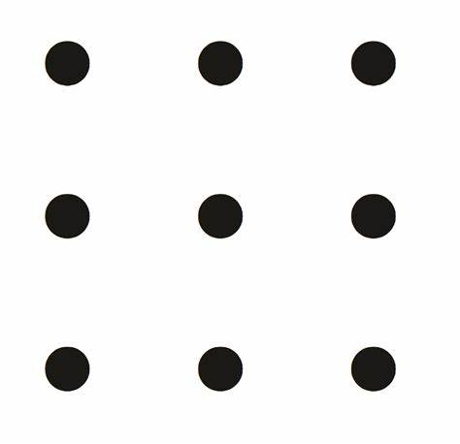

#### 16-dot grid

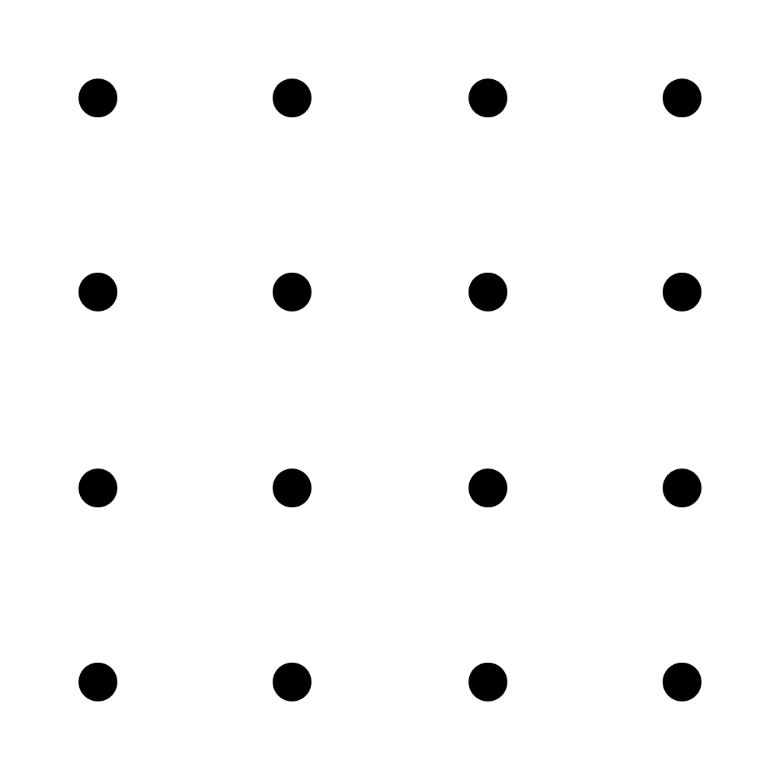

## Sample solutions

### Warm-up

$$256=64×4 \\ =16×16 \\ 180=9×20 \\ =4×45 \\ =36×5$$ 377 has no squared numbers as factors. $$540=9×60 \\ =4×135 \\ =36×15 \\ 300=100×3$$ 323 has no squared numbers as factors.

210 has no squared numbers as factors.

$$425=25×17 \\ 288=144×2 \\ =16×18 \\ =9×32 \\ =36×8$$

### Appendix A – dot grids

#### Ordered lengths for the 9-dot grid

1, $\sqrt{2},$ 2, $\sqrt{5}$ and $2\sqrt{2}$ or $\sqrt{8}$.

#### Ordered lengths for the 16-dot grid

1, 2, $\sqrt{2}, \sqrt{5}$, $2\sqrt{2}$ or $\sqrt{8}$, $3, \sqrt{10}, \sqrt{13}$ and $3\sqrt{2}$ or $\sqrt{18}$.

### Slide 12 – representing surds

$\sqrt{256}=2\sqrt{64}=4\sqrt{16}=8\sqrt{4}=16$

$\sqrt{180}=3\sqrt{20}=2\sqrt{45}=6\sqrt{5}$

1. $\sqrt{377}$ cannot be simplified
$\sqrt{540}=3\sqrt{60}=2\sqrt{135}=6\sqrt{15}$

$\sqrt{300}=10\sqrt{3}$

2. $\sqrt{323}$ cannot be simplified
3. $\sqrt{210}$ cannot be simplified

$\sqrt{425}=5\sqrt{17}$

$\sqrt{288}=2\sqrt{72}=4\sqrt{18}=3\sqrt{32}=6\sqrt{8}=12\sqrt{2}$

## References

This resource contains NSW Curriculum and syllabus content. The NSW Curriculum is developed by the NSW Education Standards Authority. This content is prepared by NESA for and on behalf of the Crown in right of the State of New South Wales. The material is protected by Crown copyright.

Please refer to the NESA Copyright Disclaimer for more information [https://educationstandards.nsw.edu.au/wps/portal/nesa/mini-footer/copyright](https://aus01.safelinks.protection.outlook.com/?url=https%3A%2F%2Feducationstandards.nsw.edu.au%2Fwps%2Fportal%2Fnesa%2Fmini-footer%2Fcopyright&data=05%7C01%7CCaitlin.Pace1%40det.nsw.edu.au%7C9c2c1a9f59c94d2df30708dafa7edb23%7C05a0e69a418a47c19c259387261bf991%7C0%7C0%7C638097720042599463%7CUnknown%7CTWFpbGZsb3d8eyJWIjoiMC4wLjAwMDAiLCJQIjoiV2luMzIiLCJBTiI6Ik1haWwiLCJXVCI6Mn0%3D%7C3000%7C%7C%7C&sdata=BzQh0UsffVZE3eO22b2Xba3p0VMOBZSHfS21FGHXtZM%3D&reserved=0).

NESA holds the only official and up-to-date versions of the NSW Curriculum and syllabus documents. Please visit the NSW Education Standards Authority (NESA) website <https://educationstandards.nsw.edu.au/> and the NSW Curriculum website <https://curriculum.nsw.edu.au/>.

[Mathematics K–10 Syllabus](https://curriculum.nsw.edu.au/learning-areas/mathematics/mathematics-k-10-2022/overview) © NSW Education Standards Authority (NESA) for and on behalf of the Crown in right of the State of New South Wales, 2022.

**© State of New South Wales (Department of Education), 2025**

The copyright material published in this resource is subject to the *Copyright Act 1968* (Cth) and is owned by the NSW Department of Education or, where indicated, by a party other than the NSW Department of Education (third-party material).

Copyright material available in this resource and owned by the NSW Department of Education is licensed under a [Creative Commons Attribution 4.0 International (CC BY 4.0) license](https://creativecommons.org/licenses/by/4.0/).

[](https://creativecommons.org/licenses/by/4.0/)

This license allows you to share and adapt the material for any purpose, even commercially.

Attribution should be given to © State of New South Wales (Department of Education), 2025.

Material in this resource not available under a Creative Commons license:

* the NSW Department of Education logo, other logos and trademark-protected material
* material owned by a third party that has been reproduced with permission. You will need to obtain permission from the third party to reuse its material.

**Links to third-party material and websites**

Please note that the provided (reading/viewing material/list/links/texts) are a suggestion only and implies no endorsement, by the New South Wales Department of Education, of any author, publisher, or book title. School principals and teachers are best placed to assess the suitability of resources that would complement the curriculum and reflect the needs and interests of their students.

If you use the links provided in this document to access a third-party's website, you acknowledge that the terms of use, including licence terms set out on the third-party's website apply to the use which may be made of the materials on that third-party website or where permitted by the *Copyright Act 1968* (Cth). The department accepts no responsibility for content on third-party websites.