# Exact ratios

Students learn where the exact values for the sine, cosine and tangent ratios originate from, why they always work and how to easily recall them.

## Visible learning

This lesson incorporates Path content.

Learning intentions and success criteria should be shared with students later in the learning episode.

### Learning intentions

* To understand the origin of the exact values of trigonometric ratios for specific angles.
* To be able to solve problems using exact values for trigonometric ratios.

### Success criteria

* I can determine the sine, cosine, and tangent ratios of given angles within a right-angled triangle using the exact trigonometric ratios.
* I can draw and label the special right-angled triangles used to find the exact values of trigonometric ratios.
* I can substitute exact values into trigonometric equations.
* I can simplify trigonometric expressions involving exact values.

### Syllabus outcomes

A student:

* develops understanding and fluency in mathematics through exploring and connecting mathematical concepts, choosing and applying mathematical techniques to solve problems, and communicating their thinking and reasoning coherently and clearly **MAO-WM-01**
* establishes and applies the properties of trigonometric functions and finds solutions to trigonometric equations **MA5-TRG-P-02**

[Mathematics K–10 Syllabus](https://curriculum.nsw.edu.au/learning-areas/mathematics/mathematics-k-10-2022/overview) © NSW Education Standards Authority (NESA) for and on behalf of the Crown in right of the State of New South Wales, 2022.

Table 1: lesson summary

|  |  |  |  |
| --- | --- | --- | --- |
| Section | Summary of activity | Teaching strategies | Teaching points |
| **Launch** | Students observe 3 bridges from slides 3–5 of the PowerPoint Exact ratios (ER PPT) and discuss what they notice and wonder. | Think-Pair-Share  Notice and wonder | Students are introduced to the importance of trigonometry in bridge building. |
| **Explore** | Students identify exact values in the trigonometry table (Appendix A). Students investigate the sine, cosine, and tangent ratios of isosceles triangles of varying length and conclude that the ratios are the same. They then use a bisected equilateral triangle of length 2 and various other lengths to discover the exact value ratios for the 60°, 30° triangle. | Visibly random groups of 3  Vertical non-permanent surfaces  Notice and wonder | This section aims to encourage students to think about what the other exact ratios in the trigonometry table are. The purpose of this section is to allow students to investigate various triangles with angles 30°,60° and 45° and recognise that the trigonometric ratios are consistent. |
| **Summarise** | The exact values for trigonometric ratios are confirmed (slides 10 and 11) and students discuss how they will remember them. Students are explicitly taught how to find exact values using a calculator (Appendix B). Students practise solving trigonometric equations using Appendix C. | Think-Pair-Share  Your turn method  Variation Theory  Notes to future forgetful selves | The aim of this section is for students to develop ways of remembering the exact values and practise using them to solve problems. |
| **Apply** | Students complete a triangle puzzle using exact values (Appendix D). |  | Students practise using exact values to find lengths. |

## Activity structure

Please use the associated PowerPoint *Exact ratios* (ER PPT) to display images in this lesson.

### Launch

1. Display slides 3–5 of the PowerPoint (ER PPT) and ask students in a Think-Pair-Share ([bit.ly/thinkpairsharestrategy](https://bit.ly/thinkpairsharestrategy)) to discuss what they notice and wonder ([bit.ly/noticewonderstrategy](https://bit.ly/noticewonderstrategy)) about the images.

Students might notice that the images are all bridges and that they are made up of triangles. Students might wonder why triangles are used or what type of triangles are used.

1. Show students the learning intentions and success criteria for the lesson.

### Explore

1. Ask students if they have heard of or know anything about a trigonometry table, which many people shorten to ‘trig table’.
2. Explain to students that a trig table was used before calculators to calculate the trigonometric ratio associated with each angle.
3. Distribute Appendix A ‘Trig table’ to pairs of students and have students check some of the values using their calculator.
4. In a Think-Pair-Share have students define the term ‘exact value’ and then identify if there are any exact values in the table.

An exact value is considered a value that can be expressed as a fraction. Students should identify that the ratios for 0° and 90° as well as $\tan{45°}=1,\cos{60°}=\frac{1}{2}$ and $\sin{30°}=\frac{1}{2}$ are exact values.

1. Assign students to visibly random groups of 3 ([bit.ly/visiblegroups](https://bit.ly/visiblegroups)) at vertical non-permanent surfaces ([bit.ly/VNPSstrategy](https://bit.ly/VNPSstrategy)).
2. Ask students to write down everything they know about isosceles triangles on their vertical surfaces.

Students should know that isosceles triangles have 2 equal sides and the 2 base angles are equal.

1. Ask students to sketch a right-angled isosceles triangle with the equal sides having a length of one unit. They should then calculate and add as much additional information as they can to the diagram.

Students should be able to find the size of all sides and angles using the properties of an isosceles triangle, the angle sum of a triangle and Pythagoras’ theorem. Slide 7 of the PowerPoint (ER PPT) models this for students.

1. Ask students to use their triangles to find the values for $\tan{45°},\cos{45°}$ and $\sin{45°}$.
2. Ask students to change the equal side lengths in their triangles from 1 to $x$, and again find the values of $\tan{45°}, \cos{45°}$ and $\sin{45°,}$ leaving their trigonometric ratios in the simplest form.

Students may need to be reminded that they will need to recalculate the hypotenuse of their triangle.

1. Ask groups to discuss what they notice and wonder about their answers.

Students should notice that the value of the ratios stayed the same and scaling the triangles did not change the trigonometric ratios.

Students might wonder if exact value ratios can be derived in a similar way for other angles.

1. Ask students to write down everything they know about equilateral triangles on their vertical surfaces.
2. Ask students to label the sides of their triangle with one unit like in the isosceles triangle and challenge students to find the values for $\tan{30°},\cos{30°}$ and $\sin{30°}$ as well as $\tan{60°},\cos{60°}$ and $\sin{60°}$.

Teachers may need to remind students that they need to find a right-angled triangle if they wish to use Pythagoras’ theorem or the trigonometric ratios. This can be achieved by bisecting their equilateral triangle.

1. In their groups have students discuss what they notice and wonder about the answers.

Students should observe that the answer is a fraction containing a surd and they might wonder whether it can be simplified into a more manageable or precise form.

1. Still in their groups, have the students discuss changes they could make to the equilateral triangle that would make the ratios simpler. Allow groups time to test their theory.

Students should realise that if the initial side length is 2, then the bisected side length will be 1, eliminating the need for fractions in the lengths. This is modelled on slide 8 of the PowerPoint. (ER PPT)

1. Ask students to find the value of the hypothenuse and then the values for $\tan{30°},\cos{30°},$ $\sin{30°},$ $\tan{60°},\cos{60°}$ and $\sin{60°}$.
2. Ask students to change the side lengths of their equilateral triangle to $2x$. Students should again calculate the values for $\tan{30°},\cos{30°},$ $\sin{30°},$ $\tan{60°},\cos{60°}$ and $\sin{60°}$ leaving their answers in simplest form.
3. Ask groups to discuss what they notice about their answers.

Students should notice that the answer is always the same.

### Summarise

1. Display slides 10 and 11 of the PowerPoint (ER PPT) revealing the 2 triangles and 9 exact values.
2. Tell students that many people draw the triangle each time they need to find an exact value and some choose to use their calculators.

The exact value triangles are on the current Stage 6 reference sheet but newer calculators will display the ratios in surd form.

1. Distribute Appendix B ‘Exact values and my calculator’ to each student and have them complete the table.
2. In a Think-Pair-Share ask students to share what they notice and what they wonder about the answers.

Students should notice that some trigonometric ratios produce a rational number and some do not. Students might wonder how the calculator helps students get the exact values from decimals.

1. Use slides 12–15 of the PowerPoint (ER PPT) for explicit teaching of using the calculator to find exact values. The explicit teaching technique used in the associated PowerPoint (ER PPT) is ‘Your turn’ ([bit.ly/supportingstrategies](https://bit.ly/supportingstrategies)).
2. Students are to create notes to their future forgetful selves ([bit.ly/notestofutureself](https://bit.ly/notestofutureself)) on the exact values for the trigonometric ratios of a right-angled triangle.
3. Distribute Appendix C ‘Variation Theory’ to each student and have them complete the questions.

Students can check their answers with peers at any time during the activity.

### Apply

Distribute Appendix D ‘Triangle puzzle’ and have students find the value of each side in the triangles. The shaded triangles are isosceles and the other triangles have angles of 60° and 30°.

## Assessment and differentiation

### Suggested opportunities for differentiation

**Launch**

* **This is an open-ended launch so all students can participate and share.**

**Explore**

* Students might benefit from the trigonometry table being enlarged to A3 size.
* Students might benefit from revising the definition of an exact value.
* Students might benefit from revising right-angled trigonometry and the properties of different triangles.
* Students might benefit from changing side lengths to multiples of 2 or 3 before moving on to $x.$
* Scaffolds could be provided as well as images of the triangles.
* Students should be encouraged to rationalise the denominator.
* The activity might need to be completed as a whole class.

**Summarise**

* **Individual activities could be completed in pairs.**
* **Some newer models of calculators give the exact value for trigonometric calculations.**
* **Challenge students to provide reasons why $tan 90°$ has no exact value.**
* **Students could be challenged by incorporating exact values into non-right-angled trigonometry problems or three-dimensional problems.**

**Apply**

* **Less ready students may need to be given more angles or sides.**

### Suggested opportunities for assessment

**Explore**

* Monitor responses in class discussions to check for student understanding of different triangles and trigonometric ratios.
* When placed in groups of 3, students provide and receive peer feedback on their understanding.
* Students will demonstrate their Working mathematically skills in justifying why the exact ratios stay the same for all right-angled isosceles and equilateral triangles.

**Summarise**

* Review students’ notes to their future forgetful selves for understanding of how they are going to remember the exact values.
* Monitor student responses in the ‘Your turn’ section to check for understanding.
* The teacher could collect Appendix C to form part of the formative assessment for this unit.

**Apply**

* Appendix D could be collected as an exit ticket for this unit.

## Appendix A

### Trig table

|  |  |  |  |  |  |  |  |
| --- | --- | --- | --- | --- | --- | --- | --- |
| A | sin (A) | cos (A) | tan (A) | A | sin (A) | cos (A) | tan (A) |
| 0 | 0.0000 | 1.0000 | 0.0000 | 45 | 0.7071 | 0.7071 | 1.0000 |
| 1 | 0.0175 | 0.9998 | 0.0175 | 46 | 0.7193 | 0.6947 | 1.0355 |
| 2 | 0.0349 | 0.9994 | 0.0349 | 47 | 0.7314 | 0.6820 | 1.0724 |
| 3 | 0.0523 | 0.9986 | 0.0524 | 48 | 0.7431 | 0.6691 | 1.1106 |
| 4 | 0.0698 | 0.9976 | 0.0699 | 49 | 0.7547 | 0.6561 | 1.1504 |
| 5 | 0.0872 | 0.9962 | 0.0875 | 50 | 0.7660 | 0.6428 | 1.1918 |
| 6 | 0.1045 | 0.9945 | 0.1051 | 51 | 0.7771 | 0.6293 | 1.2349 |
| 7 | 0.1219 | 0.9925 | 0.1228 | 52 | 0.7880 | 0.6157 | 1.2799 |
| 8 | 0.1392 | 0.9903 | 0.1405 | 53 | 0.7986 | 0.6018 | 1.3270 |
| 9 | 0.1564 | 0.9877 | 0.1574 | 54 | 0.8090 | 0.5978 | 1.3764 |
| 10 | 0.1736 | 0.9848 | 0.1763 | 55 | 0.8192 | 0.5739 | 1.4281 |
| 11 | 0.1908 | 0.9816 | 0.1944 | 56 | 0.8290 | 0.5592 | 1.4826 |
| 12 | 0.2079 | 0.9748 | 0.2126 | 57 | 0.8387 | 0.5446 | 1.5399 |
| 13 | 0.2250 | 0.9744 | 0.2309 | 58 | 0.8480 | 0.5299 | 1.6003 |
| 14 | 0.2419 | 0.9703 | 0.2493 | 59 | 0.8472 | 0.5150 | 1.6643 |
| 15 | 0.2588 | 0.9659 | 0.2679 | 60 | 0.8660 | 0.5000 | 1.7321 |
| 16 | 0.2756 | 0.9613 | 0.2867 | 61 | 0.8746 | 0.4848 | 1.8040 |
| 17 | 0.2924 | 0.9563 | 0.3057 | 62 | 0.8829 | 0.4695 | 1.8807 |
| 18 | 0.3090 | 0.9511 | 0.3249 | 63 | 0.8910 | 0.4540 | 1.9626 |
| 19 | 0.3256 | 0.9455 | 0.3443 | 64 | 0.8988 | 0.4384 | 2.0503 |
| 20 | 0.3420 | 0.9397 | 0.3640 | 65 | 0.9063 | 0.4226 | 2.1445 |
| 21 | 0.3584 | 0.9336 | 0.3839 | 66 | 0.9135 | 0.4067 | 2.2460 |
| 22 | 0.3746 | 0.9272 | 0.4040 | 67 | 0.9205 | 0.3907 | 2.3449 |
| 23 | 0.3907 | 0.9205 | 0.4245 | 68 | 0.9272 | 0.3746 | 2.4751 |
| 24 | 0.4067 | 0.9135 | 0.4452 | 69 | 0.9336 | 0.3584 | 2.6051 |
| 25 | 0.4226 | 0.9063 | 0.4663 | 70 | 0.9397 | 0.3420 | 2.7475 |
| 26 | 0.4384 | 0.8988 | 0.4877 | 71 | 0.9455 | 0.3256 | 2.9042 |
| 27 | 0.4540 | 0.8910 | 0.5095 | 72 | 0.9511 | 0.3090 | 3.0777 |
| 28 | 0.4695 | 0.8829 | 0.5317 | 73 | 0.9563 | 0.2924 | 3.2709 |
| 29 | 0.4848 | 0.8746 | 0.5543 | 74 | 0.9613 | 0.2756 | 3.4874 |
| 30 | 0.5000 | 0.8660 | 0.5774 | 75 | 0.9659 | 0.2588 | 3.7321 |
| 31 | 0.5150 | 0.8572 | 0.6009 | 76 | 0.9703 | 0.2419 | 4.0108 |
| 32 | 0.5299 | 0.8480 | 0.6249 | 77 | 0.9744 | 0.2250 | 4.3315 |
| 33 | 0.5446 | 0.8387 | 0.6494 | 78 | 0.9781 | 0.2079 | 4.7046 |
| 34 | 0.5592 | 0.8290 | 0.6745 | 79 | 0.9816 | 0.1908 | 5.1446 |
| 35 | 0.5736 | 0.8192 | 0.7002 | 80 | 0.9848 | 0.1736 | 5.6713 |
| 36 | 0.5878 | 0.8090 | 0.7265 | 81 | 0.9877 | 0.1584 | 6.3138 |
| 37 | 0.6018 | 0.7983 | 0.7536 | 82 | 0.9903 | 0.1392 | 7.1154 |
| 38 | 0.6157 | 0.7880 | 0.7819 | 83 | 0.9925 | 0.1219 | 8.1443 |
| 39 | 0.6293 | 0.7771 | 0.8098 | 84 | 0.9945 | 0.1045 | 9.5144 |
| 40 | 0.6428 | 0.7660 | 0.8691 | 85 | 0.9962 | 0.0872 | 11.4301 |
| 41 | 0.6561 | 0.7547 | 0.8693 | 86 | 0.9976 | 0.0698 | 14.3007 |
| 42 | 0.6691 | 0.7431 | 0.9004 | 87 | 0.9989 | 0.0523 | 19.0811 |
| 43 | 0.6820 | 0.7314 | 0.9325 | 88 | 0.9999 | 0.0349 | 28.6363 |
| 44 | 0.6945 | 0.7193 | 0.9647 | 89 | 0.9998 | 0.0175 | 57.2900 |
| 45 | 0.7071 | 0.7071 | 1.0000 | 90 | 1.0000 | 0.0000 |  |

## Appendix B

### Exact value and my calculator

|  |  |
| --- | --- |
| Calculator input | Calculator output |
| $$\tan{45°}$$ |  |
| $$\sin{45°}$$ |  |
| $$\cos{45°}$$ |  |
| $$\tan{60°}$$ |  |
| $$\sin{60°}$$ |  |
| $$\cos{60°}$$ |  |
| $$\tan{30°}$$ |  |
| $$\sin{30°}$$ |  |
| $$\cos{30°}$$ |  |
| $$\tan{0°}$$ |  |
| $$\sin{0°}$$ |  |
| $$\cos{0°}$$ |  |
| $$\sin{90°}$$ |  |
| $$\cos{90°}$$ |  |

## Appendix C

### Variation theory

Find the value of

|  |  |  |  |
| --- | --- | --- | --- |
| 1. | A right-angled triangle with angle 30 degrees. Hypotenuse 6m and adjacent side Xm. | 5. | A right-angled triangle with angle 45 degrees. Adjacent side Xm and opposite side 6m. |
| 2. | A right-angled triangle with angle 30 degrees. Hypotenuse Xm and adjacent side 6m. | 6. | A right-angled triangle with angle 45 degrees. Adjacent side Xm and hypotenuse 6m. |
| 3. | A right-angled triangle with angle 30 degrees. Hypotenuse Xm and opposite side 6m. | 7. | A right-angled triangle with angle 45 degrees. hypotenuse Xm and opposite side 6m. |
| 4. | A right-angled triangle with angle 30 degrees. Hypotenuse Xm and opposite side 12m. | 8. | A right-angled triangle with angle 60 degrees. Adjacent side 6m and opposite side Xm. |

## Appendix D

### Triangle puzzle

Find all side lengths in the diagram. The shaded triangles are isosceles triangles and the dot indicates an angle of 30°.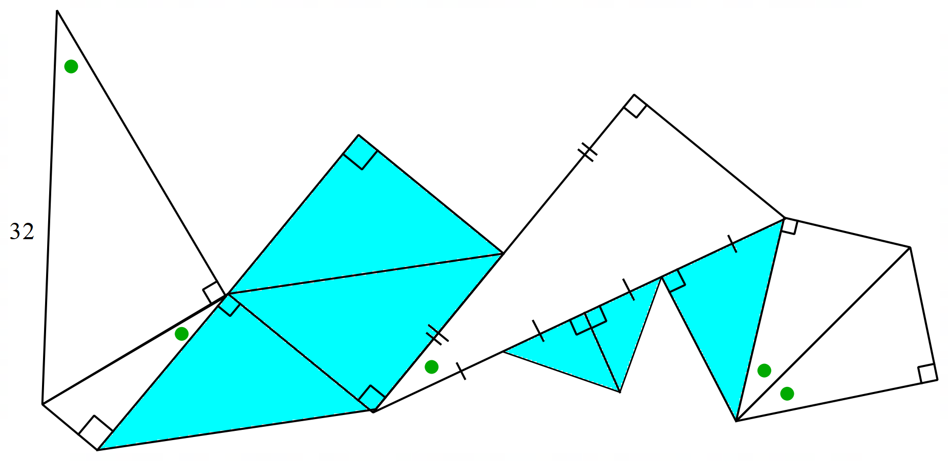

Not to scale

## Sample solutions

### Appendix B – exact value and my calculator

|  |  |
| --- | --- |
| Calculator input | Calculator output |
| $$\tan{45°}$$ | $$1$$ |
| $$\sin{45°}$$ | $$0.7071067$$ |
| $$\cos{45°}$$ | $$0.7071067$$ |
| $$\tan{60°}$$ | $$1.7320508$$ |
| $$\sin{60°}$$ | $$0.866025$$ |
| $$\cos{60°}$$ | $$0.5$$ |
| $$\tan{30°}$$ | $$0.5773503$$ |
| $$\sin{30°}$$ | $$0.5$$ |
| $$\cos{30°}$$ | $$0.866025$$ |
| $$\tan{0°}$$ | $$0$$ |
| $$\sin{0°}$$ | $$0$$ |
| $$\cos{0°}$$ | $$1$$ |
| $$\sin{90°}$$ | $$1$$ |
| $$\cos{90°}$$ | $$0$$ |

### Appendix C – Variation Theory

|  |  |  |  |
| --- | --- | --- | --- |
| 1. | $$\cos{30°}=\frac{x}{6} \\ \frac{\sqrt{3}}{2}=\frac{x}{6} \\ x=3\sqrt{3} m$$ | 5. | $$\tan{45°}=\frac{6}{x} \\ 1=\frac{6}{x} \\ x=6 m$$ |
| 2. | $$\cos{30°}=\frac{6}{x} \\ \frac{\sqrt{3}}{2}=\frac{6}{x} \\ x\sqrt{3}=12 \\ x=\frac{12}{\sqrt{3} }$$ | 6. | $$\cos{45°}=\frac{x}{6} \\ \frac{1}{\sqrt{2}}=\frac{x}{6} \\ x=\frac{6}{\sqrt{2}} m$$ |
| 3. | $$\sin{30°}=\frac{6}{x} \\ \frac{1}{2}=\frac{6}{x} \\ x=12 m$$ | 7. | $$\sin{45°}=\frac{6}{x} \\ \frac{1}{\sqrt{2}}=\frac{6}{x} \\ x=6\sqrt{2} m$$ |
| 4. | $$\sin{30°}=\frac{12}{x} \\ \frac{1}{2}=\frac{12}{x} \\ x=24 m$$ | 8. | $$\tan{60°}=\frac{x}{6} \\ \sqrt{3}=\frac{x}{6} \\ x=6\sqrt{3} m$$ |

### Appendix D – triangle puzzle

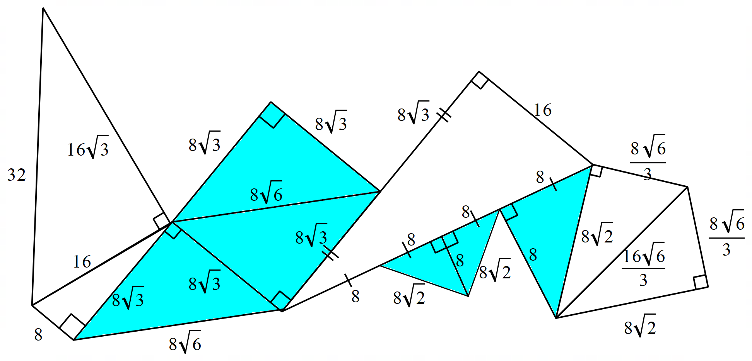

#### References

This resource contains NSW Curriculum and syllabus content. The NSW Curriculum is developed by the NSW Education Standards Authority. This content is prepared by NESA for and on behalf of the Crown in right of the State of New South Wales. The material is protected by Crown copyright.

Please refer to the NESA Copyright Disclaimer for more information [https://educationstandards.nsw.edu.au/wps/portal/nesa/mini-footer/copyright](https://aus01.safelinks.protection.outlook.com/?url=https%3A%2F%2Feducationstandards.nsw.edu.au%2Fwps%2Fportal%2Fnesa%2Fmini-footer%2Fcopyright&data=05%7C01%7CCaitlin.Pace1%40det.nsw.edu.au%7C9c2c1a9f59c94d2df30708dafa7edb23%7C05a0e69a418a47c19c259387261bf991%7C0%7C0%7C638097720042599463%7CUnknown%7CTWFpbGZsb3d8eyJWIjoiMC4wLjAwMDAiLCJQIjoiV2luMzIiLCJBTiI6Ik1haWwiLCJXVCI6Mn0%3D%7C3000%7C%7C%7C&sdata=BzQh0UsffVZE3eO22b2Xba3p0VMOBZSHfS21FGHXtZM%3D&reserved=0).

NESA holds the only official and up-to-date versions of the NSW Curriculum and syllabus documents. Please visit the NSW Education Standards Authority (NESA) website <https://educationstandards.nsw.edu.au/> and the NSW Curriculum website <https://curriculum.nsw.edu.au/>.

[Mathematics K–10 Syllabus](https://curriculum.nsw.edu.au/learning-areas/mathematics/mathematics-k-10-2022/overview) © NSW Education Standards Authority (NESA) for and on behalf of the Crown in right of the State of New South Wales, 2022.

**© State of New South Wales (Department of Education), 2025**

The copyright material published in this resource is subject to the *Copyright Act 1968* (Cth) and is owned by the NSW Department of Education or, where indicated, by a party other than the NSW Department of Education (third-party material).

Copyright material available in this resource and owned by the NSW Department of Education is licensed under a [Creative Commons Attribution 4.0 International (CC BY 4.0) license](https://creativecommons.org/licenses/by/4.0/).

[](https://creativecommons.org/licenses/by/4.0/)

This license allows you to share and adapt the material for any purpose, even commercially.

Attribution should be given to © State of New South Wales (Department of Education), 2025.

Material in this resource not available under a Creative Commons license:

* the NSW Department of Education logo, other logos and trademark-protected material
* material owned by a third party that has been reproduced with permission. You will need to obtain permission from the third party to reuse its material.

**Links to third-party material and websites**

Please note that the provided (reading/viewing material/list/links/texts) are a suggestion only and implies no endorsement, by the New South Wales Department of Education, of any author, publisher, or book title. School principals and teachers are best placed to assess the suitability of resources that would complement the curriculum and reflect the needs and interests of their students.

If you use the links provided in this document to access a third-party's website, you acknowledge that the terms of use, including licence terms set out on the third-party's website apply to the use which may be made of the materials on that third-party website or where permitted by the *Copyright Act 1968* (Cth). The department accepts no responsibility for content on third-party websites.