# Special trigonometric relationships

Students investigate complementary angles and why $\tan{θ=\frac{\sin{θ}}{\cos{θ}}}$.

## Visible learning

Learning intentions and success criteria should be shared with students later in the learning episode.

This lesson incorporates Path content.

### Learning intentions

* To use complementary angles to find results
* To verify that $\tan{θ=\frac{\sin{θ}}{\cos{θ}}}$

### Success criteria

* I can identify pairs of complementary angles.
* I can explain why $\sin{θ}=\cos{(90-θ)}$ and $\cos{θ=\sin{(90-θ)}}$
* I can prove why $\tan{θ=\frac{\sin{θ}}{\cos{θ}}}$.

### Syllabus outcomes

A student:

* develops understanding and fluency in mathematics through exploring and connecting mathematical concepts, choosing and applying mathematical techniques to solve problems, and communicating their thinking and reasoning coherently and clearly **MAO-WM-01**
* establishes and applies the properties of trigonometric functions and finds solutions to trigonometric equations **MA5-TRG-P-02**

[Mathematics K–10 Syllabus](https://curriculum.nsw.edu.au/learning-areas/mathematics/mathematics-k-10-2022/overview) © NSW Education Standards Authority (NESA) for and on behalf of the Crown in right of the State of New South Wales, 2022.

Table 1: lesson summary

|  |  |  |  |
| --- | --- | --- | --- |
| Section | Summary of activity | Teaching strategies | Teaching points |
| **Launch** | Students are shown a video ‘Exact Trig Values - Hand Trick’ (4:07) ([bit.ly/Trighandtrick](https://bit.ly/Trighandtrick)) demonstrating the hand trick used to remember the exact values for trigonometric ratios. |  | The purpose of this section is to initiate thinking about relationships related to trigonometric ratios. |
| **Explore 1** | Students use their calculators to complete Appendix A and observe any patterns. They verify their thinking using the graphs of $y=\sin{x}$ and $y=\cos{x}.$ | Think-Pair-Share  Notice and wonder  Pose-Pause-Pounce-Bounce | Students discover the complementary relationship between $\sin{θ}$ and $\cos{θ}$ |
| **Summarise 1** | Complementary angles are defined and unpacked further using slide 3–4 of the PowerPoint Special trigonometric relationships (STR PPT). |  | This section formalises the complementary angle relationship. |
| **Explore 2** | Students use their calculators to complete Appendix B and observe any patterns. | Think-Pair-Share | Students discover the relationship between $tan θ$ and $sin θ,\cos{θ}$. |
| **Summarise 2** | $\tan{θ=\frac{\sin{θ}}{\cos{θ}}}$ is defined and unpacked further using the PowerPoint. Students perform proofs using exact angles. | Think-Pair-Share | This section formalises rule $\tan{θ=\frac{\sin{θ}}{\cos{θ}}}$. |
| **Apply** | Students revisit the hand trick from the launch and try to explain why it works using the new relationships. | Think-Pair-Share  Pose-Pause-Pounce-Bounce | This section aims to determine the mathematics behind the hand trick. |

## Activity structure

Please use the associated PowerPoint *Special trigonometric relationships* (STR PPT) to display images in this lesson.

### Launch

1. Show students the video ‘Exact Trig Values - Hand Trick’ (4:07) ([bit.ly/Trighandtrick](https://bit.ly/Trighandtrick)).
2. In pairs allow students time to practise finding the exact trigonometric values using the hand trick.
3. Inform students that in this lesson they will discover some trigonometric relationships that help to explain why the hand trick works.

The students will not have enough information yet to explain why the trick works.  
The hand trick relies on symmetry; all ratios being divided by 2 and there are 5 different angles and 5 fingers. This will be explained in more detail later in the lesson.

### Explore 1 – complementary angles

1. Distribute Appendix A ‘Comparing answers’ to students and ask them to use their calculators to fill in the table.
2. In a Think-Pair-Share ([bit.ly/thinkpairsharestrategy](https://bit.ly/thinkpairsharestrategy)) ask students to consider what they notice and what they wonder ([bit.ly/noticewonderstrategy](https://bit.ly/noticewonderstrategy)) about their answers.

Students should observe that certain sine and cosine ratios for specific angles are identical. This should prompt curiosity about the relationship between these angles and the reasoning behind their equivalence.

1. Draw student's attention to the graph at the bottom of Appendix A. Tell students that these are the graphs of $y=\cos{x}$ and $y=\sin{x}$ between 0° and 90°.
2. Have students use the graph to verify what they noticed about the values in the table.

Figure 1: verifying results

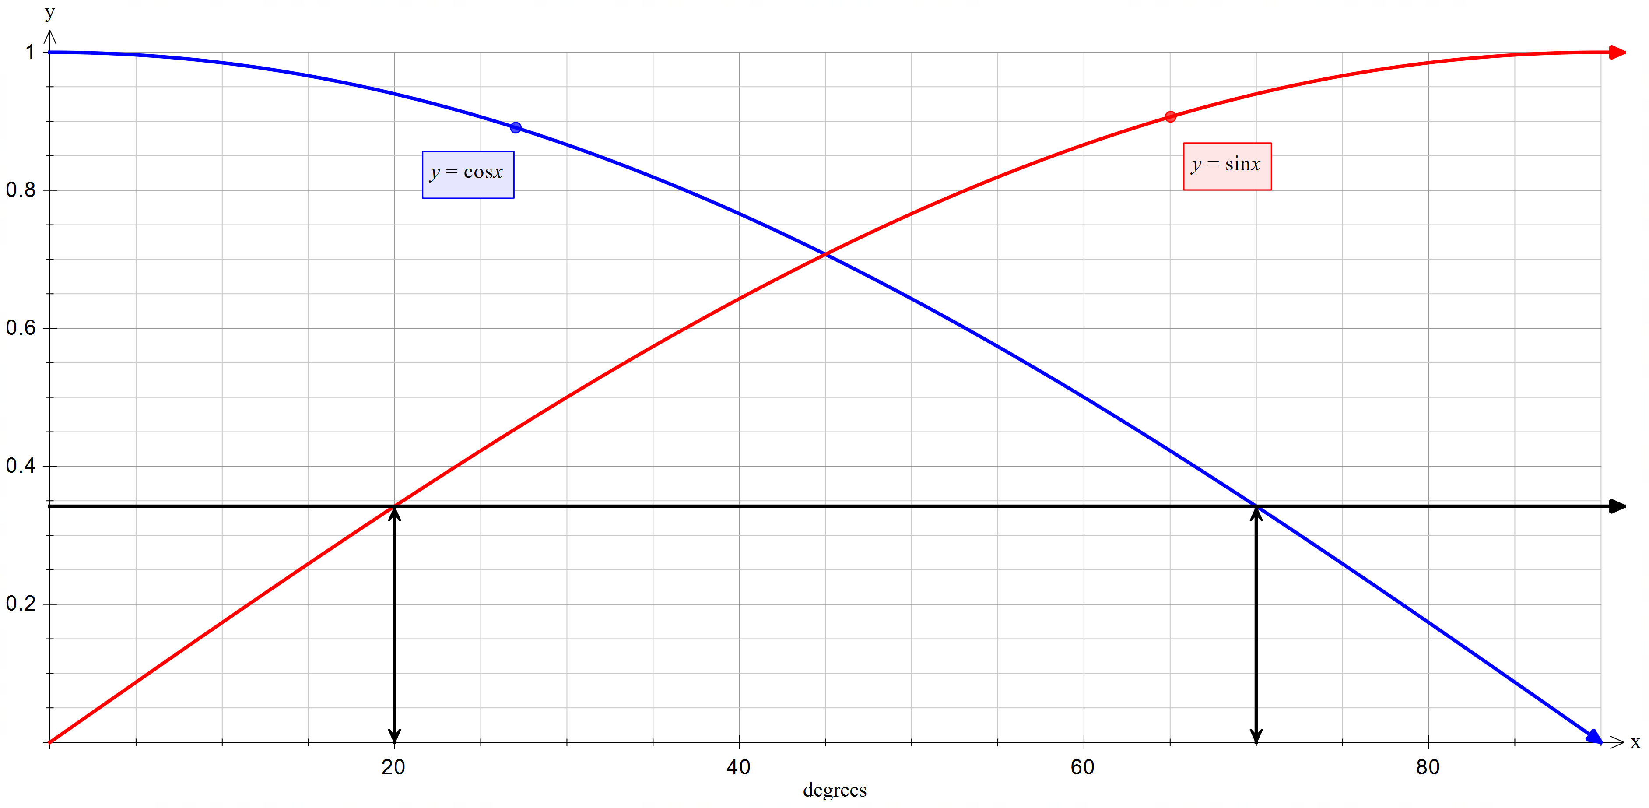

Students can draw vertical and horizontal lines showing 2 points with the same $y$ value as seen in Figure 1: verifying results

1. Use the Pose-Pause-Pounce-Bounce questioning strategy (PDF 557 KB) ([bit.ly/posepausepouncebounce](https://bit.ly/posepausepouncebounce)) to unpack students thinking.

### Summarise 1 – complementary angles

1. Reveal the relevant learning intentions and success criteria outlining to students the complementary angle rule.
2. Remind students of the concept that complementary angles add to 90° and display slide 3 of the PowerPoint (STR PPT) to display the relationships.
3. Display slide 4 of the PowerPoint (STR PPT) and have students answer the prompting questions in a Think-Pair-Share.
4. Revisit the exact value trigonometric ratios. Have students match all the complementary angles.

$\sin{60° =\cos{30°}}$, $\sin{30°=\cos{60°}}$, $\sin{45°=\cos{45°}}$, $\sin{90°=\cos{0°}}$, $\sin{0°=\cos{90°}}$

### Explore 2 - $\tan{x}$

1. Distribute Appendix B ‘Investigating tan’, and have students complete the columns in the table for ‘ $\tan{x}$ and $\frac{\sin{x}}{\cos{x}}$’ using their calculators.
2. In a Think-Pair-Share, ask students to consider what they notice and what they wonder about their answers.

Students should observe that the tangent ratio of an angle is equal to the sine ratio divided by the cosine ratio for that angle. This may prompt curiosity about why this relationship holds and why some answers show slight discrepancies. This provides an excellent opportunity to revisit the impact of rounding in calculations and how it affects results and why we use exact values when we can.

### Summarise 2 – $\tan{x}$

1. Display slide 5 of the PowerPoint (STR PPT) to formalise the relationship $\tan{θ=\frac{\sin{θ}}{\cos{θ}}}$.
2. In a Think-Pair-Share have students answer the prompting questions from slide 6.

Slide 7 models the proof for the angle A.

1. Using a 45° exact value triangle, have students prove that $\tan{45°=\frac{\sin{45°}}{\cos{45°}}}$.
2. Repeat the step above using the 60°,30° exact value triangle, proving that $\tan{30°=\frac{\sin{30°}}{\cos{30°}}}$ and $\tan{60°=\frac{\sin{60°}}{\cos{60°}}}$.

These proofs are in the suggested solutions.

### Apply

1. Revisit the hand trick from the launch.
2. Pose the question ‘Why does the hand trick work?’ and have students reconsider their response knowing the different relationships.
3. Allow students time to Think-Pair-Share before initiating a sharing of ideas and reasoning using the Pose-Pause-Pounce-Bounce questioning strategy.

The hand trick produces complementary angles for sine and cosine. It does this by counting below the finger for sine and above the finger for cosine. This works because the 5 angles and the pairs are in corresponding positions. The flipping of the hand to calculate the tangent of an angle places the sine value on the top and the cosine on the bottom, corresponding with the formula.

## Assessment and differentiation

### Suggested opportunities for differentiation

**Launch**

* Students may benefit from a visual prompt such as a hand, labelled with the angles.

**Explore**

* Appendix A or B could be completed in pairs or as a matching activity.
* Students could be extended into supplementary angles and asked to explain why they only exist for sine angles. This could be linked back to obtuse angles in non-right-angled triangles.

**Summarise**

* Students could be extended into writing formal proofs.
* Students may benefit from revising fraction division.
* Students could be extended into proving and using the, outside, inside shortcut for dividing fractions.

The outside, inside shortcut for dividing fractions involves multiplying the outside numbers together to form the numerator and then the inside numbers together to form the denominator. Students should understand why the shortcut works before using it. For example, $\frac{\frac{a}{b}}{\frac{c}{d}}=\frac{ad}{bc}$ where $a$ and $d$ are the outside values and $b$ and $c$ are the inside values.

**Apply**

* Students could be challenged to explain the hand trick to the class or make a short video explaining why the hand trick works.

### Suggested opportunities for assessment

**Launch**

* Self-assessment of the hand trick can be performed by checking answers on the calculator or using the exact ratio triangles.
* Students give each other peer feedback, before sharing with the class in a Think-Pair-Share.

**Explore**

* **The teacher should monitor students to ensure that the complementary angles are paired.**

**Summarise**

* Students will **demonstrate** their Working mathematically skills in answering the prompting questions from the PowerPoint slide.

**Apply**

* **The teacher should monitor students' responses to explanations to check for understanding of the 2 relationships to ensure that the complementary angles are paired.**

## Appendix A

### Comparing answers

$$\sin{x} and \cos{x}$$

|  |  |  |  |
| --- | --- | --- | --- |
| $$\sin{x=}$$ | answer | $$\cos{x=}$$ | answer |
| $$\sin{0°}$$ |  | $$\cos{0°}$$ |  |
| $$\sin{10°}$$ |  | $$\cos{10°}$$ |  |
| $$\sin{20°}$$ |  | $$\cos{20°}$$ |  |
| $$\sin{30°}$$ |  | $$\cos{30°}$$ |  |
| $$\sin{40°}$$ |  | $$\cos{40°}$$ |  |
| $$\sin{50°}$$ |  | $$\cos{50°}$$ |  |
| $$\sin{60°}$$ |  | $$\cos{60°}$$ |  |
| $$\sin{70°}$$ |  | $$\cos{70°}$$ |  |
| $$\sin{80°}$$ |  | $$\cos{80°}$$ |  |
| $$\sin{90°}$$ |  | $$\cos{90°}$$ |  |

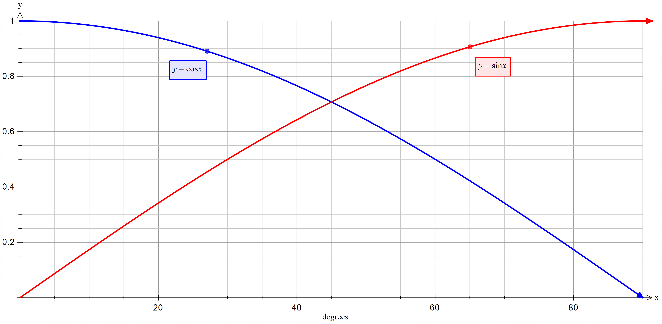

## Appendix B

### Investigating tan

$$\tan{x} and \frac{\sin{x}}{\cos{x}}$$

|  |  |  |  |
| --- | --- | --- | --- |
| $$\tan{x}=$$ | answer | $$s\frac{\sin{x}}{\cos{x}}=$$ | answer |
| $$\tan{0°}$$ |  | $$\frac{\sin{0°}}{\cos{0°}}$$ |  |
| $$\tan{10°}$$ |  | $$\frac{\sin{10°}}{\cos{10°}}$$ |  |
| $$\tan{20°}$$ |  | $$\frac{\sin{20°}}{\cos{20°}}$$ |  |
| $$\tan{30°}$$ |  | $$\frac{\sin{30°}}{\cos{30°}}$$ |  |
| $$\tan{40°}$$ |  | $$\frac{\sin{40°}}{\cos{40°}}$$ |  |
| $$\tan{50°}$$ |  | $$\frac{\sin{50°}}{\cos{50°}}$$ |  |
| $$\tan{60°}$$ |  | $$\frac{\sin{60°}}{\cos{60°}}$$ |  |
| $$\tan{70°}$$ |  | $$\frac{\sin{70°}}{\cos{70°}}$$ |  |
| $$\tan{80°}$$ |  | $$\frac{\sin{80°}}{\cos{80°}}$$ |  |
| $$\tan{90°}$$ |  | $$\frac{\sin{90°}}{\cos{90°}}$$ |  |

## Suggested solutions

### Appendix A – comparing answers

|  |  |  |  |
| --- | --- | --- | --- |
| $$\sin{x=}$$ | answer | $$\cos{x=}$$ | answer |
| $$\sin{0°}$$ | $$0$$ | $$\cos{0°}$$ | $$1$$ |
| $$\sin{10°}$$ | $$0.174$$ | $$\cos{10°}$$ | $$0.985$$ |
| $$\sin{20°}$$ | $$0.342$$ | $$\cos{20°}$$ | $$0.940$$ |
| $$\sin{30°}$$ | $$0.5$$ | $$\cos{30°}$$ | $$0.866$$ |
| $$\sin{40°}$$ | $$0.643$$ | $$\cos{40°}$$ | $$0.766$$ |
| $$\sin{50°}$$ | $$0.766$$ | $$\cos{50°}$$ | $$0.643$$ |
| $$\sin{60°}$$ | $$0.866$$ | $$\cos{60°}$$ | $$0.5$$ |
| $$\sin{70°}$$ | $$0.940$$ | $$\cos{70°}$$ | $$0.342$$ |
| $$\sin{80°}$$ | $$0.985$$ | $$\cos{80°}$$ | $$0.174$$ |
| $$\sin{90°}$$ | $$1$$ | $$\cos{90°}$$ | $$0$$ |

### Appendix B – investigating tan

|  |  |  |  |
| --- | --- | --- | --- |
| $$\tan{x}=$$ | answer | $$s\frac{\sin{x}}{\cos{x}}=$$ | answer |
| $$\tan{0°}$$ | $$0$$ | $$\frac{\sin{0°}}{\cos{0°}}$$ | $$0$$ |
| $$\tan{10°}$$ | $$0.176$$ | $$\frac{\sin{10°}}{\cos{10°}}$$ | $$0.177$$ |
| $$\tan{20°}$$ | $$0.364$$ | $$\frac{\sin{20°}}{\cos{20°}}$$ | $$0.364$$ |
| $$\tan{30°}$$ | $$0.577$$ | $$\frac{\sin{30°}}{\cos{30°}}$$ | $$0.577$$ |
| $$\tan{40°}$$ | $$0.839$$ | $$\frac{\sin{40°}}{\cos{40°}}$$ | $$0.839$$ |
| $$\tan{50°}$$ | $$1.192$$ | $$\frac{\sin{50°}}{\cos{50°}}$$ | $$1.191$$ |
| $$\tan{60°}$$ | $$1.732$$ | $$\frac{\sin{60°}}{\cos{60°}}$$ | $$1.732$$ |
| $$\tan{70°}$$ | $$2.747$$ | $$\frac{\sin{70°}}{\cos{70°}}$$ | $$2.749$$ |
| $$\tan{80°}$$ | $$5.671$$ | $$\frac{\sin{80°}}{\cos{80°}}$$ | $$5.661$$ |
| $$\tan{90°}$$ | undefined | $$\frac{\sin{90°}}{\cos{90°}}$$ | undefined |

### Summarise

$$\tan{45°=\frac{\sin{45°}}{\cos{45°}}} \\ =\frac{1}{\sqrt{2}}÷\frac{1}{\sqrt{2}} \\ =1$$

$$\tan{60°=\frac{\sin{60°}}{\cos{60°}}} \\ =\frac{\sqrt{3}}{2}÷\frac{1}{2} \\ =\frac{\sqrt{3}}{2}×\frac{2}{1} \\ =\sqrt{3}$$

$$\tan{30°=\frac{\sin{30°}}{\cos{30°}}} \\ =\frac{1}{2}÷\frac{\sqrt{3}}{2} \\ =\frac{1}{2}×\frac{2}{\sqrt{3}} \\ =\frac{1}{\sqrt{3}}$$

## References

This resource contains NSW Curriculum and syllabus content. The NSW Curriculum is developed by the NSW Education Standards Authority. This content is prepared by NESA for and on behalf of the Crown in right of the State of New South Wales. The material is protected by Crown copyright.

Please refer to the NESA Copyright Disclaimer for more information [https://educationstandards.nsw.edu.au/wps/portal/nesa/mini-footer/copyright](https://aus01.safelinks.protection.outlook.com/?url=https%3A%2F%2Feducationstandards.nsw.edu.au%2Fwps%2Fportal%2Fnesa%2Fmini-footer%2Fcopyright&data=05%7C01%7CCaitlin.Pace1%40det.nsw.edu.au%7C9c2c1a9f59c94d2df30708dafa7edb23%7C05a0e69a418a47c19c259387261bf991%7C0%7C0%7C638097720042599463%7CUnknown%7CTWFpbGZsb3d8eyJWIjoiMC4wLjAwMDAiLCJQIjoiV2luMzIiLCJBTiI6Ik1haWwiLCJXVCI6Mn0%3D%7C3000%7C%7C%7C&sdata=BzQh0UsffVZE3eO22b2Xba3p0VMOBZSHfS21FGHXtZM%3D&reserved=0).

NESA holds the only official and up-to-date versions of the NSW Curriculum and syllabus documents. Please visit the NSW Education Standards Authority (NESA) website <https://educationstandards.nsw.edu.au/> and the NSW Curriculum website <https://curriculum.nsw.edu.au/>.

[Mathematics K–10 Syllabus](https://curriculum.nsw.edu.au/learning-areas/mathematics/mathematics-k-10-2022/overview) © NSW Education Standards Authority (NESA) for and on behalf of the Crown in right of the State of New South Wales, 2022.

**© State of New South Wales (Department of Education), 2025**

The copyright material published in this resource is subject to the *Copyright Act 1968* (Cth) and is owned by the NSW Department of Education or, where indicated, by a party other than the NSW Department of Education (third-party material).

Copyright material available in this resource and owned by the NSW Department of Education is licensed under a [Creative Commons Attribution 4.0 International (CC BY 4.0) license](https://creativecommons.org/licenses/by/4.0/).

[](https://creativecommons.org/licenses/by/4.0/)

This license allows you to share and adapt the material for any purpose, even commercially.

Attribution should be given to © State of New South Wales (Department of Education), 2025.

Material in this resource not available under a Creative Commons license:

* the NSW Department of Education logo, other logos and trademark-protected material
* material owned by a third party that has been reproduced with permission. You will need to obtain permission from the third party to reuse its material.

**Links to third-party material and websites**

Please note that the provided (reading/viewing material/list/links/texts) are a suggestion only and implies no endorsement, by the New South Wales Department of Education, of any author, publisher, or book title. School principals and teachers are best placed to assess the suitability of resources that would complement the curriculum and reflect the needs and interests of their students.

If you use the links provided in this document to access a third-party's website, you acknowledge that the terms of use, including licence terms set out on the third-party's website apply to the use which may be made of the materials on that third-party website or where permitted by the *Copyright Act 1968* (Cth). The department accepts no responsibility for content on third-party websites.