# A circle and 4 quadrants

Students are introduced to the unit circle, the 4 quadrants and measuring angles in each quadrant.

Students will need at least one digital device per pair during this lesson.

## Visible learning

This lesson incorporates Path content.

### Learning intention

* To understand the unit circle and how it applies to trigonometry.

### Success criteria

* I can accurately draw and label the unit circle.
* I can label the 4 quadrants in a unit circle
* I can identify different angles around the unit circle.

### Syllabus outcomes

A student:

* develops understanding and fluency in mathematics through exploring and connecting mathematical concepts, choosing and applying mathematical techniques to solve problems, and communicating their thinking and reasoning coherently and clearly **MAO-WM-01**
* establishes and applies the properties of trigonometric functions and finds solutions to trigonometric equations **MA5-TRG-P-02**

[Mathematics K–10 Syllabus](https://curriculum.nsw.edu.au/learning-areas/mathematics/mathematics-k-10-2022/overview) © NSW Education Standards Authority (NESA) for and on behalf of the Crown in right of the State of New South Wales, 2022.

Table 1: lesson summary

|  |  |  |  |
| --- | --- | --- | --- |
| Section | Summary of activity | Teaching strategies | Teaching points |
| **Launch** | Students are introduced to the unit circle through an animation ([nrich.maths.org/5615](https://nrich.maths.org/5615)). | Think-Pair-Share  Notice and wonder | This section introduces the concept of the unit circle. |
| **Explore** | Students construct the 3 exact value triangles in quadrant 1 (Appendix A) to develop an understanding of the direction of the angles. Using the unit circle (Appendix B) they continue the direction of angles into quadrant 2, 3 and 4.  Slides 3–5 of the PowerPointA circle and 4 quadrants (CA4Q PPT) are used as visual support for students. | Pose-Pause-Pounce-Bounce  Think-Pair-Share | This section aims for students to discover the direction of angles around a unit circle and how to label quadrants. |
| **Summarise** | Slides 7 and 8 of the PowerPoint are used to formalise the quadrants in a unit circle, that angles become larger as you move anticlockwise around the circle and how to measure angles in each quadrant. | Notes to future forgetful selves | This section aims to consolidate the points of intersection and the angles around the unit circle. |
| **Apply** | Students then play a game locating different angles on the unit circle ([bit.ly/anglesinunitcircle](https://bit.ly/anglesinunitcircle)). |  | Students practise finding angles around the unit circle. |

## Activity structure

Please use the associated PowerPoint *A circle and 4 quadrants* (CA4Q PPT) to display images in this lesson.

### Launch

1. Navigate to the NRICH webpage ‘Where is the dot?’ ([nrich.maths.org/5615](https://nrich.maths.org/5615)) and play the GeoGebra animation for students.
2. In a Think-Pair-Share ([bit.ly/thinkpairsharestrategy](https://bit.ly/thinkpairsharestrategy)) have students consider what they notice and what they wonder ([bit.ly/noticewonderstrategy](https://bit.ly/noticewonderstrategy)) about the animation.

Students should notice that the circle has a radius of 1, it is broken up into quarters and that $x$ and $y$ values are displayed.

1. Inform students that the unit circle is a circle on the coordinate plane with a centre at the origin and a radius of 1.

### Explore

1. Distribute Appendix A ‘Quadrant 1’ to each student.
2. Display slide 3 of the PowerPoint (CA4Q PPT) which shows where quadrant 1 fits into the unit circle.
3. In a Think-Pair-Share ask students to consider why we would assign this quadrant to be quadrant 1.

Students may recognise that in this quadrant both $x$ and $y$ are positive values.

1. Ask students to draw lines which join the centre (0,0) to each of the blue points on the circumference of quadrant 1.
2. Using the Pose-Pause-Pounce-Bounce (PDF 557 KB) ([bit.ly/posepausepouncebounce](https://bit.ly/posepausepouncebounce)) questioning strategy ask students what length each of the lines are and how they know.

Each length is one unit long as they are all radii of the circle.

1. Have students construct triangles where the lines they have drawn are the hypotenuse and the $x$-axis is the base of the triangle. Slide 4 of the PowerPoint (CA4Q PPT) demonstrates this for students.
2. Inform students that they have just constructed exact value triangles and ask students to label the angle at the centre of the unit circle for each triangle.
3. In a Think-Pair-Share ask students what they notice and wonder about the angles they have marked.

Students should notice that they go up in ascending order and wonder what the angles around the rest of the circle may look like.

1. Using the Pose-Pause-Pounce-Bounce questioning strategy ask students where 0° and 90° might be.
2. Show slide 5 of the PowerPoint (CA4Q PPT) to model this for students.
3. Distribute Appendix B ‘The unit circle’ to students and in a Think-Pair-Share, ask them where quadrants 2, 3 and 4 would be and why.

Students should label 2, 3 and 4 in an anticlockwise direction as this is the direction in which the angles are getting bigger. Students might need prompting to consider how many degrees are in a circle and apply this to their diagram.

### Summarise

1. Formally introduce the unit circle to students using slide 7 of the PowerPoint (CA4Q PPT). Highlight important features such as the quadrant numbers, the direction of the angles and the angles at the axis.
2. Have students label the quadrants and the angles on their unit circle (Appendix B).
3. Display slide 8 of the PowerPoint (CA4Q PPT) to show students how we measure angles in each quadrant.
4. Ask students to draw and label the angles 45°,135°,225° and 315° on their copy of the unit circle.
5. Have students write notes to their future forgetful selves ([bit.ly/notestofutureself](https://bit.ly/notestofutureself)) on the unit circle.

### Apply

1. With at least one device per pair of students, have students navigate to ([bit.ly/anglesinunitcircle).](https://bit.ly/anglesinunitcircle)
2. Allow students time to play the game, finding the angles indicated on the circle.

Students click on the blue point they think corresponds to the angle provided. Students should take it in turns and complete the game trying to improve on their times.

## Assessment and differentiation

### Suggested opportunities for differentiation

**Launch**

* A notice and wonder strategy is used where there is no correct answer so that all students can participate in the discussion.

**Explore**

* The activity might need to be completed as a whole class.
* Students could be extended by using the scale to confirm the triangles are the exact triangles.
* Students could be presented with one quadrant at a time or only interact with the 2 top quadrants.

**Summarise**

* Students could be extended to consider angles that rotate in the opposite direction.

**Apply**

* Students may benefit from different angles being presented one at a time, not in digital format.
* Students could be extended by considering negative angles or angles greater than 360°.

### Suggested opportunities for assessment

**Explore**

* The teacher could monitor students' constructions in the first quadrant to determine readiness for the second to fourth quadrants.

**Summarise**

* The teacher could collect the notes to future forgetful selves as formative assessment for this unit.
* Monitor students’ unit circle diagrams for their understanding of angles around the unit circle.

**Apply**

* The teacher could monitor the unit circles angle game scores to check for understanding of angles around a unit circle by collecting times.

## Appendix A

### Quadrant 1

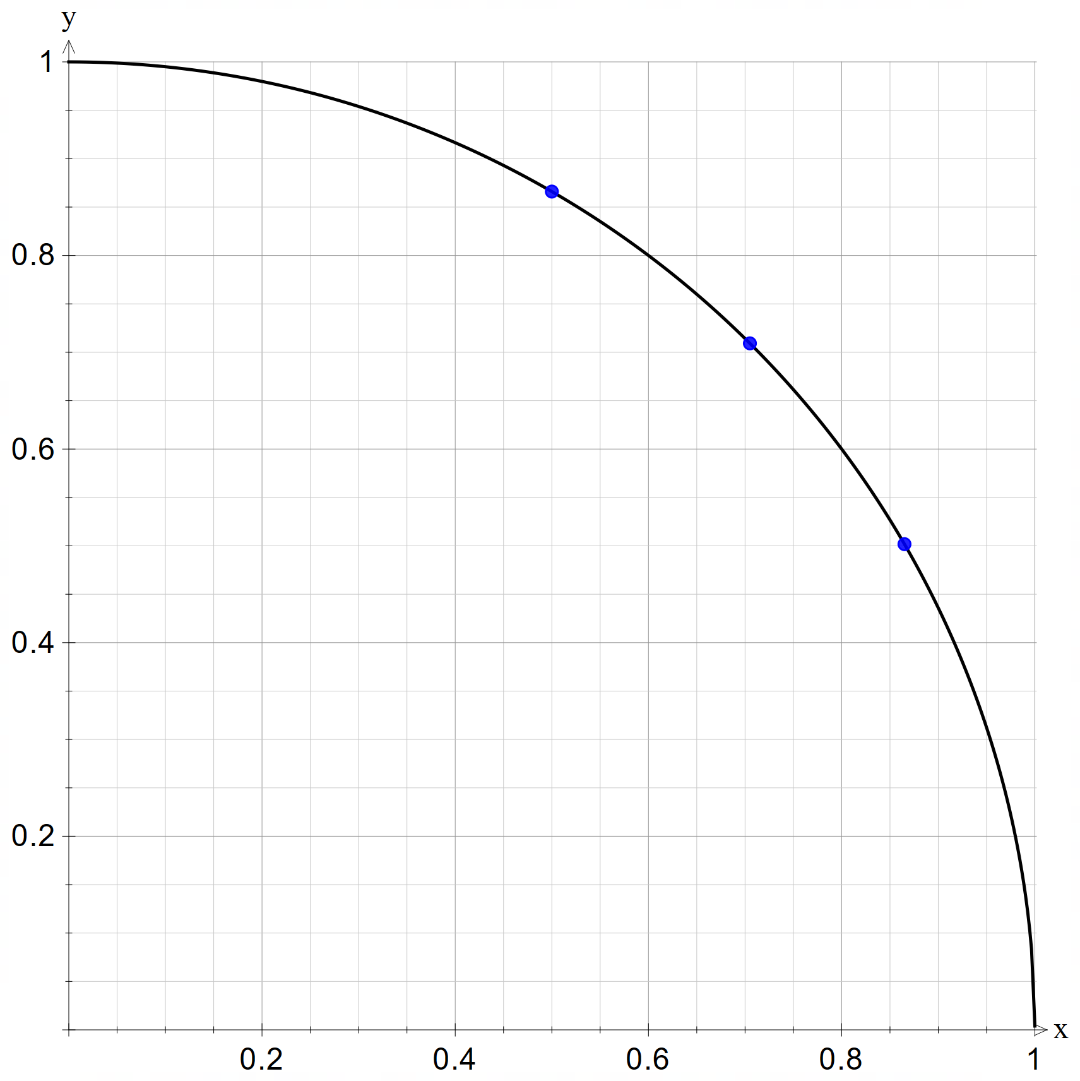

## Appendix B

### The unit circle

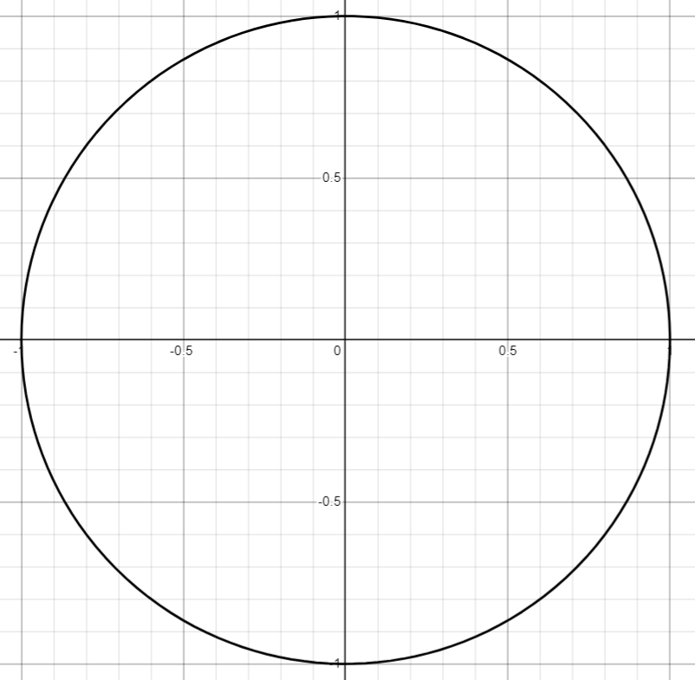

## References

This resource contains NSW Curriculum and syllabus content. The NSW Curriculum is developed by the NSW Education Standards Authority. This content is prepared by NESA for and on behalf of the Crown in right of the State of New South Wales. The material is protected by Crown copyright.

Please refer to the NESA Copyright Disclaimer for more information [https://educationstandards.nsw.edu.au/wps/portal/nesa/mini-footer/copyright](https://aus01.safelinks.protection.outlook.com/?url=https%3A%2F%2Feducationstandards.nsw.edu.au%2Fwps%2Fportal%2Fnesa%2Fmini-footer%2Fcopyright&data=05%7C01%7CCaitlin.Pace1%40det.nsw.edu.au%7C9c2c1a9f59c94d2df30708dafa7edb23%7C05a0e69a418a47c19c259387261bf991%7C0%7C0%7C638097720042599463%7CUnknown%7CTWFpbGZsb3d8eyJWIjoiMC4wLjAwMDAiLCJQIjoiV2luMzIiLCJBTiI6Ik1haWwiLCJXVCI6Mn0%3D%7C3000%7C%7C%7C&sdata=BzQh0UsffVZE3eO22b2Xba3p0VMOBZSHfS21FGHXtZM%3D&reserved=0).

NESA holds the only official and up-to-date versions of the NSW Curriculum and syllabus documents. Please visit the NSW Education Standards Authority (NESA) website <https://educationstandards.nsw.edu.au/> and the NSW Curriculum website <https://curriculum.nsw.edu.au/>.

[Mathematics K–10 Syllabus](https://curriculum.nsw.edu.au/learning-areas/mathematics/mathematics-k-10-2022/overview) © NSW Education Standards Authority (NESA) for and on behalf of the Crown in right of the State of New South Wales, 2022.

**© State of New South Wales (Department of Education), 2025**

The copyright material published in this resource is subject to the *Copyright Act 1968* (Cth) and is owned by the NSW Department of Education or, where indicated, by a party other than the NSW Department of Education (third-party material).

Copyright material available in this resource and owned by the NSW Department of Education is licensed under a [Creative Commons Attribution 4.0 International (CC BY 4.0) license](https://creativecommons.org/licenses/by/4.0/).

[](https://creativecommons.org/licenses/by/4.0/)

This license allows you to share and adapt the material for any purpose, even commercially.

Attribution should be given to © State of New South Wales (Department of Education), 2025.

Material in this resource not available under a Creative Commons license:

* the NSW Department of Education logo, other logos and trademark-protected material
* material owned by a third party that has been reproduced with permission. You will need to obtain permission from the third party to reuse its material.

**Links to third-party material and websites**

Please note that the provided (reading/viewing material/list/links/texts) are a suggestion only and implies no endorsement, by the New South Wales Department of Education, of any author, publisher, or book title. School principals and teachers are best placed to assess the suitability of resources that would complement the curriculum and reflect the needs and interests of their students.

If you use the links provided in this document to access a third-party's website, you acknowledge that the terms of use, including licence terms set out on the third-party's website apply to the use which may be made of the materials on that third-party website or where permitted by the *Copyright Act 1968* (Cth). The department accepts no responsibility for content on third-party websites.