# Exact values in 4 quadrants

Students link exact values and the Cartesian plane to produce unit circles.

Students will need at least one digital device per pair during this lesson.

## Visible learning

This lesson incorporates Path content.

### Learning intention

* To investigate angles and trigonometric values in quadrants 2–4 of the unit circle.

### Success criteria

* I can accurately draw and label the unit circle.
* I can find trigonometric ratios using the unit circle.
* I can plot points on the Cartesian plane corresponding to the exact trigonometric values.

### Syllabus outcomes

A student:

* develops understanding and fluency in mathematics through exploring and connecting mathematical concepts, choosing and applying mathematical techniques to solve problems, and communicating their thinking and reasoning coherently and clearly **MAO-WM-01**
* establishes and applies the properties of trigonometric functions and finds solutions to trigonometric equations **MA5-TRG-P-02**

[Mathematics K–10 Syllabus](https://curriculum.nsw.edu.au/learning-areas/mathematics/mathematics-k-10-2022/overview) © NSW Education Standards Authority (NESA) for and on behalf of the Crown in right of the State of New South Wales, 2022.

Table 1: lesson summary

|  |  |  |  |
| --- | --- | --- | --- |
| Section | Summary of activity | Teaching strategies | Teaching points |
| **Launch** | Students use trigonometric graphs from Appendix A to establish that there are 4 answers for every trigonometric ratio in a revolution, 2 positive and 2 negative. | Think-Pair-Share  Notice and wonder  Pose-Pause-Pounce-Bounce | This section starts students thinking about multiple solutions to trigonometric ratios, including negative solutions. |
| **Explore** | Students use Appendix B and Appendix C to explore where exact value triangles occur in all 4 quadrants. They then use slide 3 of the PowerPoint Exact values in 4 quadrants (EV4Q PPT) to develop establish the relationships $x=\cos{θ}$ and $y=\sin{θ}$. | Visibly random groups of 3  Vertical non-permanent surfaces  Gallery walk  Pose-Pause-Pounce-Bounce | This section aims to extend student understanding from one quadrant into 4 quadrants. |
| **Summarise** | Students use Appendix D to create paper plate unit circles showing exact values. Students are explicitly taught how to use the unit circle to find exact values around the unit circle using slides 6–9 of the PowerPoint. | Your turn | This section aims to consolidate the points of intersection and the angles around the unit circle. |
| **Apply** | Students use their paper plate unit circles to find the value of $\cos{θ} and\sin{θ}$ for various angles around the unit circle. Appendix E. | Variation Theory | In this section, students can read from their paper plate circles to solve equations. |

## Activity structure

Please use the associated PowerPoint *Exact values in 4 quadrants* (EV4Q PPT) to display images in this lesson.

### Launch

1. Distribute Appendix A ‘Trigonometric graphs’ to pairs of students.
2. Looking at Graph 1: $y=\sin{x, }$ have students find the angles (or corresponding $x$ values) where $y=\frac{1}{2}$ and $y=-\frac{1}{2}$.
3. Repeat step 2 using Graph 2: $y=\cos{x}$.
4. In a Think-Pair-Share ([bit.ly/thinkpairsharestrategy](https://bit.ly/thinkpairsharestrategy)), have students consider what they notice and what they wonder ([bit.ly/noticewonderstrategy](https://bit.ly/noticewonderstrategy)) about the solutions.

Students should notice that there are 2 angles for $y=\frac{1}{2}$ and 2 for $y=-\frac{1}{2}$ on each graph. Students should notice that these are related to the exact value triangles and might wonder how this relates to the unit circle or how the ratio of a trigonometric function can be negative given that they are lengths.

1. Pose the question for students to consider ‘Is this the same for all $y$ values?’ and allow pairs time to investigate their thinking using the 2 graphs on Appendix A.

Students could be prompted to consider $y$ = 0 or $y$ = 1 and then extended into considering other values that are easy to read from the graph, such as $y$ = 0.25.

1. Use the Pose-Pause-Pounce-Bounce questioning strategy (PDF 557 KB) ([bit.ly/posepausepouncebounce](https://bit.ly/posepausepouncebounce)) to unpack students' thinking.
2. Inform students that in this lesson they will be using the unit circle to understand why there are 2 solutions for both positive and negative values of $y$ and why a ratio can be negative.

### Explore

1. Assign students to visibly random groups of 3 ([bit.ly/visiblegroups](https://bit.ly/visiblegroups)) at vertical non-permanent surfaces ([bit.ly/VNPSstrategy](https://bit.ly/VNPSstrategy)).
2. Have students draw the 2 exact value triangles on the non-permanent surface and then distribute Appendix C ‘Unit circle triangles’ to each group.
3. Ask groups to change the side values on their exact value triangles to match that of the triangles in Appendix C.

Students will divide all sides by the hypotenuse to make the value of the hypotenuse 1.

Students should notice that the unit circle triangles are mathematically similar to the exact value triangles they are familiar with.

1. Distribute Appendix B ‘The unit circle’ to each group in A3 plastic sleeves.
2. Have groups choose a triangle from Appendix C, place it in the first quadrant and trace around it. Students will need to cut out the triangle before completing this step.

To assist students to place the triangle, they will need to recall that the hypotenuse of the triangle is 1 which is the same as the radius of the unit circle.

1. Ask groups to manipulate and trace the triangle so that they have a triangle in each quadrant. Instruct students to label the angles and sides as they progress around the circle.
2. Allow students time to do a gallery walk ([bit.ly/DLSgallerywalk](https://bit.ly/DLSgallerywalk)) observing other groups who have chosen a different sized triangle.
3. Have students return to their group and add any details they observed from other groups.

Students should have every angle and side of the triangles marked, as well as the points of intersection between the unit circle and the triangles.

Students might need to be reminded of the features of the Cartesian plane. For example, that $x$ values on the left side of the plane are negative, and that $y$ values below the $x$-axis are negative.

1. On students' vertical non-permanent surfaces, have them copy and complete the table from slide 3 of the PowerPoint (EV4Q PPT).

Do not erase the tables from the vertical non-permanent surfaces as these will be needed later in the lesson.

1. Allow students time to do a gallery walk to observe groups that have chosen different triangles.
2. Using the Pose-Pause-Pounce-Bounce questioning strategy, ask students what conclusions they can reach from their tables and to explain why this may be true.

Students should recognise from their tables that $\cos{θ}=x$ and $\sin{θ}=y$. This is because these trigonometric ratios have the hypotenuse as their denominator. Since the hypotenuse is 1, the ratio will equal the numerator, being the $x$ and $y$ values.

### Summarise

1. Distribute a paper plate to each student and Appendix D ‘Paper plate instructions’.

Students will need a plain paper plate with a crimpled rim around the edge.

1. Students are to construct a paper plate unit circle by using the instructions from Appendix D .

A picture of the completed plate is on slide 5 of the PowerPoint (EV4Q PPT).   
Students can use the table from step 9 of the explore activity, which should still be visible on the vertical non-permanent surfaces to assist them to label points on their unit circle.

1. Use slides 6–9 from the PowerPoint (EV4Q PPT) for explicit teaching of using the unit circle to find trigonometric ratios using the Worked examples (Your turn) method ([bit.ly/supportingstrategies](https://bit.ly/supportingstrategies)).

If students are not yet confident that $y=sinθ$ and $x=cosθ$ they could complete the worked examples using the trigonometric ratios $sinθ=\frac{opp}{hyp}$ and $cosθ=\frac{adj}{hyp}$ to reinforce these concepts.

### Apply

1. Distribute Appendix E ‘Variation Theory’ to students and have them use their paper plate unit circles to answer the questions.
2. Have students check their answers using their calculator.

## Assessment and differentiation

### Suggested opportunities for differentiation

**Launch**

* A notice and wonder strategy is used where there is no correct answer so that all students can participate in the discussion.
* Students might benefit from horizontal lines being added to the graphs in Appendix A at $y=\frac{1}{2}$ and $y=-\frac{1}{2}$.
* Students could be encouraged to use the graph of $y=\tan{x}$ and $y=±1$.

**Explore**

* Students could be presented with blank triangles and asked to find the sides and angles.
* The activity might need to be completed as a whole class.
* Students could be presented with one quadrant at a time or only interact with the 2 top quadrants.
* Students might benefit from repeating the activity for all 3 triangles presented in Appendix C.

**Summarise**

* A visual of the final paper plate could be provided to students (Slide 3 of the PowerPoint (EV4Q PPT)).
* Students might like to use a protractor instead of folding the plate.

**Apply**

* Students could be extended to negative angles or angles greater than 360°.
* Students might benefit from the teacher's explanation in moving from the diagram to the questions in Appendix E.

### Suggested opportunities for assessment

**Explore**

* The teacher should monitor students to check for the correct placement of the exact values on the unit circle.
* The teacher could monitor student’s responses to the table to ensure that the sign and value are correct.

**Summarise**

* The teacher could collect the paper plate unit circles as formative assessment for this unit.
* Monitor student responses in the ‘Your turn’ section to check for understanding.

**Apply**

* Students check their answers using their calculator. The teacher should monitor students achievement to inform learning for the next lesson.
* Some questions from Appendix E could be collected as an exit ticket.

## Appendix A

### Trigonometric graphs

Graph 1: $y =\sin{x}$

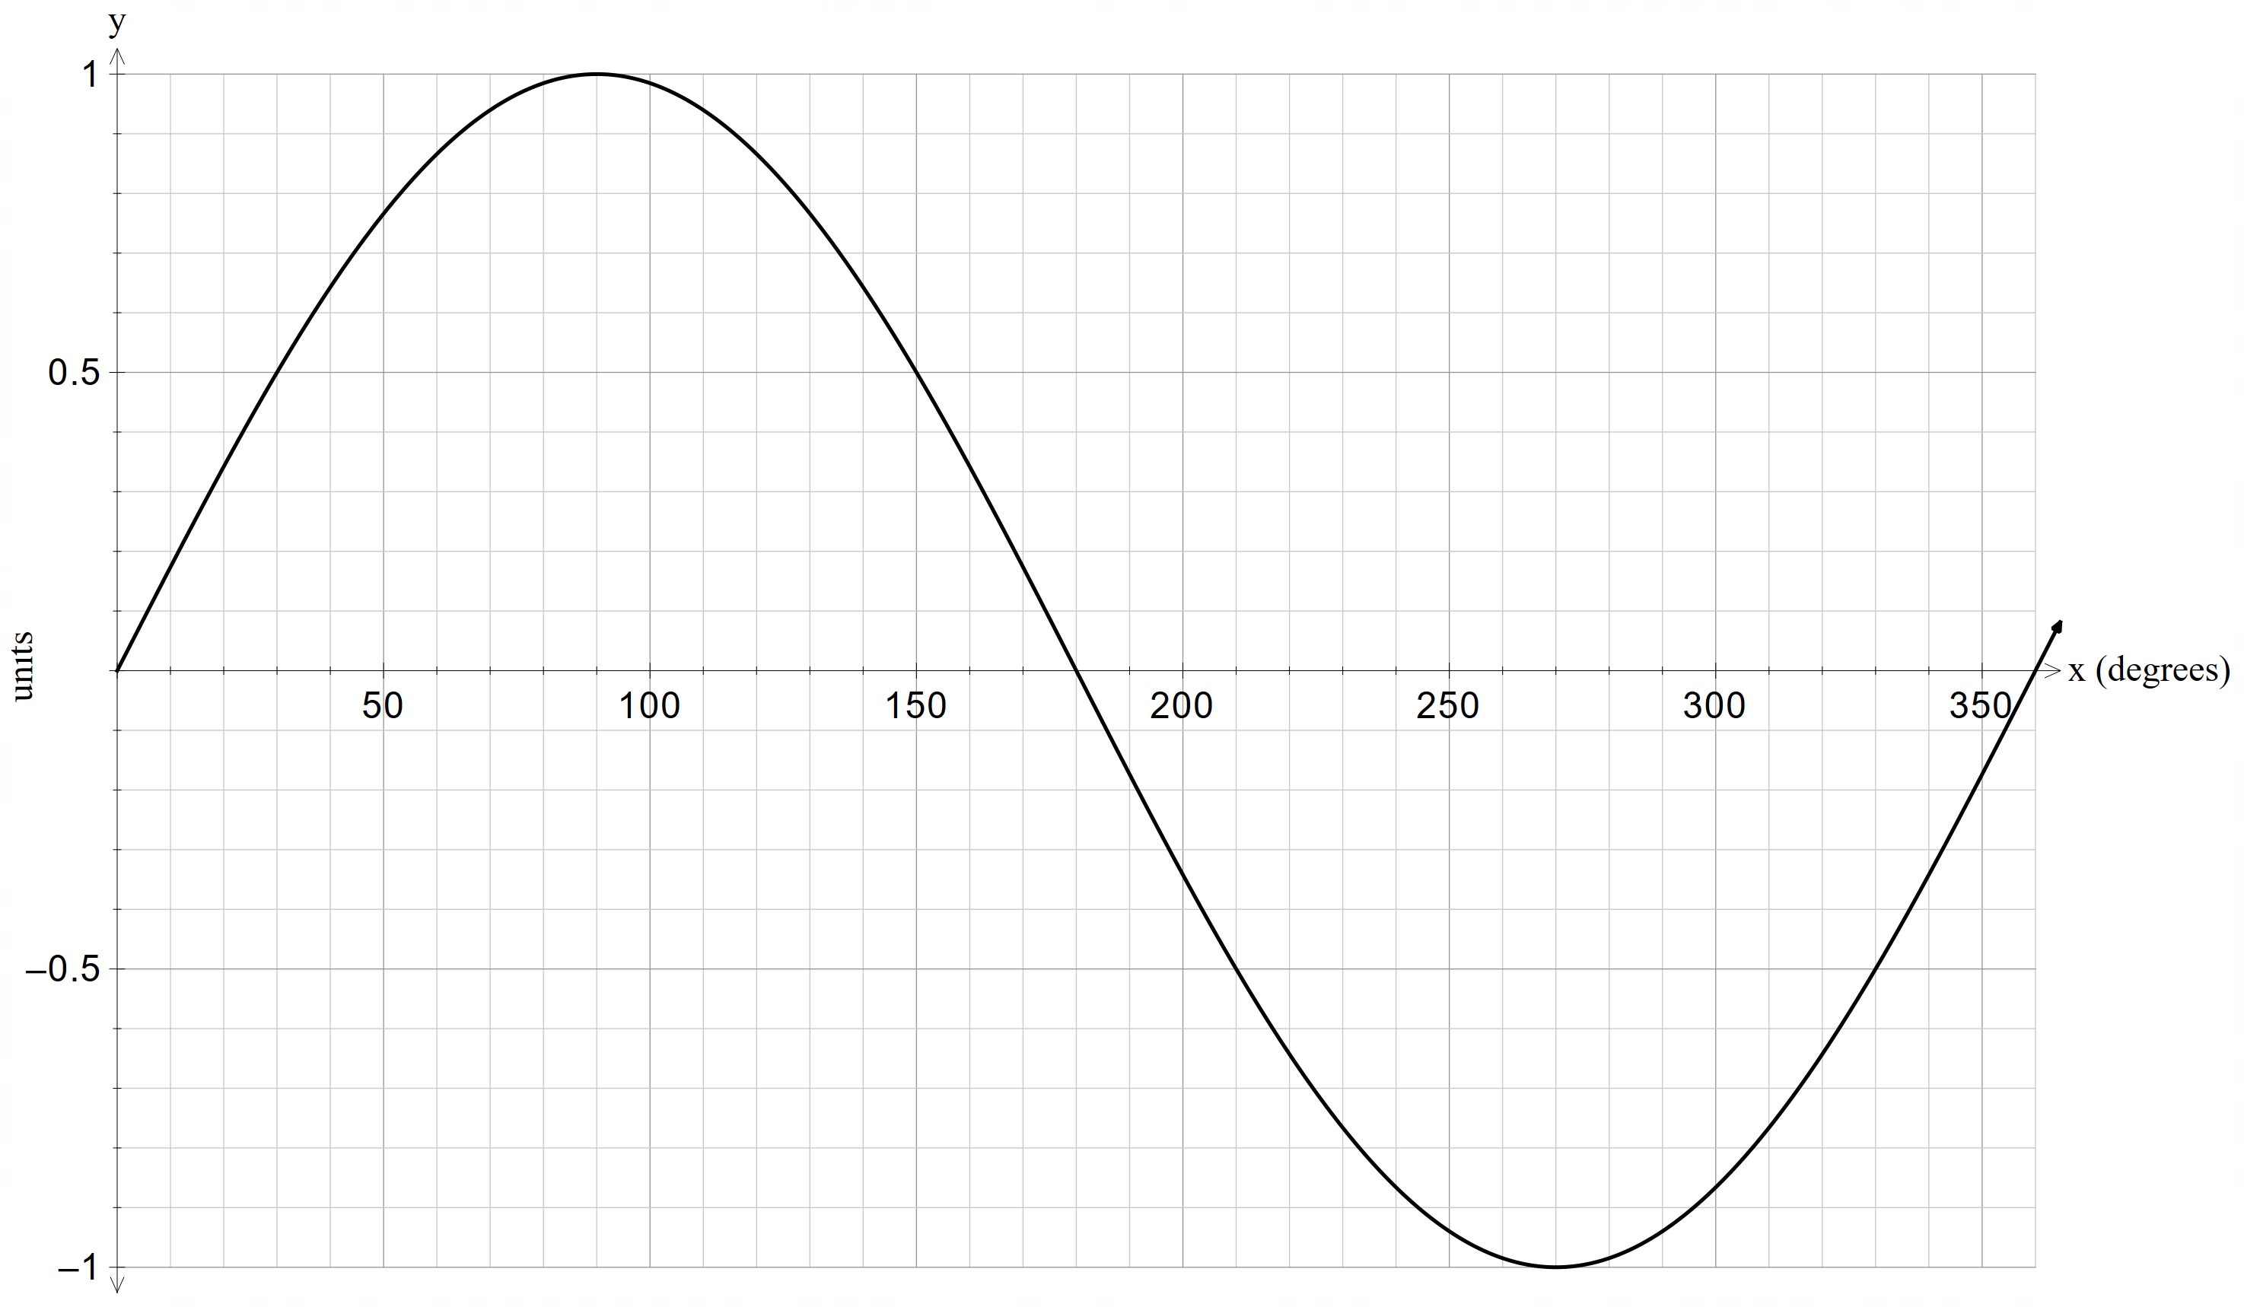

Graph 2: $y =\cos{x}$

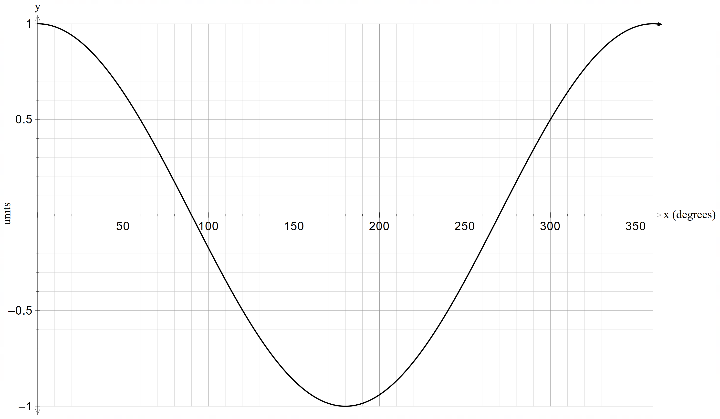

## Appendix B

### The unit circle

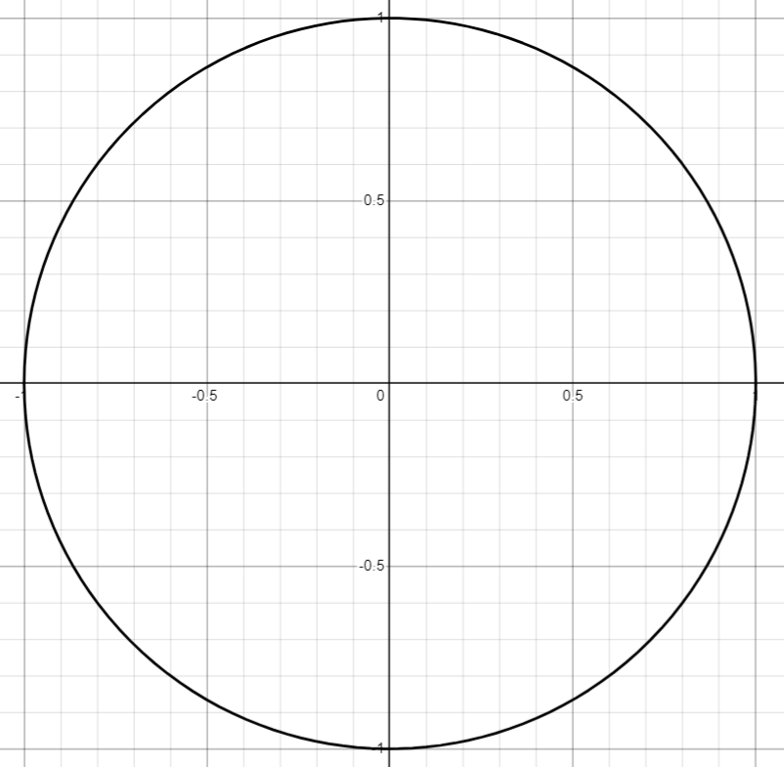

## Appendix C

### Unit circle triangles

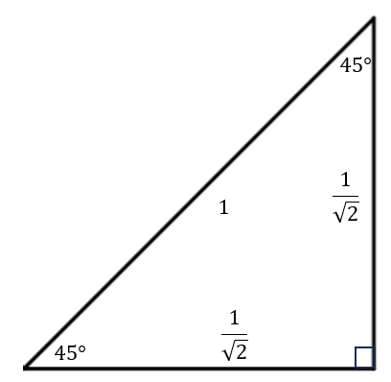

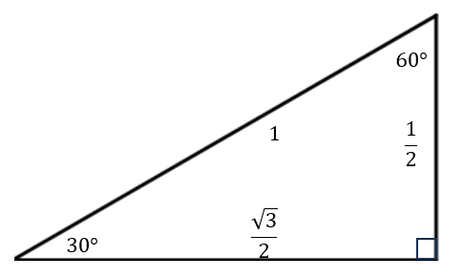

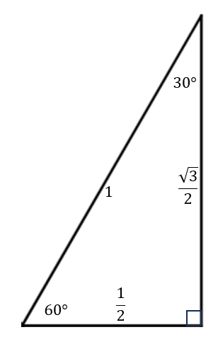

## Appendix D

### Paper plate instructions

1. Draw a circle separating the edge section of the plate from the middle smooth section.
2. Fold the plate in half and then in half again to create 4 quadrants.
3. Unfold the plate and draw and label the angles 0°,90°,180°,270° and 360° ensuring that quadrant 1 is in the top right side of the plate.
4. Fold the plate in eighths.
5. Unfold the plate and draw and label the angles 45°,135°,225°,315°.
6. Label the points of intersection of the circumference and the angle rays using the exact value triangle with base angle 45° or the table step 9 of the Explore that should still be visible on the vertical non-permanent surfaces.
7. Fold the plate in half along the $x$-axis and then in thirds.

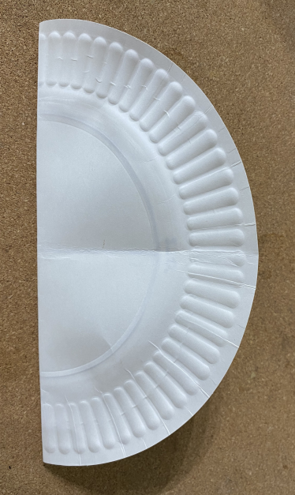

1. Unfold the plate and draw and label the angles 60°,120°,240°,300°.
2. Label the points of intersection of the circumference and the angle rays using the exact value triangle with base angle 60°.
3. Fold the plate in half along the $y$-axis and then in thirds.

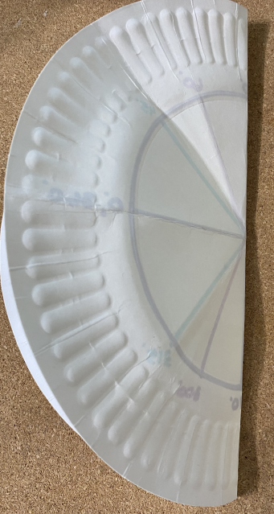

1. Unfold the plate and draw and label the angles 30°, 150°, 210°, 330°.
2. Label the points of intersection of the circumference and the angle rays using the exact value triangle with base angle 30° or the table step 9 of the Explore that should still be visible on the vertical non-permanent surfaces.

## Appendix E

### Variation Theory

|  |  |  |  |
| --- | --- | --- | --- |
| 1. | $$\sin{45°}$$ | 14. | $$\sin{330}°$$ |
| 2. | $$\sin{135°}$$ | 15. | $$\sin{300}°$$ |
| 3. | $$\sin{225°}$$ | 16. | $$\cos{60}°$$ |
| 4. | $$\sin{315°}$$ | 17. | $$\cos{120}°$$ |
| 5. | $$\cos{45°}$$ | 18. | $$\cos{150}°$$ |
| 6. | $$\cos{135°}$$ | 19. | $$\cos{210}°$$ |
| 7. | $$\cos{225°}$$ | 20. | $$\cos{300}°$$ |
| 8. | $$\cos{315°}$$ | 21. | $$\cos{330°}$$ |
| 9. | $$\sin{60°}$$ | 22. | $$\cos{270}°$$ |
| 10. | $$\sin{120}°$$ | 23. | $$\cos{90}°$$ |
| 11. | $$\sin{150}°$$ | 24. | $$\sin{90}°$$ |
| 12. | $$\sin{210}°$$ | 25. | $$\sin{270}°$$ |
| 13. | $$\sin{240}°$$ | 26. | $$\sin{180}°$$ |

## Sample solutions

### Explore tables

|  |  |  |  |  |
| --- | --- | --- | --- | --- |
| Quadrant | $$x value$$ | $$\cos{θ°}$$ | $$y value$$ | $$\sin{θ}$$ |
| 1 | $$\frac{1}{2}$$ | $$\frac{1}{2}$$ | $$\frac{\sqrt{3}}{2}$$ | $$\frac{\sqrt{3}}{2}$$ |
| 2 | $$-\frac{1}{2}$$ | $$-\frac{1}{2}$$ | $$\frac{\sqrt{3}}{2}$$ | $$\frac{\sqrt{3}}{2}$$ |
| 3 | $$-\frac{1}{2}$$ | $$-\frac{1}{2}$$ | $$-\frac{\sqrt{3}}{2}$$ | $$-\frac{\sqrt{3}}{2}$$ |
| 4 |  |  |  |  |

|  |  |  |  |  |
| --- | --- | --- | --- | --- |
| Quadrant | $$x value$$ | $$\cos{θ°}$$ | $$y value$$ | $$\sin{θ}$$ |
| 1 | $$\frac{1}{\sqrt{2}}$$ | $$\frac{1}{\sqrt{2}}$$ | $$\frac{1}{\sqrt{2}}$$ | $$\frac{1}{\sqrt{2}}$$ |
| 2 | $$-\frac{1}{\sqrt{2}}$$ | $$-\frac{1}{\sqrt{2}}$$ | $$\frac{1}{\sqrt{2}}$$ | $$\frac{1}{\sqrt{2}}$$ |
| 3 | $$-\frac{1}{\sqrt{2}}$$ | $$-\frac{1}{\sqrt{2}}$$ | $$-\frac{1}{\sqrt{2}}$$ | $$-\frac{1}{\sqrt{2}}$$ |
| 4 |  |  |  |  |

|  |  |  |  |  |
| --- | --- | --- | --- | --- |
| Quadrant | $$x value$$ | $$\cos{θ°}$$ | $$y value$$ | $$\sin{θ}$$ |
| 1 | $$\frac{\sqrt{3}}{2}$$ | $$\frac{\sqrt{3}}{2}$$ | $$\frac{1}{2}$$ | $$\frac{1}{2}$$ |
| 2 | $$-\frac{\sqrt{3}}{2}$$ | $$-\frac{\sqrt{3}}{2}$$ | $$\frac{1}{2}$$ | $$\frac{1}{2}$$ |
| 3 | $$-\frac{\sqrt{3}}{2}$$ | $$-\frac{\sqrt{3}}{2}$$ | $$-\frac{1}{2}$$ | $$-\frac{1}{2}$$ |
| 4 | $$\frac{\sqrt{3}}{2}$$ | $$\frac{\sqrt{3}}{2}$$ | $$-\frac{1}{2}$$ | $$-\frac{1}{2}$$ |

### Appendix E – Variation Theory

|  |  |  |  |
| --- | --- | --- | --- |
| 1. | $$\sin{45°}=\frac{1}{\sqrt{2}}$$ | 14. | $$\sin{330}°=-\frac{1}{2}$$ |
| 2. | $$\sin{135°=\frac{1}{\sqrt{2}}}$$ | 15. | $$\sin{300}°=\frac{-\sqrt{3}}{2}$$ |
| 3. | $$\sin{225°}=-\frac{1}{\sqrt{2}}$$ | 16. | $$\cos{60}°=\frac{1}{2}$$ |
| 4. | $$\sin{315°=-\frac{1}{\sqrt{2}}}$$ | 17. | $$\cos{120}°=-\frac{1}{2}$$ |
| 5. | $$\cos{45°}=\frac{1}{\sqrt{2}}$$ | 18. | $$\cos{150}°=-\frac{\sqrt{3}}{2}$$ |
| 6. | $$\cos{135°}=-\frac{1}{\sqrt{2}}$$ | 19. | $$\cos{210}°=\frac{-\sqrt{3}}{2}$$ |
| 7. | $$\cos{225°=-\frac{1}{\sqrt{2}}}$$ | 20. | $$\cos{300}°=\frac{1}{2}$$ |
| 8. | $$\cos{315°}=\frac{1}{\sqrt{2}}$$ | 21. | $$\cos{330°=\frac{\sqrt{3}}{2}}$$ |
| 9. | $$\sin{60°}=\frac{\sqrt{3}}{2}$$ | 22. | $$\cos{270}°=0$$ |
| 10. | $$\sin{120}°=\frac{\sqrt{3}}{2}$$ | 23. | $$\cos{90}°=0$$ |
| 11. | $$\sin{150}°=\frac{1}{2}$$ | 24. | $$\sin{90}°=1$$ |
| 12. | $$\sin{210}°=-\frac{1}{2}$$ | 25. | $$\sin{270}°=-1$$ |
| 13. | $$\sin{240}°=-\frac{\sqrt{3}}{2}$$ | 26. | $$\sin{180}°=0$$ |

## References

This resource contains NSW Curriculum and syllabus content. The NSW Curriculum is developed by the NSW Education Standards Authority. This content is prepared by NESA for and on behalf of the Crown in right of the State of New South Wales. The material is protected by Crown copyright.

Please refer to the NESA Copyright Disclaimer for more information [https://educationstandards.nsw.edu.au/wps/portal/nesa/mini-footer/copyright](https://aus01.safelinks.protection.outlook.com/?url=https%3A%2F%2Feducationstandards.nsw.edu.au%2Fwps%2Fportal%2Fnesa%2Fmini-footer%2Fcopyright&data=05%7C01%7CCaitlin.Pace1%40det.nsw.edu.au%7C9c2c1a9f59c94d2df30708dafa7edb23%7C05a0e69a418a47c19c259387261bf991%7C0%7C0%7C638097720042599463%7CUnknown%7CTWFpbGZsb3d8eyJWIjoiMC4wLjAwMDAiLCJQIjoiV2luMzIiLCJBTiI6Ik1haWwiLCJXVCI6Mn0%3D%7C3000%7C%7C%7C&sdata=BzQh0UsffVZE3eO22b2Xba3p0VMOBZSHfS21FGHXtZM%3D&reserved=0).

NESA holds the only official and up-to-date versions of the NSW Curriculum and syllabus documents. Please visit the NSW Education Standards Authority (NESA) website <https://educationstandards.nsw.edu.au/> and the NSW Curriculum website <https://curriculum.nsw.edu.au/>.

[Mathematics K–10 Syllabus](https://curriculum.nsw.edu.au/learning-areas/mathematics/mathematics-k-10-2022/overview) © NSW Education Standards Authority (NESA) for and on behalf of the Crown in right of the State of New South Wales, 2022.

**© State of New South Wales (Department of Education), 2025**

The copyright material published in this resource is subject to the *Copyright Act 1968* (Cth) and is owned by the NSW Department of Education or, where indicated, by a party other than the NSW Department of Education (third-party material).

Copyright material available in this resource and owned by the NSW Department of Education is licensed under a [Creative Commons Attribution 4.0 International (CC BY 4.0) license](https://creativecommons.org/licenses/by/4.0/).

[](https://creativecommons.org/licenses/by/4.0/)

This license allows you to share and adapt the material for any purpose, even commercially.

Attribution should be given to © State of New South Wales (Department of Education), 2025.

Material in this resource not available under a Creative Commons license:

* the NSW Department of Education logo, other logos and trademark-protected material
* material owned by a third party that has been reproduced with permission. You will need to obtain permission from the third party to reuse its material.

**Links to third-party material and websites**

Please note that the provided (reading/viewing material/list/links/texts) are a suggestion only and implies no endorsement, by the New South Wales Department of Education, of any author, publisher, or book title. School principals and teachers are best placed to assess the suitability of resources that would complement the curriculum and reflect the needs and interests of their students.

If you use the links provided in this document to access a third-party's website, you acknowledge that the terms of use, including licence terms set out on the third-party's website apply to the use which may be made of the materials on that third-party website or where permitted by the *Copyright Act 1968* (Cth). The department accepts no responsibility for content on third-party websites.