# The unit circle

Students will determine the sign of any angle in the unit circle and practise matching equivalent ratios for positive angles up to 360°.

## Visible learning

This lesson incorporates Path content.

Learning intentions and success criteria are released to students after the launch activity.

### Learning intention

* To identify equivalent trigonometric ratios in the unit circle.

### Success criteria

* I can identify in which quadrants trigonometric ratios are negative or positive.
* I can explain why different trigonometric ratios in the unit circle are positive or negative.
* I can match trigonometric ratios that are equivalent.

### Syllabus outcomes

A student:

* develops understanding and fluency in mathematics through exploring and connecting mathematical concepts, choosing and applying mathematical techniques to solve problems, and communicating their thinking and reasoning coherently and clearly **MAO-WM-01**
* establishes and applies the properties of trigonometric functions and finds solutions to trigonometric equations **MA5-TRG-P-02**

[Mathematics K–10 Syllabus](https://curriculum.nsw.edu.au/learning-areas/mathematics/mathematics-k-10-2022/overview) © NSW Education Standards Authority (NESA) for and on behalf of the Crown in right of the State of New South Wales, 2022.

Table 1: lesson summary

|  |  |  |  |
| --- | --- | --- | --- |
| Section | Summary of activity | Teaching strategies | Teaching points |
| **Launch** | Display slide 3 of the PowerPoint The unit circle (TUC PPT) and ask students to choose which one does not belong. | Think-Pair-Share | Students should start to wonder how the sign of the trigonometric function can be found. |
| **Explore** | Students use the unit circle (Appendix A) and the points $(x,y)(-x,y)(-x,-y)(x,-y)$ to discover the trigonometric ratios in all 4 quadrants. They also discover the general angle formula for each quadrant. | Think-Pair-Share  Notice and wonder | Students develop an understanding of why different angles in different quadrants are the same but with different signs. |
| **Summarise** | Students are explicitly taught how to match trigonometric ratios and summarise their learnings using Appendix B. | Your turn | Students summarise their thinking and practise applying the unit circle to different trigonometric values. |
| **Apply** | Students apply their knowledge by grouping Appendix C cards into positive and negative ratios and then matching the cards with the equivalent value. | Visibly random groups of 3  Advancing and assessing questions  Vertical non-permanent surfaces | Students should realise that every angle in the unit circle has another matching angle. |

## Activity structure

Please use the associated PowerPoint *The unit circle* (TUC PPT) to display images in this lesson.

### Launch

1. Using slide 3 of the PowerPoint (TUC PPT), display Table 2: Which one does not belong?

Table 2: Which one does not belong?

|  |  |
| --- | --- |
| $$\sin{20°}$$ | $$\cos{70°}$$ |
| $$\sin{160°}$$ | $$\sin{200°}$$ |

1. In a Think-Pair-Share ([bit.ly/thinkpairsharestrategy](https://bit.ly/thinkpairsharestrategy)), ask students which one doesn’t belong ([bit.ly/wodb](https://talkingmathwithkids.com/wodb/)).

While there is no correct answer to the which one does not belong, in the discussion draw out that $\sin{200°}$ is the same magnitude as the other 3 but a different sign.

### Explore

1. Distribute Appendix A ‘The unit circle’ to each student and have students construct a triangle in the first quadrant similar to the exact ratio triangles and mark the angle at the centre as $θ$ and the point on the circumference $(x,y)$.

Students have constructed triangles in all four quadrants in Lesson 6 – exact values in 4 quadrants.

1. Using $θ$ as the angle at the centre of the circle, ask students to find $\sin{θ},\cos{θ} \&\tan{θ}$ in terms of $x$ and $y$.
2. Display slide 5 of the PowerPoint (TUC PPT) to model the triangle in the first quadrant, and click to reveal the ratios.
3. Have students construct 3 more triangles the same size as their first in each of the other 3 quadrants.
4. Have students label the points $\left(-x,y\right),\left(-x,-y\right), \left(x,-y\right)$ and the angle at the centre $θ$.
5. Again, using $θ$ as the angle at the centre of the circle, ask students to find $\sin{θ},\cos{θ} and \tan{θ}$ in terms of $x$ and $y$ for each quadrant.

Slides 6–8 of the PowerPoint (TUC PPT) demonstrate to students how to find $\sin{θ},\cos{θ} and \tan{θ}$ in terms of $x$ and $y$ for each quadrant.

1. In a Think-Pair-Share have students comment on what they notice and wonder ([bit.ly/noticewonderstrategy](https://bit.ly/noticewonderstrategy)) about the trigonometric ratios they have found.

Students should notice that they have the same values but different signs. Students might wonder what this means or how this fact could be used to solve problems.

1. Display slide 9 of the PowerPoint (TUC PPT) and ask students in a Think-Pair-Share to answer the question prompts for each circle. Click to reveal the answer once students have shared.
2. Repeat for slide 10 of the PowerPoint (TUC PPT).

### Summarise

1. Distribute Appendix B ‘Summary notes’ to students and display slide 12 of the PowerPoint (TUC PPT).
2. Ask students to highlight the inequality in each quadrant that is the ‘odd one out’ (if applicable).
3. Generate a class discussion using the Pose-Pause-Pounce-Bounce questioning strategy (PDF 557 KB) ([bit.ly/posepausepouncebounce](https://bit.ly/posepausepouncebounce)). The questions should be based on the success criteria.

* How can I identify which quadrant an angle belongs in?
* How do I know if the trigonometric ratio is positive or negative?

Students should realise that the acute angles are in the first quadrant, obtuse angles are in the second, angles between 180° and 270° are in the third and angles between 270° and 360° are in the fourth.

Students should realise that in the first quadrant all ratios are positive, in the second, sine is the only positive, in the third quadrant, tan is the only positive and in the fourth, cosine is the only positive. It is more beneficial for students to have a deep conceptual understanding of why this occurs rather than remembering acronyms such as ‘All Stations To Central’.

1. Explicitly teach students how to identify if 2 angles have equivalent trigonometric ratios using slides 13–16 of the PowerPoint (TUC PPT) using the Worked examples (Your turn) method ([bit.ly/supportingstrategies](https://bit.ly/supportingstrategies)).
2. Have students add notes to their future forgetful selves ([bit.ly/notestofutureself](https://bit.ly/notestofutureself)) to Appendix B.
3. Allow students time to do a Think-Pair-Share determining any clarifying questions they might have about the work so far.

### Apply

1. Assign students to visibly random groups of 3 ([bit.ly/visiblegroups](https://bit.ly/visiblegroups)) at vertical non-permanent surfaces ([bit.ly/VNPSstrategy](https://bit.ly/VNPSstrategy)).
2. Distribute Appendix C ‘Card sort’ and adhesive putty.

These cards can be cut out before the lesson or students can cut them out during the lesson.

1. Ask students to write the words positive and negative on their surface and stick the cards under one of these headings.
2. To further student thinking, ask students assessing and advancing questions ([bit.ly/supportingstrategies](https://bit.ly/supportingstrategies)). Some suggestions are provided in Table 3.

Table 3: assessing and advancing questions

|  |  |
| --- | --- |
| Assessing questions | Advancing questions |
| Why have you put that card in the negative pile? | What are the angles in the second quadrant? |
| Does your calculator support that answer? | What ratio’s answers are negative in the second quadrant? |
| Can that card belong in either pile? | What do you know about all the acute angle ratios? |

1. Once students have sorted the cards into 2 piles, have groups match the cards that have the same value.

Students should check their answers on a calculator.

## Assessment and differentiation

### Suggested opportunities for differentiation

**Launch**

* There are no correct answers during the launch and all students should be encouraged to participate and share their thoughts.
* Students could be encouraged to make their own ‘Which one does not belong?’

**Explore**

* Students could be given a triangle to use as a template as they move between quadrants.
* Students could be given a point on the unit circle for each quadrant rather than $x$ and $y$ values. Examples of points could be $\left(0.6,0.8\right), \left(-0.6,0.8\right), \left(-0.6,-0.8\right) and (0.6, -0.8)$

**Summarise**

* Students could be given sentence starters to probe thinking.
* The inequalities within the Appendix B ‘Summary table’ could be simplified.

**Apply**

* Students could be encouraged to initially categorise the angles into the correct quadrant.
* Angles can be changed depending upon the ability of the students.
* Students could move straight to matching the cards rather than separating the cards into positive and negative values.
* Students could be given blank cards to create their own set of matching cards.
* Students could be encouraged to move outside the domain of $0≤θ≤360°.$
* The teacher could provide students with some starter ratios.

### Suggested opportunities for assessment

**Launch**

* Monitor student's responses to Think-Pair-Share to assess their understanding of the unit circle and complementary angles.

**Explore**

* Monitor students’ construction of triangles in the unit circle to assess understanding of finding trigonometric ratios and angles in the unit circle.

**Summarise**

* Monitor student responses in the ‘Your turn’ section to check for understanding.
* Review students’ notes to their future forgetful selves for understanding of finding the trigonometric ratio using the unit circle.

**Apply**

* Monitor students' reasoning behind classifying the cards as either negative or positive.
* Students can monitor their own work by checking answers using their calculator.
* Use one of the pairs of trigonometric ratios as an exit ticket.

## Appendix A

### The unit circle

A circle with radius 1 unit. 



## Appendix B

### Summary notes

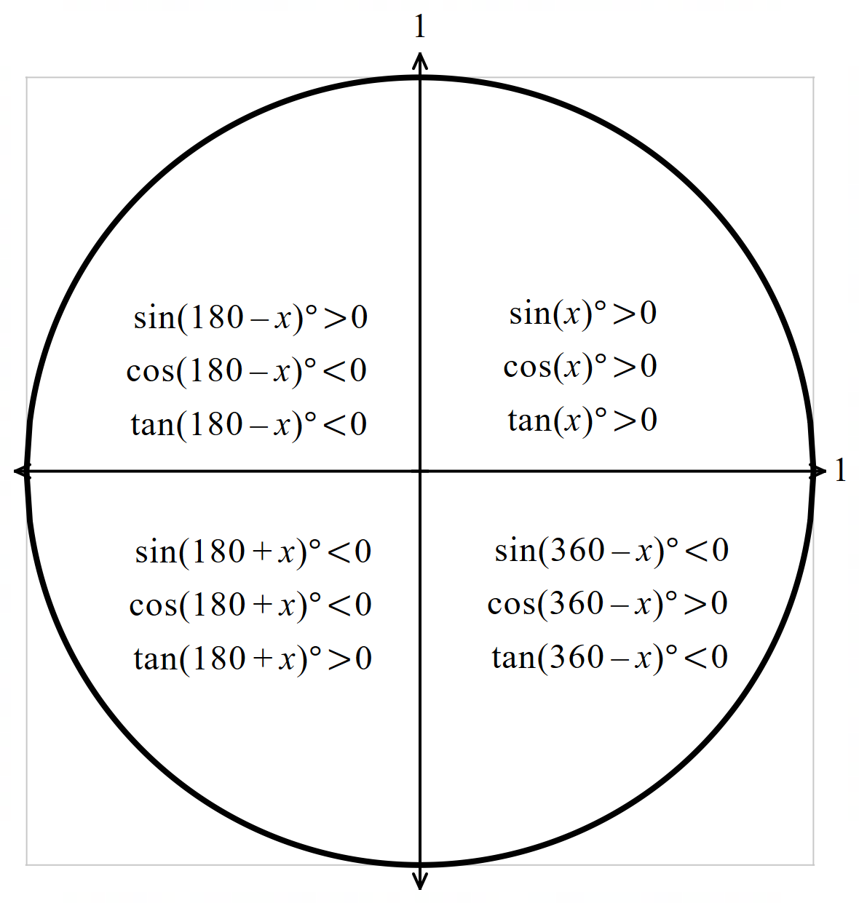

## Appendix C

### Card sort

|  |  |  |
| --- | --- | --- |
| $$\cos{21°}$$ | $$\sin{21}°$$ | $$\tan{21}°$$ |
| $$\cos{159}°$$ | $$\sin{159}°$$ | $$\tan{159}°$$ |
| $$\cos{201}°$$ | $$\sin{201}°$$ | $$\tan{201}°$$ |
| $$\cos{339}°$$ | $$\sin{339}°$$ | $$\tan{339}°$$ |
| $$\cos{35}°$$ | $$\sin{35}°$$ | $$\tan{35}°$$ |
| $$\cos{145}°$$ | $$\sin{145}°$$ | $$\tan{145}°$$ |
| $$\cos{215}°$$ | $$\sin{215}°$$ | $$\tan{215}°$$ |
| $$\cos{325}°$$ | $$\sin{325}°$$ | $$\tan{325}°$$ |
| $$\cos{55}°$$ | $$\sin{55}°$$ | $$\tan{55}°$$ |
| $$\cos{125}°$$ | $$\sin{125}°$$ | $$\tan{125}°$$ |
| $$\cos{235}°$$ | $$\sin{235}°$$ | $$\tan{235}°$$ |
| $$\cos{305}°$$ | $$\sin{305}°$$ | $$\tan{305}°$$ |
| $$\cos{72}°$$ | $$\sin{72}°$$ | $$\tan{72}°$$ |
| $$\cos{108}°$$ | $$\sin{108}°$$ | $$\tan{108}°$$ |
| $$\cos{252}°$$ | $$\sin{252}°$$ | $$\tan{252}°$$ |
| $$\cos{288}°$$ | $$\sin{288}°$$ | $$\tan{288}°$$ |

## Sample solutions

### Appendix C – card sort

|  |  |
| --- | --- |
| Positive | Negative |
| $$\cos{21°}=\cos{339°}$$ | $$\cos{159°}=\cos{201°}$$ |
| $$\sin{21°}=\sin{159°}$$ | $$\sin{201°}=\sin{339°}$$ |
| $$\tan{21°}=\tan{201°}$$ | $$\tan{159°}=\tan{339°}$$ |
| $$\cos{35°}=\cos{325°}$$ | $$\cos{145°}=\cos{215°}$$ |
| $$\sin{35°}=\sin{145°}$$ | $$\sin{215°}=\sin{325°}$$ |
| $$\tan{35°}=\tan{215°}$$ | $$\tan{145°}=\tan{325°}$$ |
| $$\cos{55°}=\cos{305°}$$ | $$\cos{125°}=\cos{235°}$$ |
| $$\sin{55°}=\sin{125°}$$ | $$\sin{235°}=\sin{305°}$$ |
| $$\tan{55°}=\tan{235°}$$ | $$\tan{125°}=\tan{305°}$$ |
| $$\cos{72°}=\cos{288°}$$ | $$\cos{102°}=\cos{258°}$$ |
| $$\sin{78°}=\sin{102°}$$ | $$\sin{258°}=\sin{288°}$$ |
| $$\tan{78°}=\tan{258°}$$ | $$\tan{102°}=\tan{288°}$$ |

## References

This resource contains NSW Curriculum and syllabus content. The NSW Curriculum is developed by the NSW Education Standards Authority. This content is prepared by NESA for and on behalf of the Crown in right of the State of New South Wales. The material is protected by Crown copyright.

Please refer to the NESA Copyright Disclaimer for more information [https://educationstandards.nsw.edu.au/wps/portal/nesa/mini-footer/copyright](https://aus01.safelinks.protection.outlook.com/?url=https%3A%2F%2Feducationstandards.nsw.edu.au%2Fwps%2Fportal%2Fnesa%2Fmini-footer%2Fcopyright&data=05%7C01%7CCaitlin.Pace1%40det.nsw.edu.au%7C9c2c1a9f59c94d2df30708dafa7edb23%7C05a0e69a418a47c19c259387261bf991%7C0%7C0%7C638097720042599463%7CUnknown%7CTWFpbGZsb3d8eyJWIjoiMC4wLjAwMDAiLCJQIjoiV2luMzIiLCJBTiI6Ik1haWwiLCJXVCI6Mn0%3D%7C3000%7C%7C%7C&sdata=BzQh0UsffVZE3eO22b2Xba3p0VMOBZSHfS21FGHXtZM%3D&reserved=0).

NESA holds the only official and up-to-date versions of the NSW Curriculum and syllabus documents. Please visit the NSW Education Standards Authority (NESA) website <https://educationstandards.nsw.edu.au/> and the NSW Curriculum website <https://curriculum.nsw.edu.au/>.

[Mathematics K–10 Syllabus](https://curriculum.nsw.edu.au/learning-areas/mathematics/mathematics-k-10-2022/overview) © NSW Education Standards Authority (NESA) for and on behalf of the Crown in right of the State of New South Wales, 2022.

**© State of New South Wales (Department of Education), 2025**

The copyright material published in this resource is subject to the *Copyright Act 1968* (Cth) and is owned by the NSW Department of Education or, where indicated, by a party other than the NSW Department of Education (third-party material).

Copyright material available in this resource and owned by the NSW Department of Education is licensed under a [Creative Commons Attribution 4.0 International (CC BY 4.0) license](https://creativecommons.org/licenses/by/4.0/).

[](https://creativecommons.org/licenses/by/4.0/)

This license allows you to share and adapt the material for any purpose, even commercially.

Attribution should be given to © State of New South Wales (Department of Education), 2025.

Material in this resource not available under a Creative Commons license:

* the NSW Department of Education logo, other logos and trademark-protected material
* material owned by a third party that has been reproduced with permission. You will need to obtain permission from the third party to reuse its material.

**Links to third-party material and websites**

Please note that the provided (reading/viewing material/list/links/texts) are a suggestion only and implies no endorsement, by the New South Wales Department of Education, of any author, publisher, or book title. School principals and teachers are best placed to assess the suitability of resources that would complement the curriculum and reflect the needs and interests of their students.

If you use the links provided in this document to access a third-party's website, you acknowledge that the terms of use, including licence terms set out on the third-party's website apply to the use which may be made of the materials on that third-party website or where permitted by the *Copyright Act 1968* (Cth). The department accepts no responsibility for content on third-party websites.