# Graphing using the unit circle

Students use spaghetti to construct the graphs of sine and cosine from the unit circle.

## Visible learning

This lesson incorporates Path content.

The learning intention and success criteria will be revealed to students after the launch.

### Learning intentions

* To be able to graph trigonometric functions
* To understand the relationship between the unit circle and trigonometric graphs.

### Success criteria

* I can draw a graph of the trigonometric functions over one or more periods.
* I can explain the connection between the unit circle and the graphs of trigonometric functions.

### Syllabus outcomes

A student:

* develops understanding and fluency in mathematics through exploring and connecting mathematical concepts, choosing and applying mathematical techniques to solve problems, and communicating their thinking and reasoning coherently and clearly **MAO-WM-01**
* establishes and applies the properties of trigonometric functions and finds solutions to trigonometric equations **MA5-TRG-P-02**

[Mathematics K–10 Syllabus](https://curriculum.nsw.edu.au/learning-areas/mathematics/mathematics-k-10-2022/overview) © NSW Education Standards Authority (NESA) for and on behalf of the Crown in right of the State of New South Wales, 2022.

Table 1: lesson summary

|  |  |  |  |
| --- | --- | --- | --- |
| Section | Summary of activity | Teaching strategies | Teaching points |
| **Launch** | Students watch a short clip ([bit.ly/FerrisWheelgraph](https://bit.ly/FerrisWheelgraph)) on Ferris wheels and consider what a graph of a person's journey may look like. | Think-Pair-Share | This section aims to link graphing trigonometric functions to an application. |
| **Explore** | Students watch an animation that links the $x$ coordinates in the unit circle with the cosine ratio and the $y$ coordinates in the unit circle with the sine ratio ([nrich.maths.org/5615](https://nrich.maths.org/5615)). They then measure the $y$ values in a unit circle Appendix A to create a graph of the sine curve out of spaghetti. They repeat this using the $x$ values.  Students use their sine and cosine graphs to unpack what the tan graph may look like (Appendix B). | Think-Pair-Share  Gallery walk  Pose-Pose-Pounce-Bounce | This section aims to link angles in the unit circle to the graphs of sine and cosine by measuring each point. |
| **Summarise** | Graphs are demonstrated using the applet ([bit.ly/triggraphsgeogebra](https://bit.ly/triggraphsgeogebra)) and students’ graph and complete a table of values for all 3 graphs using Appendix C. | Notes to future forgetful selves | This section aims to demonstrate the 3 graphs and have students identify important points on the graphs. |
| **Apply** | Students revisit the Ferris wheel problem, creating a graph of the journey of a Ferris wheel from different starting points around the circle. | Think-Pair-Share | This section aims to link trigonometric graphs to an application. |

## Activity structure

Please use the associated PowerPoint *Graphing using the unit circle* (GUC PPT)to display images in this lesson.

### Launch

1. Show students the video ‘Dubai has built the world’s biggest observation wheel’ (up to 1:29) ([bit.ly/FerrisWheelgraph](https://bit.ly/FerrisWheelgraph)).
2. In a Think-Pair-Share ([bit.ly/thinkpairsharestrategy](https://bit.ly/thinkpairsharestrategy)), ask students to consider how they would graph a person’s journey on a Ferris wheel. That is, their distance above the ground over time. Prompting questions for the discussion could include the following:

* What would each axis be measuring?
* What shape do you expect the graph to be? Would the graph be circular in shape?
* How long do you think one rotation will take?

1. Reveal the learning intentions and success criteria for the lesson.

### Explore

1. Display the NRICH animation ‘Where is the Dot?’ ([nrich.maths.org/5615](https://nrich.maths.org/5615)) and play the GeoGebra animation for students.

Students have seen this animation in Lesson 5 – a circle and 4 quadrants. Pressing the play icon will start the animation.

1. In a Think-Pair-Share ask students to consider the following questions:

* Can you assign a general value for $\sin{θ}$?
* Can you assign a general value for $\cos{θ}$?

Students should remember that $\cos{θ}=x$ and $\sin{θ}=y$. This was developed in Lesson 6 – exact values in 4 quadrants.

1. Distribute to each student a piece of graph paper and Appendix A ‘Unit circle divided into $10°$’ increments.

Graph paper can be found on the website ‘Free Printable Graph Paper’ ([print-graph-paper.com/](https://print-graph-paper.com/)).

1. In a Think-Pair-Share ask student to consider the scale of their axes. Some suggested question prompts include:

* What is the maximum and minimum values of $y$?
* What is the $x$-axis measuring?
* What is the minimum and maximum $x$ values?

Students should conclude that the $x$-values are angles and will go from 0° up to 360° and the $y$-values range from −1 to 1.

1. Have students draw an axis on their graph paper reflecting the maximum and minimum $y$ values and divide the $x axis$ into intervals of 10° $.$
2. Provide students with the equipment needed to complete the activity and outline the method for students using slide 3 of the PowerPoint (GUC PPT) to assist.

##### Equipment

* Spaghetti (approximately 40 lengths)
* Scissors
* Glue

##### Method

1. Joining the origin to the first point on the unit circle, form a triangle with a radius of 1 and an angle of 10°.
2. Measure the $y$-value of this triangle.
3. Cut a piece of spaghetti the same length.
4. Glue the spaghetti onto the graph paper, perpendicular to the $x$-axis at 10°.
5. Repeat the previous 4 steps for each angle around the circle.
6. Use the Pose-Pause-Pounce-Bounce questioning strategy (PDF 557 KB) ([bit.ly/posepausepouncebounce](https://bit.ly/posepausepouncebounce)) to initiate a class discussion about the graphs. Possible questions could include:

* What could this graph represent?
* What similarities can you find between the spaghetti graph and the unit circle?

The students’ graph represents $y=\sin{θ}$ because they have graphed the $y$-values and $\sin{θ}=y$. Students should see that the spaghetti graph follows the same pattern for sine in the unit circle, positive in the first quadrant, positive in the second quadrant and negative in the last 2 quadrants, and that the range is between 1 and −1, like the unit circle.

1. Distribute another sheet of graph paper and have students repeat the activity, this time graphing $y=\cos{θ}$. Students should recall that $\cos{θ}$ represents the $x$-values.

Slide 4 of the PowerPoint (GUC PPT) demonstrates the $x$-value the students are graphing.

1. Use the Pose-Pause-Pounce-Bounce questioning strategy to initiate a class discussion about the graph. Possible questions could include:

* Which graph have you created? How do you know?
* What similarities can you find between the spaghetti graph and the unit circle?

The students’ graph is $y=\cos{θ}$ because they have graphed the $x$-values and $\cos{θ}=x$. Students should see that the spaghetti graph follows the same pattern for cosine in the unit circle, positive in the first and last quarter and negative in the middle 2 quadrants and that the range is between 1 and −1 like the unit circle.

1. In a Think-Pair-Share, ask students to consider the 2 graphs they have just constructed and predict what the $y=\tan{θ}$ graph may look like.

Students should recall that $\tan{θ=\frac{\sin{θ}}{\cos{θ}}}$ from Lesson 4 – special trigonometric relationships.

1. Distribute Appendix B ‘Graphing tan’ and have students complete the table of values.
2. Use the Pose-Pause-Pounce-Bounce questioning strategy to discuss:

* Can we divide something by nothing?
* Where might you see zero appear as the denominator around the unit circle?
* What does this mean for the graph?

1. Remind students of the term ‘asymptote’, which they used when drawing exponential graphs.

Students are first introduced to asymptotes in Lesson 4 – invasive species in Unit 11 – applying exponentials.

1. Distribute another piece of graph paper and allow time for students to plot the asymptotes and points from the table in Appendix B and then graph $y=\tan{θ}$.

### Summarise

1. Use the GeoGebra applet ‘Unit Circle and the Trigonometric Functions’ ([bit.ly/triggraphsgeogebra](https://bit.ly/triggraphsgeogebra)) to demonstrate the graphs of sine, cosine and tangent for students.
2. Distribute Appendix C ‘Trigonometric graphs’ and have students complete it.
3. Students are to create notes to their future forgetful selves ([bit.ly/notestofutureself](https://bit.ly/notestofutureself)) using Appendix C as a guide.

### Apply

1. Revisit the Ferris wheel problem from the launch by displaying the radius of the different Ferris wheels using slide 6 of the PowerPoint (GUC PPT).
2. In a Think-Pair-Share ask students to discuss the differences between their unit circle trigonometric graphs and the graph of the Ferris wheel.

Students may note that the radius changes or that people may go around more than once, meaning the graph continues. Students may also suggest that the graph starts at a different place.

1. Use the Pose-Pause-Pounce-Bounce questioning strategy to discuss where it might be best to start a person's journey on any Ferris wheel when using a sine curve or a cosine curve.
2. Have students draw 2 graphs of a chosen Ferris wheel.
3. In a Think-Pair-Share have students consider why the tangent graph cannot be used to model a Ferris wheel ride.
4. Ask students to consider how they would calculate how far a person travels in one revolution.

To find how far a person travels in one revolution students would need to calculate the circumference of a circle, again, linking the unit circle to the trigonometric graphs.

## Assessment and differentiation

### Suggested opportunities for differentiation

**Explore**

* Students could be given a unit circle with the triangles constructed.
* Students might benefit from a demonstration before starting their own spaghetti graphs.
* Students might benefit from increasing or decreasing the angle sizes.
* Students might benefit from completing the Summarise section for the sine and cosine graphs before starting the section on the tangent graph.
* Students could be extended to construct the tangent graph using spaghetti.

**Summarise**

* The applet has colours linking the values of the unit circle to the graph. This might need to be explicitly called out for students.
* The animation could be paused at various angles around the circle to assist students to complete the table of values.
* The $x$-axis could be divided into 4 sections (90°, 180°, 270°, 360°) like the unit circle to assist students in constructing their graphs.
* Students could be challenged to consider the graphs when extended in either direction.

**Apply**

* Students could be extended to consider the impact that changing the radius of the circle has on the equation of the graph.
* Students could be given a radius of 1 m for their Ferris wheels.

### Suggested opportunities for assessment

**Launch**

* Students have opportunities to contribute to and hear from pair and class discussions, these act as opportunities for self- and peer-reflection.

**Explore**

* Monitor responses in class discussions to check for student understanding of why the $y$ value is the sine ratio and the $x$ value is the cosine ratio.
* The teacher could monitor the placement of the spaghetti to assess students' understanding of using the unit circle to graph trigonometric functions.
* The teacher could ask students to explain and justify why the first graph is the sine graph and the second is the cosine graph.

**Summary**

* The teacher could collect Appendix C ‘Trigonometric graphs’ as an exit ticket to check for understanding of drawing trigonometric graphs and reading relevant points from the graph.

**Apply**

* Students will demonstrate their Working mathematically skills in linking their graphs to the Ferris wheel and justifying why the tangent graph is not appropriate for this scenario.

## Appendix A

### Unit circle divided into $10°$

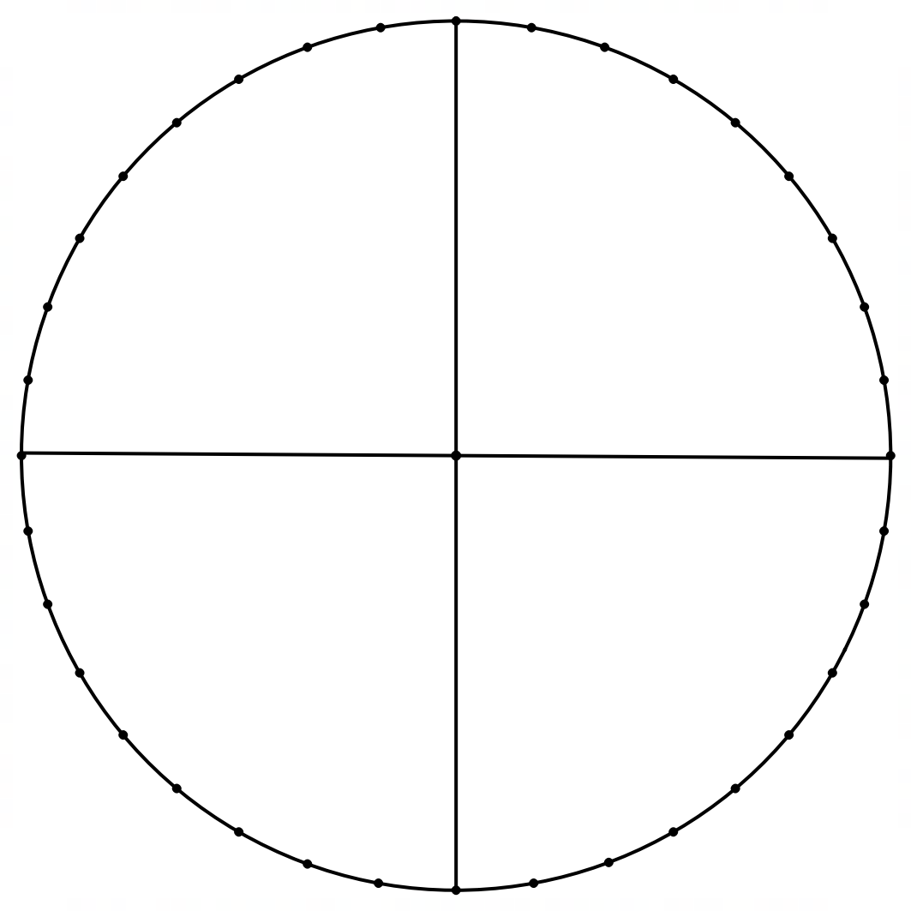

## Appendix B

### Graphing tan

|  |  |  |  |  |
| --- | --- | --- | --- | --- |
| Angle $(x)$ | $$\sin{x}$$ | $$\cos{x}$$ | $$\frac{\sin{x}}{\cos{x}}$$ | $$\tan{x}$$ |
| $$0°$$ |  |  |  |  |
| $$45°$$ |  |  |  |  |
| $$90°$$ |  |  |  |  |
| $$135°$$ |  |  |  |  |
| $$180°$$ |  |  |  |  |
| $$225°$$ |  |  |  |  |
| $$270°$$ |  |  |  |  |
| $$315°$$ |  |  |  |  |
| $$360°$$ |  |  |  |  |

## Appendix C

### Trigonometric graphs

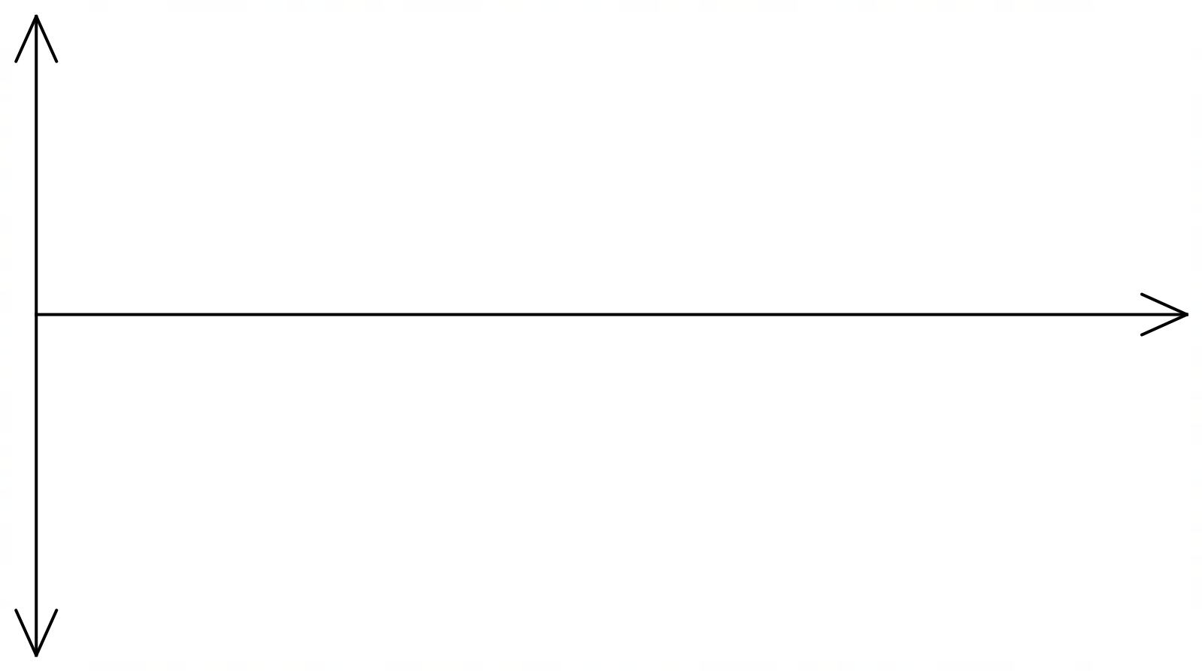

|  |  |  |  |  |  |  |  |  |  |
| --- | --- | --- | --- | --- | --- | --- | --- | --- | --- |
|  |  |  |  |  |  |  |  |  |  |
|  |  |  |  |  |  |  |  |  |  |



|  |  |  |  |  |  |  |  |  |  |
| --- | --- | --- | --- | --- | --- | --- | --- | --- | --- |
|  |  |  |  |  |  |  |  |  |  |
|  |  |  |  |  |  |  |  |  |  |



|  |  |  |  |  |  |  |  |  |  |
| --- | --- | --- | --- | --- | --- | --- | --- | --- | --- |
|  |  |  |  |  |  |  |  |  |  |
|  |  |  |  |  |  |  |  |  |  |

## Sample solutions

### Appendix B – graphing tan

|  |  |  |  |  |
| --- | --- | --- | --- | --- |
| Angle $(x)$ | $$\sin{x}$$ | $$\cos{x}$$ | $$\frac{\sin{x}}{\cos{x}}$$ | $$\tan{x}$$ |
| $$0°$$ | $$0$$ | $$1$$ | $$\frac{0}{1}$$ | $$0$$ |
| $$45°$$ | $$\frac{1}{\sqrt{2}}$$ | $$\frac{1}{\sqrt{2}}$$ | $$\frac{\frac{1}{\sqrt{2}}}{\frac{1}{\sqrt{2}}}$$ | $$1$$ |
| $$90°$$ | $$1$$ | $$0$$ | $$\frac{1}{0}$$ | no value |
| $$135°$$ | $$\frac{1}{\sqrt{2}}$$ | $$-\frac{1}{\sqrt{2}}$$ | $$-\frac{\frac{1}{\sqrt{2}}}{\frac{1}{\sqrt{2}}}$$ | $$-1$$ |
| $$180°$$ | $$0$$ | $$-1$$ | $$\frac{0}{-1}$$ | $$0$$ |
| $$225°$$ | $$-\frac{1}{\sqrt{2}}$$ | $$-\frac{1}{\sqrt{2}}$$ | $$\frac{-\frac{1}{\sqrt{2}}}{-\frac{1}{\sqrt{2}}}$$ | $$1$$ |
| $$270°$$ | $$-1$$ | $$0$$ | $$\frac{-1}{0}$$ | no value |
| $$315°$$ | $$-\frac{1}{\sqrt{2}}$$ | $$\frac{1}{\sqrt{2}}$$ | $$-\frac{\frac{1}{\sqrt{2}}}{\frac{1}{\sqrt{2}}}$$ | $$-1$$ |
| $$360°$$ | $$0$$ | $$1$$ | $$\frac{0}{1}$$ | $$0$$ |

### Appendix C – trigonometric graphs

$$y=\sin{x}$$

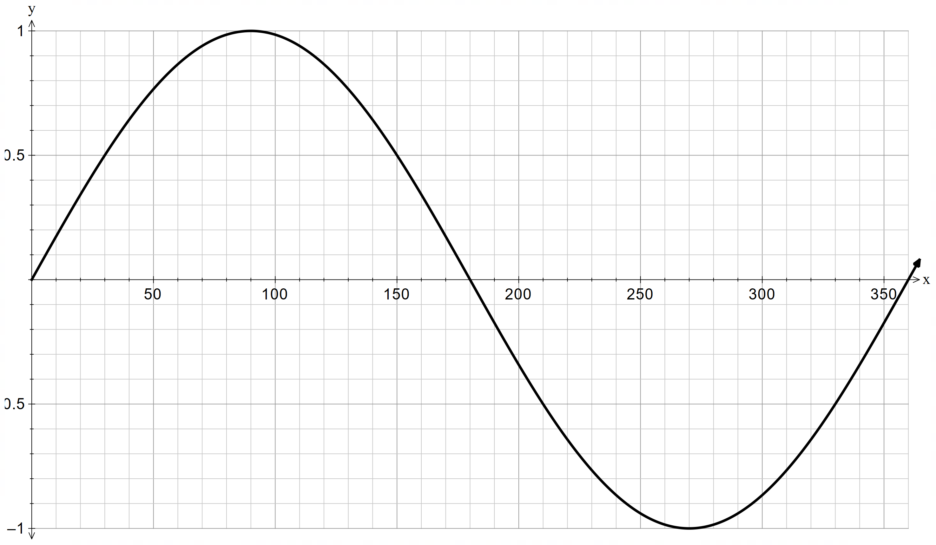

|  |  |  |  |  |  |  |  |  |  |
| --- | --- | --- | --- | --- | --- | --- | --- | --- | --- |
| $$x$$ | $$0$$ | $$30$$ | $$90$$ | $$150$$ | $$180$$ | $$210$$ | $$270$$ | $$330$$ | $$360$$ |
| $$\sin{x}$$ | $$0$$ | $$\frac{1}{2}$$ | $$1$$ | $$\frac{1}{2}$$ | $$0$$ | $$-\frac{1}{2}$$ | $$-1$$ | $$-\frac{1}{2}$$ | $$0$$ |

$$y=\cos{x}$$

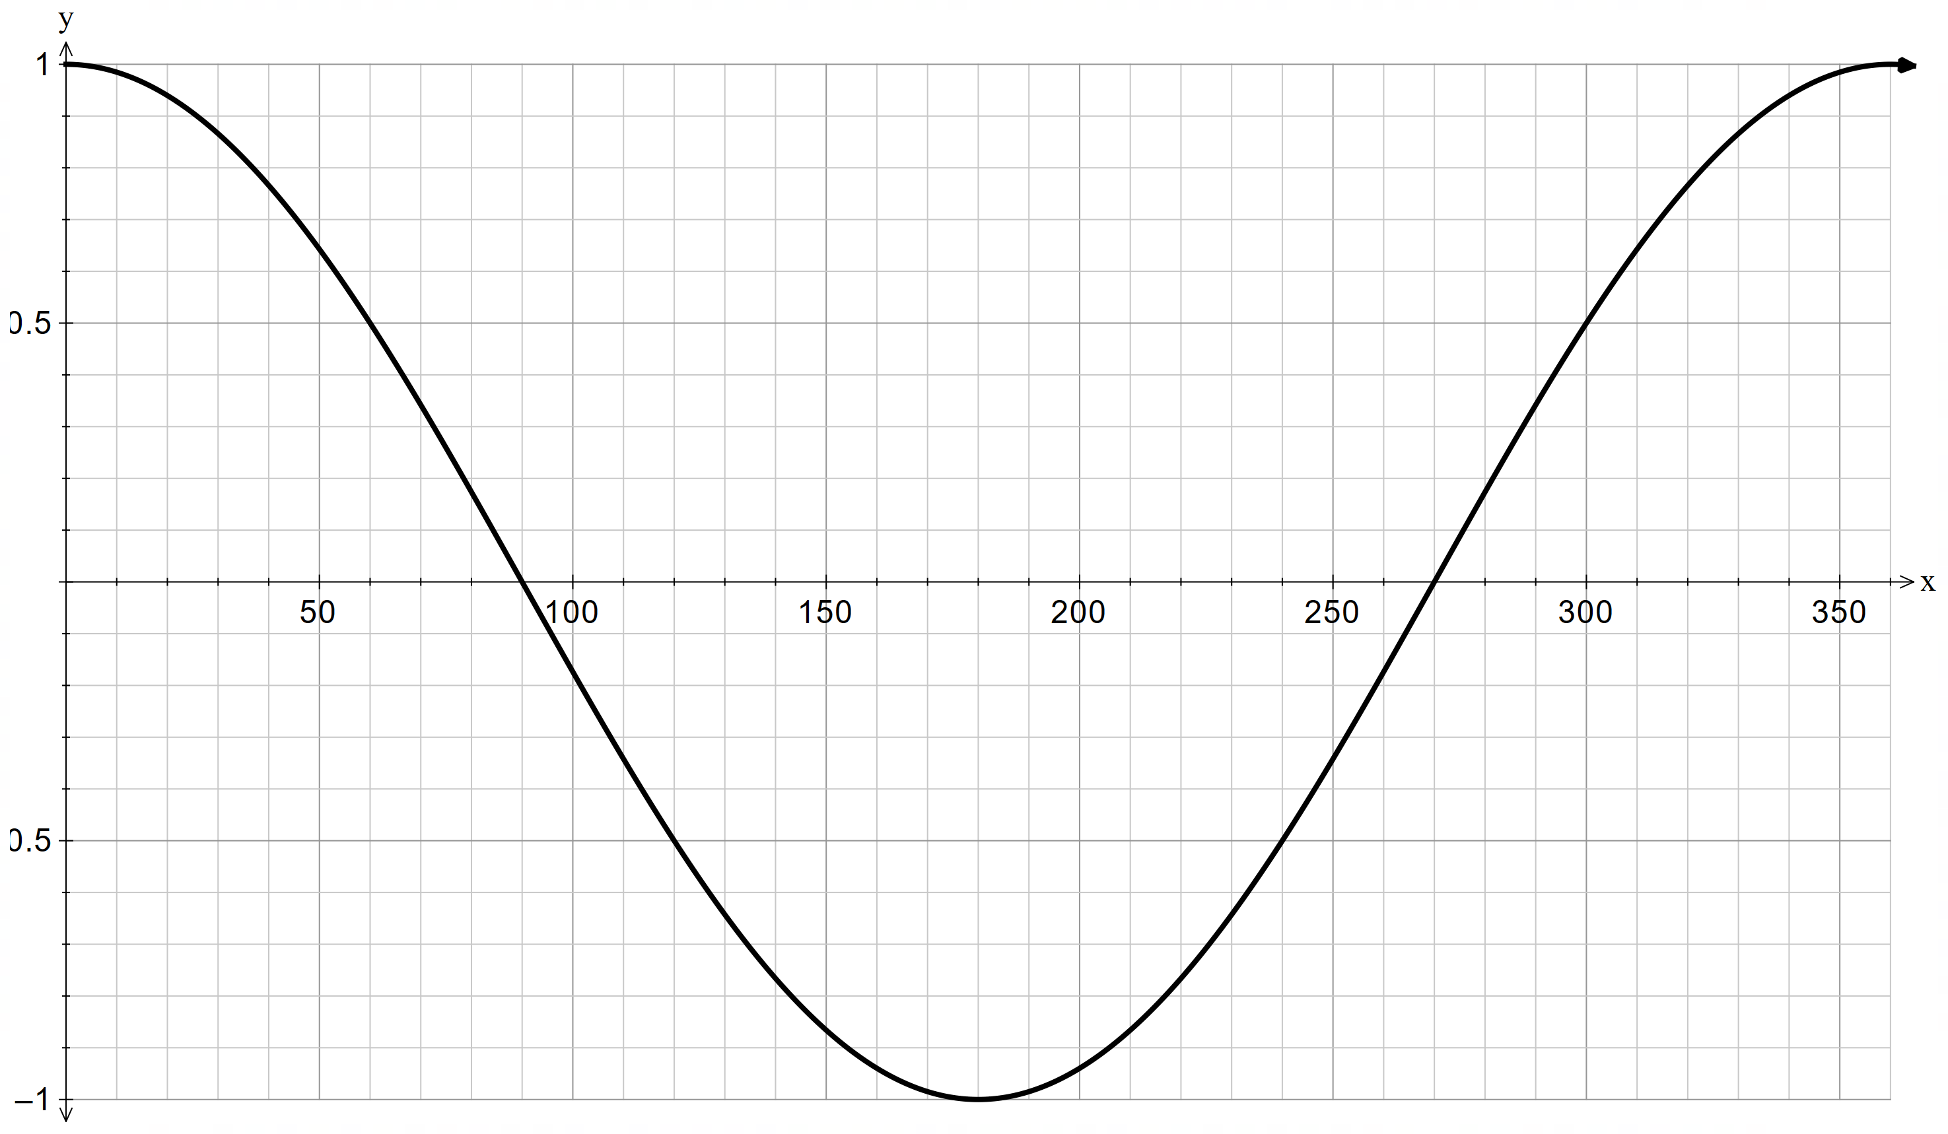

|  |  |  |  |  |  |  |  |  |  |
| --- | --- | --- | --- | --- | --- | --- | --- | --- | --- |
| $$x$$ | $$0$$ | $$60$$ | $$90$$ | $$120$$ | $$180$$ | $$210$$ | $$270$$ | $$330$$ | $$360$$ |
| $$\cos{x}$$ | $$1$$ | $$\frac{1}{2}$$ | $$0$$ | $$-\frac{1}{2}$$ | $$-1$$ | $$-\frac{1}{2}$$ | $$0$$ | $$\frac{1}{2}$$ | $$1$$ |

$$y=\tan{x}$$

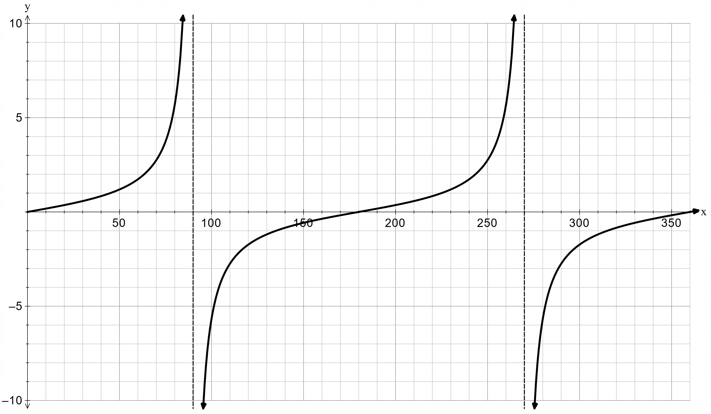

|  |  |  |  |  |  |  |  |  |  |
| --- | --- | --- | --- | --- | --- | --- | --- | --- | --- |
| $$x$$ | $$0$$ | $$45$$ | $$90$$ | $$135$$ | $$180$$ | $$215$$ | $$270$$ | $$315$$ | $$360$$ |
| $$\tan{x}$$ | $$0$$ | $$1$$ |  | $$-1$$ | $$0$$ | $$1$$ |  | $$-1$$ | $$0$$ |

### Apply

Graph 1: Dubai, United Arab Emirates

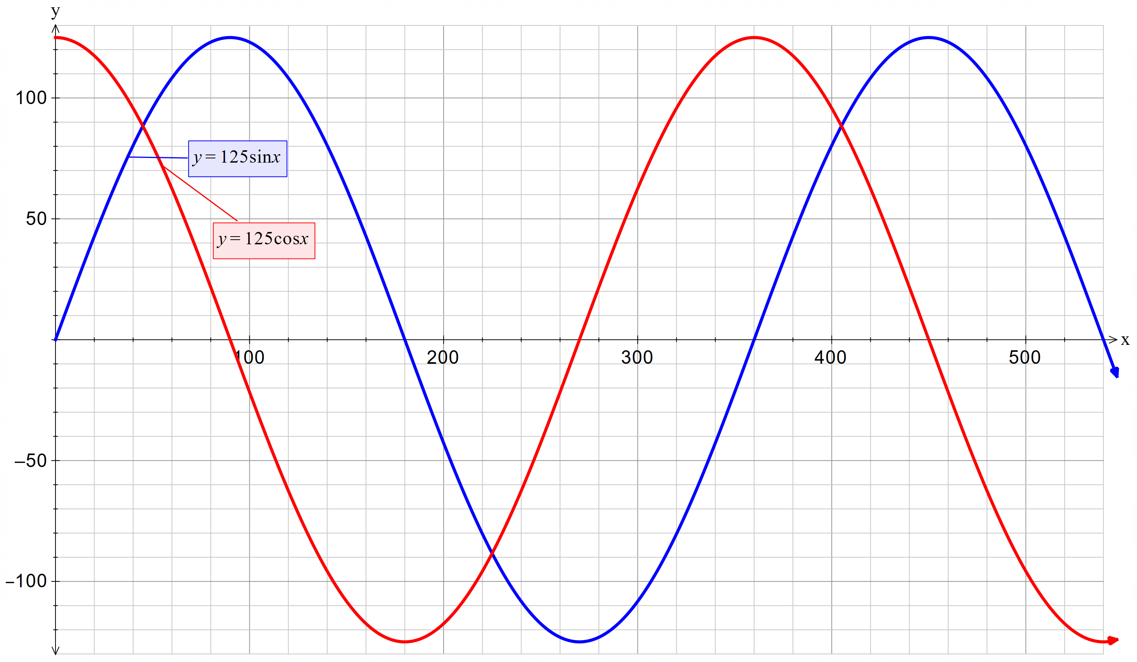

Graph 2: Las Vegas, USA

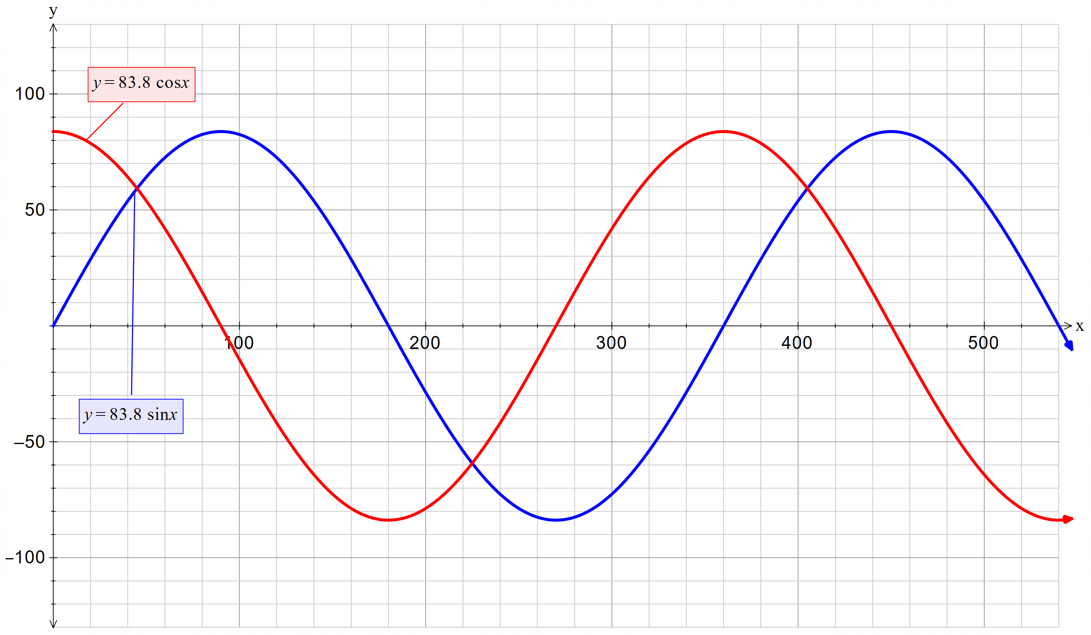

Graph 3: Singapore

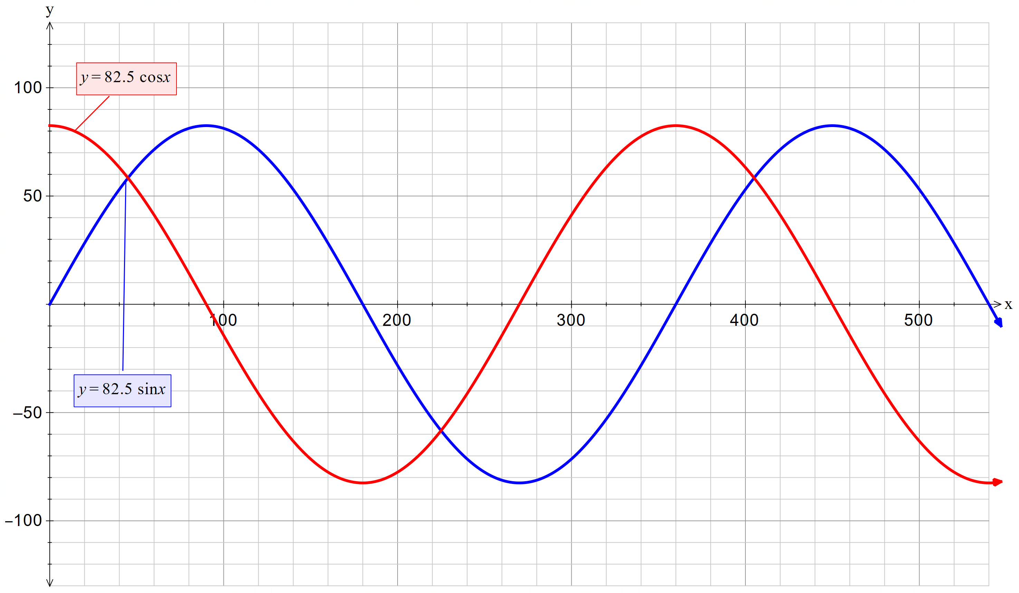

Graph 4: London

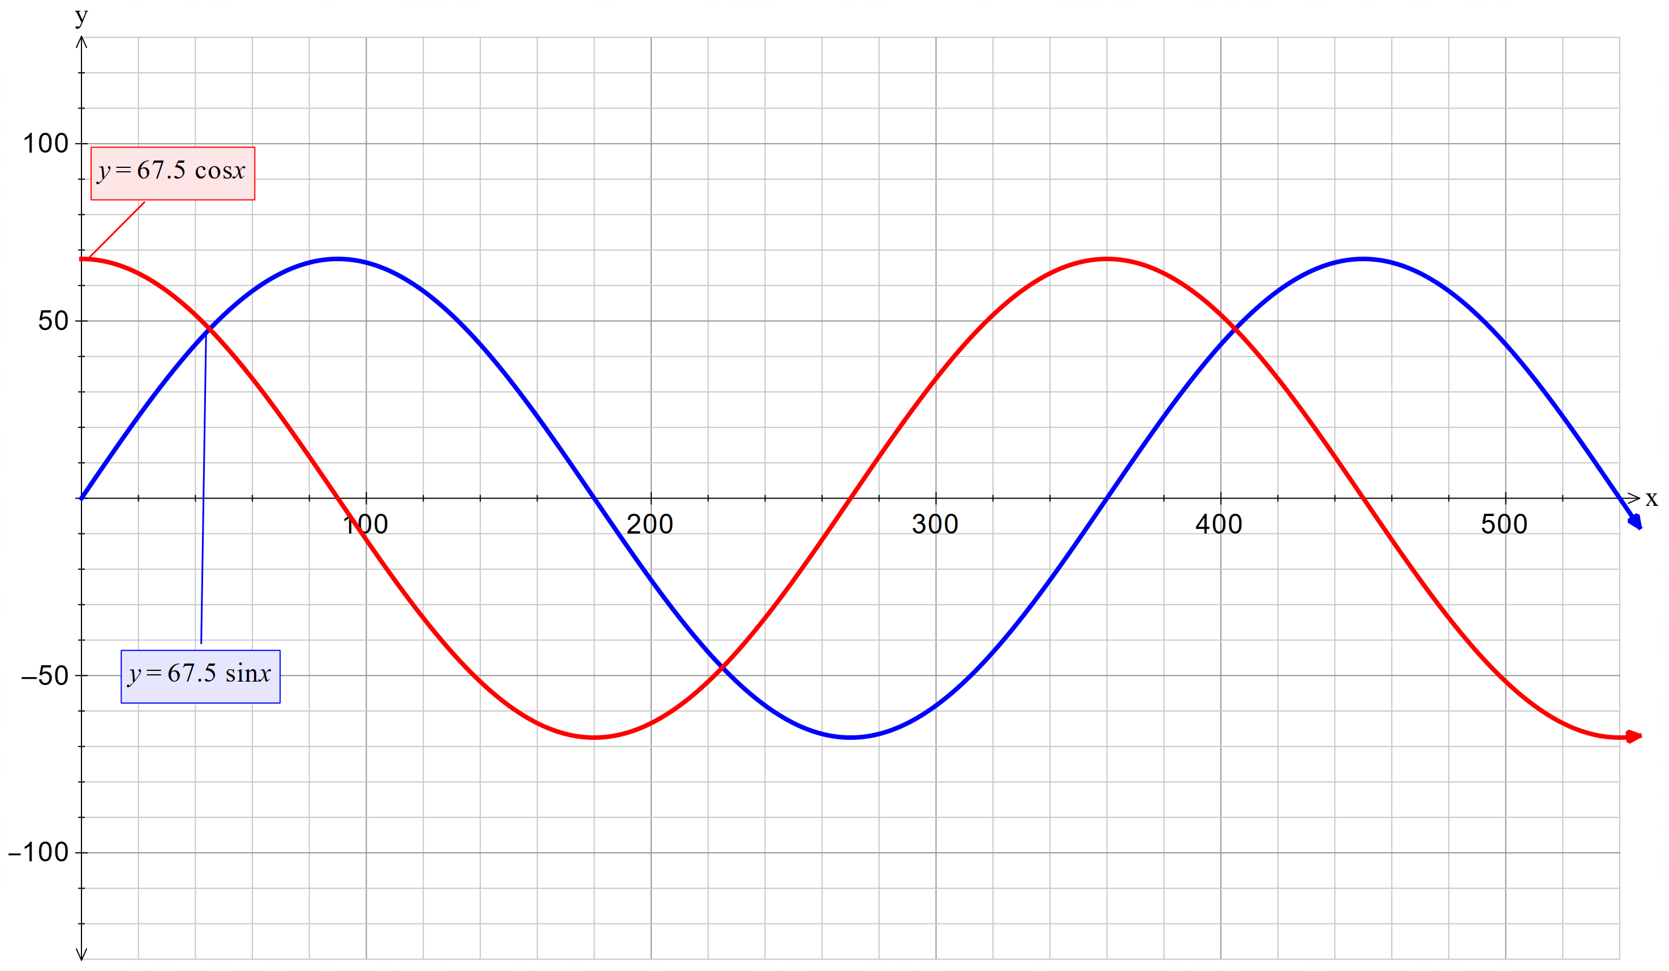

## References

This resource contains NSW Curriculum and syllabus content. The NSW Curriculum is developed by the NSW Education Standards Authority. This content is prepared by NESA for and on behalf of the Crown in right of the State of New South Wales. The material is protected by Crown copyright.

Please refer to the NESA Copyright Disclaimer for more information [https://educationstandards.nsw.edu.au/wps/portal/nesa/mini-footer/copyright](https://aus01.safelinks.protection.outlook.com/?url=https%3A%2F%2Feducationstandards.nsw.edu.au%2Fwps%2Fportal%2Fnesa%2Fmini-footer%2Fcopyright&data=05%7C01%7CCaitlin.Pace1%40det.nsw.edu.au%7C9c2c1a9f59c94d2df30708dafa7edb23%7C05a0e69a418a47c19c259387261bf991%7C0%7C0%7C638097720042599463%7CUnknown%7CTWFpbGZsb3d8eyJWIjoiMC4wLjAwMDAiLCJQIjoiV2luMzIiLCJBTiI6Ik1haWwiLCJXVCI6Mn0%3D%7C3000%7C%7C%7C&sdata=BzQh0UsffVZE3eO22b2Xba3p0VMOBZSHfS21FGHXtZM%3D&reserved=0).

NESA holds the only official and up-to-date versions of the NSW Curriculum and syllabus documents. Please visit the NSW Education Standards Authority (NESA) website <https://educationstandards.nsw.edu.au/> and the NSW Curriculum website <https://curriculum.nsw.edu.au/>.

[Mathematics K–10 Syllabus](https://curriculum.nsw.edu.au/learning-areas/mathematics/mathematics-k-10-2022/overview) © NSW Education Standards Authority (NESA) for and on behalf of the Crown in right of the State of New South Wales, 2022.

**© State of New South Wales (Department of Education), 2025**

The copyright material published in this resource is subject to the *Copyright Act 1968* (Cth) and is owned by the NSW Department of Education or, where indicated, by a party other than the NSW Department of Education (third-party material).

Copyright material available in this resource and owned by the NSW Department of Education is licensed under a [Creative Commons Attribution 4.0 International (CC BY 4.0) license](https://creativecommons.org/licenses/by/4.0/).

[](https://creativecommons.org/licenses/by/4.0/)

This license allows you to share and adapt the material for any purpose, even commercially.

Attribution should be given to © State of New South Wales (Department of Education), 2025.

Material in this resource not available under a Creative Commons license:

* the NSW Department of Education logo, other logos and trademark-protected material
* material owned by a third party that has been reproduced with permission. You will need to obtain permission from the third party to reuse its material.

**Links to third-party material and websites**

Please note that the provided (reading/viewing material/list/links/texts) are a suggestion only and implies no endorsement, by the New South Wales Department of Education, of any author, publisher, or book title. School principals and teachers are best placed to assess the suitability of resources that would complement the curriculum and reflect the needs and interests of their students.

If you use the links provided in this document to access a third-party's website, you acknowledge that the terms of use, including licence terms set out on the third-party's website apply to the use which may be made of the materials on that third-party website or where permitted by the *Copyright Act 1968* (Cth). The department accepts no responsibility for content on third-party websites.