Who gets to drive?
Three datasets are presented to students in the form of lap times of F1 drivers and students are asked to determine the best driver. Students use technology to calculate standard deviation and interpret standard deviation as a measure of spread.
Students will need at least one digital device per pair to interact with GeoGebra during this lesson.
In this learning episode, when referring to standard deviation, population standard deviation ($σ$) is used. Sample standard deviation ($s$) applies when finding the standard deviation of a sample from a larger dataset.

Visible learning

Learning intention
- To understand the relationship between standard deviation and consistency.

Success criteria
- I can describe the spread of data in a dataset.
- I can calculate standard deviation using technology.
- I can compare datasets using standard deviation.
- I can explain how standard deviation relates to consistency.

Syllabus outcomes
A student:
- develops understanding and fluency in mathematics through exploring and connecting mathematical concepts, choosing and applying mathematical techniques to solve problems, and communicating their thinking and reasoning coherently and clearly MAO-WM-01
- compares and analyses datasets using summary statistics and graphical representations MA5-DAT-C-01
Mathematics K–10 Syllabus © NSW Education Standards Authority (NESA) for and on behalf of the Crown in right of the State of New South Wales, 2022.

Activity structure
Please use the associated PowerPoint Who gets to drive? to display support in this lesson.

Launch
- Assign students to visibly random groups of 3 (bit.ly/visiblegroups) at vertical non-permanent surfaces (bit.ly/VNPSstrategy) around the classroom.
- Ask students to consider the following scenario, which can be displayed on slide 3 of the Who gets to drive? PowerPoint:
A Formula 1 team wants a new driver to race for them. The team is having difficulty deciding between 3 drivers, so they ask the drivers to complete some laps to help them decide. The lap times are displayed below, in seconds. As the team statistician, you are asked to recommend a driver for the team based on the lap times.
Which driver would you recommend and why?
- Driver A: 72, 72, 73, 76, 80, 82, 82, 83, 86, 90, 92, 96
- Driver B: 75, 77, 78, 79, 80, 82, 82, 82, 83, 86, 88, 92
- Driver C: 67, 70, 74, 77, 79, 82, 82, 88, 89, 90, 91, 95
- Allow students time to select which driver they would choose. Are they convinced that one driver is better than the others?
Students may need to be prompted to find the mean, mode, median and range of each dataset. These are not enough to choose one driver over the others as the mean and median for the 3 datasets are the same (82).

Explore
- Distribute the cut-out graphs from Appendix A ‘Visualising standard deviation’ to each group and ask them to match the graphs to the data for the 3 F1 drivers in the Launch. Groups can use adhesive putty to stick graphs onto their vertical non-permanent surfaces.
The graphs include dot plots, histograms with a bin width of 1 and histograms with a bin width of 5 for each dataset.
- Conduct a gallery walk (bit.ly/DLSgallerywalk) for students to observe how their peers matched the graphs. Groups return to their vertical non-permanent surfaces and discuss if they will change any of their answers.
- Facilitate a class discussion using a questioning strategy such as Pose-Pause-Pounce-Bounce (PDF 557 KB) (bit.ly/posepausepouncebounce) to ask students:
- Which graph did your group identify first? Why?
- How would you describe the graphs for each driver?
If not mentioned, prompt students to consider the spread of each dataset. Ask students to describe the consistency of each driver.

Further visualising standard deviation
For this activity students will need at least one digital device between pairs. Alternatively, the GeoGebra applet could be displayed for students and a discussion had as a whole class.
- Bring students back to their seats.
- With one digital device between pairs of students, direct students to the GeoGebra applet ‘The mean and standard deviation of a set of data’ (bit.ly/visualstddev).

- There are 2 ways that students can interact with the applet:
- Dragging the slider on the left of the applet will change the number of data points.
- Selecting and dragging a data point, will alter the mean (red vertical line) and standard deviation (represented by a blue arrow).
Selecting the circular arrows in the top right corner will reset the graph.
- Allow time for students to play with the applet by investigating using different combinations of data points.
- In a Think-Pair-Share (bit.ly/thinkpairsharestrategy), ask students to respond to the following prompts:
- What happens to the mean and standard deviation if I move 3 points further to the right?
- What happens to the mean and standard deviation if I move 2 points further left and 2 points further right?
- What happens to the mean and standard deviation if I move outside points closer to the middle?
- What could a graph tell you about the standard deviation of a dataset?

Summarise

Calculating standard deviation
- Students continue working in pairs.
- Remind students of the symbol for standard deviation ($σ$) and teach students how to calculate standard deviation using their calculator.

Below are ‘how to’ guides for popular calculator models approved by NESA. Many videos are available on YouTube that walk-through examples of finding standard deviation.
- bit.ly/casiostddev
- bit.ly/sharpstddev
- Students calculate the standard deviation for each of the drivers using their calculators, checking that the person next to them has obtained the same value.
- Students are to create notes to their forgetful future selves (bit.ly/notesstrategy) on how to find the standard deviation using their calculators.
- Groups return to their vertical non-permanent surfaces. Provide students with time to revisit the graphs and to consider the prompt:
- Now that you have calculated the standard deviation, how is this number reflected in the graphs you viewed earlier?
Students may require prompting to correlate standard deviation with the spread of data. Students should use common language to explain their reasoning, such as ’Driver C's times were all closer to each other.’
- Use a Pose-Pause-Pounce-Bounce to facilitate a class discussion about the graphs and the standard deviation.

Apply
- Display slide 3 of the PowerPoint Who gets to drive? which displays the data for each of the drivers.
- Distribute Appendix B ‘How would you choose?’ and ask students to engage in a Think-Pair-Share to complete the questions.
- Use the Pose-Pause-Pounce-Bounce questioning strategy to facilitate a whole class discussion about how changes in data can affect the mean and the standard deviation.
- Place students back into visibly random groups of 3 at vertical non-permanent surfaces around the classroom and hand out Appendix C ‘More/Same/Less’ for students to complete.
- Use the Pose-Pause-Pounce-Bounce questioning strategy to facilitate a whole class discussion about the strategies used to complete the table. Useful question prompts may include:
- What strategies did you use to find data with a lower or higher mean?
- What strategies did you use to find data with a lower or higher standard deviation?
- Which part of the table was the least challenging to complete?
- Which part of the table was the most challenging to complete?

Assessment and differentiation

Suggested opportunities for differentiation
Launch
- Smaller numbers and/or a reduced dataset could be privately provided to students who are not ready to work with the datasets provided.
- Mean, median, mode and range values could be provided along with the datasets to support students.
- Students could be challenged to describe the shape and skew of each dataset, by referring to spread.
Explore
- Students could be challenged to draw rough sketches of the shape and skew of each dataset prior to being provided the graphs.
- Students who require support when using the GeoGebra applet ‘The mean and standard deviation of a set of data’ (bit.ly/visualstddev) to further visualise standard deviation could look at what happens to the mean first when they move data points and then repeat to focus on the standard deviation.
Summarise
- Teaching students how to use a calculator to find standard deviation could be done as a Think-Pair-Share activity where students are provided verbal steps such as ‘Put your calculator into statistics mode’, students then try to find it themselves, discuss with a partner, then discuss as a class.
- Students can be supported to better visualise the link between the data, graphs and the calculated standard deviation, by drawing a red line for the mean on the graphs.
Apply
- Students will likely require additional practice using their calculators to find standard deviation following this learning episode. However, standard deviation will also be featured in future learning episodes.

Suggested opportunities for assessment
Launch
- Observe how students find and/or explain the significance of the mean, median, mode and range values.
Explore
- Students working at vertical non-permanent surfaces allows the teacher to observe how students are grouping graphs.
Summarise
- Student notes to their future forgetful selves could be collected or scanned for the teacher to assess that students know how to use their calculator to find standard deviation. Student notes could be shared in an online classroom so that students can benefit from viewing each other’s instructions.
- An exit ticket using a small and simple dataset could be created to ensure students can successfully find standard deviation using their calculators.
Apply
- Teachers could collect the more/same/less tables to formatively assess student work.
- Monitor student responses during class discussion to listen for appropriate use of language associated with calculating and comparing the mean and standard deviation for different datasets.

Appendix A

Visualising standard deviation
Graph 1
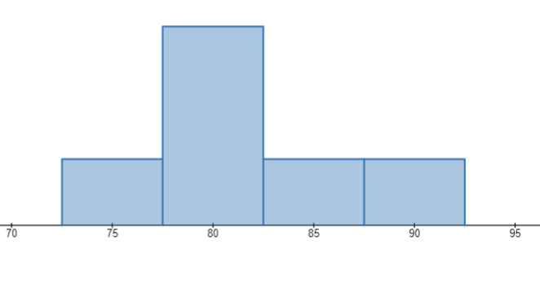

Graph 2
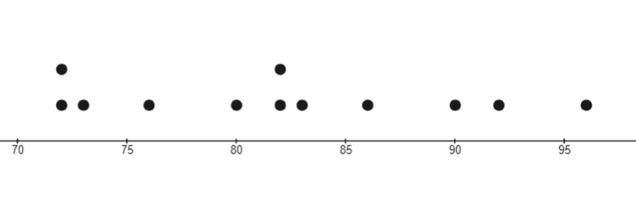

Graph 3
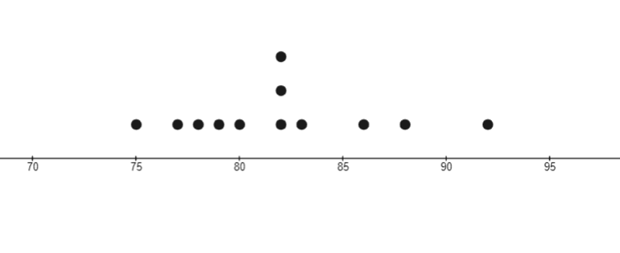

Graph 4
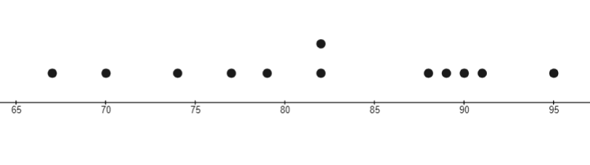

Graph 5
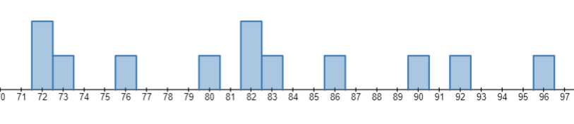

Graph 6
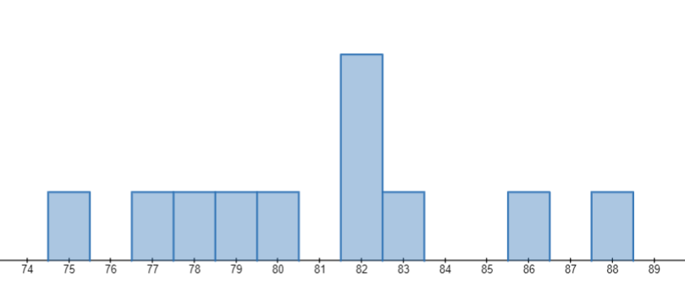

Graph 7
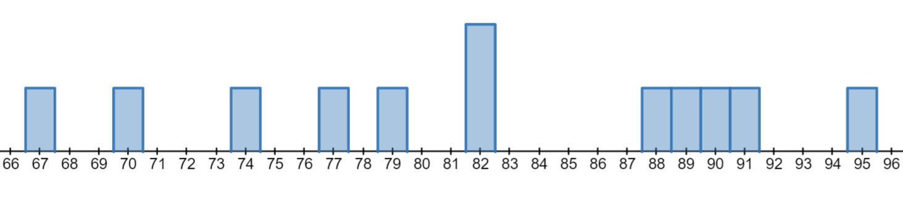

Graph 8
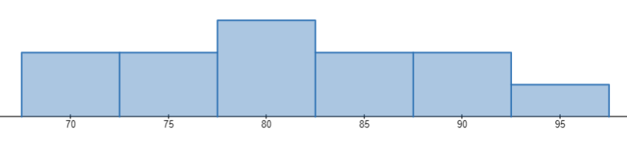

Graph 9
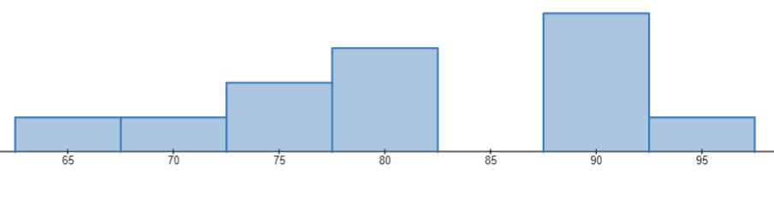

Appendix B

How would you choose?
- Would you choose a driver whose lap times produced a large or small calculated standard deviation? Why?
- A fourth driver, D, is asked to complete 12 laps and all their lap times were the same – 82.
- What is the mean and standard deviation for this driver?
- What conclusion(s) can you make about driver D?
- If Driver B were to cut 2 seconds off each lap, what would happen to the standard deviation and to the mean?
- If Driver C were to do one more lap, what lap time would they need so that the standard deviation remains the same?

Appendix C

More/Same/Less
- Find the mean and standard deviation for the dataset in the middle cell.
- Complete all the other cells with different datasets that meet the mean and standard deviation conditions. Example, the cell above the middle cell needs data that has the same standard deviation as the original dataset but needs a larger mean.
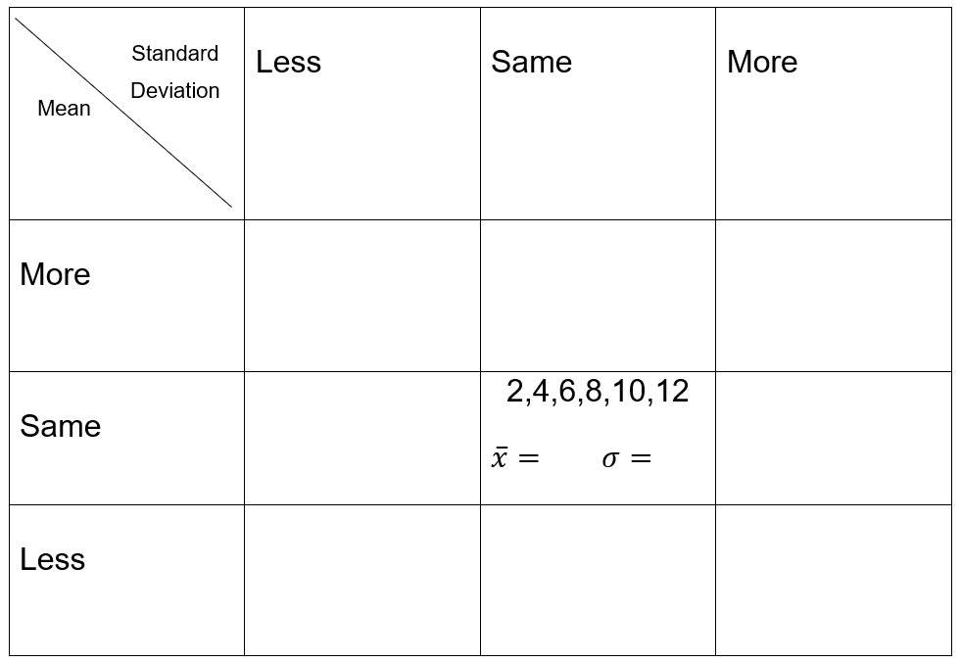

Sample solutions

Appendix A – visualising standard deviation
Graph 1: Histogram (Bin width 5) – Driver B.
Graph 2: Dot plot – Driver A.
Graph 3: Dot plot – Driver B.
Graph 4: Dot plot – Driver C.
Graph 5: Histogram (Bin width 1) – Driver A.
Graph 6: Histogram (Bin width 1) – Driver B.
Graph 7: Histogram (Bin width 1) – Driver C.
Graph 8: Histogram (Bin width 5) – Driver A.
Graph 9: Histogram (Bin width 5) – Driver C.
Alternatively:
Driver A | Driver B | Driver C
Graph 2: Dot plot | Graph 3: Dot plot | Graph 4: Dot plot
Graph 5: Histogram  (Bin width 1) | Graph 6: Histogram  (Bin width 1) | Graph 7: Histogram  (Bin width 1)
Graph 8: Histogram  (Bin width 5) | Graph 1: Histogram  (Bin width 5) | Graph 9: Histogram  (Bin width 5)

Standard deviation calculations
Driver A: 7.6
Driver B: 4.6
Driver C: 8.5

Appendix B – How would you choose?
- Encourage students to state an opinion and justify their reasoning for either large or small.
- Possible reasons for choosing a driver with a large standard deviation may include that laps which are much higher than the mean could suggest that the driver can go faster more often, with more practice.
- Possible reasons for choosing a driver with a smaller standard deviation may include that it reflects a driver who has consistent lap times.
- Mean is 82, SD is 0. The driver is very consistent.
- The mean would decrease by 2, the SD would remain the same.
- Would need to do the mean time of 82 so that the SD does not change.

Appendix C – More/Same/Less
These are some suggested solutions, however more solutions exist.
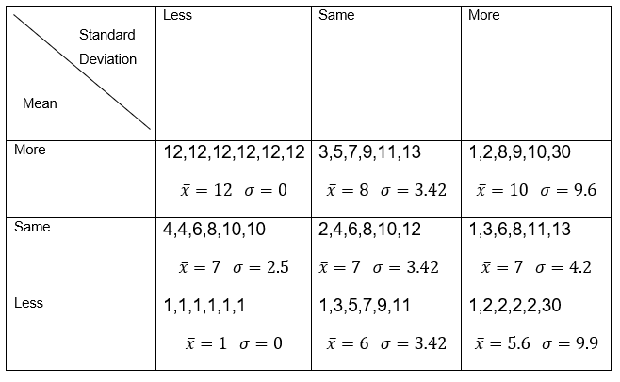

References
This resource contains NSW Curriculum and syllabus content. The NSW Curriculum is developed by the NSW Education Standards Authority. This content is prepared by NESA for and on behalf of the Crown in right of the State of New South Wales. The material is protected by Crown copyright.
Please refer to the NESA Copyright Disclaimer for more information https://educationstandards.nsw.edu.au/wps/portal/nesa/mini-footer/copyright.
NESA holds the only official and up-to-date versions of the NSW Curriculum and syllabus documents. Please visit the NSW Education Standards Authority (NESA) website https://educationstandards.nsw.edu.au/ and the NSW Curriculum website https://curriculum.nsw.edu.au/.
Mathematics K–10 Syllabus © NSW Education Standards Authority (NESA) for and on behalf of the Crown in right of the State of New South Wales, 2022.

© State of New South Wales (Department of Education), 2024
The copyright material published in this resource is subject to the Copyright Act 1968 (Cth) and is owned by the NSW Department of Education or, where indicated, by a party other than the NSW Department of Education (third-party material).
Copyright material available in this resource and owned by the NSW Department of Education is licensed under a Creative Commons Attribution 4.0 International (CC BY 4.0) license.
This license allows you to share and adapt the material for any purpose, even commercially.
Attribution should be given to © State of New South Wales (Department of Education), 2024.
Material in this resource not available under a Creative Commons license:
- the NSW Department of Education logo, other logos and trademark-protected material
- material owned by a third party that has been reproduced with permission. You will need to obtain permission from the third party to reuse its material.
Links to third-party material and websites
Please note that the provided (reading/viewing material/list/links/texts) are a suggestion only and implies no endorsement, by the New South Wales Department of Education, of any author, publisher, or book title. School principals and teachers are best placed to assess the suitability of resources that would complement the curriculum and reflect the needs and interests of their students.
If you use the links provided in this document to access a third-party's website, you acknowledge that the terms of use, including licence terms set out on the third-party's website apply to the use which may be made of the materials on that third-party website or where permitted by the Copyright Act 1968 (Cth). The department accepts no responsibility for content on third-party websites.

