Four equal groups
In this lesson, students explore finding quartiles and generating a 5-number summary.
Students will need at least one digital device per pair if choosing to engage in the Desmos activity.

Visible learning

Learning intention
- To know how to generate a 5-number summary for a set of data.

Success criteria
- I can demonstrate that quartiles divide a set of data into approximately 4 equal groups.
- I can find the lower and upper quartiles of a dataset.
- I can explain what the values mean in a 5-number summary.

Syllabus outcomes
A student:
- develops understanding and fluency in mathematics through exploring and connecting mathematical concepts, choosing and applying mathematical techniques to solve problems, and communicating their thinking and reasoning coherently and clearly MAO-WM-01
- compares and analyses datasets using summary statistics and graphical representations MA5-DAT-C-01
Mathematics K–10 Syllabus © NSW Education Standards Authority (NESA) for and on behalf of the Crown in right of the State of New South Wales, 2022.

Activity structure
Please use the associated PowerPoint Four equal groups to display images in this lesson.

Launch
The toy car launch activity can be given either digitally or physically.

Digital activity
The toy cars Desmos activity comes from the Desmos Math 6–A1 curriculum program. It can be assigned and presented to your class but is not able to be copied and edited without a subscription. Please ignore the use of inches in this activity and ask students to interpret the data collected as centimetres.
Before setting this task (bit.ly/toycarsdesmos), you will need to set up a Desmos classroom (bit.ly/desmosclassroomstrategy) and use the pacing feature to restrict the students to screens 1–2. Only screens 1–2 are used for this lesson. Teachers could choose to use the full activity which covers the median and dot plots.
- With one digital device between pairs of students, allow students time to customise their car.
- On screen 2, students select ‘Launch’ 12–15 times. Students will need to record their lengths in their workbooks. These will form their dataset.
- Challenge each pair to find the mode, median and mean score for their dataset.
- Pairs compare results with a nearby pair and discuss whose car typically goes farther? How do you know?

Alternate activity – toy cars
Equipment
- Pull back car (1 per group)
- Tape measure (1 per group)
- Chalk (1 per group)
Method
- By working in visibly random groups of 3 (bit.ly/visiblegroups) provide each group with the equipment listed above.
- Take students outside to an area with concrete or asphalt.
- Groups draw a line and place the tape measure next to the path the car is expected to travel.
- Groups launch their pull-back cars from the line 12–20 times, measuring the length of travel to form a dataset.
- Once all groups have recorded at least 12 scores, bring students back to the classroom.
- Groups compare results with a nearby group and discuss whose car typically goes the furthest? How do you know?

Explore
- In their groups, students are to complete the following tasks:
- Write your distances in ascending order.
- Find the value that is the median.
- Find the median of the top half of the data, and the median of the bottom half of the data. The data has now been split into 4 groups with the same number of values or distances in each group.
- In a Think-Pair-Share (bit.ly/thinkpairsharestrategy), students discuss:
- When the distances are split into 4 equally-sized groups, what fraction of the entire set does each group represent?
- In statistics we use the terms lower quartile and upper quartile. What do you think these terms mean in relation to the 4 equally-sized groups?
This discussion aims to reinforce the syllabus definition of quartiles. Quartiles are the values that divide an ordered dataset into 4 (approximately) equal parts. There are 3 quartiles. The first, the lower quartile Q₁, divides off (approximately) the lower 25% of data values. The second quartile Q₂ is the median. The third quartile, the upper quartile Q₃, divides off (approximately) the upper 25% of data values.
- Display slide 3 of the PowerPoint Four equal groups.
- Ask students to engage in a Think-Pair-Share to consider what they notice and what they wonder (bit.ly/noticewonderstrategy) about the graph, discussing the following questions:
- What do you think ‘min’ and ‘max’ mean?
- What do you think the Q₁ and Q₃ represent?
- Explain to students that the min, Q_{1,} median, Q₃, max values make up what we refer to as the 5-number summary.
The values for the 5-number summary of the graph are 1, 2.5, 5.5, 7.5 and 10.
- Students are to write out the 5-number summary for their dataset.
- Students can use playing cards to create additional datasets that they can use to practise finding 5-number summaries (ace = 1, jack = 11, queen = 12, king = 13).

Summarise
- Place a copy of the Appendix A ‘Four quadrant notes’, printed on A3 paper, in reusable plastic sleeves and use adhesive putty to stick the plastic sleeves up around the room.
- Assign new random groups of 3 and allocate each group to a plastic sleeve to work at. Provide each group with one whiteboard marker and cloth.
- Groups are to discuss and work through the Four quadrant notes as described below:
Students complete the first example. This could be done as a class.
Example 1: students generate their own values and complete the example, using the dataset provided.
Example 2: students generate their own numbers and repeat the process. Students may prefer to use a dataset from another group.
Things to remember: students write down anything they believe would be important for their future forgetful selves to remember.
- Distribute an individual copy of Appendix A to the students and allow them time to do a gallery walk (bit.ly/DLSgallerywalk) before completing a set of notes for themselves.

Apply
- By working in visibly random groups of 3 on vertical non-permanent surfaces (bit.ly/VNPSstrategy), ask students to investigate and discuss which set of values would give a 5-number summary of: 2, 3.5, 6, 7.5, 9.
One possible solution is: 2, 2, 3, 4, 5, 6, 6, 7, 7, 8, 8, 9.
- Still in their groups of 3, ask students to complete Appendix B ‘Venn diagram’.

Assessment and differentiation

Suggested opportunities for differentiation
Explore
- The teacher could initiate a discussion with the students around why the word approximately is used in the quartile definition. Students could suggest the values in datasets where approximately 25% of scores would be in each quartile.
- Students could be encouraged to remove or add one more value at a time and make a general statement about the number of data points and the method of finding the median.
Summarise
- Students could compare the results of their 5-number summary with other students to make decisions about whose car travelled the furthest.
Apply
- Challenge students to find as many solutions as possible to the given 5-number summary.
- Introduce restrictions to the dataset students must find from the given 5-number summary. For example:
- Your dataset has 10 values
- What is the minimum number of values you can have in your dataset?
- Students can be encouraged to find multiple sets of data to meet the criteria in different zones.
- Students can be encouraged to identify patterns in the sets of numbers that can fill the zones.
- Challenge students to create their own Venn diagram task. They could swap Venn tasks with another group to complete.

Suggested opportunities for assessment
Explore
- Students can check their calculations by entering the data into their calculator’s statistics mode and calculating the 5-number summary.
Summary
- The Four quadrant notes could be collected to check for understanding.
Apply
- Solutions to the Venn diagram can be assessed, noticing which zones students were and were not able to find datasets to satisfy the criteria.
- Create an exit ticket where students create a dataset of their choosing and find the 5-number summary.

Appendix A

Four quadrant notes
Find the 5-number summary for this set of data.  $$1, 3, 4, 5, 5, 6, 7, 8, 8, 9, 9$$  Smallest value: ☐  Median, Q₂: ☐  Lower quartile, Q₁: ☐  Upper quartile, Q₃: ☐  Largest value: ☐  The 5-number summary is: ☐, ☐, ☐, ☐, ☐ | Example 1  Find the 5-number summary for this set of data.  $$2, 2, 3, 4, 4, 4, 5, 6, 6, 6, 7, 7$$
Things to remember | Example 2  Find the 5-number summary for a set of data.

Appendix B

Venn diagram
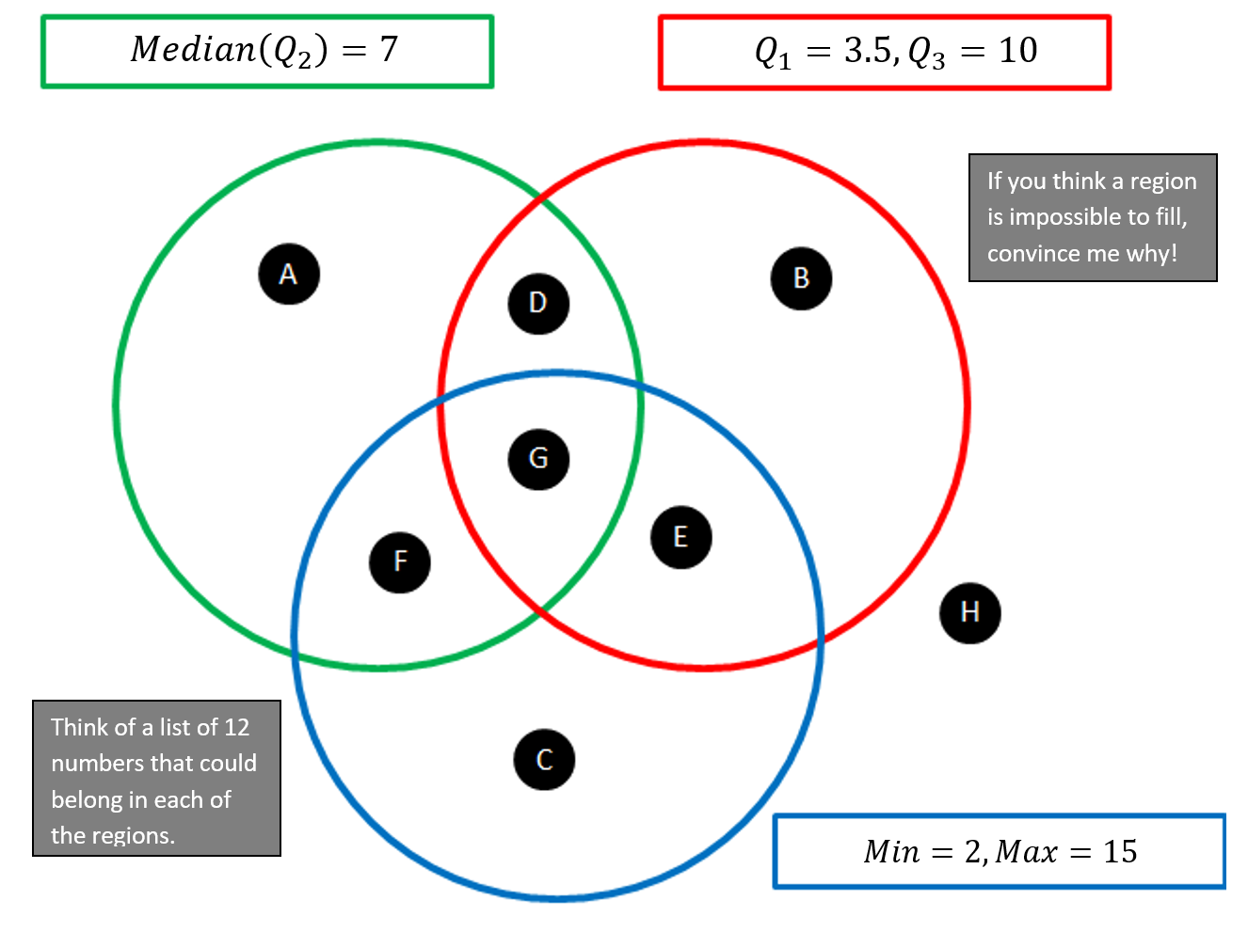

Sample solutions

Appendix A – four quadrant notes
Find the 5-number summary for this set of data  $$1, 3, 4, 5, 5, 6, 7, 8, 8, 9,9$$  Smallest value: 1  Median, Q₂: 6  Lower quartile, Q₁: 4  Upper quartile, Q₃: 8  Largest value: 9  The 5-number summary is: 1,4,6,8,9 | Example 1  Find the 5-number summary for this set of data  $$2, 2, 3, 4, 4, 4, 5, 6, 6, 6, 7, 7$$  Smallest value: 2  Median, Q₂: $\frac{4 + 5}{2}$ = $4.5$  Lower quartile, Q₁: $\frac{4 +3}{2}$ = 3.5  Upper quartile, Q₃: 6  Largest value: 7  The 5-number summary is: 2, 3.5, 4.5, 6, 7

Appendix B – Venn diagram
Possible solutions
A | 1 | 2 | 2 | 4 | 7 | 7 | 7 | 8 | 10 | 11 | 11 | 12
B | 1 | 2 | 3 | 4 | 4 | 5 | 6 | 10 | 10 | 10 | 11 | 12
C | 2 | 3 | 4 | 5 | 6 | 7 | 8 | 9 | 10 | 12 | 14 | 15
D | 1 | 2 | 3 | 4 | 5 | 7 | 7 | 8 | 10 | 10 | 11 | 12
E | 2 | 2 | 3 | 4 | 5 | 7 | 8 | 8 | 10 | 10 | 11 | 15
F | 2 | 2 | 2 | 4 | 5 | 7 | 7 | 8 | 8 | 10 | 11 | 15
G | 2 | 3 | 3 | 4 | 5 | 7 | 7 | 8 | 10 | 10 | 12 | 15
H | 1 | 2 | 2 | 3 | 4 | 5 | 6 | 7 | 8 | 9 | 10 | 11

References
This resource contains NSW Curriculum and syllabus content. The NSW Curriculum is developed by the NSW Education Standards Authority. This content is prepared by NESA for and on behalf of the Crown in right of the State of New South Wales. The material is protected by Crown copyright.
Please refer to the NESA Copyright Disclaimer for more information https://educationstandards.nsw.edu.au/wps/portal/nesa/mini-footer/copyright.
NESA holds the only official and up-to-date versions of the NSW Curriculum and syllabus documents. Please visit the NSW Education Standards Authority (NESA) website https://educationstandards.nsw.edu.au and the NSW Curriculum website https://curriculum.nsw.edu.au.
Mathematics K–10 Syllabus © NSW Education Standards Authority (NESA) for and on behalf of the Crown in right of the State of New South Wales, 2022.

© State of New South Wales (Department of Education), 2024
The copyright material published in this resource is subject to the Copyright Act 1968 (Cth) and is owned by the NSW Department of Education or, where indicated, by a party other than the NSW Department of Education (third-party material).
Copyright material available in this resource and owned by the NSW Department of Education is licensed under a Creative Commons Attribution 4.0 International (CC BY 4.0) license.
This license allows you to share and adapt the material for any purpose, even commercially.
Attribution should be given to © State of New South Wales (Department of Education), 2024.
Material in this resource not available under a Creative Commons license:
- the NSW Department of Education logo, other logos and trademark-protected material
- material owned by a third party that has been reproduced with permission. You will need to obtain permission from the third party to reuse its material.
Links to third-party material and websites
Please note that the provided (reading/viewing material/list/links/texts) are a suggestion only and implies no endorsement, by the New South Wales Department of Education, of any author, publisher, or book title. School principals and teachers are best placed to assess the suitability of resources that would complement the curriculum and reflect the needs and interests of their students.
If you use the links provided in this document to access a third-party's website, you acknowledge that the terms of use, including licence terms set out on the third-party's website apply to the use which may be made of the materials on that third-party website or where permitted by the Copyright Act 1968 (Cth). The department accepts no responsibility for content on third-party websites.

