IQR and box plots
Students use Amplify’s Polypad to construct box plots, comparing 5-number summaries and interquartile range.
Students will need at least one digital device per pair to interact with Polypad during this lesson.

Visible learning

Learning intentions
- To be able to represent numerical data as a box plot.
- To be able to calculate and interpret the interquartile range.

Success criteria
- I can find the interquartile range of a dataset.
- I can use a 5-number summary to draw box plots.
- I can interpret box plots.

Syllabus outcomes
A student:
- develops understanding and fluency in mathematics through exploring and connecting mathematical concepts, choosing and applying mathematical techniques to solve problems, and communicating their thinking and reasoning coherently and clearly MAO-WM-01
- analyses simple datasets using measures of centre, range and shape of the data
MA4-DAT-C-02
Mathematics K–10 Syllabus © NSW Education Standards Authority (NESA) for and on behalf of the Crown in right of the State of New South Wales, 2022.

Activity structure
Please use the associated PowerPoint IQR and box plots to display images in this lesson.

Launch
Students will work in pairs during the launch, explore and summarise sections.
- Ask students to predict an answer to the following question, writing their answers on mini whiteboards:
How much waste (in kilograms) does the average person in Australia generate in one year?
- Students hold up their mini whiteboards to reveal their answers.
- Use a questioning strategy such as Pose-Pause-Pounce-Bounce (PDF 557 KB) (https://bit.ly/posepausepouncebounce) to facilitate a class discussion, allowing students to explain their answers.
- Reveal the actual number (as of 2022) is 2950 kg per person.
This weight is approximately equivalent to a white rhinoceros, a baby blue whale or a Hummer truck.
- Ask students if they think Australia produces more waste or less waste than other countries and to explain their reasoning.
- Distribute to each pair a copy of Appendix A ‘Country’s household waste (2021)’.
- In a Think-Pair-Share (bit.ly/thinkpairsharestrategy), ask students to consider the questions below:
- Is Australia about average?
- Are there any outliers? Why?
- Ask students to calculate the 5-number summary for all countries, using the data provided.
The 5-number summary for the dataset is 0.5, 5.05, 13.1, 32.9, 285.2
- Students discuss the questions below in a Think-Pair-Share:
- Which countries are within the middle 50% of data, between the lower and upper quartiles?
- How is the data skewed?

Explore
- In a Think-Pair-Share ask students to draw a graph or visual representation of their 5-number summary for ‘Country’s household waste (2021)’.
- As students work, the teacher should mentally take note of interesting representations to share with the rest of the class.
- The teacher asks the pairs they mentally selected to show their graphs to the rest of the class and explain their reasoning for choosing their representation.
- Explain to students that they will now be looking at a special type of graph, called a box plot, that is designed to display a 5-number summary.
- Print and distribute Appendix B ‘Country’s household waste (2021) – box plot’ to each student. The box plot can also be displayed on slide 3 of the IQR and box plots PowerPoint.
- In a Think-Pair-Share, students discuss:
- What does each vertical line represent?
- What does the box represent?
- Why is there such a long distance between the box and the maximum?

If not revealed through student discussions, reveal that the vertical lines represent the 5-number summary and the shaded box represents the values between the lower quartile and the upper quartile, which is called the interquartile range. Emphasise to students that the interquartile range represents the middle 50% of the dataset.
From the syllabus glossary: Interquartile range (IQR) is a measure of the spread within a numerical dataset. It is equal to the upper quartile $(Q_{3})$ minus the lower quartile $(Q_{1})$; that is,
$IQR=\left(Q_{3}\right)-\left(Q_{1}\right).$ The IQR is the width of an interval that contains the middle 50% (approximately) of the data values (NESA 2024).
- Ask students to find the interquartile range for the household waste dataset.
- Use a questioning strategy such as Pose-Pause-Pounce-Bounce to discuss as a class:
- What does the range tell us about a dataset?
- What does the interquartile range tell us about a dataset?
- When might you choose to use the interquartile range instead of the range?
- With at least one device between pairs of students, have students work through Appendix C ‘Box plots using Polypad’.
Students can draw 12 random cards from a deck of cards and complete a similar activity. The benefit of Polypad is that it constructs a box plot using the student’s data so that they can receive immediate feedback on their individual box plot.
- Have students check their box plots using Polypad. Appendix D ‘Is my box plot correct?’ outlines the steps to do this.
- Allow students time to repeat the process to practise drawing box plots and checking their answers.
- Bring the class back together to discuss how much data fits into each section of the box plot? Have students drag the data to each section of their box plot as seen in Figure 1.
Figure 1: Where is the data?
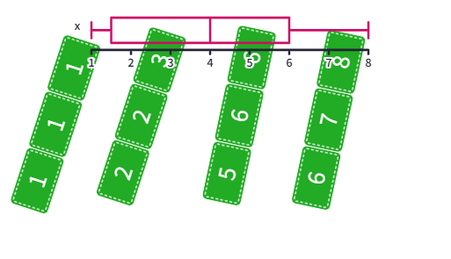
A common misconception students encounter with box plots is that they think a longer section represents more data. Students physically dragging the data into each section should provide a visual to help eliminate this misconception.

Summarise
- Display slide 5 of the IQR and box plots PowerPoint for students. Two sets of cards are shown, one set with 5 cards and the other 8 cards.
- For each set of cards, students are to:
- Find the 5-number summary.
- Find the interquartile range.
Ace counts as 1, Jack counts as 11, Queen as 12, and King as 13. The 5 number summaries are: 9, 9, 12, 12.5, 13 and 1, 4.5, 6.5, 9, 11.
- Students are to draw the first row of cards as a box plot in their books or on mini whiteboards.
- Model for students how to draw the second row of cards as a parallel box plot above the first box plot.
- In a Think-Pair-Share students check that their box plots are alike, then discuss the following questions:
- Why did we draw the box plots on the same axis?
- Which row of cards had the greater interquartile range?
- What does it mean to have a greater interquartile range?
- Could you add one card to the other row to make it have the greater interquartile range?
- With one deck of cards between pairs of students, students take turns drawing cards until they have between 5 and 10 cards each. Students are aiming to have a smaller interquartile range than their partner. They can choose to stop drawing cards once they have at least 5 cards in front of them.
- Students calculate their interquartile ranges to determine a winner.
- Students are to create notes to their forgetful future selves (bit.ly/notesstrategy) on how to draw a box plot and find interquartile range.
Students could create an example box plot within their notes, using Polypad to assist them.

Apply
This activity combines students current learning on interquartile range with the previously explored content on standard deviation, shape of data and histograms.
- Distribute Appendix E ‘Data sorting activity’ to pairs of students.
- Students work in pairs to match the cards corresponding to the same dataset.
- When students have finished, challenge them to find the interquartile range for each dataset.

Assessment and differentiation

Suggested opportunities for differentiation
Launch
- Students are asked to find the 5-number summary as a hinge point question in the launch. If individual students are not confident with this, they can be supported independently or in a small group. If many students are not confident finding a 5-number summary, that should be retaught before commencing with this learning episode.
Explore
- If students would benefit from concrete manipulatives, they could use concrete number tiles to physically order their numbers and rulers or pencils to represent quartiles.
- Students could be provided Appendices B and C and be allowed to progress at their own pace. Alternatively, students who require additional support could complete the Explore activities in a small, supported group.
Apply
- Challenge students to find the interquartile range of each dataset using only the histograms. Students could be asked to explain to the class how they did so.

Suggested opportunities for assessment
Launch
- There are many opportunities within the Launch to assess students’ prior learning that will be a prerequisite for this learning episode. Teachers should observe student contributions to ensure all students are confident finding the 5-number summary for a dataset.
Explore
- Students self-assess their box plots using the Appendix instructions.
- A screenshot of students’ work could be uploaded to a shared classroom for the teacher to assess students’ understanding.
Summarise
- Students peer-assess as they play the interquartile range card game.
Apply
- Teachers can formatively assess student completion of the data sorting activity.

Appendix A

Country’s household waste (2021)
Country | Waste (million tonnes) | Country | Waste (million tonnes)
Australia | 12.5 | Netherlands | 9.0
Belgium | 8.8 | Poland | 13.7
France | 38.0 | Slovenia | 1.1
Germany | 53.7 | Spain | 22.4
Hungary | 4.0 | Switzerland | 6.1
Italy | 28.9 | Turkey | 34.6
Luxembourg | 0.5 | United Kingdom | 31.2
Croatia | 1.8 | United States | 285.2
Data source: bit.ly/householdwaste2021.

Appendix B

Country’s household waste (2021) – box plot
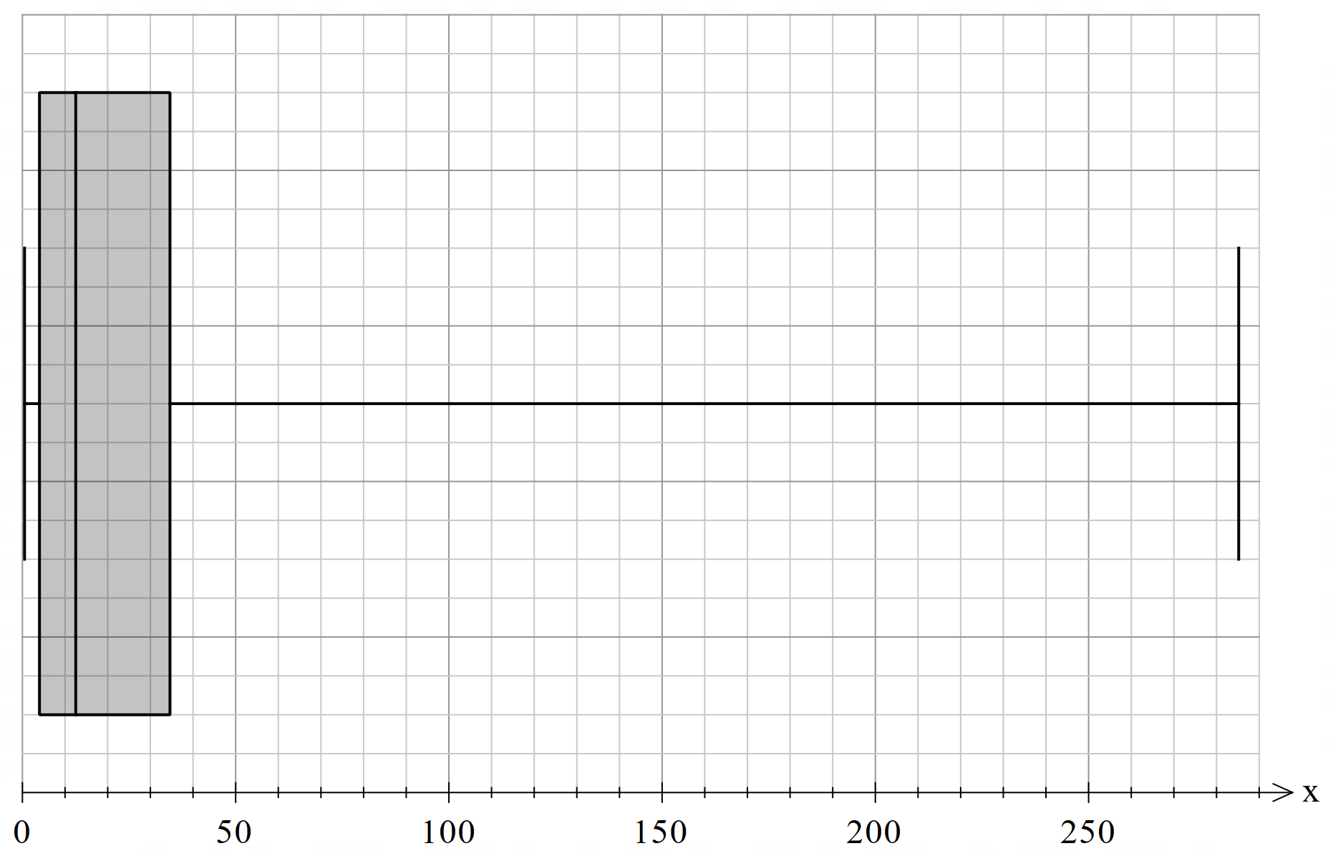

Appendix C

Box plots using Polypad

Finding the quartiles
- Copy the link (bit.ly/polycompare) into the browser to open Polypad.
- Select and drag over the 12 green number tiles to select them.
- Select the Randomise button that will appear to create a unique set of numbers.
- Arrange the numbers in ascending order.
Figure 2: random numbers in ascending order
- Create a vertical line to represent the median, Q1 and Q3. The line tool can be accessed using the tool kit at the bottom of the page.
Figure 3: median and quartiles
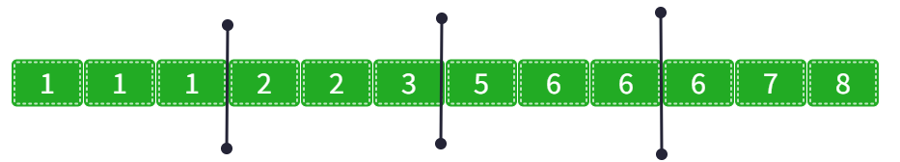

Constructing a box plot
- Draw a vertical line above the number line at the median, Q1 and Q3 and join them to form a box, like shown below.
Figure 4: forming the box
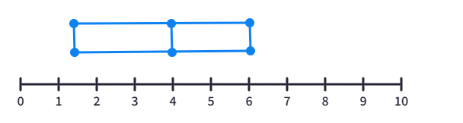
- Draw a horizontal line from the edge of the box to the lowest score and to the highest score to form the whiskers.
Figure 5: complete box plot
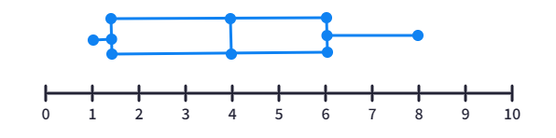

Appendix D

Is my box plot correct?
Use the following steps to check your calculations and box plot are correct.
- Double click in a cell in the table to enter your numbers into the table. You can select Enter to move from one cell to another.
- Compare the box plot created be the table to the you created previously. Are they the same?
Figure 6: completed box plot
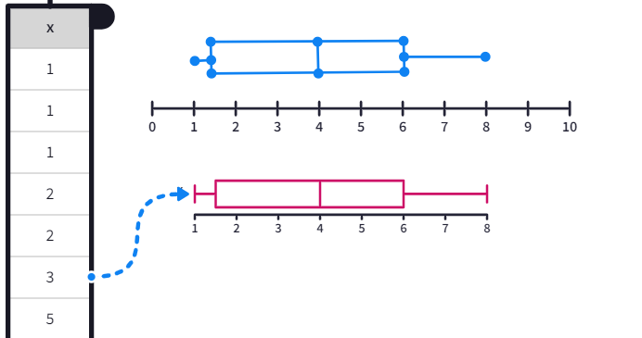

Appendix E

Data sorting activity
Print the following cards.
Have students work with a partner to match the boxplot, histogram and summary statistics.
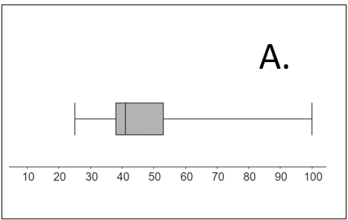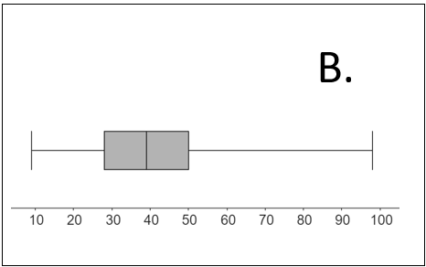
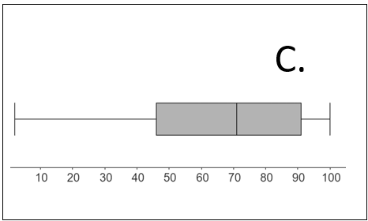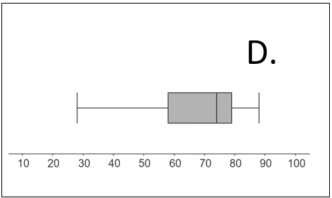
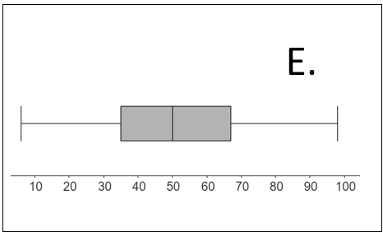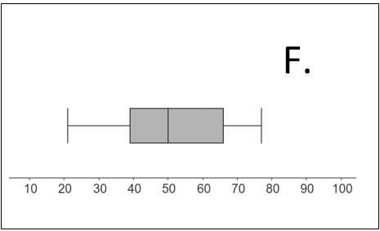
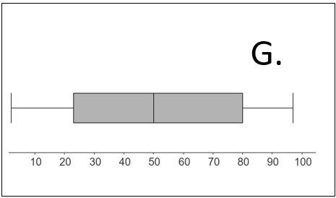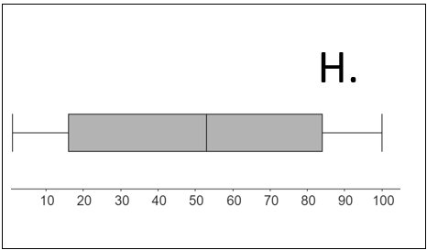
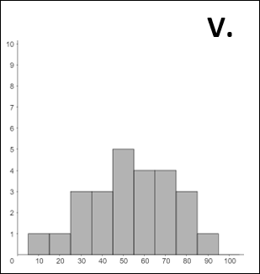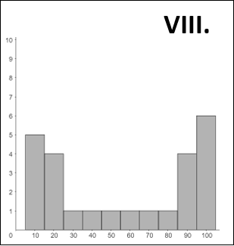
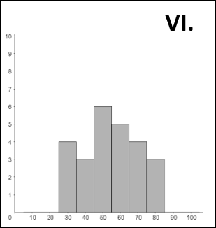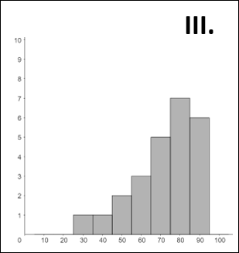
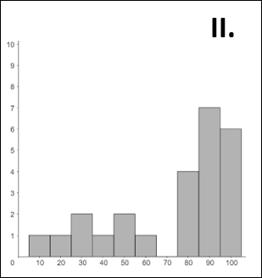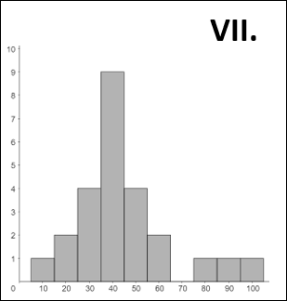
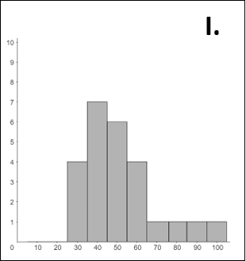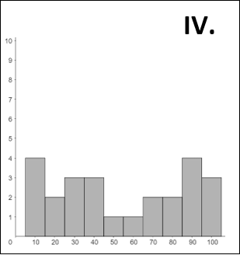
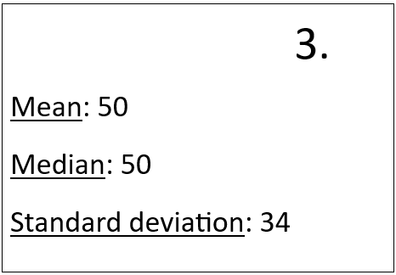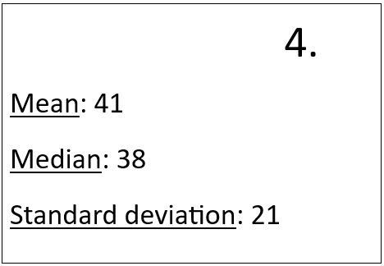
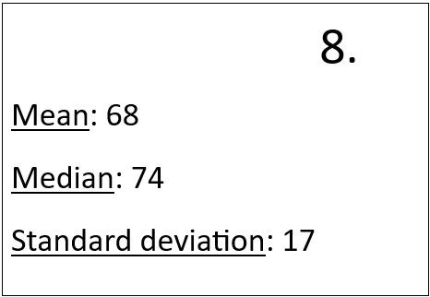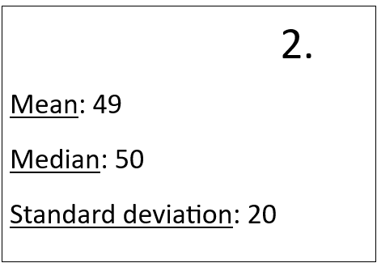
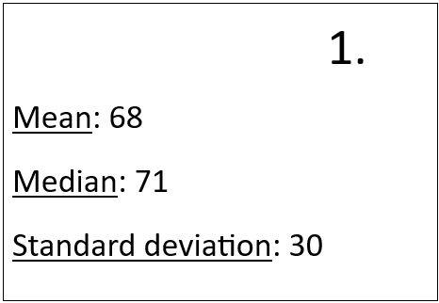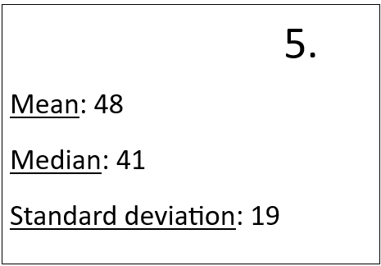
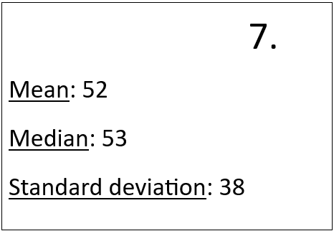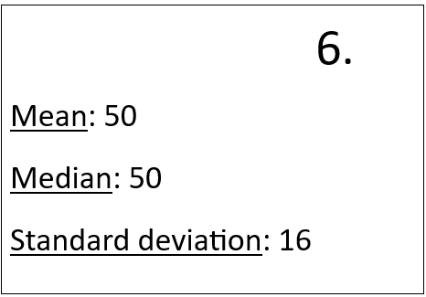

Sample solutions

Appendix E – data sorting activity
Histograms | Boxplots | Summary statistics
I | A | 5
II | C | 1
III | D | 8
IV | G | 3
V | E | 2
VI | F | 6
VII | B | 4
VIII | H | 7

References
This resource contains NSW Curriculum and syllabus content. The NSW Curriculum is developed by the NSW Education Standards Authority. This content is prepared by NESA for and on behalf of the Crown in right of the State of New South Wales. The material is protected by Crown copyright.
Please refer to the NESA Copyright Disclaimer for more information https://educationstandards.nsw.edu.au/wps/portal/nesa/mini-footer/copyright.
NESA holds the only official and up-to-date versions of the NSW Curriculum and syllabus documents. Please visit the NSW Education Standards Authority (NESA) website https://educationstandards.nsw.edu.au and the NSW Curriculum website https://curriculum.nsw.edu.au.
Mathematics K–10 Syllabus © NSW Education Standards Authority (NESA) for and on behalf of the Crown in right of the State of New South Wales, 2022.
NESA (NSW Education Standards Authority) (2024) ‘Glossary’, Resources, NESA website, accessed 3 April 2024
Images created using the free virtual manipulatives at Polypad.org.

© State of New South Wales (Department of Education), 2024
The copyright material published in this resource is subject to the Copyright Act 1968 (Cth) and is owned by the NSW Department of Education or, where indicated, by a party other than the NSW Department of Education (third-party material).
Copyright material available in this resource and owned by the NSW Department of Education is licensed under a Creative Commons Attribution 4.0 International (CC BY 4.0) license.
This license allows you to share and adapt the material for any purpose, even commercially.
Attribution should be given to © State of New South Wales (Department of Education), 2024.
Material in this resource not available under a Creative Commons license:
- the NSW Department of Education logo, other logos and trademark-protected material
- material owned by a third party that has been reproduced with permission. You will need to obtain permission from the third party to reuse its material.
Links to third-party material and websites
Please note that the provided (reading/viewing material/list/links/texts) are a suggestion only and implies no endorsement, by the New South Wales Department of Education, of any author, publisher, or book title. School principals and teachers are best placed to assess the suitability of resources that would complement the curriculum and reflect the needs and interests of their students.
If you use the links provided in this document to access a third-party's website, you acknowledge that the terms of use, including licence terms set out on the third-party's website apply to the use which may be made of the materials on that third-party website or where permitted by the Copyright Act 1968 (Cth). The department accepts no responsibility for content on third-party websites.

