# Traverse survey

Students conduct a traverse offset survey and calculate the area and perimeter of the irregular shape.

This lesson contains the Stage 4 outcomes **MA4-ARE-C-01** – Area and **MA4-PYT-C-01** – Right-angled triangles (Pythagoras’ theorem). This lesson allows students to revise this content before starting the Stage 5 content.

## Learning intentions

* To be able to use Pythagoras' theorem to solve problems.
* To be able to use the area of a right-angled triangle to solve problems.

## Success criteria

* I can conduct a traverse offset survey.
* I can calculate areas to solve problems.
* I can calculate the length of an unknown side.

## Syllabus outcomes

A student:

* develops understanding and fluency in mathematics through exploring and connecting mathematical concepts, choosing and applying mathematical techniques to solve problems, and communicating their thinking and reasoning coherently and clearly **MAO-WM-01**
* applies Pythagoras’ theorem to solve problems in various contexts **MA4-PYT-C-01**
* applies knowledge of area and composite area involving triangles, quadrilaterals and circles to solve problems **MA4-ARE-C-01**

[Mathematics K–10 Syllabus](https://curriculum.nsw.edu.au/learning-areas/mathematics/mathematics-k-10-2022/overview) © NSW Education Standards Authority (NESA) for and on behalf of the Crown in right of the State of New South Wales, 2022.

## Activity structure

Please use the associated PowerPoint *Traverse survey* to display images in this lesson.

### Warm up

1. Students are to work with a partner to find 3 rectangles, 3 triangles, and 3 trapeziums that each have an area of $80{cm}^{2}$.
2. Students then continue to work in pairs on the goal-free problem ([bit.ly/goalfreeproblems](https://bit.ly/goalfreeproblems)) in Appendix A ‘Goal-free problem’.

### Launch

1. Show students slide 3 from the PowerPoint *Traverse survey* which shows satellite imagery of rural properties.

This image shows a large array of different-shaped paddocks. The different colours reflect the different compositions of the paddocks. This imagery can show early changes in a crop’s health ([bit.ly/infred_paddock](http://www.bit.ly/infred_paddock)).

1. Ask students to consider what they notice and wonder ([bit.ly/noticewonderstrategy](https://bit.ly/noticewonderstrategy)) about this satellite image.
2. In a Think-Pair-Share ([bit.ly/thinkpairsharestrategy](https://bit.ly/thinkpairsharestrategy)), students are to discuss how they might take measurements of a large paddock to determine the area and perimeter.
3. Randomly choose pairs to share their strategies.

### Explore

1. Show students slide 5 from the PowerPoint *Traverse survey* which displays Figure 1, an outline of an area representing a ‘paddock’.

Figure 1: paddock

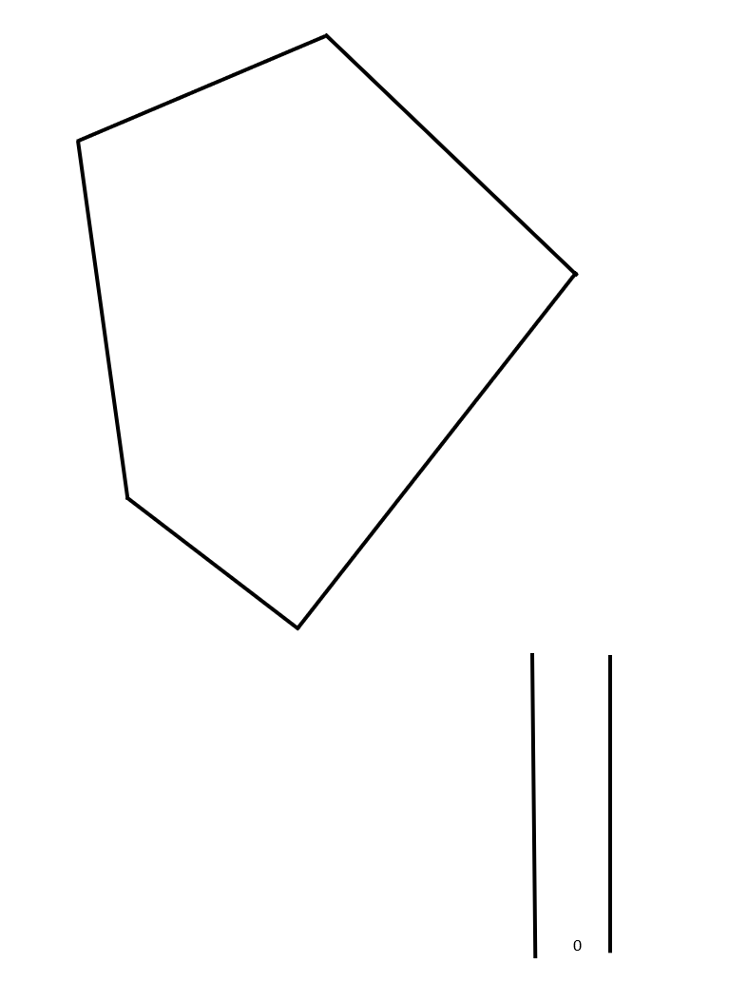

1. In visibly random groups of 3 ([bit.ly/visiblegroups](https://bit.ly/visiblegroups)) at vertical non-permanent surfaces ([bit.ly/VNPSstrategy](https://bit.ly/VNPSstrategy)), ask students to consider how they would split up an irregular shape like this into familiar shapes that they can calculate the area and perimeter of.

Students could be prompted to draw in a diagonal and consider how they could make known shapes with right angles from the diagonal. Teachers can refer students back to the warm-up activity for suggestions of shapes.

Figure 2: paddock with a centreline

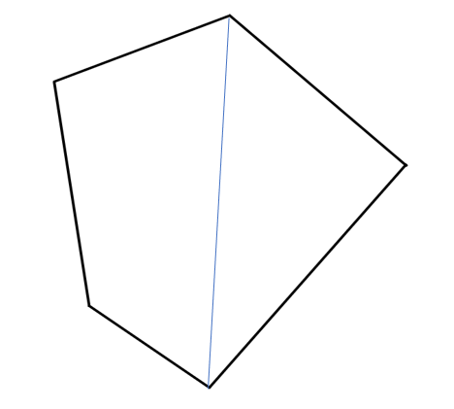

Students should identify that the shape can be cut into a series of right-angled triangles and trapeziums.

1. Display slide 6 from the PowerPoint *Traverse survey* which displays the traverse survey in Figure 3. Tell students this picture shows the centreline and offsets.

Figure 3: traverse survey

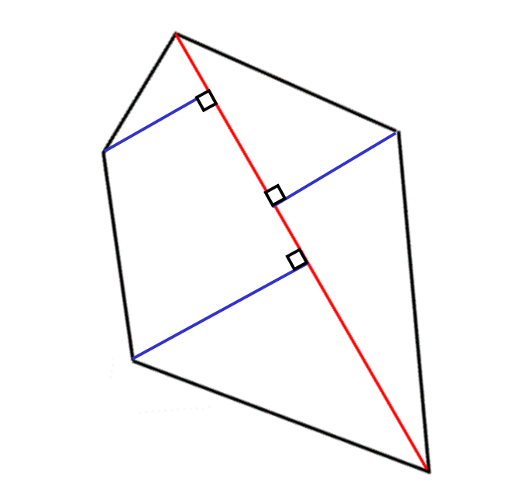

1. Using the Pose-Pause-Pounce-Bounce questioning strategy (PDF 557 KB) ([bit.ly/posepausepouncebounce](https://bit.ly/posepausepouncebounce)) ask students what they think a centreline and offsets are.

A centreline is a line that bisects a plane figure.

An offset is a perpendicular distance taken from either side of the centreline to a vertex.

1. Display slide 7 from the PowerPoint *Traverse survey,* which shows a traverse survey and a notebook entry, and ask students what they notice and wonder.

Students may notice:

* The numbers in the middle column of the notebook entry relate to the lengths from the bottom of the centreline to each offset.
* The numbers in the left and right columns relate to the lengths of each offset and their direction from the centreline

Students may wonder:

* What are the advantages and disadvantages of each representation of the field?

#### Equipment

* 5 witches’ hats, cones or markers
* Set square per group
* 2 tape measures per group
* Appendix B ‘Traverse survey’ on A4 paper (one per student)

If access to a set square is not available, students can use the corner of a piece of paper to determine right angles.

#### Method

1. Continuing in their random groups of 3, inform students that they are going to conduct their own traverse survey on a smaller scale and record their measurements in a notebook entry before coming inside to draw a field diagram.
2. Each group is to be given the equipment listed above to conduct a traverse survey. Instructions and space to draw a traverse survey and also complete a notebook entry, can be found in Appendix B ‘Traverse survey’.

Students can use the corner of a sheet of paper to show they are perpendicular to the centreline.

1. Return to the classroom and challenge students to find the area and perimeter of the paddock they created with their cones.

The purpose of this activity is not to have students come to a solution but to monitor their problem-solving skills and pay attention to the mathematics they attempt to use to solve the problem.

1. Using the Pose-Pause-Pounce-Bounce questioning technique, ask students what strategies they used to attempt to solve the problem and why.

This can be used as formative assessment to check student understanding of when to use formulas for area as well as Pythagoras’ theorem for finding unknown lengths.

### Summarise

If students are competent at finding the area and perimeter of their traverse survey, they should not return to the problem in steps 2 and 5, and the worked examples on slides 9–15 could be omitted.

Such students can skip straight to attempting Appendix C ‘Maths Venn’.

1. Use slides 9–12 from the PowerPoint *Traverse survey* for explicit teaching of finding areas using the formula for the area of right-angled triangles and trapeziums. Use the [worked examples (Your turn) method (DOCX 420 KB)](https://education.nsw.gov.au/content/dam/main-education/documents/teaching-and-learning/curriculum/mathematics/mathematics-s4-supporting-strategies-worked-examples-your-turn.docx).
2. Continuing with the vertical non-permanent surface, students are to work out the area of the paddock they measured outside.
3. Students then do a gallery walk ([bit.ly/DLSgallerywalk](https://bit.ly/DLSgallerywalk)) using the Two stars and a wish feedback strategy ([bit.ly/2starwish](https://bit.ly/2starwish)) to evaluate the work of other groups.
4. Use slides 12–15 from the PowerPoint *Traverse survey* for explicit teaching of finding perimeters using Pythagoras’ theorem. Use the worked examples (your turn) method.
5. Continuing with the vertical non-permanent surface, students are to work out the perimeter of the paddock they measured outside.
6. Students then do a gallery walk using the Two stars and a wish feedback strategy to evaluate the work of other groups.
7. Continuing in their groups of 3, students should work through Appendix C ‘Maths Venn’.
8. Students should conduct a gallery walk, making note of the different solutions for each group and if there was a section of the Venn diagram that wasn’t filled.

### Apply

1. Give each student a copy of Appendix D ’Rainfall’ and complete the questions related to the scenario. These questions involve both area and perimeter calculations.
2. Students are to compare their solutions with another student. If they have differing answers, they must work together to find the correct solution.

## Assessment and differentiation

### Suggested opportunities for differentiation

**Launch**

* All students can participate as there are no right answers and everyone can notice and wonder.
* Students should be challenged to make connections with their prior knowledge of types of triangles, Pythagoras’ theorem and the area of plane shapes.

**Explore**

* Students requiring support may create a traverse offset survey with fewer cones or with offsets only on one side.

**Summarise**

* If a student is struggling to contribute to the task, encourage them to move around the room and find an answer from another group. They should ask that group how they know that area is correct before reporting back to their group.
* Encourage students who struggle with the formula for a trapezium to break the shape into a triangle and a rectangle.
* Students can be encouraged to find plane shapes to complete the Venn diagram in Appendix C.

**Apply**

* Students struggling with the calculation could be given a simpler task that doesn’t require unit conversions.

### Suggested opportunities for assessment

**Launch**

* Students’ responses to the goal-free problem may reveal misconceptions that should be addressed before continuing with the lesson.

**Summarise**

* Review student work on vertical non-permanent surfaces to check their understanding of Pythagoras’ theorem and area of plane shapes.

**Apply**

* Appendix D could be collected and analysed as evidence of student learning.
* When working at vertical non-permanent surfaces, students can self-assess by comparing their answers to their peers.
* Ask students to justify their answers as you move around the room.

## Appendix A

### Goal-free problem

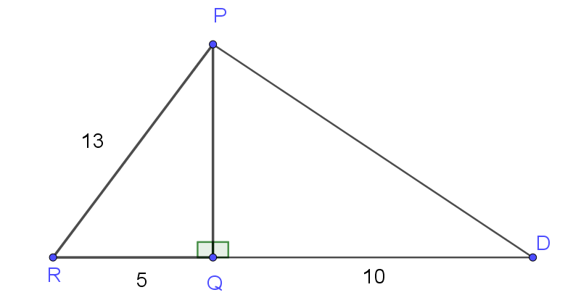

The diagram above shows two right-angled triangles. Work out or calculate as much information as you can from the diagram.

## Appendix B

### Traverse survey

#### Setting up a survey

1. Create a ‘paddock’ with your cones by placing the 5 markers on the ground to form a large irregular polygon.
2. Join 2 markers with a tape measure to bisect your ‘paddock’ and create your centreline.
3. Measure the distance along the centreline and mark it on your survey.
4. Walk along the centreline until you reach a point where you are perpendicular to the first vertex/marker.
5. Measure the distance from the centreline to the vertex and label the offset length on your survey.
6. Continue along the centreline, measuring and recording measurements for the centreline and offsets, until you have measured the entire centreline. The length of the centreline should be the top number on your notebook entry.

#### My survey

1. Draw your traverse survey.

|  |
| --- |
|  |

1. Complete the notebook entry.

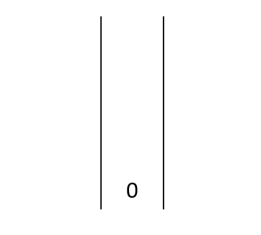

## Appendix C

### Maths Venn

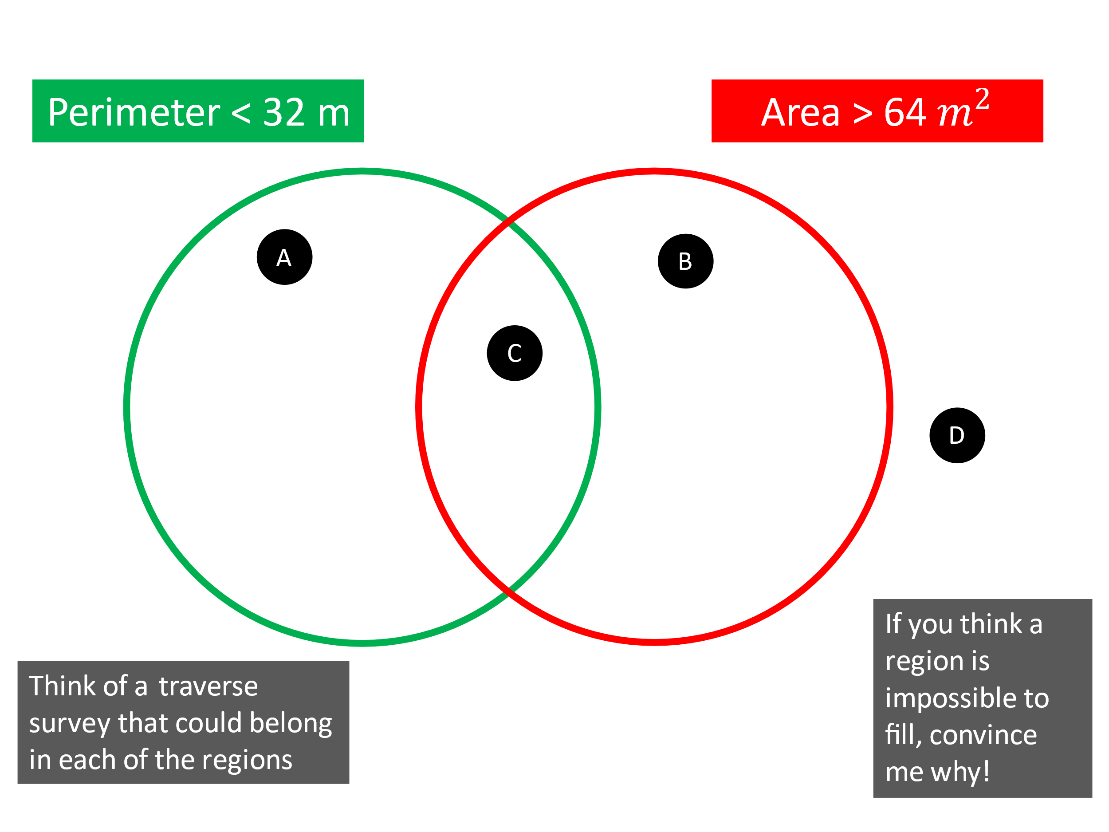

## Appendix D

### Rainfall

Below is a satellite image of a field showing crops and pastures of different colours depending on different environmental factors and the health of the vegetation.

1. Using the notebook entry below, sketch the area showing all measurements.
2. Calculate the area and perimeter of the space.

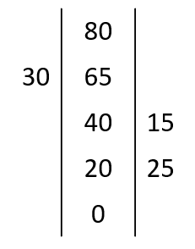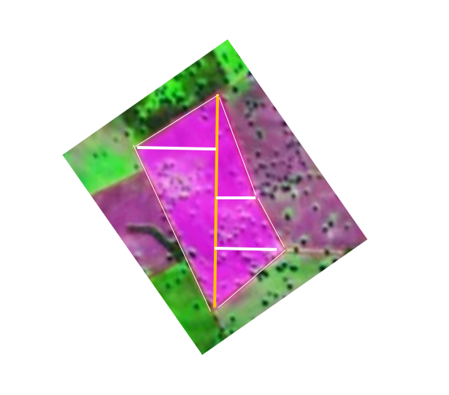

1. If it costs $25 per metre to install fencing, calculate the overall cost to fence the area.
2. This space is a catchment area for a dam. Calculate the volume of water that has fallen on the field if 100 mm of rain fell.

## Sample solutions

### Warm Up

One example of each shape that has an area of 80 cm2.

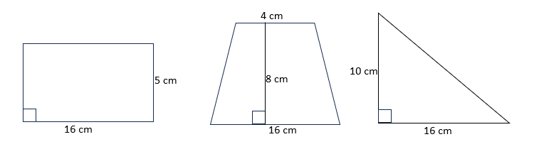

|  |  |  |
| --- | --- | --- |
|  |  |  |

### Appendix C – Maths Venn

#### Section A

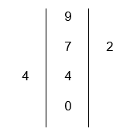

**Perimeter**

$$\sqrt{4^{2}+4^{2}}+\sqrt{5^{2}+4^{2}}+\sqrt{2^{2}+2^{2}}+\sqrt{7^{2}+2^{2}}≈22.17 m$$

**Area**

$$\left(\frac{1}{2}×9×4\right)+\left(\frac{1}{2}×9×2\right)=27 m^{2}$$

#### Section B

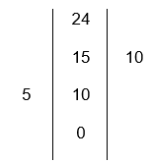

**Perimeter**

$$\sqrt{{10}^{2}+5^{2}}+\sqrt{{14}^{2}+5^{2}}+\sqrt{{15}^{2}+{10}^{2}}+\sqrt{9^{2}+{10}^{2}}≈57.53 m$$

**Area**

$$\left(\frac{1}{2}×24×5\right)+\left(\frac{1}{2}×24×10\right)=180 m^{2}$$

#### Section C

This section is impossible, as the area of a shape that has the smallest perimeter, but maximal area is a square. If we had a square with the area of 64, the side lengths would need to be 8, which would give us a perimeter of 32, so we cannot have a number less than that.

#### Section D

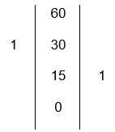

**Perimeter**

$$\sqrt{{30}^{2}+1^{2}}+\sqrt{{30}^{2}+1^{2}}+\sqrt{{15}^{2}+1^{2}}+\sqrt{{45}^{2}+1^{2}}≈120.08 m$$

**Area**

$$\left(\frac{1}{2}×60×1\right)+\left(\frac{1}{2}×60×1\right)=60 m^{2}$$

### Appendix D – Rainfall

1. Sketch is not to scale

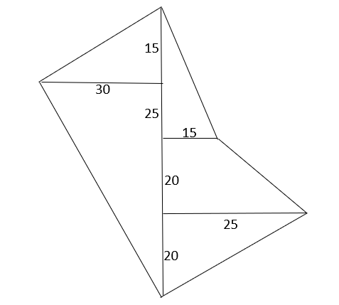

1. Find the perimeter of this figure.

**Length 1**

$$l=\sqrt{{15}^{2}+{30}^{2}} \\ =33.541…$$

**Length 2**

$$l=\sqrt{{30}^{2}+{65}^{2}} \\ =71.589….$$

**Length 3**

$$l=\sqrt{{25}^{2}+{20}^{2}} \\ =32.016$$

**Length 4**

$$l=\sqrt{{20}^{2}+{10}^{2}} \\ =22.361$$

**Length 5**

$$l=\sqrt{{40}^{2}+{15}^{2}} \\ =42.720…$$**Perimeter**

$$l=33.541+71.589+32.016+22.361+42.720 \\ =202.227… \\ ≈202 m$$

Cost of Fencing

$$Cost =203 ×\$25 \\ =\$5075$$

1. Find the area of this figure.

**Area 1**

$$A=\frac{1}{2}×30×80 \\ =1200$$

**Area 2**

$$A=\frac{1}{2}×20×25 \\ =250$$

**Area 3**

$$A=\frac{1}{2}×20×\left(15+25\right) \\ =400$$

**Area 4**

$$A=\frac{1}{2}×15×40 \\ =300$$**Area total**

$$A=1200+250+400+300 \\ =2150 m^{2}$$**Volume**

$$V=2150×0.1 \\ =215 m^{3} \\ =215 kL$$

## References

This resource contains NSW Curriculum and syllabus content. The NSW Curriculum is developed by the NSW Education Standards Authority. This content is prepared by NESA for and on behalf of the Crown in right of the State of New South Wales. The material is protected by Crown copyright.

Please refer to the NESA Copyright Disclaimer for more information <https://educationstandards.nsw.edu.au/wps/portal/nesa/mini-footer/copyright>.

NESA holds the only official and up-to-date versions of the NSW Curriculum and syllabus documents. Please visit the NSW Education Standards Authority (NESA) website <https://educationstandards.nsw.edu.au/> and the NSW Curriculum website [https://curriculum.nsw.edu.au](https://curriculum.nsw.edu.au/).

[Mathematics K–10 Syllabus](https://curriculum.nsw.edu.au/learning-areas/mathematics/mathematics-k-10-2022/overview) © NSW Education Standards Authority (NESA) for and on behalf of the Crown in right of the State of New South Wales, 2022.

**© State of New South Wales (Department of Education), 2024**

The copyright material published in this resource is subject to the *Copyright Act 1968* (Cth) and is owned by the NSW Department of Education or, where indicated, by a party other than the NSW Department of Education (third-party material).

Copyright material available in this resource and owned by the NSW Department of Education is licensed under a [Creative Commons Attribution 4.0 International (CC BY 4.0) license](https://creativecommons.org/licenses/by/4.0/).

[](https://creativecommons.org/licenses/by/4.0/)

This license allows you to share and adapt the material for any purpose, even commercially.

Attribution should be given to © State of New South Wales (Department of Education), 2024.

Material in this resource not available under a Creative Commons license:

* the NSW Department of Education logo, other logos and trademark-protected material
* material owned by a third party that has been reproduced with permission. You will need to obtain permission from the third party to reuse its material.

**Links to third-party material and websites**

Please note that the provided (reading/viewing material/list/links/texts) are a suggestion only and implies no endorsement, by the New South Wales Department of Education, of any author, publisher, or book title. School principals and teachers are best placed to assess the suitability of resources that would complement the curriculum and reflect the needs and interests of their students.

If you use the links provided in this document to access a third-party's website, you acknowledge that the terms of use, including licence terms set out on the third-party's website apply to the use which may be made of the materials on that third-party website or where permitted by the *Copyright Act 1968* (Cth). The department accepts no responsibility for content on third-party websites.