Approximating distance
Students explore similar triangles to approximate their distance from an object.

Visible learning

Learning intentions
- To understand the concept of similar figures.
- To be able to use similar figures to solve problems.

Success criteria
- I can explain why 2 triangles are similar.
- I can explain how similar triangles can be used to find unknown sides.
- I can calculate the value of an unknown side using similar figures.

Syllabus outcomes
A student:
- develops understanding and fluency in mathematics through exploring and connecting mathematical concepts, choosing and applying mathematical techniques to solve problems, and communicating their thinking and reasoning coherently and clear MAO-WM-01
- identifies and applies the properties of similar figures and scale drawings to solve problems MA5-GEO-C-01
Mathematics K–10 Syllabus © NSW Education Standards Authority (NESA) for and on behalf of the Crown in right of the State of New South Wales, 2022.

Activity structure
Please use the associated PowerPoint Approximating distance to display images in this lesson.

Launch
- Assign students into visibly random groups of 3 (bit.ly/visiblegroups).
- Display slide 2 from the PowerPoint Approximating distance, which shows Figure 1.
Figure 1: Sydney skyline
Image licensed under Unsplash License.
- Ask students to discuss how they could determine how far away from the Harbour bridge the photographer was when the photo was taken.
- Use a class discussion for students to share their strategies.
Students may suggest getting a boat and measuring the distance, others may suggest looking it up on Google Maps or equivalent.
The picture can be changed to another landscape that is more familiar to students.
- Ask students if they were given a ruler and a tape measure could they tell how far it is from where the photographer is standing to the Harbour bridge?

Explore
- State to students that surveyors use similar triangles to help them find distances between objects they can’t measure directly. Explain to students that they will explore a strategy called the parallax method.
- In their groups of 3, move students to vertical non-permanent surfaces containing an isometric grid printed on A3 paper and placed in a plastic pocket for each group of students.
Isometric paper can be found on the Printable Paper website ‘Isometric Graph Paper’ (printablepaper.net/category/isometric_graph).
Alternatively, you can distribute a geoboard to students or use dynamic software such as GeoGebra (geogebra.org/calculator).
- Distribute Appendix A ‘Investigation’ to each group. This appendix contains an investigation that uses similar triangles in a parallax formation. Students measure side lengths to show the sides are all in the same ratio and therefore the triangles are similar. Students will need a ruler to measure the lengths.
Students may need to be reminded of the proofs for similar triangles by referring to Lesson 4 – how many angles of Unit 1 – geometrical representations.
- Groups are to compare their triangles to those from other groups. Students are to discuss the similarities and differences between their solutions.
Students should note that their ratios may differ but their consistency across all sides of their triangles is the same.
- In their groups, students must create a proposal on how they could use the parallex method to find the distance between themselves and another point in the school that they can see (a building or other structure). Students can record their proposals on their vertical non-permanent surfaces (bit.ly/VNPSstrategy).
- Students are to do a gallery walk (bit.ly/DLSgallerywalk). They will visit another proposal and give peer feedback using the Plus, Minus, Interesting (PMI) strategy (bit.ly/PMIactivity).
- In a class discussion, ask students about any common themes they found within each of the proposals.

Field work
Students will now conduct fieldwork to see how the parallex method can be used to measure distances in a real-life context.

Equipment (per group)
- Ruler
- Tape measure
- Appendix B ‘Fieldwork’

Method
- Have students look at a wall in the classroom and ask them to close one eye. Now repeat with the other eye. Ask students what they notice and wonder.
Figure 2: thumb position when each eye is closed
Students' attention should be drawn to the position of their thumb in relation to the building. When our left eye is closed we produce the image on the right, and when our right eye is closed it creates the image on the left. This image can be displayed using Slide 3 of the Approximating distance PowerPoint.
- Draw attention to Figure 3, seen in Appendix B and on slide 4 of the Approximating distance PowerPoint. Ask students what they notice and wonder (bit.ly/noticewonderstrategy).
Figure 3: similar triangles for approximating distance
Students should notice that this is the same diagram as the one they looked at in Appendix A, except the triangles are isosceles.
Students should recognise that the image on the left of the diagram represents their eyes and the distance between them. The image in the middle of the diagram represents their thumb, and the 2 points marked on the building represent the 2 positions of their thumb when each eye is closed.
- Ask students what might be easy to measure in this scenario.
Students should say that it is easy to measure the distance between their eyes and the distance between their eyes and their thumb.
- Explain to students that we need these measurements to approximate the distance to an object and that one other measurement is needed.
- Explain to students that windows on buildings are usually in standard sizes which makes it easy to estimate the length between where our thumb was when we closed each eye, but today we would like to be more accurate so we will also be measuring the distance between the 2 points identified on the building.
- In their groups, students should assign the following roles. These can also be seen in Appendix B ‘Fieldwork’:
Viewer: this person stays in the beginning position. They will have the distance between their eyes measured and they will explain where the points go on the object being measured.
Measurement surveyor: this person will measure the viewer and the object. They are the only person allowed to use the ruler and tape measure.
Field surveyor: this person will go to the object being measured and place points as instructed by the viewer.
- Take students outside to find a position where you can see from one side of the school to another. Ensure there is a building or object at the other end.
- Students should complete the instructions and activity in Appendix B ‘Fieldwork’.
- Students should repeat the process, each having a turn at a different role to improve accuracy.

Summarise
- Find the real distance across the school using ‘Six maps’ (maps.six.nsw.gov.au/) and ask students to compare it to the length they found.
- Ask students to turn and talk (bit.ly/classroomtalkmoves) to the person next to them about how accurate the process was.

Apply
- Inform students of the method farmers use to determine distances.
Farmers use the parallax method to determine the length of their fields or how far away livestock are. They use the fact that the length of a cow is approximately 2.5 m. Farmers look towards a group of cows in the distance and estimate the number of cows (or part thereof) that would fit between their thumbs. They then multiply this width by 10 to find the approximate distance between themselves and the cows.
For example, if approximately 2 cows could fit in between my thumbs after I shut each eye then I would have my approximate width of $2.5×2$, which would then be multiplied by 10 to get the approximate distance between myself and the cows $2.5×2×10=50 m$.
This can be seen in the following diagram.
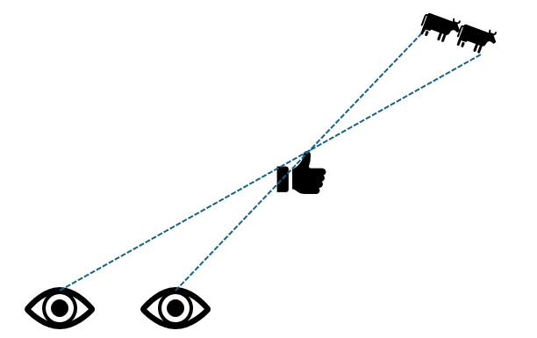
- In their groups of 3, ask students to justify why farmers use a factor of 10. Students could reference their previous calculations.
Students should have generalised from previous activities that the distance they are away from an object is always approximately 10 times the width between the 2 points on the object, viewed between their thumbs.
- Initiate a sharing of ideas and reasoning using the Pose-Pause-Pounce-Bounce question strategy (PDF 557 KB) (bit.ly/posepausepouncebounce).

Assessment and differentiation

Suggested opportunities for differentiation
Explore
- You can use geoboards to create the diagram.
- For students who struggle with literacy, they can complete the activity in Appendix A by measuring the diagram provided.
- To challenge students, the formal similarity proof for each triangle could be constructed.
- To enable students, students could complete activities from Stage 5 Unit 1 – geometrical representations to review similarity.
- Extend students by challenging them to find a distance of 100 m.
Apply
- Students could be given diagrams with distances labelled using the parallax method to help justify why farmers use the factor of 10.
- Students could be extended by exploring if multiplying by a different number would make a better estimate.

Suggested opportunities for assessment
Launch
- Collect student's proposals to assess how they approach solving a problem by working mathematically.
Explore
- The teacher could facilitate class discussions and observe students’ reasoning and justification in response to the provided prompts.
- Collect student logbooks to assess their understanding of finding missing sides in similar figures.
Summarise
- Students' ability to brainstorm other situations where they can apply the parallax method and perform another calculation can be used as evidence of the understanding of applying similar figures.

Appendix A

Investigation
- Create a straight line AB, of any length on the isometric grid.
- Mark the midpoint of line AB as point F.
- Create another straight line DE, that is parallel to AB but a different length.
- Mark the midpoint of the line DE as point G.
- Connect A to E, B to D, and F to G. Mark where they intersect as point C.
- If drawn correctly your diagram should look similar to the one below.
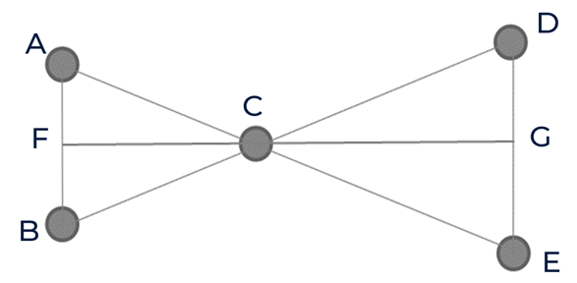
- Measure the lengths in each triangle, including CF and CG.
Side | Length
AB
AC
CB
CF
CD
DE
CE
CG
- Considering AB is parallel to DE, use alternate angles on parallel lines to mark angles that are the same in each triangle. What do you notice?
- Identify which triangles are similar and justify why they are similar.
- Match the corresponding sides in each triangle.
- Compare the ratios for each corresponding pair of sides. Simplify to a common scale factor.
$$\frac{AB}{DE}=\frac{AC}{CE}=\frac{BC}{DC}=\frac{CF}{CG}$$
- Explain what is meant by the term ‘scale factor’.
- Create a new diagram, using the instructions 1–6.
- Knowing these triangles are similar, calculate the side CG by only measuring 3 other sides.

Appendix B

Fieldwork
Viewer: this person stays in the beginning position. They will have the distance between their eyes measured and they will explain where the points go on the object being measured.
Measurement surveyor: this person will measure the viewer and the object. They are the only person allowed to use the ruler and tape measure.
Field surveyor: this person will go to the object being measured and place points as instructed by the viewer.

Task 1 – setting up the boundaries
- Given the diagram below, the viewer will try to explain to the field surveyor where their thumb sits in relation to the object.
- These positions should be marked by the field surveyor and the distance between the markers should be measured.

Task 2 – measuring
- The measurement surveyor is to take the following measurements:
Description | Length (cm)
Length between eyes (AB)
Eyes to the outstretched thumb (FC)
Distance between markers
- The surveyor will then place the measurements onto the diagram.

Task 3 – calculating
- Using similar triangles, calculate the distance the viewer was from the object.
- Repeat this process and change roles to improve your accuracy.

Sample solutions

Appendix A – investigation
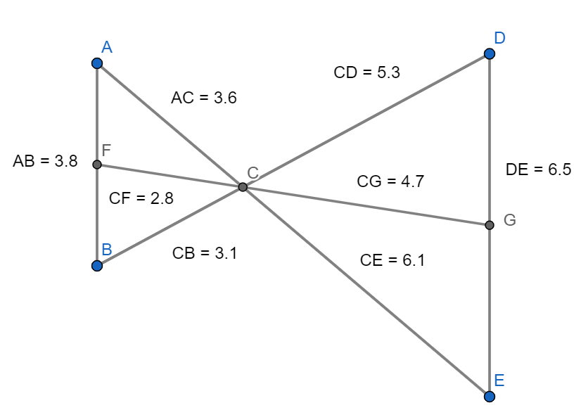
- Measure the lengths in each triangle, including the altitudes (CF and CG).
Side | Length
AB | 3.8 cm
AC | 3.6 cm
CB | 3.1 cm
CF | 2.8 cm
CD | 5.3 cm
DE | 6.5 cm
CE | 6.1 cm
CG | 4.7 cm

- Using angles on parallel lines, match the angles that are the same in each triangle. What do you notice?
- $∠BAC=∠CED∵$ alternate angles in parallel lines are equal.
- $∠ABC=∠CDE∵$ alternate angles in parallel lines are equal.
- $∠ACF=∠GCE∵$ vertically opposite angles are equal.
- $∠BCF=∠GCD∵$ vertically opposite angles are equal.
- $∠ACB=∠DCE∵$ vertically opposite angles are equal.
- $∠CGE=∠AFC∵$ alternate angles in parallel lines are equal.
- $∠CGD=∠BFC∵$ alternate angles in parallel lines are equal.
Each triangle has a matching set of angles to another triangle.
- Identify what triangles are similar.
- $∆ABC$ is similar to $∆EDC∵$ equiangular.
- $∆ACF$ is similar to $∆EGC$ $∵$ equiangular.
- $∆BCF$ is similar to $∆DCG$ $∵$ equiangular.
- Match the corresponding sides in each triangle.
Side in $∆ ABC$ | Matching side in $∆DEC$
AB | ED
AC | EC
BC | DC

Side in $∆AFC$ | Matching side in $∆EGC$
AF | EG
AC | EC
FC | GC

Side in $∆BFC$ | Matching side in $∆DGC$
BF | DG
BC | DC
FC | GC

$$\frac{AB}{DE}=\frac{AC}{CE}=\frac{BC}{DC}=\frac{CF}{CG}$$
$$\frac{3.8}{6.5}=\frac{3.6}{6.1}=\frac{3.1}{5.3}=\frac{2.8}{4.7}$$
$$\frac{38}{65}=\frac{36}{61}=\frac{31}{53}=\frac{28}{47}$$
$$0.58=0.59=0.58=0.6$$
- The scale factor between the triangles is approximately 0.6.
- Scale factor is the number used to multiply or divide to find the side in another similar figure.
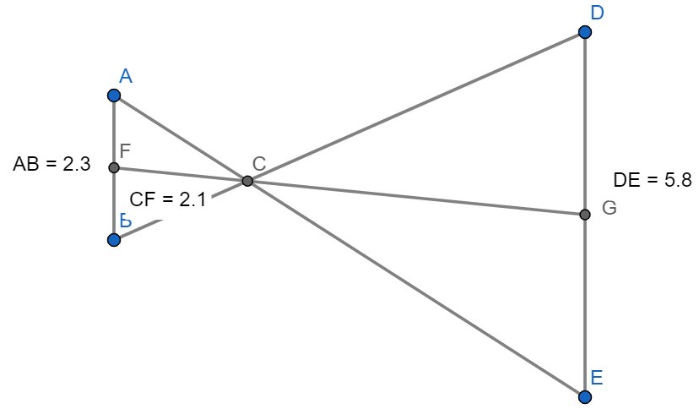

$$\frac{CG}{2.1}=\frac{5.8}{2.3} \\ =\frac{5.8}{2.3}×2.1 \\ =5.3$$

References
This resource contains NSW Curriculum and syllabus content. The NSW Curriculum is developed by the NSW Education Standards Authority. This content is prepared by NESA for and on behalf of the Crown in right of the State of New South Wales. The material is protected by Crown copyright.
Please refer to the NESA Copyright Disclaimer for more information https://educationstandards.nsw.edu.au/wps/portal/nesa/mini-footer/copyright.
NESA holds the only official and up-to-date versions of the NSW Curriculum and syllabus documents. Please visit the NSW Education Standards Authority (NESA) website https://educationstandards.nsw.edu.au/ and the NSW Curriculum website https://curriculum.nsw.edu.au/.
Mathematics K–10 Syllabus © NSW Education Standards Authority (NESA) for and on behalf of the Crown in right of the State of New South Wales, 2022.

© State of New South Wales (Department of Education), 2024
The copyright material published in this resource is subject to the Copyright Act 1968 (Cth) and is owned by the NSW Department of Education or, where indicated, by a party other than the NSW Department of Education (third-party material).
Copyright material available in this resource and owned by the NSW Department of Education is licensed under a Creative Commons Attribution 4.0 International (CC BY 4.0) license.
This license allows you to share and adapt the material for any purpose, even commercially.
Attribution should be given to © State of New South Wales (Department of Education), 2024.
Material in this resource not available under a Creative Commons license:
- the NSW Department of Education logo, other logos and trademark-protected material
- material owned by a third party that has been reproduced with permission. You will need to obtain permission from the third party to reuse its material.
Links to third-party material and websites
Please note that the provided (reading/viewing material/list/links/texts) are a suggestion only and implies no endorsement, by the New South Wales Department of Education, of any author, publisher, or book title. School principals and teachers are best placed to assess the suitability of resources that would complement the curriculum and reflect the needs and interests of their students.
If you use the links provided in this document to access a third-party's website, you acknowledge that the terms of use, including licence terms set out on the third-party's website apply to the use which may be made of the materials on that third-party website or where permitted by the Copyright Act 1968 (Cth). The department accepts no responsibility for content on third-party websites.

