# River crossing

Students discover how to find the distance ‘as the crow flies’ between objects separated by an obstruction using similar triangles.

## Visible learning

### Learning intention

* To understand how to use similar triangles to find distances.

### Success criteria

* I can explain why 2 triangles are similar.
* I can find an unknown length using similar triangles.
* I can explain the most efficient method to solve a problem.

## Syllabus outcomes

A student:

* develops understanding and fluency in mathematics through exploring and connecting mathematical concepts, choosing and applying mathematical techniques to solve problems, and communicating their thinking and reasoning coherently and clearly **MAO-WM-01**
* identifies and applies the properties of similar figures and scale drawings to solve problems **MA5-GEO-C-01**

[Mathematics K–10 Syllabus](https://curriculum.nsw.edu.au/learning-areas/mathematics/mathematics-k-10-2022/overview) © NSW Education Standards Authority (NESA) for and on behalf of the Crown in right of the State of New South Wales, 2022.

## Activity structure

Please use the associated PowerPoint *River crossing* to display images in this lesson.

### Launch

1. Display slide 2 from the PowerPoint *River crossing* which shows Figure 1.

Figure 1: Hunter River

Photo of the Hunter River.

1. Explain to students that during the First and Second World Wars, when land was captured, a team of engineers and surveyors would need to advance ahead of the army troops to manage obstacles. When the engineers and surveyors approached an obstacle, such as a river, they would need to work out how wide the river was so they could build a bridge, allowing the troops to continue to move forward.
2. In a Think-Pair-Share ([bit.ly/thinkpairsharestrategy](https://bit.ly/thinkpairsharestrategy)), ask students how the engineers or surveyors might have found the distance across the river given that they could not cross it.
3. Randomly select pairs to share their strategies.

### Explore

In this section of the lesson, students will be going outside to calculate distances. It is suggested that obstructions be set up before the lesson occurs. An obstruction could be 2 ropes set up to mimic a river or a basketball court that separates the playground.

1. Explain to students that surveyors in the war used similar triangles to find distances that they couldn’t measure.
2. Using a questioning strategy such as Pose-Pause-Pounce-Bounce (PDF 557 KB) (<https://bit.ly/posepausepouncebounce>) ask students what they need to know to make sure 2 triangles are similar.
3. Display Figure 2 to students. This can also be found on slide 3 of the PowerPoint *River crossing.*

Figure 2: similar triangles

Two diagrams of similar triangles.
The first is of 2 right-angled triangles, AED and BCD, meet at point D. The angles at point D are vertically opposite. Right angles at A and B.
The second is of 2 triangles, AED and BCD, meeting at point D. There are right angles at A and B. Angle EDA is equal to angle DCB. 

1. In a Think-Pair-Share, ask students to explain why both sets of triangles are similar.

Students explored tests for similarity in Lesson 4 – how many angles of Unit 1 – geometrical representations.

To ensure 2 triangles are similar we need to show that 2 sets of corresponding angles in each triangle are equal. This can be seen in each set of triangles.

The first set has a matching right angle as well as vertically opposite angles.

The second set has a matching right angle as well as corresponding angles in parallel lines.

##### Equipment per group

* 1 roll of masking tape
* 1 ball of yarn
* A tape measure
* Appendix A ‘Staying on one side’

If the obstruction is set up on a grassed area, it is advised to use tent pegs rather than masking tape.

##### Method

1. Display Figure 3 to the class. This can also be found on slide 4 of the PowerPoint *River crossing*.

Figure 3: obstruction diagram

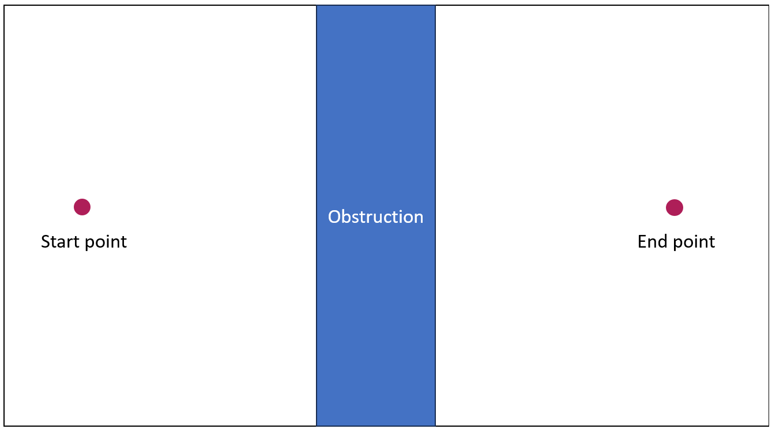

1. Assign students into visibly random groups of 3 ([bit.ly/visiblegroups](https://bit.ly/visiblegroups)) and distribute the equipment to each group of students.
2. Distribute Appendix A ‘Staying on one side’ to each group of students. This appendix contains 2 ways to conduct a chain survey to find the distance between 2 points over an obstruction.

Appendix A uses the term ‘collinear’. Students may need this word defined for them. Collinear is the term we use to describe points that lie on the same straight line.

1. Take students outside to the obstruction you set up before the lesson. Select 2 points on either side of the obstruction for students to find the distance between.

You can select different points for each group to enable all students access to complete the task. To make these values the same, make sure each pair of points are on parallel lines.

1. In their groups of 3, ask students to follow the instructions in Appendix A to conduct at least one chain survey to find the distance between the 2 points over the obstruction.
2. Remind students that they can use the corner of a piece of paper to find the direction that is perpendicular to their current direction.

Before measuring lengths and performing calculations, ensure students have a right angle as it gives more accurate results.

Students may also use either the masking tape or the yarn to act as their chain.

1. Advise students they are to provide all diagrams and calculations, and you will collect them upon completion.

Students explored using scale factor to find missing lengths in similar triangles in Lesson 7 – scale factor in similar triangles of Unit 1 – geometrical representations.

Explicit teaching of finding an unknown length using similar triangles may be required if students are not familiar with the concept before this lesson. The sample solutions can be used as worked examples for explicit teaching.

1. Students are to swap their calculations with another group and provide peer feedback using the TAG feedback strategy ([bit.ly/TAGstrategy](https://bit.ly/TAGstrategy)).
2. Students are then to return to their groups to respond or enact their feedback.
3. Ask students to find the real measurement by measuring the distance between the 2 points and compare their solution to the real distance.

### Summarise

1. Collate student results so all students can see them.
2. Students are to compare their results with other groups and the real measurement. Ask students to reflect on the following questions:

* How accurate are your results?
* Why are your results different?
* How can we improve the accuracy of our results?

1. Ask students to create an instructional poster that tells surveyors about each method and their limitations.

### Apply

1. In new visibly random groups of 3, give students a ball of yarn and a tape measure. Ask students to find distances across the school and/or surrounds, including across buildings and bodies of water.

It is best to use a very long ball of yarn as your chain. Students may require more than one ball of yarn when doing their fieldwork. If students are finding measurements on grass, tent pegs are also a useful item to use for the chain surveys.

1. Students are to create a logbook of their measurements. These must include diagrams and calculations and descriptions of the distances they calculated, such as between school buildings.
2. Students are to check their answers using an online website such as ‘Six maps’ ([maps.six.nsw.gov.au/](https://maps.six.nsw.gov.au/)) by using the distance tool.

## Assessment and differentiation

### Suggested opportunities for differentiation

**Explore**

* Due to the way the chain is set up for obstructions, the triangles are similar as they are equiangular. As an extension, students could prove this using knowledge of parallel lines.
* To extend students, ask them to find the shortest chain or the distance that gives them the most accurate solution for each method. Ask if they can confirm this for all lengths.
* Students may benefit from an alternate diagram where the 2 triangles from diagrams in the Appendix are drawn side by side in the same orientation, to help students visualise the similar triangles.

**Apply**

* Students can use data to find measures of centre to see if it increases the accuracy.

### Suggested opportunities for assessment

**Explore**

* Students’ knowledge of measuring equipment and what it can be used for can be assessed when brainstorming.
* Check student confidence and accuracy in using measuring tools.
* Collect student diagrams and calculations to assess their measurement skills and understanding of finding a side with similar figures.

**Summarise**

* Student posters can show students' understanding of using different methods to solve problems.

**Apply**

* Collect student logbooks to see calculations, measurements and diagrams and check for understanding.

## Appendix A

### Staying on one side

#### Vertically opposite angles

1. Set out your survey using the following instructions:

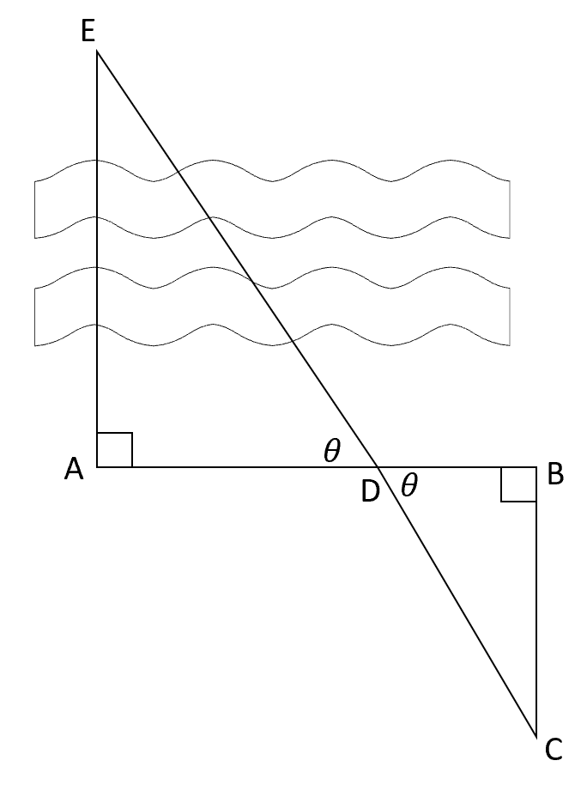

1. To measure the distance between 2 points over an obstruction, use the following steps:
2. Place a peg at your starting point (A).
3. Pick a place for end point (E) we can visually see and reference on the other side of the obstruction, as we cannot place a peg.
4. Starting from (A), walk in a direction that is perpendicular to (E) and place peg (B). Thread the chain from (A) to (B).
5. Starting from (B), walk a distance away from (E), perpendicular to AB, and place peg (C). You must be able to see (E) from (C). Thread the chain.
6. Walk with the chain towards (E), until you meet line AB. Mark this as peg (D) and thread the chain.
7. Measure AD, BD, and BC. Label these on the diagram above.
8. Solve for the unknown distance AE using similar triangles.

#### Corresponding angles

1. Set out your survey using the following instructions:

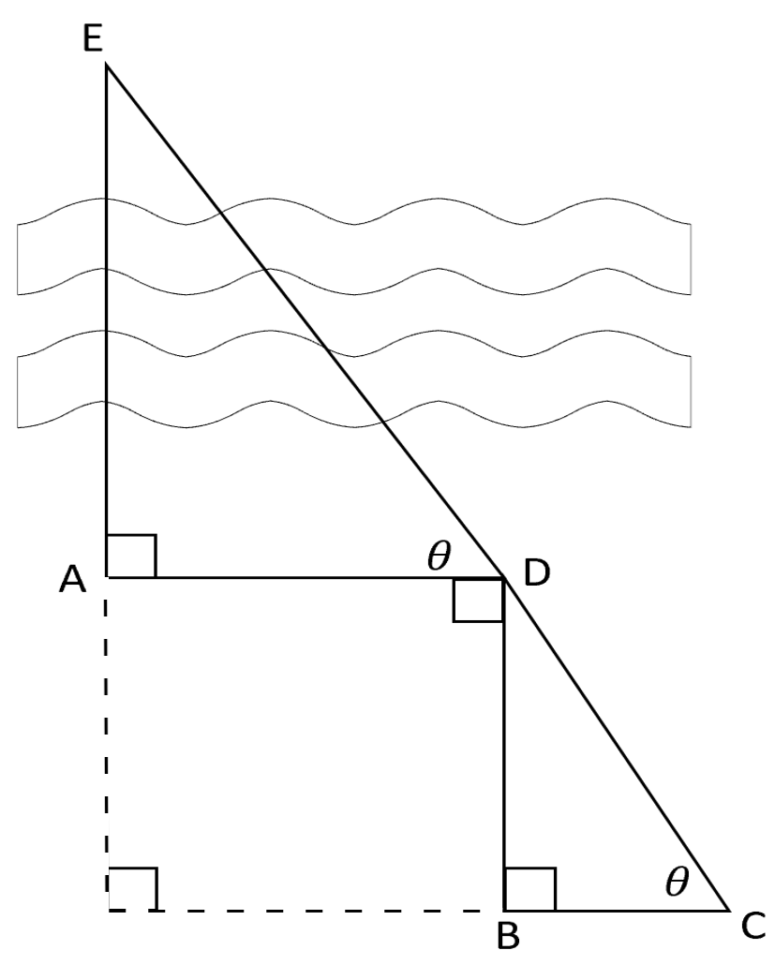

1. To measure the distance between 2 points over an obstruction, use the following steps:
2. Place a peg at your starting point (A). Pick a location on the other side of the obstruction to reference as your end point (E).
3. Starting from (A), walk in a direction that is perpendicular to (E) and place peg (D). Thread the chain from (A) to (D).
4. Start from (D), walk a distance that is perpendicular from AD, away from (E). Place a peg (B). Thread the chain.
5. Start from (B), walk in the direction that is perpendicular from BD, away from (A), until (D) is collinear with your location, and (E). Place a peg (C). Thread the chain.
6. Thread the chain from (C) to (D).
7. Measure AD, BD and BC. Label these on the diagram above.
8. Solve for the unknown distance AE using similar triangles.

## Sample solutions

### Appendix A – Staying on one side

|  |  |
| --- | --- |
| Diagram | Working space |
| Two right-angled triangles, AED and BCD, meet at point D. The angles at point D are vertically opposite. Right angles at A and B. One triangle is intersected by a river icon. AD is 11.2 metres, BD is 5.1 metres and BC is 27.3 metres. | (2 significant figures) |
| Two triangles, AED and BCD, meet at point D. There are right angles at A and B. Angle EDA is equal to angle DCB. One triangle is intersected by a river icon. AD is 9 metres, BD is 19.1 metres and BC is 4.3 metres. | (1 significant figure) |

## References

This resource contains NSW Curriculum and syllabus content. The NSW Curriculum is developed by the NSW Education Standards Authority. This content is prepared by NESA for and on behalf of the Crown in right of the State of New South Wales. The material is protected by Crown copyright.

Please refer to the NESA Copyright Disclaimer for more information <https://educationstandards.nsw.edu.au/wps/portal/nesa/mini-footer/copyright>.

NESA holds the only official and up-to-date versions of the NSW Curriculum and syllabus documents. Please visit the NSW Education Standards Authority (NESA) website <https://educationstandards.nsw.edu.au/> and the NSW Curriculum website [https://curriculum.nsw.edu.au](https://curriculum.nsw.edu.au/).

[Mathematics K–10 Syllabus](https://curriculum.nsw.edu.au/learning-areas/mathematics/mathematics-k-10-2022/overview) © NSW Education Standards Authority (NESA) for and on behalf of the Crown in right of the State of New South Wales, 2022.

**© State of New South Wales (Department of Education), 2024**

The copyright material published in this resource is subject to the *Copyright Act 1968* (Cth) and is owned by the NSW Department of Education or, where indicated, by a party other than the NSW Department of Education (third-party material).

Copyright material available in this resource and owned by the NSW Department of Education is licensed under a [Creative Commons Attribution 4.0 International (CC BY 4.0) license](https://creativecommons.org/licenses/by/4.0/).

[](https://creativecommons.org/licenses/by/4.0/)

This license allows you to share and adapt the material for any purpose, even commercially.

Attribution should be given to © State of New South Wales (Department of Education), 2024.

Material in this resource not available under a Creative Commons license:

* the NSW Department of Education logo, other logos and trademark-protected material
* material owned by a third party that has been reproduced with permission. You will need to obtain permission from the third party to reuse its material.

**Links to third-party material and websites**

Please note that the provided (reading/viewing material/list/links/texts) are a suggestion only and implies no endorsement, by the New South Wales Department of Education, of any author, publisher, or book title. School principals and teachers are best placed to assess the suitability of resources that would complement the curriculum and reflect the needs and interests of their students.

If you use the links provided in this document to access a third-party's website, you acknowledge that the terms of use, including licence terms set out on the third-party's website apply to the use which may be made of the materials on that third-party website or where permitted by the *Copyright Act 1968* (Cth). The department accepts no responsibility for content on third-party websites.